Inference :
Inferences (in the context of your ontology project) are one of the most important parts the teacher wants to see.

Simple Explanation
An inference is new knowledge that the computer (the reasoner) automatically discovers from the rules (axioms, restrictions, class hierarchies, property characteristics) you defined in your ontology — without you explicitly stating it.
This is the power of Description Logics / OWL (the formal language behind ontologies). It’s not just a database — it can reason like a logical system.

Real Example from Your Harry Potter Ontology
In your slides you already mention this (great!):
You modeled Student and Wizard as siblings (both direct subclasses of Person), not Student as a subclass of Wizard.
Then you added something like:
- castsSpell is a property that only Wizards should have (or you defined a restriction like Wizard ⊑ ∃castsSpell.Spell).
What the reasoner (HermiT) does:
When you assert:
- Harry_Potter is a Student
- Harry_Potter castsSpell Expelliarmus
The reasoner infers (automatically concludes):
- Harry_Potter is also a Wizard
This is a non-trivial inference. You didn’t have to manually say “Harry is a Wizard”. The logic derived it.

Other Common Types of Inferences in Your Project
- Class Membership Inference (the example above)
- Subclass Inference — e.g., if something satisfies all conditions of a class, it gets classified automatically.
- Property Inferences — thanks to inverse properties (teaches ↔ taughtBy), symmetric properties (friendOf), transitive properties, etc.
- Contradiction Detection — e.g., if someone is both Professor and Student (but you made them disjoint), the reasoner says “inconsistent”.
- Existential / Universal Restrictions — e.g., every Student must belong to a House → reasoner can flag missing information or infer things.

Why the Course Cares So Much About This
From the guidelines (page 8):
“Use a reasoner to check and discuss inferences” “Discuss specific modeling choices also using inferences”
They want you to show that you didn’t just draw boxes and arrows — you used formal semantics so the machine can reason.

How to Present It Well in Your Project
- Show a before/after with the reasoner:
  - Screenshot of Protégé before running the reasoner.
  - Screenshot after running HermiT (with new inferred types highlighted).
- Pick 2–3 interesting inferences and explain:
  - What did I assert?
  - What did the reasoner infer?
  - Why is this useful / good modeling?

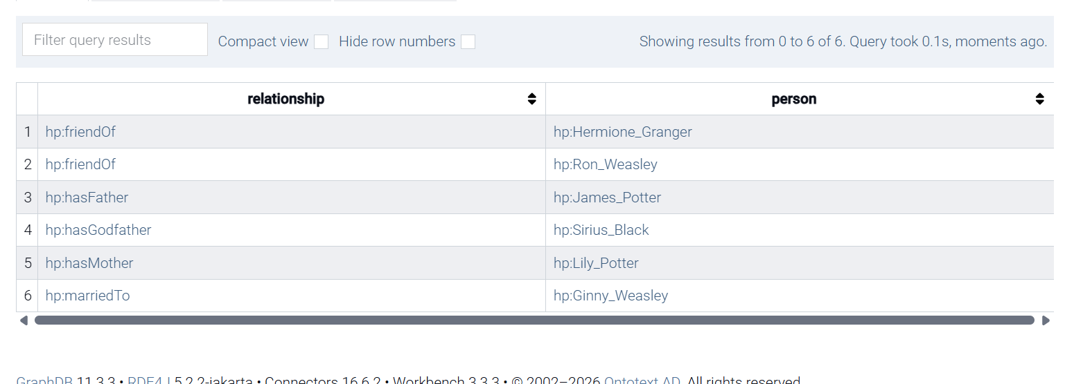
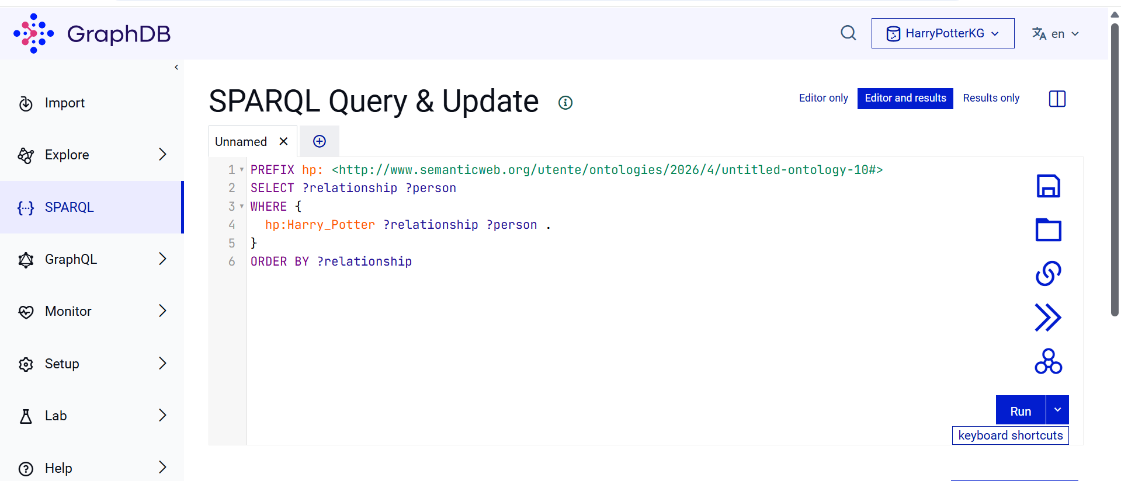
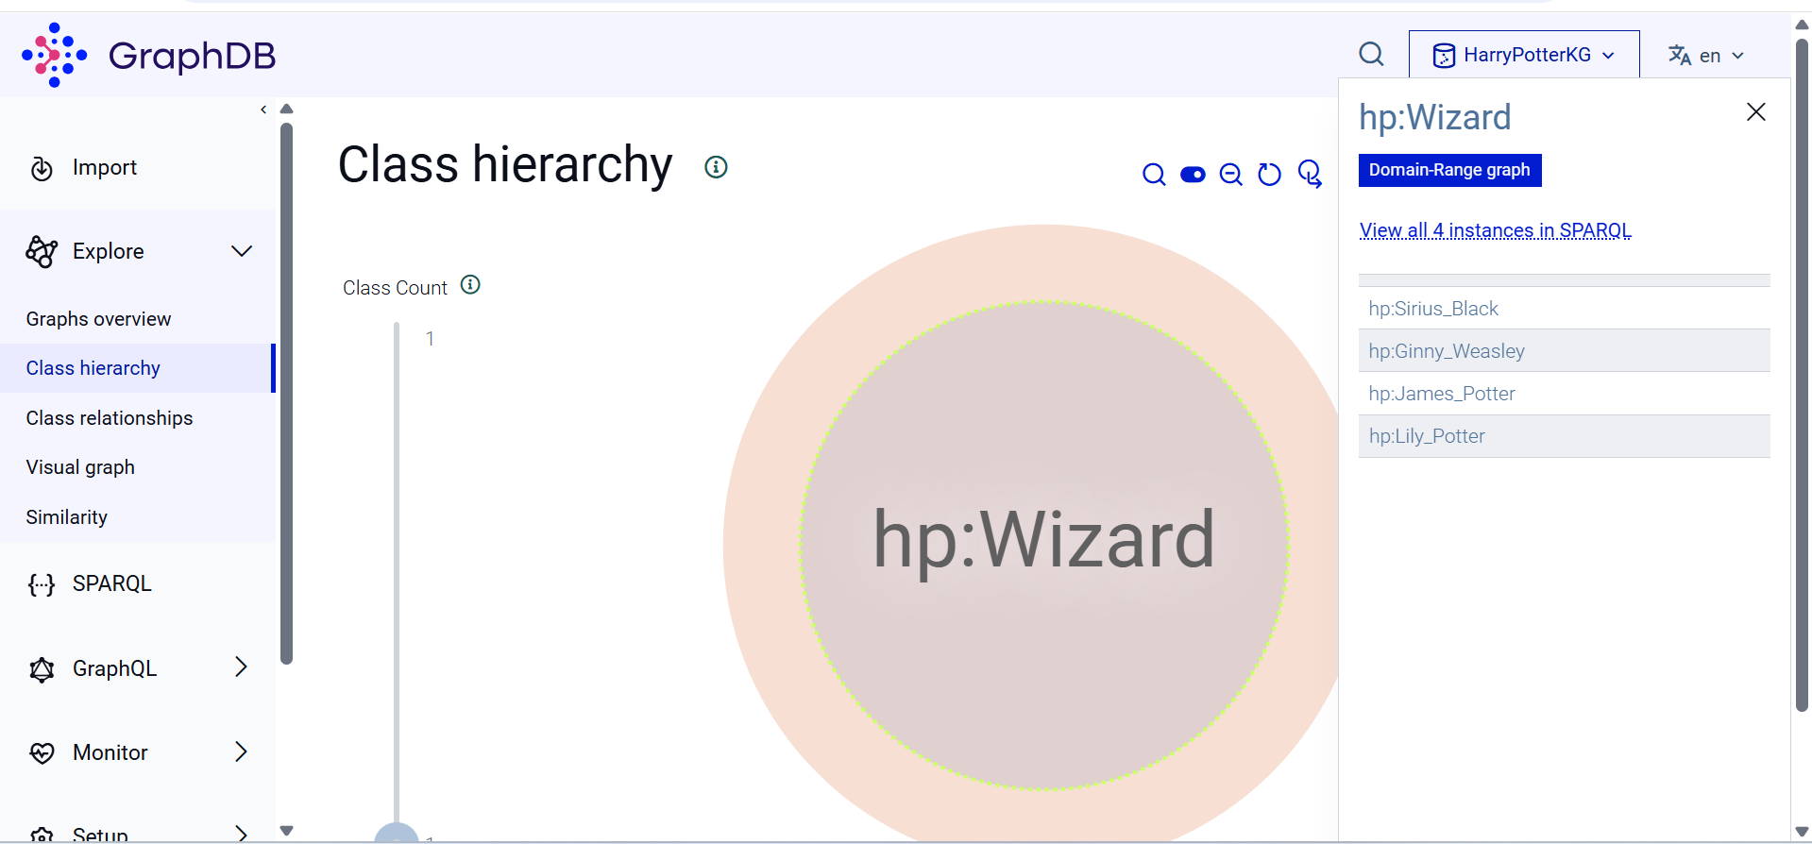
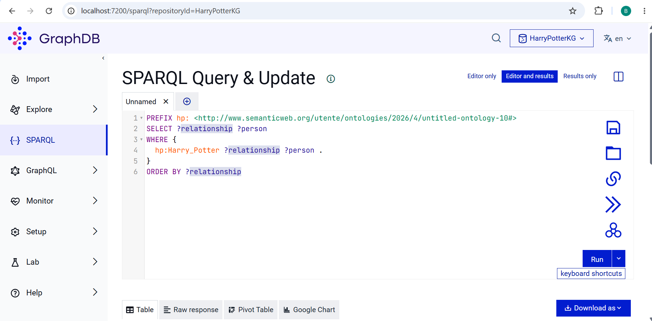

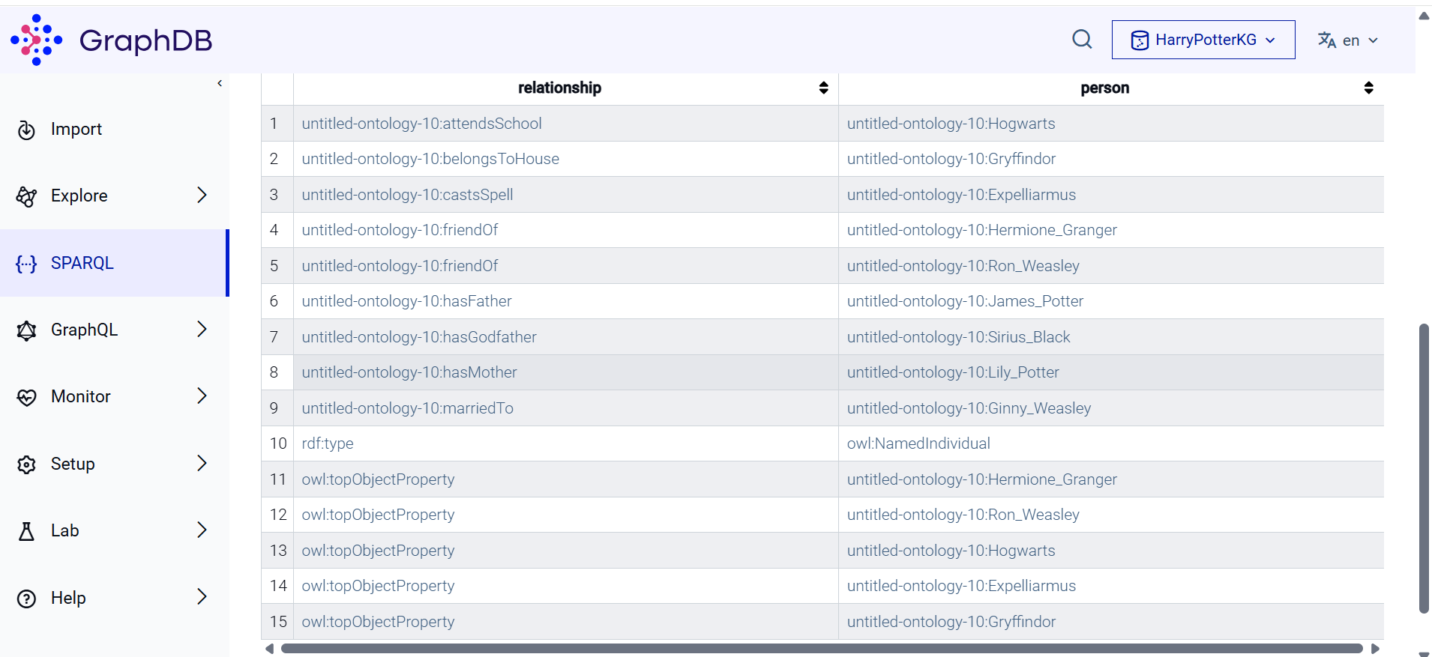

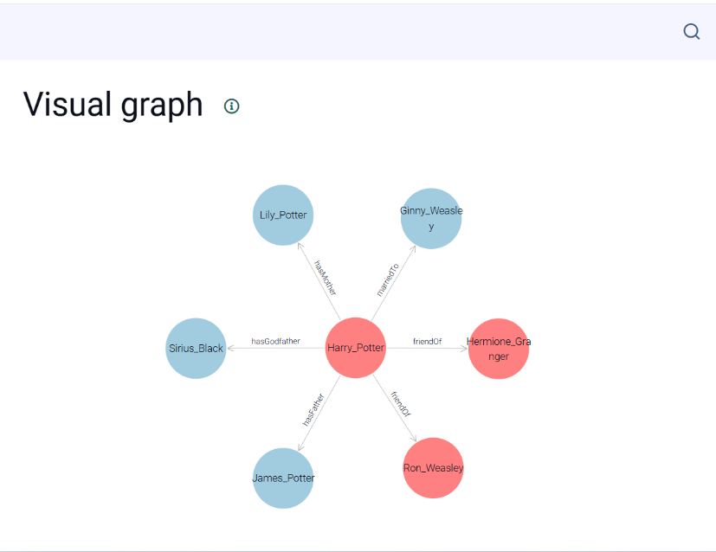

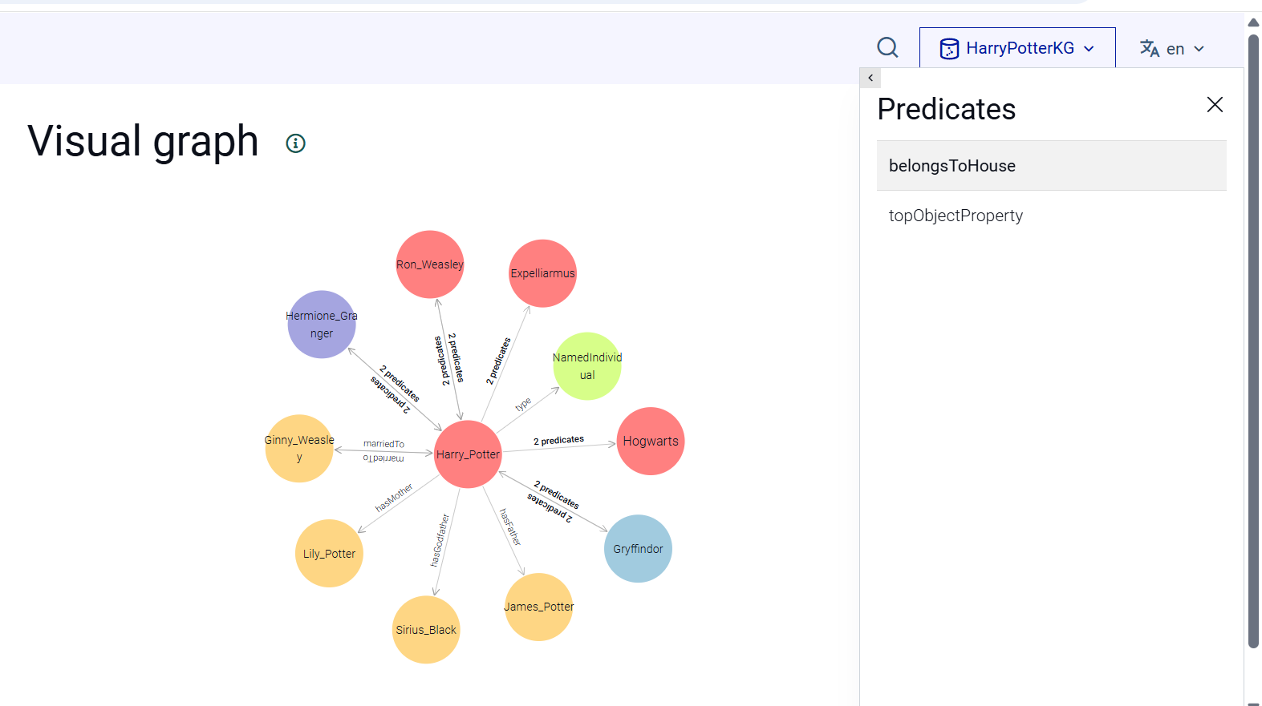

اگر استاد پرسید چرا گراف توی گرف دی بی با گرف دست ساز خودتون فرق داره و انگاری ناقصه چی بگم ؟
The manual graph and the GraphDB visualization serve different purposes. The manual graph was created to clearly illustrate the key relationships in the ontology for presentation purposes. GraphDB, on the other hand, automatically generates the visualization from the RDF triples stored in the repository. Therefore, the appearance and level of detail may differ depending on the imported data, visualization settings, and the selected starting node. The ontology itself remains complete and can be fully validated through SPARQL queries.

2. Object Properties vs. Data Properties
The Graph Visualization tool in GraphDB is primarily designed to show relationships between resources/instances (nodes).
- Data Properties: If a relationship in Protégé is defined as a Data Property (linking an instance to a literal value, like a string or an integer—e.g., hasAge -> 25), it will not appear as a visual edge connecting two nodes. Instead, it is treated as an attribute and is usually displayed in the side panel when you click on that specific node.
- Object Properties: Only Object Properties (relationships that connect one class/instance to another class/instance) are rendered as actual graphical edges in the main view.

اگر استاد فردا بپرسد:
How did you address the feedback about manually created graphs?
به نظرم جواب خیلی خوب این است:
Initially, we manually created the ontology and a small knowledge graph to define the domain structure. Following the feedback, we explored a more realistic workflow by extracting additional knowledge from an external source (Harry Potter Wiki), generating RDF triples with the help of an LLM, importing them into GraphDB, and validating the results through SPARQL queries. This allowed us to study challenges related to knowledge integration and ontology enrichment.

Could you have done the queries in Protégé?
جواب درست اینه:
Yes, Protégé supports ontology querying and reasoning. However, we imported the ontology into GraphDB because GraphDB is a dedicated RDF triple store and provides a more realistic environment for knowledge graph storage and SPARQL-based retrieval.

اگر پرسید چرا از graphdb استفاده کردیم ؟
Protégé was used for ontology development and reasoning, while GraphDB was used to demonstrate RDF storage and SPARQL querying in a real knowledge graph environment. The import was not strictly necessary, but it allowed us to validate the ontology using standard Semantic Web technologies.
Initially, the ontology and core relationships were created in Protégé. Later, when we wanted to enrich the knowledge graph with additional information extracted from external sources, converting the data into RDF/Turtle and importing it into GraphDB became a more efficient and scalable approach. GraphDB allowed us to integrate the original ontology with newly extracted triples and validate the combined knowledge using SPARQL queries.
GraphDB provided a more convenient and scalable environment for integrating and querying additional RDF data.

