1-> 37

( TITLE ( "Parkinson*" OR "PD" ) AND TITLE-ABS-KEY ( "sustained" OR "vowel" OR "phonation" OR "voice" OR "speech" ) AND TITLE-ABS-KEY ( "deep learning" OR "DL" OR "machine learning" OR "ML" OR "computer*" ) AND TITLE-ABS-KEY ( "class*" OR "detect*" OR "progno*" OR "diagno*" OR "predict*" OR "early" OR "feature" OR "spectrogram" OR "pre-trained" OR "transfer" ) ) AND PUBYEAR > 2019 AND PUBYEAR < 2026 AND ( LIMIT-TO ( LANGUAGE , "English" ) ) AND ( LIMIT-TO ( DOCTYPE , "re" ) )

2-> 288

( TITLE ( "Parkinson*" OR "PD" ) AND TITLE-ABS-KEY ( "sustained" OR "vowel" OR "phonation" OR "voice" OR "speech" ) AND TITLE-ABS-KEY ( "deep learning" OR "DL" OR "machine learning" OR "ML" OR "computer*" ) AND TITLE-ABS-KEY ( "class*" OR "detect*" OR "progno*" OR "diagno*" OR "predict*" OR "early" OR "feature" OR "spectrogram" OR "pre-trained" OR "transfer" ) ) AND PUBYEAR > 2022 AND PUBYEAR < 2026 AND ( LIMIT-TO ( LANGUAGE , "English" ) ) AND ( LIMIT-TO ( DOCTYPE , "ar" ) )

3-> 4

**Title: (Parkinson* OR PD) OR ("sustained" OR "vowel" OR "phonation" OR "voice" OR "speech" AND "deep learning" OR DL OR "machine learning" OR ML OR computer* AND class* OR detect* OR progno* OR diagno* OR predict* OR early OR feature OR spectrogram OR "pre-trained" OR transfer)**

Showing 1–50 of 846045 results

Advanced filters: **Title: (Parkinson* OR PD) OR ("sustained" OR "vowel" OR "phonation" OR "voice" OR "speech" AND "deep learning" OR DL OR "machine learning" OR ML OR computer* AND class* OR detect* OR progno* OR diagno* OR predict* OR early OR feature OR spectrogram OR "pre-trained" OR transfer)** [Clear advanced filters](https://www.nature.com/search?order=relevance&article_type=research%2C+reviews)

* 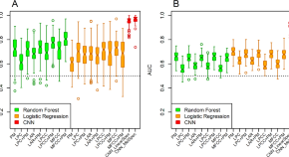

[**Pre-trained convolutional neural networks identify Parkinson’s disease from spectrogram images of voice samples**](https://www.nature.com/articles/s41598-025-92105-6)

* + Yasir Rahmatallah
  + Aaron S. Kemp
  + Fred Prior

**Research**Open Access01 Mar 2025

**Scientific Reports**

Volume: 15, P: 1-13

* 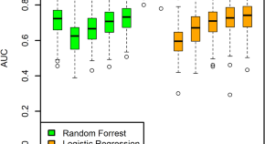

[**A machine learning method to process voice samples for identification of Parkinson’s disease**](https://www.nature.com/articles/s41598-023-47568-w)

* + Anu Iyer
  + Aaron Kemp
  + Tuhin Virmani

**Research**Open Access23 Nov 2023

**Scientific Reports**

Volume: 13, P: 1-9

* 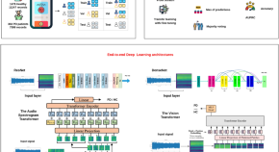

[**Transformer-based transfer learning on self-reported voice recordings for Parkinson’s disease diagnosis**](https://www.nature.com/articles/s41598-024-81824-x)

* + Ilias Tougui
  + Mehdi Zakroum
  + Mounir Ghogho

**Research**Open Access03 Dec 2024

**Scientific Reports**

Volume: 14, P: 1-21

* 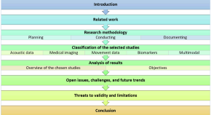

[**Machine learning for Parkinson’s disease: a comprehensive review of datasets, algorithms, and challenges**](https://www.nature.com/articles/s41531-025-01025-9)

* + Sahar Shokrpour
  + AmirMehdi MoghadamFarid
  + Mostafa Sarvizadeh

**Reviews**Open Access01 Jul 2025

**npj Parkinson's Disease**

Volume: 11, P: 1-52

* 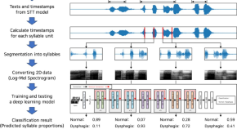

4-> 31

( TITLE-ABS-KEY ( "wav2vec 2.0" OR "Wav2Vec2.0" OR "Wav2Vec" OR "HuBERT" OR "Hubert model" OR "hidden-unit BERT" ) AND TITLE ( "Parkinson*" OR "PD" OR "parkinsonian" OR "Parkinson&apos;s disease" OR "dysarthria" ) ) AND ( LIMIT-TO ( LANGUAGE , "English" ) )