**Natural Language Processing (NLP) vs Natural Language Understanding (NLU)**

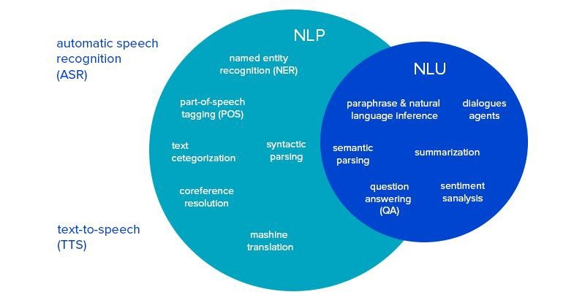

* NLP 🡪 Focus on literal sense; NLU 🡪 focuses on semantic sense.