**What is a Code?**

* **Definition**: “Word or short phrase that represents qualitative data”.
  + The data can be: any kind of text, photographs, video, or audio.
  + Coding is an **interpretive act**. It can be different from one person and another.
  + Coding isn't just about reducing data into smaller, simpler components. It also involves **capturing the essence or key themes in the data**.
* **Objective:** One of the coder’s primary goals is to **find repetitive patterns of action** and consistencies in human affairs as documented in the data.
  + Remember that: Idiosyncrasy is a pattern and there can be patterned variation in data.
  + Characteristics pattern:
    - Similarity 🡺 Things happen the same way.
    - Difference 🡺 They happen in predictably different ways.
    - Frequency 🡺 They happen often or seldom.
    - Sequence 🡺 They happen in a certain order.
    - Correspondence 🡺 They happen in relation to other activities or events.
    - Causation 🡺 One appears to cause another.
  + **CAUTION:** Too much focus on codification pattern can lead oversimply analytic process of qualitative data. This could lead to the reproduction of existing assumptions rather than the development of new and potentially more insightful theories.
* **Coding as a heuristic:** Heuristic means “to discover” 🡺 exploratory problem-solving technique without specific algorithms to follow.
  + Coding is not just labelling, it’s linking 🡺 The codes are captured essential elements of the data, then clustered (linking) all codes based on its pattern.
  + Coding is a cylical process 🡺 Once a code is applied to a datum during first cycle analysis, it is not a fixed representation but a dynamic and malleable process.

NOTE: Heuristic fluidity is necessary to prioritize insightful qualitative analytics discovery over mere mechanistic validation.

**Coding Examples:**

|  |  |  |
| --- | --- | --- |
| *1I notice that the grand majority of homes have chain link fences in front of them. There are many dogs (mostly German shepherds) with signs on fences that say “Beware of the Dog”* | |  | | --- | | 1SECURITY | |

NOTES:

* The one-word capitalized code in the right column is a **Descriptive Code**.
* It’s summarizes the primary topic of the determined superscript number.

|  |  |  |
| --- | --- | --- |
| *1 He cares about me. He has never told me but he does. 2 He’s always been there for me, even when my parents were not. He’s one of the few things that I hold as a constant in my life. So it’s nice. 3 I really feel comfortable around him.* | |  | | --- | | 1SENSE OF SELF-WORTH |   2STABILITY  3”COMFORTABLE” |

NOTES:

* The code that is taken directly from what the participant says and is placed in quotation marks is the **Vivo Code**. In this case is “COMFORTABLE”.

|  |  |  |  |  |  |  |  |  |  |  |  |  |  |  |
| --- | --- | --- | --- | --- | --- | --- | --- | --- | --- | --- | --- | --- | --- | --- |
| *1My son, Barry, went through a really tough time about, probably started the end of fifth grade and went into sixth grade. 2When he was growing up young in school he was a people-pleaser and his teachers loved him to death. 3Two boys in particular that he chose to try to emulate, wouldn’t, were not very good for him. 4They were very critical of him, they put him down all the time, and he kind of just took that and really kind of internalized it, I think, for a long time. 5In that time period, in the fifth grade, early sixth grade, they really just kind of shunned him all together, and so his network as he knew it was gone.* | |  | | --- | | 1 MIDDLE-SCHOOL HELL | |  | | 2 TEACHER’S PET | |  | |  | | 3 BAD INFLUENCES | |  | | 4 TWEEN ANGST | |  | |  | | 5 THE LOST BOY | |  | |  | |

NOTES:

* This is an example of **Eclectic Coding, It’s a flexible way of coding the data**. Instead of sticking to one specific coding technique, the researcher combines different coding strategies to capture the complexity and richness of the data.
* This approach is particularly useful when dealing with diverse, multifaceted data sets that require different lenses to be fully understood.

|  |  |  |  |  |  |  |  |  |  |  |  |  |  |  |  |
| --- | --- | --- | --- | --- | --- | --- | --- | --- | --- | --- | --- | --- | --- | --- | --- |
| **Alternative 1:**   |  |  |  |  |  |  |  |  |  |  |  |  |  |  |  | | --- | --- | --- | --- | --- | --- | --- | --- | --- | --- | --- | --- | --- | --- | --- | | *1Mrs. Jackson rises from her desk and announces, “Ok, you guys, let’s get lined up for lunch. Row one.” Five children seated in the first row of desks rise and walk to the classroom door. Some of the seated children talk to each other. 2Mrs. Jackson looks at them and says, “No talking, save it for the cafetaria. 3Row Two.” Five children seated in the second row of desks rise and walk to the children already standing in line.* | |  | | --- | | 1 LINNING UP FOR LUNCH | |  | |  | |  | | 2 MANAGING BEHAVIOR | |  | | 3 LINING UP FOR LUNCH | |  | |  | |  | |  | |  | |  | | |
| **Alternative 2:**   |  |  |  |  |  |  |  |  |  |  |  |  |  |  |  | | --- | --- | --- | --- | --- | --- | --- | --- | --- | --- | --- | --- | --- | --- | --- | | *1Mrs. Jackson rises from her desk and announces, “Ok, you guys, let’s get lined up for lunch. Row one.” Five children seated in the first row of desks rise and walk to the classroom door. Some of the seated children talk to each other. 1aMrs. Jackson looks at them and says, “No talking, save it for the cafetaria. Row Two.” Five children seated in the second row of desks rise and walk to the children already standing in line.* | |  | | --- | | 1 LINNING UP FOR LUNCH | |  | |  | |  | | 1a MANAGING BEHAVIOR | |  | |  | |  | |  | |  | |  | |  | |  | | |

NOTES:

* Alternative 1 using multiple Process Code.
* Alternative 2 using Simultaneous Coding.

|  |  |  |  |
| --- | --- | --- | --- |
| **Alternative 1:**   |  |  |  | | --- | --- | --- | | *1There’s just no place in this country for illegal immigrants. Round them up and send those criminals back to where they came from.* | |  | | --- | | 1”NO PLACE” | | |
| **Alternative 2:**   |  |  |  | | --- | --- | --- | | *1There’s just no place in this country for illegal immigrants. Round them up and send those criminals back to where they came from.* | |  | | --- | | 1IMMIGRATION ISSUES | | |
| **Alternative 3:**   |  |  |  | | --- | --- | --- | | *1There’s just no place in this country for illegal immigrants. Round them up and send those criminals back to where they came from.* | |  | | --- | | 1XENOPHOBIA | | |

NOTES:

* How we perceive and interpret data depends on which angle we view the phenomenon.
* Alternative 1 using Vivo Coding 🡺 Based on participant’s own language.
* Alternative 2 using Descriptive Coding 🡺 Summarize primary content of data.
* Alternative 3 using Values Coding 🡺 Capture and label subjective perspectives.

**Codifying and Categorizing**

* **Definition:** Codifying is a process that permits data to be divided, grouped, reorganized, and linked in order to consolidate meaning and develop explanation.
  + This happens when we apply and reapply codes to qualitative data.
  + Remember that coding is a cyclical process.
* **Definition:** Categorizing is a process of grouping data that share similar characteristic.
  + In this case, categorizing is how we get ‘up’ from diversity of data to the shapes of the data.
* **Definition:** Synthesis is taking different pieces of coding and integrating them to form more complex ideas or insights.
  + In quantitative, we have mean and any statistic to ex

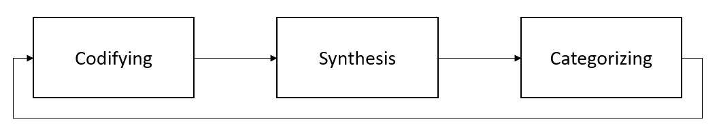

* We repeat this process until we get the thematic/conceptual from our data.
  + Concepts are how we get up more general, higher-level, and more abstract constructs.
  + We get this data by comparing the major categories with each other.
  + **Theme is phrase of sentence** that describes more subtle and tacit processes. **Category is a word or phrase**that describes some segment of our data.

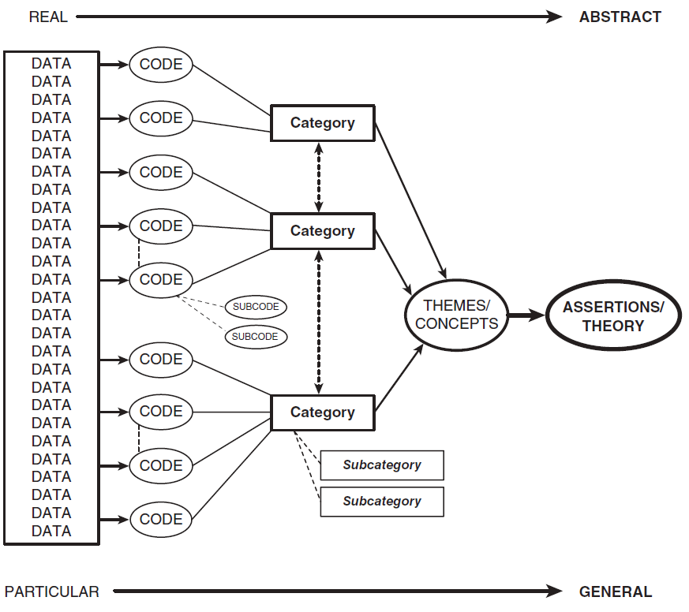

* ada