Penetration Testing Report
Footprinting, Reconnaissance & Network Scanning
Week 2 W2-PM1 & W2-PM5

Pentester Name | Bahati
Program / Batch | B084 - Networkwalks Cybersecurity Internship
Date | 9 November 2026
Modules Completed | W2-PM1 (Multiple Kali Tools) -Complete | W2-PM5 (Zenmap) Complete
Target Scope | networkwalks.com (public website + DNS) and tester's own LAN, per signed Letter of Authorization NW-LOA-B082-017

Liability Disclaimer
This report documents educational, authorized security testing performed under the NetworkWalks Cybersecurity Internship (Batch B084). All activities were carried out strictly within the scope and dates authorized in writing by the Client (Networkwalks), per Letter of Authorization NW-LOA-B082-017. No exploitation, unauthorized access, or disruptive activity was attempted. Findings are recorded for educational purposes only.

Introduction
Footprinting and reconnaissance is the first phase of a penetration test. It gathers public information about a target domain ownership, hosting, technologies, DNS records, and network layout without touching the target directly, laying the foundation for later testing phases.

W2-PM1: Footprinting with Multiple Kali Tools (networkwalks.com)

Task 1: whois
Command:
whois networkwalks.com
Findings:
- Registrar: GoDaddy.com, LLC
- Creation Date: 6 Nov 2019
- Expiry Date: 6 Nov 2027
- Name Servers: NS6135.HOSTGATOR.COM, NS6136.HOSTGATOR.COM (confirms HostGator as hosting provider)
- Registrant identity hidden via Domains By Proxy
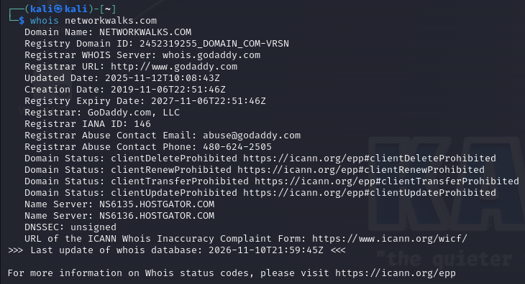

Task 2: whatweb
Command:
whatweb networkwalks.com
Findings:
- Web server: Apache
- CMS: WordPress 7.1.4
- Plugin: WordPress Download Manager 3.3.76
- Bootstrap 7.1.4, jQuery 3.7.1
- Server IP: 192.232.216.135
- Contact email exposed: info@networkwalks.com
- Country: United States

Task 3: nslookup
Command:
nslookup networkwalks.com
Findings:
- Resolves to IP: 192.232.216.135 (matches the IP found via whatweb)
- DNS server used: 8.8.8.8 (Google DNS)
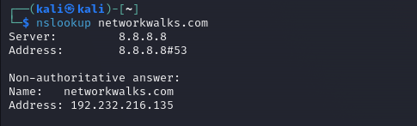

Task 4: curl -I
Command:
curl -I https://networkwalks.com
Findings:
- Server: Apache
- WordPress confirmed again via x-nginx-cache header
- A WordPress REST API endpoint is exposed via the link header (/wp-json/)
- Cache-related headers (x-endurance-cache-level, x-nginx-cache) leak the caching stack
- CSP/permissions-policy headers reference reCAPTCHA, hCaptcha, and Cloudflare challenges
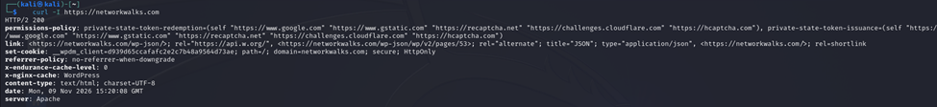

Task 5: wafw00f
Command:
wafw00f networkwalks.com
Findings:
- The site is behind a ModSecurity (SpiderLabs) Web Application Firewall
- This means naive scanning/exploitation attempts would likely be blocked or logged
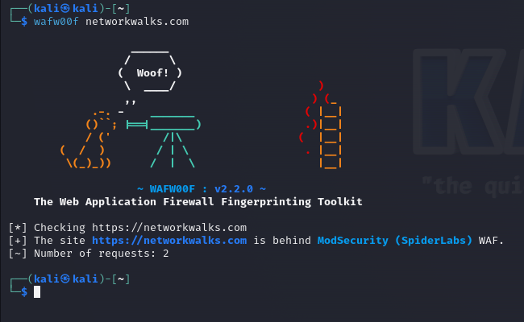

Task 6: dnsrecon
Command:
dnsrecon -d networkwalks.com
Findings:
- DNSSEC not configured
- Name servers: ns6135.hostgator.com, ns6136.hostgator.com (Bind version 9.16.23-RH on both)
- Mail server (MX): mail.networkwalks.com (192.232.216.135)
- SPF record: v=spf1 +a +mx +ip4:50.87.144.87 +include:websitewelcome.com ~all
- Google site verification TXT record present
- 8 SRV records found all pointing to cPanel email autodiscovery (cpanelemaildiscovery.cpanel.net), confirming cPanel hosting
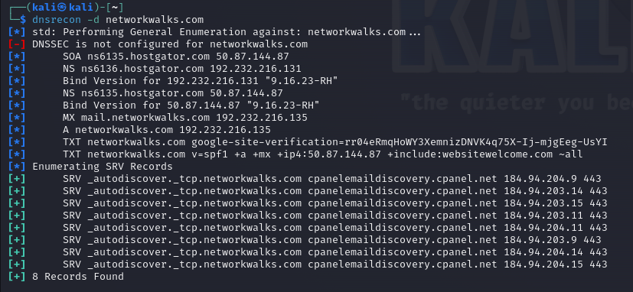

W2-PM5: Network Scanning with Zenmap/Nmap (Local LAN)

Task 1-2: Local IP and subnet
Command:
ip a
Kali VM local IP is 10.0.0.2/24, so the LAN subnet is 10.0.0.0/24.

Task 3-6: Live hosts, count, IPs, MAC addresses
Command:
nmap -sn 10.0.0.0/24 (run via Zenmap GUI, Ping scan profile)
Findings:
- 2 hosts live out of 256 IP addresses scanned
- Live hosts: 10.0.0.1 (NAT gateway, MAC 52:54:00:12:35:00 QEMU virtual NIC) and 10.0.0.2 (Kali VM, this tester's machine)
- Only one other device was on the network segment (the virtual NAT gateway); the isolated lab network has no additional hosts
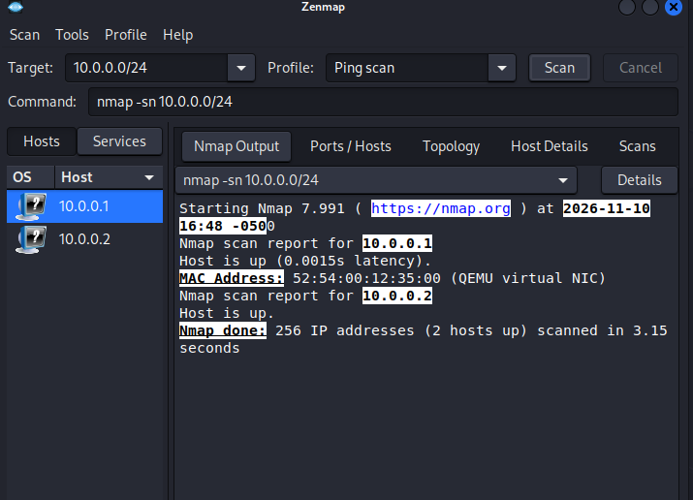

Task 7: Topology output
Topology view (via Zenmap GUI, Topology tab with Legend enabled) shows 2 nodes: localhost (this Kali VM) connected to the NAT gateway at 10.0.0.1. Saved as a PDF graphic for submission.
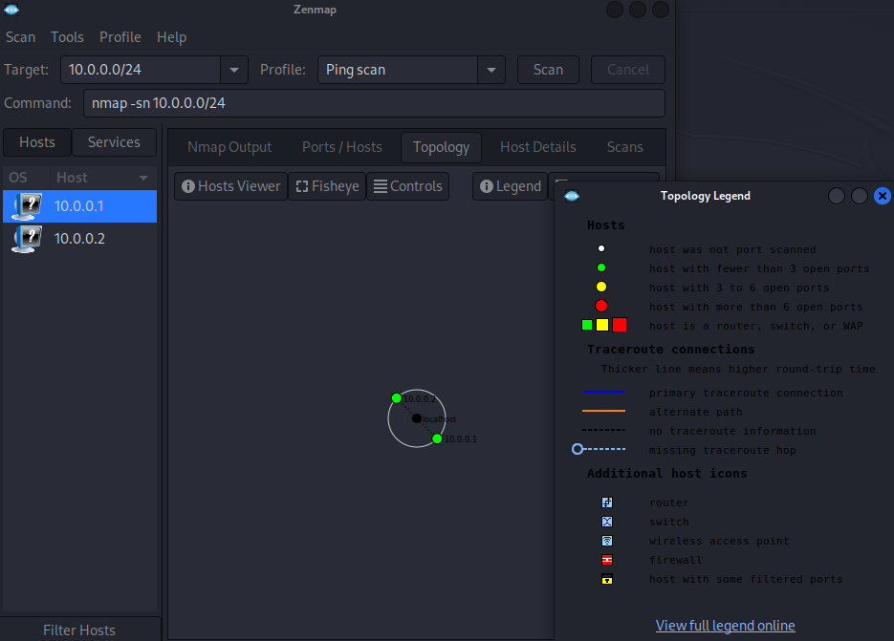

Conclusion
This engagement demonstrated how much information about a target can be gathered using only passive, publicly-available data without ever touching the target system directly.
Footprinting (W2-PM1) on networkwalks.com revealed:
- Hosting provider (HostGator) and registrar (GoDaddy) via whois
- Exact CMS and plugin versions (WordPress 7.1.4, WordPress Download Manager 3.3.76) via whatweb both could be checked against known CVEs
- Server IP (192.232.216.135) via nslookup, confirmed across multiple tools
- Exposed REST API endpoint and caching stack via HTTP headers (curl)
- An active ModSecurity WAF via wafw00f, which would shape how an attacker approaches further testing
- Full DNS footprint (mail servers, SPF policy, cPanel SRV records) via dnsrecon, with DNSSEC notably not configured

Network scanning (W2-PM5) on the tester's own LAN confirmed host discovery fundamentals: identifying all live hosts, their IPs and MAC addresses, and visualizing the network topology skills directly transferable to scanning any authorized target network.
Taken together, these findings illustrate why organizations should minimize what they expose publicly: every piece of information gathered here (hosting provider, software versions, DNS records, WAF presence) narrows the attack surface an adversary needs to map before attempting exploitation. All testing in this report stayed within the scope and conditions of Letter of Authorization NW-LOA-B082-017.

