ATTACHMENT-3
HOT GAS GENERATOR INFORMATION DOCUMENT

GENERAL INFORMATION ABOUT HOT GAS GENERATOR
A Hot Gas Generator (HGG) is a pyrotechnic capsule that will be provided to the competing teams by the Competition Committee. Teams planning to pressure a certain closed volume using pyrotechnic materials in the recovery system must use the HGGs to be provided by the Competition Committee in accordance with the competition specifications.
Teams will not be required to interfere with the pyrotechnic material in the HGG, as a ready-made product (in capsule form).
The mass of the HGG is 78g+/-5g.
Teams will install the system with the aid of bolts and apply tension to the connection points on the generator to activate it. Teams will not need to do any operations other than wiring and bolt installation.

HGG CONNECTION INTERFACE
The HGG comprises two main parts: the connection interface, and the pyrotechnic capsule. The HGG can be mounted through its connection interface (clip on the HGG). It will be sufficient for the teams to bolt the connection interface to their rockets as a mechanical connection, after which the capsule can be connected to the interface with clips. The activation of the capsule will require two (2) cable connections.
The assembled version of the HGG is shown in Figure 1. As can be seen, the clip on the bottom of the capsule will slot into the interface, completing the installation.
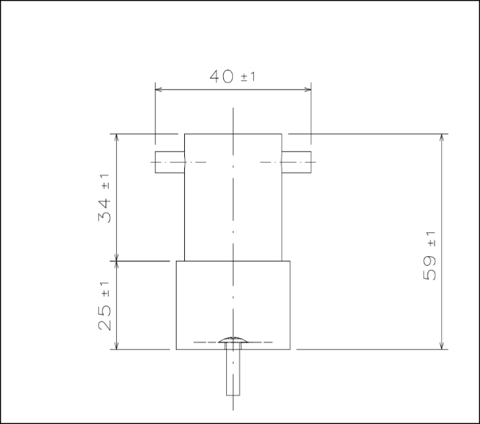
Capsule and Connection Interface (Assembled)
Figure 1. HGG and Connection Interface (Assembled)
The image of the pyrotechnic capsule is shown in Figure 2. The parts shown here with number 1 will be used to activate the pyrotechnic material. Teams will connect the cables of their systems to these points to provide electrical connection.
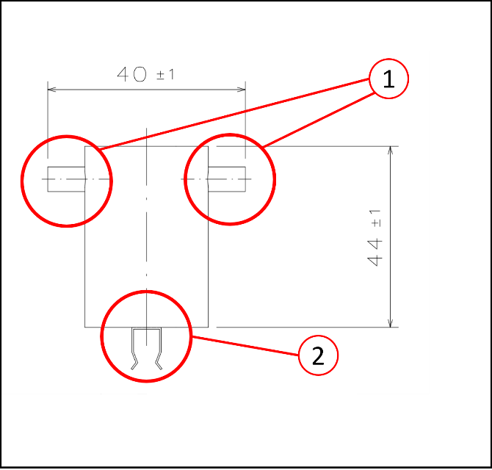
Pyrotechnic Capsule
1. Electrical Connections
2. Interface Connection Clip
Figure 2. Pyrotechnic Capsule
The installation will be completed after placing the pyrotechnic capsule on the connection interface with the help of the clip underneath. The connection interface into which the pyrotechnic capsule will fit is shown in Figure 3. The connection interface will contain a hole that will allow the teams to easily mount the interface to their systems. This hole is designed to allow an M4 bolt to pass through. For the connection in question, raised head bolts should be preferred.
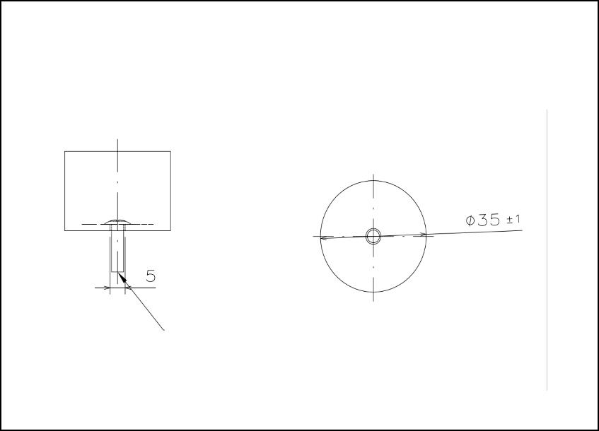
Connection Interface
M4 Raised head bolts

Figure 3. Connection Interface

HGG CURRENT VALUES
Hot Gas Generator current charts are given in Figure 4, 5, 6 and 7.
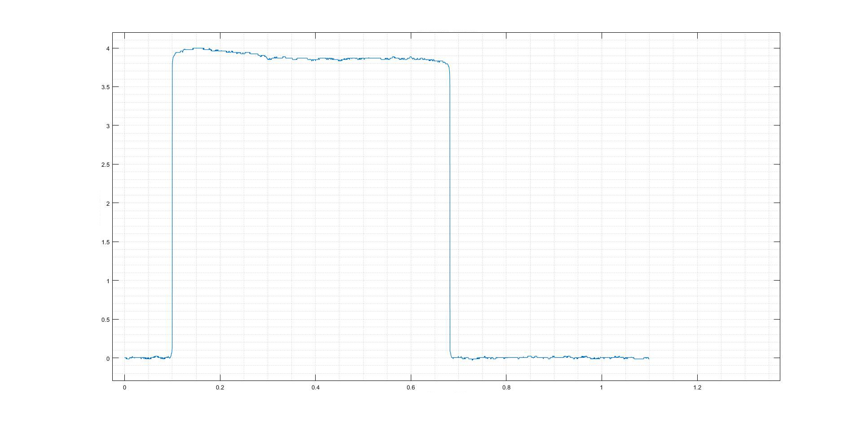
Current [A]
7.0V Current - Time
Time [h]
Figure 4. Current under 7V voltage

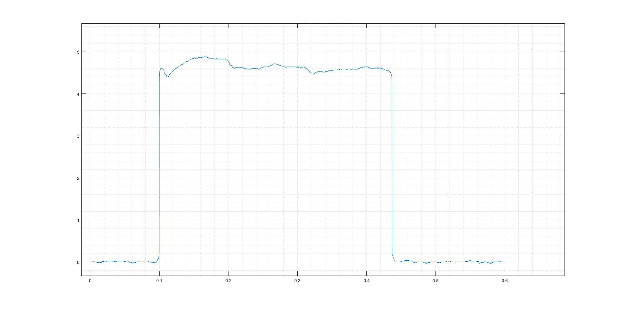
Current [A]
7.0V Current - Time
Time [h]
Figure 5. Current under 8.4V voltage

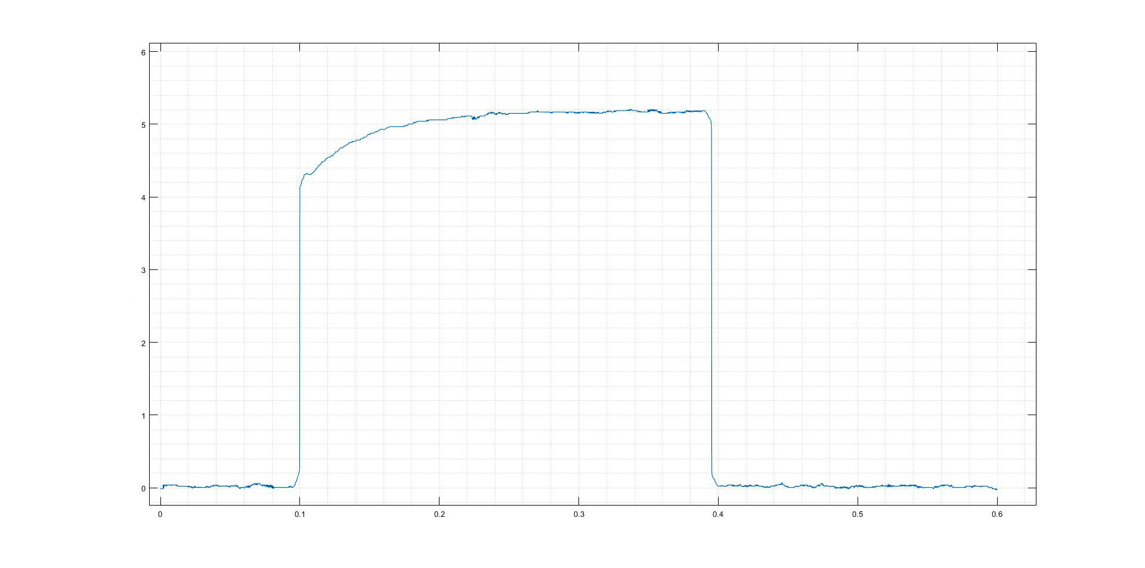
Current [A]
7.0V Current - Time
Time [h]
Figure 6. Current under 11.1V voltage

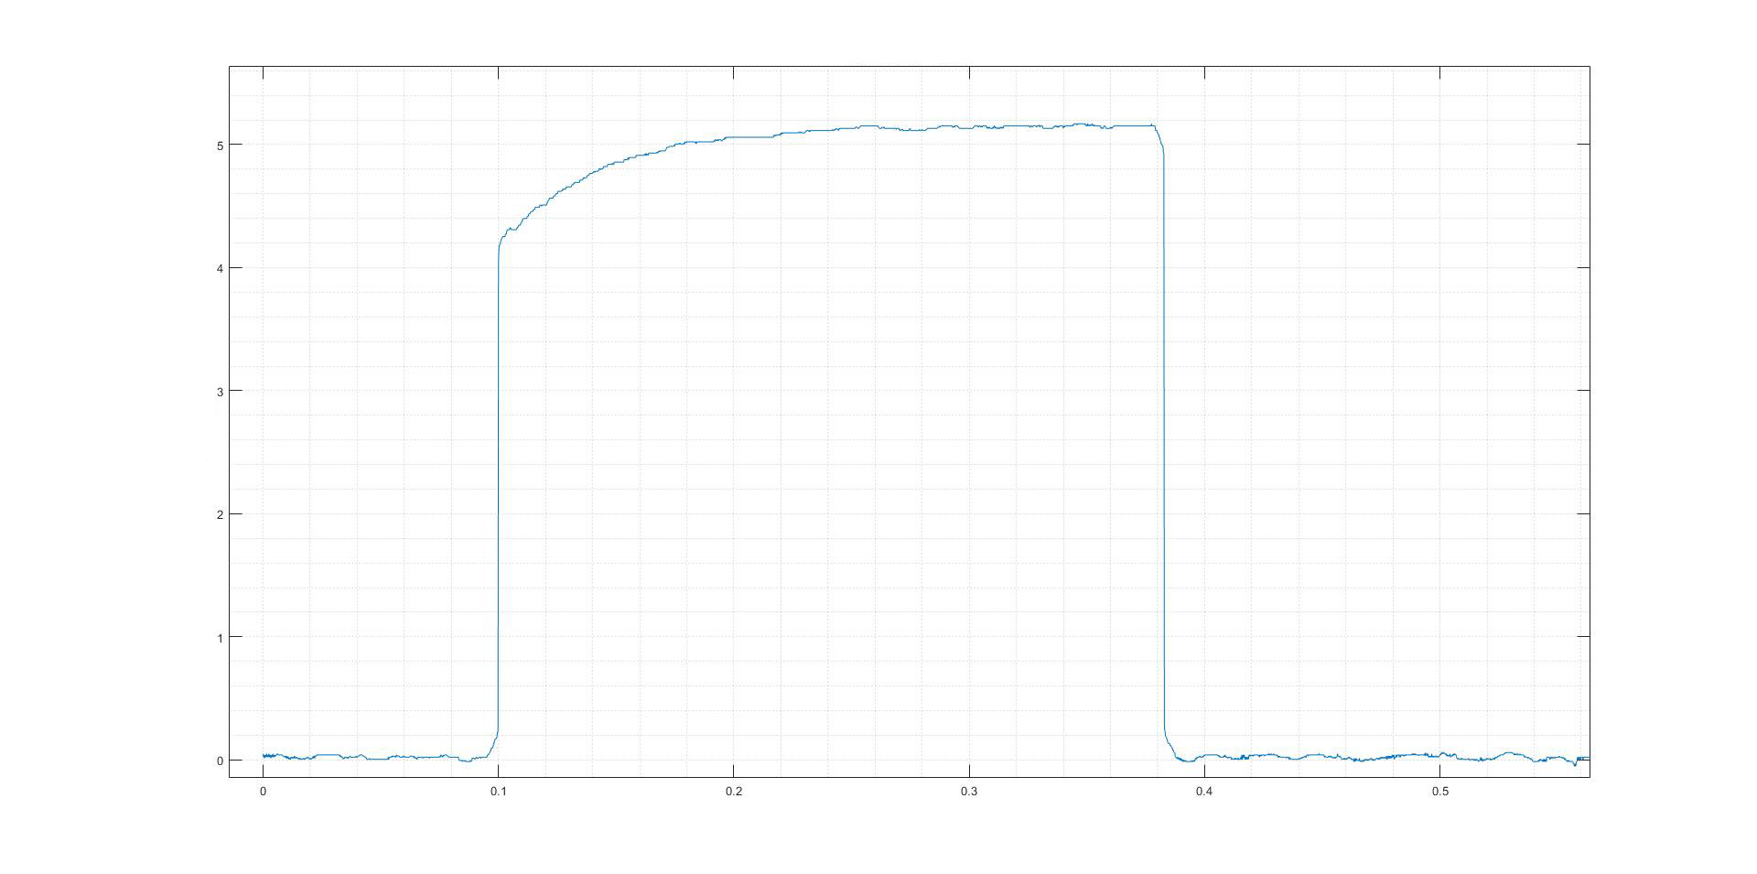
Current [A]
7.0V Current - Time
Time [h]
Figure 7. Current under 12.6V voltage

HGG PRESSURE VALUES
The pressure graph following from the activation of the HGG within a 1-litre closed control volume is shared in Figure 8.
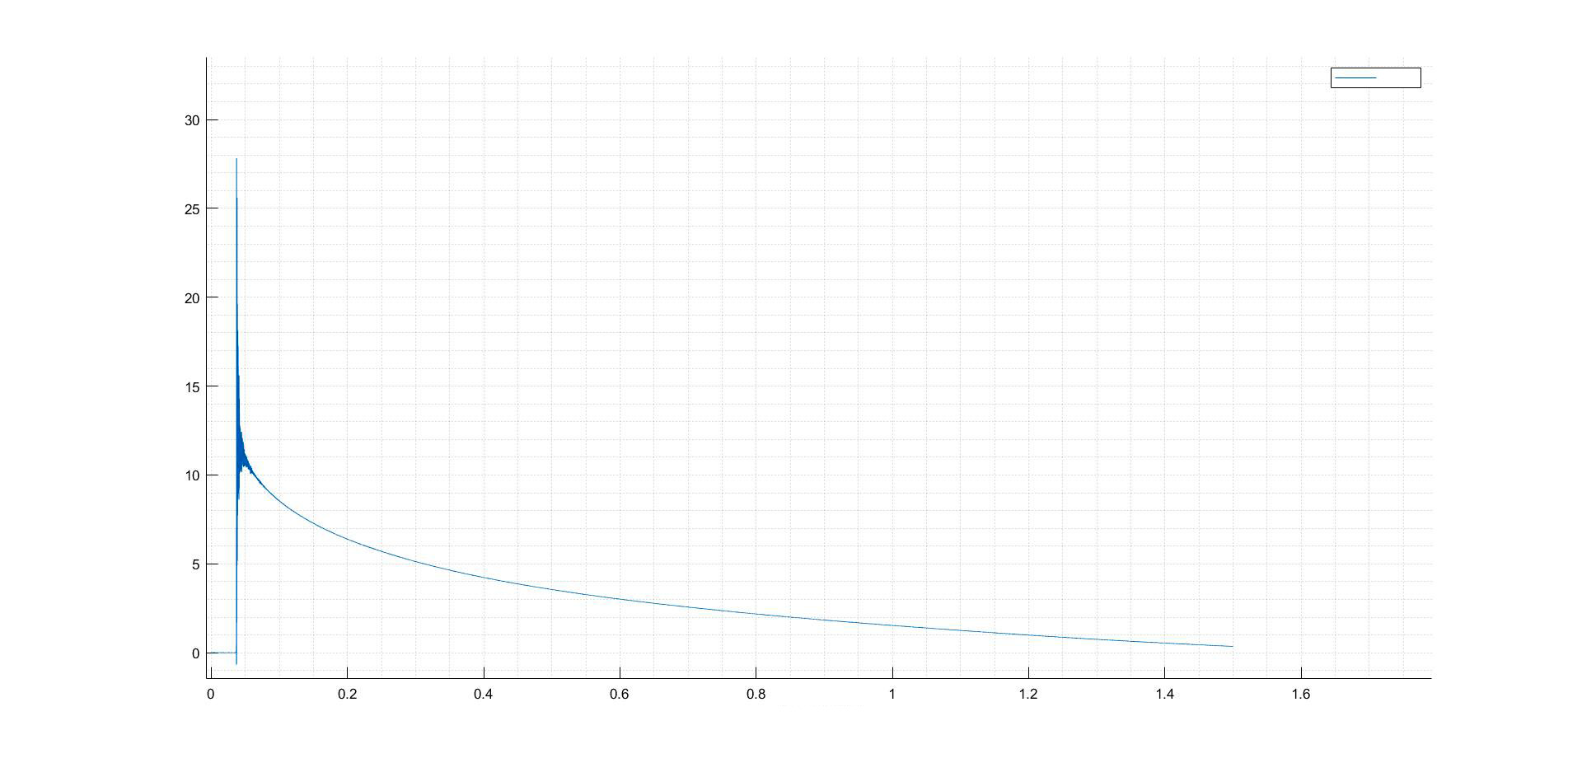
Pressure [bar]
SGU Pressure - Time
Time [h]
Pressure

