ATTACHMENT- 7
REFEREE GROUND STATION INFORMATION DOCUMENT

GENERAL INFORMATION ABOUT THE REFEREE GROUND STATION
In the TEKNOFEST Rocket Competition, teams must transmit their location information to the ground station they have developed to recover their rockets. The teams in the Group A categories are required to transfer information transmitted to their own ground station to the Referee Ground Station (RGS) of the Competition Committee.
GPS data, which must be transmitted to the Competition Committee for recovery, will be received with the help of live data transmitted by the competitors from ground stations to the RGS.
This document presents the technical information necessary for the teams to transmit other data downloaded to their ground stations to the Competition Committee.
All teams must transmit GPS Altitude, GPS latitude and GPS longitude data to RGS during the flight.
A test software has been developed to allow teams to test their communication with the RGS.

REFEREE GROUND STATION COMMUNICATION PROTOCOL
The RGS is the transmission and processing system through which the contestants’ rocket data are sent to the referees. In order for the competitors to transmit their data, they will be asked to connect the RGS device to their computers when data transmission will be done. The connector of the device will be USB. RGS will appear as a serial communication device in the operating system’s Device Manager.
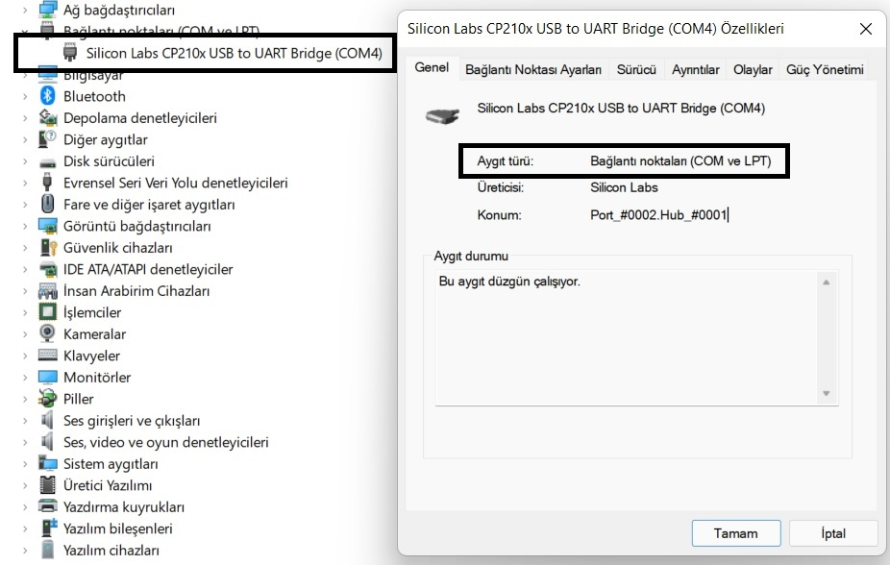
Figure 1. Device Manager RGS View
As seen in the figure, the device is listed as a COM port in Device Manager. The manufacturer of the USB-UART bridge hardware is representative, but the operating principle of the hardware is standard. There will be no need to install additional drivers for the device to be recognised on the computer, and it can be connected to the computer since it is a plug and play device. Teams must be able to send data to the RGS device connected to their computers via the COM port in accordance with the specified standards. Since no data will be sent from the RGS to the computer, there is no need for the computer software to have the infrastructure to receive and process data from the RGS.
Since the data that the competitors will send to the RGS via computer software is rocket data, the computer software that interprets the data from the rocket and the software that will send data to the RGS must be the same.
  - RGS COM Port Settings
-Baud Rate: 19200 baud
-Word Length: 8 bit
-Parity: None
-Stop Bits: 1
  - Data Accepted by the RGS
14 (fourteen) different meaningful data can be sent to the RGS device. The data that can be sent can be listed as follows:
- Team ID: Data from the competitors will be collected in a single centre. To determine which team the collected data comes from while processing, the competitors will be given a team ID between 0 and 255 and will be asked to share their team ID in the relevant section of all data sent to the RGS device.
- Package Counter: Competitors must send packet counter information to detect the continuity of communication between the RGS system and their computer. The packet counter starts from 0 and goes up to 255. The counter value is increased by 1 with each packet sent. After the packet with the counter value of 255 is sent, the counter value in the packet to be sent becomes 0 and continues until 255 again.
- Altitude: It is the processed and sent version of the altitude value obtained by the pressure sensor. Although altitude data with respect to sea level is obtained by the pressure sensor, competitors are expected to subtract the launch rail altitude at which their electronic systems are turned on from the data they send. Necessary action must be taken to accept the altitude value measured on the launch rail as zero.
- Rocket GPS Altitude: Altitude data from the GPS system should be sent without further processing. The unit must be metre.
- Rocket Latitude: Latitude data from the GPS system can be sent.
- Rocket Longitude: Longitude data from the GPS system can be sent.
- Payload GPS Altitude: Altitude data from the GPS system should be sent without further processing. The unit must be metre.
- Payload Latitude: Latitude data from the GPS system can be sent.
- Payload Longitude: Longitude data from the GPS system can be sent.
- Stage GPS Altitude: Altitude data from the GPS system should be sent without further processing. The unit must be metre. (Challenging Mission Category Only)
- Stage Latitude: Latitude data from the GPS system can be sent. (Challenging Mission Category Only)
- Stage Longitude: Longitude data from the GPS system can be sent. (Challenging Mission Category Only)
FOOTNOTE: When sending the latitude and longitude data from the GPS system, care must be taken to send the coordinates correctly. If the sent latitude and longitude point to the correct location when typed into the Google Maps application in the "LATITUDE, LONGITUDE" format, the coordinates have been sent correctly. For example, the coordinates of the Grand National Assembly of Turkiye are latitude: 39.910211 longitude: 32.852796. In order for the RGS device to detect the location of the Grand National Assembly of Turkiye, the data should be sent as latitude: 39.910211 and longitude: 32.852796. If the Turkish Grand National Assembly appears when "39.910211,32.852796" is searched on Google Maps, it means the correct latitude and longitude have been sent.
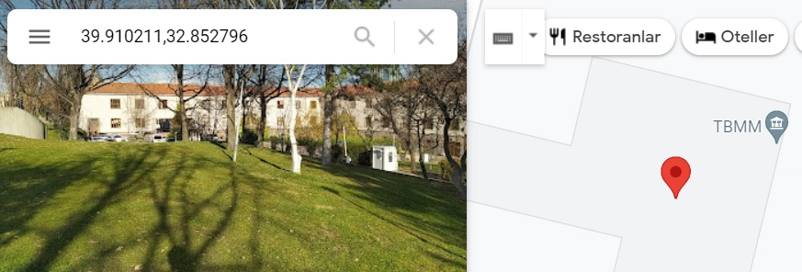
Figure 2. Sample Latitude and Longitude Representation
- Gyroscope X: X-axis rotation data received from the rocket. Its unit must be dps.
- Gyroscope Y: Y-axis rotation data received from the rocket. Its unit must be dps.
- Gyroscope Z: Z-axis rotation data received from the rocket. Its unit must be dps.
- Acceleration X: X-axis acceleration data received from the rocket. Its unit should be g (g-force).
- Acceleration Y: Y-axis acceleration data received from the rocket. Its unit should be g (g-force).
- Acceleration Z: Z-axis acceleration data received from the rocket. Its unit should be g (g-force).
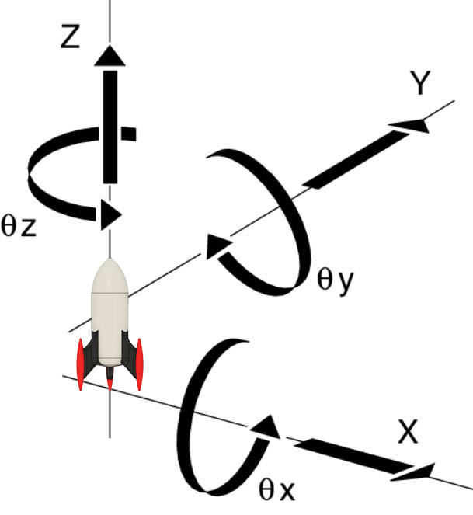
Figure 3. Representation of Rocket Rotation and Acceleration Axes
FOOTNOTE: The x, y and z axes for the data received from the acceleration sensor and gyroscope should be as shown in the figure. The engine-nose direction of the rocket and the z-axes of the sensors must coincide. Since the x and y axes are perpendicular to the z axis, there is no need to adjust them according to the axes on the rocket, but it is important that the z axis coincides with the engine-nose direction of the rocket in order to make sense of the data sent to the RGS. As seen in the figure, when the rocket is stationary on the launch rail, the gravitational acceleration should affect the z axis the most and its value should be negative. Since the thrust direction and z direction coincide when the rocket engine is burning, the z-axis acceleration value should show the acceleration resulting from the engine thrust and its value should be positive. If the rocket rotates around its own axis in the direction of the z rotation arrow, the transmitted z rotation value should be positive. If it rotates in the opposite direction, the transmitted z rotation value should be negative.
- Angle: The acceleration obtained from the rocket is the smaller of the angles made by the rocket's z-axis with the earth's normal vector, which can be obtained using rotation and magnetic field measurements.
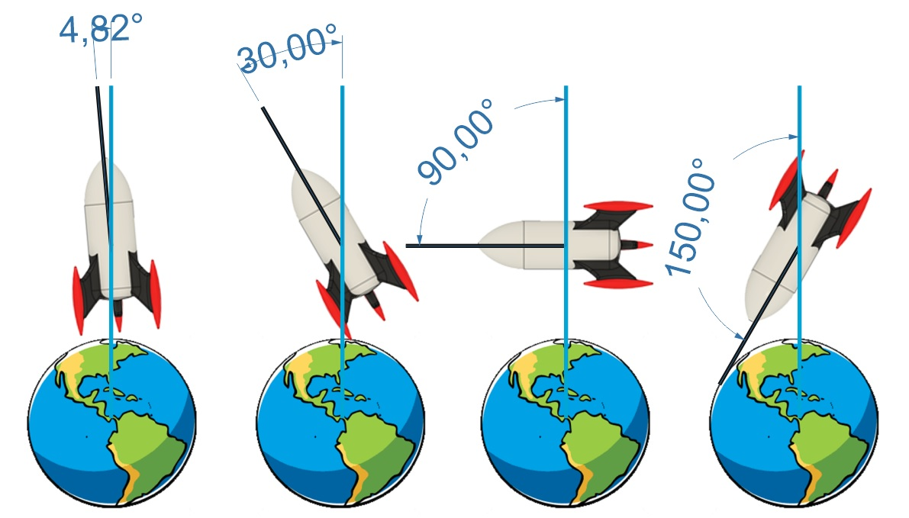
Figure 4. Representation of Rocket Angle Data
FOOTNOTE: In the figure, the turquoise lines show the direction of the earth normal vector, and the black lines show the direction of the rocket engine-nose. When these two directions intersect, two angles will be formed that complement each other to 360 degrees. Unless these angles are equal, one will be less than 180 degrees and the other will be greater than 180 degrees. When the two angles are equal—i.e. when the nose of the rocket points towards the earth—both angles will be 180 degrees. The angle to be sent to the RGS system must be the one less than or equal to 180 degrees. In other words, the angle to be sent can take values between 0 and 180 degrees.
- Status: It is information indicating the status of the rocket avionics triggering the separation system that will enable the primary and secondary parachutes to be deployed.
Status Value | Primary Parachute | Secondary Parachute
1 | Not triggered | Not triggered
2 | Triggered | Not triggered
3 | Not triggered | Triggered
4 | Triggered | Triggered
Table 1. Status Value Table
  - Package Structure Accepted by the RGS
RGS accepts data packets of 78 bytes in length. Necessary space is reserved in the package content for the data listed in the section Accepted Data. If there is data that cannot be provided by the competitor, the value 0x00 HEX (Decimal 0) should be written in the sections reserved for this data and the length of the sent packets should always remain 78 bytes.
Byte 1 | Byte 2 | Byte 3 | Byte 4 | Byte 5
UINT8 | UINT8 | UINT8 | UINT8 | UINT8
0xFF | 0xFF | 0x54 | 0x52 | TEAM ID
Byte 6 | Byte 7 | Byte 8 | Byte 9 | Byte 10
UINT8 | FLOAT32[0] | FLOAT32[1] | FLOAT32[2] | FLOAT32[3]
PACKAGE COUNTER | ALTITUDE 1 | ALTITUDE 2 | ALTITUDE 3 | ALTITUDE 4
Byte 11 | Byte 12 | Byte 13 | Byte 14 | Byte 15
FLOAT32[0] | FLOAT32[1] | FLOAT32[2] | FLOAT32[3] | FLOAT32[0]
ROCKET GPS ALTITUDE 1 | ROCKET GPS ALTITUDE 2 | ROCKET GPS ALTITUDE 3 | ROCKET GPS ALTITUDE 4 | ROCKET LATITUDE 1
Byte 16 | Byte 17 | Byte 18 | Byte 19 | Byte 20
FLOAT32[1] | FLOAT32[2] | FLOAT32[3] | FLOAT32[0] | FLOAT32[1]
ROCKET LATITUDE 2 | ROCKET LATITUDE 3 | ROCKET LATITUDE 4 | ROCKET LONGITUDE 1 | ROCKET LONGITUDE 2
Byte 21 | Byte 22 | Byte 23 | Byte 24 | Byte 25
FLOAT32[2] | FLOAT32[3] | FLOAT32[0] | FLOAT32[1] | FLOAT32[2]
ROCKET LONGITUDE 3 | ROCKET LONGITUDE 4 | PAYLOAD GPS ALTITUDE 1 | PAYLOAD GPS ALTITUDE 2 | PAYLOAD GPS ALTITUDE 3
Byte 26 | Byte 27 | Byte 28 | Byte 29 | Byte 30
FLOAT32[3] | FLOAT32[0] | FLOAT32[1] | FLOAT32[2] | FLOAT32[3]
PAYLOAD GPS ALTITUDE 4 | PAYLOAD LATITUDE 1 | PAYLOAD LATITUDE 2 | PAYLOAD LATITUDE 3 | PAYLOAD LATITUDE 4
Byte 31 | Byte 32 | Byte 33 | Byte 34 | Byte 35
FLOAT32[0] | FLOAT32[1] | FLOAT32[2] | FLOAT32[3] | FLOAT32[0]
PAYLOAD LONGITUDE 1 | PAYLOAD LONGITUDE 2 | PAYLOAD LONGITUDE 3 | PAYLOAD LONGITUDE 4 | STAGE GPS ALTITUDE 1
Byte 36 | Byte 37 | Byte 38 | Byte 39 | Byte 40
FLOAT32[1] | FLOAT32[2] | FLOAT32[3] | FLOAT32[0] | FLOAT32[1]
STAGE GPS ALTITUDE 2 | STAGE GPS ALTITUDE 3 | STAGE GPS ALTITUDE 4 | STAGE LATITUDE 1 | STAGE LATITUDE 2
Byte 41 | Byte 42 | Byte 43 | Byte 44 | Byte 45
FLOAT32[2] | FLOAT32[3] | FLOAT32[0] | FLOAT32[1] | FLOAT32[2]
STAGE LATITUDE 3 | STAGE LATITUDE 4 | STAGE LONGITUDE 1 | STAGE LONGITUDE 2 | STAGE LONGITUDE 3
Byte 46 | Byte 47 | Byte 48 | Byte 49 | Byte 50
FLOAT32[3] | FLOAT32[0] | FLOAT32[1] | FLOAT32[2] | FLOAT32[3]
STAGE LONGITUDE 4 | GYROSCOPE X 1 | GYROSCOPE X 2 | GYROSCOPE X 3 | GYROSCOPE X 4
Byte 51 | Byte 52 | Byte 53 | Byte 54 | Byte 55
FLOAT32[0] | FLOAT32[1] | FLOAT32[2] | FLOAT32[3] | FLOAT32[0]
GYROSCOPE Y 1 | GYROSCOPE Y 2 | GYROSCOPE Y 3 | GYROSCOPE Y 4 | GYROSCOPE Z 1
Byte 56 | Byte 57 | Byte 58 | Byte 59 | Byte 60
FLOAT32[1] | FLOAT32[2] | FLOAT32[3] | FLOAT32[0] | FLOAT32[1]
GYROSCOPE Z 2 | GYROSCOPE Z 3 | GYROSCOPE Z 4 | ACCELERATION X 1 | ACCELERATION X 2
Byte 61 | Byte 62 | Byte 63 | Byte 64 | Byte 65
FLOAT32[2] | FLOAT32[3] | FLOAT32[0] | FLOAT32[1] | FLOAT32[2]
ACCELERATION X 3 | ACCELERATION X 4 | ACCELERATION Y 1 | ACCELERATION Y 2 | ACCELERATION Y 3
Byte 66 | Byte 67 | Byte 68 | Byte 69 | Byte 70
FLOAT32[3] | FLOAT32[0] | FLOAT32[1] | FLOAT32[2] | FLOAT32[3]
ACCELERATION Y 4 | ACCELERATION Z 1 | ACCELERATION Z 2 | ACCELERATION Z 3 | ACCELERATION Z 4
Byte 71 | Byte 72 | Byte 73 | Byte 74 | Byte 75
FLOAT32[0] | FLOAT32[1] | FLOAT32[2] | FLOAT32[3] | UINT8
ANGLE 1 | ANGLE 2 | ANGLE 3 | ANGLE 4 | STATUS
Byte 76 | Byte 77 | Byte 78
UINT8 | UINT8 | UINT8
CRC | 0x0D | 0x0A
Table 2. Package Contents Table
Byte 1, Byte 2, Byte 3, Byte 4, Byte 77 and Byte 78 will have the same value in all packages and will not change. Byte 76 will have the CheckSum value, which is used to check that the data is not corrupted while being transmitted after creation of packet content. The remaining bytes will carry meaningful data of the competitors.
- UINT8 – Byte Conversion: Since the UINT8 value takes up 1 byte, UINT8 values can be written directly into bytes.
- FLOAT32 – Byte Conversion: Since the float32 variable takes up 4 bytes in memory, values that should be float32 can be taken as 4 bytes.
- CheckSum Calculation: CheckSum value is obtained by adding the values between Byte 5 and Byte 75, including Byte 5 and Byte 75, and calculating the 256 mode value of the result.
FOOTNOTE: A sample C code for all calculations and assignments made and a test link of the code can be found at https://onlinegdb.com/vKETasdSk

#include <stdio.h>

// For more information about using Union, see https://www.learn-c.org/en/Unions
typedef union{
float sayi;
unsigned char array[4];
}FLOAT32_UINT8_DONUSTURUCU;

// Global definition of the package to be created. If you are planning a different use,
// you can change name and location where this variable is defined. In this case create_package
Note that you also need to update the // function.
unsigned char olusturalacak_paket[78];

// Calculates the check_sum of the olusturalacak_paket array received globally.
unsigned char check_sum_hesapla(){
int check_sum = 0;

for(int i = 4; i < 75; i++){
check_sum += olusturalacak_paket[i];
}

return (unsigned char) (check_sum % 256);
}

// Updates the contents of the olusturalacak_paket array and calculates the check_sum.
void paket_olustur(){
olusturalacak_paket[0] = 0xFF; // Sabit
olusturalacak_paket[1] = 0xFF; // Sabit
olusturalacak_paket[2] = 0x54; // Sabit
olusturalacak_paket[3] = 0x52; // Sabit

olusturalacak_paket[4] = 0; // Takim ID = 0
olusturalacak_paket[5] = 0; // Sayac degeri = 0

FLOAT32_UINT8_DONUSTURUCU irtifa_float32_uint8_donusturucu;
irtifa_float32_uint8_donusturucu.sayi = 10.2; // We assign the altitude value.
olusturalacak_paket[6] = irtifa_float32_uint8_donusturucu.array[0];
olusturalacak_paket[7] = irtifa_float32_uint8_donusturucu.array[1];
olusturalacak_paket[8] = irtifa_float32_uint8_donusturucu.array[2];
olusturalacak_paket[9] = irtifa_float32_uint8_donusturucu.array[3];

FLOAT32_UINT8_DONUSTURUCU roket_gps_irtifa_float32_uint8_donusturucu;
roket_gps_irtifa_float32_uint8_donusturucu.sayi = 1461.55; // We assign the Rocket GPS Altitude value.
olusturalacak_paket[10] = roket_gps_irtifa_float32_uint8_donusturucu.array[0];
olusturalacak_paket[11] = roket_gps_irtifa_float32_uint8_donusturucu.array[1];
olusturalacak_paket[12] = roket_gps_irtifa_float32_uint8_donusturucu.array[2];
olusturalacak_paket[13] = roket_gps_irtifa_float32_uint8_donusturucu.array[3];

FLOAT32_UINT8_DONUSTURUCU roket_enlem_float32_uint8_donusturucu;
roket_enlem_float32_uint8_donusturucu.sayi = 39.925019; // We assign the rocket latitude value.
olusturalacak_paket[14] = roket_enlem_float32_uint8_donusturucu.array[0];
olusturalacak_paket[15] = roket_enlem_float32_uint8_donusturucu.array[1];
olusturalacak_paket[16] = roket_enlem_float32_uint8_donusturucu.array[2];
olusturalacak_paket[17] = roket_enlem_float32_uint8_donusturucu.array[3];

FLOAT32_UINT8_DONUSTURUCU roket_boylam_irtifa_float32_uint8_donusturucu;
roket_boylam_irtifa_float32_uint8_donusturucu.sayi = 32.836954; // We assign the rocket longitude value.
olusturalacak_paket[18] = roket_boylam_irtifa_float32_uint8_donusturucu.array[0];
olusturalacak_paket[19] = roket_boylam_irtifa_float32_uint8_donusturucu.array[1];
olusturalacak_paket[20] = roket_boylam_irtifa_float32_uint8_donusturucu.array[2];
olusturalacak_paket[21] = roket_boylam_irtifa_float32_uint8_donusturucu.array[3];

FLOAT32_UINT8_DONUSTURUCU gorev_yuku_gps_irtifa_float32_uint8_donusturucu;
gorev_yuku_gps_irtifa_float32_uint8_donusturucu.sayi = 1361.61; // We assign the payload GPS altitude value.
olusturalacak_paket[22] = gorev_yuku_gps_irtifa_float32_uint8_donusturucu.array[0];
olusturalacak_paket[23] = gorev_yuku_gps_irtifa_float32_uint8_donusturucu.array[1];
olusturalacak_paket[24] = gorev_yuku_gps_irtifa_float32_uint8_donusturucu.array[2];
olusturalacak_paket[25] = gorev_yuku_gps_irtifa_float32_uint8_donusturucu.array[3];

FLOAT32_UINT8_DONUSTURUCU gorev_yuku_enlem_float32_uint8_donusturucu;
gorev_yuku_enlem_float32_uint8_donusturucu.sayi = 41.104593; // We assign the payload latitude value.
olusturalacak_paket[26] = gorev_yuku_enlem_float32_uint8_donusturucu.array[0];
olusturalacak_paket[27] = gorev_yuku_enlem_float32_uint8_donusturucu.array[1];
olusturalacak_paket[28] = gorev_yuku_enlem_float32_uint8_donusturucu.array[2];
olusturalacak_paket[29] = gorev_yuku_enlem_float32_uint8_donusturucu.array[3];

FLOAT32_UINT8_DONUSTURUCU gorev_yuku_boylam_irtifa_float32_uint8_donusturucu;
gorev_yuku_boylam_irtifa_float32_uint8_donusturucu.sayi = 29.024411; // We assign the payload longitude value.
olusturalacak_paket[30] = gorev_yuku_boylam_irtifa_float32_uint8_donusturucu.array[0];
olusturalacak_paket[31] = gorev_yuku_boylam_irtifa_float32_uint8_donusturucu.array[1];
olusturalacak_paket[32] = gorev_yuku_boylam_irtifa_float32_uint8_donusturucu.array[2];
olusturalacak_paket[33] = gorev_yuku_boylam_irtifa_float32_uint8_donusturucu.array[3];

FLOAT32_UINT8_DONUSTURUCU kademe_gps_irtifa_float32_uint8_donusturucu;
kademe_gps_irtifa_float32_uint8_donusturucu.sayi = 1666.61; // We assign the stage GPS Altitude value.
olusturalacak_paket[34] = kademe_gps_irtifa_float32_uint8_donusturucu.array[0];
olusturalacak_paket[35] = kademe_gps_irtifa_float32_uint8_donusturucu.array[1];
olusturalacak_paket[36] = kademe_gps_irtifa_float32_uint8_donusturucu.array[2];
olusturalacak_paket[37] = kademe_gps_irtifa_float32_uint8_donusturucu.array[3];

FLOAT32_UINT8_DONUSTURUCU kademe_enlem_float32_uint8_donusturucu;
kademe_enlem_float32_uint8_donusturucu.sayi = 41.091485; // We assign the stage latitude value.
olusturalacak_paket[38] = kademe_enlem_float32_uint8_donusturucu.array[0];
olusturalacak_paket[39] = kademe_enlem_float32_uint8_donusturucu.array[1];
olusturalacak_paket[40] = kademe_enlem_float32_uint8_donusturucu.array[2];
olusturalacak_paket[41] = kademe_enlem_float32_uint8_donusturucu.array[3];

FLOAT32_UINT8_DONUSTURUCU kademe_boylam_irtifa_float32_uint8_donusturucu;
kademe_boylam_irtifa_float32_uint8_donusturucu.sayi = 29.061412; // We assign the stage longitude value
olusturalacak_paket[42] = kademe_boylam_irtifa_float32_uint8_donusturucu.array[0];
olusturalacak_paket[43] = kademe_boylam_irtifa_float32_uint8_donusturucu.array[1];
olusturalacak_paket[44] = kademe_boylam_irtifa_float32_uint8_donusturucu.array[2];
olusturalacak_paket[45] = kademe_boylam_irtifa_float32_uint8_donusturucu.array[3];

FLOAT32_UINT8_DONUSTURUCU jiroskop_x_float32_uint8_donusturucu;
jiroskop_x_float32_uint8_donusturucu.sayi = 1.51; // We assign the gyroscope X value.
olusturalacak_paket[46] = jiroskop_x_float32_uint8_donusturucu.array[0];
olusturalacak_paket[47] = jiroskop_x_float32_uint8_donusturucu.array[1];
olusturalacak_paket[48] = jiroskop_x_float32_uint8_donusturucu.array[2];
olusturalacak_paket[49] = jiroskop_x_float32_uint8_donusturucu.array[3];

FLOAT32_UINT8_DONUSTURUCU jiroskop_y_float32_uint8_donusturucu;
jiroskop_y_float32_uint8_donusturucu.sayi = 0.49; // We assign the gyroscope Y value.
olusturalacak_paket[50] = jiroskop_y_float32_uint8_donusturucu.array[0];
olusturalacak_paket[51] = jiroskop_y_float32_uint8_donusturucu.array[1];
olusturalacak_paket[52] = jiroskop_y_float32_uint8_donusturucu.array[2];
olusturalacak_paket[53] = jiroskop_y_float32_uint8_donusturucu.array[3];

FLOAT32_UINT8_DONUSTURUCU jiroskop_z_float32_uint8_donusturucu;
jiroskop_z_float32_uint8_donusturucu.sayi = 0.61; // We assign the gyroscope Z value.
olusturalacak_paket[54] = jiroskop_z_float32_uint8_donusturucu.array[0];
olusturalacak_paket[55] = jiroskop_z_float32_uint8_donusturucu.array[1];
olusturalacak_paket[56] = jiroskop_z_float32_uint8_donusturucu.array[2];
olusturalacak_paket[57] = jiroskop_z_float32_uint8_donusturucu.array[3];

FLOAT32_UINT8_DONUSTURUCU ivme_x_float32_uint8_donusturucu;
ivme_x_float32_uint8_donusturucu.sayi = 0.0411; // We assign the acceleration X value.
olusturalacak_paket[58] = ivme_x_float32_uint8_donusturucu.array[0];
olusturalacak_paket[59] = ivme_x_float32_uint8_donusturucu.array[1];
olusturalacak_paket[60] = ivme_x_float32_uint8_donusturucu.array[2];
olusturalacak_paket[61] = ivme_x_float32_uint8_donusturucu.array[3];

FLOAT32_UINT8_DONUSTURUCU ivme_y_float32_uint8_donusturucu;
ivme_y_float32_uint8_donusturucu.sayi = 0.0140; // We assign the acceleration Y value.
olusturalacak_paket[62] = ivme_y_float32_uint8_donusturucu.array[0];
olusturalacak_paket[63] = ivme_y_float32_uint8_donusturucu.array[1];
olusturalacak_paket[64] = ivme_y_float32_uint8_donusturucu.array[2];
olusturalacak_paket[65] = ivme_y_float32_uint8_donusturucu.array[3];

FLOAT32_UINT8_DONUSTURUCU ivme_z_float32_uint8_donusturucu;
ivme_z_float32_uint8_donusturucu.sayi = -0.9552; // We assign the acceleration Z value.
olusturalacak_paket[66] = ivme_z_float32_uint8_donusturucu.array[0];
olusturalacak_paket[67] = ivme_z_float32_uint8_donusturucu.array[1];
olusturalacak_paket[68] = ivme_z_float32_uint8_donusturucu.array[2];
olusturalacak_paket[69] = ivme_z_float32_uint8_donusturucu.array[3];

FLOAT32_UINT8_DONUSTURUCU aci_float32_uint8_donusturucu;
aci_float32_uint8_donusturucu.sayi = 5.08; // We assign the angle value.
olusturalacak_paket[70] = aci_float32_uint8_donusturucu.array[0];
olusturalacak_paket[71] = aci_float32_uint8_donusturucu.array[1];
olusturalacak_paket[72] = aci_float32_uint8_donusturucu.array[2];
olusturalacak_paket[73] = aci_float32_uint8_donusturucu.array[3];

olusturalacak_paket[74] = 1; // Status information = Neither parachutes triggered

olusturalacak_paket[75] = check_sum_hesapla(); // Check_sum = check_sum_hesapla();
olusturalacak_paket[76] = 0x0D; // Sabit
olusturalacak_paket[77] = 0x0A; // Sabit
}

int main()
{
for(int i = 0; i < 78; i++){
printf("0x%02hhX ", olusturalacak_paket[i]);
}
printf("\n");
printf("\n");
paket_olustur();

for(int i = 0; i < 78; i++){
printf("0x%02hhX ", olusturalacak_paket[i]);
}
printf("\n");

return 0;
}

REFEREE GROUND STATION PACKAGE TEST INTERFACE
A package testing application has been developed so that competitors can test their own data transmission algorithms.
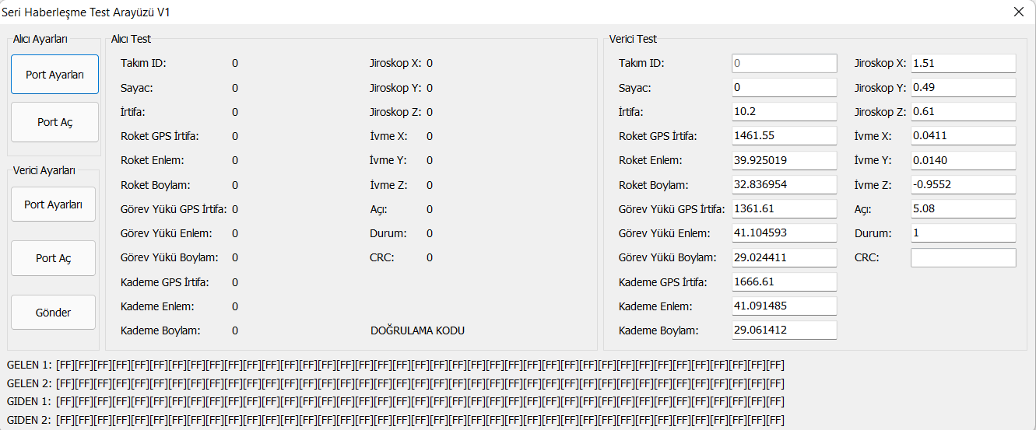
Figure 5. Opening of Test Interface
Receiver Settings: It will be used to test the accuracy of the packages created by the competitors. The COM port from which the packet will be received must be set using the Port Settings button, and then the port must be activated using the Open Port button.
Transmitter Settings: It will be used to test the package that will be formed according to the data to be sent. The COM port to which the packet will be sent must be set using the Port Settings button, and then the port must be activated using the Open Port button.
Receiver Test: When a data packet in the correct form arrives at the port set with the receiver settings, the converted version of the packet content will be displayed in the receiver test section. This display is the same as the results of the conversion made by the RGS device. The VERIFICATION CODE section is not included in the package received. The verification code, which is recalculated with each package received, will be used to confirm that the competitors can use the application and transmit their data.
Transmitter Test: The information entered in the transmitter test section is converted into a package and sent to the port set with the transmitter settings. When competitors cannot display the package they sent on the interface as they wish, they can determine where they made a mistake by including the data they added to the package they sent in this section. Team ID and CRC sections are closed for editing. Team ID will be specific to each team, and when reporting that communication can be established, competitors will be asked to prove that they are communicating using their Team ID. Team ID cannot be edited so that it can be verified that the communication requested in the reporting is established with the competitor ground station application, not with the test interface. CRC information cannot be changed because it is automatically calculated based on other information contained in the package.
INCOMING 1: When a valid data packet of 78 bytes in length arrives at the receiver port, the first 39 bytes of the incoming packet are displayed here from left to right in HEX format. This information is shared to give competitors the opportunity to make a comprehensive review.
INCOMING 2: When a valid data packet of 78 bytes in length arrives at the receiver port, the last 39 bytes of the incoming packet are displayed here from left to right in HEX format. This information is shared to give competitors the opportunity to make a comprehensive review.
OUTGOING 1: When a valid data packet of 78 bytes in length is sent to the transmitter port, the first 39 bytes of the sent packet are displayed here from left to right in HEX format. This information is shared to give competitors the opportunity to make a comprehensive review.
OUTGOING 2: When a valid data packet of 78 bytes in length is sent to the transmitter port, the last 39 bytes of the sent packet are displayed here from left to right in HEX format. This information is shared to give competitors the opportunity to make a comprehensive review.
A double click on the VERIFICATION CODE, INCOMING 1, INCOMING 2, OUTCOMING 1 and OUTCOMING 2 with the mouse will copy their contents. Since this information may be requested in the questions to be submitted to the competition committee, this feature has been added for the convenience of the competitors.
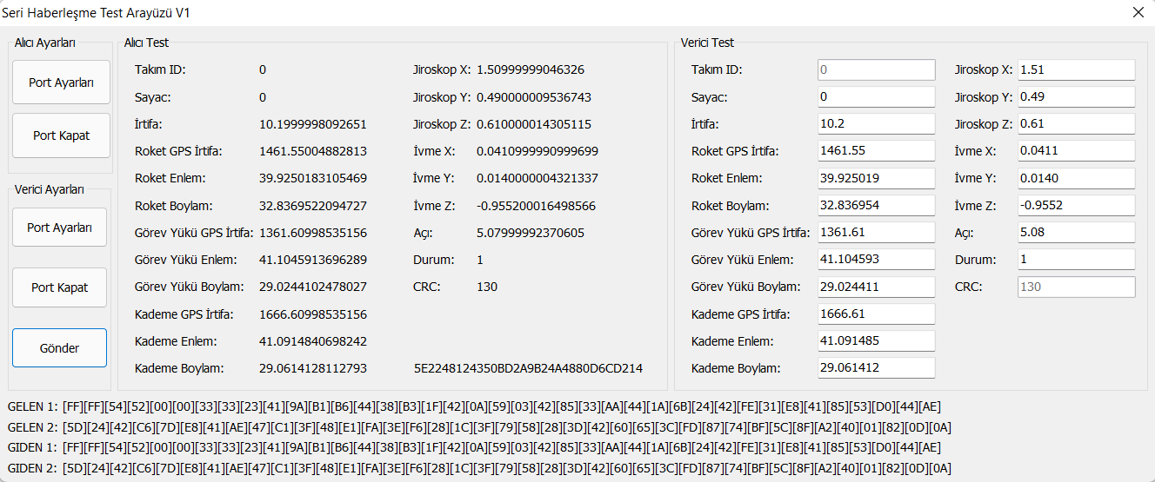
Figure 6. Test Interface Sample Package
Creating the Test Environment: Competitors need two computers and two correctly connected USB-TTL converters to perform communication tests.
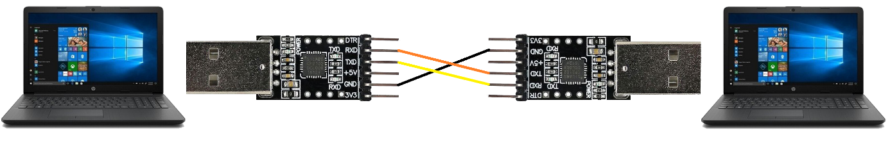
Computer 1
TTL 1
TTL 2
Computer 2

Figure 7. Test Environment Connection Guide
Two USB-TTL converters must be plugged into computers, connected to each other through the ports as shown in the figure.
Test Environment Testing: After the test environment is created, the test interface must be installed on both computers. Computer 1 should be set as receiver and Computer 2 should be set as transmitter. If the Computer 2 Transmitter Test data appears correctly on the Computer 1 Receiver Test screen when the Send button on Computer 2 is pressed, there is no error in the test environment.
Competitor Software Testing: While the competitor software is running on Computer 1, the test interface should be run on Computer 2. On computer 2, the test interface must be set as receiver. When the competitor software creates the correct packet with the data to be sent and sends it to the port, the information will appear in the Computer 2 Receiver Test section. There must be at least 100 milliseconds between packets sent by the competitors in the competition area.

