Week 4: Predictive Modeling and Optimization in Logistics Systems
Project Report | Forecasting Shipment Delivery Time

1. Introduction and Problem Definition
The purpose of this project is to predict shipment delivery time and use the predictions to support logistics planning. Late deliveries can affect customer satisfaction, inventory availability, and operating costs. A model that estimates delivery time before dispatch can help teams identify shipments that may need attention and plan resources more effectively.

2. Dataset Simulation
A reproducible hypothetical dataset of 500 shipments was created using Python. It is simulated for academic demonstration and does not represent real company operations. Each row represents one shipment.
Feature | Description | Role
Distance_km | Planned shipment distance in kilometres | Input
Shipment_Volume_kg | Shipment weight in kilograms | Input
Transport_Mode | Road, Rail, Air, or Sea | Input
Region | North, South, East, or West | Input
Traffic_Level | Ordinal traffic score from 1 (low) to 5 (severe) | Input
Weather | Clear, Rain, or Storm | Input
Weekend_Departure | 1 for weekend departure, otherwise 0 | Input
Delivery_Time_days | Simulated elapsed delivery time in days | Target
Target variable: Delivery_Time_days. Predictors include route distance, shipment volume, transport mode, region, traffic, weather, and weekend departure.

3. Data Preparation
The data is separated into predictors (X) and target (y). An 80/20 train-test split is used with a fixed random state to make the evaluation reproducible. Numeric missing values are imputed with the median and categorical missing values with the most frequent category. Categorical variables are converted using one-hot encoding. Preprocessing is placed inside a scikit-learn Pipeline and fitted only on training folds to reduce data leakage.

4. Model Selection and Rationale
Two regression algorithms are compared. Linear Regression is a simple, interpretable baseline that estimates a linear relationship between input features and delivery time. Random Forest Regression combines many decision trees and can capture non-linear relationships and interactions, making it suitable for mixed logistics variables. The Random Forest is selected as the final model when its held-out performance is stronger.

5. Training, Validation, and Evaluation
Both models are trained on the training set and evaluated on the untouched test set. Mean Absolute Error (MAE) measures the average absolute prediction error in days and is easy to interpret. Root Mean Squared Error (RMSE) penalizes larger errors more strongly. R-squared (R²) indicates the proportion of target variance explained by the model; it can be negative when predictions are worse than a simple mean baseline.
Model | MAE (days) | RMSE (days) | R²
Linear Regression | 2.475 | 3.602 | 0.886
Random Forest | 1.526 | 1.929 | 0.967
Random Forest 5-fold cross-validation on the training data produced an average MAE of 1.441 days (standard deviation 0.077). Cross-validation checks whether performance is reasonably consistent across different training folds. The final test set remains separate from model fitting.
The fixed random seed makes this simulated exercise reproducible. Results may differ if the simulation rules, random seed, or software versions are changed.

6. Diagnostic Visualizations

Figure 1. Actual versus predicted delivery time
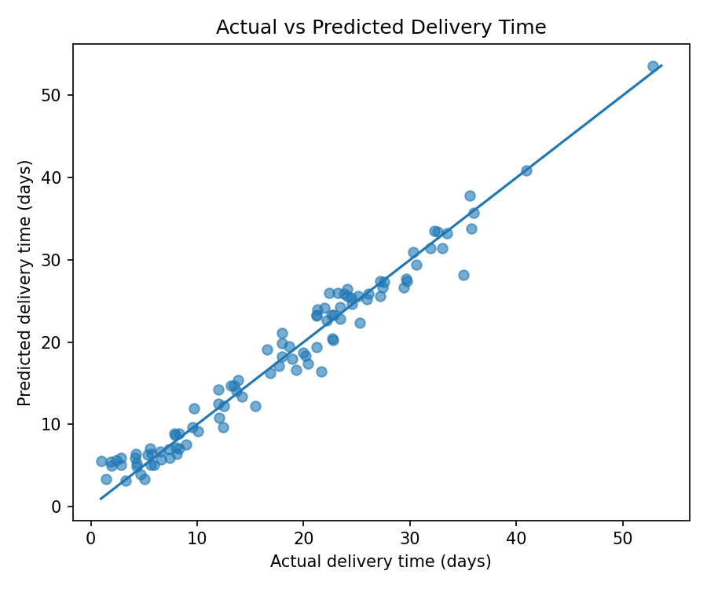
Points close to the diagonal line indicate predictions close to actual outcomes. Larger deviations identify shipments with greater prediction errors.

Figure 2. Prediction error distribution
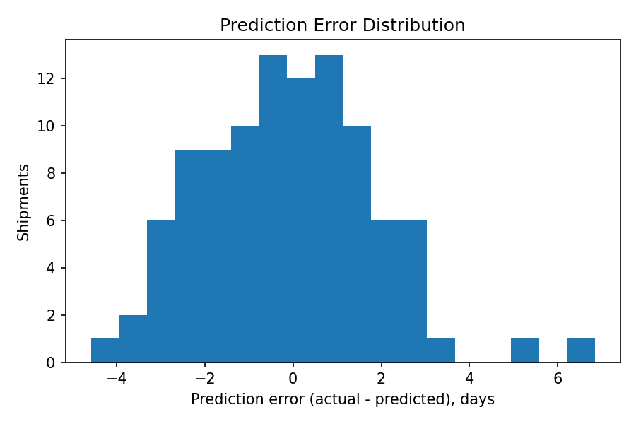
Errors are calculated as actual minus predicted delivery time. A distribution centred near zero suggests limited systematic bias; a wide spread indicates uncertain predictions.

Figure 3. Random Forest feature importance
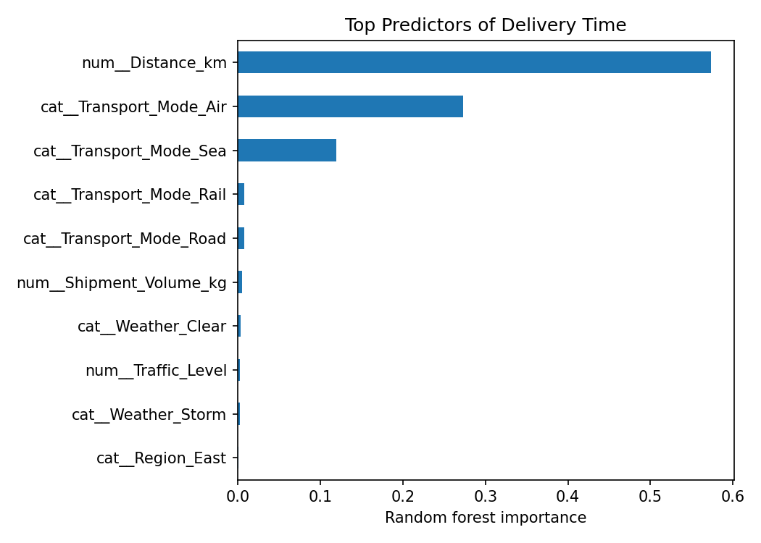
Feature importance ranks variables used by the fitted forest. It is a model-specific indicator of predictive contribution, not proof that a variable causes delay.

7. Optimization Strategies
- Early-warning queue: flag shipments with predicted delivery time above the service target (for example, 7 days) for dispatcher review before dispatch.
- Route and mode review: for flagged shipments, compare feasible alternative routes or transport modes using both predicted delivery time and total cost; do not select the fastest option without considering cost and capacity.
- Resource allocation: schedule additional handling capacity or reserve vehicles for periods and regions where the model consistently predicts longer lead times.
- Buffer and customer communication: use prediction ranges and historical error to set realistic delivery promises and proactively inform customers when risk is high.
- Continuous monitoring: compare predicted and actual delivery times weekly, retrain when route patterns or operating conditions change, and monitor MAE/RMSE by region and transport mode.
These are decision-support recommendations rather than a mathematical global optimum. A full optimization model would require operational constraints such as vehicle capacity, driver hours, route networks, service windows, and cost coefficients.

8. Limitations and Responsible Use
The data is synthetic and uses assumed relationships. Real delivery times are affected by additional factors such as loading delays, customs, carrier reliability, road closures, and service commitments. Feature importance does not establish causation. Before deployment, the model should be trained and validated on representative historical data, checked for subgroup errors, and used with human oversight.

9. Conclusion
This project demonstrates an end-to-end predictive analytics workflow for logistics: define a delivery-time forecasting problem, simulate shipment records, prepare mixed-type features, compare regression models, validate performance, and translate predictions into operational actions. Predictive estimates can support earlier intervention, better resource planning, and more informed route and transport-mode decisions.

10. Python Implementation
The accompanying file week4_logistics_prediction.py contains reproducible code for data simulation, preprocessing, model training, test evaluation, five-fold cross-validation, diagnostic plots, and an example threshold-based review flag. Install dependencies with: pip install pandas numpy scikit-learn matplotlib. Run with: python week4_logistics_prediction.py.
The accompanying CSV file, week4_logistics_prediction_dataset.csv, contains the 500 simulated shipment records used in this report.

