Week 3: Advanced Data Analysis and Visualization in Logistics
Project Report | Hypothetical Logistics Dataset

1. Introduction and Objective
This report explores a hypothetical logistics dataset using Python. The objective is to examine delivery performance, shipment volumes, transportation costs, and relationships among operational variables. Exploratory Data Analysis (EDA) and visualizations are used to identify patterns, possible cost drivers, and areas where logistics operations may be improved.

2. Dataset Simulation and Structure
A simulated dataset of 120 shipments was generated for this exercise. It is illustrative and does not represent actual company records. Each row represents one shipment.
Variable | Description | Type
Shipment_ID | Unique shipment reference | Text
Region | North, South, East, or West | Category
Transport_Mode | Road, Rail, Air, or Sea | Category
Distance_km | Shipment distance in kilometres | Numeric
Shipment_Volume_kg | Shipment weight in kilograms | Numeric
Delivery_Time_days | Elapsed delivery time in days | Numeric
Transport_Cost_INR | Estimated transport cost in Indian rupees | Numeric
On_Time | 1 indicates at or below the dataset's 70th-percentile delivery-time threshold | Binary
Dataset size: 120 rows and 8 columns. The dataset was generated with a fixed random seed so the exercise can be reproduced.

3. Methodology and Tools
Python was used with Pandas for tabular data handling, NumPy for numerical calculations and simulation, and Matplotlib for charts. The workflow was: generate data, inspect its structure, calculate descriptive statistics, compare groups, calculate correlations, create visualizations, and interpret the results.

4. Exploratory Data Analysis

4.1 Data inspection
The dataset was checked using head(), info(), describe(), and isnull().sum(). The simulated dataset contains no intentionally inserted missing values or duplicate shipment IDs. In a real project, these checks should be performed before analysis and any missing or duplicated records should be investigated rather than silently removed.

4.2 Descriptive statistics
Metric | Distance (km) | Volume (kg) | Delivery (days) | Cost (INR)
mean | 910.08 | 258.53 | 100.20 | 157.37
50% | 938.00 | 273.00 | 120.00 | 122.38
std | 514.18 | 138.57 | 33.17 | 130.51
min | 51.00 | 14.00 | 16.80 | 30.00
max | 1,793.00 | 499.00 | 120.00 | 638.95
The mean describes the arithmetic average, while the median (50th percentile) is the middle observation and is less sensitive to extreme values. Standard deviation indicates how spread out values are. Minimum and maximum values show the observed range.

4.3 Group comparisons and correlation
Mode | Mean delivery (days) | Mean cost (INR)
Air | 46.50 | 385.62
Rail | 109.41 | 105.66
Road | 110.54 | 119.41
Sea | 117.42 | 63.02
Pearson correlation measures the strength and direction of a linear relationship, ranging from -1 to +1. Correlation does not prove causation. Distance and delivery time are expected to be positively related in this simulated dataset; shipment volume may also contribute to cost.

5. Visualizations and Interpretation

Figure 1. Delivery-time distribution
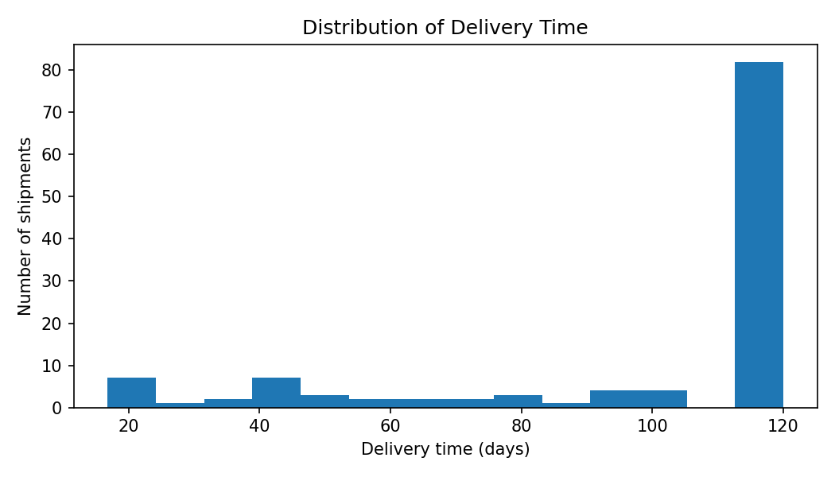
A histogram shows how frequently delivery times occur within ranges. It helps identify the typical delivery window, spread, and unusually long deliveries. A long right tail would suggest a smaller number of delayed shipments.

Figure 2. Average transport cost by mode
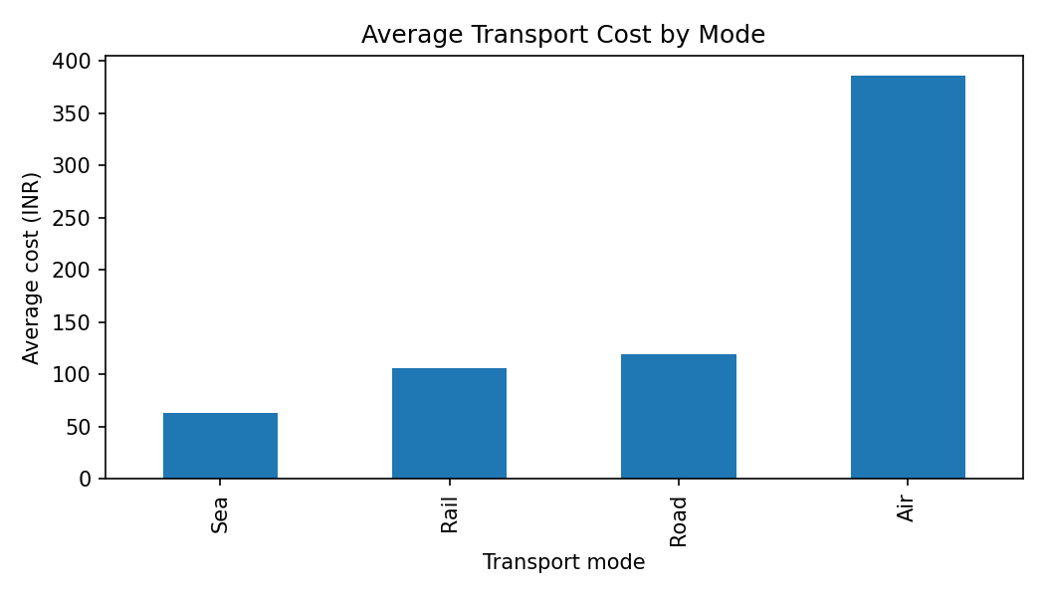
A bar chart makes it easy to compare average costs across road, rail, air, and sea. Mode-level differences can support decisions about selecting a suitable transport method while considering service speed and shipment requirements.

Figure 3. Average delivery time by region
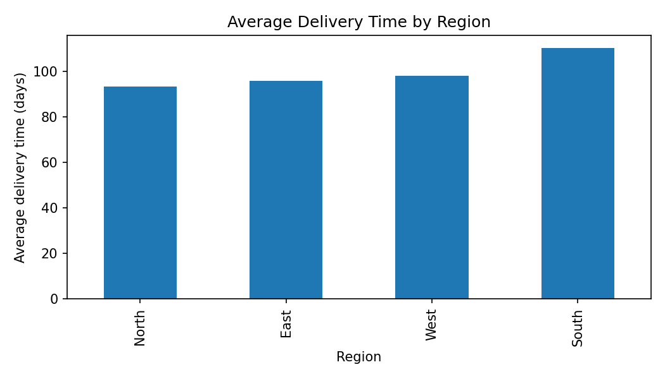
A bar chart compares regional delivery performance. Regions with higher average delivery times may require investigation of route distance, infrastructure, capacity, or local handling processes.

Figure 4. Distance versus delivery time
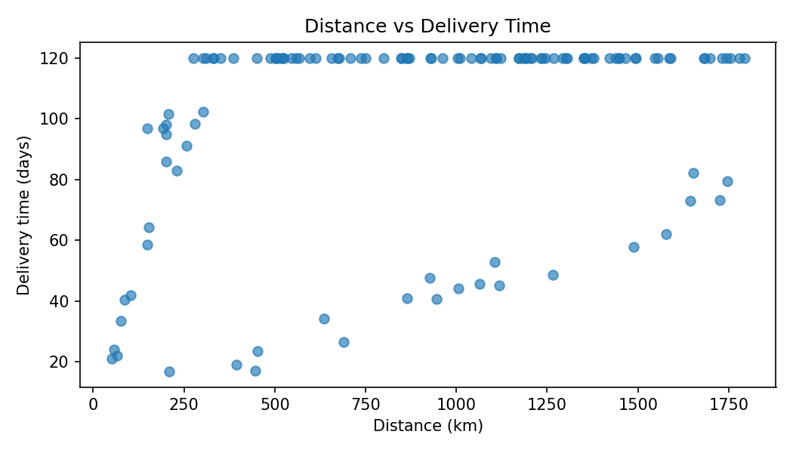
A scatter plot shows individual shipments and whether longer distances tend to be associated with longer delivery times. Points far from the general pattern may represent unusual routes or operational exceptions.

Figure 5. Correlation matrix
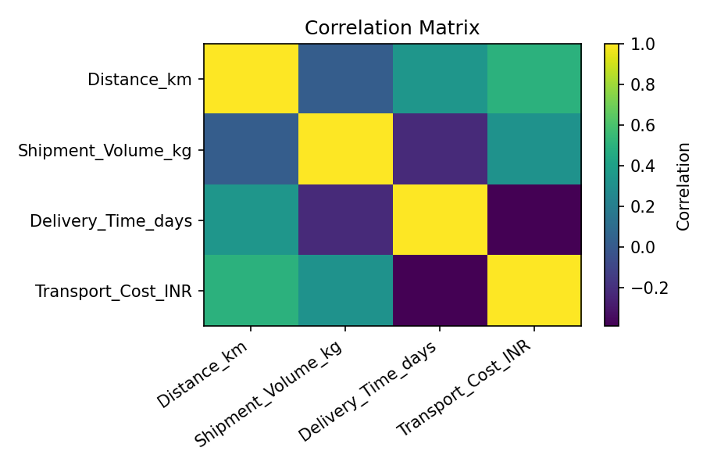
A correlation heatmap summarizes pairwise linear relationships among numeric variables. It helps identify variables that move together and suggests which factors deserve further investigation.

6. Key Analytical Insights
• In this simulated sample, South has the highest average delivery time and North the lowest. This points to a region-level difference worth investigating, not proof of a specific cause.
• Air has the highest average transport cost per shipment in the simulated data, while Sea has the lowest. Cost should be compared alongside delivery speed, reliability, and shipment suitability.
• The correlation between distance and delivery time is 0.34; the correlation between distance and transport cost is 0.50. These values indicate the strength of linear association in this sample, not causation.
• The delivery-time distribution helps operations teams understand typical performance and identify the tail of potentially delayed shipments. The scatter plot can help locate individual exceptions for follow-up.

7. Recommendations
- Review shipments in the slowest-performing region and segment them by route, transport mode, and shipment volume.
- Compare transport modes using total cost, delivery time, and service reliability rather than cost alone.
- Track delivery-time percentiles (for example, median and 90th percentile) in addition to averages so that long delays are not hidden.
- Investigate high-distance and high-cost shipments individually; consider route consolidation or alternative modes where operationally suitable.
- Use a larger real-world dataset with promised delivery dates, actual delivery dates, fuel costs, and delay reasons to validate these preliminary patterns.

8. Limitations
The dataset is hypothetical, relatively small, and generated using assumed relationships and random variation. The On_Time flag is a simple illustrative threshold, not a contractual service-level measure. The findings demonstrate analytical methods only and must not be treated as evidence about a real logistics company. Real decisions require validated operational data and business context.

9. Conclusion
This exercise demonstrates how EDA and visualization can turn shipment-level data into understandable performance indicators. Descriptive statistics summarize the data, group comparisons highlight differences among modes and regions, and charts reveal distributions and relationships. These techniques help logistics teams identify questions for investigation, monitor performance, and make more informed operational decisions.

10. Python Code and Reproducibility
The accompanying Python script, week3_logistics_analysis.py, generates the hypothetical dataset, prints descriptive statistics and correlations, and saves five visualization files. Install the required libraries with: pip install pandas numpy matplotlib. Run the script with: python week3_logistics_analysis.py. The generated CSV is week3_hypothetical_logistics_data.csv.
The full script is provided as a separate .py file to keep this report readable. The charts embedded above are outputs from the same simulation and fixed random seed.

Appendix: Key Python techniques
Examples of the methods used: data.describe() for descriptive statistics; data.groupby('Transport_Mode').mean() for group summaries; data.corr() for numeric correlations; plt.hist() for distributions; plt.bar()/Pandas plotting for comparisons; and plt.scatter() for relationships.

