**Export Tool**

**Project Name** : Inomap

**Tool Name** : Export Tool

**Purpose** : The tool is developed to export the data from postgres database to the selected folder in Json format.

**Software used**: Python 3 , Qgis 3.28 , PyQt

Plugin Icon



Tool Interface

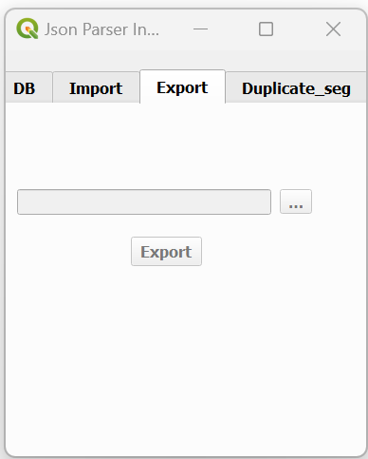

**Steps to run the Tool**

**Step 1**: User should create a local folder(D:\\T106_000_v1_8_export_18- 09-23) to export the data and then copy the given two template files into the folder. Go to the plugin folder and copy the two files from ‘sample_code_use’ folder and then paste into created folder .

**Note**: Create folder name like schema name_export_date format as below.

**Sample_folder_code**--->Copy---->**JP_T106_000_v1_8_export_18-09-23**

1. Sample_segment.segment
2. Test.zone

Note : Make sure before export data , only the above two files should be Present in the exported folder

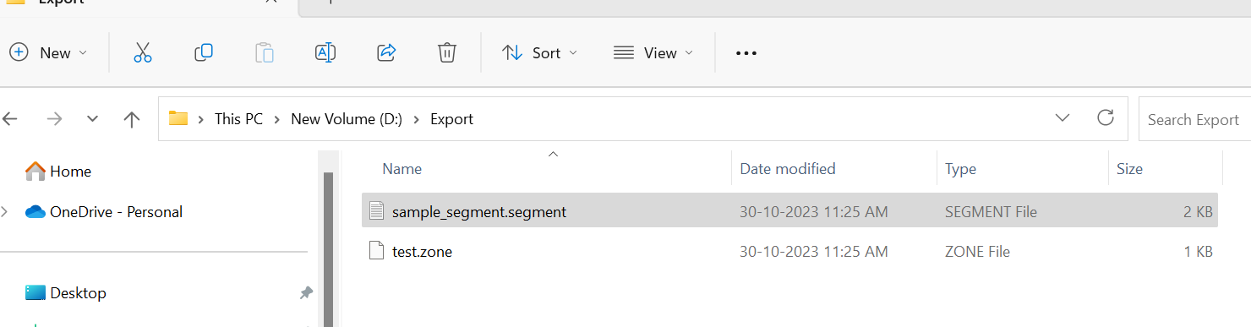

**Step2** : Go to the plugin folder and check the App configure file for the Database credentials and change the credentials and save if Required.

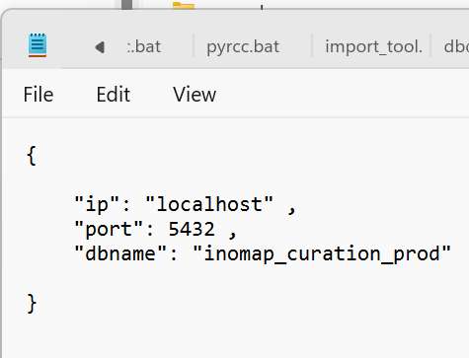

**Step3**: Enter the user name and password to connect the database and

Click on the connect button.

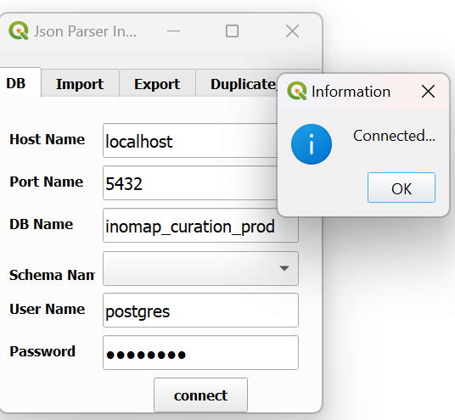

**Step4**: Once db is connected successfully, the schema names are shown In the drop down list.

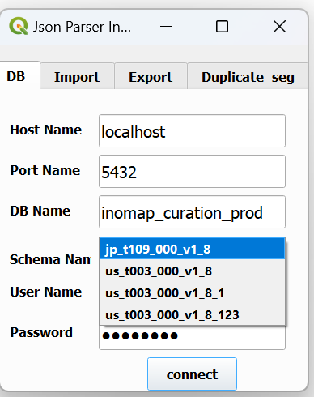

**Step 5**: Select the specific schema name and open the export tab.

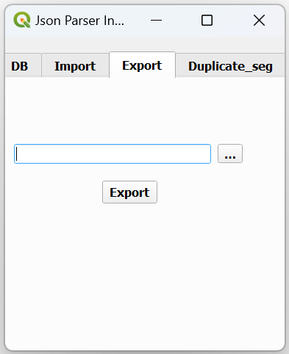

**Step6** : Click the browse button and select the Export folder and click the export button.

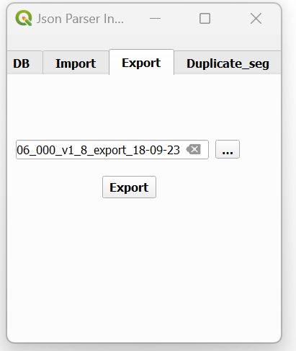

**Step 8**: After completion of all the data export process , the message box will be shown “Data exported successfully”.

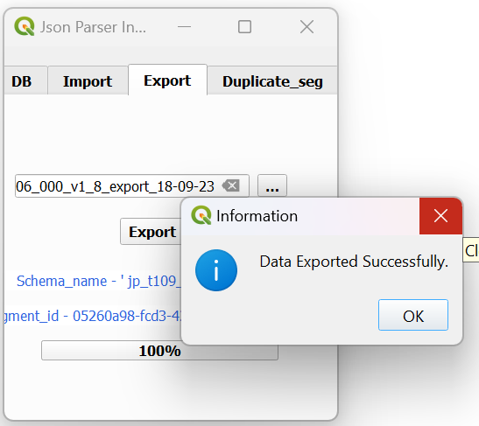

**Step 10** : Go to the exported folder and verify the segment files count and open files and check the exported data.

**Sep 11** : Remove the below files from the folder.

Sample_segment.segment

Test.zone

**Step 12**: Run the Duplicate segments check

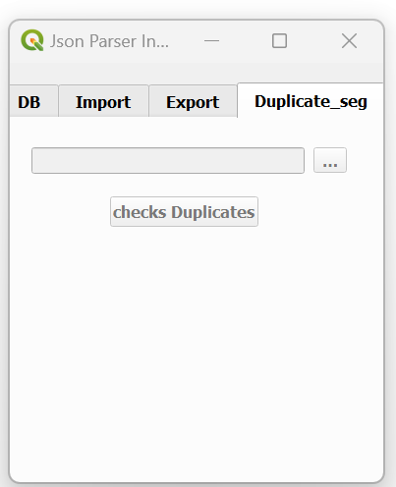

**Step 13**: Select the exported folder path and click the Check Duplicate button.

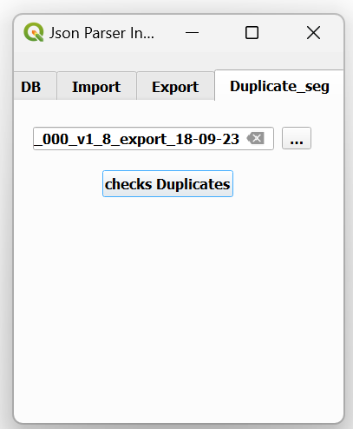

**Step 14**: Message box is displayed after duplicate check.

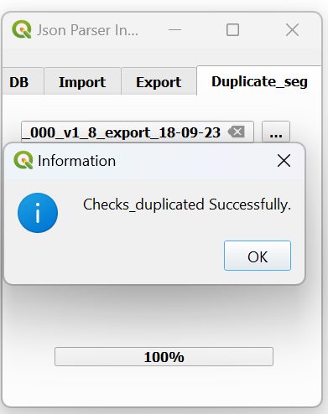

***Note : if any error find during the export and check duplicate process , verify the message bar and run the tool again***