**Import Tool**

**Project Name** : Inomap

**Tool Name** : Import Tool

**Purpose** : The tool is developed to import the client data from json format to postgres database.

**Software used**: Python 3 , Qgis 3.28 , PyQt

Plugin Icon



Tool Interface

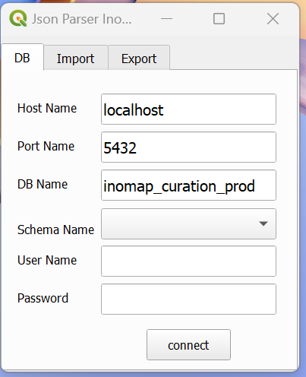

Source data is given in .segment files and stored in a folder.

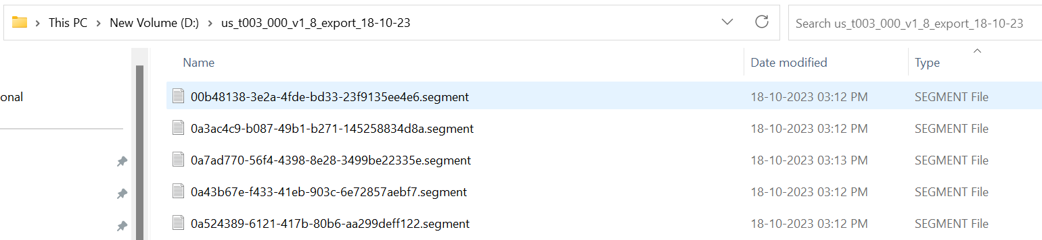

**Steps to run the Tool**

**Step1**: Install the plugin in Qgis application and reload the plugin using Configure plugin re-loader option.

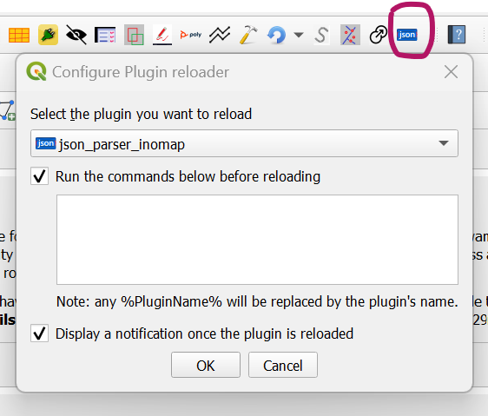

**Step2** : Go to the plugin folder and check the App configure file for the Database credentials and change the credentials and save if Required.

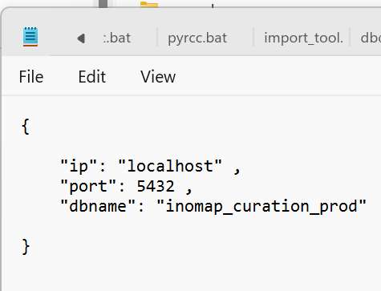

**Step3**: Go to Qgis and refresh the plugin and open the plugin, it will shown the db credentials except username and password.



**Step4**: Enter the user name and password to connect the database and

Click on connect button.

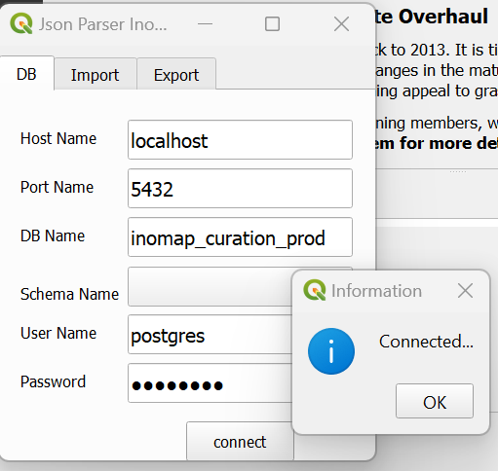

**Step5**: Once db is connected successfully, the schema names are shown In the drop down list.

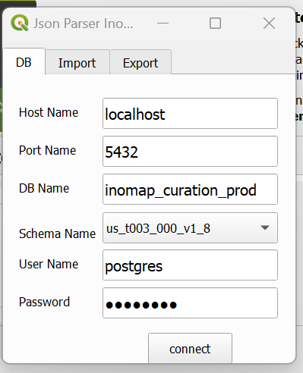

**Step 6**: Select the specific schema name and open the import tab.

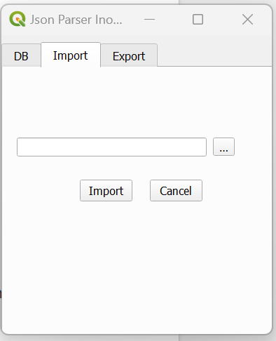

**Step7** : Click the browse button and select the folder where source Segment files are stored and the folder should not shown The .segemnt files but select the folder.

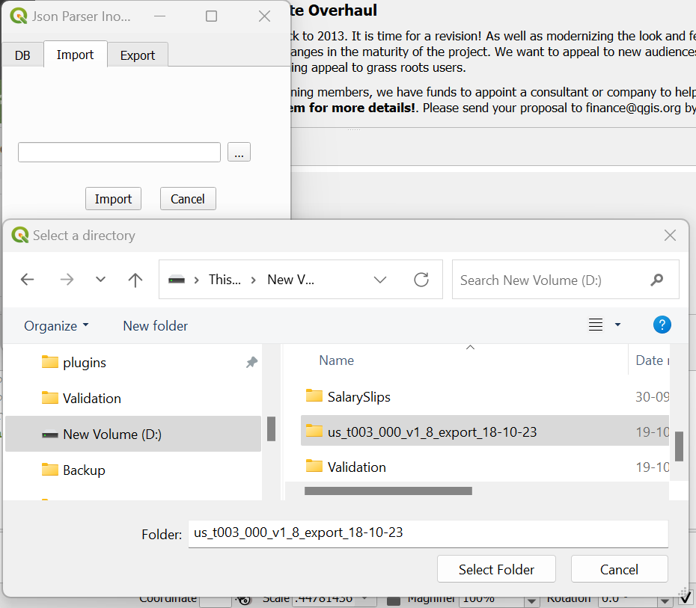

**Step 8**: Make sure folder path is displayed and then click import button To import the data into the selected schema from the db.

**Step 9**: After completion of all the data import process , the message box will be shown “Data imported successfully”.

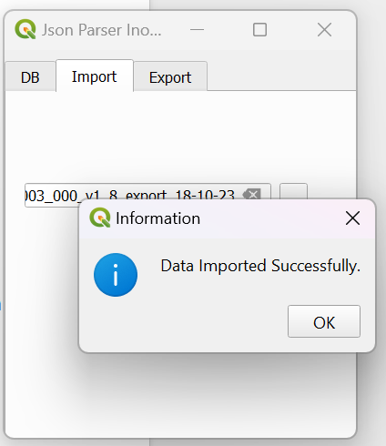

**Step 10** : In Qgis check the layers from the chosen schema weather the Data is imported properly or not and the attribute count . ( Lane_lines , Lanes , segment , transition).