Project 1 :Malaria in Africa Dashboard

Project description
A large part of working with data is being able to interpret data visualizations and explain your insights to others. To give you some practice with this, we’ve selected a few Tableau dashboards for you to explore. The links are below, under "Choose from these Dashboards." Choose one of these dashboards, whichever one interests you the most, and find three insights in the visualizations. For each insight, provide a static image that shares what you found. Write a short report explaining each observation and how you found the information to reach your conclusion from the dashboard. Altogether (including images), your report should be 1-2 pages.

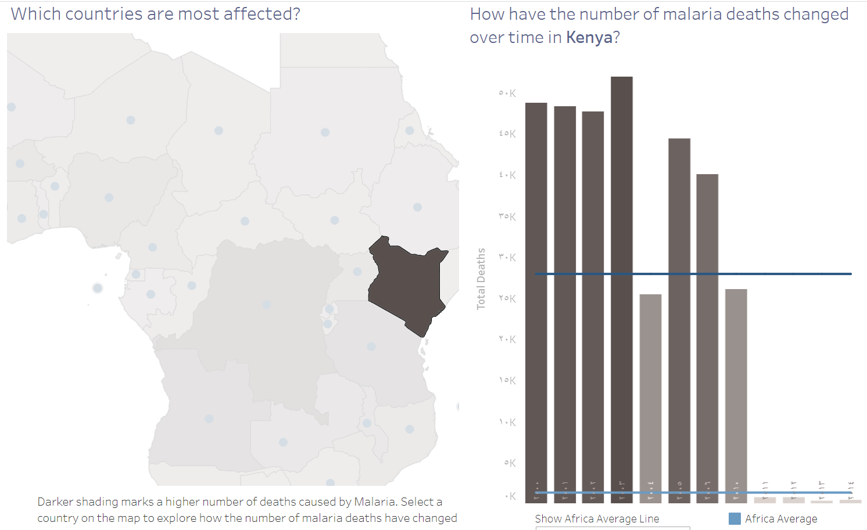

The dashboard demonstrates the number of deaths due to malaria in Kenya between the year 2000 and 2014 ,Kenya has the highest reported cases in the whole continent of Africa, it is clear that the number of deaths is increased from 2000 to 2006 ,and the number of deaths is decreased after 2006, and the country average 1405.
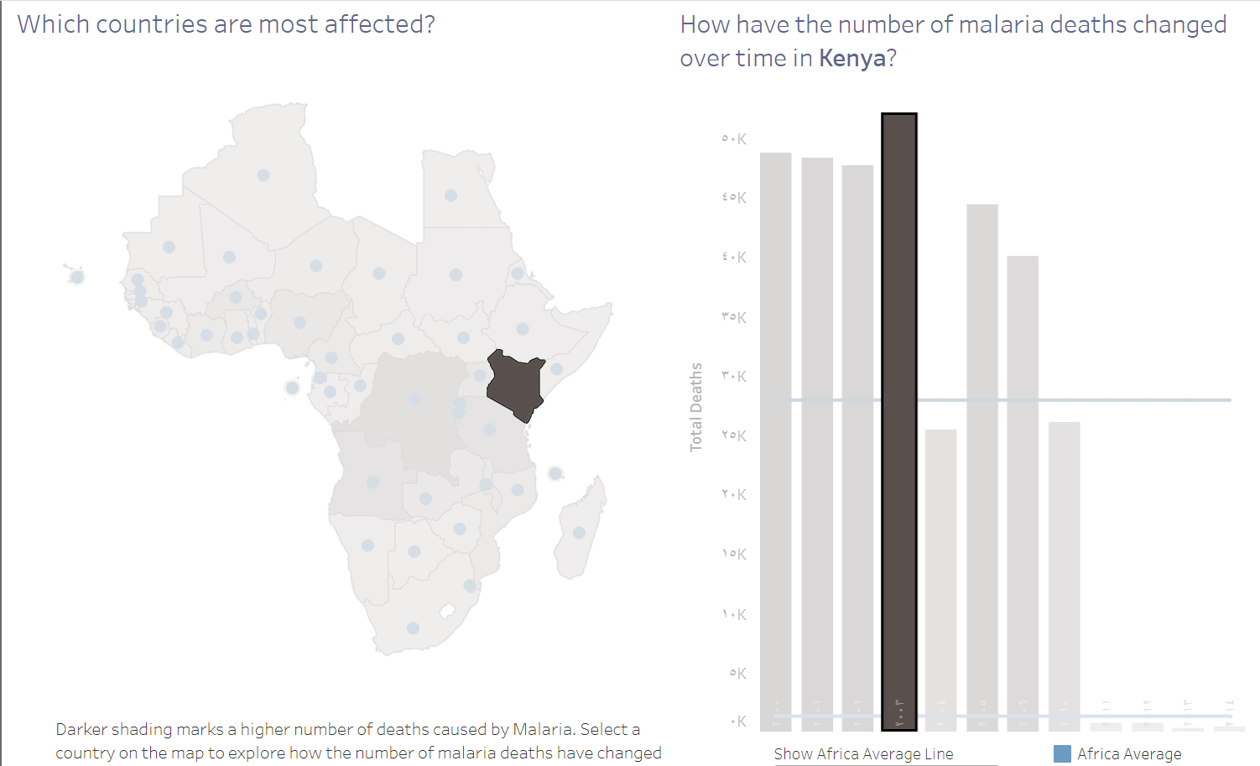
And the most cases occur in 2003 an it is above 50k .

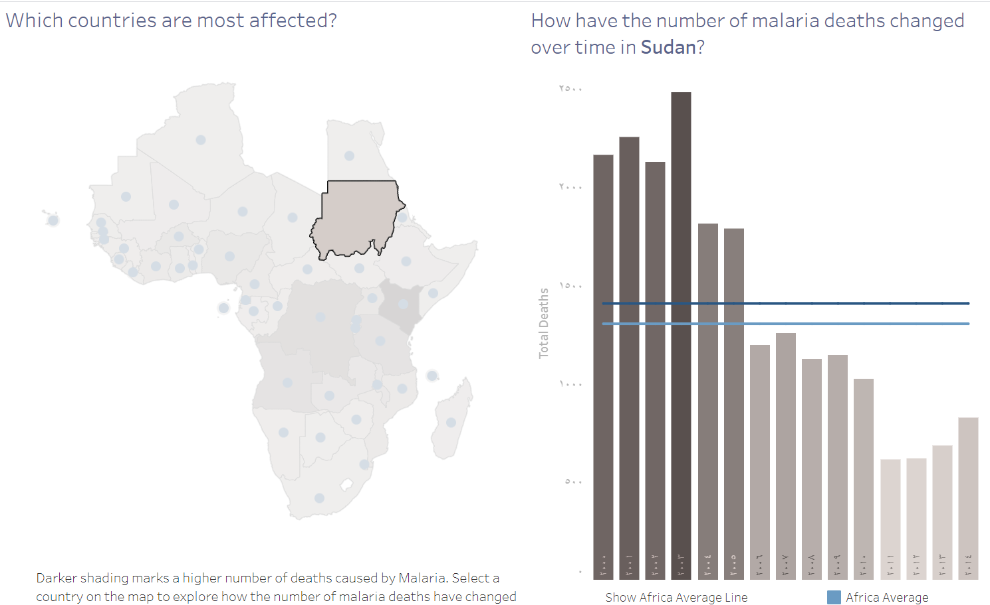
The dashboard illustrates the number of deaths due to malaria in Sudan between the years 2000 and 2014, The highest cases reached 2500 in 2003 ,and after that the cases began to decrease, and the country average is 1406.

