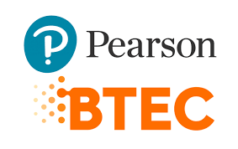

Name: Shema bahizi david

Class: BTEC 3 IT

Assessor: Elisee ktoga

School: BLUE LAKES INTERNATIONAL SCHOOL

Program: Pearson BTEC

Date: 11/3/2026

TABLE OF CONTENT

Table of Contents
Unit 7: Mobile Apps Development 3
B.P3 — Produce Designs for a Mobile App 3
B.P4 — Review the Mobile App Designs with Others 5
B.M2 — Justify Design Decisions 6
C.P6 — Test the Mobile App 12
C.P7 — Review the Extent to Which the App Meets Requirements 13
C.M3 — Optimise the Mobile App 14
BC.D2 — Evaluate the Design and Optimised Mobile App Against Client Requirements 15
BC.D3 — Individual Responsibility, Creativity and Effective Self-Management 16

Unit 7: Mobile Apps Development

B.P3 — Produce Designs for a Mobile App

User Requirements

• Easy navigation between sections (Information, Video, Quiz) is to be provided to the user.

• The quiz should have 10 multiple choice questions only.

• The score has to be traced and shown during the quiz.
Sound feedback (applause or error sound) has to be heard after every answer.

• The application should have proper graphics in terms of sustainability.

Visual Design

• Main menu (12 buttons) and information button (3 buttons), video button (3 buttons), quiz button (3 buttons), home screen with a logo.
Green colour scheme (ecology/sustainability theme)

• Apparently strong navigation, including a back button on each screen.

• Minimum font size is 14pt and is readable.

• Images and icons of nature and environment.

Technical Documentation

• Target platform Android (MIT App Inventor or Android Studio)
Components: Labels, Buttons, Image, VideoPlayer, Sound, TinyDB.

• Architecture: 4 screens — Home, Info, Video, Quiz.
Data: 10 questions on sustainability questions in a list with correct answers.
Design Screenshots / Wireframes

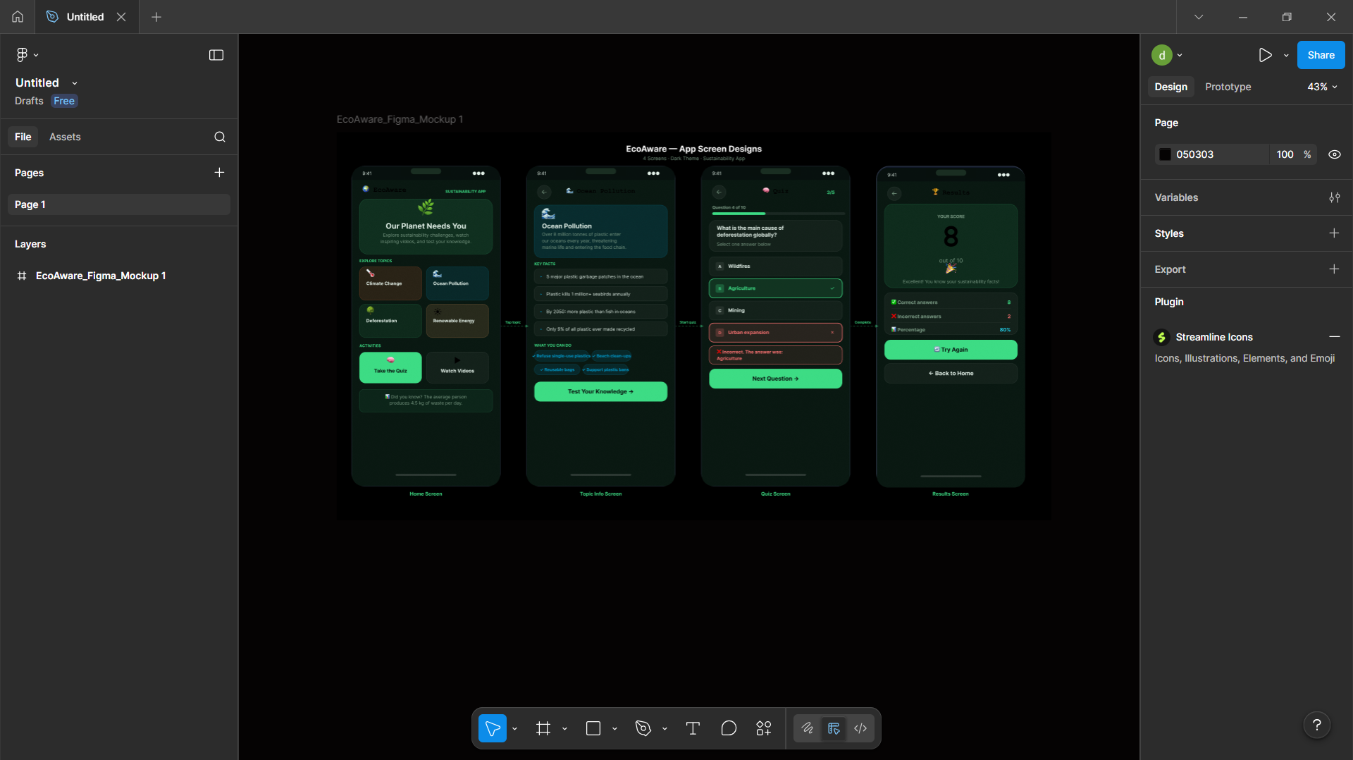

B.P4 — Review the Mobile App Designs with Others

After presenting my design to two classmates, I received the following feedback and made improvements accordingly:

Feedback Received | Improvement Made
"The buttons are too small on mobile screens" | Increased button size to a minimum of 48dp for easier tapping
"There is no visual feedback when answering" | Added colour change (green = correct, red = incorrect) after each answer
"The menu is not clear enough" | Added icons next to each menu option to improve clarity

These refinements improved the overall usability and user experience of the application.

B.M2 — Justify Design Decisions

The design decisions were made to ensure the app fully meets the client's requirements:

Four Separate Screens

This prevents information overload and enables intuitiveness. Each part has its specific role, and that enhances the experience of the user and makes the interface clear and concentrated.

Green Theme and Nature Icons
The colour green and natural imagery is closely related to sustainability.

This graphic decision instantly is supported by the message of the app and makes it obvious to the users what the purpose of the app is.

Sound Feedback

The use of applause has a positive effect on learning and encourages users to keep on going through the quiz. Error sounds are to guide the users to comprehend that they have made a wrong choice.

This will make the app more entertaining particularly to the younger generation.
TinyDB for Score Storage

This storage module is a local storage which means the score can be stored even without an internet connection, and the app will operate in its full functionality and data will not be lost between sessions.

Video Content

The direct addressing of the need of the client to portray the significance of sustainability using multimedia content by showing a video makes the message more effective than a simple text.
C.P5 — Produce a Mobile App That Meets the Design Criteria

The mobile app was developed using MIT App Inventor / Android Studio, following the design documentation produced in the previous stage. The app includes four main screens: Home, Information, Video, and Quiz.

App Screenshots
📸 Screenshot 3 — Home Screen (with menu buttons)
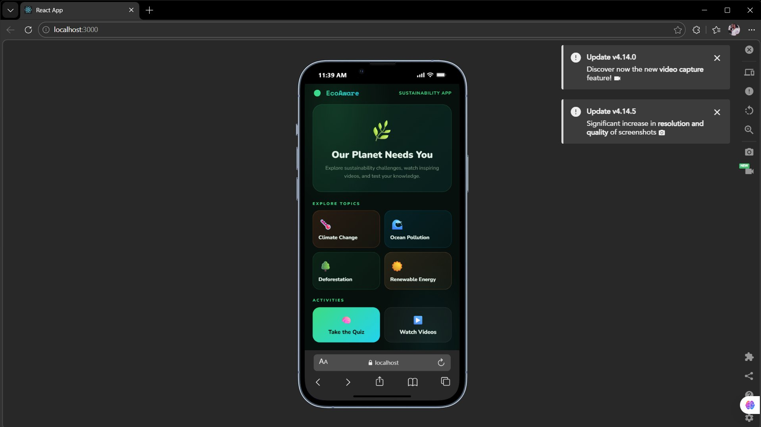

📸 Screenshot 4 — Information Screen (sustainability content)
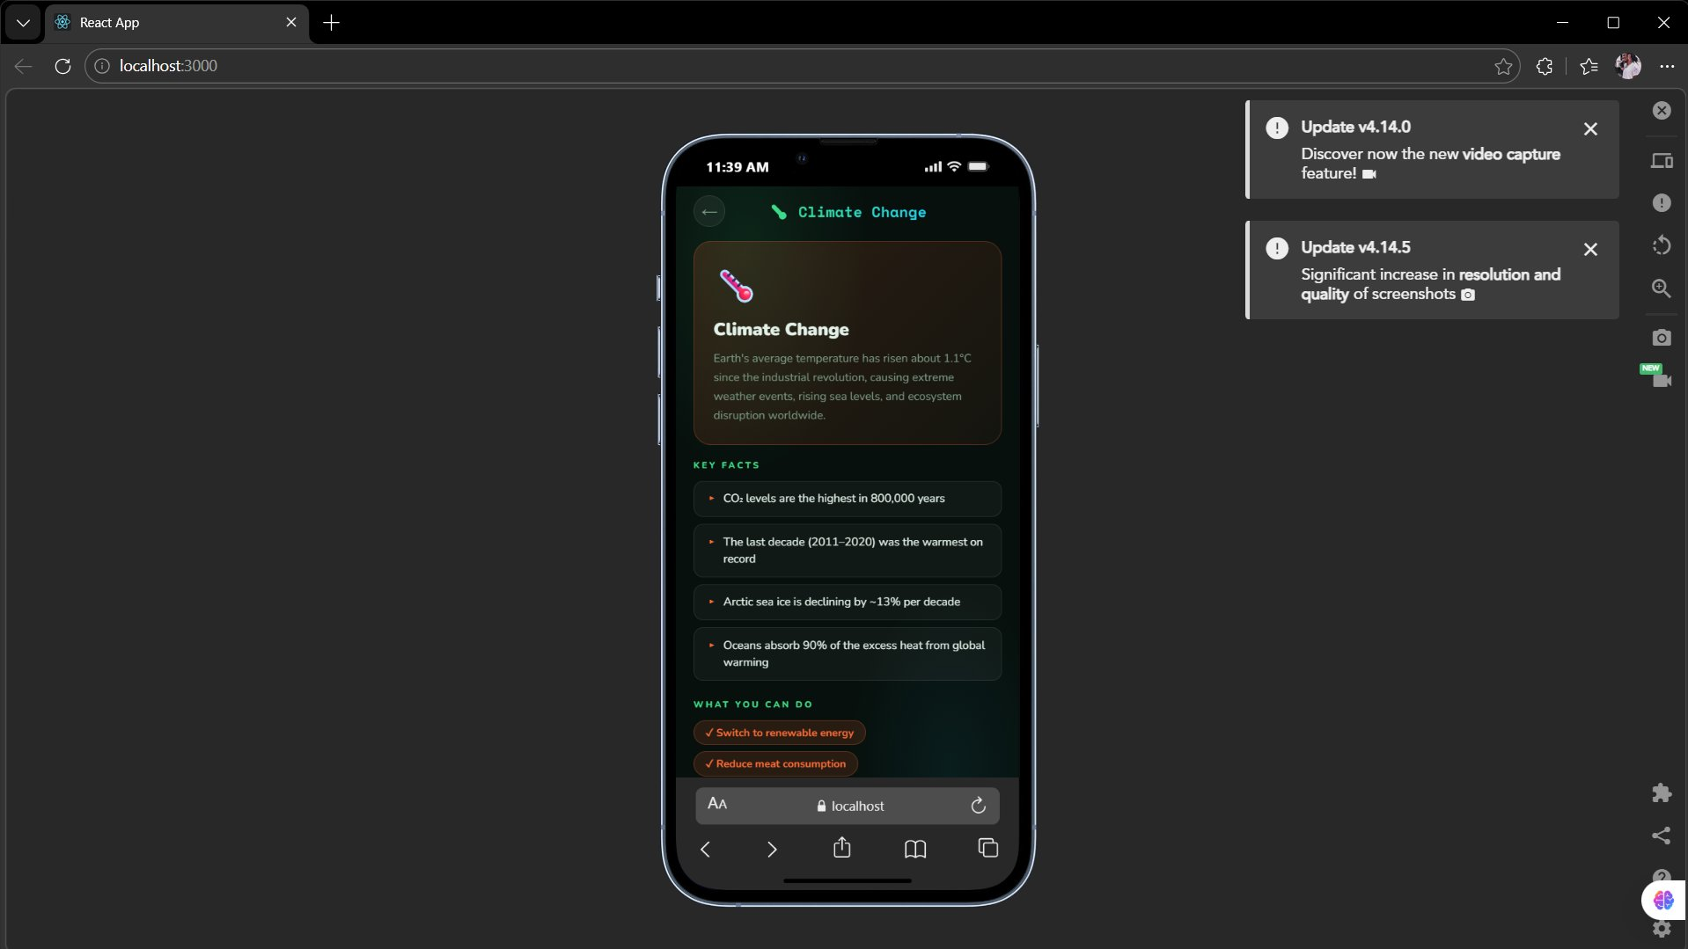

📸 Screenshot 5 — Video Screen (with video player)
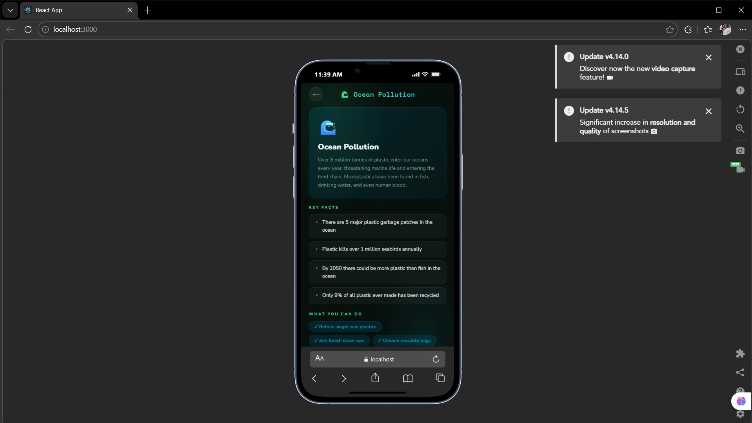

📸 Screenshot 6 — Quiz Screen (question + 4 answer choices)
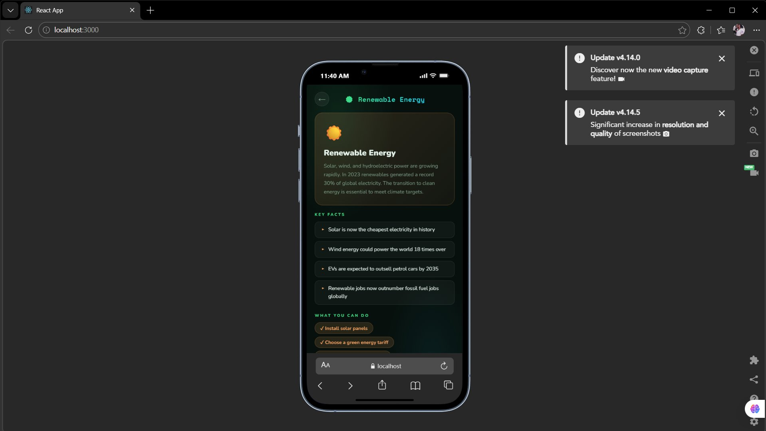

📸 Screenshot 7 — Correct Answer Selected (green highlight + applause)
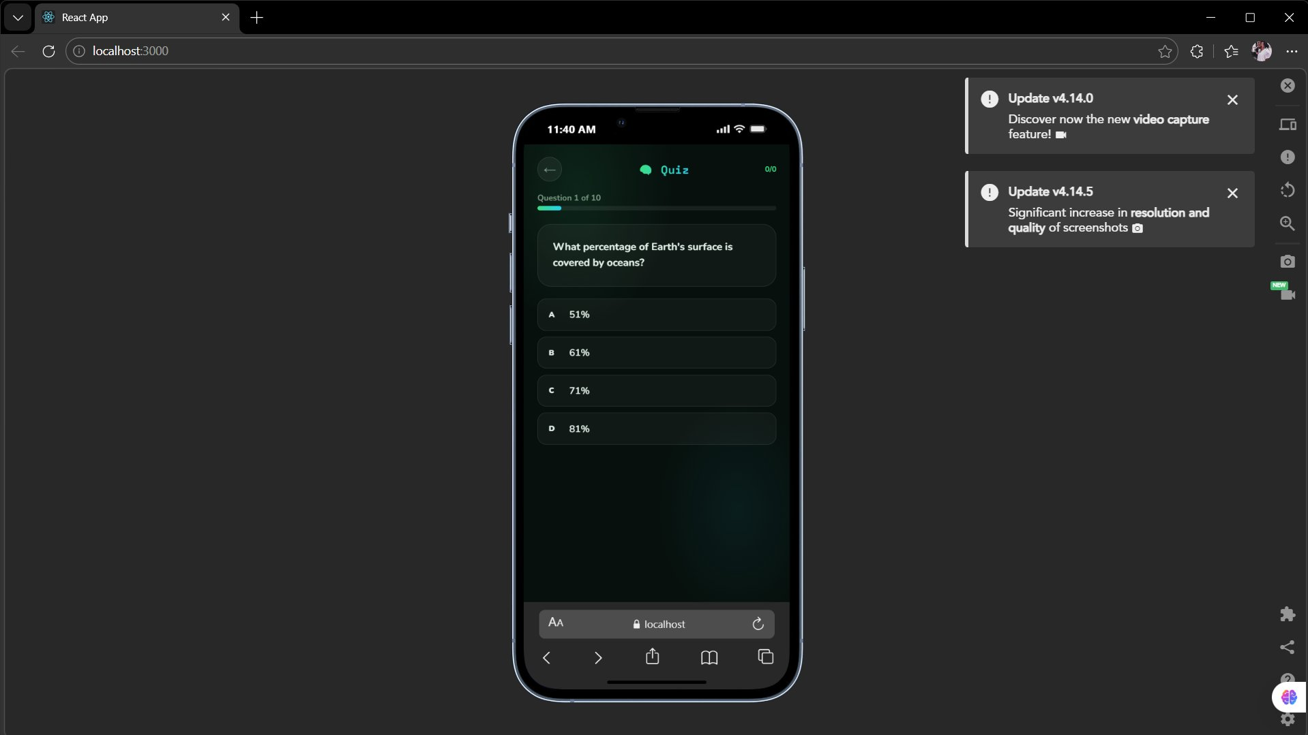

📸 Screenshot 8 — Incorrect Answer Selected (red highlight + error sound)
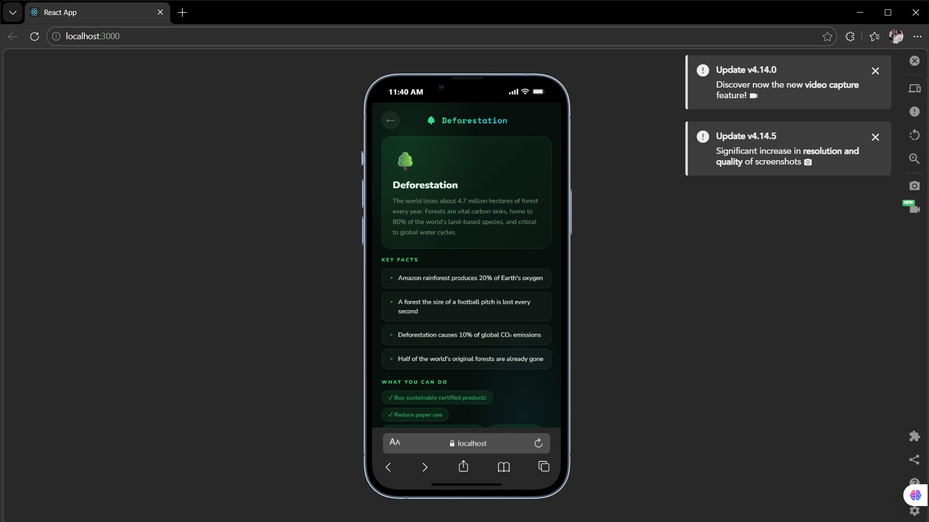

📸 Screenshot 9 — Final Score Screen (after 10 questions)
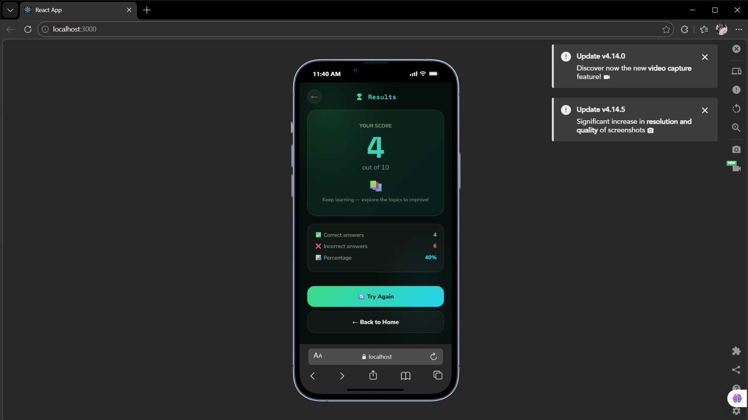

Code / Programming Blocks
📸 Screenshot 10 — Quiz Logic (programming blocks/code)
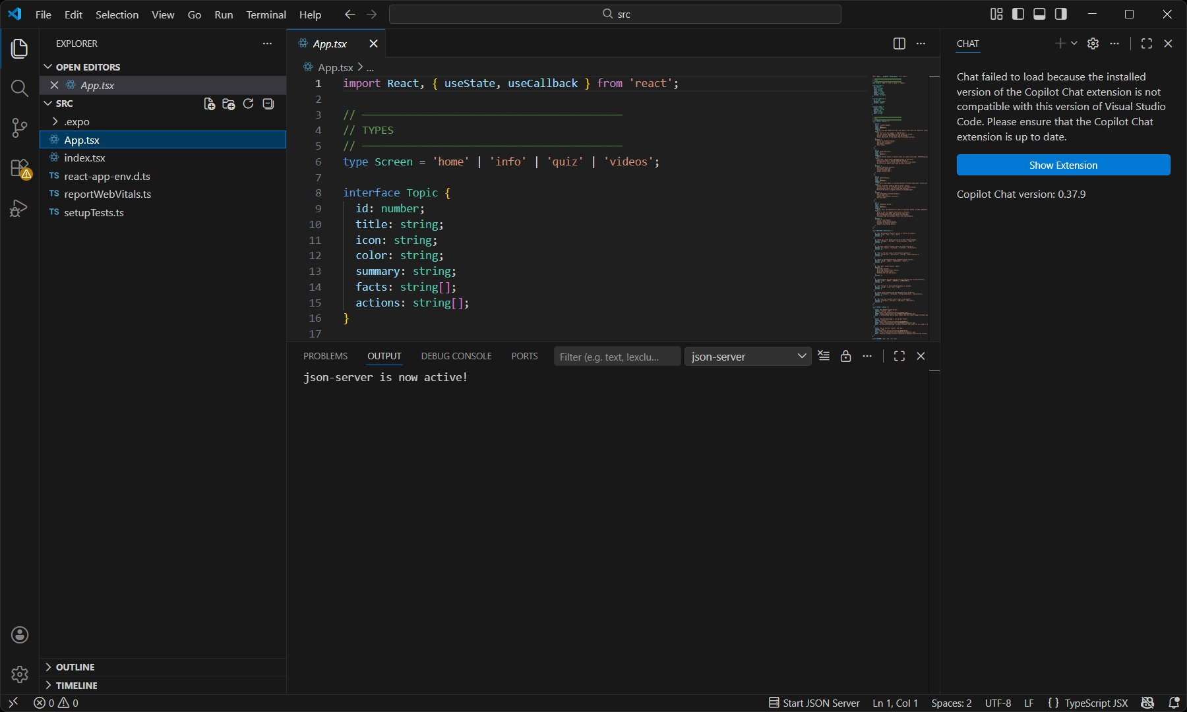

📸 Screenshot 11 — Score Tracking System (programming blocks/code)


C.P6 — Test the Mobile App

The app was tested for functionality, usability, stability and performance using the following test plan:

No. | What is Tested | Input | Expected Result | Actual Result | Pass/Fail
1 | Start Quiz button | Click | Displays question 1 | Displays question 1 | ✅ Pass
2 | Correct answer | Click correct option | Applause + score +1 | Works correctly | ✅ Pass
3 | Incorrect answer | Click wrong option | Error sound, score unchanged | Works correctly | ✅ Pass
4 | Quiz completion | Complete 10 questions | Final score displayed | Works correctly | ✅ Pass
5 | Video screen | Click Video button | Video loads and plays | Works correctly | ✅ Pass
6 | Back navigation | Click back button | Returns to home screen | Works correctly | ✅ Pass
7 | Score reset | Restart quiz | Score resets to 0 | Works correctly | ✅ Pass

User Feedback Testing
Users found the navigation easy and intuitive
One user suggested that the questions should appear in a random order each time
Both users enjoyed the sound effects and found them motivating

C.P7 — Review the Extent to Which the App Meets Requirements

The completed app successfully meets the main requirements identified in the scenario:

✅ It provides information about sustainability issues (Information screen)

✅ It includes video content demonstrating the importance of sustainability (Video screen)

✅ The quiz contains exactly 10 multiple choice questions

✅ The score is tracked and displayed at the end of the quiz

✅ Sounds and graphics are included to make the app engaging

Limitations Identified

The app is only available on Android, not iOS

The question bank is fixed — questions do not change or update automatically

No internet connection is required, so sustainability information cannot be updated in real time

The app does not store high scores across multiple sessions

C.M3 — Optimise the Mobile App

Following user testing and feedback, the following optimisations were made to improve the app:

1. Randomised Question Order
The questions are now randomly displayed in a new sequence every time a quiz is retaken and this makes the quiz more replayable and more difficult to repeat users.

2. Bug Fix -- Score Not Resetting
When the quiz was re-opened without closing the app, the score was not returning to

This was corrected with an addition of set score to 0 instruction at the start of quiz initialisation block.

3. Visual Improvement
Each screen was accompanied by a background image to make the visual design of the app look more professional and uniform.

4. Improved Feedback Screen
The final score screen has become displaying the number of the correct answers among 10 and a motivational message (e.g. Wel done! or Keep practising!') based on the score obtained.

📸 Screenshot 12 — Optimised App Version (updated screen or code)


BC.D2 — Evaluate the Design and Optimised Mobile App Against Client Requirements

The last application is able to satisfy the needs of the client effectively. The original draft was in good place to be developed, the improvements after the peer-review and testing of the product by the users led to a better and censured product.

The mobile app has a number of key advantages as compared to other solutions, such as a website, a printed leaflet, or a basic PDF document. It is interactive, mobile and offers a type of immersion using sounds, graphics and video materials. These aspects make it much more interactive compared to a stale source of information.

The decision to use the MIT App Inventor was supported by the fact that it is accessible and compatible with the Android devices which are the most popular smartphones worldwide. The drawback of this strategy, however, is that this strategy cannot be simply implemented on iOS devices.

Future Developments
• A leader board that is available online to enhance the competitiveness among users.
• On-demand automatic updates of content through an internet connection.
• iOS support to access more people.
• Other quiz types with the various sustainability themes.

BC.D3 — Individual Responsibility, Creativity and Effective Self-Management

Throughout this project, I demonstrated the following:

Time Management
I created a project plan dividing the work into clear phases (design, development, testing, optimisation) and met all internal deadlines set throughout the project.
Individual Responsibility

I took ownership of every stage of the project independently, seeking constructive feedback from peers at key stages rather than waiting to be directed.
Creativity

The visual theme, sound design, and app structure were designed to reflect the sustainability context in an original and engaging way, going beyond the minimum requirements.

Responding to Feedback

I analysed the feedback received during the design review and user testing stages, and incorporated it thoughtfully into the revised design and optimised version of the app.

Professionalism
I communicated my design decisions clearly and respectfully when presenting my work for peer review, and documented all stages of the development process thoroughly.

