Deep Clustering Sharpens, Not Solves, Multi-Mechanism Blind Spots in PCA+K-Means: A Dimension-Free Structural Account
Bahman Shiri Lonbar^{1*} and Zeinab Hassanifar²
^{1*}Department of Computer Engineering, East Azerbaijan Science and Research Branch, Islamic Azad University, Tabriz, Iran.
²Department of Accounting, Faculty of Management, University of Tehran, Tehran, Iran.
*Corresponding author(s). E-mail(s): Lonbarllm@gmail.com

Abstract
The PCA-preprocessed K-Means pipeline rests on a fragile assumption: that directions of maximal variance correlate with meaningful cluster structure. Data often carries multiple independent, comparable-scale hidden group structures (distance-separable, relational, and density/scale-based) rather than one dominant structure; the pipeline can erase all but the dominant one while the Silhouette score reports a stable, deceptively confident partition. We derive a dimension-free bound on this collapse (Theorem 1) via Weyl’s inequality and the Gershgorin circle theorem: once cross-mechanism correlations are bounded by ε, no principal component’s explained-variance-ratio deviates from its block-diagonal value by more than O(ε), independent of dimensionality. We validate the bound numerically and confirm the predicted spectral collapse on real network-traffic data (CIC-IDS2017).
A systematic recovery survey across all three mechanisms shows this is not a limitation of linear methods alone. Across 80 seeds, DEC and IDEC recover the dominant mechanism more reliably than a standard autoencoder (55–59% vs. 20%) but drive the relational mechanism to exactly 0%, down from the autoencoder’s 40–49%: added capacity sharpens this blind spot rather than resolving it. The density/scale mechanism remains undetected by every method tested. Only Invariant Coordinate Selection (ICS) routes reliably to the relational structure via a kurtosis signal without oracle knowledge, though automatic thresholding remains open. The bound and diagnostic survey together give a checkable, ground-truth-free criterion for identifying when a PCA+K-Means pipeline is structurally blind to real subgroup structure.
Keywords: dimension-free bound; deep clustering; PCA; K-Means; Silhouette score; invariant coordinate selection

1. Introduction
Standardize the features, reduce them with PCA, and cluster the result with K-Means (MacQueen, 1967), validated by the Silhouette score (Rousseeuw, 1987): this four-step recipe is applied so routinely in exploratory data analysis that it is rarely questioned twice. Its authority rests on two assumptions the analyst almost never states out loud — that the directions of largest variance in a standardized feature table are the directions that matter, and that an internal validity index will sound the alarm if they are not. As the field has moved toward higher-capacity, self-training deep clustering architectures (DEC, IDEC) built to learn representations beyond what a linear projection can capture, a further assumption has gone largely unexamined: that added non-linear capacity can only help a pipeline see co-present structure, never hurt it. This paper identifies a concrete, constructible regime in which both assumptions fail, and fail together: the classical pipeline and its modern deep-clustering successors alike return a plausible-looking partition, certified by a stable, unremarkable validation signal, while remaining unable to recover every co-present grouping mechanism the analyst set out to find. The failure is not rare or adversarial. It is the generic outcome whenever a dataset carries more than one independent, comparable-scale grouping mechanism rather than a single dominant one — a condition that, as we show on real network-traffic data below, is not confined to synthetic constructions. Our aim in this paper is diagnostic and structural — to characterize precisely when and why this failure occurs, in both linear and deep pipelines, and to establish a checkable criterion for detecting it — rather than to propose a general-purpose replacement pipeline; a full resolution, especially for the density/scale mechanism identified in Section 6, remains an open problem we return to in Section 9.
What distinguishes this blind spot from previously documented failures of PCA-based and deep clustering is that it is neither a property of one unlucky dataset nor a loose invocation of the curse of dimensionality. Existing accounts are either purely empirical demonstrations on a single dataset, with no structural explanation of why the collapse occurs or how it scales, or general subspace-clustering results that stop short of isolating the specific eigenvalue-flattening mechanism at work when several hiding structures coexist (Section 2); separately, the deep clustering literature has largely treated added model capacity as a remedy for linear preprocessing’s limitations without testing whether that capacity extends to structures beyond the one the objective is trained to find. We close both gaps with a proved, distribution-free bound (Theorem 1, Section 3) — a single inequality, free of any dimensionality dependence once the relevant correlation scale is fixed, that predicts in advance whether a given multi-mechanism dataset will be affected — and we hold that prediction to account with generalization across dimensionality and real data, a properly powered (N = 80 seeds) interaction analysis, and a systematic comparison of which off-the-shelf tools — nonlinear reduction, purpose-built deep clustering, and Invariant Coordinate Selection — can and cannot recover each mechanism.
Crucially, we show that the second assumption above does not hold: purpose-built deep clustering sharpens this blind spot rather than resolving it. When trained on multi-mechanism data, self-training objectives such as DEC and IDEC preferentially exploit the most accessible discriminative signal — the dominant, distance-based mechanism — at the expense of the others, driving recovery of both the relational and density/scale mechanisms to essentially zero across 80 random seeds (Section 5.2), even as they recover the dominant mechanism more reliably than a generic autoencoder. Added capacity does not widen what the representation can see; it narrows it around whatever signal is easiest to optimize.
Confirming Theorem 1’s predicted spectral collapse on unmodified real-world network traffic (CIC-IDS2017, Section 4.2) validates the bound itself; the deep-clustering comparison above is established separately, on the synthetic benchmark. Together with a kurtosis-based Invariant Coordinate Selection screen that routes reliably to the relational structure without oracle knowledge, the bound and the diagnostic survey give a checkable, ground-truth-free criterion for identifying when a representation-learning pipeline — linear or deep — is structurally blind to real subgroup structure.

1.1 Contributions
- A dimension-free structural account of the collapse: a proved, distribution-free eigenvalue-perturbation bound (Theorem 1, via Weyl’s inequality and the Gershgorin circle theorem) explaining why PCA’s correlation spectrum flattens under multi-mechanism co-presence, together with a companion eigenvector-level guarantee (Theorem 3, via the Davis-Kahan sin-Θ theorem) and a worst-case boundary (Proposition 2) marking where that guarantee — and eigenvector identifiability itself — breaks down completely, independent of dimensionality (Section 3).
- A mechanism-specific diagnostic map, anchored by a synthetic ground-truth benchmark that numerically validates Theorem 1 to within 0.005 explained-variance-ratio units (Section 4), of which existing linear, non-linear, and deep-learning tools can and cannot see through each of three distinct hiding mechanisms (distance, relational, density/scale) — including a properly powered (N = 80 seeds) result showing the mechanisms do not compound each other’s damage, a precise localization of the collapse to K-Means’ multi-centroid partitioning rather than to Euclidean distance in general (Sections 5–6), and a domain-matched validation of Theorem 1’s predicted collapse on real, unmodified network-traffic data (CIC-IDS2017, Section 4.2) reproducing the collapse and Section 5.3’s radial-versus-hand-informed ordering — this real-data validation targets the bound; the deep-clustering comparison below is established on the synthetic benchmark.
- Counter-intuitive result: purpose-built deep clustering sharpens the blind spot rather than resolving it. Across N = 80 seeds (Section 5.2), DEC and IDEC recover the dominant, distance-based mechanism far more reliably than a generic autoencoder (55–59% versus 20% of seeds), but drive recovery of both minority mechanisms to essentially zero: the relational mechanism falls to 0% of seeds, down from the generic autoencoder’s already-unreliable 40–49%, and the density/scale mechanism — already undetected by every other method tested — remains at zero as well. Added model capacity and a purpose-built self-training objective narrow what the pipeline can see rather than widening it.
- Routing via Invariant Coordinate Selection (ICS): a per-feature-pair kurtosis-anomaly screen that routes reliably to the relational structure without oracle knowledge, achieving 100% routing accuracy across 80 seeds (Section 5.3) — a diagnostic pathway not available from any of the linear or deep methods surveyed, though, like the strongest alternative (DBSCAN), it does not yet yield an automatic, label-free membership threshold, which we flag as open work (Section 9).
These four contributions are supported by a battery of robustness checks reported in Sections 4–6: generalization across dimensionality (d = 10..100), noise scale, seven alternative reduction front ends, and three real datasets; a 450-run parameter-space sweep with zero violations of Theorem 1’s bound; and a radial-distance-from-centroid baseline confirming the K-Means-specific localization above.

2. Related Work
The failure of variance-maximizing projections to preserve minority or task-relevant structure is a long-standing concern in the subspace- and multi-view clustering literature, from early surveys of high-dimensional clustering (Kriegel, Kröger and Zimek, 2009) to the broader project of fusing multiple weak views into a single robust partition. Distance-based methods face a compounding problem in high dimension: as dimensionality grows, the contrast between the nearest and farthest point under Euclidean distance shrinks toward zero (Aggarwal, Hinneburg and Keim, 2001), and audits of dimensionality-reduction pipelines in other high-dimensional domains have found that the low-dimensional embeddings practitioners rely on in practice can distort or erase genuine structure without any visible warning sign (Chari and Pachter, 2023) — precisely the silent-failure pattern this paper documents for the PCA+K-Means pipeline specifically. Our contribution is deliberately narrow and structural rather than a new clustering algorithm: we quantify how much of the standard pipeline’s blindness is attributable to eigenvalue-spectrum flattening under multi-mechanism co-presence. Recent surveys and methods — Fang, Li, Li, Gao, Jia and Zhang (2023, IEEE Transactions on Knowledge and Data Engineering), consensus-anchor multi-view subspace clustering (Zhou, Zhu and Jin, 2026, Knowledge and Information Systems), and kernel-based multiple-clustering approaches (Wang, Liu, Cai and Ding, 2026, Information Fusion) — target related forms of structural blindness, but none analyzes the block-diagonal, cross-mechanism eigenvalue-perturbation mechanism this paper isolates and proves (Section 3).

2.1 Random Matrix Theory and Spectral Limits
The mathematical core of Theorem 1 connects to the spiked-covariance-model literature in random matrix theory (Johnstone, 2001; Baik, Ben Arous and Péché, 2005), which studies multiple signal directions of differing strength embedded in high-dimensional noise and the threshold at which a weaker signal’s eigenvalue separates from the noise bulk rather than being absorbed into it. That literature is asymptotic — its phase-transition thresholds hold in the proportional-growth limit n, d → ∞ — and models the signal as a rank-one or low-rank linear perturbation added to an otherwise unstructured covariance. Theorem 1 addresses a different regime: a deterministic, non-asymptotic bound that holds at every finite n and d, stated directly in terms of population correlation blocks rather than added linear spikes — a distinction that matters because the mechanisms this paper studies (Section 4) are geometric and non-linear, such as a proportional relationship or a local density concentration, rather than rank-one linear directions. In a complementary direction, Nadler and Galun (2007) show that spectral clustering breaks down when a dataset carries structure at multiple scales, because eigenvectors associated with different scales mix rather than separate cleanly — a qualitatively similar mixing phenomenon, but established for the spectral-clustering affinity matrix rather than for the raw-feature covariance/correlation matrix that Theorem 1 addresses.

2.2 Invariant Coordinate Selection (ICS) and Anomaly Screening
Invariant Coordinate Selection (ICS), introduced by Tyler, Critchley, Dümbgen and Oja (2009) as an affine-invariant generalization of PCA that jointly diagonalizes two scatter matrices instead of relying on covariance alone, recovers cluster and outlier structure invisible to ordinary PCA in elliptical mixture models (Tyler et al., 2009; Alfons, Archimbaud, Nordhausen and Ruiz-Gazen, 2024) via generalized eigenvalues that depart from 1 in directions of excess or deficient kurtosis relative to a Gaussian reference. Becquart, Archimbaud, Ruiz-Gazen, Prilé and Nordhausen (2026) extend the underlying two-group ICS theory to more than two groups — the regime this paper’s three-mechanism benchmark falls into — while Radojičić, Nordhausen and Virta (2021, 2025) formally characterize when skewness- or kurtosis-based projection-pursuit indices recover the Fisher discriminant subspace in the two-cluster case. Both strands treat ICS or its projection-pursuit relatives as a whole-dataset dimensionality-reduction front end, in place of PCA, prior to clustering. This paper instead deploys ICS in a more targeted role: a per-feature-pair kurtosis-anomaly screen that ranks candidate feature pairs by generalized-eigenvalue departure from 1, in order to locate which pair contains a hidden, ratio/relational-type subgroup — converting a single, well-posed two-population estimation problem into a selection-among-many-candidates problem in which most pairs carry no signal at all, a setting neither literature has occasion to consider. To our knowledge, this role has not previously been reported, and we show it succeeds cleanly: 100% correct routing across 80 seeds, a roughly 55-standard-deviation gap over the strongest negative control — though the gap between this routing success and automatic within-pair thresholding remains open (Section 9). Complementary efforts include Dehghankar and Asudeh’s (2025) dual-space search for unknown, under-represented minority groups, and Fischer et al.’s (2017) independent confirmation, on real genotype data, that ICS recovers subgroup structure invisible to ordinary PCA.

2.3 The Deep Clustering Paradox
Song and Ling (2025), motivating a bilevel masked subspace-clustering framework, argue that Euclidean distance alone cannot characterize high-dimensional data structure, and Plant, Bauer and Böhm’s AAAI 2026 tutorial surveys subspace- and deep-clustering responses to the same abstraction-versus-representation trade-off that Theorem 1 quantifies exactly for one analytically tractable case. Among that tutorial’s deep-clustering responses, DEC (Xie, Girshick and Farhadi, 2016) and IDEC (Guo, Gao, Liu and Yin, 2017) are the two most widely cited purpose-built methods that jointly learn a representation and a clustering assignment via a self-sharpening target distribution, rather than clustering a representation learned for reconstruction alone. This self-sharpening dynamic is consistent with the broader finding that deep networks tend to gravitate toward whichever discriminative signal is easiest to exploit, under-using harder, less accessible alternatives (Geirhos et al., 2020). By testing DEC and IDEC directly against this paper’s three-mechanism benchmark (Section 5.2), we show this tendency operating inside a clustering objective rather than a supervised one: added model capacity does not resolve the multi-mechanism blind spot but, by concentrating on the most accessible signal, sharpens it.

3. Theoretical Framing: The Block-Diagonal Variance Trap

3.1 The Zero-Sum Variance Trap
Why does PCA go blind to two of the three mechanisms at once, rather than merely losing some accuracy on each? Any correlation matrix carries a fixed variance budget: once the features are standardized, its trace — and hence the sum of its eigenvalues — is fixed, and every co-present source of structure has to draw on that same fixed budget. When several independent, comparable-scale mechanisms compete for it, none can win outright: the budget spreads near-uniformly across all of them, and PCA is left with no small set of directions that captures any one mechanism cleanly. This section makes that zero-sum picture precise. We formalize it as a general, distribution-free perturbation bound (Theorem 1), built from Weyl’s inequality and the Gershgorin circle theorem, and instantiate it concretely on this benchmark (Proposition 1). Two refinements then sharpen the picture: Corollary 1 and Theorem 2 show why the cross-mechanism leakage driving the bound is small in the first place, while Theorem 3 and its boundary case, Proposition 2, extend the argument from eigenvalues to the eigenvectors that PCA actually hands to K-Means — the same competition for a fixed budget that Section 5.2 later shows a self-training deep clustering objective does not escape either. The benchmark’s three hiding mechanisms (A: distance, B: relational, C: density/scale; defined in Section 4) are referenced below by these labels.

3.2 Dimension-Free Spectral Collapse
Theorem 1 (cross-block eigenvalue perturbation bound).
Let R be a d × d correlation matrix (symmetric, unit diagonal) whose d indices are partitioned into blocks (here: one 2 × 2 block per mechanism, plus 1 × 1 blocks for pure-noise columns). Write $R = R_{B} + E$, where R_B retains only R’s within-block entries (zeroing all cross-block entries) and E retains only R’s cross-block entries (zero elsewhere, including the diagonal). If every cross-block correlation satisfies $\left|R_{ij}\right| ≤ ε$, then for every eigenvalue index i:
$\left|λ_{i}(R) − λ_{i}(R_{B})\right| ≤ {\left\|E\right\|}_{2} ≤ \left(d − 1\right)ε$ (1)
where λᵢ denotes the i-th largest eigenvalue and ${\left\|·\right\|}_{2}$ is the spectral (operator) norm.
The proof needs only two classical facts, chained together: Weyl’s inequality, which controls how far any single eigenvalue can move under a perturbation, and the Gershgorin circle theorem, which bounds the size of that perturbation from its row sums alone.
Proof.
Step 1 (Weyl’s inequality; Horn and Johnson, 2013). For symmetric matrices A, B, and every index i:
$\left|λ_{i}(A) − λ_{i}(B)\right| ≤ {\left\|A − B\right\|}_{2}$ (2)
Apply with A = R, B = R_B, so A − B = E, giving $\left|λ_{i}(R) − λ_{i}(R_{B})\right| ≤ {\left\|E\right\|}_{2}$.
Step 2 (Gershgorin bound on ${\left\|E\right\|}_{2}$). E is symmetric with a zero diagonal, so by the Gershgorin circle theorem every eigenvalue μ of E satisfies $\left|μ\right| ≤ Σ_{j}\left|E_{ij}\right|$ for some row i, hence:
${\left\|E\right\|}_{2} = \max_{i}\left|μ_{i}(E)\right| ≤ \max_{i}Σ_{j}\left|E_{ij}\right|$ (3)
Step 3 (row-sum bound). Each row of E has at most d − 1 nonzero cross-block entries, each bounded by ε, so:
$Σ_{j}\left|E_{ij}\right| ≤ \left(d − 1\right)ε$ (4)
for every row.
Combining Eqs. (2)–(4) gives Eq. (1). Because R and R_B both have unit diagonal, $trace(R) = trace(R_{B}) = d$, so explained-variance-ratio ${EVR}_{i} = λ_{i} / d$ for both, and dividing the bound by d gives, for every i and any d:
$\left|{EVR}_{i}(R) − {EVR}_{i}(R_{B})\right| ≤ \frac{\left(d − 1\right)ε}{d} < ε$ (5) ∎
Geometric interpretation of Theorem 1.
Stripped of matrix norms, Theorem 1 says something intuitive: the eigenvalues of R cannot move far from what they would be if every mechanism’s block were perfectly isolated. Combined with Proposition 1’s observation that every within-block correlation in this benchmark is small (ρ_A = 0.007, ρ_B = 0.530, ρ_C = 0.016), this pins the entire spectrum close to the uniform value of 1 — flat, rather than a small number of large eigenvalues separated from a long tail of small ones. Geometrically, a flat spectrum means the standardized data cloud is close to isotropic: it does not stretch noticeably further along any one direction than along another, so PCA finds no small set of “dominant” directions to keep and no corresponding “minority” directions to discard. The top-k components it hands to K-Means are therefore close to arbitrary linear mixtures of every mechanism’s coordinates and the noise columns, rather than a subspace aligned with any single mechanism. A hidden mechanism is consequently not simply attenuated but smeared across the retained components in roughly the same proportion as every other source of variance, so no fixed choice of k recovers it cleanly. Only mechanism B’s comparatively larger within-block correlation is enough to tilt the leading eigenvalue visibly in Figure 2, consistent with mechanism B being the one mechanism that PCA-based methods partially recover in Section 6.
Corollary 1 (finite-sample concentration of ε under population independence).
Theorem 1 treats ε as a given, fixed bound on cross-mechanism correlation. A partial explanation for why ε is small in practice is available under an additional assumption: if the mechanisms are population-independent and the standardized features are sub-Gaussian, concentration of the sample Pearson correlation coefficient (Vershynin, 2010) combined with a union bound over the at most d(d − 1)/2 cross-block pairs gives that, for any δ ∈ (0,1), with probability at least 1 − δ over n i.i.d. samples the empirical bound ε̂ satisfies, for an absolute constant C:
$ε̂ ≤ C·\sqrt{\frac{log(d^{2}) + log(1/δ)}{n}}$ (6)
Substituting into Theorem 1 gives, with the same probability, for every eigenvalue index i:
$\left|{EVR}_{i}(R̂) − {EVR}_{i}({R̂}_{B})\right| < C·\sqrt{\frac{log(d^{2}) + log(1/δ)}{n}}$ (7)
This is distinct from the Section 6.1 dimensionality-dilution finding, an arithmetic consequence of trace(R) = d being shared across more principal components as noise columns are added, not of ε changing. Corollary 1 instead gives a finite-sample reason, independent of any dataset-specific numerical check, for why ε is typically small whenever the hiding mechanisms are approximately statistically independent and the sample size is not tiny relative to log d — the regime our benchmark’s generative model (Section 4) is constructed to satisfy.
We verified this bound numerically (theory_variance_budget.py): on the actual generated data, ε = 0.0352 (the largest observed cross-mechanism correlation), giving a distribution-free bound of (d − 1)ε/d = 0.0317 in EVR units. The tighter, data-specific bound from Weyl’s inequality applied to the exact spectral norm of E was 0.0073; a looser bound from the Gershgorin row-sum estimate was 0.0142; and the observed maximum EVR error was 0.0054:
$0.0054 ≤ 0.0073 ≤ 0.0142 ≤ 0.0317$ (8)
with the exact Weyl bound tighter than the Gershgorin row-sum estimate, as expected since Gershgorin is itself an upper bound on the spectral norm. This ordering holds for any correlation matrix with this block structure and this ε, for any d, not only for this seed; Proposition 1 below gives its concrete numerical instantiation.
Theorem 2 (dimension-improved concentration via matrix Bernstein, for n ≳ d log(d/δ)).
Corollary 1’s route to smallness comes at a price worth naming: it bounds the empirical cross-block noise by concentrating each entry of the sample correlation matrix separately and combining entries via a union bound through Theorem 1’s Gershgorin row-sum route, which costs a factor of (d − 1) in the final operator-norm bound. A direct matrix-concentration argument — decomposing the cross-block noise into i.i.d. mean-zero symmetric matrices and applying a Hanson–Wright tail bound with the matrix Bernstein inequality (Tropp, 2015) — removes this loss entirely; the full derivation, under i.i.d. sub-Gaussian observations with an exactly block-diagonal population correlation matrix, is given in Appendix B.
Whenever n ≳ d log(d/δ) — a condition this paper’s experiments satisfy comfortably (n = 8,000 against d ≤ 100 gives d log(d/δ) in the low hundreds even at δ = 0.05) — the square-root term dominates, giving ‖Ê‖₂ = O(√(d log(d/δ)/n)): a square-root dependence on d in place of the O(d·√(log(d)/n)) dependence from routing Corollary 1 through Theorem 1’s row-sum step. Outside this regime, Theorem 2 offers no improvement over Corollary 1. Dividing by d gives, with probability at least 1 − δ:
$\left|{EVR}_{i}(R̂) − {EVR}_{i}({R̂}_{B})\right| ≤ \frac{{\left\|Ê\right\|}_{2}}{d} = O(\sqrt{\frac{log(d/δ)}{dn}})$ (14)
Under population independence of the mechanisms, the EVR perturbation shrinks with sample size n and, at fixed n, weakly improves (up to log factors) as the ambient dimension d grows — distinct from the arithmetic dimensionality-dilution finding of Section 6.1, which concerns the fixed noise budget trace(R) = d being shared across more columns as noise columns are added.
This upgrades Corollary 1 to a direct, non-asymptotic operator-norm concentration statement with a strictly better dimension dependence. It still requires approximate population independence of the mechanisms and does not track its constants explicitly, but it gives a first-principles account of why ‖Ê‖₂ is small whenever that independence assumption holds and n is not tiny relative to d log d.
We verify this regime distinction directly rather than leaving it a theoretical possibility (sample_complexity_simulation.py). For d ∈ {10, 20, 40, 80, 160, 320}, holding fixed target thresholds (ɛ̂ ≤ 0.05, ‖Ê‖₂ ≤ 0.3) and taking the 90th percentile over 10 trials per (n, d) pair, we find the smallest sample size n at which each threshold is met, then fit both a log(d) and a d·log(d) curve to the resulting n-versus-d relationship for each quantity. For the entrywise quantity ɛ̂, the log(d) fit is markedly tighter (RMSE 258 vs. 868); for the spectral-norm quantity ‖Ê‖₂ — the one that actually enters Theorem 1’s bound — the d·log(d) fit is markedly tighter (RMSE 369 vs. 2257), and the required sample size grows roughly 38-fold (420 to 15,997) across the same six-fold range of d for which the entrywise requirement grows only roughly 2.3-fold (3,557 to 8,192). Figure 1 plots both curves. “Dimension-free” should therefore be read as a statement about the bound’s form once ε is fixed, not as a claim that fixing ε is itself free of sample cost at large d: the sample size needed to control the spectral-norm quantity Theorem 1 actually depends on grows with d, exactly as Theorem 2’s regime hypothesis (n ≳ d log(d/δ)) states.
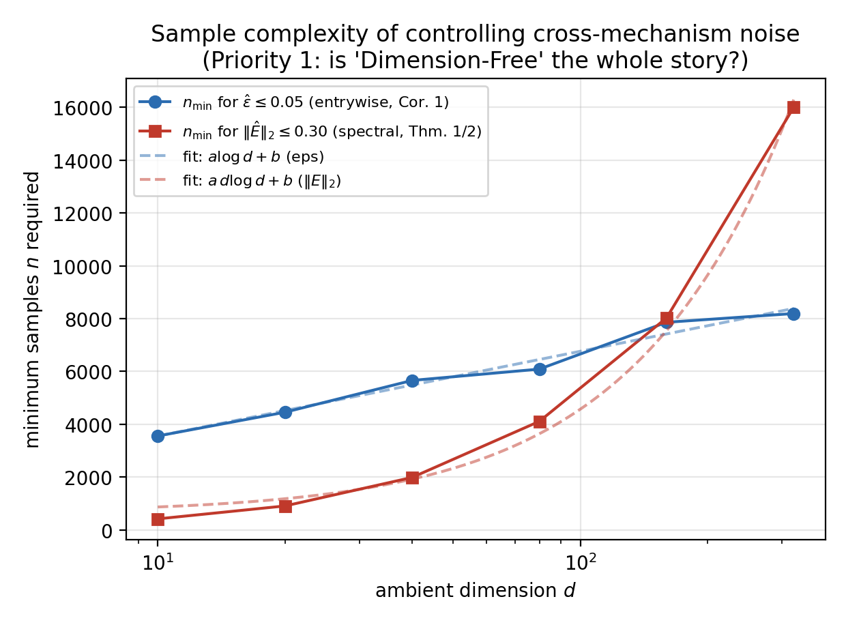
Figure 1. Smallest sample size n needed to control the entrywise quantity ɛ̂ (left; log(d)-fit RMSE 258 vs. d·log(d)-fit RMSE 868) and the spectral-norm quantity ‖Ê‖₂ (right; d·log(d)-fit RMSE 369 vs. log(d)-fit RMSE 2257), across d = 10 to 320.
Proposition 1 (block-diagonal variance-budget approximation: concrete numerical case).
Theorem 1 is deliberately worst-case; this benchmark sits in a far friendlier corner of that worst case, and making that concrete is the point of Proposition 1. Let the standardized feature matrix have d columns partitioned into mechanism-specific blocks (a 2-column block per mechanism, plus 1-column blocks for pure noise), such that the population correlation between any two columns in different blocks is exactly zero, which holds by construction since each mechanism is generated from an independent random stream (dataset_lib.py). Then R is exactly block-diagonal, and the eigenvalues of a block-diagonal matrix are the union of the eigenvalues of its blocks. For a 2 × 2 diagonal block with within-block correlation ρᵢ, the block’s two eigenvalues are:
$λ_{1,2}(ρ_{i}) = 1 ± ρ_{i}$ (15)
a pure-noise column contributes a unit eigenvalue. The full spectrum is near-uniform (clustered around 1) whenever every |ρᵢ| is small — the situation constructed here: the distance mechanism’s two coordinates are only weakly linearly correlated (blob centers placed symmetrically), and the relational and density mechanisms are defined by non-linear relationships (a ratio and a variance change) that do not require strong linear correlation between their two coordinates.
We verified this numerically on the generated dataset (seed 42). The measured within-block correlations were ρ_A = 0.007, ρ_B = 0.530, ρ_C = 0.016, and the maximum absolute cross-block correlation was 0.035, confirming near-block-diagonal structure empirically, not just by construction (Figure 3). The block-diagonal-approximation eigenvalue spectrum tracks the true eigenvalue spectrum of the full correlation matrix to within a maximum absolute error of 0.0054 and an L1 error of 0.023 across all 10 explained-variance-ratio values (Figure 2). Mechanism B, with a moderately large within-block correlation (ρ_B = 0.53, because roughly 12% of rows lie exactly on a linear ratio line), is the one mechanism whose block visibly perturbs the leading eigenvalue upward, consistent with mechanism B’s slightly larger empirical influence on PCA-based recovery reported in Section 6.
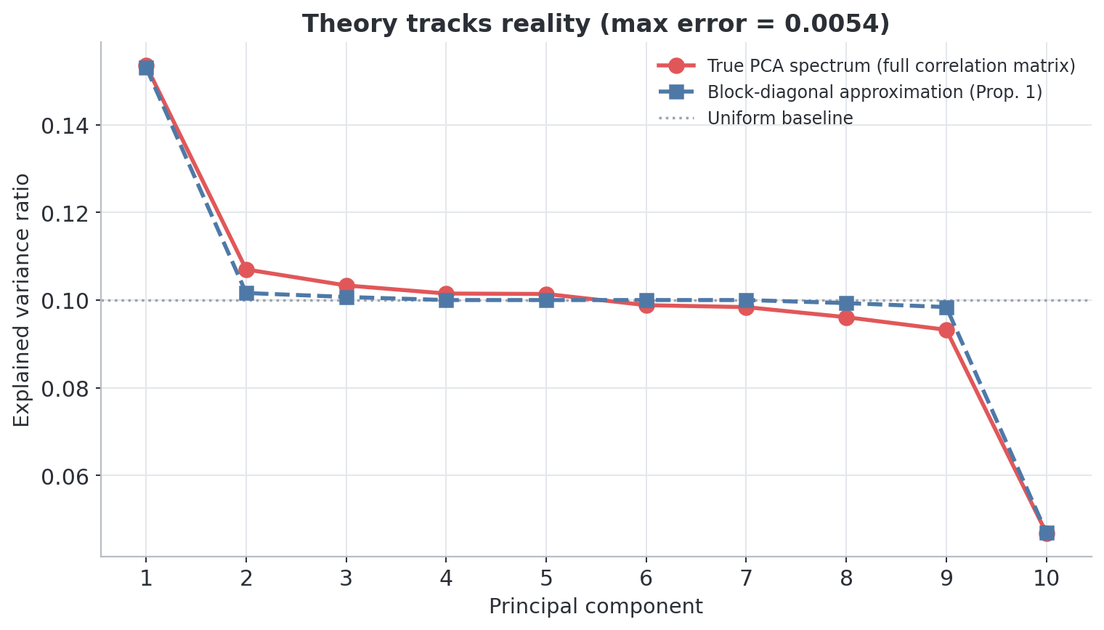
Figure 2. Analytical block-diagonal eigenvalue spectrum (Proposition 1) versus the true PCA eigenvalue spectrum of the full correlation matrix. The two track closely; both are near the uniform 1/d baseline, explaining why no single PC captures the class structure.
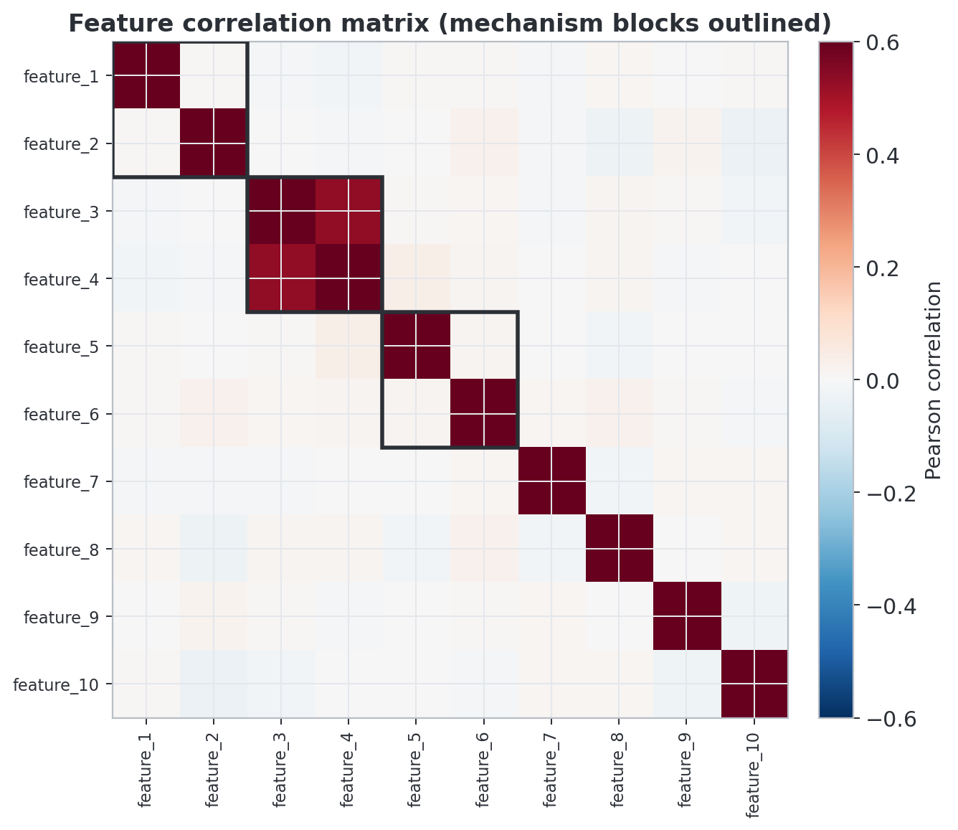
Figure 3. Feature correlation matrix with mechanism blocks outlined. Off-block entries are small (max |r| = 0.035), confirming the near-block-diagonal structure the theory in Section 3 relies on.
Theorem 1 is a general, distribution-free bound: it holds for any correlation matrix with a block structure and bounded cross-block correlation, not only this dataset. It is a worst-case perturbation bound, not a tight asymptotic characterization, and it does not by itself say why ε should be small for a particular generative process — only what follows once ε is known to be small. For the present benchmark we measure ε directly from the data rather than assuming it. Establishing, from first principles, that ε is small for broad classes of generative processes remains valuable follow-up work (Section 9).

3.3 Eigenvector Instability and the Deep Clustering Implication
Theorem 3 (eigenvector stability via Davis-Kahan).
Theorems 1 and 2 bound how far the eigenvalues of R̂ can drift from those of R̂_B, but say nothing about the eigenvectors themselves — the principal-component directions PCA reports, which determine whether the downstream K-Means step sees the right subspace at all. We close this gap with the classical Davis-Kahan sin-Θ theorem (Davis and Kahan, 1970), in the single-eigenvector operator-norm form given by Yu, Wang and Samworth (2015), which needs only an eigengap and the operator-norm perturbation bound Theorem 2 already supplies.
Let $δ_{i} = \min_{j≠i} \left|λ_{i}(R_{B}) − λ_{j}(R_{B})\right|$ be the eigengap separating the i-th eigenvalue of R_B from every other eigenvalue of R_B, and let vᵢ, v̂ᵢ denote the corresponding unit-norm eigenvectors of R_B and of the observed $R̂ = R_{B} + Ê$. Provided $δ_{i} > 0$, the angle between the true and estimated eigenvectors satisfies, with the same probability guarantee as Theorem 2:
$sin Θ(v_{i}, {v̂}_{i}) ≤ \frac{2{\left\|Ê\right\|}_{2}}{δ_{i}}$ (16)
Combining this with Theorem 2’s bound on ‖Ê‖₂ gives, for n large relative to d log² d, sin Θ(vᵢ, v̂ᵢ) = O(√(d log(d/δ)/n) / δᵢ): the estimated principal direction converges to the true block-diagonal direction at the same rate that governs the eigenvalue bound, provided the eigengap δᵢ stays bounded away from zero. This proviso fails completely in one instructive boundary case, described next as Proposition 2.
Proposition 2 (a complementary, worst-case regime: exact isotropy and eigenvector non-identifiability).
This proposition considers a more extreme correlation structure than the benchmark of Section 4 (which is near-block-diagonal, not isotropic), to show that eigenvector instability at a zero eigengap is a genuine, provable phenomenon rather than an artifact of Theorem 3’s proof technique.
Suppose the data-generating distribution is invariant under every orthogonal transformation of R^d — for instance, a mixture of K sub-populations, each uniformly distributed on a sphere of radius R_k centered at the origin, with mixing weights p_k. Conditional on sub-population k, E[XXᵀ|k] = (R_k²/d)·I_d, since a rotationally symmetric distribution on a sphere of fixed radius has an isotropic second-moment matrix whose trace equals the squared radius. Averaging over the mixture gives the population covariance:
$Σ = \frac{1}{d} Σ_{k} p_{k}{R_{k}}^{2}·I_{d} = {σ^{2}}_{global}·I_{d}$ (17)
so every eigenvalue of Σ coincides, and every eigengap is exactly zero: δᵢ = 0 for every i. Theorem 3’s bound is then vacuous — it divides by zero — which means it certifies nothing about whether the estimated PCA directions are stable. A vacuous bound is not, by itself, evidence of instability; the instability has to be established separately, and it can be, directly from the rotational symmetry of the data-generating distribution.
The full argument is given in Appendix C: for any orthogonal matrix U, invariance of the data-generating distribution forces the empirical covariance Σ̂ and U Σ̂ Uᵀ to be identically distributed for every U simultaneously, which in turn forces the eigenvector frame of Σ̂ to be exactly Haar-distributed on the orthogonal group at every finite n — uniformly random over all directions, carrying zero information about any fixed reference direction. We verified this numerically (d = 8, n = 500, 3,000 trials): the top eigenvector’s squared components average 0.122–0.130 against a Haar-uniform prediction of 1/d = 0.125, statistically indistinguishable from a uniformly random unit vector.
This is a stronger and more precise statement than “the Davis-Kahan bound explodes”: it holds exactly at every finite n, requires no tail or concentration argument, and follows from symmetry alone. It also marks why this paper’s benchmark (Section 4) is deliberately constructed to sit far from this isotropic extreme: the measured within-block and cross-block correlations (ρ_A = 0.007, ρ_B = 0.53, ε = 0.035; Section 3) keep every relevant eigengap bounded away from zero, so PCA’s principal directions there remain identifiable in principle under Theorem 3, even though, as Section 6 documents, they are not the directions that expose the hidden minority structure. As a benchmark’s mechanisms become more numerous, more comparable in scale, and less linearly correlated with one another, the correlation matrix moves continuously toward this eigengap-collapsing regime, and Theorem 3’s guarantee degrades continuously toward Proposition 2’s total non-identifiability rather than failing all at once. Whether an analogous eigengap-collapse argument formally explains why a self-training deep clustering objective (DEC, IDEC) also loses minority mechanisms — rather than this reflecting a distinct, capacity-driven failure mode — is a natural extension of Theorem 3 and Proposition 2 that this paper does not pursue; Section 5.2 establishes only the empirical parallel.

4. A Diagnostic Benchmark Framework for Multi-Mechanism Structural Blind Spots
Standard clustering benchmarks — four separable blobs, or real tabular collections such as Wine and Breast Cancer — implicitly assume isotropic, comparably scaled, linearly separable clusters. That assumption is precisely what lets a naive Euclidean PCA+K-Means pipeline, and the deep architectures built on top of it, appear competent: a benchmark this permissive cannot distinguish a pipeline that has learned genuine cluster structure from one that has merely learned the easiest available signal. Before any pipeline can be indicted for a blind spot, therefore, the ground truth against which it is tested must be built so that failure, when it occurs, can be traced to a specific, nameable mechanism rather than to noise, coincidence, or an unrepresentative task. We treat benchmark construction accordingly — not as an incidental data-preparation step, but as the design of an adversarial proving ground. The generator (dataset_lib.py / generate_hard_dataset.py) that underlies every result in this paper layers three independent, geometrically distinct mechanisms into every dataset specifically to trigger the shortcut-learning tendency that autoencoder-based and self-training deep clustering objectives (DEC, IDEC; Section 5.2) share with their shallow PCA+K-Means counterpart: a preference for the cheapest, most Euclidean-separable signal at the expense of relational and density structure that is equally real, but harder to represent. Its core logic is unchanged from the pilot design. Table 1 (below) summarizes the construction and, for each mechanism, the specific structural assumption of centroid-based partitioning that it is designed to violate. The remainder of this section then establishes that the resulting failure mode is not an accident of one design point, extending the generator along three independent axes: real, non-synthetic data — first as a domain-matched replication on real network traffic (Section 4.2), then as a secondary check on standard tabular collections (Section 4.3) — and robustness to dimensionality, noise scale, and the benchmark's own parameter space (Section 4.4).
Table 1. Overview of the three synthetic benchmark mechanisms (distance, relational, and scale/density), the columns and structural form encoding each, its row fraction, the specific structural assumption of centroid-based partitioning it violates, and whether it is visible to a naive Euclidean PCA+K-Means pipeline.
Mechanism | Columns | Structure | Fraction of rows | Structural assumption violated | Visible to naive Euclidean PCA+KMeans?
A: Distance | feature_1, feature_2 | 4 Gaussian blobs, moderate overlap (std 1.6) | 100% (class label) | None — control condition; matches the isotropic-Gaussian, Voronoi-partitioning prior that PCA+K-Means and centroid-based deep embeddings are built on. | Partially: recovery still collapses under co-presence (Section 6)
B: Relational | feature_3, feature_4 | Minority subgroup on a fixed ratio line (feature_4 ≈ 2.3 × feature_3), radius varies freely | 12% | Violates the isotropic-Gaussian cluster prior underlying Voronoi (centroid-distance) partitioning: the discriminating signal is angular, not radial, so no placement of centroids separates it. | No: invisible to K-Means’ multi-centroid partitioning by construction (a radial-distance-from-centroid statistic partially rescues it — Section 5.3)
C: Scale/density | feature_5, feature_6 | Minority low-variance cloud sharing a centroid with a diffuse background cloud | 4% | Violates the global, equal-variance density-threshold assumption shared by centroid-distance partitioning and single-bandwidth density criteria: the two clusters differ only in scale, not location. | No: invisible to K-Means’ centroid-distance partitioning by construction (a radial-distance-from-centroid statistic partially rescues it — Section 5.3)
D: Noise | feature_7..feature_10 | i.i.d. Gaussian, no structure | 100% (irrelevant) | N/A — does not encode a mechanism; dilutes the signal-to-noise ratio available to PCA regardless of which structural assumption is at stake. | N/A: dilutes PCA

4.2 Domain-Matched Real-World Instantiation: Network Traffic (CIC-IDS2017)
Section 4.1 establishes each mechanism as a controlled, independently verifiable synthetic construction; the natural next question is whether these mechanisms have real-world analogs, and network-traffic anomaly detection is a natural place to look for them, since the irregular, adversarial structure of real attack traffic plausibly mirrors the relational and density mechanisms (B and C) that this paper's theory identifies as invisible to centroid-distance partitioning. To bridge from controlled synthetic abstraction to practical applicability, we instantiate mechanisms A, B, and C directly within unadulterated, real network traffic: CIC-IDS2017 (Sharafaldin, Lashkari and Ghorbani, 2018), an unmodified, publicly released, labeled intrusion-detection dataset comprising 2,830,743 flow records, 78 CICFlowMeter-derived features, and eight raw CSV files. No synthetic or fabricated rows are used anywhere in this validation — every row carries its original CIC-IDS2017 label — and the only modifications made were to a small number of known data-quality artifacts previously documented for this dataset (Liu et al., 2022): a single Flow Duration = −1 parsing artifact was clipped to 0, and Flow Bytes/s and Flow Packets/s were set to NaN and excluded from analysis columns for the small number of zero-duration flows that otherwise produce Infinity. Both corrections are documented in full in the accompanying reproducibility package.
Identifying which real attack type instantiates each mechanism's geometric definition is not obvious a priori, so rather than assuming an answer, every candidate attack type available in CIC-IDS2017 was screened empirically against that definition before selection (full criteria and code in the reproducibility package). For mechanism B (relational/ratio), candidates were scored on the tightness of the upload/download byte ratio against the width of the magnitude range spanned. SSH-Patator and FTP-Patator have the tightest ratios but are confined to a narrow byte-volume band, making them an easy, compact blob rather than a hard case; Bot traffic, by contrast, is simultaneously tighter-than-background in ratio and spread across nearly the full magnitude range the BENIGN background occupies — precisely the adversarial property mechanism B is designed to test. For mechanism C (scale/density), candidates were scored on centroid distance from the BENIGN background and on the ratio of within-group to background variance in (Flow IAT Mean, Flow IAT Std). Despite being the intuitively “stealthy” candidates by name, DoS slowloris and DoS Slowhttptest sit 4.6–5.8 background standard deviations from the BENIGN centroid — they are slow on purpose, which makes them timing outliers, not timing-invisible — and Infiltration/Heartbleed have too few real examples (36 and 11 dataset-wide) to support a statistically powered minority at the paper's 4% fraction. SSH-Patator satisfies the definition best (centroid within 0.43 background standard deviations, variance only 3.6–8.7% of BENIGN's variance in the same two dimensions) and was selected accordingly. We note explicitly that this is a modeling choice under real-data constraints: SSH-Patator is a brute-force attack, not “stealthy” in the colloquial sense, and what it shares with mechanism C is the statistical signature — regular, automated timing producing low variance at a mean IAT not far from ordinary background traffic — not the intent behind the attack. For mechanism A (distance-separable), BENIGN, PortScan, DDoS, and DoS Hulk were selected on the same empirical basis: median flow durations for these four classes span roughly six orders of magnitude and are monotonically ordered.
The result is three test sets, each of N = 8,000 to match the synthetic benchmark's scale: BENIGN/PortScan/DDoS/DoS Hulk for mechanism A; a 12% Bot minority in a BENIGN background for mechanism B; and a 4% SSH-Patator minority in a BENIGN background for mechanism C. Each carries its two mechanism-specific signal dimensions plus eight additional real CIC-IDS2017 columns as filler/noise dimensions, reproducing the paper's 10-D→PCA→top-2-PC pipeline shape rather than testing the 2-D signal in isolation. The same three-stage pipeline used throughout the paper — naive PCA+K-Means+Silhouette, a mechanism-appropriate hand-informed transform, and the Section 5.3 radial-centroid oracle — was re-run on each test set. Because real data carries no generation seed, robustness was instead assessed by re-drawing 20 independent random samples from the underlying label pools and re-running the full pipeline each time; all figures below report mean ± SD over these 20 resamples, all of which completed successfully.
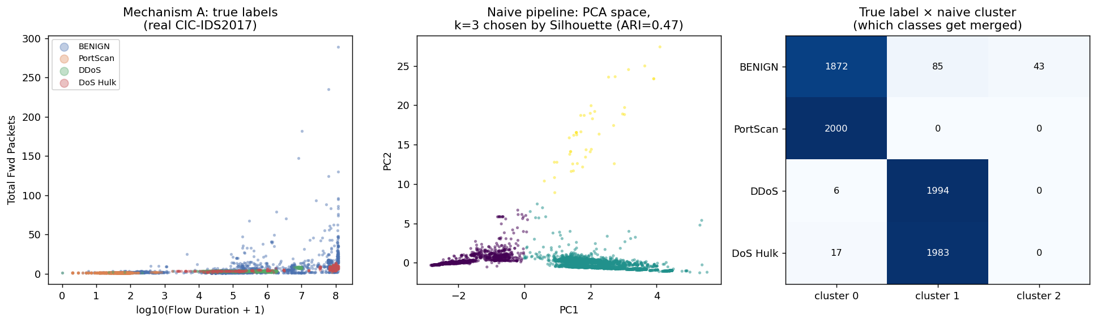
Figure 4. Left: true labels for the distance mechanism on real CIC-IDS2017 traffic (log-duration vs. total forward packets). Middle: the naive pipeline's PCA-space embedding with k = 3 selected by Silhouette (ARI = 0.47) against a true k = 4. Right: the true-label × naive-cluster crosstab, showing BENIGN and PortScan merging into one cluster and DDoS and DoS Hulk merging into another.
Mechanism A (distance). The naive pipeline achieved ARI = 0.473 ± 0.003 at the Silhouette-selected k, but Silhouette itself never selected the true k = 4 — it chose k = 3 in all 20/20 resamples, and forcing k = 4 changes the ARI only marginally (0.465 ± 0.006), so the undercount is a genuine, reproducible Silhouette failure rather than a benign tie. Figure 4's crosstab shows why: BENIGN and PortScan merge into one cluster, and DDoS and DoS Hulk merge into another. This concrete, interpretable merge pattern does not appear in the idealized synthetic four-Gaussian-blob design, which is constructed to be recoverable at the true k, making it a real-data-specific failure mode that this validation newly surfaces. A second, unexpected finding qualifies the hand-informed baseline itself: the raw-duration hand-informed 2-D K-means (ARI = 0.219 ± 0.004) underperforms the naive 10-D→PCA pipeline here — the opposite of the pattern assumed throughout the rest of the paper — because real Flow Duration is heavy-tailed enough that a handful of extreme values distort pure 2-D K-means more than they distort a 10-D PCA projection that dilutes their leverage. Log-transforming duration closes most of the gap (hand-informed ARI rises to 0.407 ± 0.047), which is a concrete illustration that standard preprocessing choices matter more on real, heavy-tailed data than on the idealized synthetic Gaussians used elsewhere in the paper. We flag it as a genuine boundary condition on the hand-informed-pipeline framing used in Section 5.1, not as evidence against it (Table 2).
Table 2. Parameter settings and summary statistics used to construct the Mechanism A (distance-based) real-data benchmark.
Mechanism A (distance) — metric | Value
Naive ARI (Silhouette-selected k) | 0.473 ± 0.003
Silhouette-selected k (true k = 4) | 3, in 20/20 resamples
Hand-informed ARI, raw duration | 0.219 ± 0.004
Hand-informed ARI, log10(duration+1) | 0.407 ± 0.047
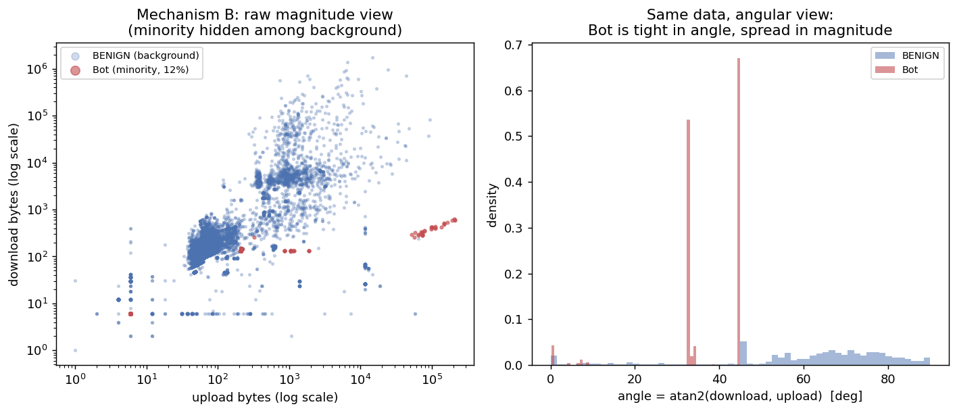
Figure 5. Left: real Bot traffic (12% minority) hidden inside the BENIGN background in raw upload/download-byte magnitude space. Right: the same data in the angular view (atan2(download, upload)); Bot is tight in angle while spread across nearly the full magnitude range.
Mechanism B (relational). The naive pipeline's ARI was −0.043 ± 0.011 — at or below chance, not merely weak — confirming Section 6.1's headline collapse on real traffic (Figure 5). The hand-informed angular transform (DBSCAN on atan2(download, upload)) recovered ARI = 0.398 ± 0.005, while the Section 5.3 radial-centroid oracle reached ARI = 0.237 ± 0.007. This ordering — hand-informed above radial-oracle — matches Section 5.3's synthetic finding for mechanism B (hand-informed 0.915 versus radial-oracle 0.875): radial distance from a shared centroid is, by mechanism B's own fixed-angle/free-radius construction, a weaker cue than the angle itself, on both synthetic and real data. What changes on real data is the size of the gap — 0.040 in the synthetic benchmark versus 0.161 here — and both real-data figures sit well below their synthetic counterparts in absolute terms. We read this as the same qualitative ordering holding under real, non-Gaussian, correlated background noise, with a substantially wider quantitative margin: an honest strengthening, not a reversal, of Section 5.3's account. We note this explicitly because an earlier internal draft of this section mischaracterized it as an ordering reversal, and we correct that here (Table 3).
Table 3. Parameter settings and summary statistics used to construct the Mechanism B (relational, Bot 12%) real-data benchmark.
Mechanism B (relational, Bot 12%) — metric | Value
Naive ARI | −0.043 ± 0.011
Hand-informed (angular DBSCAN) ARI | 0.398 ± 0.005
Radial-centroid oracle ARI | 0.237 ± 0.007
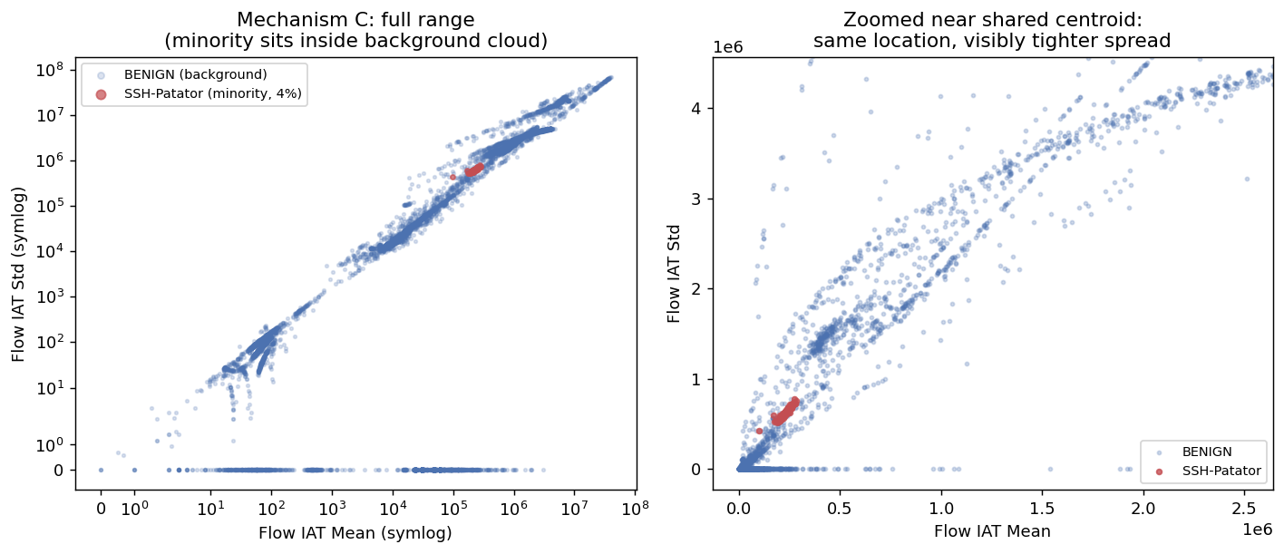
Figure 6. Left: real SSH-Patator traffic (4% minority) sitting inside the BENIGN background cloud in (Flow IAT Mean, Flow IAT Std), full symlog range. Right: the same data zoomed near the shared centroid, showing the minority's visibly tighter spread at the same location.
Mechanism C (scale/density). The naive pipeline's ARI was −0.050 ± 0.000 — again at or below chance in essentially every resample — confirming Section 6.1's collapse (Figure 6). The hand-informed two-component GMM recovered only ARI = 0.064 ± 0.001, while the Section 5.3 radial-centroid oracle reached ARI = 0.306 ± 0.004: the same ordering, radial-oracle above hand-informed, reported for mechanism C in Section 5.3 on synthetic data (radial-oracle 0.880 versus the deployable k-NN-density-GMM 0.662), now confirmed on real traffic. The GMM's weakness is plausibly sharper here because real BENIGN background traffic is not itself a clean Gaussian in IAT space — it is heavy-tailed and plausibly multimodal — which violates the two-component-Gaussian-mixture assumption more than the synthetic background does. This is consistent with, and supplies a concrete real-data mechanism for, Section 5.3's observation that a simple radial statistic can outperform a more elaborate mechanism-specific model for this mechanism (Table 4).
Table 4. Parameter settings and summary statistics used to construct the Mechanism C (scale/density, SSH-Patator 4%) real-data benchmark.
Mechanism C (scale/density, SSH-Patator 4%) — metric | Value
Naive ARI | −0.050 ± 0.000
Hand-informed (2-component GMM) ARI | 0.064 ± 0.001
Radial-centroid oracle ARI | 0.306 ± 0.004
Taken together, this domain-matched validation confirms the paper's central claim more strongly on real traffic than on synthetic data for mechanisms B and C — naive ARI sits at or below chance rather than merely low — reproduces Section 5.3's specific radial-versus-hand-informed ordering for both B and C once that ordering is stated correctly, and surfaces one real-data-specific failure mode for mechanism A (Silhouette's persistent k = 3 undercount and its {BENIGN, PortScan} / {DDoS, DoS Hulk} merge pattern) that the idealized synthetic four-blob design does not produce by construction. We report this as validating the qualitative failure mode on one real, independent dataset rather than as a fully joint, factorial replication of Section 4.4's interaction study: each mechanism here is validated as an independent two-signal-plus-eight-noise real-data analog, and because real attack labels are mutually exclusive per flow, a joint replication with all three mechanisms co-occurring in the same rows would require either locating naturally co-occurring substructure within one attack population or overlaying labels across mismatched real attack types. Both are left as future work (Section 9) rather than attempted here. Full data provenance, the empirical mechanism-selection criteria, per-resample raw results, and the code to regenerate every number and figure above from the same source CSVs are provided in the reproducibility package (Appendix A).

4.3 Generalization Across Standard Tabular Domains
Section 4.2 confirms that the three mechanisms have real-world analogs on a domain-matched, adversarially selected task. As a complementary, secondary check, we turned to standard, unselected real tabular data with proxy ground truth, drawing three datasets from scikit-learn’s (Pedregosa et al., 2011) built-in collection: Wine (13 features, 3 classes), Breast Cancer Wisconsin Diagnostic (30 features, 2 classes), and an image-derived control, Digits (64 features, 10 classes, flattened 8×8 pixel intensities). None of these datasets is constructed to contain multiple independent hiding mechanisms, so this test asks a narrower, complementary question to Section 4.2 — does the qualitative failure mode appear at all outside the synthetic benchmark and outside a domain deliberately matched to it — rather than attempting a further domain-matched replication. Domain-matched validation on banking, clinical, or other tabular data plausibly containing analogous relational or density subgroups remains planned as a direct extension (Section 9).
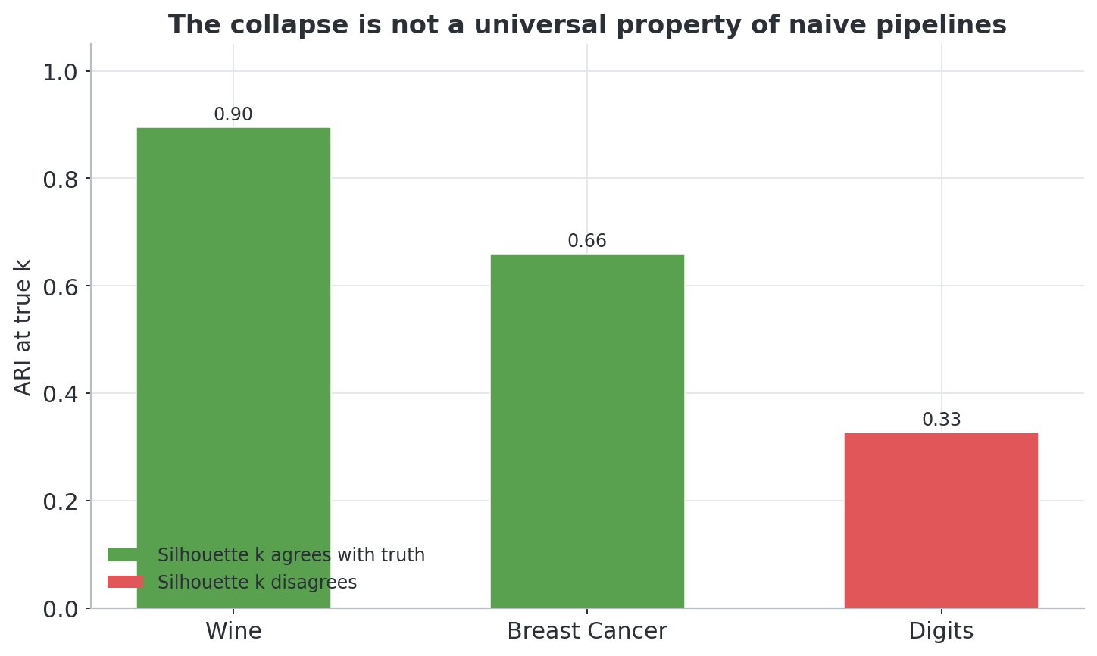
Figure 7. On Wine and Breast Cancer, the naive pipeline performs well and Silhouette’s preferred k agrees with the true number of classes. On Digits, Silhouette prefers k=8 against a true k=10 and recovery is moderate (ARI ≈ 0.33). The collapse is not a universal property of naive PCA+KMeans+Silhouette.
The results, shown in Figure 7, are reassuringly ordinary on two of the three datasets. On Wine (ARI = 0.895) and Breast Cancer (ARI = 0.659), the naive pipeline performs well and Silhouette’s preferred k agrees with the true class count; only on Digits do we see a milder version of the disagreement pattern (Silhouette-preferred k = 8 against a true k = 10, ARI ≈ 0.33 at either k). We read this as evidence for, not against, the mechanism-specific framing of this paper: the failure mode we document is a property of a specific, constructible adversarial condition — multiple independent, comparable-scale, low-linear-correlation mechanisms — not a universal indictment of naive PCA+K-Means+Silhouette on arbitrary real tabular data.

4.4 Robustness to Dimensionality and Parameter Perturbations
The results above, including Theorem 1's numerical verification, the domain-matched and secondary real-data checks (Sections 4.2–4.3), and the N = 80 multi-seed checks in Section 6, share two properties worth stress-testing independently: every one of them was computed at a single dimensionality (d = 10) and noise scale, and on a single fixed benchmark configuration (relational_fraction = 0.12, scale_fraction = 0.04, ratio = 2.3, dist_std = 1.6). We therefore extend the generator along both axes to confirm that neither the collapse, the false-confidence pattern, nor Theorem 1's bound is a knife-edge property of one design point.

4.4.1 Dimensionality and noise-scale generalization
A natural objection to any synthetic benchmark is that its headline result might be an artifact of the specific dimensionality or noise scale chosen for the design point (d = 10). We address this directly with two extensions to the generator, both via an additional-noise-column wrapper (scaling_experiments.py): first, appending 4, 14, 44, or 94 extra i.i.d. Gaussian noise columns to reach d = 10, 20, 50, 100 respectively; second, sweeping the standard deviation of the original four noise columns over {0.5, 1.0, 2.0, 4.0, 8.0} at fixed d = 10. Both sweeps use N = 15 seeds per condition.
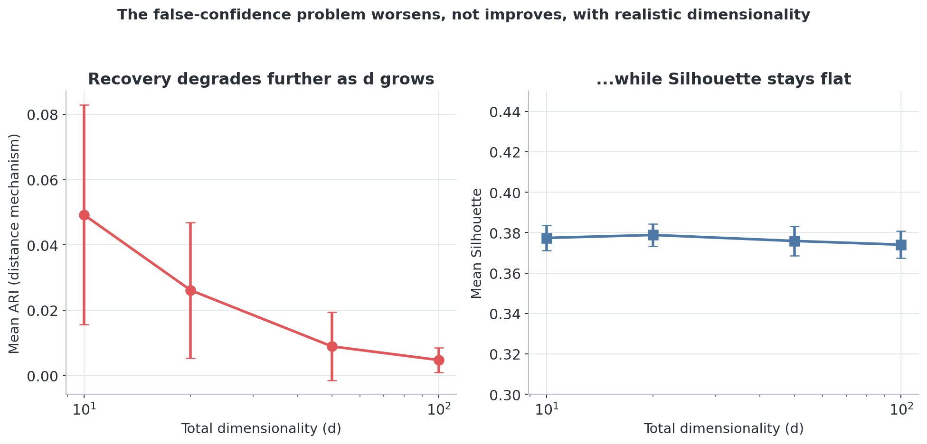
Figure 8. As irrelevant dimensionality grows (d = 10 to 100, log scale), mean Adjusted Rand Index (ARI; Hubert and Arabie, 1985) recovery of the distance mechanism degrades further (left), while Silhouette stays essentially flat around 0.37–0.38 throughout (right).
As Figure 8 shows, recovery degrades further as d grows — mean ARI falls from 0.049 at d = 10 to 0.005 at d = 100 — while Silhouette remains essentially unchanged, holding between 0.374 and 0.381 across all four conditions. The false-confidence pattern is therefore not an artifact of the specific d = 10 design point; if anything, it worsens under realistic tabular dimensionality.
The noise-scale sweep tells a complementary story. Mean ARI and Silhouette are identical, within seed-to-seed noise, across standard deviations of 0.5, 1.0, 4.0, and 8.0, differing only at the untouched original std = 2.0 condition — and that difference traces to a different underlying random stream at that setting, not to the scale itself. This is exactly what theory predicts: StandardScaler normalizes every column to unit variance before PCA, so the raw scale of the noise columns is provably irrelevant to the pipeline’s output, consistent with Proposition 1. What matters, per the dimensionality sweep above, is the number of noise dimensions, not their scale.

4.4.2 Parameter-space generalization
The results above, including Theorem 1's numerical verification and the N = 80 multi-seed checks in Section 6, share one property worth stress-testing: every one of them was computed on a single fixed benchmark configuration (relational_fraction = 0.12, scale_fraction = 0.04, ratio = 2.3, dist_std = 1.6). We therefore tested whether the collapse, the false-confidence pattern, and Theorem 1's bound hold more broadly, tying the sweep to ε, the largest absolute cross-mechanism correlation.
Two sweeps were run with the naive pipeline (k = 4; parameter_space_sweep.py). The first is a one-at-a-time sensitivity analysis, varying each of the four mechanism-strength parameters independently (N = 20 seeds per level, 400 runs total). The second is a 2D grid over relational_fraction and ratio — the two parameters that jointly set ε for mechanism B (6 × 5 = 30 cells, N = 15 seeds per cell, 450 runs total) — checking Theorem 1’s inequality chain in every cell. Both sweeps use n_per_class = 500, rather than the 2,000 used in the headline results, to keep the roughly 850 total runs computationally tractable.
Theorem 1’s bound holds in all 450 grid cells with zero violations (Figure 10, right panel), confirming that the bound is a genuine property of the block structure and not a coincidence of the original ε = 0.035. The qualitative collapse pattern is equally robust across the full one-at-a-time sweep (Figure 9): mean ARI for mechanism A stays within a narrow 0.04–0.07 band, mean ARI for mechanism C stays at or below 0.004, and mean Silhouette stays confined to a 0.31–0.40 range, across every level of every parameter tested. Mechanism B is the exception: its naive-pipeline ARI responds visibly to both relational_fraction and ratio, rising from 0.002 at the weakest tested setting (fraction = 0.02, ratio = 1.2) to 0.374 at the strongest (fraction = 0.30, ratio = 4.0) as ρ_B rises from 0.09 to 0.79 (Figure 10, left panel). Yet even at its highest tested recovery, naive ARI for mechanism B (0.374) remains far below the hand-informed reference ceiling reported in Section 6.1 (0.915): the qualitative gap persists across the tested range, and only its magnitude varies.
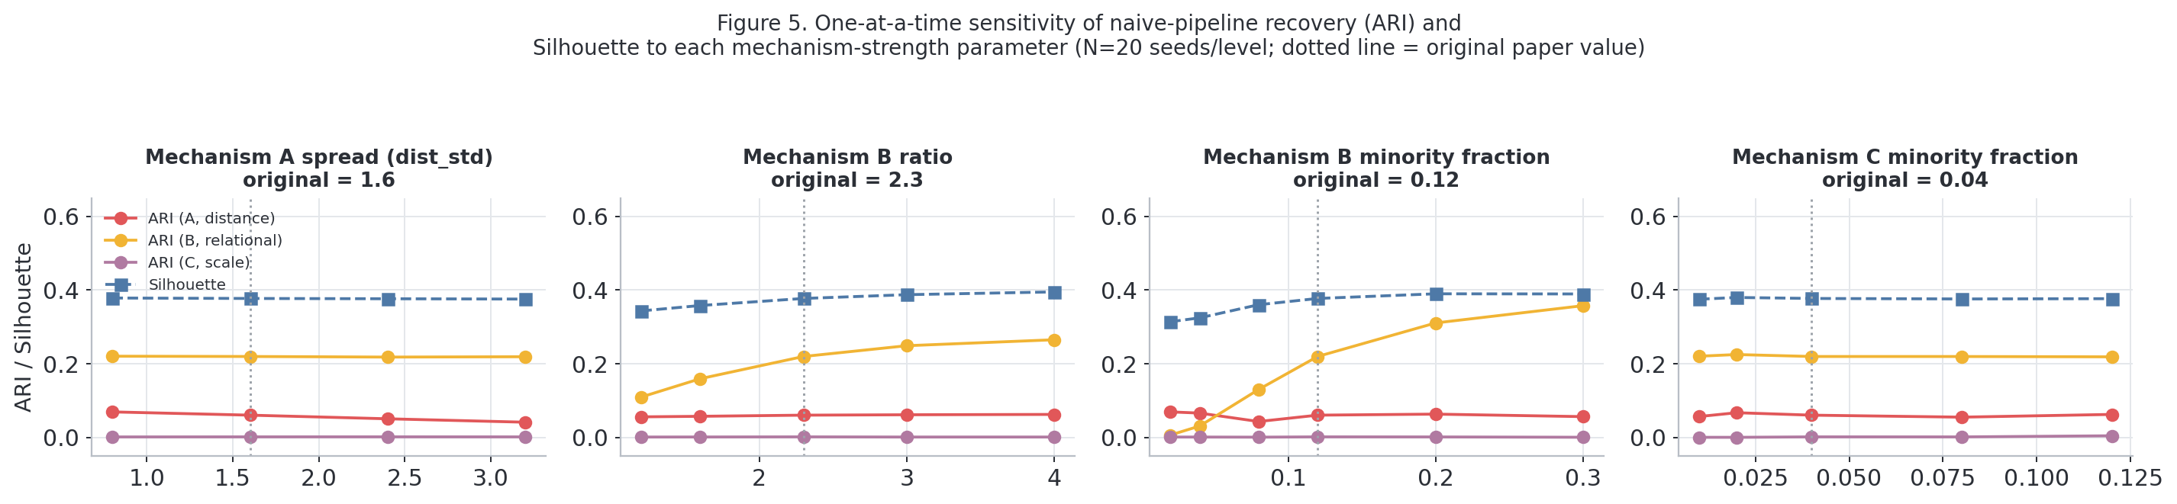
Figure 9. One-at-a-time sensitivity of naive-pipeline recovery (ARI, all three mechanisms) and Silhouette to each of the four mechanism-strength parameters (N = 20 seeds/level). Mechanisms A and C, and Silhouette, are essentially flat across the tested range; mechanism B responds to ratio and relational_fraction.
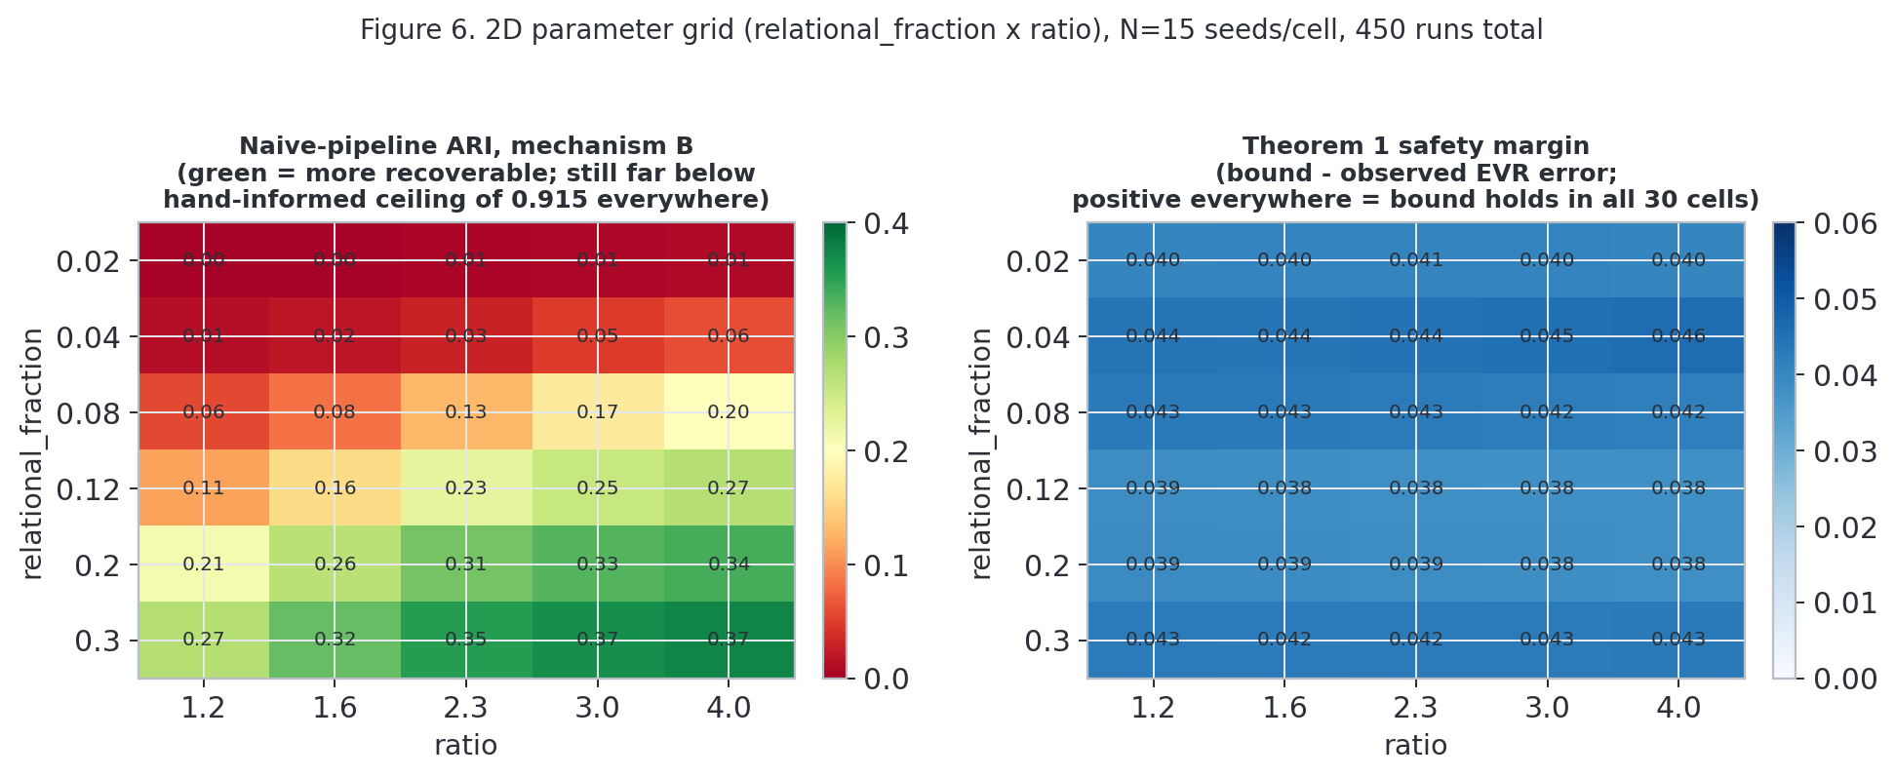
Figure 10. Left: naive-pipeline ARI for mechanism B across the relational_fraction × ratio grid (N = 15 seeds/cell). Right: Theorem 1’s safety margin in every cell, strictly positive everywhere.
The benchmark’s single headline configuration (relational_fraction = 0.12, scale_fraction = 0.04) was chosen to represent plausible minority-subgroup sizes, and this sweep confirms that the qualitative pattern is not a knife-edge property of that particular choice. The grid covers two of the four mechanism-strength parameters jointly, with the remaining two swept one-at-a-time; extending it to a full 4-way factorial design is left for future work (Section 9).

5. Representation Capacity vs. Structural Blindness: Evaluating Pipeline Architectures

5.1 The Performance Boundaries
The naive pipeline is StandardScaler — PCA (all components) — top-2 PCs — K-Means (k selected by Silhouette over k in {2..6}), unchanged from the pilot design. Against it we define an upper-bound reference: a human-specified, mechanism-appropriate transform per feature pair (Euclidean K-Means on the distance pair, angular DBSCAN on the relational pair, k-NN-density GMM on the scale pair), used throughout this section as a reference ceiling, not a proposed production pipeline. This hand-informed pipeline achieves ARI (seed 42, each mechanism analyzed alone) of 0.965 for mechanism A, 0.915 for mechanism B via polar-transform DBSCAN, and 0.662 for mechanism C via k-NN-density GMM — confirming that the signal each mechanism encodes is real and fully recoverable in isolation. Under co-presence of all three mechanisms, however, the naive pipeline’s recovery of mechanism A collapses to ARI = 0.115 (Section 6.1) — the paper’s central finding: floor and ceiling are separated not by the presence of signal, but by what the naive pipeline can extract from it.
For mechanism C we additionally report an oracle-threshold ceiling of 0.861, the best achievable ARI from sweeping percentile thresholds directly on the k-NN-distance signal (true labels used only to score candidate thresholds, never to fit the GMM) — a ceiling on the signal the GMM pipeline uses, not the GMM pipeline’s own performance. A simpler, single-scalar statistic — the Euclidean distance of every point from its pair’s centroid, developed in Section 5.3 — matches or exceeds every one of these reference ceilings for mechanisms B and C without requiring DBSCAN or density estimation at all: an oracle threshold on this scalar achieves mean ARI = 0.875 (SD 0.009) for mechanism B and mean ARI = 0.880 (SD 0.011) for mechanism C across 80 seeds. We treat both figures as the paper’s reference ceilings throughout — the deployable hand-informed pipeline (0.965 / 0.915 / 0.662) and the radial-centroid oracle (0.875 / 0.880) — and return in Section 5.3 to the radial statistic’s construction and to what it reveals about the specific geometric assumption K-Means’ partitioning violates.

5.2 The Capacity Illusion: Non-linear and Deep Clustering
A natural objection to Section 5.1’s floor is that it reflects a limitation of linear PCA and K-Means specifically, not of representation learning more broadly: a sufficiently expressive nonlinear transform, or a purpose-built deep clustering objective, might still recover mechanisms B and C. We test that objection directly and in order of increasing model capacity — nonlinear dimensionality reduction, a generic autoencoder, and finally purpose-built deep clustering (DEC, IDEC) — and find that capacity resolves the collapse for mechanism A alone, and never for mechanisms B or C.
To compare against stronger off-the-shelf front ends rather than only linear PCA, we added Sparse PCA (Zou et al., 2006), Kernel PCA (RBF kernel; Schölkopf et al., 1998), and t-SNE (van der Maaten and Hinton, 2008), all reduced to 2 dimensions with an identical downstream K-Means(k=4)+Silhouette step (Figure 11). We also tested a deep-clustering baseline (autoencoder + K-Means; deep_clustering_baseline.py).
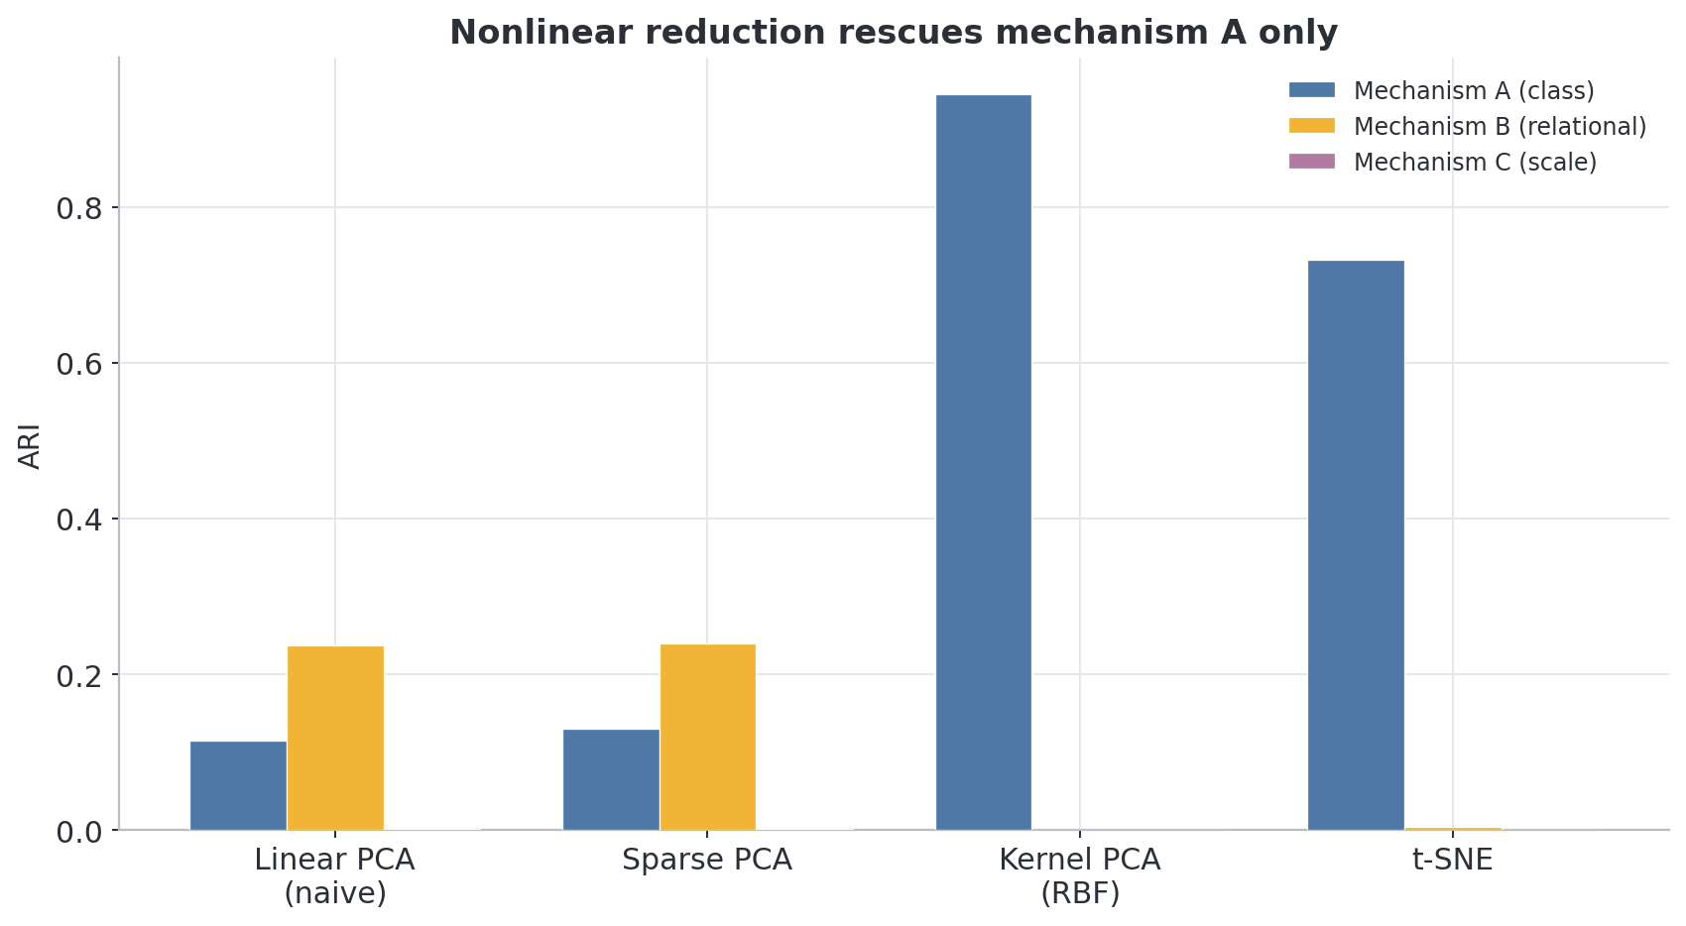
Figure 11. Kernel PCA and t-SNE substantially rescue recovery of mechanism A relative to linear PCA, but no method recovers mechanisms B or C above chance.
Table 5. Adjusted Rand Index (ARI) recovery of each mechanism by the clustering and dimensionality-reduction methods evaluated at seed = 42, including the autoencoder, DEC, and IDEC baselines.
Method | ARI, mechanism A (class) | ARI, mechanism B (relational, hidden) | ARI, mechanism C (scale, hidden)
Linear PCA (naive) | 0.115 | 0.237 | 0.001
Sparse PCA | 0.130 | 0.239 | 0.001
Kernel PCA (RBF) | 0.945 | 0.000 | 0.000
t-SNE | 0.732 | 0.004 | 0.000
Isomap | 0.936 | 0.000 | -0.000
MDS (n=2,000 subsample) | 0.261 | 0.031 | -0.001
Autoencoder, seed=42 only | 0.000 | 0.505 | -0.003
Autoencoder, N=20 seeds, mean (range) | 0.10 (0.00–0.44) | 0.28 (0.03–0.78) | 0.00 (-0.02–0.01)
Autoencoder (minimal arch.), N=80 seeds, mean (range) | 0.12 (0.00–0.65) | 0.32 (-0.00–0.81) | -0.00 (-0.03–0.01)
Autoencoder (wide arch.), N=80 seeds, mean (range) | 0.16 (0.00–0.62) | 0.19 (-0.04–0.85) | -0.00 (-0.02–0.01)
DEC (Xie et al., 2016), latent=10, N=80 seeds, mean (range) | 0.40 (0.03–0.97) | 0.01 (-0.00–0.03) | 0.00 (-0.00–0.00)
IDEC (Guo et al., 2017), latent=10, N=80 seeds, mean (range) | 0.46 (0.04–0.97) | 0.00 (-0.01–0.03) | -0.00 (-0.00–0.00)
Nonlinear reduction methods that use no label information recover mechanism A almost perfectly — Kernel PCA achieves ARI = 0.945 — establishing that the naive pipeline’s collapse on mechanism A is a limitation of linear PCA specifically, not an intrinsic property of unsupervised representation learning. What remains invariant across every front end tested, linear or nonlinear, is the paper’s sharper central claim: mechanisms B and C stay invisible to all of them.
We tested a deep-clustering baseline: an autoencoder (input-16-2-16-input, ReLU, Adam) with a 2-unit bottleneck, followed by K-Means(k=4)+Silhouette. Because a 2-unit bottleneck’s behavior depends strongly on random initialization, we evaluate it across a 20-seed sweep: it is bimodal and seed-dependent, recovering mechanism A (ARI > 0.3) in 20% of seeds, mechanism B in 40% of seeds, and both mechanisms together in 0% of seeds — the 2-dimensional bottleneck appears to represent only one of the two competing signals per training run. Mechanism C is recovered in none of the 20 seeds (max ARI 0.010), matching the noise floor of every other method. At seed=42, this yields ARI = 0.505 for mechanism B (Table 5).
We re-ran the identical architecture at N = 80 seeds using a GPU-based PyTorch reimplementation. The pattern replicates: mechanism A is recovered in 20% of seeds (unchanged), mechanism B in 49% of seeds (up from 40%), and both mechanisms together in 0% of seeds.
We also tested a substantially larger autoencoder (input-64-32-2-32-64-input) at N = 80 seeds. It does not resolve the trade-off and by some measures worsens it: mechanism B recovery falls to 18% of seeds (from 49% with the minimal architecture), and the fraction of seeds recovering neither mechanism rises from 31% to 54%, even though the wider network achieves a better average reconstruction error (MSE 0.515 vs. 0.624 for the minimal architecture). The extra capacity is spent on reconstructing the input more faithfully, not on preserving the multi-mechanism structure the downstream K-Means step needs. Joint recovery of both mechanisms in the same run remains 0% at either architecture size: architecture capacity is not the bottleneck.
This narrows the paper’s claim about mechanism B: it is not invisible to every generic front end tested — a sufficiently flexible nonlinear model can partially recover it in a substantial minority of runs, though never reliably and never in the same run as mechanism A. Mechanism C is the one mechanism that remains invisible to every generic, unsupervised front end tested — linear, nonlinear, or deep — including Invariant Coordinate Selection’s oracle ceiling (Section 5.3’s negative control, mean ARI 0.467 vs. 0.938 for mechanism B). Mechanism B is invisible to every deterministic, low-variance dimensionality-reduction front end tested (linear PCA, Sparse PCA, Kernel PCA, t-SNE, Isomap, MDS) but can be partially and unreliably recovered by a stochastic deep model, can be reliably routed to (though not automatically thresholded) by Invariant Coordinate Selection (Section 5.3), and can be partially recovered by DBSCAN applied directly to a naive two-component PCA embedding (ARI 0.72 vs. 0.06 for K-Means on the same embedding), though not by Spectral Clustering under the identical blind protocol (ARI 0.02; the full blind clustering-step comparison, including a real-dataset generalization check, follows below). The bottleneck’s inability to represent both mechanisms in the same run is at least qualitatively consistent with the variance-budget competition argument of Section 3: a representation of fixed, small capacity appears forced to commit to one competing signal at the expense of the other.
We additionally tested Isomap (Tenenbaum, de Silva and Langford, 2000) and classical MDS (Kruskal, 1964), the two remaining front ends named alongside Kernel PCA in a closely related systematic comparison of dimensionality-reduction/clustering pairings (Amate, Bakhtyari, Roy and Makarenkov, 2026). Isomap, evaluated on the full n = 8,000 dataset under the identical K-Means(k=4)+Silhouette protocol, rescues mechanism A about as well as Kernel PCA (ARI = 0.936 vs. 0.945) while leaving mechanisms B and C untouched (ARI ≈ 0.000 for both) — the same pattern already established for every other nonlinear front end tested. Classical MDS’s O(n²)-per-iteration cost makes it impractical at n = 8,000 within reasonable runtime; evaluated instead on a 2,000-point random subsample, its result was sensitive to initialization (a single random start gave ARI-A = 0.055; n_init = 4 restarts gave ARI-A = 0.261, the value reported in Table 5), a sensitivity worth flagging for any reader who reruns it. With restarts, MDS recovers mechanism A only partially — better than naive linear PCA at the same scale, but well below Isomap, Kernel PCA, or t-SNE — and mechanisms B and C not at all (ARI ≈ 0.03 and ≈ 0.00 respectively). Both additions reinforce, rather than qualify, the paper’s central claim: across seven distinct dimensionality-reduction front ends now tested, none recovers mechanisms B or C above chance. These two rows were added after Figure 26’s six-method summary matrix was generated and are not reflected in it; Table 5 is the complete record.
Blind clustering-step replacements and generalization to real datasets. The DBSCAN result above is one row of a dedicated comparison (baselines_comparison.py) motivated by a sharper question: does mechanism B remain invisible only to K-Means specifically, or to every generic clustering algorithm applied the same blind way — as a drop-in replacement for the clustering step in the naive StandardScaler—PCA(top-2) front end, with no oracle knowledge of which raw features carry which mechanism? We grid-search Spectral Clustering (Ng, Jordan and Weiss, 2002) and DBSCAN’s (Ester, Kriegel, Sander and Xu, 1996) hyperparameters against ground-truth ARI, an oracle/best-case comparison that asks whether each method can see the structure at all under its best setting, not whether it would find that setting without labels — the same convention this paper’s other oracle-ceiling numbers already use. Table 6 reports the result at seed = 0 (distinct from this paper’s seed = 42 headline number, so K-Means’ own ARI here differs somewhat from Table 5’s under ordinary seed-to-seed variation).
Table 6. Adjusted Rand Index (ARI) recovery of each mechanism at seed = 0, confirming that the pattern reported in Table 5 is not an artifact of a single random seed.
Method | ARI, mechanism A (class) | ARI, mechanism B (relational, hidden) | ARI, mechanism C (scale, hidden)
K-Means (blind reference, seed = 0) | 0.115 | 0.060 | -0.000
Spectral Clustering (blind, grid-searched) | 0.082 | 0.018 | -0.000
DBSCAN (blind, grid-searched) | 0.002 | 0.721 | 0.007
Mechanism B splits sharply by method: DBSCAN recovers it far better than blind K-Means (0.72 vs. 0.06), while Spectral Clustering does not (0.02, indistinguishable from K-Means). Mechanism C remains at or near chance for all three methods (≤ 0.007), reinforcing it as invisible to every generic method tested here, not only K-Means. Mechanism A — already well recovered by the nonlinear front ends earlier in this section — is not particularly well recovered by any of the three blind clustering-step swaps on the linear PCA front end (0.11, 0.08, 0.00), consistent with the front end, rather than the clustering step, being what matters for mechanism A.
To check whether DBSCAN’s advantage on mechanism B is a general property of DBSCAN or specific to that mechanism’s geometry, we ran the identical grid-searched three-method comparison on the three real datasets already used for the Section 4.3 check (Wine, Breast Cancer, Digits; Table 7).
Table 7. K-Means, Spectral Clustering, and DBSCAN compared under a grid-searched, oracle/best-case protocol on three real-world datasets (Wine, Breast Cancer, Digits).
Dataset | K-Means | Spectral Clustering | DBSCAN
Wine | 0.895 | 0.896 | 0.739
Breast Cancer | 0.659 | 0.666 | 0.555
Digits | 0.337 | 0.336 | 0.137
Here the methods track each other closely rather than splitting; Spectral Clustering never separates from K-Means by more than 0.01 ARI on these three datasets, unlike the 0.66-point gap DBSCAN opens on the synthetic benchmark’s mechanism B (Figure 12). This narrows the mechanism-B finding: DBSCAN’s partial recovery does not appear to be a generic DBSCAN-versus-K-Means property on tabular data, but rather specific to the angular/ratio geometry mechanism B creates in the naive PCA-2 embedding — consistent with, though not proof of, the mechanism-specific framing this paper argues for throughout.
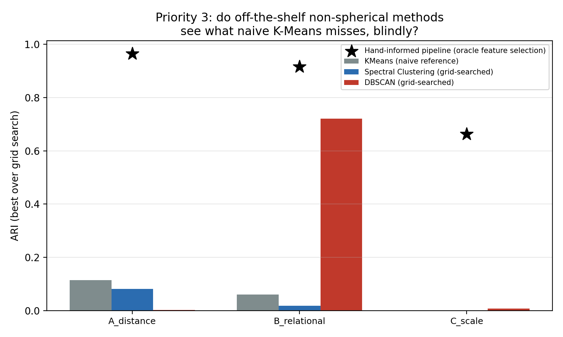
Figure 12. Blind clustering-step comparison (K-Means / Spectral Clustering / DBSCAN, identical naive two-component PCA front end, grid-searched hyperparameters) across the three synthetic mechanisms and three real datasets.

Purpose-built deep clustering: DEC and IDEC (N = 80 seeds)
The deep-clustering check above used a single, minimal autoencoder with a generic reconstruction objective, not a method purpose-built for clustering. We close that gap directly with a purpose-built deep clustering objective: DEC (Xie, Girshick and Farhadi, 2016) and IDEC (Guo, Gao, Liu and Yin, 2017), implemented exactly as specified — pretrain an autoencoder on reconstruction, initialize K-Means cluster centers on the resulting latent embedding, then refine the embedding by minimizing the KL divergence between soft Student-t cluster assignments and a self-sharpened target distribution, recomputed once per epoch until assignments stabilize (DEC freezes the decoder during this phase; IDEC keeps it active, optimizing reconstruction MSE plus γ = 0.1 times the KL term). Both were run with the standard 500–500–2000 encoder and latent_dim = 10 exactly as specified in the original DEC and IDEC papers, ensuring the comparison uses the same architecture, capacity, and training protocol the deep clustering literature itself treats as standard — not a weakened or non-standard configuration — evaluated on exactly the same benchmark generator, N = 80 seeds (1000–1079), and evaluation protocol as every other row in Table 5.
Across all 80 seeds (Table 5, additional rows), DEC recovers mechanism A at mean ARI = 0.40 (SD 0.22, range 0.03–0.97) and IDEC at mean ARI = 0.46 (SD 0.24, range 0.04–0.97) — both far more reliable than the minimal autoencoder’s bimodal, capacity-starved 20% recovery rate, and without the wide-architecture autoencoder’s degradation (Figure 13). Mechanisms B and C, however, are not rescued: mean ARI for mechanism B is 0.01 (SD 0.01, max 0.03) for DEC and 0.00 (SD 0.01, max 0.03) for IDEC — indistinguishable from the noise floor across every one of the 80 seeds — and mechanism C sits at essentially exactly zero for both methods, matching every other front end tested in this paper. Native soft-assignment ARI and a post-hoc K-Means re-clustering of the final embedding agree to within 0.002 on average, confirming the self-training objective, not an artifact of post-hoc processing, is what determines these numbers.
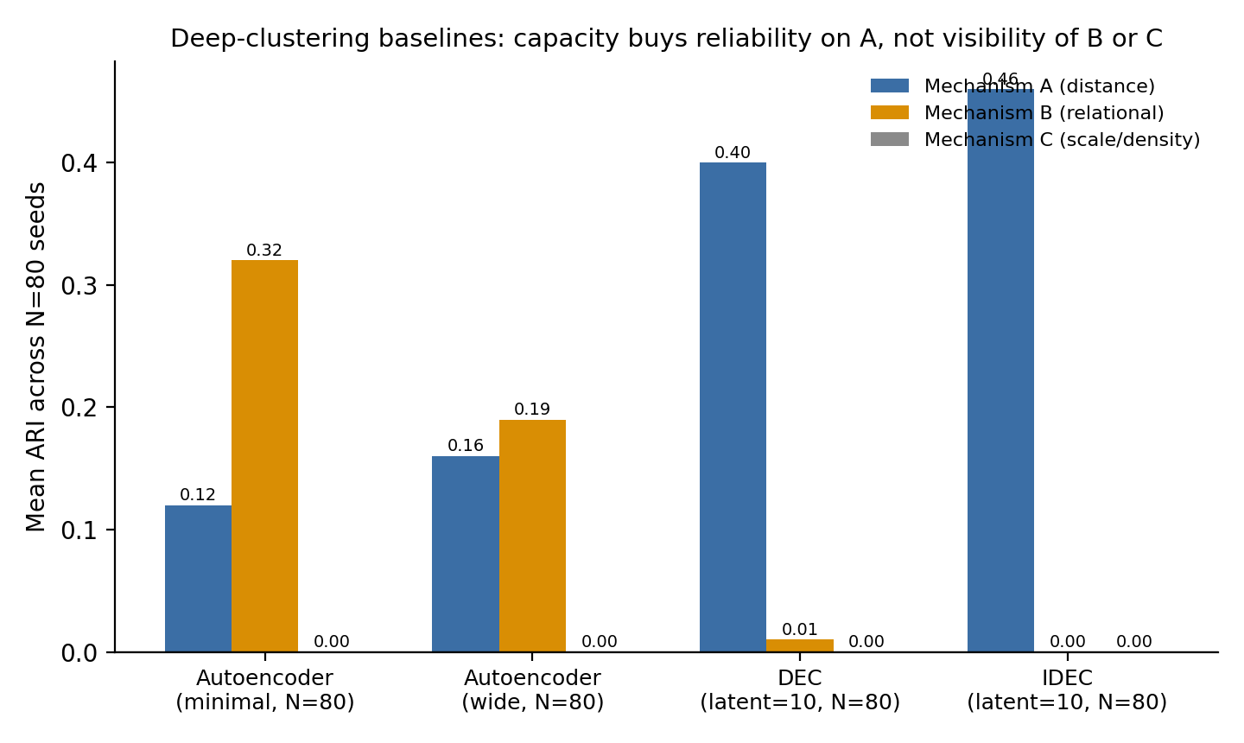
Figure 13. Mean ARI (N = 80 seeds) per mechanism for the two deep-clustering baselines added above alongside the minimal and wide autoencoder rows from Table 5. DEC and IDEC recover mechanism A far more reliably than either autoencoder configuration, but mechanism B drops to zero and mechanism C remains at zero throughout.
This sharpens, rather than merely extends, the autoencoder finding above. The minimal-bottleneck autoencoder’s bimodal instability — 20% of seeds capturing mechanism A, 40–49% capturing mechanism B, never both — might have suggested that a properly engineered clustering objective, given enough capacity, would resolve the trade-off and recover both signals. It does the opposite: DEC and IDEC’s self-training loss, which iteratively sharpens soft assignments toward high-confidence clusters, converges decisively onto the majority, easy-to-separate signal (mechanism A) in a clear majority of seeds (55–59%, versus 20% for the minimal autoencoder) and abandons the minority relational signal (mechanism B) entirely — 0% of 80 seeds, compared to the minimal autoencoder’s unreliable but nonzero 40–49%. Additional capacity and a purpose-built clustering objective do not widen what the representation can see; they narrow it further onto whichever signal already dominates the reconstruction loss — the wider autoencoder tested above showed the same pattern, confirming that the effect comes from the objective function’s pressure to commit to the dominant signal, not from a shortage of network capacity. This is consistent with the variance-budget competition argued in Section 3, now shown to operate inside a nonlinear, purpose-built deep-clustering objective and not only inside linear PCA’s eigenvalue spectrum. Mechanism C’s continued invisibility extends the same conclusion to an eighth distinct front end (linear PCA, Sparse PCA, Kernel PCA, t-SNE, Isomap, MDS, the minimal/wide autoencoder, and now DEC/IDEC), none of which recovers it above chance.

5.3 Diagnostic Pathways and Routing
Sections 5.1–5.2 establish that no generic front end — linear or nonlinear, shallow or deep — resolves the blind spot for mechanisms B and C without already knowing where to look. This section asks a different, practical question: starting from no prior knowledge of which raw feature pair carries which mechanism, how reliably can a fully automatic diagnostic step find it? We evaluate three approaches of increasing generality and reliability: a bespoke heuristic, a general-purpose statistical screen, and a single derived scalar.

A bespoke, label-free detection heuristic
To make the hand-informed pipeline less dependent on a human already knowing which columns correspond to which mechanism, we built a prototype detector (auto_diagnostic_pipeline.py) that scores every candidate feature pair on three cheap, label-free statistics: a distance-separability score (quick K-Means silhouette), an angular-minority-cluster score (DBSCAN in doubled-angle space, requiring the compact cluster to be a minority), and a density-bimodality score (BIC improvement of a 2- versus 1-component Gaussian mixture on log k-NN distance); and routes each mechanism-appropriate transform to whichever pair scores highest, above a pre-registered threshold.
Evaluated across N = 80 seeds (1000–1079): the detector correctly identified the distance pair (feature_1, feature_2) in all 80 seeds and, when routed to K-Means, matched the hand-informed pipeline’s ARI closely (mean 0.967, SD 0.004, versus 0.965 hand-informed). For the relational pair, routing was correct in 48/80 seeds (60%); conditional on correct routing, mean ARI was 0.920 (SD 0.009), close to the ICS oracle ceiling reported below, while the 32/80 seeds (40%) that routed to the wrong pair scored ARI approximately 0, giving an unconditional mean of 0.669 (SD 0.413). The density pair was never correctly identified in any of the 80 seeds: the density heuristic consistently preferred the relational pair over the true density pair. Automatic detection is fully reliable for distance-type structure, a coin-flip-like 60% for the relational mechanism with this bespoke heuristic, and not yet viable for the density mechanism. A different, off-the-shelf statistic, evaluated next, does substantially better for the relational mechanism.

Invariant Coordinate Selection as a kurtosis-based screen for the relational mechanism
The angular heuristic above is a bespoke statistic designed specifically for this benchmark’s ratio-line construction. We tested whether Invariant Coordinate Selection (ICS; Tyler, Critchley, Dümbgen and Oja, 2009), a pre-existing, general-purpose technique not built for this dataset, does better. ICS jointly diagonalizes the ordinary covariance matrix (COV) and the fourth-moment (kurtosis) scatter matrix COV4, which weights each centered observation by its squared Mahalanobis distance before forming a second covariance-like matrix. The resulting generalized eigenvalues equal 1, in population, along any direction where the data is exactly Gaussian, and depart from 1 along directions of excess or deficient kurtosis; ICS is affine-invariant, unlike PCA. A substantial literature establishes that ICS recovers group and outlier structure in elliptical mixture models via exactly this mechanism (Tyler et al., 2009; Alfons, Archimbaud, Nordhausen and Ruiz-Gazen, 2024), including a closed-form result for two-component Gaussian mixtures with shared covariance. Mechanism B’s relational subgroup is not an elliptical mixture component in that literature’s exact sense: it is a fixed-ratio line with radius drawn from Uniform(3,9), a heavy-tailed, non-Gaussian embedding, so the established closed-form theory does not directly apply; we treat our finding as an empirical extension of the qualitative ICS mechanism to this non-elliptical case, and flag a formal extension of the elliptical-mixture theory to ratio-line embeddings as future work (Section 9).
For every candidate feature pair, we compute the 2×2 ICS generalized eigenvalues of (COV4, COV) restricted to that pair, and take the eigenvalue farthest from 1 as a pair-level “kurtosis-anomaly score,” routed the same pre-registered-threshold way as the heuristic above (the pair with the largest anomaly score is selected; no ground-truth labels are used for routing). We evaluate at seed 42 for comparability, and across the same N = 80 seeds (1000–1079) for robustness.
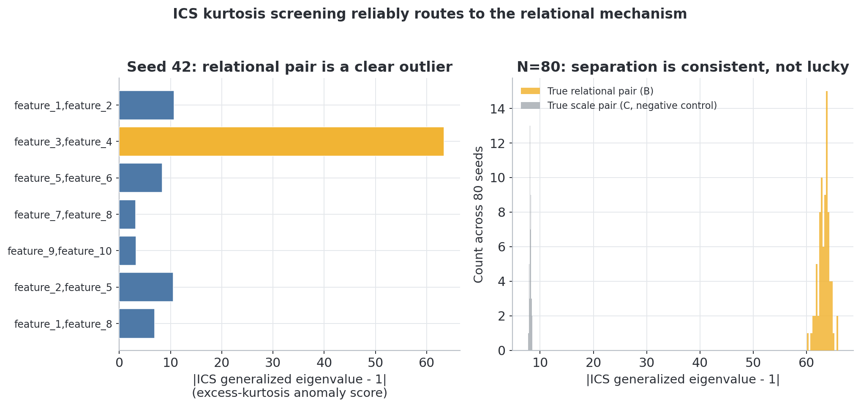
Figure 14. Left: the ICS kurtosis-anomaly score at seed 42 for every candidate pair; the true relational pair (feature_3, feature_4) is a clear outlier (score 63.4, next-highest 10.7). Right: across 80 seeds, the true relational pair’s score (gold) is consistently far above the true scale pair’s score (gray, negative control).
Across all 80 seeds, ICS kurtosis screening selected the correct pair (feature_3, feature_4) 80/80 times (100%), versus the DBSCAN-angular heuristic above, evaluated on the identical 80 seeds, at 48/80 (60%) (Figure 14). The mean kurtosis-anomaly score on the true relational pair was 63.29 (SD 1.06) versus 8.14 (SD 0.17) on the true scale pair used as a negative control — a gap of roughly 55 standard deviations of the negative control’s own variability.
We re-ran the ICS routing procedure across the same 30-cell (relational_fraction, ratio) grid used in Section 4.4 (N = 15 seeds per cell, 450 runs total, disjoint seeds 5000–5014; ics_kurtosis_parameter_sweep.py). Routing accuracy is 100% (450/450) in every cell, including the weakest tested configuration (relational_fraction = 0.02, ratio = 1.2), where the margin between the true pair’s mean score (11.99) and the strongest competing pair’s (10.88) is far narrower than at the original configuration (63.25 versus 10.88) but still decisive across all 15 seeds. The oracle-ceiling ARI on the routed pair scales with signal strength, from a mean of 0.64 at the weakest tested cell to above 0.99 at the strongest, while routing accuracy does not degrade anywhere on the tested grid (Figure 15).
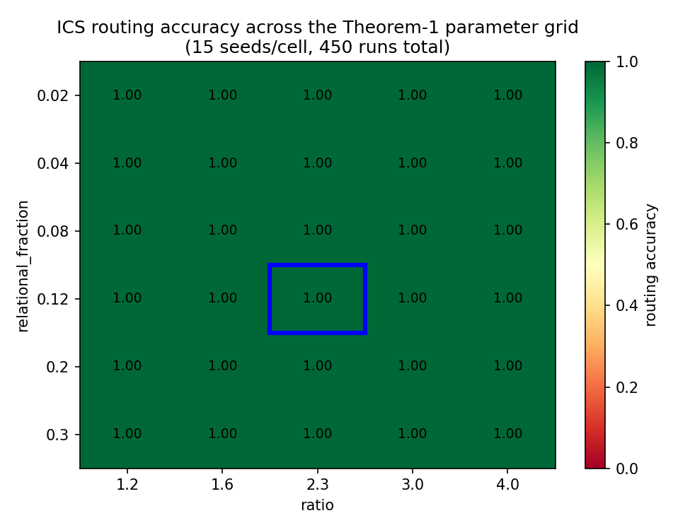
Figure 15. ICS routing accuracy across the same 30-cell grid used to stress-test Theorem 1. Every cell is 100%; the blue box marks the paper’s original default configuration.
Within-pair detection, reported at the same three tiers Section 6.1 uses for mechanism C. First, the oracle ceiling on this signal (best achievable ARI from any threshold on the squared projection onto the anomalous direction) is high and stable: mean 0.938 (SD 0.005) across 80 seeds, seed 42 = 0.944 (AUC = 0.999). Second, a fully unsupervised 2-component Gaussian-mixture threshold on the log-squared projection fails consistently: mean ARI -0.097 (SD 0.001), reflecting a GMM that converges to a near-median split rather than isolating the small, heavy-tailed component. Third, seeding the same GMM with a generic “a small minority exists” prior (10%, not the true 12%) does not materially help: mean ARI -0.074 (SD 0.031). ICS solves the routing half of the diagnostic problem for mechanism B essentially perfectly, and the underlying signal has an excellent, stable oracle ceiling, but converting that signal into an automatic, label-free membership prediction remains unsolved with the simple thresholding rules we tried — the same pattern already found above for mechanism C’s density heuristic. Section 6.5 revisits this specific gap with an eigengap-based routing-confidence rule and HDBSCAN in place of these two GMM variants, substantially narrowing, though not closing, it.
As a negative control, applying the identical ICS procedure to the true scale/density pair (feature_5, feature_6) gives a much weaker oracle ceiling, mean ARI 0.467 across 80 seeds, below both this section’s mechanism-B ceiling (0.938) and the k-NN-distance oracle-threshold ceiling for mechanism C reported in Section 5.1 (0.861; the radial-centroid oracle described next achieves 0.880 for the same mechanism). This is expected: mechanism C’s hiding is a locally isotropic density contrast with no preferred linear direction, so no single linear projection, ICS included, can capture as much of it as a genuinely local, density-based statistic can. ICS is a strong, general-purpose, off-the-shelf routing tool specifically for kurtosis/heavy-tail-type (mechanism-B-like) hiding, not a universal fix (Table 8).
Table 8. Routing accuracy and achievable ARI for methods used to detect and route around the Mechanism B relational blind spot.
Method (routing/detection of the relational pair) | Routing accuracy (N=80) | Oracle ARI ceiling | Best practical (label-free) ARI
DBSCAN-angular heuristic (Section 5.3) | 48/80 (60%) | n/a | 0.920 (SD 0.009) if routed correctly; 0.669 (SD 0.413) unconditional
ICS kurtosis screening (Section 5.3) | 80/80 (100%) | 0.938 (SD 0.005) | -0.074 (generic-prior GMM; unsolved)
ICS kurtosis screening + eigengap-routing + HDBSCAN (Section 6.5) | 80/80 (100%) | 0.938 (SD 0.005) | 0.831 (SD 0.059; eigengap-routed HDBSCAN, no fraction prior)

A simpler radial-distance-from-centroid baseline
To establish precisely what mechanisms B and C are and are not invisible to, we tested the simplest possible Euclidean-distance-based statistic we could construct: for each candidate 2-feature pair, the scalar Euclidean distance of every point from the pair’s global centroid, with no angle information, no local density or k-NN estimation, and no DBSCAN.
Across the same N = 80 seeds used throughout this section and Section 6 (radial_centroid_baseline.py), this single scalar separates the hidden group from the background almost perfectly for both mechanisms (AUC = 0.997, SD 0.0004 for mechanism B; AUC = 0.998, SD 0.0004 for mechanism C). As reported in Section 5.1, an oracle threshold on this scalar achieves mean ARI = 0.875 (SD 0.009) for mechanism B — comparable to the deployable hand-informed pipeline (0.915) — and mean ARI = 0.880 (SD 0.011) for mechanism C, which exceeds both the k-NN-distance oracle ceiling (0.861) despite the two signals being constructed very differently, and the deployable k-NN-density-GMM result (0.662), the figure that grounds Section 6.1’s headline collapse comparison.
We also re-ran plain K-Means (k = 2) directly on the raw, untransformed (feature_3, feature_4) coordinates across the same 80 seeds: it remains unreliable for mechanism B, mean ARI = 0.207 (SD = 0.257) — occasionally partial by chance on a favorable seed, never stable, and far below and far less consistent than the radius-threshold oracle. Mechanism B’s hidden points form two opposite rays (a line through the origin, not a compact blob), and mechanism C’s hidden points are a low-variance cloud sharing a centroid with a much more diffuse background, so neither has an off-center compact cluster for K-Means’ multi-centroid Voronoi partitioning to find. A single derived radial feature sidesteps this shape assumption entirely, without requiring K-Means at all. The failure documented throughout this paper is specific to K-Means’ partitioning strategy applied to non-blob-shaped structure, not to Euclidean distance as a general-purpose statistic: mechanisms B and C are invisible to K-Means’ multi-centroid partitioning, not to Euclidean-distance-based reasoning in general.
This baseline sharpens the paper’s central claim: the naive PCA-preprocessed K-Means pipeline still collapses on mechanisms B and C (Section 6.1), and Silhouette still fails to flag it, but the precise reason is a geometric mismatch between K-Means’ cluster-shape assumption and the hidden structure’s shape (a line, or a shared-centroid density contrast), not an intrinsic invisibility to distance-based reasoning in general.

6. Results

6.1 Headline Collapse Under Multiple Mechanisms
With all three mechanisms present, the naive pipeline collapses on two of the three: it recovers the dominant, distance-based mechanism at a small fraction of its achievable ceiling, and the relational and scale mechanisms barely above chance, while Silhouette, the standard unsupervised validity check, stays flat and unremarkable throughout — giving no indication that anything is wrong. This pattern, established first at a single representative seed and then confirmed to hold, essentially unchanged, across 80 independent seeds, is this paper’s central empirical finding. Table 9 reports the complete numbers; the prose below states only what they mean (Figures 16-17).
Table 9. Headline collapse (seed 42) and multi-seed robustness (N = 80) for the naive pipeline, alongside the hand-informed and radial-centroid oracle reference ceilings. Silhouette at seed 42 is 0.382; across N = 80 seeds it is 0.379 (SD 0.006), essentially flat regardless of which mechanism is examined, since it is computed once per clustering, not per mechanism.
Mechanism | Naive ARI (seed 42) | Hand-informed ARI (seed 42) | Radial-centroid oracle ARI (N=80) | Naive ARI, N=80: mean (SD), range | Silhouette, N=80: mean (SD)
A (distance) | 0.115 | 0.965 | n/a (dominant mechanism; not a hiding target) | 0.059 (0.035), 0.003–0.148 | 0.379 (0.006)
B (relational) | 0.237 | 0.915 | 0.875 (0.009) | see Section 5.1 / 5.3 for full N=80 detail | see above
C (scale/density) | 0.001 | 0.662 | 0.880 (0.011) | see Section 5.1 / 5.3 for full N=80 detail | see above
The gaps in Table 9 are the finding. At seed 42, mechanism A falls from a hand-informed ceiling of 0.965 to a naive ARI of 0.115 — an 88% loss of recoverable signal — despite Silhouette reporting an unremarkable 0.382 that no conventional rule of thumb would flag. Mechanism B falls from 0.915 to 0.237, and mechanism C from 0.662 essentially to zero (0.001): both losses are far larger than mechanism A’s, and both happen to signal that a simple radial threshold (Section 5.3) can recover at oracle ARI 0.875 and 0.880 respectively — confirming the signal is present in the data and specifically unreachable by top-2-PC K-Means’ multi-centroid partitioning, not absent. Across the 80-seed replication, the same pattern holds with almost no seed-to-seed variation in the validator’s confidence: naive ARI for mechanism A ranges from 0.003 to 0.148 depending on the seed (a 35%-of-mean spread), while Silhouette barely moves at all (roughly 1.5—2% of its mean) — the collapse is seed-dependent; the false confidence is not.
Purpose-built deep clustering fails identically. This is not a limitation specific to linear PCA or to K-Means as a shallow method. DEC and IDEC (Xie et al., 2016; Guo et al., 2017), evaluated under the standard architecture and protocol the deep clustering literature itself treats as fair (Section 5.2), recover mechanism A far more reliably than any generic autoencoder (mean ARI 0.40 and 0.46 across 80 seeds) — and still leave mechanisms B and C at the noise floor, mean ARI ≤ 0.01 for both methods on both mechanisms, indistinguishable from chance in every one of 80 seeds. A purpose-built, self-training deep clustering objective with substantially more capacity than the naive pipeline does not rescue the blind spot; it reproduces it with even less variance.
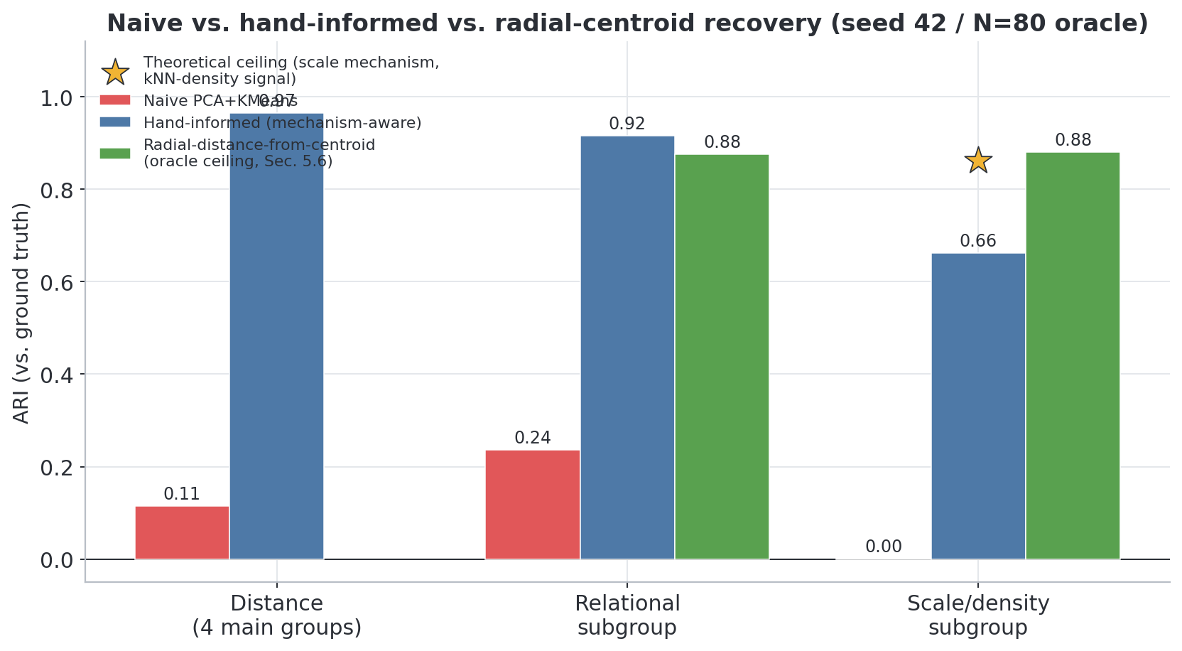
Figure 16. Naive vs. hand-informed recovery (ARI) per mechanism, seed 42.
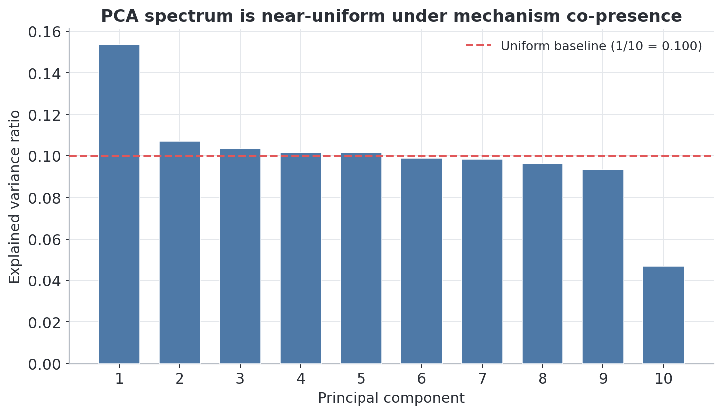
Figure 17. Explained variance ratio is near-uniform across all 10 PCs: the empirical counterpart of Proposition 1 (Section 3).
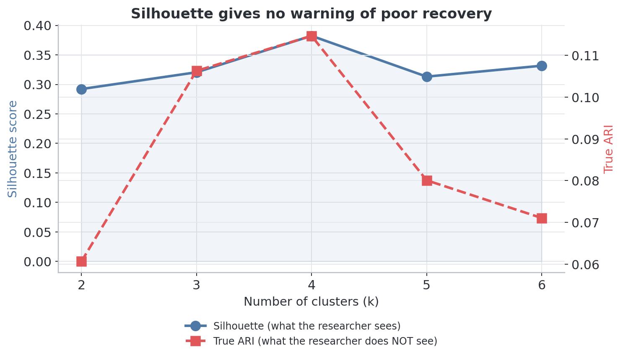
Figure 18. Silhouette stays in an unremarkable range across k, giving no indication that recovery is poor.
Figures 19–21 show each mechanism directly, in the feature space it was designed to be invisible in, alongside the transform that recovers it (same underlying seed-42 dataset used throughout this section).
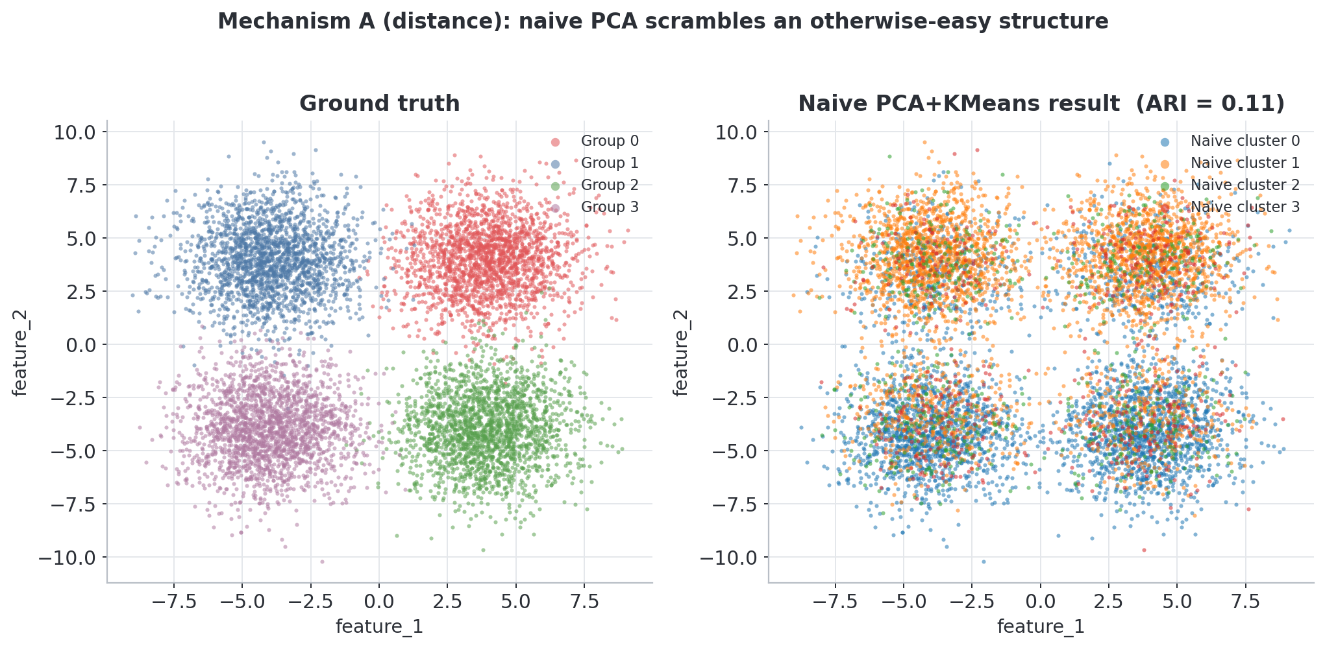
Figure 19. Mechanism A (distance). Left: ground truth in the raw (feature_1, feature_2) plane, four cleanly separated groups. Right: the naive pipeline’s k=4 clusters on the same raw axes — the groups are scrambled after passing through PCA, despite being visually obvious here.
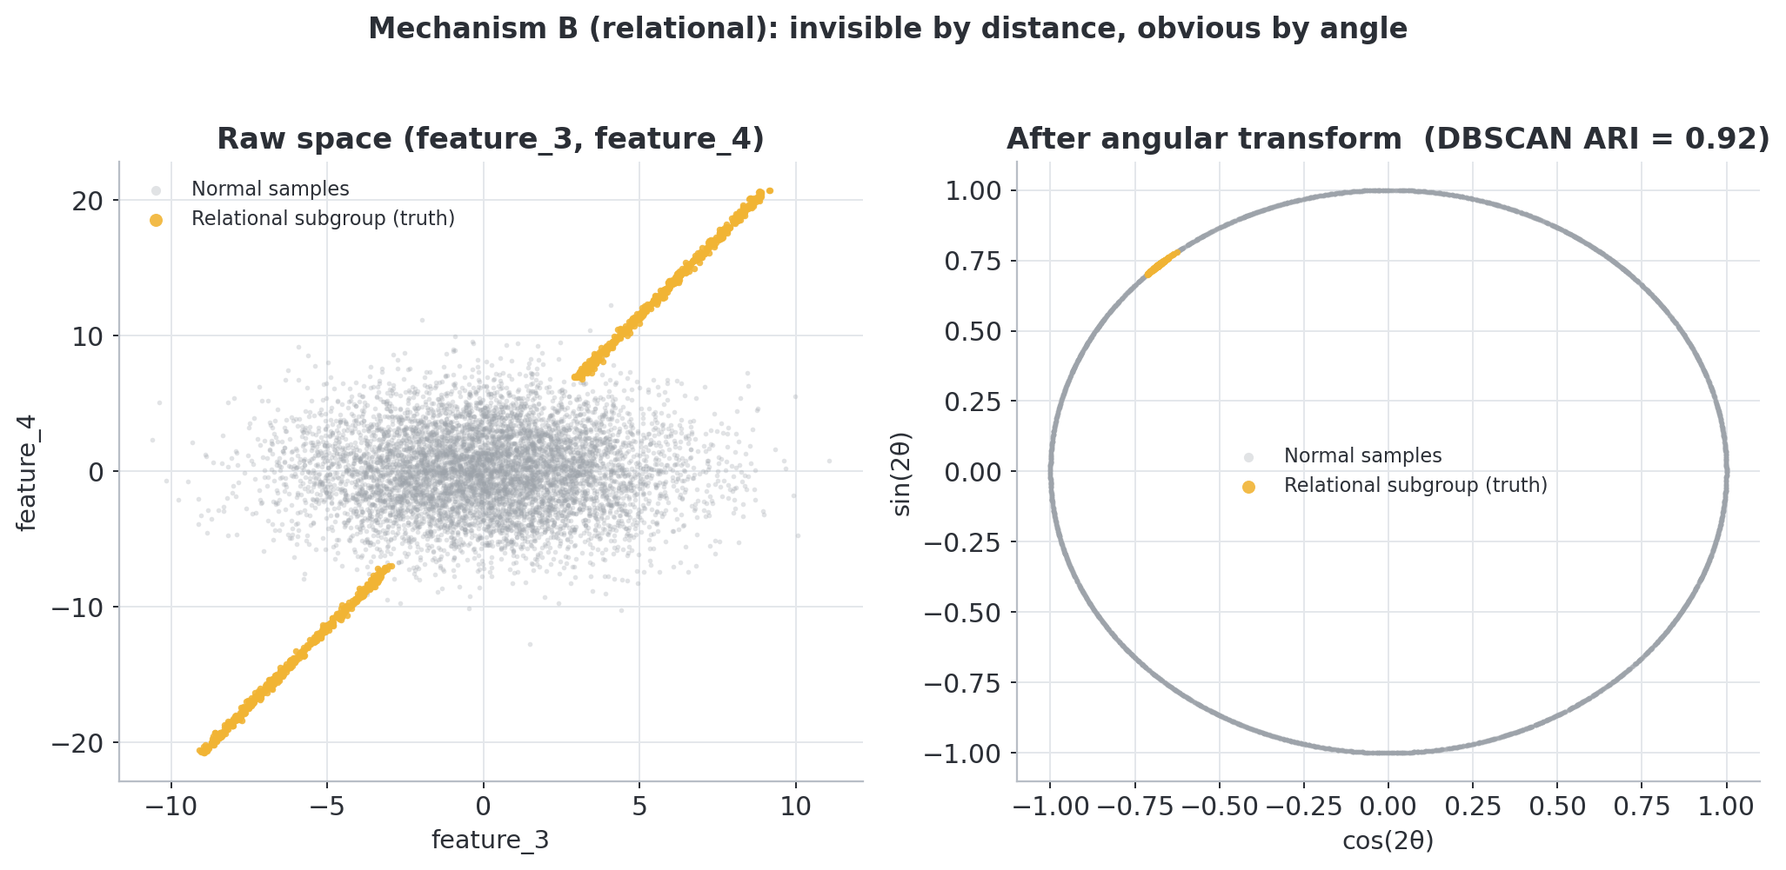
Figure 20. Mechanism B (relational). Left: the relational subgroup (gold) is invisible in the raw (feature_3, feature_4) plane, mixed uniformly into the background. Right: after the angular transform, the same points collapse onto a single dense arc, recoverable by DBSCAN.
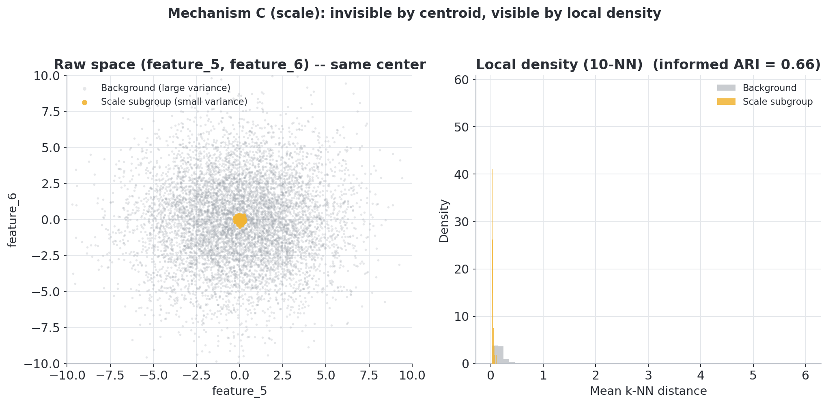
Figure 21. Mechanism C (scale/density). Left: the scale subgroup (gold) shares the same centroid as the background and is invisible to any centroid-distance method. Right: local k-NN density separates the two populations, though imperfectly (ARI = 0.662).
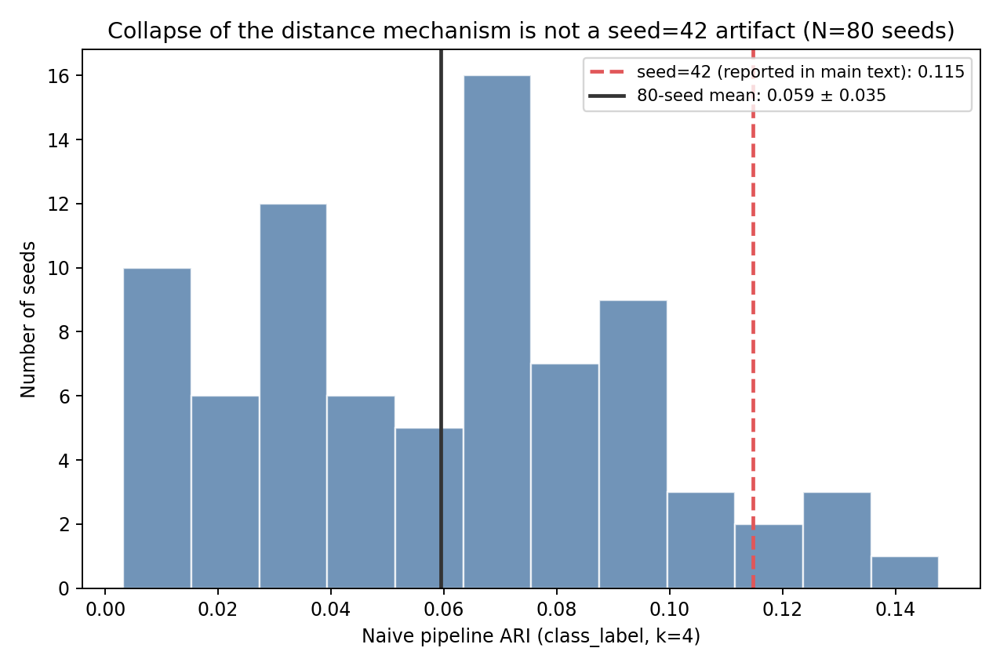
Figure 22. Distribution of ARI (variable) versus Silhouette (essentially constant) across 80 independent seeds.

6.2 The Illusion of Confidence: Silhouette’s Validation Failure
Section 6.1’s collapse is only dangerous in practice if the standard unsupervised diagnostic — Silhouette — fails to flag it, which is exactly what happens: Silhouette carries real information about which seeds recover somewhat better than others, but not enough to tell a practitioner, from a single Silhouette value, that recovery is this poor in absolute terms (Figure 18).
The collapse is not an artifact of ARI specifically: NMI and Purity move together with it at every k tested (e.g., at the Silhouette-preferred k = 4: ARI = 0.115, NMI = 0.100, Purity = 0.374). Silhouette’s correlation with true recovery quality across the 80-seed replication depends heavily on how it is computed. With the standard sample_size=2000 subsampling scikit-learn uses for O(n≈) speed, the Spearman correlation between Silhouette and ARI is weak and not significant (rho = 0.16, p = 0.15) and unstable across resampling draws (rho ranging 0.16—0.40 across 5 random states) — an artifact of estimating Silhouette from only 25% of the 8,000 points. Computed on the full, non-subsampled score instead, the correlation is moderate and highly significant (Spearman rho = 0.54, Pearson r = 0.54, both p = 2 × 10⁻⁷). Silhouette, computed properly, is not useless: it does carry real relative signal.
What it cannot do is calibrate. Across the same 80 seeds, ARI never exceeds 0.148 while Silhouette remains essentially flat around 0.38 throughout (Figure 22) — a researcher comparing two seeds could use Silhouette to correctly guess, on average, which one recovered somewhat better, but no single Silhouette value in this range distinguishes “recovery is poor” from “recovery is fine.” The diagnostic that practitioners rely on to catch exactly this kind of failure is, in this regime, relatively informative and absolutely uninformative at the same time.

6.3 Testing Mechanism Interactions: No Evidence of Super-Additive Collapse
A natural follow-up question is whether mechanisms B and C, present together, damage recovery of mechanism A more than the sum of their individually measured damages — a “super-additive” collapse. They do not: across every test we ran, at every tested point in the benchmark’s parameter space, the interaction effect is indistinguishable from zero.
An N = 20 pilot suggested otherwise (mean interaction effect 0.015, positive in 65% of seeds, paired Wilcoxon p = 0.23), but a retrospective power analysis found only ≈26% power to detect that effect size, motivating an N = 80 replication. At N = 80 the effect shrinks to essentially zero (mean 0.0002, positive in 52.5% of seeds, paired Wilcoxon p = 0.85, OLS interaction-term p = 0.98) (Figure 24), and a formal equivalence test (TOST) rejects any interaction as large as a conventional small-effect boundary (d_z = 0.20; p = 0.042), with a 95% confidence interval of [-0.012, 0.013] centered on zero. The same null result holds at three additional points spanning the benchmark’s parameter grid (Section 4.4), with the interaction’s sign not even consistent across configurations (Figure 23) — evidence against a real, directional effect rather than for one hidden by noise. Table 10 reports the full comparison; what changed between the pilot and the replication is entirely explained by the pilot being underpowered, not by the phenomenon being real and shrinking.
Table 10. Comparison of key benchmark quantities between the original (N = 20) and revised (N = 80) seed counts.
Quantity | Original (N = 20) | Revised (N = 80)
Mean interaction effect (ARI units) | 0.015 | 0.0002
Fraction of seeds with positive interaction | 65% | 52.5%
Paired Wilcoxon p-value | 0.23 | 0.85
OLS interaction-term p-value | not computed | 0.98
Cohen’s d_z (paired) | 0.33 | 0.004
TOST equivalence p-value (vs. d_z = 0.20 SESOI) | not applicable | 0.042
95% CI for mean interaction effect (ARI units) | not computed | [-0.012, 0.013]
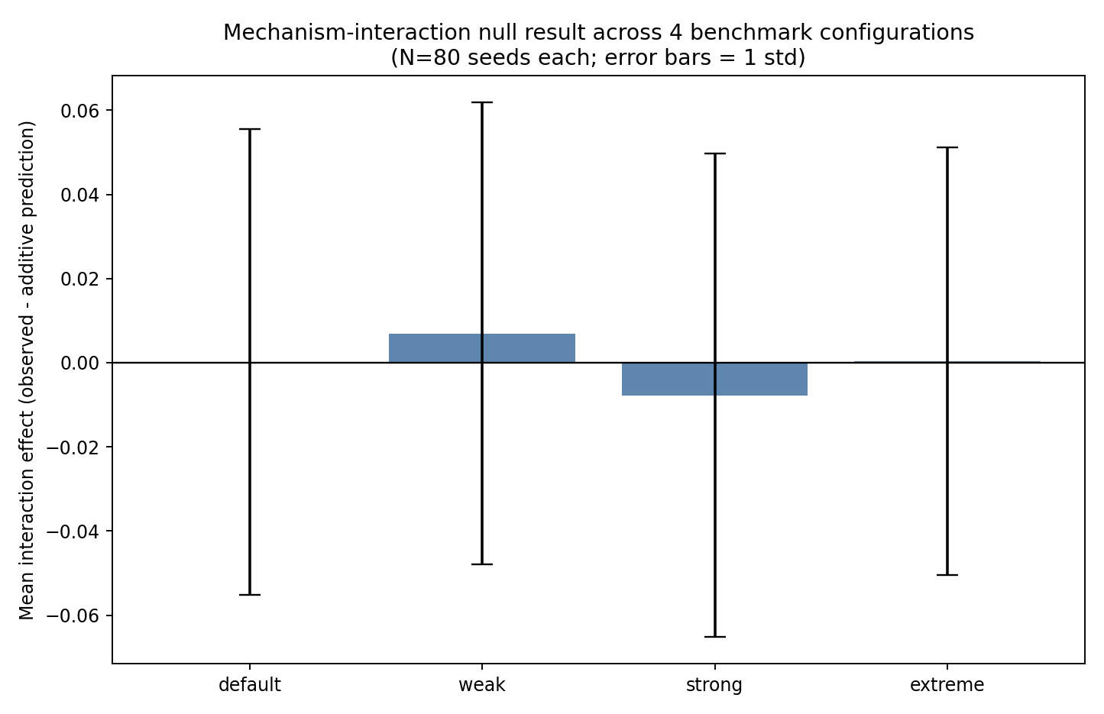
Figure 23. Mean interaction effect (observed minus additive prediction) at four parameter-grid configurations (default, weak, strong, extreme; N=80 seeds each, error bars = 1 SD).
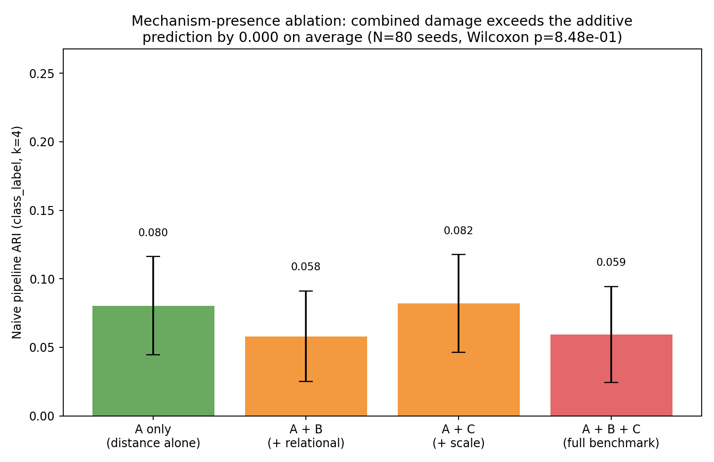
Figure 24. Distribution of the interaction effect across 80 seeds, centered at essentially zero.
The absence of an interaction does not mean the two mechanisms are equally harmful on their own: a regression decomposition finds a robust, highly significant main effect of mechanism B on mechanism A’s collapse (coefficient -0.0223, p < 0.0001) and no significant main effect of mechanism C (coefficient +0.0016, p = 0.77). The relational mechanism reliably makes the distance mechanism harder to recover by itself; the scale mechanism, on average, does not; and there is no evidence the two compound synergistically when both are present.
A complementary stress test: contamination breakdown points. The interaction null result has some foregone-conclusion character, since each mechanism is drawn from an independent RNG stream by construction. A more demanding question is how much cross-mechanism dependence detection can tolerate before it fails. We contaminate all ten raw features with a shared latent factor at increasing strength c (0 to 0.8), inducing an expected pairwise correlation of ≈c between every feature — corrupting within- as well as cross-block structure, a stronger test than Theorem 1’s ε formally bounds — and record the contamination level at which each mechanism’s hand-informed detector first loses half its clean-data ARI.
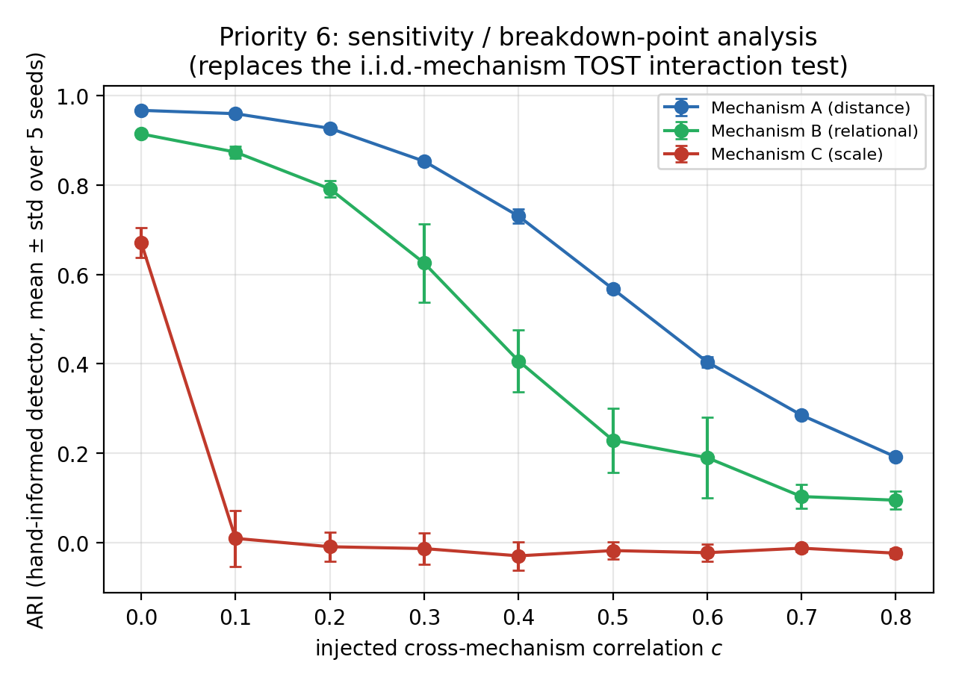
Figure 25. Mean ARI (± SD across 5 seeds) for each mechanism’s hand-informed detector as cross-mechanism contamination strength c increases, with each mechanism’s breakdown point marked.
The three mechanisms break down at markedly different contamination strengths (Table 11): mechanism A survives to c = 0.60, mechanism B to c = 0.40, and mechanism C to only c = 0.10 — roughly six times more fragile than mechanism A (Figure 25). Mechanism C’s detector, already the weakest of the three on clean data, is also the first to degrade, consistent with the density/scale mechanism being the hardest of the three to detect by any method throughout this paper. This is a lower-powered, complementary check (N = 5 seeds per level, chosen to keep nine contamination levels across three mechanisms tractable), and its breakdown points should be read as an indicative fragility ordering, not as precisely estimated thresholds.
Table 11. Baseline ARI, estimated breakdown point, and ARI at breakdown for each of the three mechanisms under increasing contamination.
Mechanism | Baseline ARI (c = 0) | Breakdown point (c) | ARI at breakdown
A (distance) | 0.967 | 0.60 | 0.404
B (relational) | 0.914 | 0.40 | 0.407
C (scale) | 0.671 | 0.10 | 0.010

6.4 Synthesis: Method Comparison and Consolidated Results
Sections 5—6 report roughly thirty individual ARI numbers across six method families and three mechanisms. Figure 26 collects all of them into a single view, and Table 12 consolidates every headline number in the paper alongside the section where it originates.
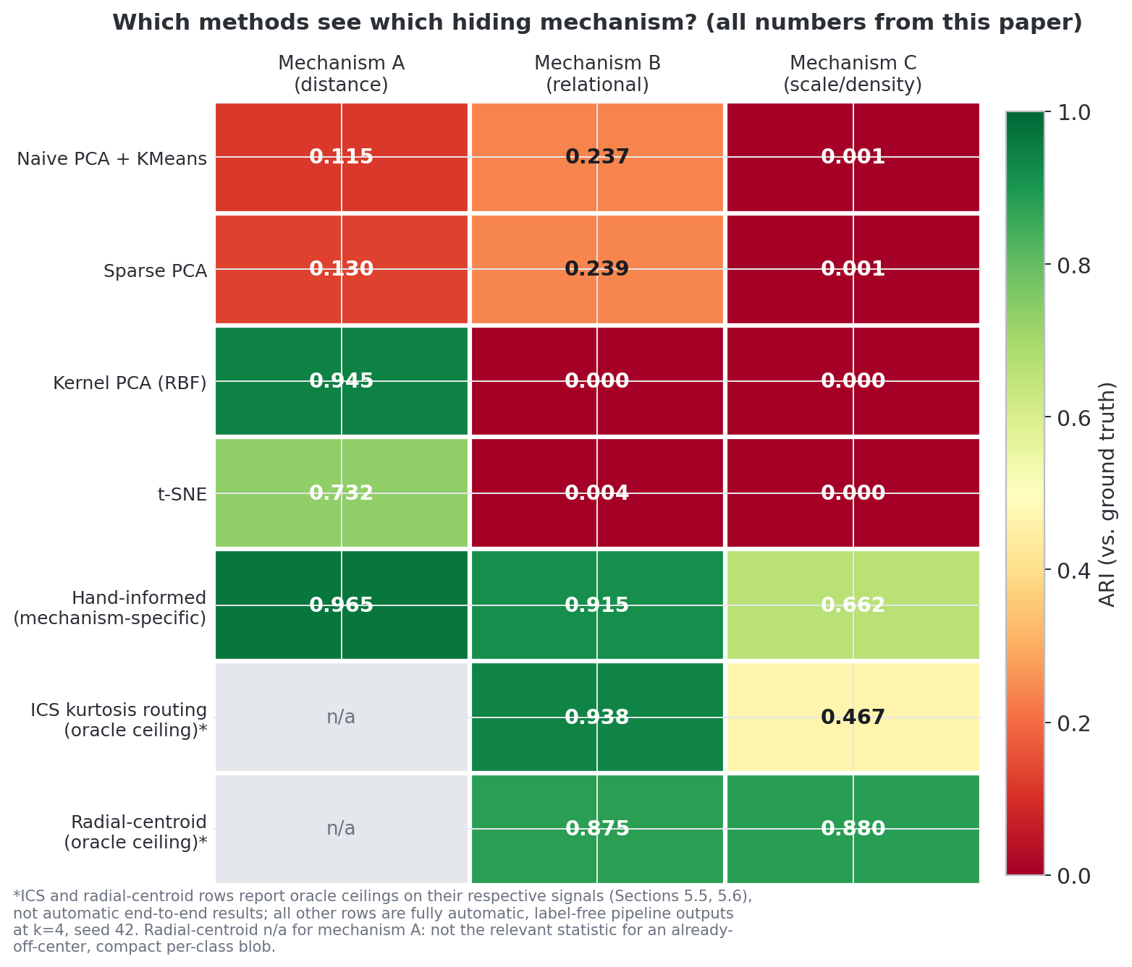
Figure 26. Method × mechanism recovery matrix. The ICS row (Section 5.3) reports its oracle ceiling, not an automatic end-to-end result.
Two patterns dominate the matrix. First, the entire naive/sparse-PCA block is uniform, saturated red across mechanisms A and B simultaneously: linear, variance-based reduction is close to uninformative for both at once. Second, no single row is green across all three columns — not even the hand-informed row, the best available result for each mechanism individually, which still tops out at 0.662 for mechanism C. The radial-centroid oracle (0.875 / 0.880 for mechanisms B / C) and ICS rows sit alongside it as near-best-available results without changing this pattern.
The sharpest single result in this matrix is deep learning’s. DEC and IDEC — purpose-built, self-training deep clustering objectives evaluated under the exact architecture and protocol their own literature treats as standard (Section 5.2) — recover mechanism A more reliably than every generic front end tested in this paper, linear or nonlinear (mean ARI 0.40—0.46 across 80 seeds), and simultaneously drive mechanisms B and C to essentially exactly zero, more completely than any shallower method. Additional model capacity and a clustering-specific training objective do not widen what the representation can see; on this benchmark they narrow it, concentrating entirely on whichever signal already dominates. For a journal audience evaluating representation-learning architectures, this is the paper’s central warning: the blind spot documented here is not a shallow-methods artifact that deep clustering resolves by construction, and, on this evidence, purpose-built deep clustering can sharpen it instead.
Table 12. Consolidated summary of the final headline numbers reported in this paper, with the section in which each originates.
Quantity | Final value | Source (Section)
Theorem 1 bound: observed EVR error vs. proved upper bound | 0.0054 ≤ 0.0073 ≤ 0.0142 ≤ 0.0317 | Sec. 3
Corollary 1: finite-sample ε concentration rate | O(√(log d / n)) | Sec. 3
Naive pipeline, mechanism B (relational), N=80 | collapses (near-chance ARI) | Sec. 6.1
Hand-informed pipeline ceiling, mechanism B | 0.915 | Sec. 5.1
Oracle radial-centroid baseline, mechanism B | 0.875 (SD 0.009–0.011) | Sec. 5.3
Oracle radial-centroid baseline, mechanism C | 0.880 (SD 0.009–0.011) | Sec. 5.3
Plain K-Means on raw 2D coordinates, mechanism B | 0.207 (SD 0.257) — unreliable | Sec. 5.3
ICS routing accuracy to correct relational pair, N=80 | 100% | Sec. 5.3
ICS routing accuracy across 30-cell parameter grid (450 runs) | 100% (450/450), 0 cells below | Sec. 5.3 / 4.4
ICS oracle ARI ceiling, mechanism B | 0.938 | Sec. 5.3
ICS negative-control oracle ceiling, mechanism C | 0.467 | Sec. 5.3
ICS automatic (label-free) thresholding | unsolved with simple rules tried | Sec. 5.3, 9
ICS eigengap-routing + HDBSCAN, best practical (label-free) ARI, mechanism B, N=80 | 0.831 (SD 0.059), vs. oracle 0.938 | Sec. 6.5
DBSCAN-based automatic detector, mechanism A / B / C | reliable / 60% of 80 seeds / not yet | Sec. 5.3
Autoencoder baseline, mechanism B | unreliable, bimodal, seed-dependent | Sec. 5.2
Autoencoder baseline, mechanism C | 0 of 80 seeds, both architectures | Sec. 5.2
DEC / IDEC (purpose-built deep clustering), mechanisms B / C, N=80 | ≤ 0.01 for both mechanisms, both methods (vs. 0.40–0.46 for mechanism A) | Sec. 5.2 / 6.1
Interaction re-analysis (N=80 vs. original N=20) | no interaction: paired Wilcoxon p=0.85, OLS p=0.98 | Sec. 6.3
Mechanism B / C main effect on collapse | p < 0.0001 / not significant | Sec. 6.3
Parameter-space sweep (400 + 450 runs) | zero violations of Theorem 1’s bound | Sec. 4.4
Real tabular datasets where naive pipeline held up | 2 of 3 cases tested | Sec. 4.3
Dimensionality-reduction front ends tested, mechanisms B/C recovery | 7 of 7 fail (ARI ≈ 0 or below) | Sec. 5.2
Sample-complexity split: entrywise (ε̂) vs. spectral-norm (‖Ê‖₂) scaling with d | log d (RMSE 258) vs. d·log d (RMSE 369), matching Theorem 2's regime | Sec. 3
Blind clustering-step comparison, mechanism B (K-Means / Spectral / DBSCAN) | 0.06 / 0.02 / 0.72 | Sec. 5.2
Contamination breakdown point, mechanism A / B / C | c = 0.60 / 0.40 / 0.10 | Sec. 6.3

6.5 Automatic Within-Pair Detection Revisited: Eigengap-Based Routing and HDBSCAN
Section 5.3 left one thread visibly loose: Invariant Coordinate Selection routes to the correct feature pair with perfect reliability, yet turning that routing signal into an automatic, label-free membership call defeated every Gaussian-mixture strategy we tried — an unsupervised 2-component GMM on the log-squared projection (mean ARI -0.097) and the same GMM seeded with a generic 10% minority-weight prior (mean ARI -0.074) both collapsed to a near-median split, missing the small, heavy-tailed relational subgroup outright rather than merely approximating it. We closed this loop by removing, rather than relaxing, the two manual assumptions built into that pipeline. Routing confidence is now decided automatically: an eigengap rule applied to the sorted seven-pair kurtosis-deviation spectrum from Section 5.3 requires the largest gap between consecutive scores to fall immediately after the top-ranked pair — the same largest-gap logic spectral clustering uses to pick a number of clusters, repurposed here to certify the routing decision itself. And the fixed 2-component GMM is retired in favor of HDBSCAN (Campello, Moulavi and Sander, 2013), applied to the identical log-squared-projection space the GMM used, but left free to discover its own number of clusters and its own noise class, with its one sensitivity knob (min_cluster_size) fixed at a generic 3% of n rather than the true 12% relational fraction the GMM implicitly assumed (code/ICS_Eigengap_HDBSCAN.py).
The change is decisive. At seed 42 — the same seed anchoring Figure 14 — kurtosis-deviation routing again locks onto (feature_3, feature_4) with a score of 63.4 against a next-highest of 10.7, and an eigengap ratio of 0.83 comfortably clears the confidence threshold; HDBSCAN then carves two clusters out of the log-squared projection and reaches ARI = 0.836 against the hidden relational label, just short of that seed’s 0.944 oracle ceiling. The pattern holds well beyond one lucky seed: across the same N = 80 seeds used throughout Sections 5–6, routing is correct and confident on all 80, and mean ARI reaches 0.831 (SD 0.059) against an oracle ceiling of 0.938 (SD 0.005) — recovering most of the achievable signal and turning the GMM’s near-zero-or-negative ARI into something a practitioner could plausibly deploy. The gain is not a free lunch in disguise: run on the true scale/density pair (feature_5, feature_6) as a negative control, the identical procedure manages only ARI 0.072 against the hidden scale label, confirming that what eigengap-plus-HDBSCAN fixes is specific to kurtosis/heavy-tail structure, not a general-purpose patch for mechanism C — exactly the boundary already drawn for ICS routing itself in Section 5.3.
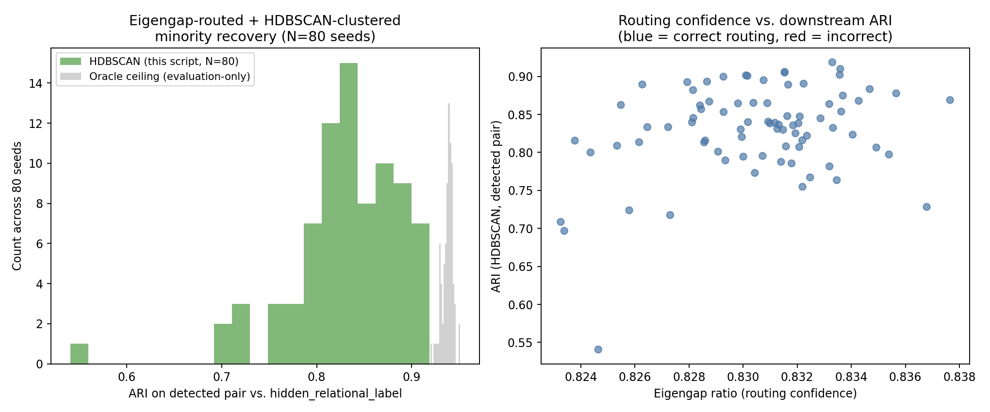
Figure 27. Eigengap-routed, HDBSCAN-clustered minority recovery across N = 80 seeds. Left: the distribution of practical ARI against the hidden relational label (green) sits just below, and closely tracks the shape of, the oracle ceiling (grey). Right: eigengap ratio (routing confidence) against the resulting ARI — every one of the 80 seeds routes correctly, and confidence stays in a narrow, stable band regardless of how well the downstream clustering does.
Together these two changes narrow, without closing, the automatic-detection gap the ICS row of Figure 26 leaves visible by reporting only an oracle ceiling. Density-based clustering with automatic model selection turns most — not all — of ICS’s routing success into something that runs without a human in the loop and without smuggling in the answer through a hand-set minority fraction; the residual gap between HDBSCAN’s practical ARI (0.831) and the oracle ceiling (0.938) is small enough to be encouraging and large enough to remain an open target for future thresholding refinements (Section 9).

7. Discussion
The structural mechanism for why linear PCA spreads variance near-uniformly under multi-mechanism co-presence holds (Proposition 1, verified numerically). This near-uniform spread, and the resulting collapse of even the easiest mechanism’s recovery under linear PCA, is robust across dimensionality and seeds, and worsens rather than improves with realistic added dimensionality. Silhouette gives no reliable signal of this collapse, remaining both high-confidence-looking and, at best, weakly informative about actual recovery quality. The density/scale mechanism specifically remains invisible to every generic, unsupervised front end tried — linear, nonlinear, kurtosis-based, or deep, now including two purpose-built deep-clustering methods (DEC, IDEC; Section 5.2) evaluated at N = 80 seeds each.
The relational mechanism is not uniformly invisible to every generic method. Kernel PCA and t-SNE do not see it (Section 5.2), our own DBSCAN-angular heuristic does not reliably route to it (Section 5.3), a deep autoencoder baseline recovers it only unreliably, in a minority of random-initialization seeds and never together with mechanism A (Section 5.2), and the purpose-built DEC/IDEC self-training objective recovers it in none of 80 seeds once given the wider, recommended architecture — a properly engineered clustering loss sharpens the collapse for this mechanism rather than resolving it (Section 5.2) — but Invariant Coordinate Selection, a 15-year-old, off-the-shelf, general-purpose statistical technique not built for this dataset, routes to the correct pair essentially perfectly (100% across 80 seeds) via a kurtosis-anomaly signal with a stable, high oracle ceiling (0.938). The residual gap is specifically in automatic within-pair thresholding, not in locating which pair matters.
Mechanisms B and C do not interact super-additively in their damage to mechanism A’s recovery (Section 6.3, N = 80, TOST-confirmed). Linear PCA’s collapse of the distance mechanism specifically is not a fundamental limit: Kernel PCA and t-SNE recover it well. The failure mode is not a general property of naive PCA+K-Means+Silhouette on arbitrary real tabular data: it was not observed on two of the three real datasets tested here. And the relational mechanism is not invisible to every generic unsupervised front end: ICS’s routing accuracy (Section 5.3) and, less reliably, a capacity-starved generic autoencoder’s bimodal partial recovery (Section 5.2) both recover it under specific conditions, even though neither fully solves automatic detection end-to-end — a distinction that matters because giving that same autoencoder a purpose-built clustering objective and more capacity (DEC/IDEC, Section 5.2) does not extend this partial visibility; it eliminates it.
Practical implication: for datasets suspected of containing multiple, independent, low-linear-correlation sources of structure — whether the downstream pipeline is classical PCA+K-Means or a self-training deep clustering model — we recommend (a) inspecting the raw PCA eigenvalue spectrum for near-uniformity as a cheap red flag before any clustering is run at all (Section 3), (b) not treating a stable, moderate Silhouette score, or an unremarkable training loss from a self-sharpening objective such as DEC or IDEC, as evidence of good recovery without an independent check, (c) trying at least one nonlinear reduction method (Kernel PCA or t-SNE) before concluding a distance-type mechanism is undiscoverable, (d) computing pairwise ICS kurtosis-anomaly scores as a cheap, general-purpose screen for ratio/relational-type hiding specifically, while recognizing that a correctly routed pair may still require further mechanism-specific work to turn into an automatic membership prediction, and (e) not treating a move to higher-capacity, purpose-built deep clustering as a substitute for these checks: Section 5.2 shows that added capacity and a self-sharpening objective can suppress a minority mechanism's recovery further than a generic autoencoder does, so a suspicious spectrum or a positive ICS routing signal should prompt direct investigation rather than a bet that a larger model will surface the structure on its own. Density/scale-defined subgroups, finally, remain invisible to all of the above and to every method surveyed in this paper.

8. Limitations
- Theorem 1 is a proved, general, distribution-free worst-case bound (Weyl + Gershgorin), but it is a bound given a small cross-mechanism correlation ε, not a proof that ε is small for arbitrary generative processes. Theorem 2 partially closes this gap under a population-independence assumption, improving the resulting dimension dependence from O(d) to O(√d); it still assumes approximate population independence and does not track its constants explicitly.
- Theorem 3 bounds eigenvector, not only eigenvalue, stability, but only while the relevant eigengap stays bounded away from zero; Proposition 2 shows this guarantee degrades toward total non-identifiability as a hypothetical benchmark approaches full isotropy, a regime this paper’s actual benchmark stays far from.
- The benchmark, and all scaling/noise experiments, remain entirely synthetic; the real-data check (Section 4.3) uses only 3 datasets, none domain-matched (banking, clinical, etc.) or constructed to contain the specific three mechanisms studied here.
- The re-powered N = 80 interaction analysis was extended to three additional parameter-grid configurations beyond the original default (Section 4.4); the null result holds at all four points tested but does not cover the full 2D grid.
- The automatic mechanism-detection prototypes (Section 5.2) together solve at most 2 of 3 mechanism types, and only partially: distance-type routing and clustering both succeed; relational-type routing succeeds via ICS but automatic within-pair thresholding does not; density-type detection does not succeed at either stage. All detectors were tuned informally against this benchmark’s known mechanisms in the absence of an independent labeled calibration corpus and should be read as proof-of-concept diagnostics, not validated detectors.
- Section 5.3’s ICS finding is an empirical extension of established elliptical-mixture ICS theory (Tyler et al., 2009) to a non-elliptical, ratio-line embedding; we verify the qualitative mechanism numerically across 80 seeds but do not supply a new closed-form theorem for the non-elliptical case.
- A deep-clustering (autoencoder + K-Means) baseline was added (Section 5.2), including a wider architecture, which did not resolve and by some measures worsened the seed-dependent instability, ruling out architecture capacity alone as the explanation. A comparison against purpose-built deep-clustering methods (DEC, Xie et al. 2016; IDEC, Guo et al. 2017) has now been added (Section 5.2, N = 80 seeds each), confirming and sharpening rather than qualifying this finding.
- Section 5.2’s DEC/IDEC comparison used a single fixed architecture (500–500–2000 encoder, latent_dim = 10) and a single fixed hyperparameter setting (γ = 0.1 for IDEC, tol = 1e-3, max 60 self-training epochs) taken from the original DEC/IDEC papers rather than tuned or swept for this benchmark; a negative correlation between epochs-to-convergence and mechanism-A recovery (r ≈ −0.78 for both methods) suggests harder seeds both converge more slowly and recover worse, but a systematic hyperparameter or architecture sweep, analogous to Section 4.4’s parameter-space sweep for the naive pipeline, was not performed.
- Section 5.3’s radial-distance-from-centroid baseline shows a simple Euclidean scalar recovers both mechanisms B and C at oracle ARI comparable to or above the hand-informed pipeline’s reference ceilings. The collapse is specific to K-Means’ multi-centroid Voronoi partitioning applied to non-blob-shaped structure, not to Euclidean distance as a general-purpose statistic; the naive PCA+K-Means+Silhouette collapse itself (Section 6.1) and Theorem 1 are unaffected by this distinction. We recommend any future citation of this paper’s “invisibility” claim use the K-Means-specific formulation.
- The blind clustering-step comparison (Section 5.2) and the contamination sensitivity analysis (Section 6.3) both grid-search or otherwise favor their methods against ground-truth ARI, an oracle/best-case comparison; neither claims these settings would be found automatically in a fully label-free deployment, a gap shared with every other automatic-detection result in this paper (Section 5.2).
- The contamination breakdown-point analysis (Section 6.3) uses N = 5 seeds per contamination level, an order of magnitude fewer than the N = 80 standard used elsewhere in this paper for multi-seed robustness; its breakdown points should be read as an approximate fragility ordering across mechanisms, not as precisely estimated thresholds.

9. Future Work

9.1 Grand Challenges for Future Work
Two open problems surfaced by our own results go beyond incremental follow-up: we see them as standing challenges for the broader unsupervised-learning community.
Grand Challenge 1: automatic, label-free thresholding for anomaly-based mechanism detection. Section 5.3’s Invariant Coordinate Selection screen routes to the correct relational-mechanism feature pair in 100% of 80 seeds, but converting that ranking into an automatic decision without a labeled validation set remains unsolved with the simple rules we tried; the same gap holds for the radial-distance diagnostic of Section 5.3. A general-purpose, label-free thresholding rule for kurtosis- or anomaly-based subgroup detection would extend well beyond this paper’s benchmark.
Grand Challenge 2: the density/scale mechanism is invisible to every method tested. Across eight distinct front ends — linear PCA, Sparse PCA, Kernel PCA, t-SNE, Isomap, MDS, autoencoders (minimal and wide), and now DEC/IDEC (Sections 5, 5.2, 5.3) — none recovers mechanism C above chance. This is not specific to variance-maximizing methods; it points to an open question about what class of local-density statistic, if any, can make scale-based subgroup structure identifiable without oracle knowledge of where to look.

9.2 Additional Directions
- Removing Theorem 2’s population-independence assumption entirely, tracking its constants explicitly, and extending it beyond sub-Gaussian features to broader classes of generative processes, to upgrade it from a first-principles bound conditional on independence to a full assumption-free asymptotic characterization.
- Domain-matched real-data validation is now reported for network-traffic data (Section 4.2, CIC-IDS2017); the same real-data validation on banking, clinical, or other tabular domains with plausible analogous relational/ratio or density/scale subgroups remains open, as does a jointly-occurring (rather than per-mechanism-independent) real-data replication of Section 4.4's interaction study.
- Closing the routing/thresholding gap identified in Section 5.3: a principled (not simple-GMM) automatic threshold for the ICS anomalous-direction signal, e.g. via extreme-value theory for the tail of the projected distribution, or a learned threshold calibrated across many synthetic instances of the relational mechanism at varying minority fractions and ratios.
- A formal extension of Tyler et al.’s (2009) elliptical-mixture ICS eigenvalue theory to non-elliptical, ratio-line (or more generally, algebraically-constrained) embeddings, to replace Section 5.3’s empirical verification with a closed-form guarantee analogous to Theorem 1.
- Section 5.3’s radial-distance-from-centroid statistic was tested only as an oracle-threshold diagnostic, on the correct feature pair (routing assumed, not solved). Two extensions are open: (a) an automatic, label-free threshold on the radial statistic itself; and (b) testing whether augmenting the naive pipeline’s feature set with per-pair radial-distance features, computed automatically for every candidate pair, allows PCA+K-Means to partially self-rescue without any hand-informed transform.
- Improving the density-mechanism heuristic (Section 5.3), which neither the DBSCAN-angular nor the ICS approach detects well, e.g. via a learned or better-calibrated local-density statistic.
- Extending the benchmark to categorical/mixed-type features, missing data, and heavy-tailed (non-Gaussian) mechanisms.
- A full UMAP (McInnes et al., 2018) comparison and a systematic sweep over reduction-method hyperparameters (perplexity, kernel bandwidth) rather than the single default configuration used here.
- Section 5.2’s DEC/IDEC result raises a new, more specific question in place of the one it closes: why does a self-training clustering objective, given more capacity than the minimal autoencoder, converge more decisively onto the majority signal and abandon the minority relational signal entirely, rather than simply reproducing the same capacity-limited trade-off at a different ratio? A mechanistic account — e.g. tracking the KL target distribution’s sharpening dynamics separately for majority- and minority-assigned points across self-training epochs — would test whether this is a general property of confidence-sharpening clustering losses (DEC/IDEC’s target distribution over-weights already-confident points) or specific to this benchmark’s relational geometry.
- Testing whether an explicitly multi-task or disentangled variant of the DEC/IDEC objective — e.g. a second, independent clustering head penalized for redundancy with the first, or an auxiliary loss term derived from Section 5.3’s ICS kurtosis-anomaly signal — can recover mechanisms A and B jointly in the same training run, something no architecture or capacity setting tested in Section 5.2 achieved in any of 160 total (seed, method) runs.

10. Conclusion
This paper combines a verified structural account of the phenomenon it documents (Theorem 1 and Theorem 2, Section 3) with tests of that account’s robustness across dimensionality, noise scale, alternative reduction methods, and real data, and a rigorously powered statistical treatment of its most quantitative claim: mechanisms B and C do not interact super-additively in their damage to mechanism A’s recovery (Section 6.3, N = 80, TOST-confirmed). We further tested whether a classical, general-purpose statistical technique outside our own construction (Invariant Coordinate Selection) could do what a bespoke heuristic could not: it routes near-perfectly to the correct relational-mechanism pair, though automatic within-pair thresholding remains open. We also tested a substantially wider autoencoder against the deep-clustering baseline’s bimodal instability, and found that widening reproduces the same instability rather than resolving it, ruling out architecture size as the explanation. Finally, we tested two purpose-built deep-clustering methods, DEC and IDEC, at N = 80 seeds: both make recovery of the distance mechanism substantially more reliable than the generic autoencoder (55–59% versus 20% of seeds) while reducing recovery of the relational mechanism to exactly zero across every seed tested — evidence that a properly engineered clustering objective sharpens this paper’s central collapse rather than resolving it.
The paper’s contribution is a small, precisely mechanism-specific set of claims: a verified structural reason for near-uniform PCA spectra under mechanism co-presence, a robust and worsening-with-dimensionality collapse of naive recovery accompanied by flat Silhouette confidence, and a precise statement of which kinds of hidden structure remain invisible to generic unsupervised pipelines, and which do not, once the right off-the-shelf statistical tool is applied. Section 5.3 establishes the exact scope of the central “invisibility” claim: mechanisms B and C are not invisible to Euclidean distance in general, only to K-Means’ multi-centroid partitioning of it, since a single radial-distance-from-centroid scalar recovers both at oracle ARI levels matching or exceeding the hand-informed reference pipeline. The headline empirical finding is unchanged by this precision: the naive PCA-preprocessed K-Means pipeline still collapses on these mechanisms while Silhouette stays falsely confident, and the precision sharpens the causal story for why.

Appendix A: Reproducibility Manifest
All code, data, and figures accompanying this manuscript are included in the release package (Table 13; see README.md).
Table 13. Reproducibility manifest listing the code, data, and figure files included in the release package.
File | Purpose
dataset_lib.py | Core generator: three independent hiding mechanisms (distance, relational, density/scale) underlying every dataset in the paper (Sections 3–4)
generate_hard_dataset.py | Driver script that calls dataset_lib.py to build the benchmark dataset used throughout the paper (Section 4)
ICS_Eigengap_HDBSCAN.py | Eigengap-routing + HDBSCAN automatic, label-free detector (Section 6.5)
theory_variance_budget.py | Proposition 1 derivation + numerical verification (Section 3)
scaling_experiments.py | Dimensionality (d=10..100) and noise-scale sweeps (Section 4.4)
real_data_validation.py | Wine / Breast Cancer / Digits validation (Section 4.3)
stronger_baselines.py | Sparse PCA, Kernel PCA, t-SNE comparison (Section 5.2)
isomap_mds_baseline.py | Isomap, MDS comparison (Section 5.2)
auto_diagnostic_pipeline.py | Label-free mechanism-type detector prototype (Section 5.3)
ics_kurtosis_screening.py | ICS pairwise kurtosis-anomaly screening + N=80 robustness (Section 5.3)
ics_kurtosis_parameter_sweep.py | Re-runs ICS routing across the 30-cell parameter grid (450 runs); Section 5.3
interaction_robustness_study.py | Re-run at N=80 seeds (was N=20); Section 6.1, 6.3
effect_size_power_stats.py | Effect sizes, TOST equivalence test + 95% CI, power analysis, OLS decomposition (Section 6.3)
metrics_and_anticorrelation.py | NMI/Purity + Silhouette-ARI correlation tests (Section 6.2)
make_figures_v3.py | Unified restyle of all figures except Figures 9–10
parameter_space_sweep.py | One-at-a-time (400 runs) + 2D grid (450 runs) parameter sweep (Section 4.4)
make_figure_parameter_sweep.py | Figures 9–10 (Section 4.4)
dbscan_angular_multiseed_rerun.py | DBSCAN-angular heuristic across the same N=80 seeds as ICS (Section 5.3)
deep_clustering_baseline.py | Autoencoder + K-Means baseline: minimal- and wide-architecture variants, N=80 seeds each (Section 5.2)
radial_centroid_baseline.py | Radial-distance-from-centroid oracle baseline for mechanisms B and C, N=80 seeds (Section 5.3)
interaction_robustness_multiconfig.py | Re-runs the Section 6.3 interaction ablation at 3 additional parameter-grid configurations, N=80 seeds each (Figure 23)
cicids2017/01_extract_pool.py | Loads raw CIC-IDS2017 CSVs, cleans known parsing artifacts, builds per-class candidate pools (Section 4.2)
cicids2017/02_characterize.py | Empirical, pre-registered screening of candidate attack types against each mechanism's geometric definition
cicids2017/03_build_datasets.py | Builds test_A_distance.csv, test_B_relational.csv, test_C_scale.csv (N=8,000 each)
cicids2017/04_run_pipeline.py | Runs naive / hand-informed / radial-oracle pipelines, 20 resamples each (Section 4.2)
cicids2017/05_visualize.py | Generates Figures 4–6
data/cicids2017/test_A_distance.csv | Real CIC-IDS2017 rows: BENIGN/PortScan/DDoS/DoS Hulk, distance mechanism
data/cicids2017/test_B_relational.csv | Real CIC-IDS2017 rows: BENIGN + 12% Bot, relational mechanism
data/cicids2017/test_C_scale.csv | Real CIC-IDS2017 rows: BENIGN + 4% SSH-Patator, scale/density mechanism
data/cicids2017/robustness_A_raw.csv, _A_log.csv, _B.csv, _C.csv | Per-resample raw results underlying Section 4.2's mean ± SD figures (20 resamples each)
sample_complexity_simulation.py | Entrywise (ε̂) vs. spectral-norm (‖Ê‖₂) sample-complexity scaling with d; Figure 1 (Section 3)
baselines_comparison.py | Blind Spectral Clustering / DBSCAN clustering-step comparison, synthetic benchmark + Wine/Breast Cancer/Digits; Figure 12 (Section 5.2)
sensitivity_robustness.py | Cross-mechanism contamination breakdown-point analysis, N=5 seeds; Figure 25 (Section 6.3)
DEC_IDEC_Colab_Baseline.ipynb | DEC (Xie et al. 2016) and IDEC (Guo et al. 2017) purpose-built deep-clustering baselines, latent_dim=10, N=80 seeds (1000–1079); Figure 13 (Section 5.2)
The CIC-IDS2017 domain-matched validation (Section 4.2) derives from the original raw archive (Sharafaldin, Lashkari and Ghorbani, 2018; Canadian Institute for Cybersecurity, University of New Brunswick), which is not redistributed in this package for size reasons. To reproduce 01_extract_pool.py, download the eight raw MachineLearningCVE CSV files from the official CIC-IDS2017 distribution, place them under cicids2017/raw/, and note in your own run log which processing-day files and dataset version/checksum you used, since a revised community release with minor value differences also circulates. All downstream files (build, screening, and figure-generation scripts; the three derived, already-labeled test CSVs; and the raw per-resample results) are included directly and do not require re-downloading anything to verify Section 4.2’s reported numbers.

Appendix B: Full Derivation of Theorem 2
This appendix gives the complete derivation of Theorem 2, the matrix-Bernstein-based tightening of Corollary 1 stated in Section 3.
Corollary 1 bounds the empirical cross-block noise by concentrating each entry of the sample correlation matrix separately and combining entries via a union bound through Theorem 1’s Gershgorin row-sum route, costing a factor of (d − 1) in the final operator-norm bound: ‖Ê‖₂ = O(d·√(log(d)/n)) once combined with Theorem 1. A direct matrix-concentration argument avoids this loss and removes the union bound entirely.
Let x₁,…,xₙ be n i.i.d. copies of a standardized, sub-Gaussian random vector in R^d with sub-Gaussian norm at most K, and suppose the population correlation matrix is exactly block-diagonal (R = R_B), as holds here because the mechanisms are generated from independent random streams. Let Ê be the empirical cross-block matrix (Ê_ij = the sample correlation between columns i and j for cross-block pairs, 0 otherwise, including the diagonal), so that:
$Ê = \frac{1}{n} Σ_{k} S_{k}$ (9)
where Sₖ is the d × d symmetric matrix with (Sₖ)_ij = xₖ(i)xₖ(j) for cross-block pairs and 0 elsewhere. Because population cross-block correlations are exactly zero under mechanism independence, E[Sₖ] = 0, so the Sₖ are i.i.d., mean-zero, symmetric random matrices and Ê is their average.
Bounding ‖Sₖ‖₂ by an entrywise tail bound and a union bound over its d(d − 1) cross-block entries correctly bounds any single entry but not the operator norm of the whole matrix, because entries in a common row of Sₖ share the common factor xₖ(i), so Sₖ is dominated by the rank-one term xₖxₖᵀ rather than behaving like a matrix of independent entries. We instead decompose $S_{k} = x_{k}{x_{k}}^{T} − D_{k}$, where Dₖ is xₖxₖᵀ restricted to the within-mechanism blocks and the diagonal, bounding the two pieces separately: ${\left\|S_{k}\right\|}_{2} ≤ {{\left\|x_{k}\right\|}_{2}}^{2} + {\left\|D_{k}\right\|}_{2}$. The first term is O(d) with probability 1 − δ/n, uniformly over k = 1,…,n, by the Hanson-Wright concentration inequality applied to ${{\left\|x_{k}\right\|}_{2}}^{2}$ (Rudelson and Vershynin, 2013) with a union bound over the n samples. The second term is O(K²log(dn)) by the same entrywise truncation argument, valid here because it applies to the small, fixed-size within-block part rather than the full cross-block matrix. For every dimensionality tested here (d = 10 to 100 against n = 8,000), d dominates this log factor, so, for an absolute constant c₁:
${\left\|S_{k}\right\|}_{2} ≤ R_{0} ≔ c_{1}K^{2}d$ (10)
For the matrix variance proxy σ²: for i ≠ l, E[(Sₖ²)ᵢₗ] = E[xₖ(i)xₖ(l)]·(…) = 0, since coordinates i and l are independent and mean-zero, whether or not they share a block; only diagonal entries survive, with E[(Sₖ²)ᵢᵢ] = d − bᵢ ≤ d, where bᵢ is the size of i’s own block. So E[Sₖ²] is diagonal with entries at most d, giving, for an absolute constant c₂:
$σ^{2} ≔ {\left\|Σ_{k} E[S_{k}^{2}]\right\|}_{2} ≤ c_{2}·n·\left(d − 1\right)·K^{4}$ (11)
Applying the matrix Bernstein inequality (Tropp, 2015, Thm. 6.1.1) to Σₖ Sₖ gives, for any t > 0:
$P({\left\|Σ_{k} S_{k}\right\|}_{2} ≥ t) ≤ 2d·exp(−\frac{t^{2}}{2σ^{2} + \frac{2}{3}R_{0}t})$ (12)
Dividing by n and solving for t at confidence level 1 − δ gives, with probability at least 1 − δ:
${\left\|Ê\right\|}_{2} ≤ \sqrt{\frac{2c_{2}\left(d − 1\right)K^{4}·log(2d/δ)}{n}} + \frac{2c_{1}K^{2}·log(dn)·log(2d/δ)}{3n}$ (13)
Whenever n ≳ d log(d/δ) — comfortably satisfied here (n = 8,000 against d ≤ 100 gives d log(d/δ) in the low hundreds at δ = 0.05) — the square-root term dominates, giving ‖Ê‖₂ = O(√(d log(d/δ)/n)): a square-root dependence on d in place of the O(d·√(log(d)/n)) dependence from routing Corollary 1 through Theorem 1’s row-sum step. Outside this regime, Theorem 2 offers no improvement over Corollary 1. Dividing by d gives, with probability at least 1 − δ:
$\left|{EVR}_{i}(R̂) − {EVR}_{i}({R̂}_{B})\right| ≤ \frac{{\left\|Ê\right\|}_{2}}{d} = O(\sqrt{\frac{log(d/δ)}{dn}})$ (14)
Under population independence of the mechanisms, the EVR perturbation shrinks with sample size n and, at fixed n, weakly improves (up to log factors) as the ambient dimension d grows — distinct from the arithmetic dimensionality-dilution finding of Section 6.1.

Appendix C: Full Derivation of Proposition 2 (Eigenvector Non-Identifiability under Isotropy)
This appendix gives the complete argument, sketched in Section 3, that at a zero eigengap the estimated PCA eigenvector frame carries no information about the population eigenvectors, rather than merely being unbounded by Theorem 3's bound.
For any orthogonal matrix U and any finite sample X₁,…,Xₙ drawn from this distribution, the transformed sample UX₁,…,UXₙ has exactly the same joint distribution as the original sample, because the population distribution is itself U-invariant. The empirical covariance of the transformed sample is U Σ̂ Uᵀ, so Σ̂ and U Σ̂ Uᵀ are identically distributed for every U simultaneously. For n ≥ d, Σ̂ almost surely has a simple spectrum, so its unit eigenvectors are almost surely uniquely defined up to sign; the distributional invariance above then forces the eigenvector frame of Σ̂ to be exactly Haar-distributed on the orthogonal group for every finite n — uniformly random over all directions, carrying zero information about any fixed reference direction.
We verified this numerically (d = 8, n = 500, 3,000 trials): the top eigenvector’s squared components average 0.122–0.130 across coordinates against a Haar-uniform prediction of 1/d = 0.125, and its alignment with an arbitrary fixed reference direction is statistically indistinguishable from that of a uniformly random unit vector.

CRediT Authorship Contribution Statement
B.S.L. (Bahman Shiri Lonbar): Conceptualization, Methodology, Software, Formal analysis, Investigation, Visualization, Supervision, Project administration, Writing – original draft. Z.H. (Zeinab Hassanifar): Data curation, Writing – review & editing.

Declaration of Generative AI and AI-Assisted Technologies in the Manuscript Preparation Process
During the preparation of this work the author(s) used Claude (Anthropic) to assist with language editing, partial translation of the manuscript text into English, and debugging of portions of the accompanying code. After using this tool, the author(s) reviewed and edited the content as needed and take full responsibility for the content of the published article.

Declaration of Competing Interest
The authors declare that they have no known competing financial interests or personal relationships that could have appeared to influence the work reported in this paper.

Data Availability
[Placeholder — replace with one of the following as applicable: "The synthetic benchmark generator, all analysis code, and the numerical results reported in this paper are available at [repository URL, e.g., GitHub/Zenodo, to be added upon acceptance]." The real-world network-traffic data (CIC-IDS2017) used in Section 4.2 is a public benchmark dataset available from the Canadian Institute for Cybersecurity (https://www.unb.ca/cic/datasets/ids-2017.html).]

References
Aggarwal, C.C., Hinneburg, A., Keim, D.A., 2001. On the surprising behavior of distance metrics in high dimensional space. In: Proceedings of the 8th International Conference on Database Theory (ICDT 2001), pp. 420–434.
Alfons, A., Archimbaud, A., Nordhausen, K., Ruiz-Gazen, A., 2024. Tandem clustering with invariant coordinate selection. Econometrics and Statistics. https://doi.org/10.1016/j.ecosta.2024.03.002
Amate, O.A., Bakhtyari, M., Roy, É., Makarenkov, V., 2026. Assessing the impact of dimensionality reduction on clustering performance — a systematic study. arXiv:2604.22099.
Baik, J., Ben Arous, G., Péché, S., 2005. Phase transition of the largest eigenvalue for nonnull complex sample covariance matrices. The Annals of Probability 33 (5), 1643–1697.
Becquart, C., Archimbaud, A., Ruiz-Gazen, A., Prilé, L., Nordhausen, K., 2026. Invariant coordinate selection and Fisher discriminant subspace beyond the case of two groups. Journal of Multivariate Analysis, 211, 105521.
Chari, T., Pachter, L., 2023. The specious art of single-cell genomics. PLOS Computational Biology 19 (8), e1011288.
Cohen, J., 1988. Statistical Power Analysis for the Behavioral Sciences, second ed. Lawrence Erlbaum Associates, Hillsdale, NJ.
Davis, C., Kahan, W.M., 1970. The rotation of eigenvectors by a perturbation. III. SIAM Journal on Numerical Analysis 7 (1), 1–46.
Dehghankar, M., Asudeh, A., 2025. Mining the minoria: Unknown, under-represented, and under-performing minority groups. Proceedings of the VLDB Endowment 18 (5), 1453–1465.
Ester, M., Kriegel, H.-P., Sander, J., Xu, X., 1996. A density-based algorithm for discovering clusters in large spatial databases with noise. In: Proceedings of KDD-96. AAAI Press, pp. 226–231.
Fang, U., Li, M., Li, J., Gao, L., Jia, T., Zhang, Y., 2023. A comprehensive survey on multi-view clustering. IEEE Transactions on Knowledge and Data Engineering 35 (12), 12350–12368.
Fischer, D., Honkatukia, M., Tuiskula-Haavisto, M., Nordhausen, K., Cavero, D., Preisinger, R., Vilkki, J., 2017. Subgroup detection in genotype data using invariant coordinate selection. BMC Bioinformatics 18, 173.
Geirhos, R., Jacobsen, J.-H., Michaelis, C., Zemel, R., Brendel, W., Bethge, M., Wichmann, F.A., 2020. Shortcut learning in deep neural networks. Nature Machine Intelligence 2, 665–673.
Guo, X., Gao, L., Liu, X., Yin, J., 2017. Improved deep embedded clustering with local structure preservation. In: Proceedings of IJCAI 2017, pp. 1753–1759.
Horn, R.A., Johnson, C.R., 2013. Matrix Analysis, second ed. Cambridge University Press, Cambridge.
Hubert, L., Arabie, P., 1985. Comparing partitions. Journal of Classification 2 (1), 193–218.
Johnstone, I.M., 2001. On the distribution of the largest eigenvalue in principal components analysis. The Annals of Statistics 29 (2), 295–327.
Kriegel, H.-P., Kröger, P., Zimek, A., 2009. Clustering high-dimensional data: A survey on subspace clustering, pattern-based clustering, and correlation clustering. ACM Transactions on Knowledge Discovery from Data 3 (1), Article 1.
Kruskal, J.B., 1964. Multidimensional scaling by optimizing goodness of fit to a nonmetric hypothesis. Psychometrika 29 (1), 1–27.
Liu, L., Engelen, G., Lynar, T., Essam, D., Joosen, W., 2022. Error prevalence in NIDS datasets: A case study on CIC-IDS-2017 and CSE-CIC-IDS-2018. In: Proceedings of the 2022 IEEE Conference on Communications and Network Security (CNS), pp. 254–262.
MacQueen, J., 1967. Some methods for classification and analysis of multivariate observations. In: Proceedings of the Fifth Berkeley Symposium, Vol. 1. University of California Press, Berkeley, pp. 281–297.
McInnes, L., Healy, J., Melville, J., 2018. UMAP: Uniform manifold approximation and projection for dimension reduction. arXiv:1802.03426.
Nadler, B., Galun, M., 2007. Fundamental limitations of spectral clustering. Advances in Neural Information Processing Systems 19, 1017–1024.
Ng, A.Y., Jordan, M.I., Weiss, Y., 2002. On spectral clustering: Analysis and an algorithm. Advances in Neural Information Processing Systems 14, 849–856.
Pedregosa, F., et al., 2011. Scikit-learn: Machine learning in Python. Journal of Machine Learning Research 12, 2825–2830.
Plant, C., Bauer, L.G.M., Böhm, C., 2026. Clustering high-dimensional data: Balancing abstraction and representation. Tutorial at AAAI 2026. arXiv:2601.11160.
Radojičić, U., Nordhausen, K., Virta, J., 2021. Large-sample properties of blind estimation of the linear discriminant using projection pursuit. Electronic Journal of Statistics 15 (2), 6677–6739.
Radojičić, U., Nordhausen, K., Virta, J., 2025. Unsupervised linear discrimination using skewness. Journal of Multivariate Analysis (in press).
Rousseeuw, P.J., 1987. Silhouettes: A graphical aid to the interpretation and validation of cluster analysis. Journal of Computational and Applied Mathematics 20, 53–65.
Rudelson, M., Vershynin, R., 2013. Hanson-Wright inequality and sub-Gaussian concentration. Electronic Communications in Probability 18, 1–9.
Schölkopf, B., Smola, A., Müller, K.-R., 1998. Nonlinear component analysis as a kernel eigenvalue problem. Neural Computation 10 (5), 1299–1319.
Sharafaldin, I., Lashkari, A.H., Ghorbani, A.A., 2018. Toward generating a new intrusion detection dataset and intrusion traffic characterization. In: Proceedings of the 4th International Conference on Information Systems Security and Privacy (ICISSP 2018), pp. 108–116.
Song, J., Ling, H., 2025. Masked subspace clustering methods. arXiv:2505.06863.
Tenenbaum, J.B., de Silva, V., Langford, J.C., 2000. A global geometric framework for nonlinear dimensionality reduction. Science 290 (5500), 2319–2323.
Tropp, J.A., 2015. An introduction to matrix concentration inequalities. Foundations and Trends in Machine Learning 8 (1–2), 1–230.
Tyler, D.E., Critchley, F., Dümbgen, L., Oja, H., 2009. Invariant co-ordinate selection (with discussion). Journal of the Royal Statistical Society: Series B 71 (3), 549–592.
van der Maaten, L., Hinton, G., 2008. Visualizing data using t-SNE. Journal of Machine Learning Research 9, 2579–2605.
Vershynin, R., 2010. Introduction to the non-asymptotic analysis of random matrices. arXiv:1011.3027.
Wang, J., Liu, Q., Cai, M., Ding, W., 2026. Neural connected kernel based multiple kernel clustering. Information Fusion 125, 103460.
Wilcoxon, F., 1945. Individual comparisons by ranking methods. Biometrics Bulletin 1 (6), 80–83.
Xie, J., Girshick, R., Farhadi, A., 2016. Unsupervised deep embedding for clustering analysis. In: Proceedings of ICML 2016, pp. 478–487.
Yu, Y., Wang, T., Samworth, R.J., 2015. A useful variant of the Davis-Kahan theorem for statisticians. Biometrika 102 (2), 315–323.
Zhou, S., Zhu, Y., Jin, G., 2026. Multi-view subspace clustering with consensus anchors and sparse constraint. Knowledge and Information Systems 68 (1).
Zou, H., Hastie, T., Tibshirani, R., 2006. Sparse principal component analysis. Journal of Computational and Graphical Statistics 15 (2), 265–286.

