

@mytweetmark User Guide

Prerequisites:
- Twitter Account
- Basic understanding of Twitter 101. http://bit.ly/ceuKuq
- Business or Blogger? Why @mytweetmark?

Hashtag:
Create a # hashtag that describes your business, e.g. farmersmarket. We allow 30 characters limit. Use useful # term that are relevant for your business. E.g. #facebook, #twitter, #farmersmarket, #food.

Blogging:
Create blogs and watch the links generated by @mytweetmark. The tweets are combined with hashtag to reach a larger audience.

Bookmarking:
Create a category for bookmarking. Watch the links generated by @mytweetmark with category and hashtag. Create bookmarks within each category and add description. The tweets are combined with hashtag to reach a larger audience.

Auto Tweet:
@mytweetmark allows 20 auto tweets. Our algorithms will schedule tweets by optimization across businesses. NEVER any spam. We will randomly pick your tweets and periodically send them out. (HINT: Copy and paste tweets generated by @mytweetmark into auto tweets and watch analytics over a period of day, week and month).

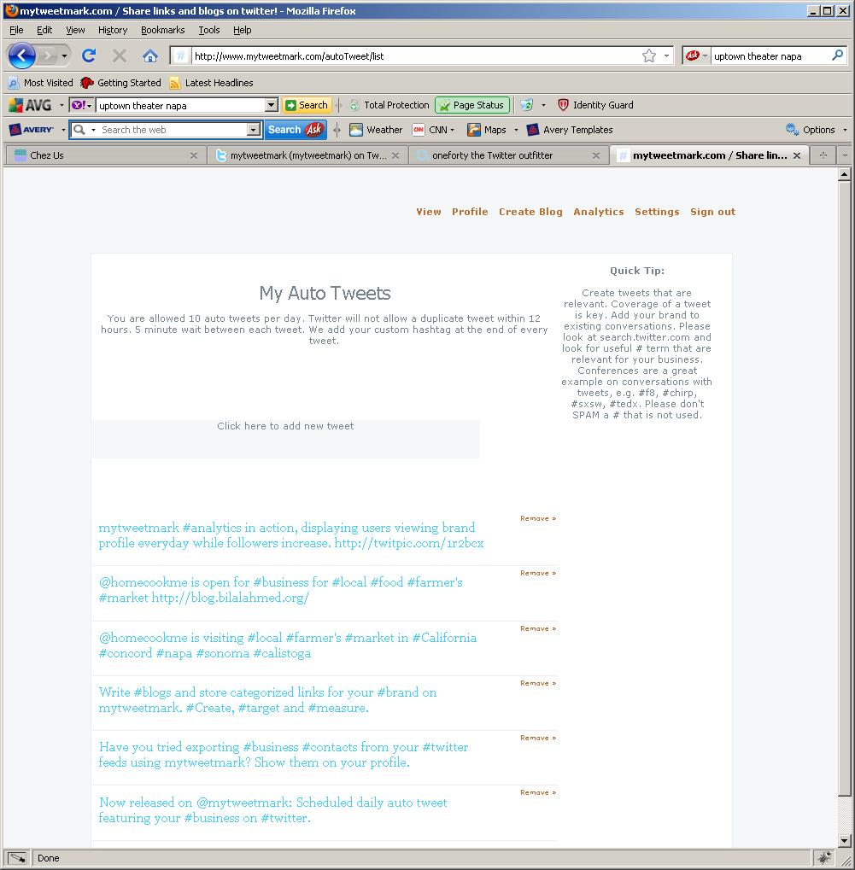

Analytics:
Any traffic that comes to @mytweetmark brand profile can be measured by analytics.

Login to @mytweetmark with @twitter account.
- To test the value of tweet by page views, go to Analytics, type in the twitter status with a link back to your @mytweetmark profile. For example, "Please try out http://www.mytweetmark.com/<usera> for #newtwitter #analytics ".
- To find the best hashtag to use, visit http://www.wefollow.com or http://search.twitter.com.
- Once measured marketing tweets impact, go to Auto Tweet section and fill in 20 tweets. In the tweets, also have links to your @mytweetmark blog that is measurable through analytics.
- Let's measure the quality and quantity of your followers and page views.
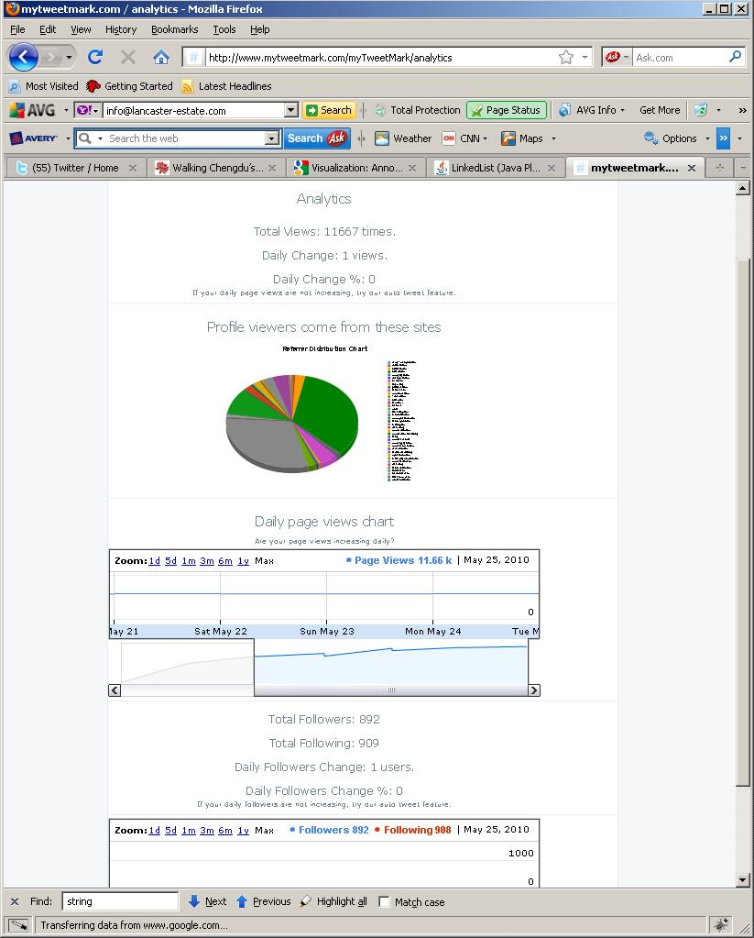

Questions?
Please email to bilal@mytweetmark.com.

