**AVFSM:** Fault-Injection Vulnerability Analysis in Finite State Machine at Gate-level

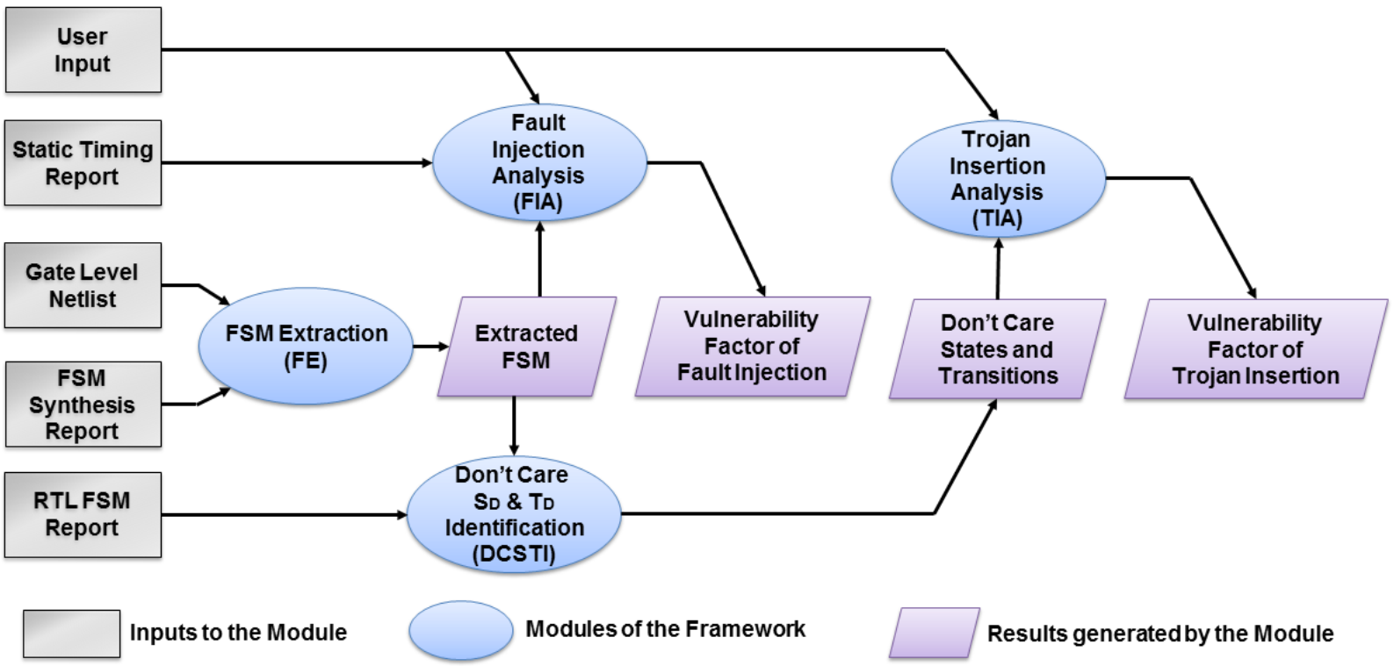

* AVFSM extracts the functionality of the FSM from a gate-level netlist. In addition to the states and transitions specified in the RTL level, AVFSM can extract the don’t-care states and transitions which are introduced during the synthesis process.
* AVFSM reports all the transitions during which a fault can be injected to gain unauthorized access to some secured or protected states.
* AVFSM reports a quantified measure of how susceptible the FSM is to fault injection and hardware Trojan.

Input: Gate-level netlist

Output: State transition graph, don’t-care states, Vulnerable transition to Fault-Injection attack, Quantified measure of the FSM vulnerability for Fault-injection and hardware trojan

**Contact**

ahmed.b@ufl.edu

**Existing CAD Tool Dependencies**

Synopsys TetraMAX, Synopsys PrimeTime, MATLAB

**Licensing Info**

For educational use only

**References**

Nahiyan, Adib, Kan Xiao, Kun Yang, Yeir Jin, Domenic Forte, and Mark Tehranipoor. "AVFSM: A framework for identifying and mitigating vulnerabilities in FSMs." In Proceedings of the 53rd Annual Design Automation Conference, pp. 1-6. 2016.

Ad security aware fsm paper