To: | Earlene W. Thomas, PE  Development Infrastructure Division  Planning & Development Department  101 City Hall Plaza, 4th Floor  Durham, NC 27701 | Date: | August 20, 2026
 |  | Project #: | R205114.000
From: | Chris Bahret, PE  Transportation Engineer, VHB | Re: | 3905 Page Road Industrial Trip Generation Durham, NC
This memorandum provides an assessment of the trip generation (site generated traffic volumes) for a proposed industrial development at 3905 Page Road in Durham, NC.

Project Background
The development at 3905 Page Road is located at the intersection of Page Road (SR 1973) and Airport Road (SR 1971), with frontage along both roadways. A concept plan is shown in Figure 1 below. Although the specific tenant has not been identified, the development is planned to be a single industrial building for light industrial use. The total building square footage in this concept plan is 132,080 sf; however, the analysis assumes up to 150,000 sf to provide a conservative buffer for minor changes to the building. Access to the proposal site is currently being reviewed; however, it will include driveway connections to Page Road along its western frontage and Airport Road along its eastern frontage.
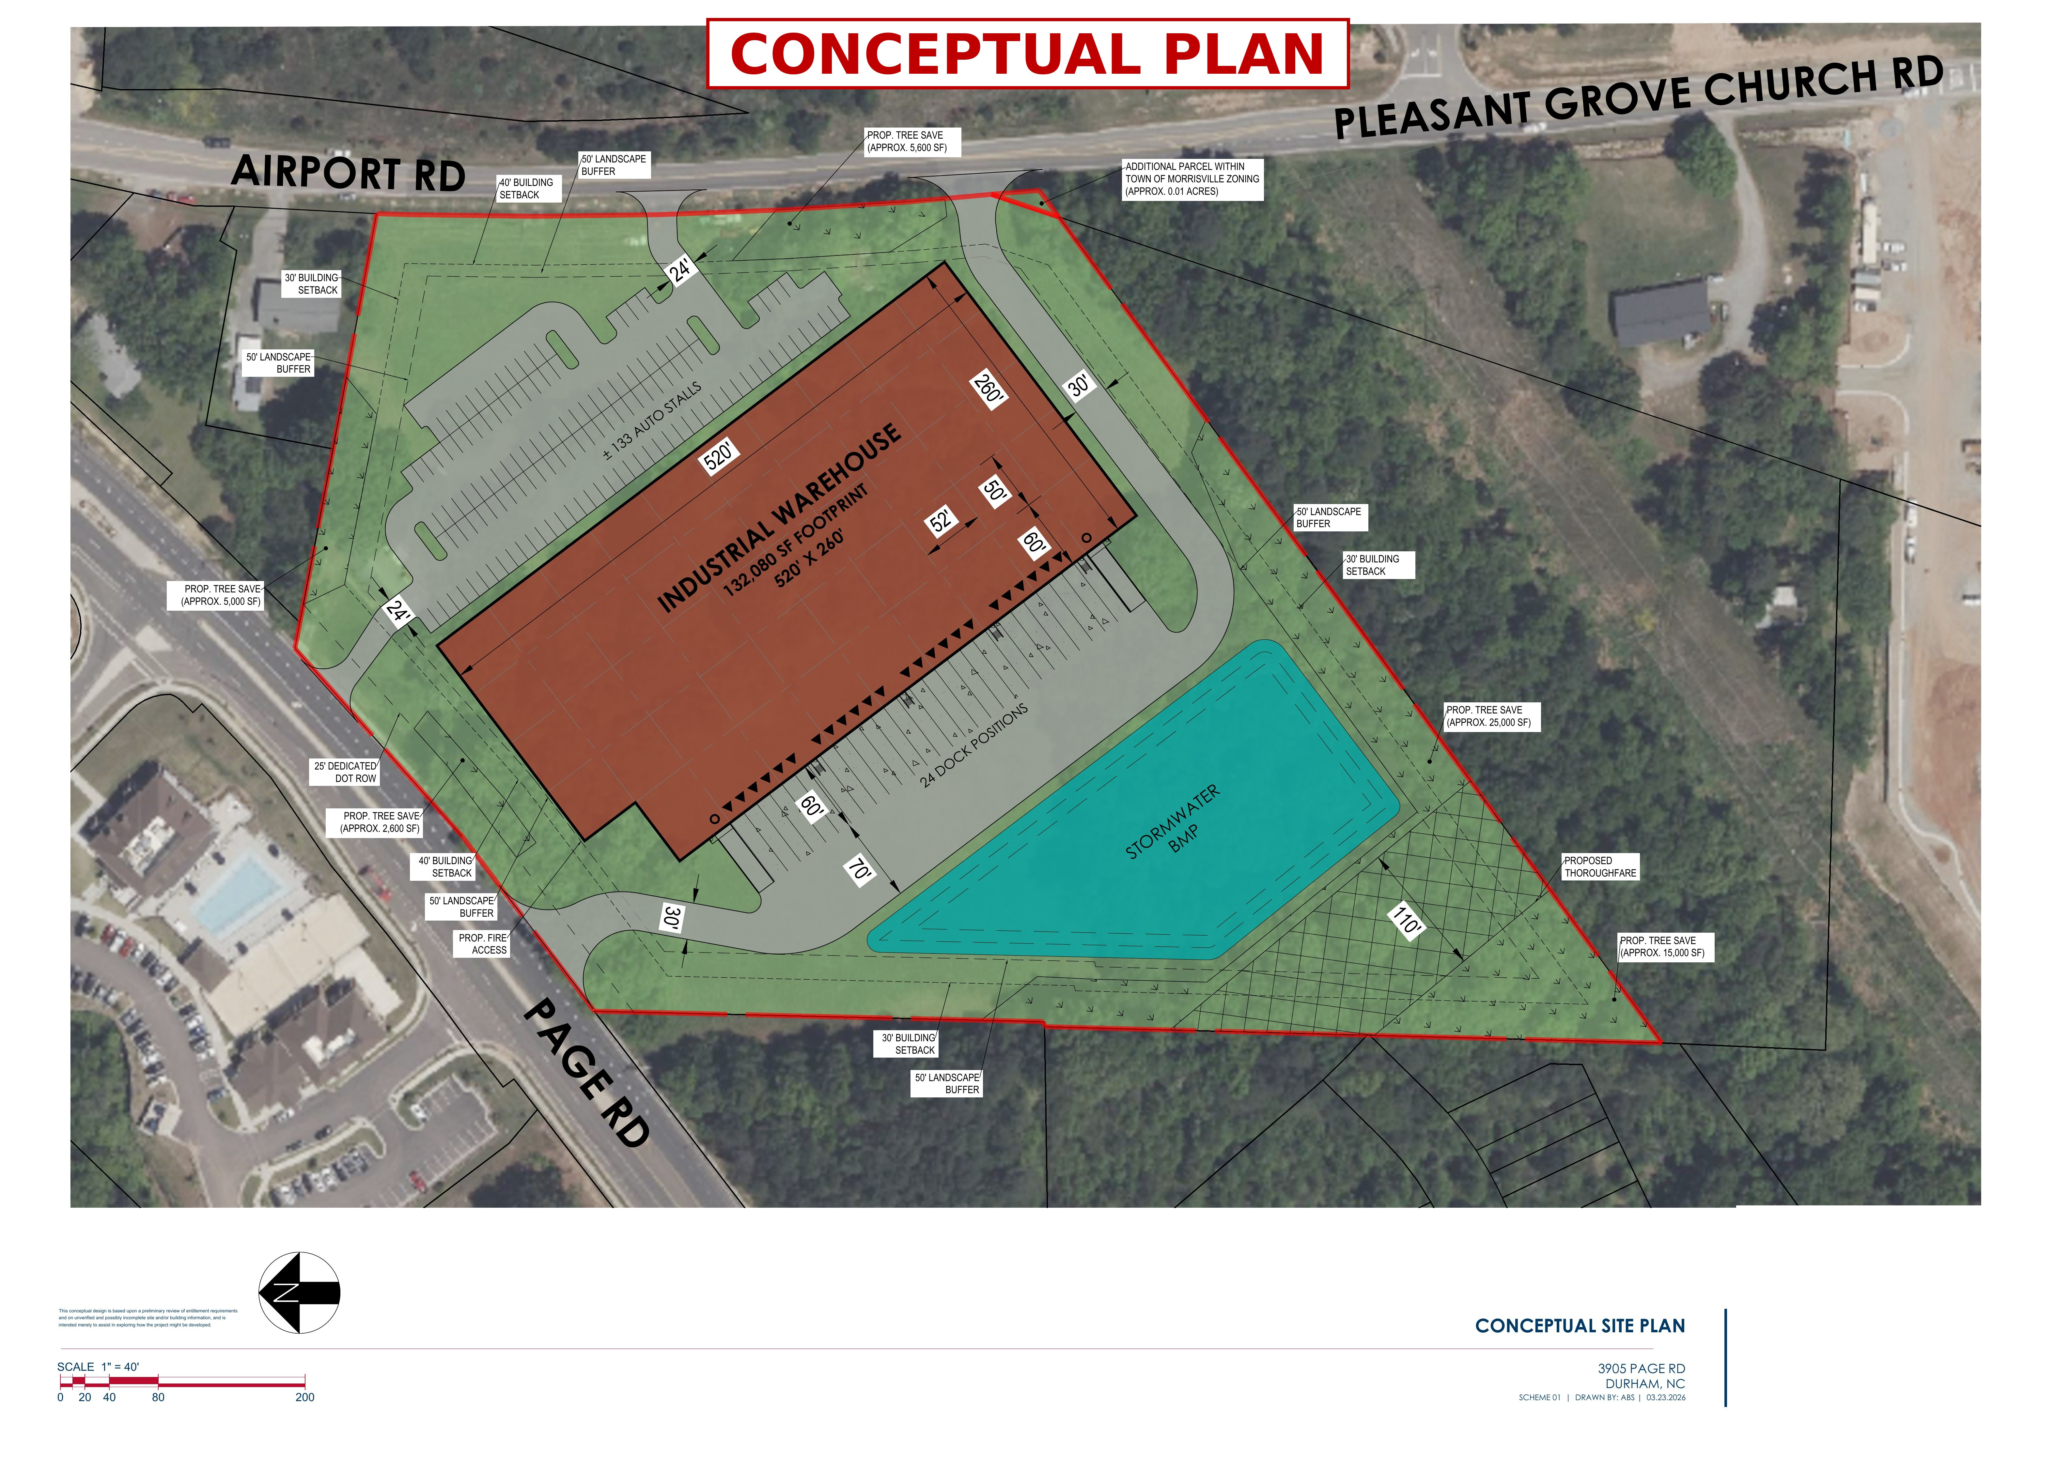
Figure 1: Concept Plan

Trip Generation
Trip generation estimates were prepared using the Institute of Transportation Engineers (ITE) Trip Generation Manual, 12th Edition. ITE Land Use Code (LUC) 110 (Light Industrial) was applied to reflect the anticipated use of the site. The resulting daily and peak-hour trips for the development are summarized in Table 1 below.

Table 1: Trip Generation – 3905 Page Road Development in Durham, NC
LUC¹ | Land Use | Unit | ADT | AM Peak Hour |  |  | PM Peak Hour
 |  |  |  | Enter | Exit | Total | Enter | Exit | Total
Total Site Trips
110 | Light Industrial | 150,000 sf | 540 | 62 | 10 | 72 | 18 | 56 | 74
Notes:
1. Land Use Code and trip generation rates are determined based on ITE Trip Generation, 12th Edition

Conclusion
Per Section 3.3 of the City of Durham Unified Development Ordinance (UDO), a Traffic Impact Analysis (TIA) is required for developments anticipated to generate 150 or more vehicle trips during a peak hour. As shown in Table 1, the proposed development is anticipated to generate 72 trips during the weekday AM peak hour and 74 trips during the weekday PM peak hour; therefore, a TIA is not required for the 3905 Page Road development. In addition, the total site trip generation of 540 daily trips is well below the NCDOT TIA threshold of 3,000 daily trips.

