To: | Earlene W. Thomas, PE  Development Infrastructure Division  Planning & Development Department  101 City Hall Plaza, 4th Floor  Durham, NC 27701 | Date: | August 7, 2026
 |  | Project #: | R205114.000
From: | Chris Bahret, PE  Transportation Engineer, VHB | Re: | 3905 Page Road Industrial Trip Generation Durham, NC
This memorandum provides an assessment of the trip generation (site generated traffic volumes) for a proposed industrial development at 3905 Page Road in Durham, NC.

Project Background
The development at 3905 Page Road is located at the intersection of Page Road (SR 1973) and Airport Road (SR 1971), with frontage along both roadways. The concept plan is shown in Figure 1 below and available in the Appendix located at the end of the memo. Although the specific tenant has not been identified, the development is planned to be a single industrial building for light industrial use. The total building square footage in the concept plan is 132,080 sf; however, the analysis assumes up to 150,000 sf to provide a conservative buffer for minor changes to the building. Access is proposed via two (2) driveways on Page Road and two (2) driveways on Airport Road.
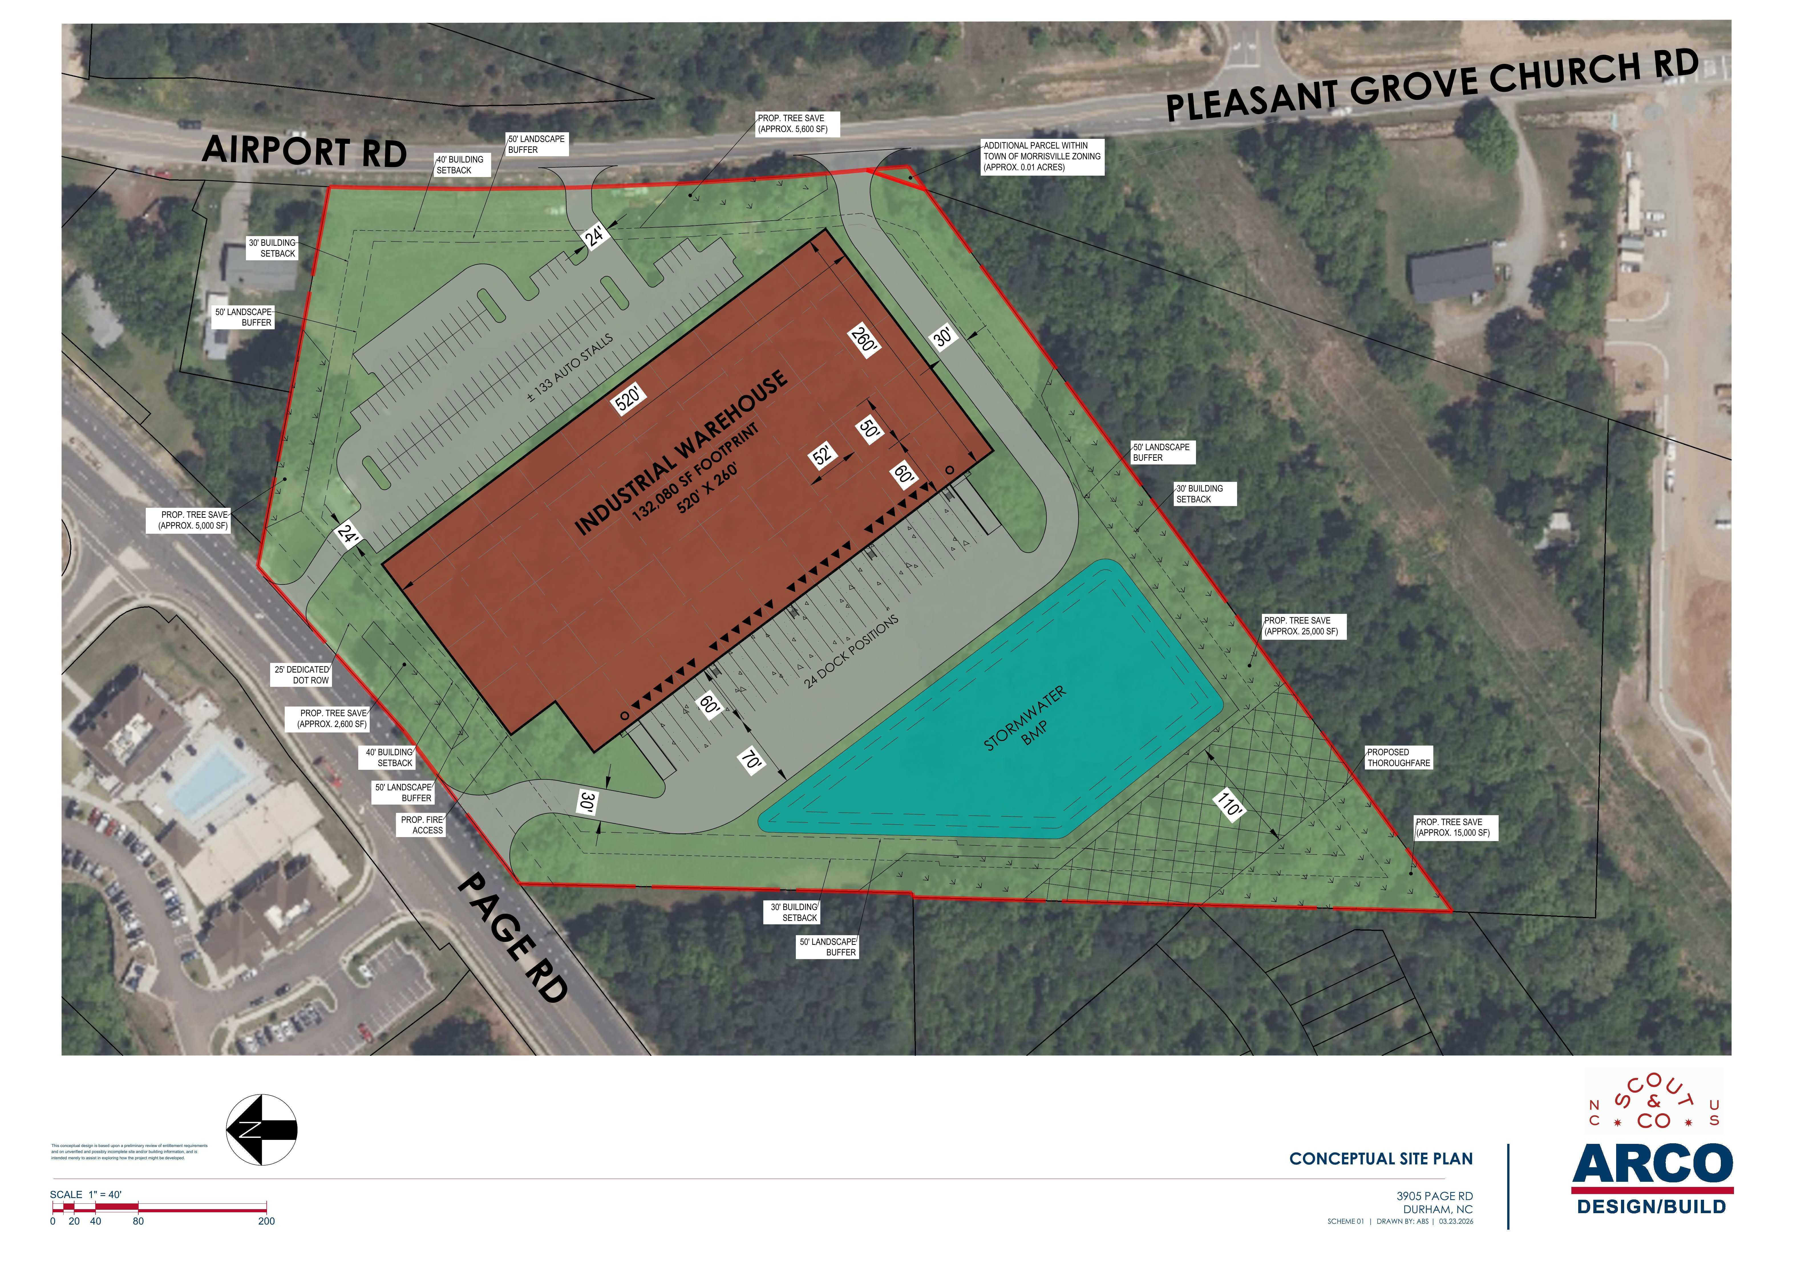
Figure 1: Concept Plan (also available at the end of the memo)

Trip Generation
Trip generation estimates were prepared using the Institute of Transportation Engineers (ITE) Trip Generation Manual, 12th Edition. ITE Land Use Code (LUC) 110 (Light Industrial) was applied to reflect the anticipated use of the site. The resulting daily and peak-hour trips for the development are summarized in Table 1 below.

Table 1: Trip Generation – 3905 Page Road Development in Durham, NC
LUC¹ | Land Use | Unit | ADT | AM Peak Hour |  |  | PM Peak Hour
 |  |  |  | Enter | Exit | Total | Enter | Exit | Total
Total Site Trips²
110 | Light Industrial | 150,000 sf | 540 | 62 | 10 | 72 | 18 | 56 | 74
Notes:
1. Land Use Code and trip generation rates are determined based on ITE Trip Generation, 12th Edition
2. Total site trips are determined based on the ITE average rates

Conclusion
Based on the trip generation results in Table 1, the proposed development is anticipated to generate 72 trips during the weekday AM peak hour and 74 trips during the weekday PM peak hour, fewer than 150 trips during both peak hours. Therefore, a Traffic Impact Analysis (TIA) is not required for the 3905 Page Road development under the City of Durham Unified Development Ordinance (UDO) Section 3.3 threshold. Given the relatively low site trip generation, the development is expected to have a minor traffic impact to the area.

Appendix
