Crash Pattern Summary and HSIP Warrant Analysis
NC 180/NC 226 (Post Rd) at SR 1103 (Pleasant Dr / Pleasant Hill Church Rd), Cleveland County, NCDOT Division 12
Order # 41000079736 | PH/SS # TSUINT716412 | TEAAS Intersection Analysis Report, 9/1/2016 to 8/31/2026 (10 years), Y-line 150 ft | 35.246324, -81.509409
Draft for the PE's review, prepared 10/10/2026 from the collision diagram (prepared from the DMV-349 reports), the TEAAS Intersection Analysis Report (29 crashes after the fiche review) and the reviewed fiche workbooks. Where the diagram and the TEAAS unit directions differ, the diagram governs (section 3f). Crash numbers are the TEAAS report order, which the diagram also uses (Appendix A).

1. The site
NC 180/NC 226 (Post Rd) is a two-lane, two-way undivided NC route posted 45 mph (every NC 180 unit on the 29 reports is coded with a 45 mph limit). SR 1103 crosses it at an acute skew of about 49 degrees: Pleasant Dr arrives from the northwest and Pleasant Hill Church Rd leaves to the southeast. Both SR 1103 approaches are stop-controlled (stop sign is the traffic control coded on 25 of the 29 reports; the other four code the double yellow centerline). The intersection is NC 180 milepost 4.601 and SR 1103 milepost 3.644 on the TEAAS features inventory. As labelled on the collision diagram, the M&D Quick Stop and a Dollar General sit on the west side of NC 180 on either side of Pleasant Dr; the east side is undeveloped land and an empty lot. Eight of the nine dark crashes are coded dark, roadway not lighted.
Traffic. Entering AADT uses each NCDOT count station's value for the middle year of the study period (2021), estimating the one missing year by straight-line interpolation (Table 1). The sum of the four legs divided by two is 12,050, rounded to 12,100 vehicles per day (TEAAS Chapter 8). The TEAAS run used 12,300, within 5 percent, so the TEAAS exposure statistics are reported as run. The two SR 1103 legs carry about 11 percent of the entering traffic.
Leg | NCDOT station | 2021 AADT | Basis
NC 180/NC 226 north | 0230000187 | 11,000 | 2021 count
NC 180/NC 226 south | 0230000152 | 10,500 | 2021 count
SR 1103 (Pleasant Dr) northwest | 0230000045 | 1,400 (estimate) | interpolated between the 2018 (1,600) and 2022 (1,300) counts, rounded to the nearest 100
SR 1103 (Pleasant Hill Church Rd) southeast | 0230000531 | 1,200 | 2021 count
Entering AADT |  | 12,100 | (11,000 + 10,500 + 1,400 + 1,200) / 2 = 12,050, rounded to the nearest hundred
Table 1. Middle-year (2021) AADT by leg (NCDOT Traffic Survey Group stations; 41000079736_AADT.xlsx and the ADT map).
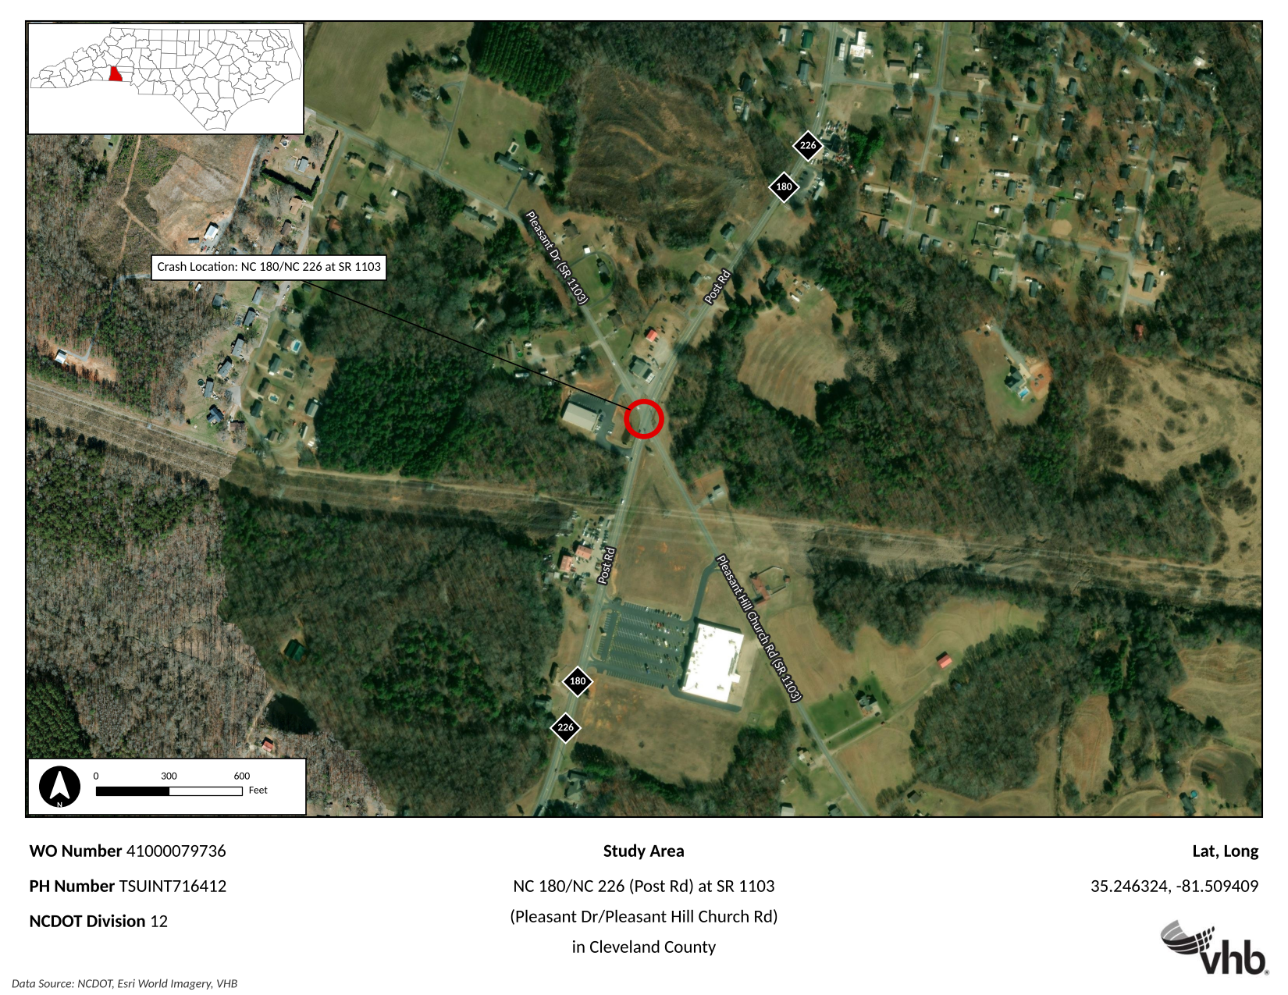
Figure 1. The study intersection (Esri World Imagery); Y-line 150 ft.

2. Crash history and TEAAS statistics
Ten years, 9/1/2016 to 8/31/2026, 29 crashes within the 150 ft Y-line after the fiche review (27 from the initial TEAAS pull, 2 added, 7 deleted; section 3j). No fatal crashes; 2 Class A, 4 Class B and 3 Class C injury crashes (18 injuries: 2 A, 6 B, 10 C) and 20 property damage only. Nine crashes at night (31 percent), four on a wet road (14 percent), none with alcohol or drugs suspected. Estimated property damage $182,400.
Exposure 44.92 million entering vehicles (MEV) at the TEAAS ADT of 12,300. Total crash rate 64.56 per 100 MEV; non-fatal injury 20.04; night 20.04; wet 8.90; EPDO rate 517.37. Severity index 8.01 and EPDO index 232.40 (76.8 for K/A, 8.4 for B/C). At the 12,100 middle-year entering AADT the exposure is 44.17 MEV and the total rate 65.66 per 100 MEV.
Crash type (TEAAS) | Crashes | Percent | Injury crashes (A / B / C)
Angle | 8 | 27.6 | 5 (1 / 2 / 2)
Left turn, different roadways | 9 | 31.0 | 2 (0 / 1 / 1)
Left turn, same roadway | 2 | 6.9 | 1 (1 / 0 / 0)
Right turn, different roadways | 2 | 6.9 | 1 (0 / 1 / 0)
Right turn, same roadway | 1 | 3.4 | 0
Frontal impact subtotal | 22 | 75.9 | 9 (2 / 4 / 3)
Rear end, slow or stop | 5 | 17.2 | 0
Fixed object (run off road) | 2 | 6.9 | 0
Total | 29 | 100.0 | 9 (2 / 4 / 3)
Table 2. Crashes by type. Frontal impact = angle, left turn and right turn (same or different roads) and head on, per the HSIP warrant definition.
Study year (Sep to Aug) | Crashes | Frontal | Injury | Crash numbers
2016-17 | 2 | 1 | 0 | 1, 2
2017-18 | 0 | 0 | 0
2018-19 | 0 | 0 | 0
2019-20 | 2 | 2 | 1 | 3, 4
2020-21 | 3 | 3 | 1 | 5, 6, 7
2021-22 | 5 | 2 | 0 | 8 to 12
2022-23 | 4 | 3 | 1 | 13 to 16
2023-24 | 3 | 2 | 1 | 17, 18, 19
2024-25 | 4 | 3 | 2 | 20 to 23
2025-26 | 6 | 6 | 3 | 24 to 29
Total | 29 | 22 | 9
Table 3. Crashes by study year. First five years 7 crashes (6 frontal, 2 injury); last five years 22 (16 frontal, 7 injury); last three years 13 (11 frontal, 6 injury); last year 6.

3. Crash patterns
Read from the collision diagram (Appendix B), which was drawn from the DMV-349 reports; Appendix A lists each crash as drawn beside the TEAAS coding.
- a. Frontal-impact crossing and turning crashes dominate. 22 of the 29 crashes (76 percent) are angle, left-turn or right-turn collisions at the intersection, and every one of the nine injury crashes is in this group. Angle crashes are the most severe type: 5 of the 8 produced injuries (crash 23 Class A, 5 and 29 Class B, 22 and 25 Class C).
- b. Every frontal crash is a minor-street vehicle entering or crossing from a SR 1103 stop sign. As drawn, all 22 involve a driver from Pleasant Dr (17 crashes) or Pleasant Hill Church Rd (5 crashes) pulling into the path of NC 180 traffic; in crash 27 the two minor-street drivers met each other entering northbound NC 180, and in crash 28 the southbound NC 180 driver (reckless) shares the fault. The reports code failure to yield for 15 of these drivers, one disregarded stop sign (26) and one inattention (1).
- c. Pleasant Dr left turns in front of southbound traffic are the pattern: inset A. Nine crashes (1, 3, 6, 10, 13, 14, 16, 21, 24) show a Pleasant Dr driver turning left toward northbound NC 180 and being struck by a southbound through vehicle (in 24 the southbound vehicle was itself turning left onto Pleasant Hill Church Rd). Two angle crashes (22, 25) put a Pleasant Dr driver crossing straight into the same southbound lane. The diagram stacks these 11 crashes at one point, the southbound lane just beyond the Pleasant Dr stop line: 38 percent of all crashes and four injuries (13 Class B, 24 Class A, 22 and 25 Class C) at a single conflict point. Four of the nine left-turn crashes were at night (1, 6, 14, 21) and two on a wet road (16, 21).
- d. The rest of the Pleasant Dr approach. Two right turns onto southbound NC 180 struck from behind by southbound traffic (4 Class B at night, 7); one left turn struck by a northbound vehicle (9, wet); two angle crashes with northbound traffic (23 Class A, 29 Class B); and the left turn that met a right-turning Pleasant Hill Church Rd driver (27). In all, 17 of the 22 frontal crashes and 7 of the 9 injury crashes start on Pleasant Dr, and in 13 of the 17 the vehicle struck was southbound.
- e. Pleasant Hill Church Rd: five frontal crashes, four of them with southbound traffic. Three angle crashes stacked in inset B where a Pleasant Hill Church Rd driver crossing straight was struck by a southbound vehicle (5 Class B at dusk, 26 at night, 28 with both drivers at fault), one left turn onto southbound NC 180 struck by a southbound vehicle (19 Class C, wet) and one right turn in front of a northbound vehicle (17).
- f. Southbound NC 180 is the through movement in 17 of the 21 frontal crashes with an NC 180 vehicle. Northbound traffic appears in only four (9, 17, 23, 29). For a driver stopped on Pleasant Dr the 49 degree skew puts southbound traffic about 130 degrees behind the left shoulder, with the M&D Quick Stop occupying the northwest quadrant between the stop line and the north leg; the north leg also bends slightly as it meets the intersection. Where the diagram governs: the TEAAS report codes the turning vehicle as a NC 180 unit in crashes 3, 13, 14, 19 and 24 and puts the minor-street vehicle on the opposite leg in 16 and 28; the diagram, drawn from the reports, shows the movements above, so no NC 180 turning pattern is counted (NC 180 vehicles are turning only as the struck vehicle in 24 and the left-turning vehicle rear-ended in 15).
- g. Rear ends: 5 crashes, all property damage only. Four are on the SR 1103 approaches behind a vehicle stopped at the stop sign (2 and 18 on Pleasant Dr, 8 and 20 on Pleasant Hill Church Rd); one (15) is northbound on NC 180 behind a vehicle slowing to turn left toward Pleasant Dr.
- h. Run-off-road: 2 crashes (11, 12), not a pattern. Both single-vehicle, at night on a dry road, property damage only: a southbound driver who overcorrected and left the west side at the Pleasant Dr corner (12), and a northbound driver turning right at 45 mph (inattention) who ran off the east side (11).
- i. Time of day. 14 of the 29 crashes (48 percent) occurred between 3:00 and 5:59 PM (7 in the 5:00 PM hour alone), 4 between 7:00 and 8:59 AM and 4 between 9:00 and 10:59 PM. Nine crashes were at night (31 percent): 7 frontal (1, 4, 6, 14, 21, 24, 26) and the 2 run-off-road crashes. Only crash 1 codes a lighted roadway. Tuesday (9) and Monday (6) are the most frequent days; December (6) the most frequent month.
- j. Weather and surface. 25 crashes on a dry road, 4 wet (9, 16, 21 Pleasant Dr left turns and 19, the Pleasant Hill Church Rd left turn). The wet rate of 8.90 per 100 MEV and the 14 percent wet share do not indicate a wet-pavement problem.
- k. Trend: frequency and severity are rising while traffic is flat. 7 crashes in the first five years against 22 in the last five; 13 (45 percent) in the last three years and 6 in the last year. Seven of the nine injury crashes occurred since September 2021 and six of them in the last three years, including both Class A crashes (23 on 5/19/2025, 24 on 12/16/2025) and the three injury crashes of the 2025-26 study year. NC 180 counts have stayed between 10,500 and 12,000 vehicles per day since 2016, so the increase is not volume-driven.
- l. Fiche review. Two crashes were added after the DMV-349s were read: 106808749 (12/17/2021, rear end on the Pleasant Hill Church Rd approach, referenced to SR 1103 MP 3.019) and 107960640 (12/15/2024, left turn at the study intersection, not mileposted). Seven were deleted: three animal crashes (105334401, 106653569, 107468199), two fixed-object crashes (106482677; 108204170 at the Dollar General driveway), one opposite-direction sideswipe (106251888) and one left-turn crash referenced just beyond 150 ft (107921860). All seven are property damage only. Adding any of them back lowers the frontal share and the severity index without changing the warrant result (section 4).

4. HSIP warrant analysis
TEAAS classes the location as rural, so the ten-year rural intersection warrants of the NCDOT Highway Safety Improvement Program apply (2024 HSIP Overview, Safety Warrants; the criteria are unchanged in the current cycle). The criteria are applied to the 29 crashes of the study window 9/1/2016 to 8/31/2026. A frontal impact crash is an angle, left-turn, right-turn or head-on crash.
Warrant | Criteria (rural, 10 years) | This location | Result
I-1r Frontal Impact Rural | At least 9 frontal impact crashes, AND at least 60% of all crashes frontal impact, AND at least 20% of all crashes in the last 3 years | 22 frontal impact crashes; 75.9% of 29; 13 of 29 (44.8%) in 9/2023 to 8/2026 | MET
I-2r Last Year Increase Rural | At least 20 total crashes AND at least 32% of them in the last year | 29 crashes; 6 (20.7%) in 9/2025 to 8/2026 | Not met
I-3r Frequency with Severity Index Minimum Rural | At least 20 total crashes AND severity index at least 9.0 AND at least 30% of crashes in the last 3 years | 29 crashes; severity index 8.01; 44.8% in the last 3 years | Not met (severity index)
I-3 Fatal and Severe Injury (urban and rural) | At least 3 fatal or A injury frontal impact crashes in the last 5 years | 2 in 9/2021 to 8/2026: 108120512 (angle, 5/19/2025) and 108353439 (left turn, 12/16/2025) | Not met
I-4r Night Location Rural | At least 10 night crashes AND at least 46% of crashes at night AND at least 20% of crashes in the last 3 years | 9 night crashes (31.0%); 44.8% in the last 3 years | Not met
Table 4. NCDOT HSIP rural intersection warrants applied to the 29-crash, 10-year study.
Result. The location meets Warrant I-1r, Frontal Impact Rural: 22 frontal impact crashes, 76 percent of all crashes, with 45 percent of the crashes in the last three years. The identified pattern is minor-street vehicles from SR 1103, chiefly Pleasant Dr drivers turning left or crossing in front of southbound NC 180 traffic (inset A on the diagram), failing to yield to through traffic.
Margins on the other warrants. I-3 is one crash short: a third fatal or A injury frontal impact crash in the five-year window would satisfy it, and both A crashes to date occurred in 2025. I-3r is short only on the severity index (8.01 against 9.0); one more A injury crash would lift the index above 10. I-2r would need 10 crashes in a single study year (the last year had 6). I-4r would need 14 of 29 crashes at night (9 recorded).
Sensitivity to the fiche review. With all seven deleted crashes added back (36 crashes) the frontal share is 64 percent and the severity index 6.65; with only the two fixed-object crashes added back (31 crashes) 71 percent and 7.56; with the six non-frontal deletions added back (35 crashes) 63 percent and 6.81. I-1r is met in every case and no other warrant changes (warrants.py, review/warrant_check_10yr.txt).
Five-year check. For reference, the five-year window 9/2021 to 8/2026 (22 crashes, 16 frontal, 73 percent, 10 of 22 in the last two years) would also satisfy the urban frontal impact warrant I-1u(a) if the location were treated as urban.

5. Findings
- The intersection has a clear, worsening frontal-impact pattern that meets HSIP Warrant I-1r. Three quarters of the crashes and all nine injury crashes are minor-street vehicles entering or crossing NC 180 from the SR 1103 stop signs.
- The dominant conflict is a Pleasant Dr driver turning left (9 crashes) or crossing (2) in front of southbound NC 180 traffic, stacked at one point just beyond the Pleasant Dr stop line (inset A: 11 of 29 crashes, four with injuries). With the six other Pleasant Dr entries, 17 of the 22 frontal crashes and 7 of the 9 injury crashes start on that one approach, and in 13 of the 17 the vehicle struck was southbound. The 49 degree skew places southbound traffic far behind the stopped driver's left shoulder and the M&D Quick Stop sits in that sight triangle; sight distance, the skew and the driveways are the field questions that decide the countermeasure.
- Pleasant Hill Church Rd adds five frontal crashes, four of them with southbound traffic (the three stacked angle crashes of inset B and the left turn 19); the same southbound movement is the striking vehicle in 17 of the 21 frontal crashes with an NC 180 unit.
- As drawn from the reports there is no NC 180 turning pattern; the TEAAS unit directions that code a NC 180 turner in crashes 3, 13, 14, 19 and 24 are superseded by the diagram.
- Severity is concentrated in the last two years: both Class A crashes and 5 of the 9 injury crashes since March 2025. The location is one K or A frontal crash short of Warrant I-3 and one severe crash short of the I-3r severity index.
- Night (31 percent) and wet (14 percent) shares are not patterns in themselves, but 7 of the 9 night crashes are frontal impacts at an unlit intersection, so lighting belongs in the countermeasure discussion.

6. Field investigation: what to verify on site
- Intersection sight distance from the Pleasant Dr stop line looking north (left) toward southbound traffic, and from the Pleasant Hill Church Rd stop line in both directions, measured against the 45 mph requirement; the skew angle; the M&D Quick Stop building, canopy, signs and parked vehicles in the northwest sight triangle; vegetation, utility poles and the Dollar General frontage.
- Where the Pleasant Dr stop line sits relative to the southbound lane: with the skew, the distance from the stop line to the conflict point of inset A, and whether drivers creep past it to see.
- Stop control: STOP sign size, condition and retroreflectivity, STOP AHEAD signing, stop bar and centerline condition on both SR 1103 approaches; whether a CROSS TRAFFIC DOES NOT STOP plaque is posted; approach grades.
- The southbound NC 180 approach: alignment and grade of the north leg into the intersection, intersection warning signs (W2-1 or W2-2 with street name plaques) and their advance distance, lane and shoulder widths, pavement markings, passing-zone striping through the intersection (four reports code the double yellow line as the control); the same for northbound.
- Posted speed limits in both directions on NC 180 and on SR 1103 (the reports code 45 mph on NC 180; SR 1103 units are mostly coded 45 but three are coded 35).
- Lighting: confirm none is present; location of the existing light at the convenience store (crash 1 is coded dark, lighted).
- Driveways: number, width and throat of the Dollar General and M&D Quick Stop driveways and their distance to the SR 1103 stop lines; the fixed-object crash 108204170 was deleted as a driveway (PVA) crash.
- Spot speeds on southbound NC 180 (impact speeds of 45 to 55 mph appear on the reports) and a count of the SR 1103 approach volumes and turning movements during the 3:00 to 6:00 PM peak, when half the crashes occurred; the Pleasant Dr left-turn volume in particular.
- Evidence of the pattern still visible: tire marks and debris at the inset A conflict point in the southbound lane, damaged signs or poles.

7. Candidate countermeasures for the PE's consideration
The site findings decide which of these apply; they are listed from low cost to capital.
- Stop-approach conspicuity on SR 1103, Pleasant Dr first: oversize STOP signs with retroreflective post strips or flashing LED borders, STOP AHEAD signs, CROSS TRAFFIC DOES NOT STOP plaques, refreshed stop bars, and transverse rumble strips on the Pleasant Dr approach.
- Sight-line clearing in the northwest quadrant (M&D Quick Stop frontage) and driveway management on Pleasant Dr.
- Advance intersection warning on NC 180 in both directions with street-name plaques, and an intersection conflict warning system (VEHICLE ENTERING WHEN FLASHING beacons on the southbound approach, actuated from the SR 1103 approaches) if the sight-distance review supports it.
- Intersection lighting, given 7 frontal crashes in the dark at an unlit location.
- Geometric correction of the skew: realigning the Pleasant Dr approach to meet NC 180 near 90 degrees, which turns the look-back for southbound traffic into a normal left look, or offsetting the two SR 1103 legs.
- Restricting the Pleasant Dr left turn and the through movement: a reduced-conflict (J-turn) configuration on NC 180 removes the 9 left-turn and 2 crossing crashes of inset A and the inset B crossings from Pleasant Hill Church Rd at their source; an all-way stop or signal study is the alternative. Minor-street volumes of 1,200 to 1,400 vehicles per day are unlikely to satisfy volume warrants, but the 6 crashes of the last study year, 5 of them frontal, are worth a check against the MUTCD crash-experience signal warrant during the field investigation.

8. Record
- TEAAS: data/41000079736_CrashAnalysis10yr.pdf (Intersection Analysis Report, 29 crashes), data/41000079736_CrashAnalysis10yr_29crashes.csv, Features Reports for NC 180 and SR 1103.
- Fiche: 41000079736_Fiche10yr.xlsx (both reviewed fiche workbooks combined in the package layout, reviewer's comments kept); fiche_review.py and review/ for the screening.
- Collision diagram: data/41000079736_CollisionDiagram_VHB.pdf (MicroStation sheet with the AADT and speed labels) and maps/41000079736_CollisionDiagram_labeled.pdf (the same sheet enlarged, Appendix B); review/collision_diagram_listing.csv and review/collision_diagram_as_drawn.csv (Appendix A).
- AADT: 41000079736_AADT.xlsx, 41000079736_CalculatedAADT.xls, aadt.json, maps/41000079736_ADTMap.pdf.
- Maps: maps/41000079736_LocationMap.pdf, 41000079736_AreaMap.pdf, 41000079736_ADTMap.pdf.
- Warrants: warrants.py and review/warrant_check_10yr.txt (scenarios A to D); criteria from the NCDOT 2024 HSIP Overview, Safety Warrants.

Appendix A. The 29 crashes (TEAAS report order)
No | Crash ID | Date | Time | TEAAS type | Sev | Light | Road | TEAAS units (direction / maneuver / impact speed / contributing circumstance) | As drawn on the collision diagram (at-fault vehicle vs other vehicle) | Differs
1 | 104908181 | 11/08/2016 | 19:02 | Angle | O | Dark-lighted | Dry | U1 E left turn 10 mph - inattention; U2 S straight 40 mph | Pleasant Dr (NW leg) left turn vs NC 180 southbound straight | yes
2 | 105162557 | 07/16/2017 | 13:53 | Rear end, slow or stop | O | Daylight | Dry | U1 E straight 5 mph - failure to reduce speed; U2 E stopped 0 mph | Rear end on Pleasant Dr approach: struck a vehicle stopped ahead
3 | 106032499 | 10/14/2019 | 07:59 | Left turn, different roadways | O | Daylight | Dry | U1 N left turn 10 mph - failed to yield ROW; U2 S straight 35 mph | Pleasant Dr (NW leg) left turn vs NC 180 southbound straight | yes
4 | 106234219 | 05/23/2020 | 21:31 | Right turn, different roadways | B | Dark-not lighted | Dry | U1 E right turn 10 mph - failed to yield ROW; U2 S straight 35 mph | Pleasant Dr (NW leg) right turn vs NC 180 southbound straight
5 | 106423994 | 12/01/2020 | 17:41 | Angle | B | Dusk | Dry | U1 W straight 20 mph - failed to yield ROW; U2 S straight 45 mph; U3 E stopped 0 mph | Pleasant Hill Church Rd (SE leg) straight vs NC 180 southbound straight
6 | 106442060 | 12/19/2020 | 17:44 | Left turn, different roadways | O | Dark-not lighted | Dry | U1 E left turn 15 mph - failed to yield ROW; U2 S straight 35 mph | Pleasant Dr (NW leg) left turn vs NC 180 southbound straight
7 | 106691473 | 08/24/2021 | 15:45 | Right turn, different roadways | O | Daylight | Dry | U1 SE right turn 10 mph - failed to yield ROW; U2 S straight 45 mph | Pleasant Dr (NW leg) right turn vs NC 180 southbound straight
8 | 106808749 | 12/17/2021 | 15:17 | Rear end, slow or stop | O | Daylight | Dry | U1 W straight 10 mph; U2 W stopped 0 mph | Rear end on Pleasant Hill Church Rd approach: struck a vehicle stopped ahead
9 | 106839126 | 01/20/2022 | 07:57 | Left turn, different roadways | O | Daylight | Wet | U1 E left turn 15 mph - failed to yield ROW; U2 N straight 45 mph | Pleasant Dr (NW leg) left turn vs NC 180 northbound straight
10 | 106893683 | 03/15/2022 | 11:33 | Left turn, different roadways | O | Daylight | Dry | U1 E left turn 25 mph - failed to yield ROW; U2 S slowing 10 mph | Pleasant Dr (NW leg) left turn vs NC 180 southbound straight
11 | 107037107 | 08/03/2022 | 22:43 | Fixed object | O | Dark-not lighted | Dry | U1 N right turn 45 mph - inattention | NC 180 northbound vehicle ran off road east
12 | 107067627 | 08/28/2022 | 00:08 | Fixed object | O | Dark-not lighted | Dry | U1 S straight 45 mph - overcorrected | NC 180 southbound vehicle ran off road west
13 | 107086689 | 09/13/2022 | 17:28 | Left turn, different roadways | B | Daylight | Dry | U1 N left turn 10 mph - failed to yield ROW; U2 S straight 35 mph | Pleasant Dr (NW leg) left turn vs NC 180 southbound straight | yes
14 | 107127945 | 10/24/2022 | 20:40 | Left turn, different roadways | O | Dark-not lighted | Dry | U1 S left turn 25 mph - failed to yield ROW; U2 N straight 55 mph | Pleasant Dr (NW leg) left turn vs NC 180 southbound straight | yes
15 | 107162484 | 11/28/2022 | 16:16 | Rear end, slow or stop | O | Daylight | Dry | U1 N straight 40 mph - failure to reduce speed; U2 N stopped 0 mph | Rear end on NC 180 northbound: struck a vehicle ahead slowing to turn left toward Pleasant Dr
16 | 107171393 | 12/05/2022 | 15:11 | Left turn, different roadways | O | Daylight | Wet | U1 W left turn 10 mph - failed to yield ROW; U2 N straight 45 mph | Pleasant Dr (NW leg) left turn vs NC 180 southbound straight | yes
17 | 107473530 | 09/26/2023 | 17:58 | Right turn, same roadway | O | Daylight | Dry | U1 NW right turn 5 mph - failed to yield ROW; U2 N straight 40 mph | Pleasant Hill Church Rd (SE leg) right turn vs NC 180 northbound straight
18 | 107503115 | 10/24/2023 | 17:25 | Rear end, slow or stop | O | Daylight | Dry | U1 SE straight 10 mph - failure to reduce speed; U2 SE stopped 0 mph | Rear end on Pleasant Dr approach: struck a vehicle stopped ahead
19 | 107790631 | 07/16/2024 | 17:09 | Left turn, different roadways | C | Daylight | Wet | U1 S left turn 15 mph - failed to yield ROW; U2 S straight 45 mph; U3 N straight 35 mph | Pleasant Hill Church Rd (SE leg) left turn vs NC 180 southbound straight | yes
20 | 107915535 | 11/08/2024 | 16:26 | Rear end, slow or stop | O | Daylight | Dry | U1 W straight 5 mph - failure to reduce speed; U2 W stopped 0 mph | Rear end on Pleasant Hill Church Rd approach: struck a vehicle stopped ahead
21 | 107960640 | 12/15/2024 | 17:52 | Left turn, different roadways | O | Dark-not lighted | Wet | U1 E left turn 10 mph - failed to yield ROW; U2 S straight 45 mph | Pleasant Dr (NW leg) left turn vs NC 180 southbound straight
22 | 108045557 | 03/07/2025 | 14:25 | Angle | C | Daylight | Dry | U1 E straight 10 mph - failed to yield ROW; U2 S straight 30 mph | Pleasant Dr (NW leg) straight vs NC 180 southbound straight
23 | 108120512 | 05/19/2025 | 18:55 | Angle | A | Daylight | Dry | U1 E straight 15 mph - failed to yield ROW; U2 N straight 45 mph | Pleasant Dr (NW leg) straight vs NC 180 northbound straight
24 | 108353439 | 12/16/2025 | 21:12 | Left turn, same roadway | A | Dark-not lighted | Dry | U1 N left turn 15 mph - failed to yield ROW; U2 S left turn 25 mph | Pleasant Dr left turn vs NC 180 southbound vehicle turning left | yes
25 | 108387988 | 01/22/2026 | 15:02 | Angle | C | Daylight | Dry | U1 E straight 10 mph - failed to yield ROW; U2 S straight 35 mph | Pleasant Dr (NW leg) straight vs NC 180 southbound straight
26 | 108431889 | 03/14/2026 | 21:30 | Angle | O | Dark-not lighted | Dry | U1 W straight 25 mph - disregarded stop sign; U2 S straight 35 mph | Pleasant Hill Church Rd (SE leg) straight vs NC 180 southbound straight
27 | 108453977 | 03/23/2026 | 07:38 | Left turn, same roadway | O | Daylight | Dry | U1 E left turn 10 mph - failed to yield ROW; U2 W right turn 10 mph | Pleasant Dr left turn onto northbound NC 180 vs Pleasant Hill Church Rd right turn onto northbound NC 180
28 | 108502945 | 05/15/2026 | 15:00 | Angle | O | Daylight | Dry | U1 S straight 35 mph - erratic/reckless; U2 E straight 10 mph - failed to yield ROW | NC 180 southbound straight (at fault) vs Pleasant Hill Church Rd straight across (also at fault) | yes
29 | 108564225 | 07/08/2026 | 08:58 | Angle | B | Daylight | Dry | U1 N straight 45 mph; U2 E straight 15 mph - failed to yield ROW | Pleasant Dr (NW leg) straight vs NC 180 northbound straight
Severity O = property damage only. TEAAS columns from the TEAAS collision diagram export (data/41000079736_CollisionDiagramData.csv); the last two columns are read from the collision diagram, and Differs marks the crashes where the diagram places the vehicles differently from the TEAAS unit directions (the diagram governs).

Appendix B. Collision diagram
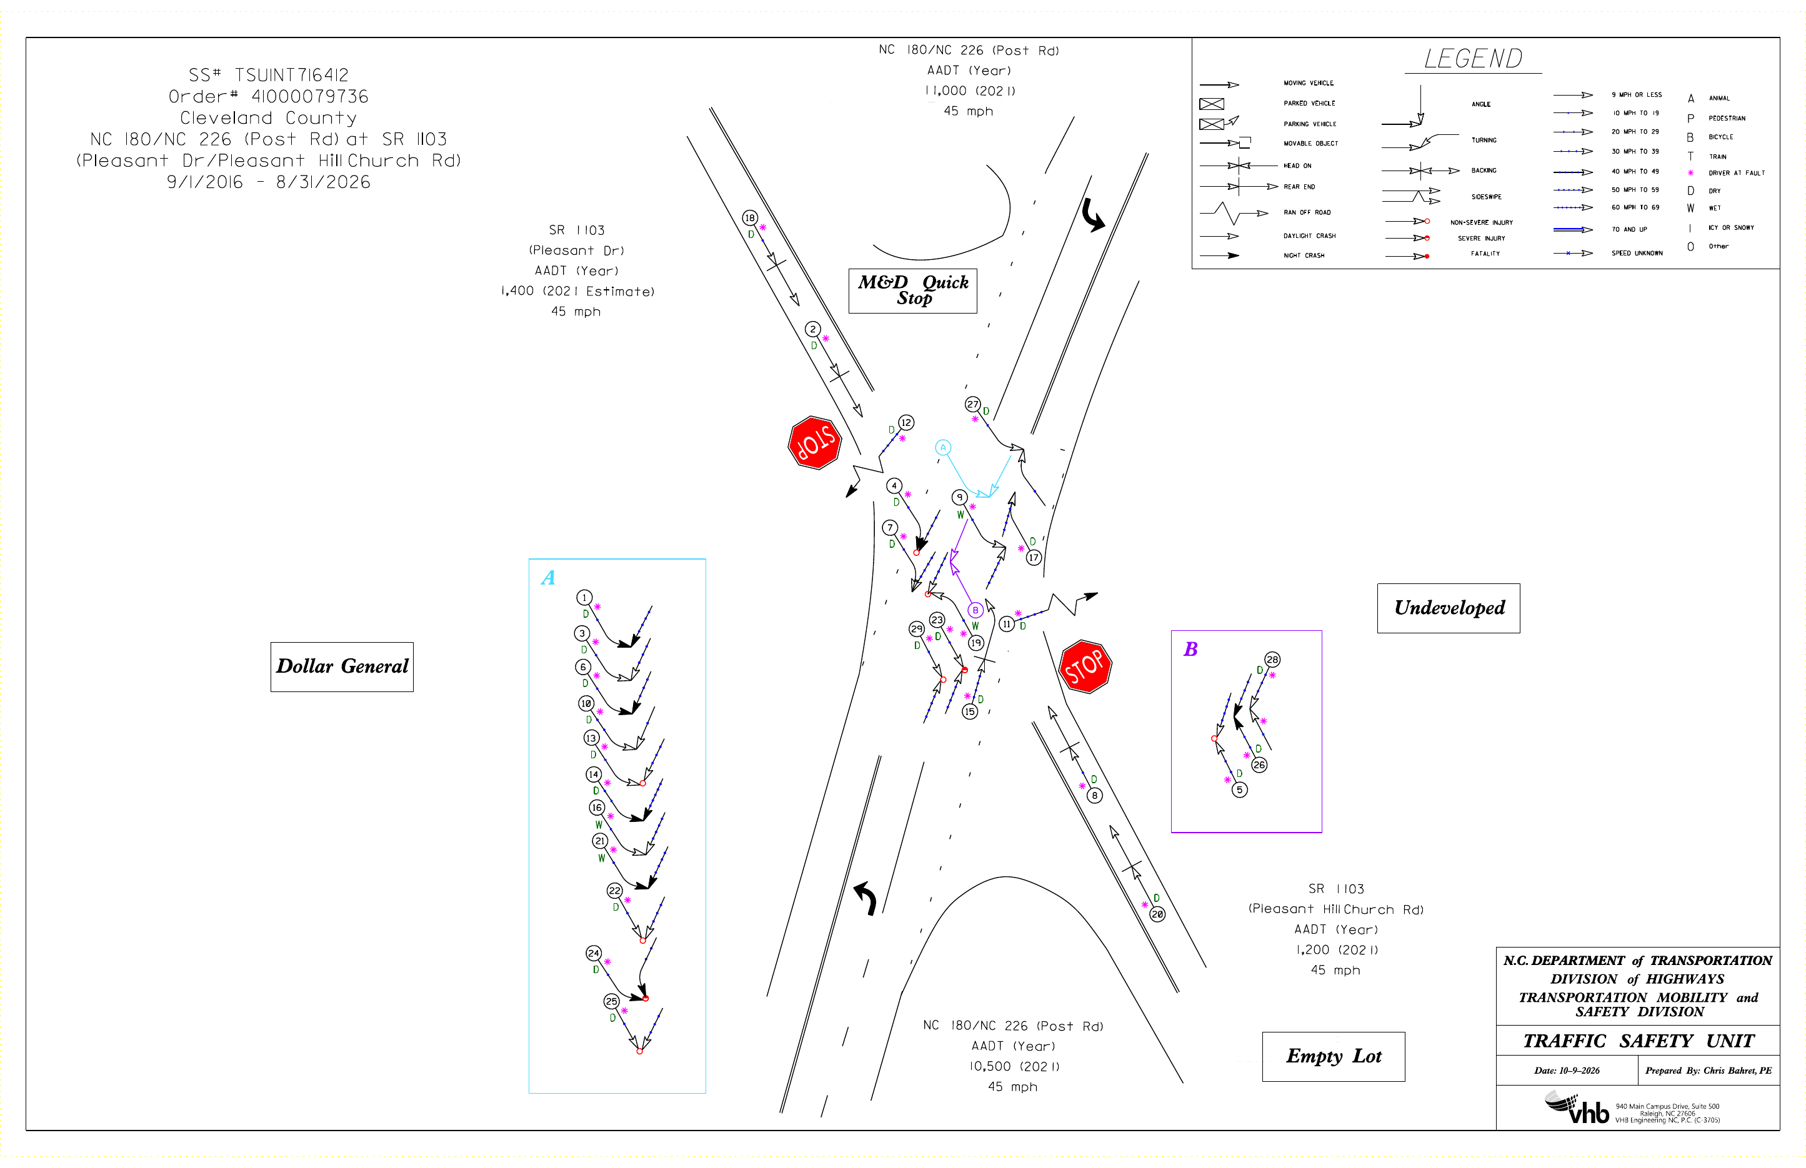
Figure 2. Collision diagram, 9/1/2016 to 8/31/2026 (MicroStation sheet, enlarged; maps/41000079736_CollisionDiagram_labeled.pdf). Numbers are the TEAAS report order of Appendix A.

