Safety Project Evaluation
Order ID: 41000076579
Project ID: 05-20-62123 (TIP #HS-2005A)
Signal ID: N/A
Location: SR 1602 (Main Street) at SR 1207 (Spring Street)
GPS Coordinates: 36.310027, -78.587328
County: Granville
City: Oxford
Division: 5

Countermeasure(s): Construct a Mini-Roundabout, replacing the stop signs on Spring Street. Pedestrian upgrades included crosswalks and curb ramps on all four legs, splitter island refuges on the north and west legs, and in-street yield to pedestrian signs (R1-6) in those islands. Signs installed were yield (R1-2) and roundabout ahead (W2-6) signs on all four approaches and chevron signs (R6-4) on the central island.
Estimated Project Cost: $278,000.00
Completion Date: 12/15/2021

 | Start Date | End Date | Length
Before Period | 3/1/2017 | 9/30/2021 | 4y, 7m
Construction Period | 10/1/2021 | 12/31/2021 | 0y, 3m
After Period | 1/1/2022 | 7/31/2026 | 4y, 7m

Analysis Criteria: Treatment data consists of all crashes within 150 ft of study intersection

Target Crashes: Frontal Impact Crashes in Intersection: Angle, Left Turn Different Roadways (LTDR), Left Turn Same Roadway (LTSR), Right Turn Different Roadways (RTDR), Right Turn Same Roadway (RTSR) and Head-On

Project Development Comparison
Crashes Per Year by Project Time Period | Project Development | Before  Period | After  Period
Years | 10 years | 4.58 years | 4.58 years
Start Date | 8/1/2010 | 3/1/2017 | 1/1/2022
End Date | 7/31/2020 | 9/30/2021 | 7/31/2026
Total | 1.90 | 1.53 | 0.65
Fatal Injury | 0.00 | 0.00 | 0.00
Class A Injury | 0.00 | 0.00 | 0.00
Class B Injury | 0.10 | 0.00 | 0.00
Class C Injury | 0.30 | 0.22 | 0.00
Property Damage Only | 1.50 | 1.31 | 0.65

Treatment Information | Before | After | Percent Reduction (-)  Percent Increase (+)
Total Crashes | 7 | 3 | -57.14%
Total Severity Index | 2.06 | 1.00 | -51.46%
Target Crashes | 3 | 2 | -33.33%
Target Crash Severity Index | 1.00 | 1.00 | 0.00%
Volume (2019, 2025) | 5,100 | 4,300 | -15.69%

Injury Crash Summary | Before | After | Percent Reduction (-)  Percent Increase (+)
Fatal Injury Crashes | 0 | 0 | n/a
Class A Injury Crashes | 0 | 0 | n/a
Class B Injury Crashes | 0 | 0 | n/a
Class C Injury Crashes | 1 | 0 | -100.00%
Property Damage Only | 6 | 3 | -50.00%

Target Injury Crash Summary | Before | After | Percent Reduction (-)  Percent Increase (+)
Fatal Injury Crashes | 0 | 0 | n/a
Class A Injury Crashes | 0 | 0 | n/a
Class B Injury Crashes | 0 | 0 | n/a
Class C Injury Crashes | 0 | 0 | n/a
Property Damage Only | 3 | 2 | -33.33%

Additional Information | Before | After | Percent Reduction (-)  Percent Increase (+)
Target Crashes: Spring St At-Fault | 3 | 2 | -33.33%
Target Crashes: Main St At-Fault | 0 | 0 | n/a
Target Crashes: Failed to Yield | 2 | 2 | 0.00%
Target Crashes: Ran Stop Sign | 1 | 0 | -100.00%
Rear End Crashes | 1 | 0 | -100.00%
On-Street Parking Crashes | 3 | 0 | -100.00%

Map/Satellite Views
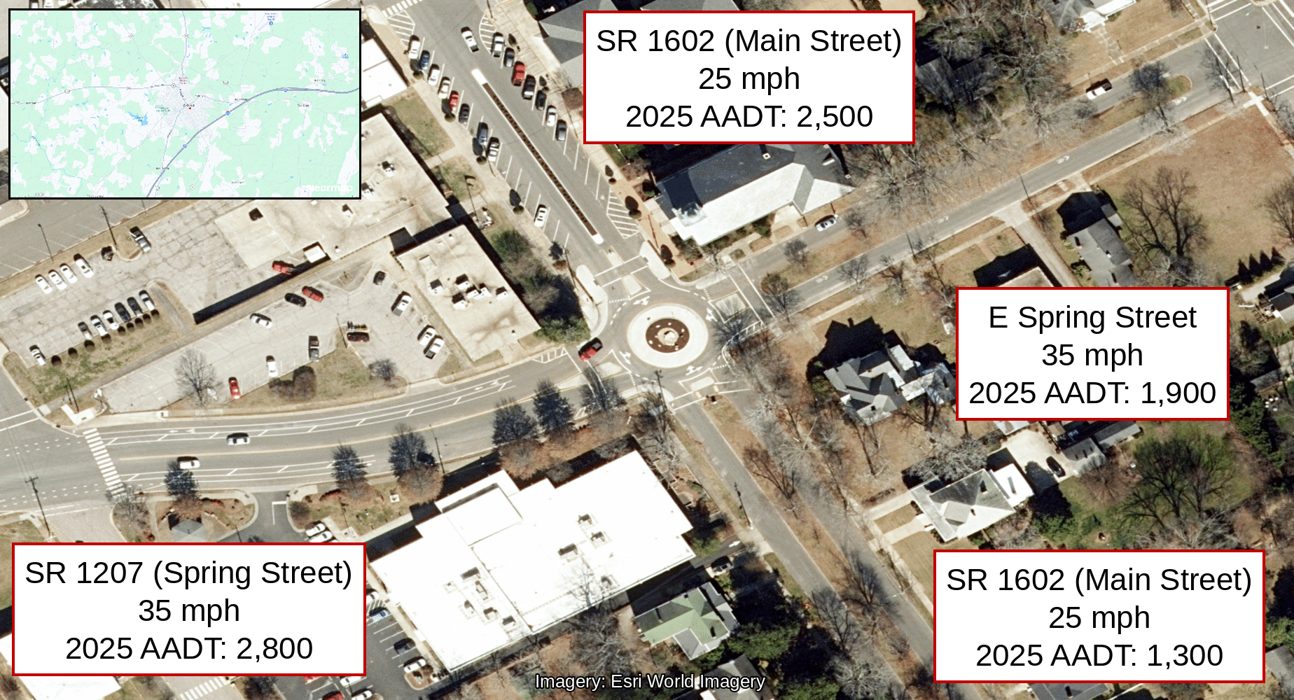

Items for Discussion
- The only crash with a reported injury in either time period was a before-period Class C-injury rear end on 12/6/2019, in which a WB vehicle on E Spring St struck a vehicle stopped at the stop line at Main St. Two additional crashes were reported with unknown severity, including a before period parked vehicle crash on 11/17/2020 and an after period target crash on 1/8/2025.
- Before-period Target Crashes: a 12/20/2017 angle crash at 2:10 PM in which an EB vehicle on Spring St ran the stop sign and struck a NB vehicle on Main St; a 7/3/2018 right-turn crash at 5:53 PM in which a SB vehicle turning from Main onto W Spring was struck by a WB through vehicle; and a 5/26/2021 left-turn crash at 11:18 AM in which an EB vehicle turning from Spring onto Main was struck by a WB through vehicle. All three were property damage only crashes.
- After-period Target Crashes: a 2/14/2022 angle crash at 9:14 AM in which a WB vehicle on Spring St entered the roundabout and struck a SB vehicle, and a 1/8/2025 right-turn crash at 9:30 AM in which a vehicle entering from E Spring St through the yield struck a NB vehicle in the roundabout. Both target crashes in the after period occurred within the roundabout’s circulating lane. The third after-period crash was a 9/20/2024 non-target sideswipe at 5:23 PM by a SB vehicle entering the roundabout.

Data Prepared For:
The Traffic Safety Unit of the
Transportation Mobility and Safety Division of the
Division of Highways of the
North Carolina Department of Transportation

Data Prepared By
Principal Investigator: Chris Bahret, PE
Work Group/ Consultant: VHB
Date: 9/24/2026
DISCLAIMER FOR 2020 DATA:
Reductions in typical roadway volumes were experienced Statewide in 2020 due to the COVID‐19
pandemic. In addition, the frequency of total crashes in 2020 was found to have decreased from prior
years, but the frequency of fatal crashes in 2020 was found to have increased from prior years. The
potential impact of the COVID‐19 pandemic and shift in data trends should be kept in mind when
reviewing traffic safety analyses and/or data reports that incorporate 2020 volume and/or crash data.
The analyses and reports that include this data may not represent typical conditions of the areas and
locations being reviewed.

