A Leakage-Audited Benchmark of Eleven Intrusion Detectors on GeNIS 2025: Calibration, Cost, and Protocol Robustness
Abstract
On shared intrusion-detection corpora, the first published numbers become reference numbers. GeNIS, released in 2025 from an independent CyberRange capture, is at that stage. The contribution to artificial intelligence is a four-test feature-audit protocol, explicit rather than a leakage-free guarantee, and the engineering application is network intrusion detection. We benchmark GeNIS across three feature conditions, two protocols and five seeds, with paired tests. Three findings have methodological implications, and we re-test two on CICIDS2017. Attribution-based auditing scored all eight behavioural shortcuts below 10⁻⁴, because they are mutually redundant and six numerically identical. Only isolated two-protocol evaluation exposed them. CICIDS2017 carries seven such pairs, ten of whose columns score zero. Chronological evaluation alone did not neutralise the shortcut disjoint attack windows create, a timestamp-only probe reaching 98.6% accuracy under a label-aware per-class temporal split against a 19.4% majority. On CICIDS2017 it falls to 10.3%, so whether temporal splitting suffices is corpus-dependent. The benign-trained autoencoder scored every flow of one flood family as more normal than every benign flow, below chance overall. A random split saturates the task, leaving eleven model pairs indistinguishable and the ranking uninterpretable. Under temporal evaluation the FT-Transformer leads and the boosted trees fall behind every neural detector and the linear model. Calibration degrades the same way for nine of eleven. On cost, logistic regression leads XGBoost on four of five axes, trailing the best temporal macro-F1 by 0.0020 at 1 097 times its throughput. We release the blacklist, splits, calibration, cost and models for later GeNIS work.
Keywords: intrusion detection, GeNIS, benchmark, shortcut learning, data leakage, temporal evaluation

1. Introduction
Learning-based network intrusion detection is evaluated, almost universally, on a small set of shared corpora, and the field has learned the hard way that the corpus shapes the conclusions. CICIDS2017, the de facto reference for nearly a decade, was later shown to carry feature-extraction and labelling errors that materially change reported performance [1, 2, 3]; systems tuned to its idiosyncrasies aged with it. As the community moves to a new generation of corpora, the question is not only which detectors perform best, but whether the first published numbers on a new corpus measure traffic patterns or artefacts of its generation. History suggests the audit should come before the leaderboard, not a decade after.
GeNIS [4] is one of the most promising corpora of this new generation: captured in February 2025 by an independent laboratory (GECAD, Polytechnic of Porto) on an Airbus CyberRange simulation of a small and medium-sized enterprise network, exported with the HERA flow exporter [5] at four aggregation intervals, and publicly archived. Its authors' companion study [6] validates binary and four-class classification with five feature-selection methods over tree ensembles and deep networks, and constitutes the official baseline. It is a careful study, and it closes with a concern it does not pursue: the models show an “overreliance on traffic volume or packet counts”. This paper takes that concern up and answers it.
The starting observation is that on the 60-second slice, a classifier given only the capture timestamp separates the nine classes at 99.70% accuracy, against a majority-class rate of 19.42%. Attack families occupy narrow, mutually disjoint windows of the capture, so position in time is very nearly a label. Two consequences drive the paper. First, any feature correlated with capture position is a shortcut, and the standard tools for finding shortcuts do not see the ones GeNIS contains. Second, the standard remedy, chronological evaluation, is insufficient here for a structural reason: because the windows are disjoint, a per-class temporal split still leaves the timestamp probe at 98.6%.
We therefore benchmark eleven supervised detectors (a majority baseline, logistic regression, Gaussian naive Bayes, k-NN, random forest, XGBoost, LightGBM, the RNN, CNN and DNN architectures of an earlier comparative study [7], whose provenance on this corpus the present paper records, and an FT-Transformer) together with a benign-trained autoencoder, under a frozen protocol: scaler fitted on the training split only, natural class distribution preserved (7.42% benign traffic), five seeds, a declared hyperparameter budget with a tuned second arm, and paired significance testing. On that common basis we run the leakage audit, measure calibration and single-host CPU inference cost, and repeat the study across all four aggregation intervals.
Contributions.
- A four-test leakage audit, of which the transferability rule is one, and the demonstration that, on GeNIS, attribution-based auditing assigns near-zero importance to the redundant shortcut features it reveals: the eight behavioural shortcuts it finds all have permutation importance below 10⁻⁴, and six of them are numerically identical columns in the released files. We publish the resulting thirteen-feature blacklist and the full transferability spectrum under two normalisations. The same audit, re-run on CICIDS2017, finds seven further pairs of numerically identical columns, ten of whose fourteen columns again score exactly zero (Section 7).
- Evidence that, on GeNIS, temporal splitting is necessary but not sufficient because the attack windows are disjoint, quantified by a timestamp probe that survives a per-class temporal protocol at 98.6%. On CICIDS2017 the same probe falls to 10.3% under that protocol, so whether temporal splitting suffices is a property of the capture schedule rather than of the method.
- A calibrated, cost-aware, statistically tested benchmark of eleven supervised detectors under the natural distribution, showing that the stratified task is saturated (eleven model pairs are not significantly different) and that the ranking is interpretable only under temporal evaluation. Calibration is reported under both protocols, and degrades under the temporal one for nine of the eleven detectors.
- A negative result for the evaluated benign-trained autoencoder: AUROC 0.4164 overall and 0.0000 against PSH-ACK floods, because volumetric attacks reconstructed better than legitimate traffic on GeNIS.
- A released artefact (blacklist, frozen splits, hyperparameter configurations, trained models, and the scripts regenerating every figure and table) intended as the reference protocol for subsequent work on GeNIS.
Section 2 positions the work, Section 3 describes the corpus and its capture chronology, Section 4 specifies the protocol and the audit procedure, Section 5 the detectors, Section 6 reports the results, Section 7 re-runs the audit on a second corpus, and Sections 8–9 discuss their scope and limits. Figure 1 sets out the chain of argument that these sections follow.
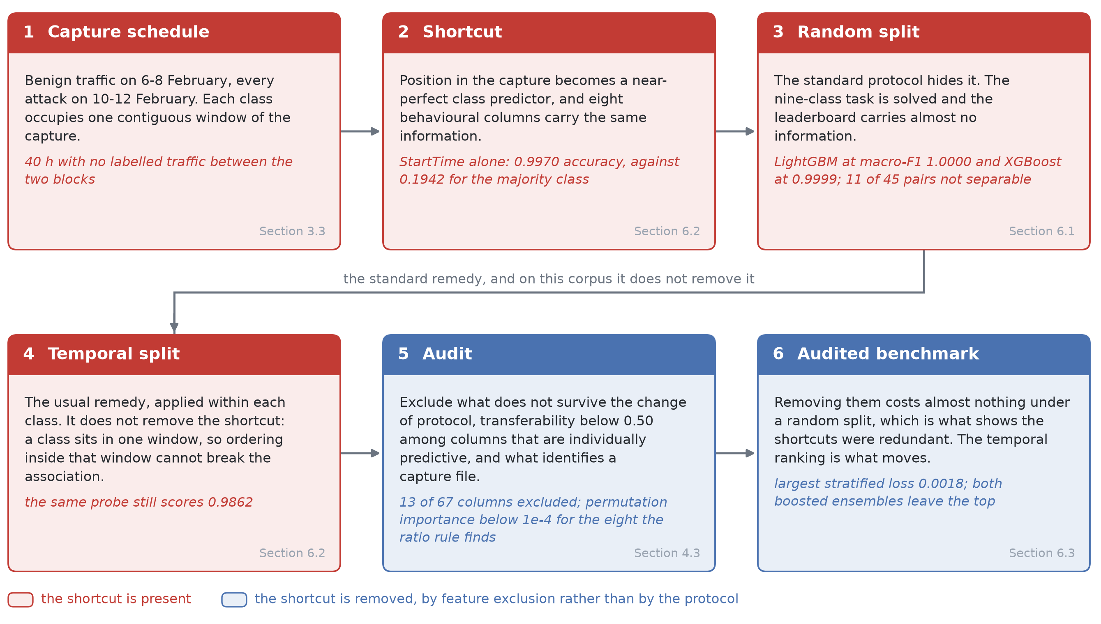
Figure 1. The chain of argument, from the capture schedule to the audited benchmark. Each stage carries the measurement that establishes it and the section that reports it. Colour marks whether the schedule shortcut is still present: it survives the random split, which hides it, and the per-class temporal split, which is the standard remedy for it, and it is removed only by excluding the columns that carry it. Stage 4 is where that remedy fails, and stage 6 reports what the exclusion costs under a random split and what it changes under the temporal one.

2. Related work

2.1 Benchmark corpora and their documented flaws
Doubts about how faithfully laboratory corpora measure intrusion detection predate deep learning: Sommer and Paxson's classic analysis already warned that closed-world evaluations reward properties of the data rather than of the detector [8]. The subsequent decade validated the warning on the field's main reference. CICIDS2017 [9] became the de facto benchmark, and was then shown to carry defects at every level of its production: errors in the CICFlowMeter feature extractor and in the labels themselves [1], an error prevalence material enough to change reported performance [2], and further labelling mistakes whose correction significantly alters detection results [3]. An independent re-extraction of the corpus from its packet captures adds duplicated and miscalculated features to that list and republishes it corrected [10]. Meanwhile, the most-cited benchmark on that corpus [11], which compares ten supervised and unsupervised algorithms on accuracy, F1 and training/testing time, predates the shortcut-learning literature and evaluates under random splits without a leakage or temporal audit, so its reference numbers inherit whatever artefacts the corpus carries. The lesson is not that testbed corpora or model-zoo benchmarks are useless; it is that a corpus's first years of use fix the community's reference numbers, so the audit of a new corpus is most valuable before a literature accumulates on it. GeNIS [4] is exactly at that stage: captured in February 2025 on an Airbus CyberRange simulation of a small and medium-sized enterprise network, exported at four aggregation intervals with the HERA tool [5], built on the Argus flow exporter, and released with raw packets so that alternative feature extractions remain possible, a design choice motivated by the observation that the exporter itself materially affects downstream model performance [12]. Its authors' companion study [6] validates binary and multiclass classification with five feature-selection methods over tree ensembles and deep networks, and stands as the official baseline this paper is anchored to. Four recent studies set the standard against which a new corpus should be read. Goldschmidt and Chudá survey eighty-nine intrusion-detection corpora across thirteen properties, downloading and inspecting each rather than trusting its documentation, and report that defects are the rule rather than the exception and that more corpora have appeared since 2020 than in all preceding years together [13]. Cantone et al. supply the complementary measurement. Four detectors trained and tested within one corpus classify almost perfectly, and the same detectors evaluated across corpora fall to approximately chance [14]. Layeghy and Portmann approach the question through explanation rather than through scores alone, evaluating machine-learned detectors across domains and comparing what feature attribution reports each of them learned [15]. Verkerken et al. carry the same measurement to unsupervised detection, where four anomaly-based methods that score well on one corpus lose 25.63% of accuracy on average when they are moved to a second, related one [16]. Together they are the reason we treat the first numbers published on GeNIS as a claim to be audited rather than a baseline to be beaten, and the reason Section 9 states plainly that our own detector ranking is a single-corpus result.

2.2 Shortcut learning and evaluation bias in learned security
That near-perfect benchmark scores can rest on features unrelated to the phenomenon of interest is now recognised across machine learning as shortcut learning [17], and security is a domain where the stakes of the confusion are highest. Arp et al. catalogue the recurring pitfalls of security ML (sampling bias, spurious correlations, data snooping) and find them endemic in published work [18]. Two lines are directly upstream of ours. TESSERACT demonstrated that ignoring temporal structure inflates malware-classification results, and argued for chronologically consistent splits as a validity requirement rather than a robustness extra [19]. Closer to network flows, D'hooge et al. first measured how twelve supervised algorithms generalize from CIC-IDS2017 to CSE-CIC-IDS2018 [20]. The same group then established the contaminating effect of metadata features in NIDS models: the destination port alone separates ten state-of-the-art IDS datasets at 70–100% accuracy, so any model given that feature learns a dataset artefact rather than traffic behaviour [21]. Our audit extends this programme along three axes: from metadata to positional features (capture timestamps and exporter sequence counters, which on GeNIS predict the class at 99.70% against a 19.42% majority-class rate); from a single split convention to a stratified-versus-chronological comparison that measures how much of the ranking survives; and from the CICIDS family to a new-generation corpus whose reference numbers are not yet fixed. The per-interval feature blacklist we release is the practical form of that countermeasure argument, instantiated for GeNIS. Two further lines bound what our audit may claim. Kapoor and Narayanan document leakage as a reproducibility failure across seventeen scientific fields and two hundred and ninety-four papers, and give a taxonomy of eight kinds ranging from textbook errors to open research problems [22]. The shortcuts we report on GeNIS belong to their illegitimate-feature category, and we use the word leakage in that restricted sense throughout rather than as a claim to have audited every kind. And the blindness of attribution under dependence is not confined to permutation importance. Aas et al. show that Kernel SHAP, which assumes independent features, misattributes when they are correlated, and give conditional estimators that do not [23]. That result is what allows Section 6.2 to extend its claim from permutation importance to the SHAP analyses a study of this corpus would otherwise rely on.

2.3 Calibration, imbalance, and the cost of a verdict
A benchmark meant to inform deployment must report more than a ranking. Modern neural networks are systematically over-confident [24], and a detector whose confidence is miscalibrated cannot drive thresholded automation; temperature scaling [24] and selective classification with a reject option [25, 26] are the standard correctives, and uncertainty quantification is increasingly argued to be a first-class requirement for trustworthy NIDS [27]. Class imbalance interacts with all of this. Under the natural distribution of GeNIS (7.4% benign traffic at the 60-second interval), accuracy is close to vacuous and metrics such as macro-F1 and the Matthews correlation coefficient are the informative ones [28]. Finally, the tabular-learning literature gives strong prior reason to include tree ensembles alongside deep detectors. Gradient-boosted trees remain consistently competitive or superior on tabular data [29, 30], with attention-based architectures such as the FT-Transformer as the strongest deep contenders [31]. Inference cost is one dimension the GeNIS baseline already reports [6]. Calibration, selective operating points, and confidence-bearing comparison are not, and this paper adds them to the same protocol. One qualification belongs here rather than later. Calibration is known to degrade when the test distribution moves away from the training one, which Section 6.5 measures on GeNIS, but the degradation is not uniform across architectures. Minderer et al. find the decay under shift markedly less pronounced in recent, non-convolutional models than in the generation on which the earlier result was established [32]. Our own measurements show both patterns at once, and Section 6.5 reports them as such.

2.4 Prior work on GeNIS and positioning
At the time of writing, the published record on GeNIS consists of the dataset descriptor [4], its authors' classification baseline [6], and one further study from the same laboratory that uses the corpus for machine unlearning [33], a goal orthogonal to benchmarking. No group independent of the corpus authors has published on GeNIS, which is the position this paper is written into.
The authors' baseline deserves a precise description, because this paper builds on it rather than competing with it, and several of its choices are already careful ones. Silva et al. combine five feature-selection methods (information gain, chi-squared, recursive feature elimination, mean absolute deviation, dispersion ratio) into a single ranking, retain the 16 highest-scoring features, and train three tree ensembles (RF, XGB, LGBM) and two neural networks (LSTM, MLP) with grid-searched hyperparameters under 5-fold cross-validation. They evaluate under the natural class distribution (7.37% benign), report training, per-epoch and inference times alongside detection metrics, deliberately exclude topology-bound features (IP, MAC and VLAN identifiers, and the HERA-specific Ssaddr/Sdaddr counters) and use SHAP to check which feature families drive predictions. They close by flagging a concern they do not pursue: the models show an “overreliance on traffic volume or packet counts”.
Four properties of that study define the space this paper occupies. First, its multiclass task uses the coarse CategoryLabel taxonomy, four classes (benign, DoS, reconnaissance, brute force), whereas we evaluate the nine-class SubCategoryLabel task, which requires separating five denial-of-service families from one another rather than pooling them. Second, evaluation rests on a single stratified split with no repetition, so no confidence interval or significance test accompanies the reported differences. Third, only the 60-second interval is used, leaving the effect of flow aggregation unmeasured. Fourth, and most consequentially for a corpus whose attack windows are disjoint in capture time (Section 3.1), the protocol is a random split with no temporal evaluation and no test for whether retained features encode capture position rather than traffic behaviour. That audit is what this paper supplies, and it turns their own SHAP-based concern into a measurement. Table 1 situates these dimensions. It carries the studies whose protocol we could read in full and score on all eight; the two closest antecedents in genre, the inter-corpus benchmark of [20] and the cross-domain evaluation of [15], are discussed in Sections 2.1 and 2.2 instead.
One consequence is worth recording for anyone building on that baseline, because it concerns the module the corpus distributes as ready for training. We inspected the 60-second pair of the 4-preprocessed module (294 844 training and 73 712 holdout flows, 87 columns, matching the one-hot encoding described in that study). The timestamps and the record rank are absent, so the capture-schedule shortcut of Section 6.2 is not transmitted by it, and the Argus counters that remain, Seq and Offset, are per-capture-file and classify below chance (0.1713 and 0.0672 against a majority-class rate of 0.1785). Two properties are inherited, however. The six numerically identical duration columns are present and unchanged, and Dur alone classifies the thirteen sub-categories at 0.8957. The topology-bound counters and the port numbers are also present, and Sdaddr alone, from 76 distinct values, reaches 0.9947 accuracy and 0.9102 macro-F1 on the thirteen sub-categories, and 0.9985 and 0.9950 on the four-class task that the baseline itself evaluates, where the destination port reaches 0.9838 and 0.9652. One qualification belongs with those figures: a legitimate volume column, TotBytes, scores 0.9892 and 0.9758 on that same task, so standalone predictive power does not by itself separate a topology counter from traffic behaviour, exactly as Section 6.2 argues. What separates them is that a topology counter is stable in time and would therefore survive our own audit, which is why Section 9 keeps exclusion by name as a separate remedy. Silva et al. exclude those columns from their experiments, so their reported results are unaffected. The observation concerns the module as distributed, which a subsequent study may load directly. Our artefact releases the two inspection scripts that produce these numbers, the reports they emit, and the script that checks every figure quoted here against them.
Table 1. Positioning against the closest related work. ✓ covered, ± partial, ✗ absent. “New corpus”: a post-2024 corpus. “Repeated”: multiple seeds with dispersion or significance testing. “Cost”: measured training and inference time.
 | new corpus | shortcut audit | temporal protocol | calibration | natural distrib. | repeated | cost | multi-interval
Maseer et al. [11] | ✗ | ✗ | ✗ | ✗ | ± | ✗ | ✓ | ✗
Silva et al. [6] | ✓ | ✗ | ✗ | ✗ | ✓ | ✗ | ✓ | ✗
D'hooge et al. [21] | ✗ | ✓ | ✗ | ✗ | ✗ | ± | ✗ | ✗
Verkerken et al. [16] | ✗ | ✗ | ✗ | ✗ | ✗ | ± | ✓ | ✗
TESSERACT [19] | ✗ | ± | ✓ | ✗ | ✓ | ✓ | ✗ | ✗
Talpini et al. [27] | ✗ | ✗ | ✗ | ✓ | ± | ± | ✗ | ✗
This work | ✓ | ✓ | ✓ | ✓ | ✓ | ✓ | ✓ | ✓

3. The GeNIS corpus and its natural distribution

3.1 Origin and generation
GeNIS (GECAD Network Intrusion Scenarios) [4] was recorded between 6 and 12 February 2025 on the Airbus CyberRange platform, configured as a digital twin of a small and medium-sized enterprise network: six segmented LANs (administration, users, internal servers, a DMZ hosting public-facing web/FTP/mail services, remote VPN users, and the attacker hosts), with port mirroring feeding an isolated capture machine running dumpcap. Benign traffic was generated by the Benign User Profiler [34] under three profiles (office-user activity, system administration, and passive background traffic), while the malicious traffic realises eight sequential attack scenarios, each following the same kill-chain skeleton (DNS resolution, Nmap scanning, then the terminal action): five denial-of-service floods against the DMZ web server (Hulk, Slowloris via Metasploit, and UDP/ICMP/PSH-ACK floods via hping3) and three credential brute-force attacks (SMB, SSH, and combined SSH+FTP) using Hydra with a 10 000-password dictionary. The raw packets (37.7 million) were aggregated into labelled flows by the HERA exporter [5], built on Argus, at four flow intervals (5, 10, 30 and 60 seconds), yielding from 338 820 flows at the coarsest interval to 2.77 million at the finest, each carrying hierarchical labels (binary, category, subcategory).

3.2 The slice used in this study
The corpus is released in a modular layout; this benchmark uses the 2-flows module, which provides per-subcategory CSV files at all four intervals. Two taxonomic points must be fixed before any comparison. First, the reconnaissance subcategories (recon-nmap, recon-dns) listed in the corpus descriptor do not appear as standalone files in 2-flows. They exist only inside the 3-scenarios recompositions, so the classification task supported by this module comprises eight attack families. Second, the three benign profiles (user, administrator, background) are variants of normal traffic rather than separate detection targets. We merge them into a single benign class, yielding the nine-class task evaluated throughout (benign, bruteforce-{ftp,smb,ssh}, dos-{hulk,icmp,pshack,slowloris,udp}). Figure 2 gives the class distribution of that task.
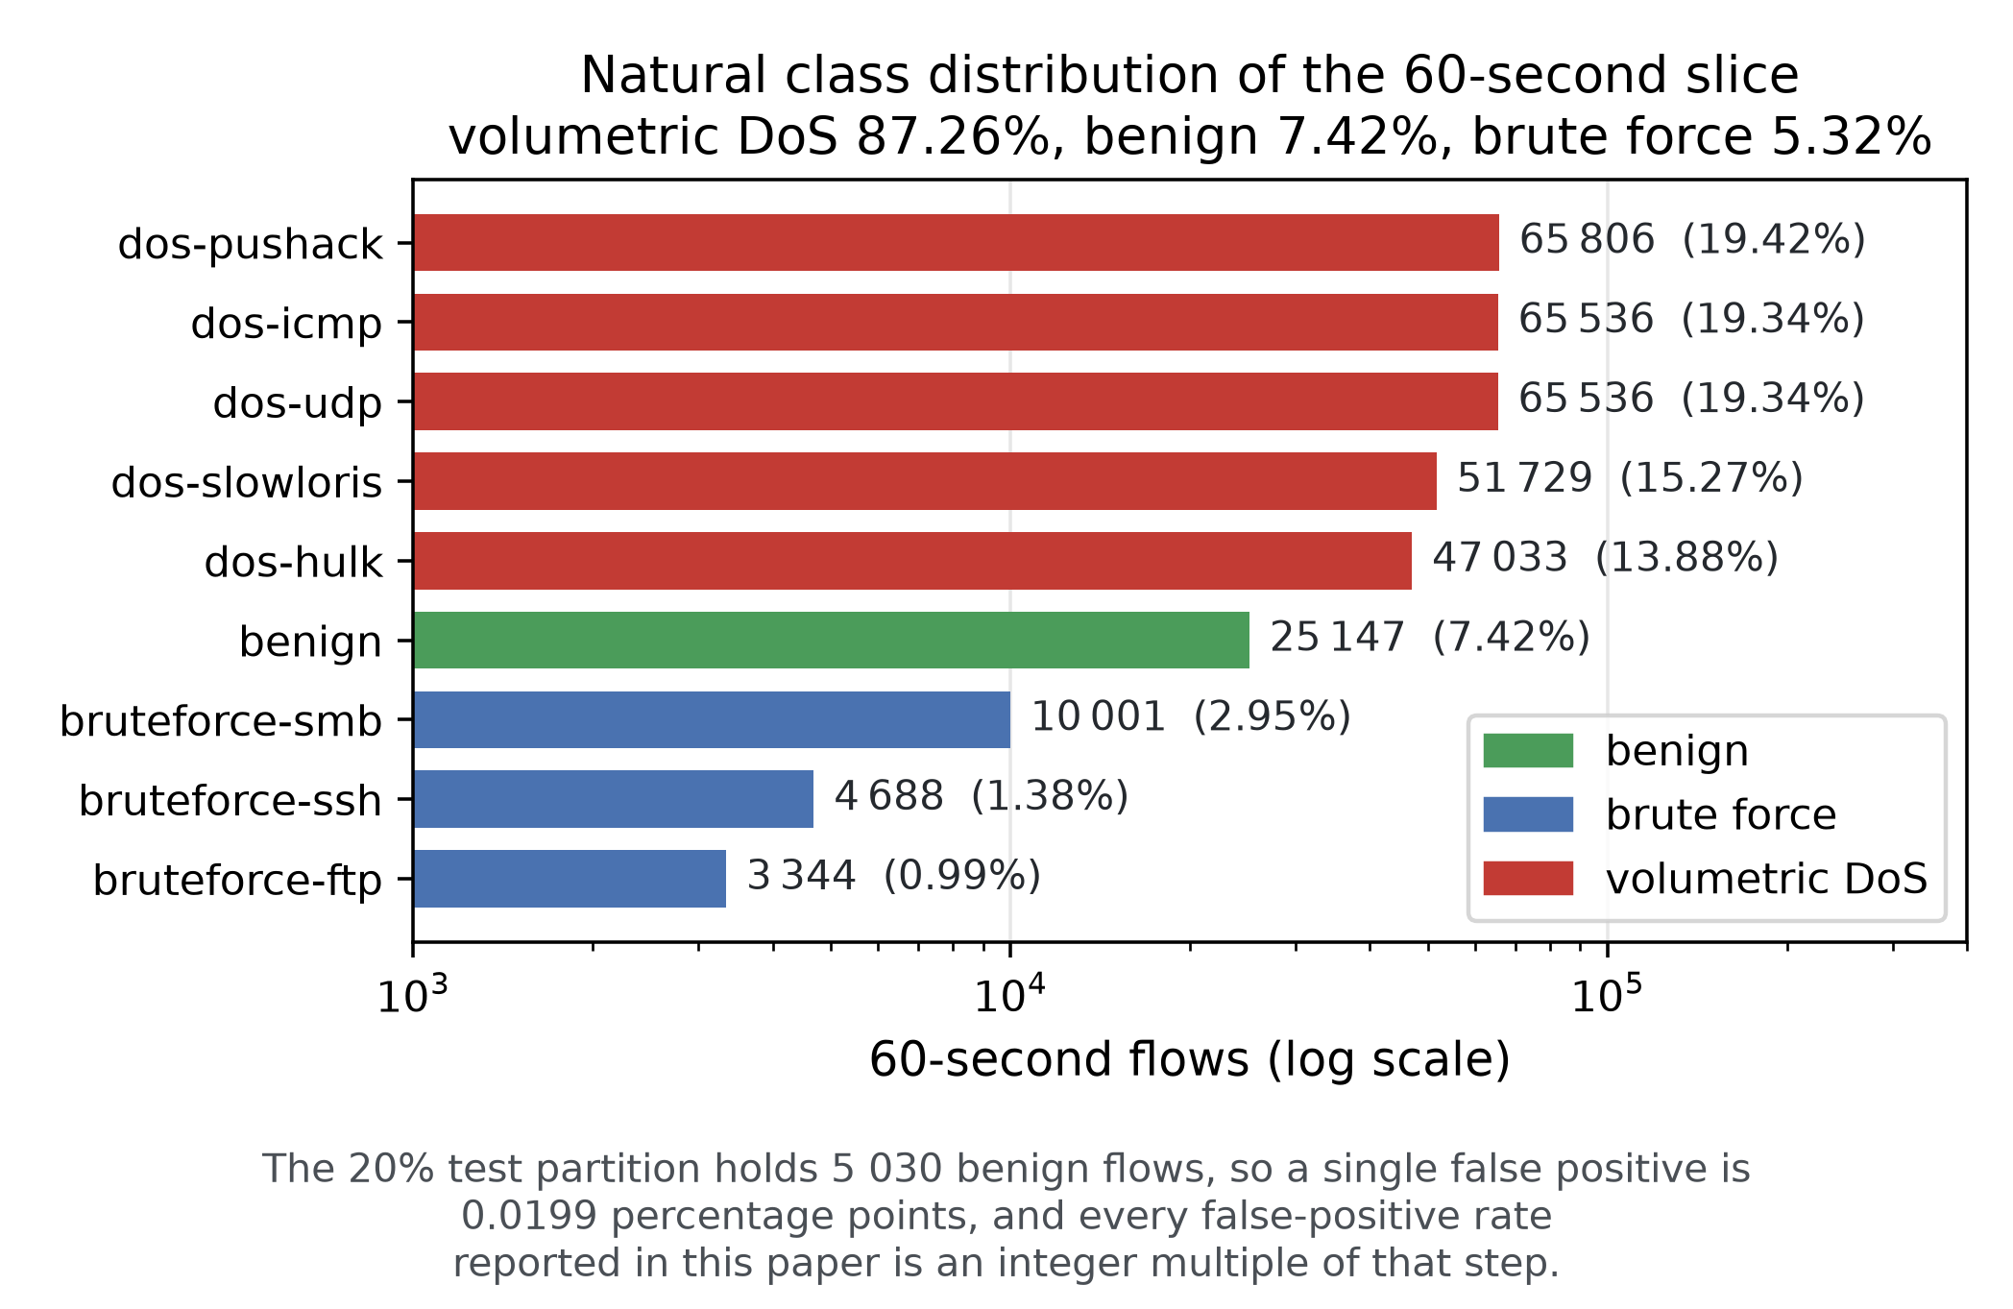
Figure 2. Class distribution of the 60-second slice, preserved end to end by our protocol. Natural here means unmodified by us: it is the distribution the CyberRange scenarios produced, not that of an operational enterprise network. Volumetric denial-of-service floods account for 87.26% of the flows, benign traffic for 7.42% and the three brute-force families for 5.32% together. Two consequences follow. Macro-F1 rather than accuracy is the meaningful headline metric, and the brute-force families, which are the smallest, are where the detectors actually differ. The 20% test partition holds 5 030 benign flows, which fixes the resolution of every false-positive rate in this paper (Section 4.5).
These choices place our task strictly between the two published alternatives, and the difference is worth stating precisely because it governs comparability. The corpus baseline [6] evaluates the four-class CategoryLabel task on 368 556 sixty-second flows, a count that includes reconnaissance; the 2-flows module we use yields 338 820. The 29 736-flow gap is fully accounted for by two independent causes, which we report because neither is documented: the absence of the reconnaissance captures (recon-nmap, 27 713 flows; recon-dns, 20) from this module, and a 2 003-flow shortfall in benign-background relative to Table 12 of the corpus descriptor [4] (8 283 released versus 10 286 reported). The same discrepancy is present at every interval (32 590 flows at 5 s, 32 051 at 10 s and 30 481 at 30 s), of which the constant 27 733 reconnaissance flows are the larger part. Table 5 reports our recounts. All figures in this paper come from the released files, and we state the released counts rather than the documented ones wherever the two disagree. This reconciliation is checkable against a third source, independent of both the descriptor and the 2-flows files. The 4-preprocessed module ships the same 60-second data as an 80/20 pair of 294 844 and 73 712 flows, 368 556 in all, and rescaling the composition of its training partition recovers every count above to the flow, the 10 286 benign-background flows included. We release that check with the code of Section 11, as experiments/verify_4preprocessed.py.

3.3 Capture chronology and its consequences
The capture schedule matters as much as the volumes: benign user and administrator activity was recorded on Thursday 6 and Friday 7 February, background traffic over the weekend of 8 February, and all attacks during the following week, 10–12 February. Benign and malicious traffic are therefore completely segregated in capture time, and each attack family occupies narrow, mutually disjoint windows within the attack days (Figure 3). Three consequences structure the rest of this paper. (i) Any feature correlated with position in the capture (timestamps, but also exporter counters) is a class-revealing shortcut, which motivates the audit of Section 6. (ii) A global chronological split is degenerate. The final portion of the capture contains only attack blocks never seen in training, so every model scores near zero, a measurement of the schedule, not of generalisation (we report it as such). (iii) Temporal evaluation must therefore be per class. Our temporal protocol orders each class's flows in time and tests on its later flows, keeping every family represented while guaranteeing that every test flow postdates every training flow of its class (Section 4).
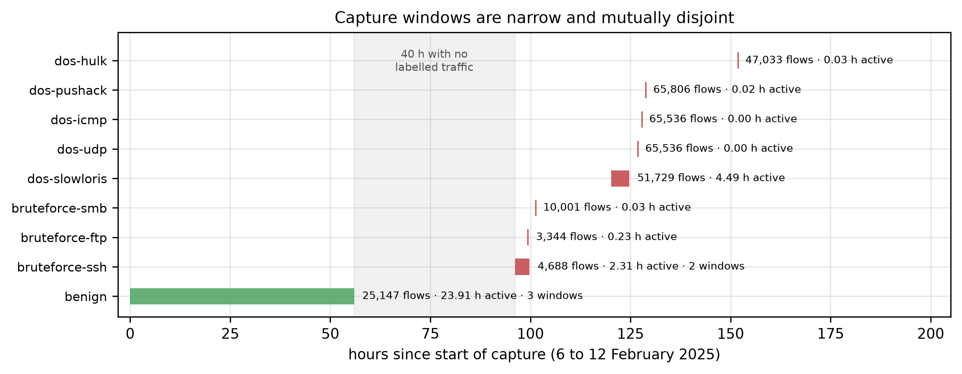
Figure 3. Capture windows per class. Benign traffic (green) is confined to the first 56 hours; every attack family (red) falls between hours 96 and 152, separated from the benign traffic by 40 hours with no labelled traffic. Several floods deliver more than 65 000 flows in under two minutes of wall-clock activity, so class membership is very nearly a function of position in the capture.

4. Evaluation protocol

4.1 Stratified protocol
Every experiment fits the feature scaler (RobustScaler, median/IQR) on the training partition alone, preserves the natural class distribution end to end, and never rebalances the test partition. The corpus is split 60/20/20 into training, validation and test, stratified by class, and the split is repeated under five seeds; the validation partition is used for hyperparameter selection and calibration only. Class imbalance is compensated at training time via balanced class weights for the neural models, which changes the loss but not the evaluation distribution. The split index arrays are generated once, frozen to disk, and reused by every model, so all reported differences are within-split differences.

4.2 Temporal protocol
A global chronological split is degenerate on GeNIS: because benign traffic was captured on 6–8 February and every attack on 10–12 February, the last 20% of the capture contains only attack families absent from the first 60%, and every model scores near zero. We report that table as a property of the corpus, not as a protocol.
The protocol we do evaluate is a per-class temporal split: within each class, flows are ordered by capture time and divided 60/20/20, so every test flow postdates every training flow of its own class while all nine classes remain represented in all three partitions. Figure 4 sets the four partition schemes this paper uses side by side on one axis of capture time. Panel (c) is this one, and panel (b) the degenerate global split described just above. We verify the ordering invariant explicitly. Two properties of this construction must be stated before any result is read from it. It uses the class label to build the partition, since the ordering is applied within each class, so it is not a model of deployment on future unlabelled traffic. The narrower question it answers is whether a detector still recognises later flows of a family it has already seen. And it is the strictest temporal evaluation this corpus supports without emptying classes, which is a statement about GeNIS rather than a general recommendation. We therefore use it as a diagnostic within-class temporal protocol throughout, and we do not present its results as deployment generalisation. That question is one of three the word temporal covers, and no single partition answers more than one of them. It is the first, and panel (c) is the partition that measures it. The second asks whether the answer depends on where the cut falls. The rolling origins of Section 6.8 move that cut to five positions, one of them a purely chronological boundary drawn without any label. The third asks whether a detector recognises a family it has never seen, which is deployment generalisation proper. No label-free partition of this corpus can pose it, because the capture schedule makes a global chronological cut degenerate, so Section 6.8 poses it directly instead by withholding one family at a time. Only the third is deployment generalisation, and no result in Sections 6.1 to 6.7 is offered as an answer to it.
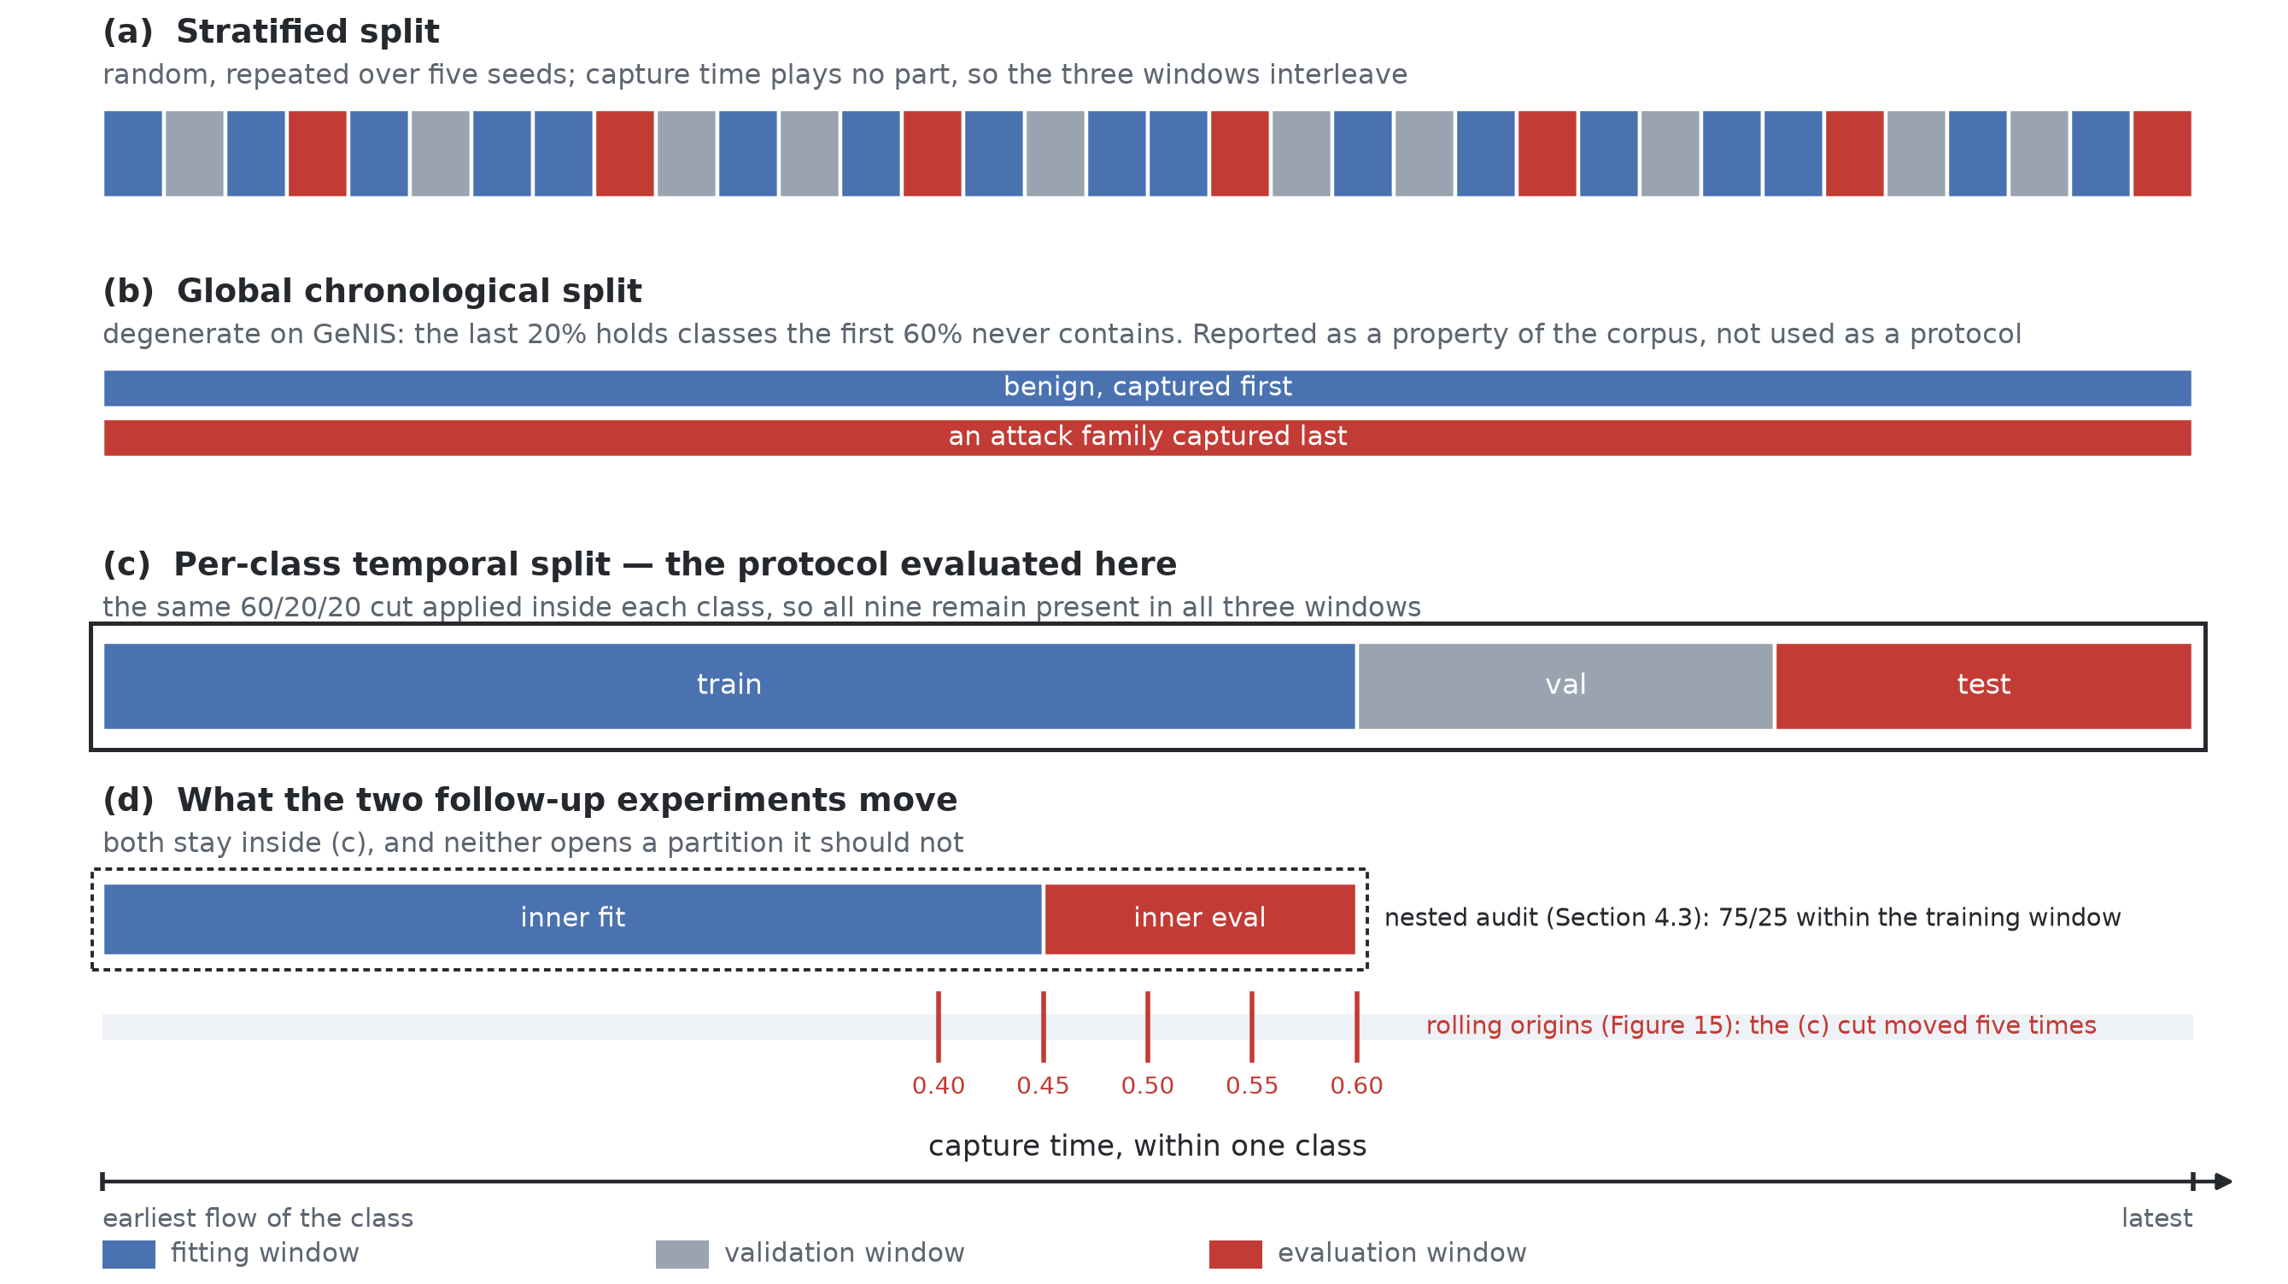
Figure 4. The four ways this paper cuts the corpus, on one axis of capture time and for a single class; the nine read alike. (a) The stratified split ignores capture time, so the three windows interleave. (b) A global chronological split cuts nothing on this axis, since a class falls entirely inside one window, which is what makes it degenerate here and why we report it as a property of the corpus rather than use it as a protocol. Its two rows are the only place where the nine classes do not read alike, so both are drawn. (c) The per-class temporal split is the protocol evaluated throughout: the same 60/20/20 cut inside every class, which keeps all nine present in all three windows at the price of using the label to build the partition. (d) Two later experiments move pieces of (c) without opening anything it does not already open: the nested audit of Section 4.3 cuts the training window alone 75/25, and the rolling origins of Section 6.8 move the cut of (c) to five positions.

4.3 The leakage audit
What leakage-audited means in this paper. The term names a procedure that was applied, not a property the corpus has been shown to possess. Four tests decide the fate of a column here, and each has a blind spot that another covers. Identifier and topology columns are excluded by name, positional columns are excluded by name, a transferability rule excludes behavioural columns whose predictive power does not survive a change of protocol, and a capture-file test that reads no label excludes columns identifying the file a flow was read from. Together they are an explicit multi-step audit, and that is the whole of the claim. It is not a claim that every form of leakage has been covered, nor that GeNIS is certified free of leakage. Two columns show both sides of that. IdleTime passed the first three tests and was caught by the fourth, which we added late enough that the audited condition had to be retrained without it, and Section 9 reports what the omission cost. Offset is returned by no test at all and yet separates benign from attack traffic at an AUC of 0.9379, so we retain it and record the anomaly rather than exclude on suspicion.
Columns are categorised by explicit name lists rather than string patterns. Twenty-three identifier columns (addresses, MAC, ports, flow and record identifiers, AS and VLAN numbers, and the topology-bound Ssaddr / Sdaddr counters) are excluded from every condition. Four positional columns (StartTime, LastTime, Rank, Seq) encode position in the capture and define the contrast between our first two conditions. The remaining columns are behavioural candidates, and the audit decides their fate.
For each behavioural feature f we train a decision tree on f alone under both protocols and define its transferability
τ(f) = acc_{temporal}(f) / acc_{stratified}(f).
A feature is excluded when it is individually predictive (acc_{stratified} > 3× the majority-class rate) and τ(f) < 0.5: it carries substantial class information that does not survive a change of evaluation protocol, which is the operational definition of a shortcut. The predictivity filter is expressed as a multiple of the majority-class rate, which is well defined on this corpus but not on every corpus. Section 7 reports where that form breaks and gives one that transfers. Neither 3.0 nor 0.50 is fixed by the data, and the threshold is the part of this rule that travels least well. The nested audit below returns the eight excluded columns as the eight lowest ratios, separated from the rest by the widest gap in that distribution, whereas a literal 0.50 cut excludes nothing under that design. What identifies a shortcut is therefore its rank and the gap that isolates it, and 0.50 is the number this campaign cut at. A reader meeting it here should also know that Section 9 retrains every detector under five alternative blacklists and reports what the choice costs. The audit is run over all behavioural features, not a shortlist. Section 6.2 shows why any shortlist derived from attribution scores would have been empty. Algorithm 1 states the procedure exactly as implemented, and the paragraph that follows it gives the settings of the probe.
Algorithm 1. The audit of Section 4.3, as implemented. Lines 3 to 6 are the transferability rule; line 7 is the capture-file test, which reads no label and catches what a ratio between protocols cannot. The score at lines 3 and 4 is nine-class accuracy on the evaluation window of the arm concerned, and the tree is the single-feature probe whose settings the paragraph below gives. The two arms are parameters rather than fixed partitions, which is what lets one procedure run at two scales: the published campaign passes the training and test partitions of seed 1 and of the per-class temporal split, and the nested audit passes a 75/25 cut of the training partition alone. Lines 11 and 12 change nothing in the blacklist; they record the duplication that makes attribution blind to it (Section 6.2).
Input B, P behavioural and positional columns of the flow matrix
y, t nine-class label and capture timestamp of every flow
c the capture file each flow was read from
S stratified arm (Sfit, Sev): a random split of the flows
T temporal arm (Tfit, Tev): the same proportions cut in
order of t inside each class, so that every flow of Tev
postdates every flow of Tfit of its own class
k, r predictivity multiple and exclusion threshold; 3.0, 0.50
Output the blacklist: the columns withheld from the audited condition

1 p_max := largest class frequency in y # 0.1942 on GeNIS
2 for every column f of B:
3 a_strat(f) := fit a tree on f over Sfit, score it on Sev
4 a_temp(f) := fit a tree on f over Tfit, score it on Tev
5 tau(f) := a_temp(f) / a_strat(f) # 1 if a_strat = 0
6 flag(f) := a_strat(f) > k * p_max and tau(f) < r
7 ident(f) := f takes at most two values in every file of c
8 and those values order the files in time
9 blacklist := P, every f of B with flag(f) or ident(f)
10 # 4 + 8 + 1 = 13
11 for every pair (f, g) of flagged columns: # reported only,
12 call f and g duplicates if they agree to 1e-5 relative
13 return blacklist

Settings of the probe. The tree of lines 3 and 4 is a scikit-learn 1.6.1 DecisionTreeClassifier left at library defaults, random_state = 1 being the only argument set: Gini impurity, the best split searched over every candidate threshold, unlimited depth, two flows required to split a node and one to form a leaf, no pruning, and no class weighting. An unpruned single-feature tree is the most permissive probe available, since it may cut the axis into as many intervals as the fitting window supports; a low a_strat therefore means the column does not separate the classes, and not that the probe was underpowered. The probe reads the columns as they are stored, positional ones in double and behavioural ones in single precision, and scales nothing. A decision tree is invariant to any strictly increasing rescaling of a single column, so the RobustScaler fitted for the detectors (Section 4.1) cannot move τ. The stratified arm is seed 1 alone and not the five-seed mean, so the ratios of Table 3 are single-split measurements and we report no seed dispersion on them. The permutation importances shown beside them in Table 3 and Figure 6 take no part in the rule. They come from a LightGBM reference model (300 trees, 63 leaves, learning rate 0.1) fitted on the clean condition of seed 1, permuted five times over a random subsample of 15 000 test flows and scored by accuracy.
What the audit is computed on. In the campaign this paper reports, the two accuracies that define τ were measured on the test partition of their respective protocols, and the permutation importances of Section 6.2 on that same partition. The blacklist was therefore selected with test-set information, and the benchmark that follows was trained on a feature set that testing helped choose. We state this plainly, and the three paragraphs that follow report what we did about it: the obvious correction fails for a reason we measure, an audit confined to the training partition works, and the blacklist it returns on its own is the published blacklist, column for column.
Why moving the audit to the validation partition does not work. The obvious remedy is not available. Recomputed on the validation partition, the rule excludes nothing at all. The stratified single-feature accuracies are the same on both partitions, to within 0.0008 on average, as exchangeable partitions of a random split should be; the temporal ones are not, validation giving a higher figure than test for 53 of the 63 behavioural columns, by 0.075 on average. Dur is the clearest case: 0.921 and 0.922 under the stratified protocol on validation and on test, and 0.627 against 0.304 under the temporal one. The per-class split places training in the first 60% of each class, validation in the next 20% and test in the last 20%, so validation is adjacent to the training window while test lies one step beyond it. A ratio built to measure decay with temporal distance cannot be estimated on the partition closest to training, and Figure 20 shows that decay directly.
The audit that does work, and what it establishes. What is available is a nested audit. Ordering each class’s training flows in time and cutting them 75/25 gives an evaluation window that postdates its own fitting window while remaining entirely inside the training partition; a matching random 75/25 cut of the same flows gives the stratified arm. Such an audit opens neither validation nor test, and panel (d) of Figure 4 shows where it sits inside the training window. Run on GeNIS it returns the eight published columns as its eight lowest transferability values, and the largest gap in the whole distribution, 0.062 between SIntPkt at 0.699 and SIntPktIdl at 0.761, falls exactly between those eight and the rest. The membership of the blacklist is therefore not an artefact of test-set information, and it is recoverable without opening the test partition at all. One thing does not transfer, and it is the threshold rather than the list. The nested audit spans a shorter temporal horizon than train-to-test, so its ratios are compressed upward and its minimum is 0.623. Applied literally, τ < 0.50 would exclude nothing. What identifies the eight is their rank and the gap that isolates them, not their position relative to a fixed number. We report 0.50 as the value the published campaign used, and the clustering as the property that survives a change of audit design. The second is what should be carried to another corpus.
The control on the blacklist the nested audit produces alone. One control remains, and it is the one that matters most: the campaign was trained on a blacklist that testing helped choose, so the list the nested audit produces on its own has to be shown to support the same conclusions. It does more than that. Ranking the 37 eligible columns by their nested transferability and cutting at the largest gap in that ranking — the rule stated above, which is not told how many columns to expect — returns the eight published columns exactly, and no others. The audited condition trained on the nested list is therefore the audited condition of this paper, column for column, and every number reported here already is that control. Because an identity can look convenient, we bracket it with the two weaker readings of the same audit, both of which we retrained. Cutting at the second-largest gap (0.052 against 0.062) keeps only the six duplicated duration columns, and applying the 0.50 threshold literally to the nested ratios excludes nothing at all. Against the published campaign, the first moves no detector but naive Bayes by more than 0.0009 under the stratified protocol and 0.0046 under the temporal one, the second by more than 0.0012 and 0.0217. Under all three the corpus is saturated under the stratified protocol, both boosted ensembles sit outside the temporal top three, and expected calibration error degrades by a median factor of roughly forty between the protocols. What does move is the order inside the leading group, which permutes across the three readings. That group is the one Section 6.1 and Section 6.8 both report as statistically indistinguishable, so the permutation confirms that finding rather than contradicting it. The check is released as experiments/e4a/verify_nested_blacklist.py.
The ratio is taken over raw accuracies. Because a nine-class accuracy of 0.194 is already attainable by predicting the majority class, we also report the chance-corrected variant τ*(f) = (acc_temporal(f) − p_max) / (acc_stratified(f) − p_max), with p_max = 0.1942, which measures the share of above-chance discriminative power that survives the change of protocol. The two are not interchangeable, and Section 9 quantifies what the choice costs. We keep τ as the operative rule, so that the blacklist used to train every model in this paper is the one the rule produced, and report τ* as a sensitivity analysis. The denominator is bounded below by 0.388 for every audited feature, since the rule applies only to features that are individually predictive, so the correction does not amplify noise.
What the rule can and cannot separate. The columns this audit touches are not of one kind, and the distinction matters for how the blacklist should be read. Four are positional: they encode where a flow sits in the capture and carry no traffic semantics at all. Twenty-three are identifiers, excluded by name before any measurement, on the argument of D'hooge et al. [21]. Among the behavioural columns the rule then separates two further kinds. Six are redundant: Dur, RunTime, Mean, Sum, Min and Max are numerically identical to one another, so a single shortcut is duplicated six times and each copy is individually predictive. The remainder are distribution-sensitive: rate and inter-packet-time statistics whose predictive power is genuine but tied to how the campaigns were paced. The rule places SIntPkt and SIntPktMax in the blacklist on the same evidence it uses for the duplicated columns, and we cannot claim that it has distinguished them. A low transferability ratio establishes that a feature's predictive power does not survive a change of protocol, but it does not establish that the power was spurious to begin with. Excluding such a feature is conservative for a benchmark, since it can only lower the reported score, but it is not the same act as removing a leak, and we do not present it as one. Two limits on the rule follow, and they govern how the whole audit should be read. It is a proposed diagnostic and not a validated leakage detector. The threshold is a declared choice rather than a statistical derivation, and the blacklist it produces changes from eight to thirteen behavioural columns under a different normalisation (Section 9). We have since retrained under four alternative lists, and Section 9 reports what the choice costs. And it detects one kind of shortcut only. Transferability compares two protocols in time, so a feature whose predictive power is stable in time passes it whatever its provenance. Identifier and topology columns are removed by name beforehand precisely because the rule would retain them (Section 9). Taken alone, the rule is a schedule-dependent shortcut test, complementary to identifier auditing rather than a general leakage-auditing framework.
The arithmetic of the blacklist is therefore explicit: four positional columns excluded by name, eight behavioural columns excluded by the rule, and one column excluded by neither, gives the thirteen of Table 3. Under the chance-corrected variant the behavioural count rises to thirteen and the blacklist to eighteen; that thirteen counts behavioural columns, and is not the thirteen of the list as a whole. Every count in this paper is one of those two, and Section 9 reports what separates them.
A third criterion, and why the first two could not have found it. One column is on the list for neither reason, and it is the one this audit came closest to missing. IdleTime takes one or two distinct values per capture file, and those values are absolute Unix timestamps: it identifies the file a flow was read from rather than anything the flow did. A decision tree given that column alone separates benign from attack traffic at an AUC of 1.0000. Every diagnostic in this paper passes it. Its transferability is 0.94, well clear of the 0.50 threshold. Under the nested audit of Section 4.3 it is 1.02, so single-feature accuracy is not lower under the temporal protocol but marginally higher. The residual audit of Section 6.2 ranks it in the middle of the retained columns. Attribution, meanwhile, gives it 0.2279, the highest permutation importance of any column in the corpus. The reason the rule misses it is structural and not accidental. A criterion built on the ratio between two protocols cannot see a leak that is frozen within each capture group, because such a leak is equally available on both sides of any split of that group. What gives the column away is not its association with the label but its values, and the test that finds it reads no labels at all — a column that is constant within every capture file, and whose values order those files in time, is a file identifier. We add that test to the procedure, and applied to all 63 behavioural candidates it returns this column and no other. Offset, the one further column whose name suggests a position in the capture, is not constant within any file, and its rank correlation with capture order reaches only 0.13 at its highest across the eleven files. The test therefore does not return it and we do not exclude it, although on its own it separates the two classes of traffic well (binary AUC 0.9379 against a nine-class accuracy of 0.0601). Section 9 records that as an anomaly we have not resolved.
Three feature conditions follow: full (behavioural + positional), clean (behavioural only), and audited (behavioural minus the blacklist).

4.4 Hyperparameter budget
Each model is evaluated in two arms. The default arm uses the published BAg-IDS architectures for the neural trio and standard library settings elsewhere. The tuned arm runs a random search selected on validation macro-F1, on the audited condition and seed 1, with the winning configuration retrained on the full training partition across all five seeds and the temporal split. Trial 0 is always the default configuration, so the search cannot degrade a model on the validation metric it optimises; Section 6.5 shows that this guarantee does not carry over to the test partition. The budget is a declared time cap of 900 s per model plus a trial ceiling (20 for classical models, 10 for neural ones), whichever binds first. Because the cap is checked between trials, one long trial can overrun it. Table 7 reports the trials actually completed per model, which range from 1 (FT-Transformer, whose single trial took 5 836 s) to 20. We state this asymmetry rather than claim an equal search everywhere.
k-nearest neighbours is fitted on a stratified subsample of at most 50 000 training flows, a declared memory budget; its inference cost is measured in full.

4.5 Metrics and statistical treatment
Accuracy is reported but never used for conclusions. The headline metric is macro-F1 over the nine classes, complemented by the Matthews correlation coefficient, per-class F1, and the operational binary view (benign versus attack) with its false-positive rate, PR-AUC and ROC-AUC. Calibration is measured by expected calibration error over 15 bins, before and after temperature scaling fitted on validation. Two statistical questions are asked separately, and they are not interchangeable. McNemar's test, under Holm correction, compares two detectors on the same seed-1 test partition. The multiclass predictions are first reduced to correctness indicators, correct or incorrect against the true label, and the test is applied to the two discordant cells of the resulting 2×2 table, the flows one detector classifies correctly and the other does not, with a continuity correction. It therefore asks whether the two detectors misclassify different flows, and not whether their macro-F1 differs; a difference in macro-F1 is a different question that this test does not address, and the bootstrap intervals below are marginal rather than paired. A paired bootstrap of the macro-F1 difference answers it directly, and Section 6.8 reports one over 1 000 resamples of the stored probability matrices. Uncertainty on macro-F1 itself is carried by 95% bootstrap confidence intervals over 1 000 resamples of that same partition. The five seeds answer a third question again. They resample the split, not the corpus, so their dispersion measures the sensitivity of a detector to which flows land in training, and they are not independent replications of the data. We therefore do not pool them into the significance test, and we report their standard deviation as a stability figure rather than as a standard error. Significance and magnitude are also reported together throughout. Where a difference is significant we give the absolute macro-F1 gap beside it, because on this corpus a gap can be statistically detectable and operationally irrelevant at the same time.
One resolution limit governs how these numbers may be read. The 60-second test partition holds 5 030 benign flows, so a single false positive is 0.0199 percentage points: every FPR we report is an integer multiple of that step, and differences below it are not measurable.

5. Models
Eleven supervised detectors and one unsupervised detector are evaluated under the identical protocol of Section 4. The selection is not meant to be exhaustive. It is meant to cover one representative of each family a practitioner would consider on tabular flow records: linear, probabilistic, distance-based, bagging, boosting, recurrent, convolutional, dense, attention-based, and reconstruction-based. Adding a second member of a family already represented would lengthen the campaign without changing any conclusion this paper draws, since every conclusion is about the protocol rather than about which detector wins.
Classical and tree ensembles. Seven detectors make up this group. They are a majority-class baseline, multinomial logistic regression, Gaussian naive Bayes and k-nearest neighbours, together with a random forest of 200 trees, XGBoost with 300 trees of depth 8 and histogram splits, and LightGBM with 300 trees and 63 leaves.
Neural detectors. The recurrent, convolutional and dense trio is reproduced exactly as published in an earlier comparative study [7] and reused in a companion system paper: SimpleRNN(64) → Dense(64); Conv1D(64,3) → Conv1D(32,3) → Dense(64); and Dense(128) → Dense(64), so that this benchmark also serves as the provenance record for those detectors. To these we add an FT-Transformer (feature tokeniser, CLS token, three attention blocks, d=64, eight heads), a strong contemporary deep architecture for tabular data [31]. All are trained with Adam for at most 30 epochs with early stopping (patience 5) and balanced class weights.
Unsupervised detector. A symmetric autoencoder with layer widths 64-32-16-32-64 is trained on benign flows only, and a flow is scored by its reconstruction error. It is evaluated separately, by AUROC, since it solves a different problem.
Declared exclusions. Kernel SVM is excluded because its O(n²) training is infeasible on 203 292 training flows within an equal budget, and because logistic regression already covers the linear family. The k-means/EM/SOM trio used by earlier benchmarks [11] is replaced by the autoencoder as a modern representative of reconstruction-based anomaly detection.

6. Results
All results below are measured on the released GeNIS 2-flows module. The first campaign comprises 154 training runs. The audited condition was then retrained in full, over 180 further runs, once the capture-file test added its thirteenth column (Section 9), and it is that repeat which every table below reports. Every number is reproducible from the released artefact, though not equally on both sides of it. For the first campaign the per-flow probability matrices are archived, so its statistics can be re-derived from the predictions. The repeat releases the derived statistics rather than the predictions, the pairwise McNemar values before and after correction, the bootstrap intervals, the calibration errors and the fitted temperatures among them, so every figure and table recomputes from experiments/e8 while the statistics themselves rest on the runs as recorded. Section 7 reports the one experiment in this paper that is not measured on GeNIS.

6.1 The corpus is saturated under the stratified protocol
Table 2 reports the nine-class benchmark. Under the stratified protocol the nine-class task, as posed here and with this feature set, is essentially solved: LightGBM reaches macro-F1 1.0000 ± 0.0001 across five seeds, and XGBoost, random forest and the FT-Transformer 0.9999 ± 0.0001, and nine of the eleven detectors exceed 0.99. McNemar tests with Holm correction confirm what the point estimates suggest (Figure 9). The majority baseline predicts a constant, so it takes no part in the pairwise tests and the ten remaining detectors give 45 pairs. Of those, 11 are not significantly different at α = 0.05, and these include every pair among {XGBoost, LightGBM, random forest, FT-Transformer} as well as logistic regression against the RNN, the CNN and the DNN. The bootstrap intervals (Figure 11) overlap accordingly.
Two consequences follow. First, a leaderboard computed on this corpus under a random split carries almost no information: the top group is statistically indistinguishable, and reporting a winner would be reporting noise. Indistinguishable is not equivalent. Failing to reject a null hypothesis is not evidence that two detectors perform identically, only that this partition does not separate them. Several of the ties we report are also ties at the resolution limit of the partition rather than demonstrated equalities, and Section 9 states where that limit falls. Second, the discriminating power of the benchmark must come from somewhere other than the stratified accuracy, which is what the remaining subsections supply.
The benchmark does still separate weak from strong: Gaussian naive Bayes reaches macro-F1 0.4464 with a 91.5% false-positive rate (4 604 of 5 030 benign flows misclassified), confirming that the near-perfect scores are a property of the corpus and the strong models, not of the metric. Figure 5 shows where the residual difficulty sits. For every strong detector the per-class F1 stays above 0.979 on all nine classes, the lowest being k-NN on benign traffic at 0.9796 and the RNN on bruteforce-ssh at 0.9822, and naive Bayes is the only model with class-level failures. Its worst class is bruteforce-ssh at 0.002, and its benign F1 of 0.156 is what the 91.5% false-positive rate above measures from the operational side.
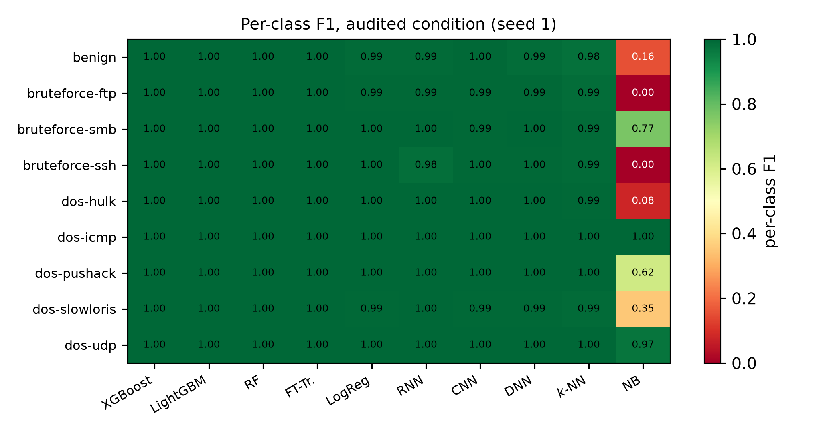
Figure 5. Per-class F1 under the audited condition. The majority baseline is not plotted; nine of the ten detectors shown are uniformly strong across all nine classes, the lowest single cell being 0.9796; only naive Bayes fails, and it fails on most classes at once, worst on bruteforce-ssh.
Table 2. Nine-class benchmark on the 60-second slice. Macro-F1 under three feature conditions; the audited column gives the five-seed mean, with the standard deviation following the ± sign. MCC and FPR are for the audited condition, seed 1. FPR resolution is 0.0199 points (one benign flow), so 0.0000 means no false positive at all.
 | stratified, default |  |  | tuned | temporal | audited, seed 1
Model | full | clean | audited | audited | audited | MCC | FPR (%)
XGBoost | 1.0000 | 1.0000 | 0.9999 ± 0.0001 | 0.9999 | 0.9666 | 0.9999 | 0.0199
LightGBM | 1.0000 | 0.9999 | 1.0000 ± 0.0001 | 1.0000 | 0.9649 | 1.0000 | 0.0000
Random forest | 1.0000 | 0.9999 | 0.9999 ± 0.0001 | 0.9999 | 0.9530 | 0.9999 | 0.0199
FT-Transformer | 1.0000 | 0.9999 | 0.9999 ± 0.0001 | 0.9999 | 0.9901 | 0.9998 | 0.0398
Logistic reg. | 0.9994 | 0.9996 | 0.9963 ± 0.0007 | 0.9960 | 0.9881 | 0.9973 | 1.6700
RNN | 0.9957 | 0.9935 | 0.9977 ± 0.0011 | 0.9977 | 0.9837 | 0.9980 | 1.6700
1D CNN | 0.9981 | 0.9877 | 0.9942 ± 0.0046 | 0.9942 | 0.9848 | 0.9977 | 0.4771
DNN | 0.9959 | 0.9990 | 0.9952 ± 0.0037 | 0.9906 | 0.9773 | 0.9971 | 0.2386
k-NN | 0.9976 | 0.9976 | 0.9916 ± 0.0012 | 0.9949 | 0.9574 | 0.9949 | 1.7097
Naive Bayes | 0.5348 | 0.5347 | 0.4464 ± 0.0145 | 0.4925 | 0.4843 | 0.6142 | 91.5308
Majority class | 0.0361 | 0.0361 | 0.0361 ± 0.0000 | – | 0.0361 | 0.0000 | 100.0000

6.2 The audit: shortcuts that attribution methods do not see
The timestamp alone predicts the class. A decision tree given only StartTime classifies the nine classes at 0.9970 ± 0.0002 under the stratified protocol, against a majority-class rate of 0.1942. The same probe reaches 0.9991, 0.9988 and 0.9983 at the 5-, 10- and 30-second intervals (Table 5): the shortcut is a property of the corpus, not of one aggregation choice.
Temporal splitting does not remove it. The per-class temporal protocol barely reduces the shortcut: the same timestamp probe still reaches 0.9862. The reason is structural. Because each class occupies narrow, mutually disjoint windows (Figure 3), the capture interval immediately following a class's training window still belongs to that class, so a tree extrapolating from the training range continues to predict correctly. The argument generalises in a precise and limited sense. Whenever a class occupies a single contiguous window, no split of that window by time can break the association between the class and its position in the capture, because the association holds at the scale of the whole capture rather than within the window. It says nothing about corpora whose classes recur at several separated times, and we have not measured such a corpus. For corpora generated by sequential attack scenarios such as this one, it suggests that the standard advice to adopt chronological evaluation [19] may be necessary but not sufficient. Excluding the offending features is what does the work here, so the correction rests on the blacklist rather than on the protocol.
All eight behavioural shortcuts have zero attribution importance. The audit scans all 63 behavioural features and excludes eight (Table 3). Every one of them has a permutation importance indistinguishable from zero (<10⁻⁴), while individually predicting the class at 0.922 to 0.963, a range that overlaps the most predictive retained feature (DstBytes, 0.961), so standalone predictive power alone does not separate shortcuts from legitimate signal; only its behaviour across protocols does. Permutation importance, and by the same mechanism SHAP, is blind to them because they are mutually redundant. Permuting one costs nothing when the others carry the same information. The duplicate check makes this concrete. Dur, RunTime, Mean, Sum, Min and Max are numerically identical columns (all 15 pairs), an undocumented redundancy in the released files that we report to the corpus authors. Figure 6 plots the two quantities against each other.
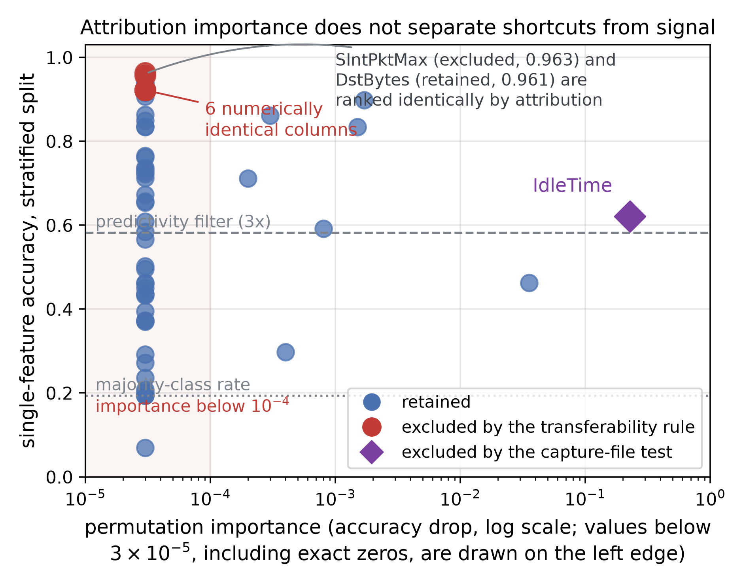
Figure 6. Attribution importance does not separate shortcuts from signal. Each point is one of the 63 behavioural features. Features whose permutation importance is exactly zero, including all eight audited shortcuts, are drawn on the left edge. The excluded features combine near-maximal standalone accuracy with importance below 10⁻⁴, while IdleTime, drawn apart because the capture-file test excludes it where neither of the other two criteria reaches it, carries an importance three orders of magnitude larger and yet appears far less predictive on its own — on the nine-class task. On the binary task it separates benign from attack traffic perfectly (AUC 1.0000), because it is a capture-file identifier and the two capture blocks are disjoint. Its vertical position here understates it, and Section 4.3 gives the measurement. SIntPktMax (excluded) and DstBytes (retained) occupy the same point, which is the configuration attribution cannot resolve.
This is the central methodological finding of the paper. On GeNIS, a shortcut audit built on attribution scores, the natural design and the one the corpus baseline's SHAP analysis approximates [6], assigned near-zero importance to all eight of these features, whereas our isolated, two-protocol evaluation exposed them. That is not evidence that the attribution measure is wrong: under dependence between predictors it estimates a different quantity, the loss attributable to one feature when the others remain available, and that quantity is genuinely near zero here. The discrepancy has a mechanical explanation that does not depend on this corpus. An importance measure defined by the loss incurred when a single feature is perturbed cannot register a feature whose information is duplicated elsewhere in the matrix. That dilution of importance across dependent predictors is documented independently of our setting [35, 36]. What is specific to GeNIS is that its shortcuts happen to be duplicated, and we cannot say from one corpus how common that configuration is. It also explains why that baseline could flag an “overreliance on traffic volume or packet counts” without being able to localise it.
Figure 7 makes the redundancy visible: the six identical columns collapse onto a single point, and the two remaining exclusions (SIntPkt, SIntPktMax) are interval statistics of the same inter-packet quantity. Every excluded feature is therefore one of a family of near-duplicates, which is precisely the configuration that defeats attribution.
Where the threshold sits, and what that depends on. Figure 8 shows the sorted transferability spectrum under both normalisations. Under τ, the excluded features lie at {0.33, 0.43, 0.49} and the lowest retained value is 0.54 (SrcLoad), so the 0.50 threshold separates two clusters. That separation is a property of the raw ratio rather than of the data: under the chance-corrected τ* the same threshold falls between 0.484 (Load) and 0.501 (DstRate), a gap of 0.017 instead of 0.047, and five further features are flagged, namely SrcLoad, SrcRate, DstLoad, Rate and Load, taking the behavioural blacklist from eight to thirteen. All five lie inside the band already shaded in Figure 7, so the chance-corrected ratio formalises the same uncertain boundary that the raw ratio made visible without being able to place it. Applying τ* < 0.5 is equivalent, on this corpus, to raising the raw threshold to approximately 0.61. We report both normalisations rather than only the one under which the threshold separates cleanly. Two observations follow. First, the boundary between shortcut and signal is not sharp on GeNIS. It is an interval, and where one cuts inside it is a modelling decision that must be declared. Second, the five features that change status are all load and rate quantities, that is, volume per unit of time, the very family the corpus baseline flagged as a possible overreliance [6]. Under the stricter normalisation, that concern extends further than our operative blacklist reaches. Section 9 states what this does and does not put at risk.
What the blacklist leaves behind. A blacklist is only as good as what survives it, so we measured the residual redundancy among the 55 retained columns directly, on a stratified sample of 120 000 flows of the audited feature matrix. Two results, pointing in opposite directions. No pair of retained columns is numerically identical: the six duplicated duration columns were the only exact duplicates in the released files, and the rule removed all six, so the loop the audit opens is closed. But exact duplication is the extreme of a continuum, and eight pairs remain correlated above 0.99 in absolute value (Table 4). Four volume columns, TotBytes, DstBytes, TotAppByte and DAppBytes, are mutually correlated above 0.9997, each carrying between 1.14 and 1.78 nats of mutual information with the label, so each of them carries most of what the other three carry. The transferability rule does not exclude them, and should not. Their predictive power survives the change of protocol, which is the signature of signal rather than of a shortcut. The consequence is for attribution, not for the blacklist. Permutation importance computed on the audited condition will still divide the credit for the volume signal arbitrarily among four columns, exactly as it divided it among six before the audit, so a near-zero importance on the audited feature set is not evidence that a column is uninformative. This is the same dilution across dependent predictors invoked above for the duplicated columns [35, 36], at a lesser degree. We therefore do not claim that no redundant shortcut survives the blacklist, which would be false. We claim the narrower thing we can measure. No exact duplication survives it, and the redundancy that does is quantified and released.
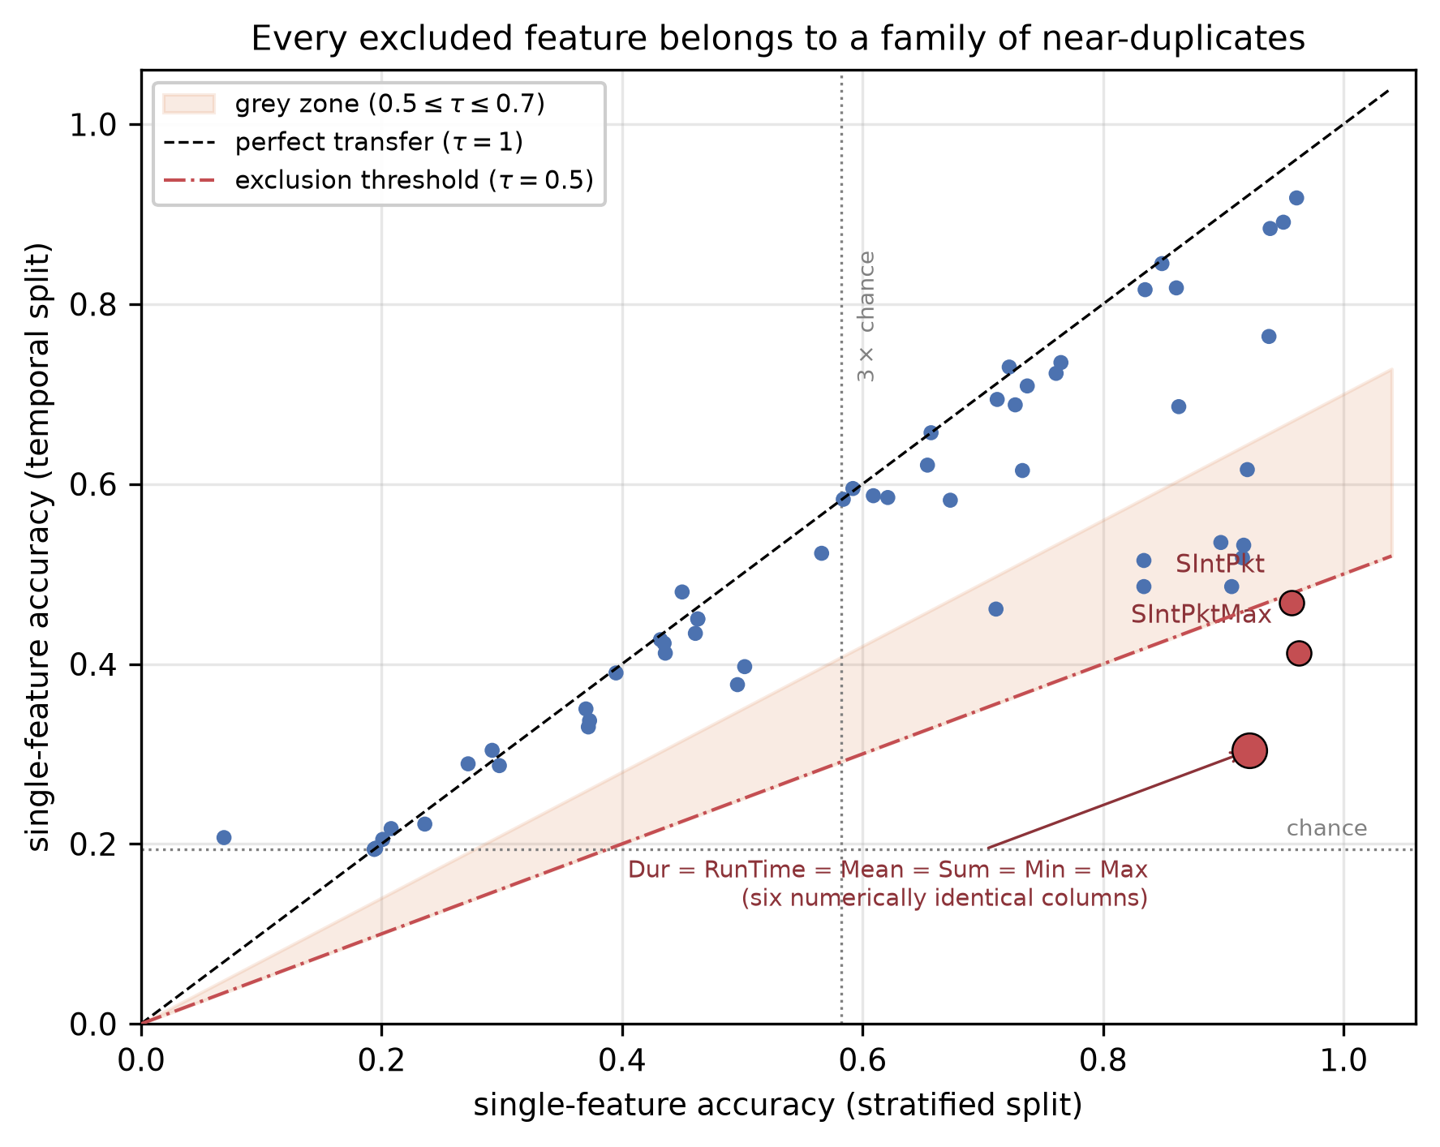
Figure 7. Single-feature accuracy under the two protocols. Points on the diagonal transfer perfectly; the eight red points fall below the exclusion threshold. The six numerically identical duration columns occupy a single point. The shaded band marks the interval in which the exclusion boundary depends on how the transferability ratio is normalised (Section 9).
Table 3. The published blacklist: 13 of 67 features. Positional columns (pos.) are excluded by construction and therefore carry no audit statistics; behavioural columns (behav.) are excluded by the transferability rule of Section 4.3, and the identifier column (id.) by the capture-file test of the same section, which neither of the other two criteria reaches. The quantities a_{strat} and a_{temp} are the single-feature accuracies under the two protocols. All eight behavioural shortcuts have permutation importance below 10⁻⁴. The identifier column carries the highest permutation importance of any column in the corpus and the highest transferability in this table, which is the whole point: neither criterion could have reached it.
Feature | Cat. | Perm. imp. | a_{strat} | a_{temp} | τ
StartTime | pos. | – | – | – | –
LastTime | pos. | – | – | – | –
Rank | pos. | – | – | – | –
Seq | pos. | – | – | – | –
Dur | behav. | 0.0000 | 0.922 | 0.304 | 0.33
RunTime | behav. | 0.0000 | 0.922 | 0.304 | 0.33
Mean | behav. | 0.0000 | 0.922 | 0.304 | 0.33
Sum | behav. | 0.0000 | 0.922 | 0.304 | 0.33
Min | behav. | 0.0000 | 0.922 | 0.304 | 0.33
Max | behav. | 0.0000 | 0.922 | 0.304 | 0.33
SIntPktMax | behav. | 0.0000 | 0.963 | 0.412 | 0.43
SIntPkt | behav. | 0.0000 | 0.957 | 0.468 | 0.49
IdleTime | id. | 0.2279 | 0.621 | 0.585 | 0.94

Table 4. Residual redundancy among the 55 columns retained after the blacklist, the eight pairs whose absolute Pearson correlation exceeds 0.99. Computed on a stratified sample of 120 000 flows of the audited matrix, without retraining. MI is the mutual information between the column and the nine-class label, in nats. Exact duplicates among the retained columns: none.
Pair of retained columns | |r| | MI, left column | MI, right column
TotAppByte / DAppBytes | 0.99999 | 1.498 | 1.144
DstBytes / DAppBytes | 0.99997 | 1.781 | 1.144
DstBytes / TotAppByte | 0.99997 | 1.781 | 1.498
TcpRtt / SynAck | 0.99995 | 0.561 | 0.566
TotBytes / DstBytes | 0.99987 | 1.760 | 1.781
TotBytes / TotAppByte | 0.99980 | 1.760 | 1.498
TotBytes / DAppBytes | 0.99979 | 1.760 | 1.144
DIntPktMin / DIntPktAct | 0.99216 | 0.583 | 0.589

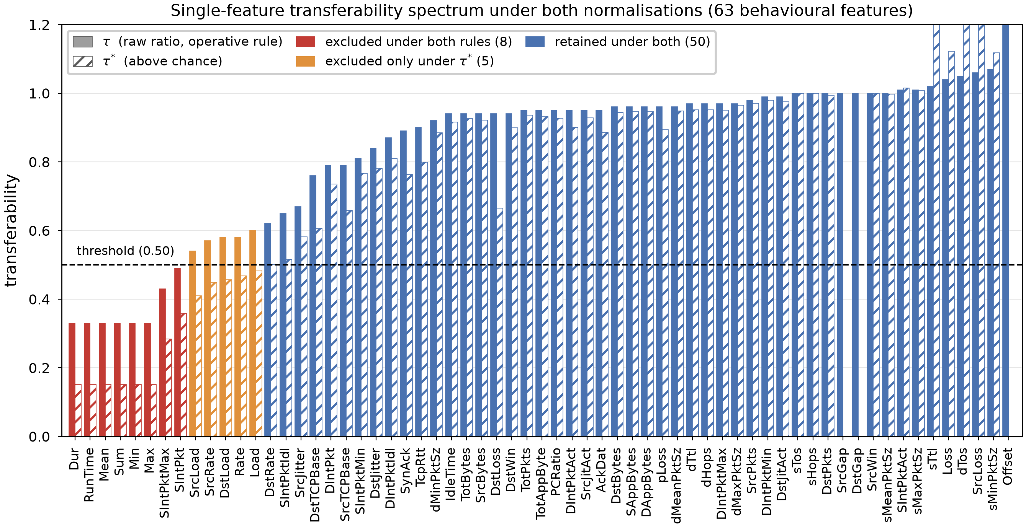
Figure 8. Single-feature transferability over all 63 behavioural features, sorted, under both normalisations. Solid bars give the raw ratio τ, hatched bars the chance-corrected τ*. Red marks the eight features excluded under both rules, orange the five excluded only under τ*. IdleTime, at 0.94, is among the blue: this rule retains it, and the capture-file test of Section 4.3 is what excludes it. Under τ the gap between 0.49 and 0.54 places the threshold between two clusters; under τ* that gap narrows to 0.017 (Section 6.2 and Table 15).
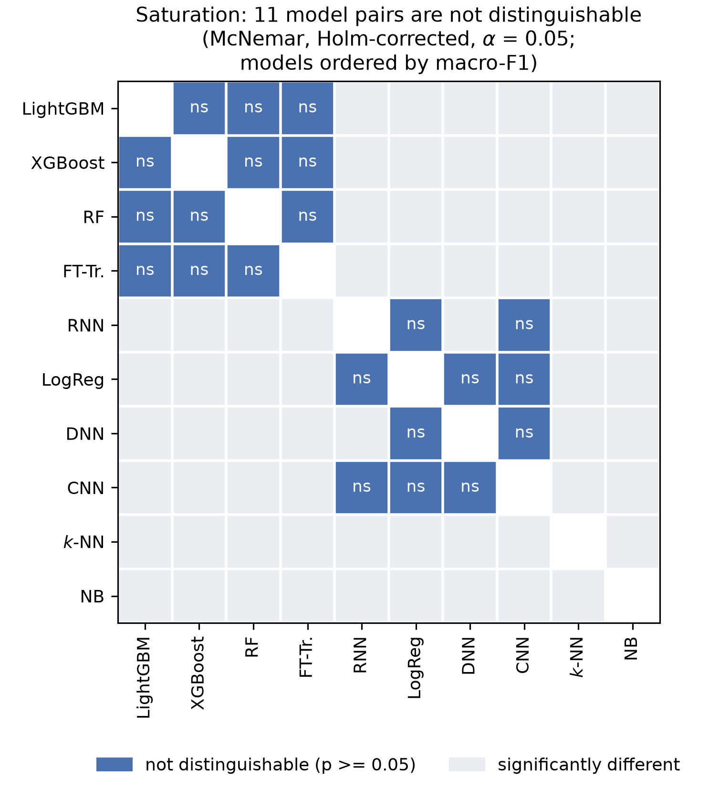
Figure 9. Pairwise McNemar tests under Holm correction on the shared test partition, audited condition, models ordered by macro-F1. The majority baseline takes no part, so the ten remaining detectors give 45 pairs, eleven of which are not distinguishable at α = 0.05, and they concentrate in the leading group. This is the rigorous form of the saturation claim: overlapping bootstrap intervals in Figure 11 are a weaker criterion, since two marginal intervals may overlap while a paired test still separates the models.

6.3 What the audit and the temporal protocol change
Excluding the twelve features the name list and the transferability rule return costs almost nothing under the stratified protocol: XGBoost, LightGBM and random forest are unchanged to four decimals, and the largest loss among the eleven detectors is 0.0018 (k-NN). The recurrent and convolutional models in fact improve (+0.0054 and +0.0103), although the clean condition is measured on a single seed and their seed dispersion is of the same order, so we do not read that as a reliable gain. The shortcuts were redundant with legitimate behavioural signal, so removing them does not remove the ability to classify; it removes the ability to classify for the wrong reason.
The temporal protocol is where the ranking moves (Figure 10). The FT-Transformer leads at 0.9901, followed by logistic regression (0.9881), the CNN (0.9848) and the RNN (0.9837); the DNN follows at 0.9773, and XGBoost and LightGBM fall to 0.9666 and 0.9649, ahead only of k-NN at 0.9574 and random forest at 0.9530. The gradient-boosted models that were unbeatable under a random split fell behind every neural detector and the linear model under the per-class temporal protocol on GeNIS, and a linear model outranked them. Because the stratified top group is statistically indistinguishable (Section 6.1), the temporal column is the only part of Table 2 in which the detectors separate at all. That is not the same as a statistically established ranking, and we do not claim one. The temporal protocol yields a single deterministic partition, so this column carries no variance estimate, no confidence interval and no paired test. It is an observed ordering on one partition. The gaps inside the leading four span 0.0064, from the FT-Transformer down to the RNN, which is the range in which the five-seed dispersion of the stratified protocol already sits, so none of those four should be read as established above another. What lies outside that range is the distance to the boosted ensembles: 0.0235 from the leader to XGBoost, five times the largest seed dispersion in Table 2 outside naive Bayes. What the column does support is the coarser and more robust observation that the two boosted ensembles, unbeatable under a random split, are no longer at the top once the protocol changes.
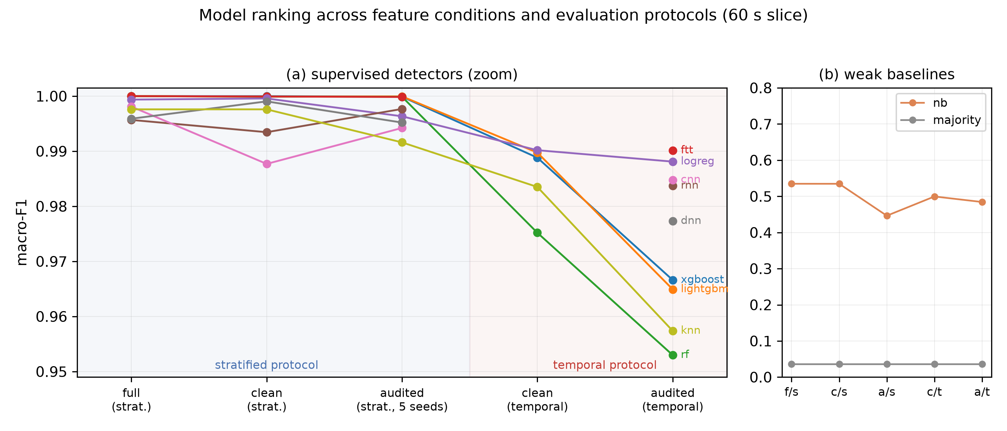
Figure 10. Macro-F1 across feature conditions and protocols. Panel (a) zooms on the supervised detectors; the reordering happens entirely inside a 5-point band that a 0–1 axis would hide. Panel (b) shows the weak baselines at true scale.
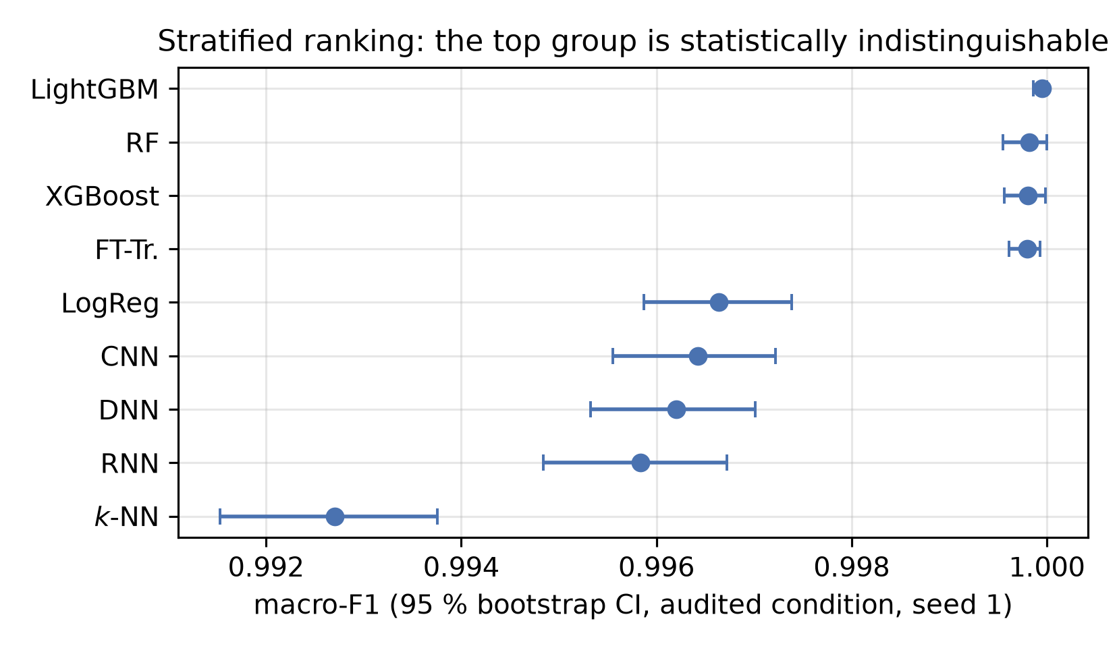
Figure 11. Bootstrap confidence intervals under the stratified protocol. The intervals of the leading group overlap, matching the 11 non-significant McNemar pairs (Figure 9).

6.4 Aggregation interval: some detectors depend on it, and depth does not predict which
The benign share falls monotonically as the aggregation window shrinks (7.42% at 60 s, 5.16% at 30 s, 2.38% at 10 s, 1.45% at 5 s), while the flow count grows from 338 820 to 2 773 578 (Table 5). Accuracy is therefore not comparable across intervals, and neither are false-positive rates.
Table 6 gives the effect on detection. The boosted trees are essentially interval-invariant: across their forty runs neither falls below 0.9998, with a single exception — LightGBM at 10 s, where four of its five runs are at or above 0.9999 and the fifth is 0.8374. That run is not dispersion around a mean but a different outcome. Five of its nine per-class F1 scores fall below 0.99, the worst being bruteforce-ftp at 0.056, and its false-positive rate is 7.7% against 0.0143% at worst for the other four seeds. We give the five figures rather than any average of them, because no run of this detector at this interval scored anything between 0.84 and 0.99. The DNN, by contrast, collapses as the window shrinks: 0.9968 at 60 s, about 0.849 at 30 s on four of five seeds with a fifth at 0.9879, 0.5120 at 10 s and 0.5235 at 5 s, with false-positive rates of 34% and 39% at the two shortest intervals. Aggregation is doing work that the dense network cannot do for itself, and an evaluation conducted only at 60 s, as in the corpus baseline, would report the neural and tree families as equivalent when they are not.
Figure 12 resolves this by family, and it withdraws a reading that averaging the runs invites. Detectability is uniformly high for the five denial-of-service families at every interval, never falling below 0.992. The brute-force families carry all of the dispersion, but not in the direction a window-length argument would predict: bruteforce-ftp scores 1.000 at 5 s, 1.000 at 30 s and 0.999 at 60 s, and the 0.685 the figure shows at 10 s is the mean of the three seeds it was drawn from, 0.999, 1.000 and 0.056, the last being the collapsed run described above. Over the five seeds now available that cell reads 0.811, which changes its value and not the reading. Set that seed aside and LightGBM classifies all nine families above 0.999 at 10 s as well. Were shorter windows fragmenting the low-rate brute-force pattern, the 5-second column would be the weakest. It is the strongest. We therefore read no window-length effect into the tree ensembles at all. The window-length effect this subsection first documented was the DNN's, and that one is systematic rather than seed-driven. Its standard deviation stays between 0.002 and 0.019 while its mean falls by nearly half.
Six further detectors, and what they settle. That study covered three detectors when this subsection was written and now covers nine. Two of the six added hold at every interval, k-NN never below 0.9931 and random forest never below 0.9998, so the stable group is not the boosted ensembles alone. The RNN takes one seed of three to 0.9163 at 10 s and stays above 0.9916 otherwise, which is the shape of LightGBM's failure and at the same interval. The CNN and logistic regression do what the DNN does and go further. One falls from 0.9942 at 60 s to 0.7388 at 30 s and 0.4620 at 5 s, the other from 0.9963 to 0.6076 and then 0.3831 at 10 s, both on all three seeds rather than on one. Naive Bayes moves the other way, from 0.4464 at 60 s to 0.7825 at 5 s, and we report that without offering a mechanism for it. What separates the two groups is not depth. k-NN is distance-based and holds, logistic regression is linear and does not.
What five seeds at every interval settled. The interval study first ran three seeds at 5, 10 and 30 s against five at 60 s, so the comparison across intervals was unbalanced and the 10-second collapse rested on one observation in three. The two missing seeds have since been measured, on a rerun that reproduced a published run to the bit before extending it, and Table 6 now carries five seeds at every interval. The collapse does not reproduce: one run of five falls to 0.8374 and the other four sit at or above 0.9999. It is an isolated failure of a single fit rather than an instability of LightGBM at that window, and it is reported as five runs rather than as a mean for that reason. The additional seeds also produced the mirror image on the DNN at 30 s, where four runs cluster near 0.849 and the fifth reaches 0.9879. The same rule applies to our own figure, and the runs are given rather than their average. Nothing else in the subsection moved. XGBoost spans 0.0002 across all twenty of its runs, and the DNN's decline with window length is carried by every seed at every interval.
What makes one fit fail and not the others. Throughout this paper a seed is the seed of the stratified split; every detector is constructed with its own random state fixed. Changing the seed therefore changes which flows are used for fitting, and with them the histogram grid LightGBM derives from those flows, since it places its bin boundaries from a subsample of 200 000 training rows. Two of the mechanisms one would suspect first are ruled out by the recorded configuration. The campaign sets only the tree budget, the leaf count and the learning rate, leaving bagging and column subsampling switched off, so neither row nor feature resampling takes place. The bin subsample is 98.4% of the 203 292 training flows at 60 s, where the grid is therefore all but determined by the data and no seed departs, against 22.6% of the 883 279 at 10 s. What the failed run looks like points to the fitting side rather than to an unlucky test draw. The damage follows class rarity rather than falling anywhere (Spearman 0.93 across the nine classes, bruteforce-ftp at 0.0561 and bruteforce-ssh at 0.6439 against 0.99 and above for the five commonest); global accuracy barely moves, at 0.9893; the binary ROC-AUC falls from 1.0000 to 0.9604, so the model has lost the ability to rank those flows and not merely to threshold them; and the fit took 336 s against 291 s for seed 1 at a fixed tree budget, which is a different tree structure and not a slower run. Bin construction was therefore the candidate, and it is wrong. It can produce this shape in isolation. With the split held fixed, a rare class at the same 0.23% share separated by an interval one thousandth of its axis, and bin construction at the 10-second coverage, sixteen seeds spread its F1 over 0.45 in discrete groups rather than around a mean, while raising the subsample above the training size returns the same value for all sixteen. On GeNIS it is not what happens. We refitted the same five splits at 10 s with the subsample raised above the training size, which makes the grid deterministic and changes nothing else, alongside a control refit of seed 1 under the original setting that reproduces its published macro-F1 to the last digit. Nothing is removed. The failure moves. Seed 3 recovers, from 0.8374 to 1.0000, and seeds 2 and 4 collapse in its place, at 0.4193 and 0.8106. The worse of the two falls further than the run we set out to explain, to a binary ROC-AUC of 0.5143 and a false-positive rate of 0.9571, with three classes at exactly zero. Neither new failure shows the lengthened fit that marked the published one. That eliminates the candidate. Bin sampling is one source of seed sensitivity among others, removing it removes nothing, and the fix we would have recommended had we stopped at the synthetic reproduction would have made this corpus worse. What remains is that at this interval the fit itself is unstable across split composition, and we have not localised that further.
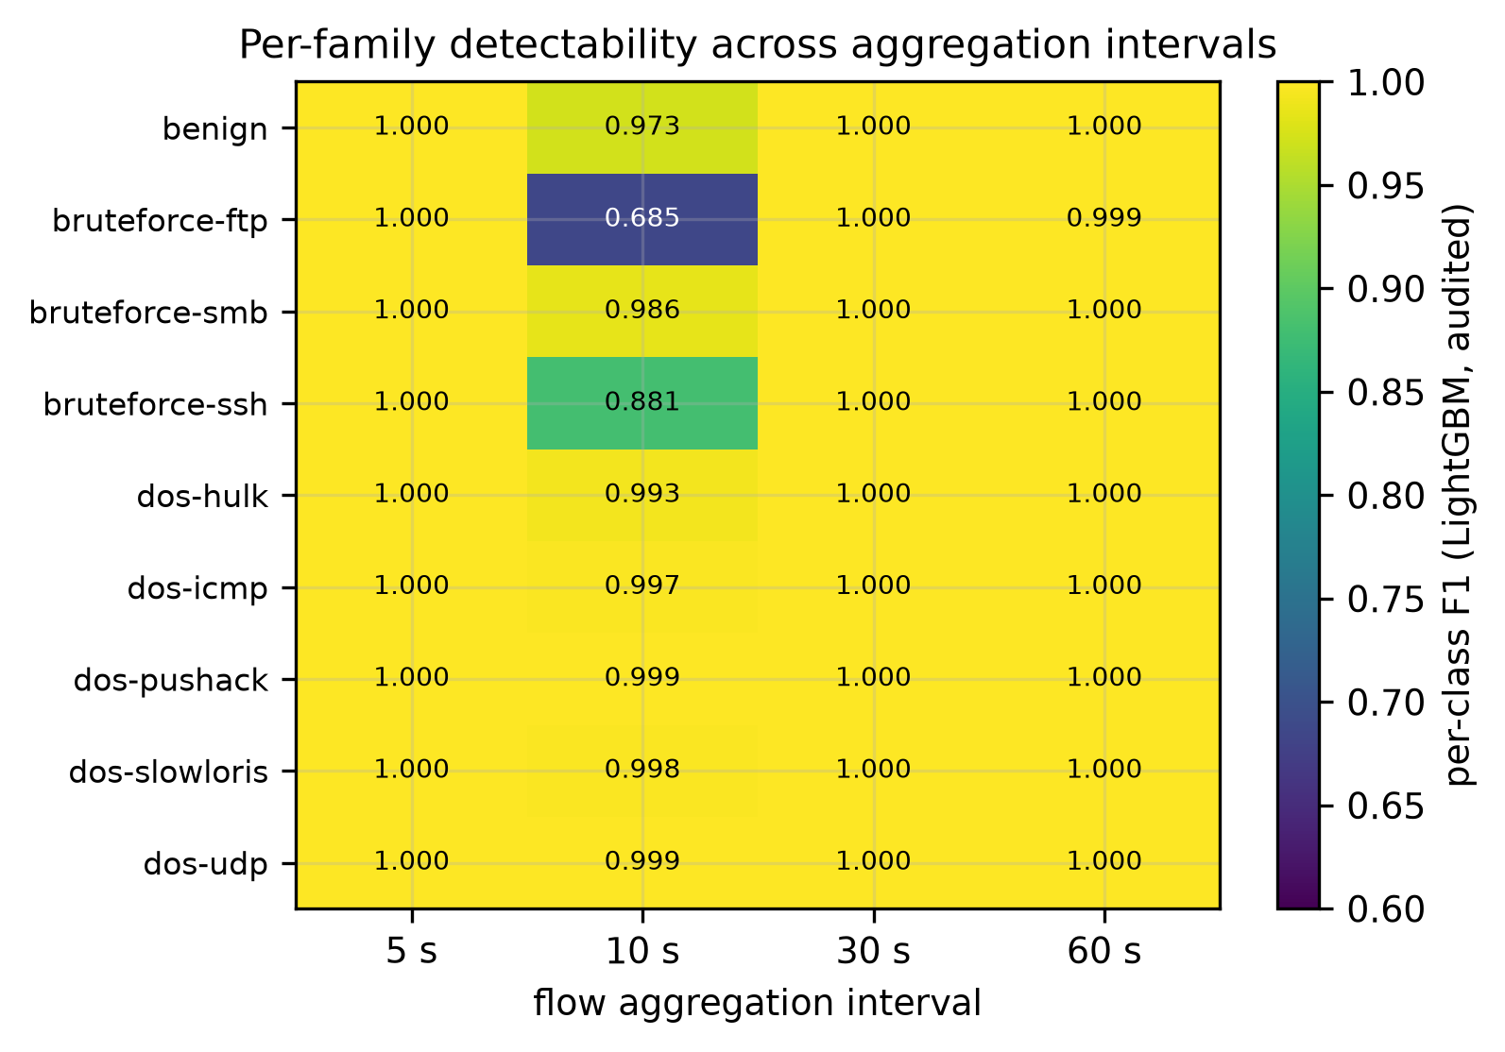
Figure 12. Per-class F1 across aggregation intervals (LightGBM, audited; mean over three seeds at 5, 10 and 30 s, seed 1 at 60 s). The heat map predates the two additional seeds of Table 6 and is drawn from three; every cell below 0.99 lies in the 10-second column, and every one of them comes from the single run that collapsed there (Section 6.4), the other four seeds classifying all nine families above 0.999 at that interval. The window length leaves the tree ensemble unaffected.
Table 5. Per-interval statistics recounted from the released 2-flows files, with the timestamp-only probe at each interval (majority-class rate 0.1942).
Interval | Flows | Benign flows | Benign (%) | Timestamp probe
5 s | 2 773 578 | 40 259 | 1.45 | 0.9991
10 s | 1 472 133 | 35 006 | 2.38 | 0.9988
30 s | 577 452 | 29 786 | 5.16 | 0.9983
60 s | 338 820 | 25 147 | 7.42 | 0.9970

Table 6. Macro-F1 by aggregation interval, audited condition as published over 55 columns and not re-run under the correction of Section 9, every individual run, five seeds at every interval. No mean is given, deliberately. LightGBM at 10 s is why: four of its five runs are at or above 0.9999 and the fifth is 0.8374, so any average of them describes no run that was performed. The two seeds missing from an earlier version of this table were measured afterwards, on a rerun that first reproduced one published run exactly before extending it.
Interval | Detector | seed 1 | seed 2 | seed 3 | seed 4 | seed 5
5 s | LightGBM | 1.0000 | 1.0000 | 1.0000 | 1.0000 | 1.0000
5 s | XGBoost | 1.0000 | 1.0000 | 1.0000 | 0.9998 | 1.0000
5 s | DNN | 0.5121 | 0.5563 | 0.5190 | 0.5127 | 0.5173
10 s | LightGBM | 0.9999 | 1.0000 | 0.8374 | 1.0000 | 1.0000
10 s | XGBoost | 1.0000 | 1.0000 | 1.0000 | 1.0000 | 1.0000
10 s | DNN | 0.5103 | 0.5150 | 0.5107 | 0.5093 | 0.5145
30 s | LightGBM | 0.9999 | 1.0000 | 0.9999 | 0.9998 | 0.9999
30 s | XGBoost | 0.9999 | 1.0000 | 0.9999 | 0.9998 | 0.9999
30 s | DNN | 0.8512 | 0.8432 | 0.8488 | 0.8515 | 0.9879
60 s | LightGBM | 0.9999 | 1.0000 | 1.0000 | 1.0000 | 0.9999
60 s | XGBoost | 1.0000 | 1.0000 | 1.0000 | 1.0000 | 1.0000
60 s | DNN | 0.9981 | 0.9969 | 0.9915 | 0.9989 | 0.9985

6.5 Calibration is a property of the protocol rather than of the detector, and tuning changes almost nothing
Table 7 reports both. Under the stratified protocol, expected calibration error is at most 0.0015 for every model except logistic regression and naive Bayes, and for the eight of them temperature scaling moves it by less than 0.001 in either direction. Logistic regression is the one the corrected blacklist moved: its stratified error rises from 0.0003 to 0.0084 once the identifier column is withheld, and scaling brings it back to 0.0016. Naive Bayes is the exception in both respects. It starts at 0.1419 and temperature scaling makes it worse (0.2240), the familiar failure of a single-parameter correction applied to a model whose errors are not a uniform over-confidence. On this saturated GeNIS benchmark the confidences were already well ordered and calibration had little left to repair, a negative result worth recording, since calibration is routinely recommended without checking whether it is needed. The fitted temperatures no longer sit at the floor of the grid as they did under the published blacklist. XGBoost, LightGBM and random forest move to 0.85, 1.46 and 0.39. Withholding the identifier column removed the column that made their posteriors near-deterministic, and the temperature says so.
Hyperparameter tuning is similarly inert where it matters. On the test partition it leaves XGBoost, LightGBM, random forest, the FT-Transformer, the RNN and the CNN untouched, for a reason worth separating from inertia: the search adopted no configuration at all for any of them, their tuned arm being their default arm. Where it did adopt one, it moves logistic regression by -0.0003, k-NN by +0.0033 and the DNN by -0.0046. It transforms only the model that was badly configured to begin with. Naive Bayes gains +0.0462, from 0.4464 to 0.4925, and still finishes last of the ten by a wide margin.
Two observations qualify this. First, a validation gain does not guarantee a test gain: the DNN improves by +0.0313 on validation yet loses 0.0046 on the test partition, and logistic regression inverts the same way on a smaller scale, +0.0005 against −0.0003. Of the four models whose search adopted a configuration at all, two moved down on the test partition after moving up on validation. Selecting on a single validation split, then retraining across five seeds, is enough to invert the sign of a small effect, a reminder that the guarantee “trial 0 is the default configuration” holds only for the quantity being optimised. Second, and despite this, the ranking of Table 2 is unchanged by tuning, which is the question a tuned arm exists to answer. The ordering is not an artefact of default settings.
Calibration degrades under the temporal protocol, and the best-calibrated detectors degrade most. Calibration appears in this paper's title, and the paragraphs above measure it under the stratified protocol alone. It is also measured under the temporal one, recomputed from the probability matrices the pipeline stored for every run, so no detector was retrained. Table 8 gives the comparison, and it is unfavourable to the reading with which this subsection opens. Nine of the eleven detectors are worse calibrated under the temporal protocol than under the stratified one. The tenth is the majority-class baseline, whose confidence does not depend on the split. The eleventh is logistic regression, and it goes the other way, at a ratio of 0.4 — not because its temporal error improved but because its stratified error rose to meet it once the identifier column was withheld. The degradation is not marginal: LightGBM moves from an expected calibration error of 0.000031 to 0.043588, a factor of 1403, XGBoost by a factor of 994, and the FT-Transformer from 0.000083 to 0.012069, a factor of 146. Those ratios are large because the stratified denominator is near zero, so the absolute change is the quantity to read. Among the nine that degrade, the expected calibration error rises by between 0.005 and 0.044 in absolute terms. A measure that does not depend on binning tells the same story. The Brier score of LightGBM moves from 0.000059 to 0.079437, of the FT-Transformer from 0.000295 to 0.023857, of XGBoost from 0.000079 to 0.055339 and of random forest from 0.000118 to 0.053395, so the degradation is not an artefact of the fifteen bins. Two readings follow. The near-perfect calibration we report under the stratified protocol is a property of that protocol rather than of the detectors. On a task a random split has saturated, well-ordered confidences are what any accurate model produces, and there is little left for calibration to repair because there is little left to get wrong. And the ordering changes with the protocol. The three detectors best calibrated under the stratified protocol, the two boosted ensembles and the FT-Transformer, are precisely the three that degrade most, so a ranking by calibration read from Table 7 inverts under the protocol this paper argues for. Neither reading is peculiar to this corpus. That predictive uncertainty degrades as the test distribution moves away from the training one, and that a post-hoc correction fitted on an in-distribution validation set does not follow it there, is the central result of the dataset-shift evaluation of Snoek et al. [37]. What our measurement adds is how little shift it takes: not a corruption, a new domain or a different network, but the same capture read in chronological order.
Temperature scaling is no longer inert under the temporal protocol, and no longer dependable. Under the stratified protocol temperature scaling moved the expected calibration error by less than 0.001 in either direction, which we recorded above as a negative result. Under the temporal protocol it does move things, but not reliably in the right direction: it improves five of the eleven detectors and worsens six, and which way it goes cannot be read off the stratified behaviour. The clearest repair is k-NN, from 0.0303 to 0.0160, and the clearest harm is random forest, from 0.0234 to 0.0410, which nearly doubles the error the scaling was fitted to reduce. The FT-Transformer, which leads under this protocol, moves the wrong way too, from 0.0121 to 0.0135. The reason is visible in the fitted temperatures. Withholding the identifier column already moved the tree ensembles off the floor of the grid under the stratified protocol (XGBoost 0.85, LightGBM 1.46, random forest 0.39), so the single parameter no longer has one dominant kind of over-confidence to undo. Under the temporal protocol it is fitted on a validation window that sits closer to training than the test window does, and it transfers that mismatch. The practical consequence is narrow but real. A temperature fitted under a random split is the wrong temperature for deployment on traffic that postdates training, and on this corpus a temperature fitted on the temporal validation window is not reliably the right one either.
A control on the measurement. These figures are recomputed from stored probability matrices, so before reading them we checked that the computation reproduces itself. The check is the published feature condition, replayed through the same code and compared against the earlier recomputation: raw expected calibration error agrees to within 0.0031 across both protocols. After temperature scaling the agreement is uneven, and the asymmetry is the point. It is 0.0002 under the stratified protocol and 0.0075 under the temporal one, although the fits underneath reproduce equally well on both. What amplifies is the scaling. The likelihood surface is flat near its optimum, so a small change in the probabilities moves the fitted temperature far enough to move the calibrated error with it. The last column of Table 8 is therefore the least stable quantity this paper reports, and its caption says so. One further caveat is arithmetic rather than statistical. The grid is bounded at 0.05 below and 5 above, so the temperature reported for naive Bayes is the ceiling of that grid and the one reported for the FT-Transformer under the temporal protocol, 0.050, is its floor; neither is an optimum. Nothing in the comparison between the two protocols depends on those bounds, since both protocols are calibrated on the same grid.
Table 7. Calibration (audited, seed 1) and hyperparameter search. T: fitted temperature; ECE_{raw} and ECE_{cal}: expected calibration error before and after temperature scaling. T is fitted by minimising negative log-likelihood on the validation partition over a grid bounded at 0.05 and 5, so the value for naive Bayes sits at the ceiling. Trials: random-search trials actually completed under the 900 s cap; the search was run on the twelve-column condition and is carried over unchanged. Δ_{val}: validation macro-F1 gain from tuning; Section 6.5 notes where it fails to transfer to the test partition.
Model | T | ECE_{raw} | ECE_{cal} | Trials | Time (s) | Δ_{val}
XGBoost | 0.854 | 0.0000 | 0.0000 | 20 | 676 | +0.0000
LightGBM | 1.455 | 0.0000 | 0.0000 | 20 | 849 | +0.0000
Random forest | 0.391 | 0.0002 | 0.0000 | 20 | 358 | +0.0000
FT-Transformer | 0.927 | 0.0001 | 0.0001 | 1 | 5 836 | +0.0000
Logistic reg. | 0.683 | 0.0084 | 0.0016 | 7 | 901 | +0.0005
RNN | 0.927 | 0.0009 | 0.0007 | 9 | 929 | +0.0000
1D CNN | 0.976 | 0.0014 | 0.0013 | 10 | 919 | +0.0000
DNN | 1.354 | 0.0015 | 0.0012 | 10 | 217 | +0.0313
k-NN | 3.076 | 0.0015 | 0.0010 | 17 | 930 | +0.0017
Naive Bayes | 5.000 | 0.1419 | 0.2240 | 20 | 12 | +0.1376

Table 8. Expected calibration error under both protocols, audited condition, default arm, seed 1 for the stratified column. Recomputed from the stored probability matrices without retraining; 67 764 and 67 769 test flows respectively. ECE columns are before temperature scaling unless stated; the last column gives the temporal error after scaling. T is the temperature fitted on the temporal validation partition, searched on a grid bounded at 0.05 and 5. Rows are ordered by the ratio between the two protocols. The last column is the least stable quantity reported in this paper: replaying the same fits reproduces raw temporal ECE to within 0.0031, but the temperature that minimises validation likelihood sits on a flat surface, and the optimum moves enough to shift the calibrated error by up to 0.0075 for the random forest, whose posteriors are near-deterministic.
Detector | ECE stratified | ECE temporal | ratio | T temporal | ECE temporal, calibrated
LightGBM | 0.000031 | 0.043588 | 1403× | 0.732 | 0.041791
XGBoost | 0.000028 | 0.028000 | 994× | 0.367 | 0.035252
FT-Transformer | 0.000083 | 0.012069 | 146× | 0.050 | 0.013501
Random forest | 0.000212 | 0.023375 | 110× | 0.318 | 0.040999
k-NN | 0.001499 | 0.030300 | 20× | 4.190 | 0.016012
DNN | 0.001453 | 0.020094 | 14× | 1.354 | 0.018289
RNN | 0.000928 | 0.007476 | 8.1× | 0.829 | 0.008415
1D CNN | 0.001408 | 0.006767 | 4.8× | 0.586 | 0.006520
Naive Bayes | 0.141884 | 0.167869 | 1.2× | 5.000 | 0.269970
Majority class | 0.805782 | 0.805781 | 1.0× | 5.000 | 0.774916
Logistic reg. | 0.008429 | 0.003307 | 0.4× | 0.951 | 0.003616

6.6 The benign-trained autoencoder fails, and fails informatively
The benign-trained autoencoder reaches a global AUROC of 0.4164 ± 0.0230: it is worse than chance. The per-family breakdown (Table 9, Figure 13) explains why, and it is what the global figure hides. Against dos-pushack the AUROC is 0.0000 (every flood flow reconstructs better than every benign flow), and it is 0.0111 for dos-udp and 0.0303 for bruteforce-ftp. Only bruteforce-smb (0.8969) and dos-icmp (0.8700) behave as the anomaly-detection premise expects.
The mechanism we observe on GeNIS is that volumetric floods are structurally simpler than legitimate traffic: a saturating stream of near-identical packets is easy to reconstruct, whereas benign office traffic is diverse. Reconstruction error therefore ranked the most damaging attacks as the most normal. The information is present, since an AUROC of 0.0000 is a perfect detector with the sign reversed, but for this architecture and corpus the standard decision rule “high reconstruction error implies anomaly” had the wrong polarity for these flood families. An operator deploying such a detector on this traffic would be systematically misled, and no threshold choice would repair it. This is a result about one architecture, one reconstruction loss and one corpus. We evaluated a single symmetric autoencoder under mean squared error. Whether the polarity failure appears for other reconstruction-based detectors, other losses, or floods captured elsewhere is a question neither this corpus nor this architecture can settle, and we draw no conclusion about reconstruction-based anomaly detection as a family. The nearest external evidence is Verkerken et al., who evaluate four unsupervised detectors including an autoencoder and report an average loss of 25.63% of accuracy when the same model is moved from CIC-IDS-2017 to CSE-CIC-IDS-2018 [16]. That result concerns transfer between corpora rather than polarity within one, so it does not settle the question just raised, but it places our observation in a literature where unsupervised detection is already known to travel badly.
Table 9. Benign-trained autoencoder, AUROC per attack family against benign (five seeds, audited condition). Values below 0.5 mean attacks reconstruct better than benign traffic.
Attack family | AUROC | s.d.
dos-pushack | 0.0000 | 0.0000
dos-udp | 0.0111 | 0.0108
bruteforce-ftp | 0.0303 | 0.0028
bruteforce-ssh | 0.3136 | 0.1069
dos-slowloris | 0.5851 | 0.0403
dos-hulk | 0.6817 | 0.0756
dos-icmp | 0.8700 | 0.0146
bruteforce-smb | 0.8969 | 0.0167
all attacks | 0.4164 | 0.0230

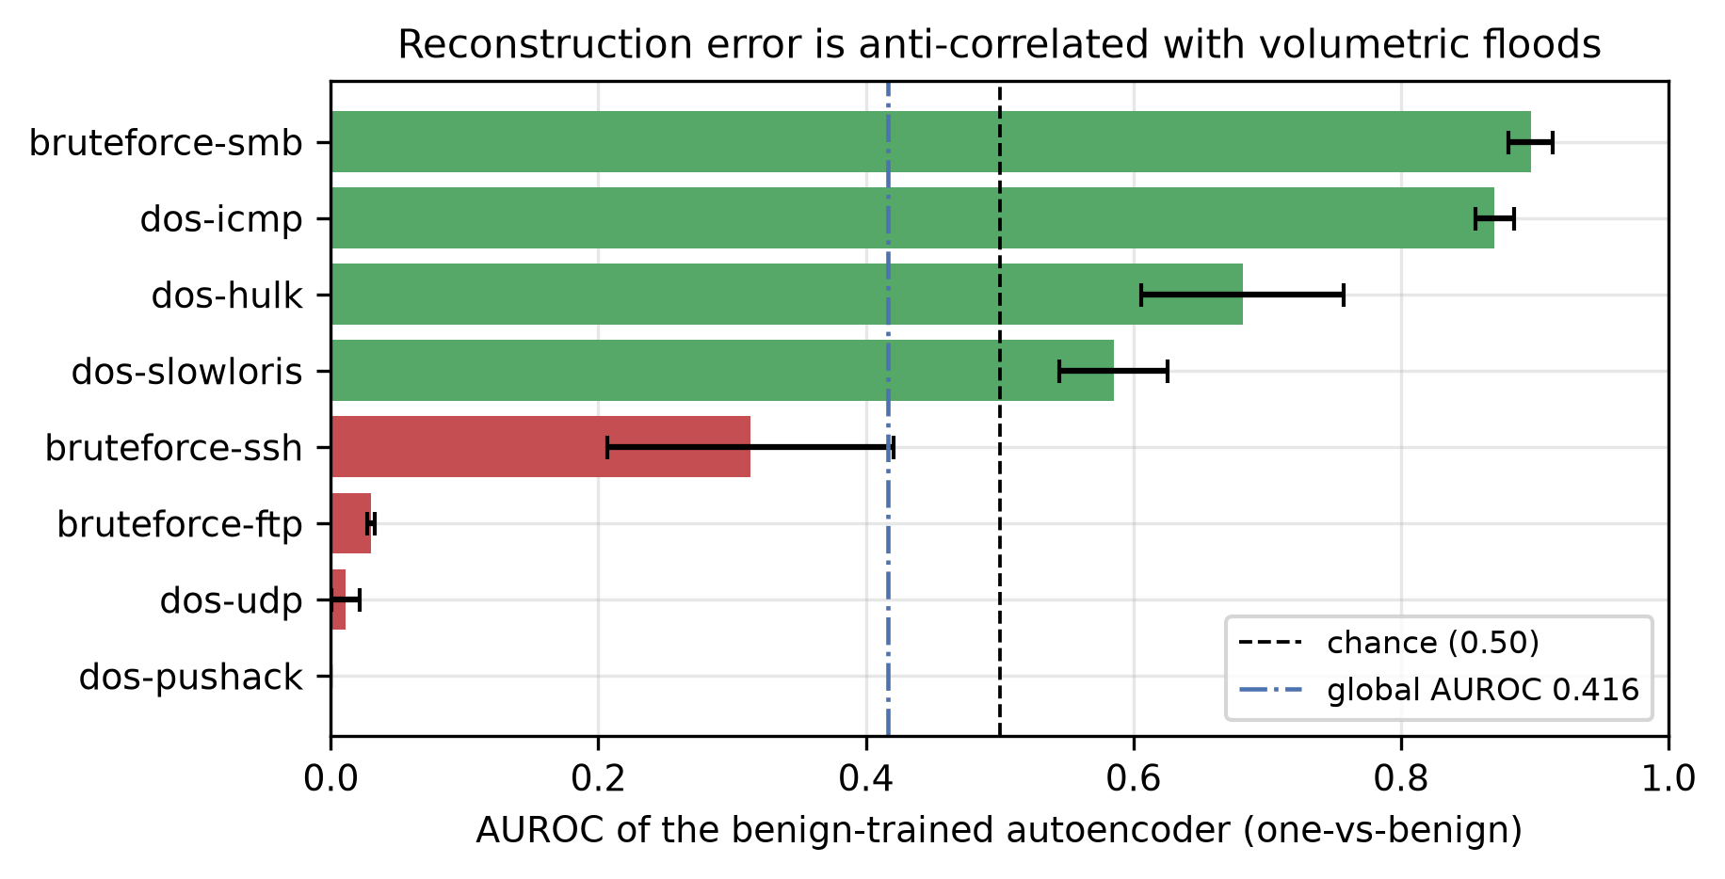
Figure 13. Per-family AUROC of the benign-trained autoencoder, five seeds, audited condition: the measurements of Table 9. Red bars fall below chance: the reconstruction error is anti-correlated with the presence of those attacks.

6.7 Inference cost separates what accuracy cannot
Since the leading models are statistically indistinguishable in accuracy, cost is the operative criterion. Table 10 and Figure 14 give single-host CPU measurements, all detectors being measured within one session under each library's default threading. The two columns rank the detectors differently, and the difference is the deployment regime rather than a measurement artefact. On batched throughput, logistic regression dominates outright at 601 449 flows/s, followed by random forest (58 151) and the DNN (51 972), with XGBoost fourth at 42 687. On single-flow latency the order inverts: random forest and the DNN need 55 and 77 ms per flow, where XGBoost answers in 1.22 ms and LightGBM in 1.55 ms. High batched throughput and low per-flow latency are not the same property, and only logistic regression leads both. The FT-Transformer is last on both, at 548 flows/s — 78 times below XGBoost, and its own lead comes only under the temporal protocol. The worst of both worlds is k-NN, paying 621 flows/s, 25.8 ms and 11.4 MB for a temporal macro-F1 of 0.9574, eighth of nine. One caveat governs how the latency column may be read. The four Keras models return median latencies inside a 4.4% band (76.8 to 80.1 ms) although their batched throughput differs by a factor of 95, so that column is dominated by a fixed per-call overhead of the prediction API and is not comparable with the scikit-learn column. The throughput column does amortise that overhead. One call covers 10 240 flows at batch size 512, so the overhead is paid once. An earlier version of this measurement looped twenty separate calls of 512 flows and therefore paid it twenty times, which inflated nothing but suppressed the throughput of every detector that has such an overhead — the four Keras models, and random forest through its parallel backend. That is why the two columns are now informative separately.
Recommendation. For a line-rate deployment on this corpus, logistic regression is the defensible default, and the margin is not close. It is ahead of XGBoost on four of the five axes we measure for both: 601 449 flows/s against 42 687, 0.14 ms against 1.22 at the median and 0.25 against 5.89 at the 99th percentile, and a temporal macro-F1 of 0.9881 against 0.9666, in a model of negligible size. Its single deficit is stratified macro-F1, at 0.9963 against 0.9999 — which is the quantity Section 6.1 finds saturated and Figure 9 finds statistically indistinguishable across eleven pairs. Only the FT-Transformer beats it under the temporal protocol, at 0.9901, 0.0020 above, and that costs 1 097 times more per flow. Random forest shows why both cost columns have to be read: second on batched throughput at 58 151 flows/s, yet 55 ms per flow, 45 times XGBoost's median latency.
Table 10. Single-host CPU inference cost, on the audited condition as corrected in Section 9, over 54 columns. Latency is measured at batch size 1 over 200 samples. All detectors were measured within one session, with the Keras models pinned to the CPU and each library left at its default thread settings (n_{jobs} = 2 for the tree ensembles and k-NN, unrestricted intra-op parallelism for the Keras models), so the figures are comparable with one another but are not single-core measurements. The batch-1 latencies of the Keras models are dominated by a fixed prediction-API overhead, discussed below. Throughput is one call over 10 240 flows at batch size 512, which amortises the per-call overhead once rather than twenty times; an earlier measurement looped twenty calls of 512 and is not comparable with this column. Model size and the majority-class row are carried over unchanged: the first is not re-measured, the second predicts a constant and marks a floor rather than a comparison.
Model | p₅₀ (ms) | p₉₉ (ms) | Flows/s | Size (MB) | macro-F1
XGBoost | 1.22 | 5.89 | 42 687 | 2.13 | 0.9999
LightGBM | 1.55 | 2.32 | 6 090 | 4.90 | 1.0000
Random forest | 55.16 | 67.36 | 58 151 | 3.34 | 0.9999
FT-Transformer | 80.14 | 168.85 | 548 | 1.49 | 0.9999
Logistic reg. | 0.14 | 0.25 | 601 449 | 0.00 | 0.9963
RNN | 77.87 | 147.63 | 22 217 | 0.14 | 0.9977
1D CNN | 76.76 | 154.96 | 28 580 | 0.79 | 0.9942
DNN | 77.13 | 147.86 | 51 972 | 0.22 | 0.9952
k-NN | 25.79 | 43.32 | 621 | 11.40 | 0.9916
Naive Bayes | 0.83 | 1.19 | 229 694 | 0.01 | 0.4464
Majority class | 0.03 | 0.05 | 16 007 604 | 0.00 | 0.0361

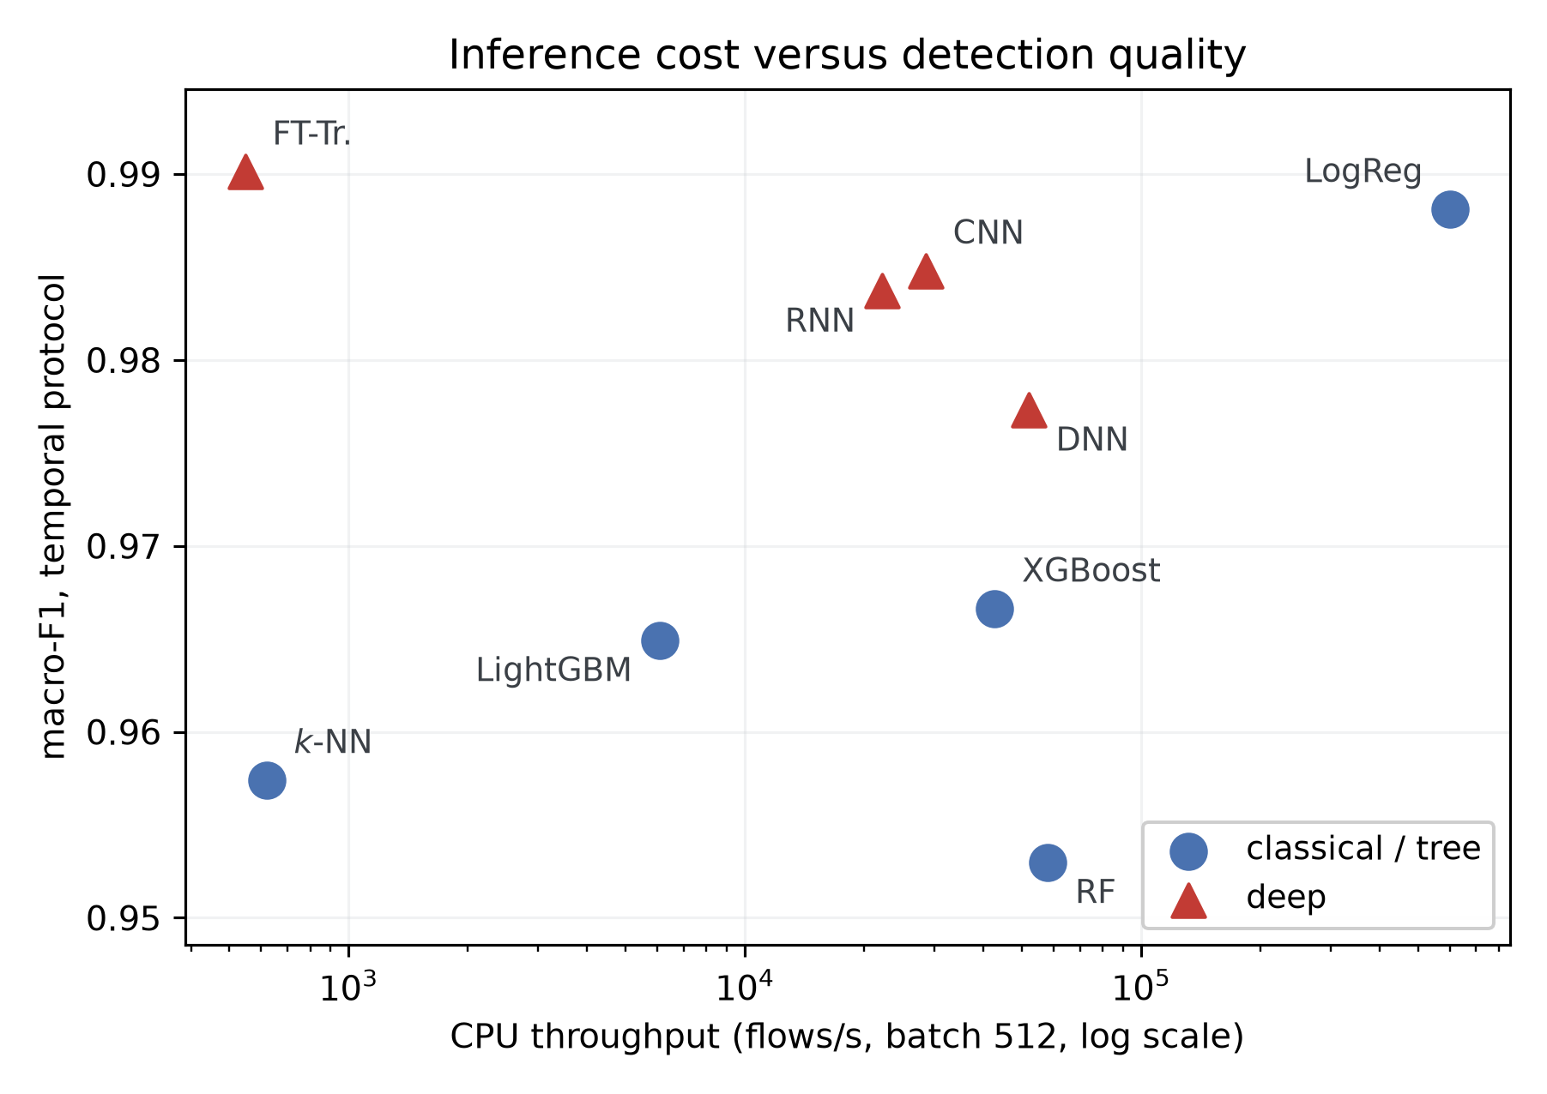
Figure 14. Inference cost against detection quality under the temporal protocol. The vertical axis deliberately carries the temporal macro-F1 rather than the stratified one: Section 6.1 shows that eleven pairs are statistically indistinguishable under a random split, so heights read from that column would not be comparable. Both axes are the audited condition as corrected in Section 9. Throughput spans three orders of magnitude, and no detector occupies the top-right corner: the FT-Transformer buys the best quality at the worst throughput, logistic regression is within 0.0020 of it at 1 097 times the throughput, and the DNN is dominated on both axes.

6.8 Repeated temporal evaluation, and an unseen family
Moving the cut: five rolling origins. Section 6.3 reads a ranking off one temporal partition, and says so. Whether that ranking is a property of the detectors or of the single cut that produced it is a different question, and it is answered by moving the cut. We refit ten of the eleven detectors at five rolling origins, the FT-Transformer excepted for the cost recorded in Section 9, from 40% to 60% of each class in steps of five points, the last of which rebuilds the published partition exactly and reproduces its four deterministic detectors to the bit. Figure 15 gives the result. The coarse observation of Section 6.3 survives and sharpens: the two boosted ensembles are not merely displaced from the top by the change of protocol, they are the least stable detectors in the set, with a standard deviation of 0.056 against 0.0013 for logistic regression, and a floor of 0.875 at the two earliest origins. At those origins their accuracy stays at 0.9886 while macro-F1 falls to 0.8812, which is one class disappearing rather than a diffuse decline. Logistic regression holds 0.9969 ± 0.0013 across the five. We read this as a statement about sensitivity to where the cut falls, not as a corrected ranking. The five origins share most of their training flows and are not independent replications.
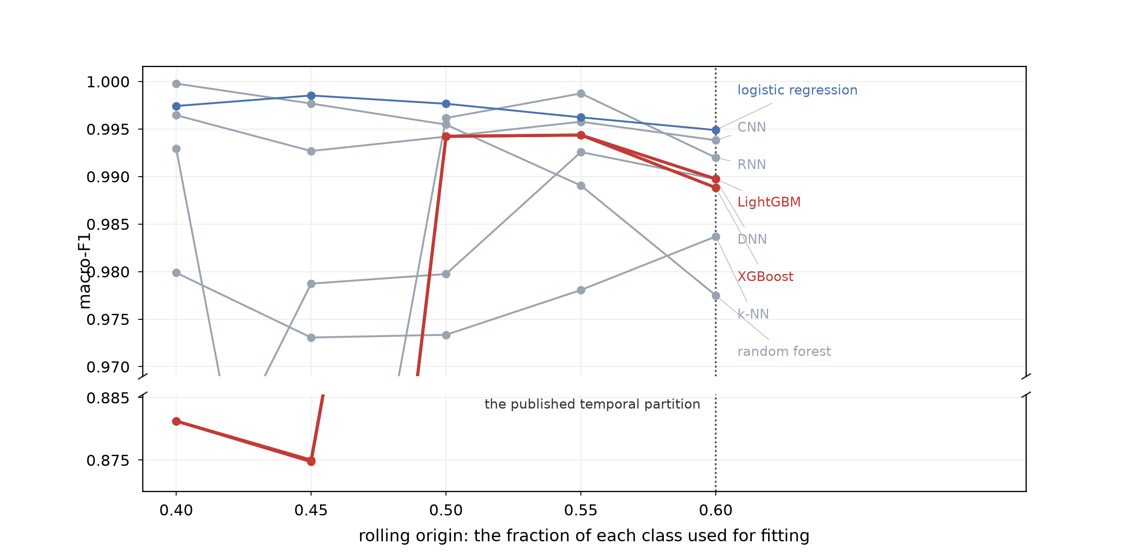
Figure 15. Macro-F1 at five rolling origins under the per-class temporal protocol, on the audited condition as published and not re-run under the correction of Section 9. Eight detectors are plotted and the vertical axis is broken. Four of them stay inside the upper 0.03 band at every origin; the two boosted ensembles leave it at the two earliest origins, which the lower panel resolves, and the RNN at 0.45 and the DNN at 0.40 dip below it without a panel of their own. The origin at 0.60 rebuilds the published partition exactly, and reproduces its four deterministic detectors to the bit. The majority baseline (0.036) and naive Bayes (0.54) lie outside both panels and are omitted.
The paired bootstrap the protocol section recommends. Section 4.5 names a paired bootstrap of the macro-F1 difference as the test that answers the question McNemar does not. We report one here, over 1 000 resamples of the stored probability matrices, which requires no retraining. Of the 45 detector pairs, the 95% interval of the difference contains zero for 7 under the stratified protocol and for 4 under the temporal one, against 11 under McNemar. The paired bootstrap is therefore the more discriminating of the two, which is what the difference between the questions predicts: McNemar asks whether two detectors misclassify different flows, the bootstrap asks whether their macro-F1 differs. The conclusion of Section 6.1 is unchanged and now rests on both tests. LightGBM against XGBoost, and random forest against XGBoost, are indistinguishable under either.
Withholding a whole family. The temporal protocol asks whether a detector recognises later flows of a family it has seen. It does not ask what happens to a family it has not. We therefore withhold each attack family from training in turn and measure how much of it the detector still reports as an attack, against the benign flows of the temporal test partition. Figure 16 gives the result and it reverses the ranking. XGBoost and LightGBM report every flow of every withheld family, at a false-positive rate of zero on benign traffic, so the outcome is not the degenerate one of a detector that answers attack everywhere. Logistic regression, the most stable detector across origins, fails on three families and reaches an AUROC of 0.4926 on dos-icmp, which is chance; the DNN does the same on dos-udp at 0.4879. No detector leads on both axes, and a benchmark reporting only one of them would recommend the wrong model for either purpose. One boundary governs how far this reads. Withholding one family leaves its siblings in training: two other brute-force families, or four other denial-of-service families. What is measured is generalisation to an unseen variant of a known category, not to a novel attack. The stronger experiment withholds a whole category, and we did not run it.
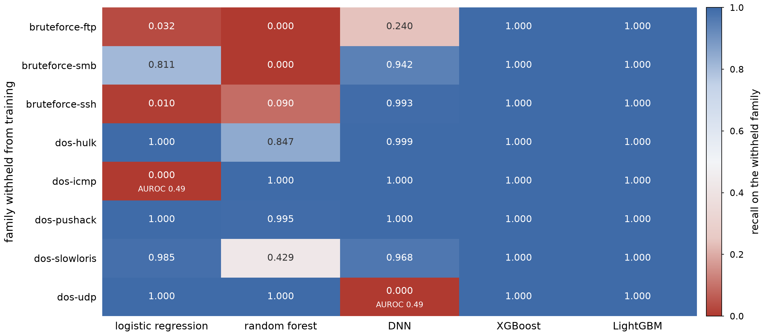
Figure 16. Leave-one-family-out, for five of the eleven detectors and on the audited condition as published. Each cell is the fraction of the withheld family's flows that the detector still reports as an attack, having never seen that family in training; the evaluation set is that family plus the benign flows of the temporal test partition. Two cells carry the AUROC because it is at chance there, which is the real failure. The reading is columnar: the two boosted ensembles are solid, and the other three are not.

7. External validation: the audit on CICIDS2017
Three of this paper's findings are methodological, and until this section all three rested on a single corpus. We therefore re-ran the audit, unchanged in form, on CICIDS2017 [9], the corpus whose decade of use motivates Section 2.1. This is not a second benchmark: we did not repeat 154 runs and we report no leaderboard. It is the audit alone, the timestamp probe, the duplicate check, the single-feature transferability scan under both protocols, and permutation importance, applied to a corpus produced by a different laboratory, with a different flow exporter, in a different year, under a different attack schedule. Two of the three findings reproduce and one does not, and the one that does not delimits the conditions under which the rule applies.
The corpus, and which distribution of it. CICIDS2017 is distributed in two forms and the choice is not free. The MachineLearningCVE distribution carries 79 columns and no timestamp; every step of this audit rests on capture order, so it cannot be used here. We load GeneratedLabelledFlows instead: eight daily files, 2 830 743 flows, 85 columns, which is the canonical count for this corpus. Six identifier columns (flow identifier, source and destination addresses, source and destination ports, protocol) and one positional column, the timestamp, are excluded by name exactly as in Section 4.3; eight constant columns are dropped; 69 behavioural columns remain, and the task is the fifteen-class label the corpus ships. The majority class, BENIGN, holds 80.30% of the flows against 19.42% on GeNIS, and that single difference drives most of what follows. One consequence for the earlier work these architectures come from. The comparative study reused here [7] reports 79 columns for CICIDS2017, which is the MachineLearningCVE count, so the identifier and timestamp columns discussed here were already absent from the files it used and its results are unaffected by them.
The timestamp shortcut reproduces, and the temporal protocol destroys it. A decision tree given only the timestamp classifies the fifteen classes at 0.9529 under a stratified split, against a majority-class rate of 0.8030. The shortcut is present and it is large: on a corpus where predicting BENIGN everywhere already scores 0.80, the probe recovers three quarters of the margin that remains. What differs is what the temporal protocol does to it. On GeNIS the same probe survives per-class temporal ordering at 0.9862, a transferability of 0.99. On CICIDS2017 it falls to 0.1028, far below the majority-class rate, a transferability of 0.11 (Table 11). The mechanism is the capture schedule in both cases, and it is the schedules that differ. GeNIS records benign traffic on three days and every attack on three later days, so ordering flows within a class cannot break the association between a class and its position in the capture, because that association holds at the scale of the whole capture. CICIDS2017 runs benign traffic through all five working days alongside the attacks, so ordering within a class destroys it. The lesson is stronger than the one GeNIS alone supported. Whether temporal splitting suffices is a property of the corpus and not of the method on these two corpora. That has to be measured, and the timestamp probe under both protocols measures it at negligible cost. Two corpora cannot establish that the diagnostic is reliable across the field, and we put it forward as an empirically supported recommendation rather than a general result. On GeNIS the answer is no and feature exclusion is required. On CICIDS2017 the answer is yes. The requirement that evaluation be chronologically consistent [19] is right and incomplete. It tells a study to order its data in time, and the probe tells it whether ordering was enough.
The global chronological split is degenerate on both corpora. Section 4.2 reports that a global chronological split on GeNIS is degenerate, the last portion of the capture containing only classes absent from the first, and presents that table as a property of the corpus rather than as a protocol. A reader may reasonably suspect an oddity of GeNIS, since CICIDS2017 carries benign traffic on every day. It is not. Splitting CICIDS2017 chronologically at the day boundary leaves exactly one class shared between the training and test sides, BENIGN: each of its fourteen attack families is executed on a single day too, from Heartbleed on the Wednesday to PortScan on the Friday. The degeneracy is therefore a property of scripted captures rather than of GeNIS, and the per-class temporal protocol of Section 4.2 is the right instrument on both corpora.
Seven pairs of identical columns, and attribution sees none of them. The duplicate check finds seven pairs of numerically identical columns among the 69 behavioural candidates (Table 12). Ten of the fourteen columns involved have a permutation importance of exactly zero, and the mechanism is the one Section 6.2 describes: perturbing one member of an identical pair costs nothing, because its twin still carries the same values. The sharpest case is Bwd Packet Length Mean, which classifies the fifteen classes at a single-feature macro-F1 of 0.385, twice the eligibility threshold, while scoring exactly 0.00000 in importance, as does its twin Avg Bwd Segment Size (Figure 17b).
What was already known, and how well. Every one of the seven pairs has a documented cause, and three are documented as duplications. Rosay et al. [10], re-extracting the corpus from its packet captures with their own tool, sort the defects of the released files into five categories and name four duplicated features under the first: Average Packet Size with Packet Length Mean, Fwd Packet Length Mean with Avg Fwd Segment Size, Bwd Packet Length Mean with Avg Bwd Segment Size, and the repeated Fwd Header Length column, which Engelen et al. [1] also trace to the extractor. Three of those four are among our seven. The remaining four of ours fall under their second category, miscalculation, and the defects they describe are precisely what would produce the identities we measure. The first is a subflow counter whose guard is always true, so that it is incremented on every packet received, which is what makes Subflow Fwd Packets and Subflow Bwd Packets coincide with Total Fwd Packets and Total Backward Packets. The second is a set of TCP flag counters inverted between SYN and PSH and between FIN and URG, with the forward and backward PSH and URG counts never updated at all, which is the family of defects that collapses Fwd PSH Flags onto SYN Flag Count and Fwd URG Flags onto CWE Flag Count. Our own loading corroborates the last of these from another direction: Bwd PSH Flags and Bwd URG Flags are constant in the released files and are dropped before the audit begins.
Where the definition and the data disagree. One pair runs the other way, and it is instructive. Average Packet Size and Packet Length Mean are duplicated by definition and are named as duplicated, yet they are not numerically identical in the released files: they take 37 309 and 38 163 distinct values and classify the fifteen classes at 0.930 and 0.922. The same study accounts for that as well, since it reports that the first packet of each flow is counted twice in the packet-length mean, standard deviation and total. A definitional duplicate can therefore survive as two distinct columns once one of the two is miscalculated, which is the reason our check measures identity on the released values rather than inferring it from the feature list.
Why documented duplication is the stronger case. That this redundancy has been documented, cause by cause, since 2021 and 2022 strengthens the argument rather than weakening it. The corpus remains in wide use in its original form; a study that audits its own models with permutation importance or SHAP, on the files as distributed, is shown a value of exactly zero for the duplicated columns, and would conclude that they carry nothing. Our claim about CICIDS2017 is therefore not that we discovered its redundancy. It is that attribution would not have revealed it on a corpus where it is already documented, which is the sharpest available form of the mechanism of Section 6.2. The blindness is a property of the measure under dependence between predictors [35, 36], not a property of how obscure the duplication happens to be.
No behavioural shortcut survives the scan. The transferability scan is the part of the audit most exposed to over-flagging. Of the 69 behavioural columns, 43 pass the predictivity filter, and not one of them falls below the transferability threshold: the lowest value is 0.6726, on Bwd IAT Std, well clear of 0.50, and the distribution has no cluster near the threshold at all (Figure 17a). The behavioural blacklist for CICIDS2017 is therefore empty, and the audited condition coincides with the clean one. This answers the symmetric objection. A rule that flags features on a two-protocol comparison could be a rule that flags features everywhere, and on this corpus it flags none. The only shortcut the audit finds here is positional, and excluding the timestamp by name removes it before any measurement is taken — which is the exclusion-by-name remedy of D’hooge et al. [21], not a contribution of our rule.
The published rule does not transfer unchanged. One component of the rule broke, and only a second corpus could have shown it. The predictivity filter of Section 4.3 keeps a feature eligible when its single-feature accuracy exceeds three times the majority-class rate. On GeNIS, where that rate is 0.1942, the threshold is 0.5827 and the filter is meaningful. On CICIDS2017 the rate is 0.8030 and three times it exceeds one, so the filter is not merely strict but arithmetically unsatisfiable: no feature can be eligible, and the audit would return an empty answer for a reason that has nothing to do with the data. Single-feature accuracy is saturated in any case on such a corpus, since predicting BENIGN everywhere already scores 0.8030, and re-expressing the filter as a fraction of the margin above chance, acc > p + κ(1 − p) with κ = 0.4818, a form that reproduces the published GeNIS rule exactly and remains defined on any corpus, leaves only nine columns eligible for that same reason. We therefore carried the rule over in form rather than in letter, applying it to macro-F1, which gives no credit for the majority class, and keeping its shape, three times the baseline, with the baseline being the measured macro-F1 of the majority-class classifier, 0.0636. The retained threshold is 0.1909, and for the same reason the transferability ratio on this corpus is taken on macro-F1 rather than on accuracy. This is a defect of the rule as published, not of the audit, and we record it as one. A predictivity filter expressed as a multiple of the majority-class rate is well defined only on corpora that no single class dominates.
What this section establishes, and what it does not. Two of the three methodological findings transfer. The blindness of attribution to duplicated columns reproduces on a corpus built by another laboratory with another exporter, and the arithmetic is if anything starker: ten columns at exactly zero, three of the seven pairs whose cause is documented in the literature [1, 10] and scored at zero all the same. The degeneracy of a global chronological split reproduces, so the per-class temporal protocol is not a device invented to rescue GeNIS. The third finding does not transfer, and the correct conclusion is not that it was wrong but that we stated it too generally: temporal splitting was insufficient on GeNIS and is sufficient on CICIDS2017, so sufficiency is a corpus property that a cheap probe measures and that no study should assume in either direction. Three limits bound this section. It is an audit and not a benchmark. We trained three detectors under both protocols to confirm that the pipeline runs end to end, and those runs are released with the artefact, but a fifteen-class macro-F1 on a corpus containing families of eleven, twenty-one and thirty-six flows measures the handling of the rarest classes more than it measures detection quality, and we do not report it as a comparison. Two corpora are not a survey. And CICIDS2017 is itself a corpus with documented extraction and labelling defects [1, 2, 3, 10], which is a reason to audit it rather than a reason to treat its numbers as ground truth.
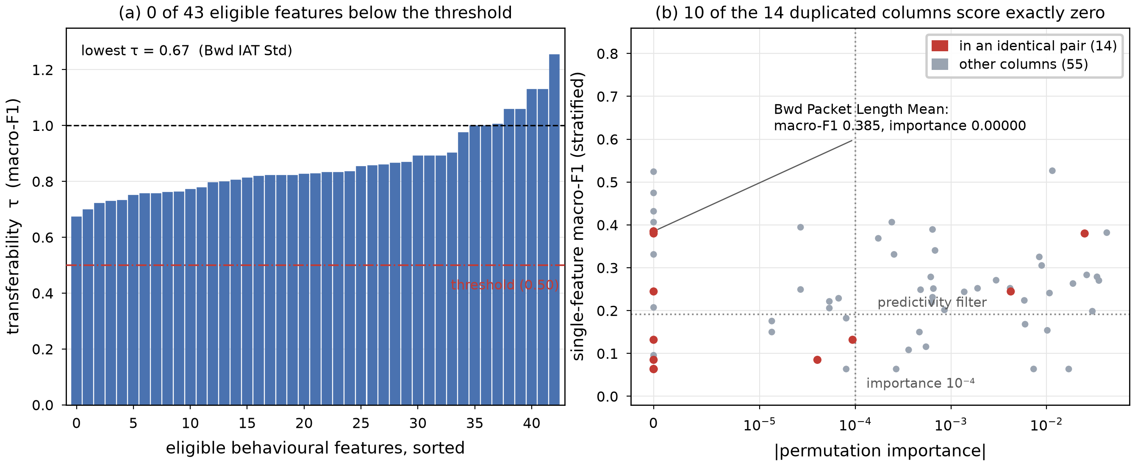
Figure 17. The audit re-run on CICIDS2017. (a) The single-feature transferability spectrum over the 43 columns that pass the predictivity filter, the counterpart of Figure 8 for this corpus. No column falls below the 0.50 threshold and the lowest value is 0.67, so the behavioural blacklist is empty. (b) Permutation importance against single-feature macro-F1 for all 69 behavioural columns. The fourteen columns belonging to the seven numerically identical pairs are drawn in red, and ten of them score exactly zero while remaining individually predictive, which is the configuration attribution cannot resolve. Both panels use macro-F1 rather than accuracy, because a corpus with an 80.30% majority class saturates single-feature accuracy.
Table 11. The audit on the two corpora, side by side. GeNIS figures are the 60-second slice reported in Sections 3 and 6; CICIDS2017 figures are computed by the same procedure on the GeneratedLabelledFlows distribution, data signature 2830743|69|15. The probe rows give nine-class and fifteen-class accuracy for a decision tree trained on the timestamp alone. The identical-pair row counts pairs, with the number of distinct columns involved in brackets.
 | GeNIS (60 s) | CICIDS2017
Flows | 338 820 | 2 830 743
Classes | 9 | 15
Majority-class rate | 0.1942 | 0.8030
Behavioural columns audited | 63 | 69
Eligible under the predictivity filter | 38 | 43
Timestamp probe, stratified | 0.9970 | 0.9529
Timestamp probe, per-class temporal | 0.9862 | 0.1028
Transferability of the probe | 0.99 | 0.11
Global chronological split | degenerate | degenerate
Numerically identical column pairs | 15 (6 columns) | 7 (14 columns)
Behavioural exclusions | 8 | 0

Table 12. The seven pairs of numerically identical columns in CICIDS2017, with their permutation importance under a LightGBM reference model on the stratified split. Ten of the fourteen columns score exactly zero, and no pair has both members above 10⁻³. The pattern is the one Section 6.2 reports on GeNIS, where six identical duration columns all scored below 10⁻⁴.
Column | Perm. imp. | Numerically identical column | Perm. imp.
Total Fwd Packets | −0.00004 | Subflow Fwd Packets | 0.00000
Total Backward Packets | +0.00009 | Subflow Bwd Packets | 0.00000
Fwd Packet Length Mean | +0.02497 | Avg Fwd Segment Size | 0.00000
Bwd Packet Length Mean | 0.00000 | Avg Bwd Segment Size | 0.00000
Fwd PSH Flags | 0.00000 | SYN Flag Count | 0.00000
Fwd URG Flags | 0.00000 | CWE Flag Count | 0.00000
Fwd Header Length | +0.00421 | Fwd Header Length.1 | 0.00000

8. Discussion
What a benchmark on a saturated corpus can and cannot say. Eleven supervised detectors, five seeds and paired significance tests converge on the conclusion that the nine-class GeNIS task is solved under a random split, and that the resulting leaderboard is not interpretable. This is not a defect of the corpus, which was built to be a reliable and modern reference; it is a property of testbed traffic in which attacks are executed one family at a time against a small enterprise topology. The productive response is to change what the benchmark measures (protocol robustness, calibration, cost, interval sensitivity) rather than to keep reporting fourth decimals.
Shortcut auditing should not be delegated to attribution alone. Our strongest transferable result is negative and methodological: on GeNIS, the eight behavioural shortcuts we identify are exactly the features that attribution methods score at zero. On this corpus, pipelines that selected candidate shortcuts using importance ranking, SHAP, or recursive elimination retained redundant shortcuts, whereas an isolated, two-protocol evaluation of each feature exposed them. The mechanism behind that failure, a measure of single-feature perturbation cannot see information that is duplicated, is not specific to GeNIS and is documented for dependent predictors [35, 36]. What we cannot establish from one corpus is how often exporters emit several statistics of the same underlying quantity. Section 7 adds one further data point: seven pairs of numerically identical columns among the 69 behavioural candidates of CICIDS2017, produced by a different exporter, ten of whose fourteen columns again score exactly zero importance. One element of the procedure does not carry to another corpus, and it is the threshold. Section 4.3 recovers the eight columns by their rank and by the gap that isolates them under an audit design where the literal 0.50 cut excludes nothing, so a study on a different corpus should transport the ranking and the gap rather than the number.
Temporal evaluation was necessary but not sufficient on GeNIS. The finding that the timestamp probe survived a per-class temporal split at 0.9862 has methodological implications for corpora with similar capture protocols. Chronological evaluation defends against learning future information; on GeNIS, it did not defend against learning which window belonged to which class when the windows are disjoint by construction. GeNIS, a corpus generated by sequential attack scenarios on a CyberRange, required feature exclusion in addition to temporal splitting, and the two remedies were not interchangeable on this benchmark. Put to a second corpus in Section 7, that finding does not survive. On CICIDS2017 the same probe falls to 0.1028 under the per-class temporal protocol, below the majority-class rate, because benign traffic runs on every capture day. Whether temporal splitting suffices is therefore a property of the capture schedule, measurable by the timestamp probe under both protocols, and neither answer generalises from one corpus to the next.
Which detectors are actually viable, and on which axis. The four preceding subsections each rank the detectors differently, so a synthesis is needed. We deliberately exclude training time from the criteria: it was measured in a hosted runtime whose accelerator allocation varied between sessions, so it reflects hardware availability as much as model cost (Section 9). All four axes below are measured on a stable basis, Table 13 collects them and Figure 18 shows where each detector actually loses.
No detector wins on all four axes, and the ordering inverts between them. Under the temporal protocol the FT-Transformer leads at 0.9901, but it processes 548 flows per second, 78 times fewer than XGBoost. XGBoost falls behind every neural detector and the linear model on quality at 0.9666 and is fourth on batched throughput at 42 687 flows per second, but it answers a single flow in 1.22 ms where the three detectors above it on throughput need 0.14 to 77 ms, in a 2.13 MB model, and is unchanged to four decimals by tuning. A benchmark that reports a single axis therefore selects its winner by selecting its axis, which is the practical form of the saturation problem: when eleven pairs are statistically indistinguishable on accuracy, the operative criteria are the ones accuracy does not capture.
Logistic regression. It reaches 0.9881 under the temporal protocol, second overall and ahead of both gradient-boosted ensembles and every recurrent or dense network, at 601 449 flows per second and a negligible model footprint. Its fitted temperature of 0.68 also leaves usable probability estimates. On this corpus, the quality-per-unit-cost argument favours it by a wide margin at the 60-second interval, and only there. Section 6.4 measures it at 0.6076 at 30 s and 0.3831 at 10 s, so the recommendation holds where the aggregation window is the deployer's to fix and not otherwise. Any claim that a deep architecture is required here still has to answer the cost number first.
Robustness to the aggregation interval separates the families more sharply than accuracy does. The interval is an infrastructure parameter chosen by whoever deploys the exporter, not a property the detector controls, so sensitivity to it is a viability question. Four detectors are indifferent to it. XGBoost never falls below 0.9998 across its twenty runs, with a zero false-positive rate at every interval, and random forest and k-NN never fall below 0.9998 and 0.9931. LightGBM holds as well, apart from the single seed Section 6.4 documents. The DNN is not: it falls from 0.9968 at 60 s to about 0.849 at 30 s on four of five seeds, with a fifth at 0.9879, and to roughly 0.51 at 10 and 5 s, with false-positive rates of 34 and 39% at the two shortest intervals. Combined with its weak showing under the temporal protocol (0.9773), the DNN is the one detector in this benchmark we would not deploy. We also record an instability on the other side. At the 10-second interval one LightGBM seed out of five collapsed to 0.8374 with a 7.71% false-positive rate while the other four stayed at or above 0.9999.
Sharp posteriors are a liability wherever confidence is consumed. Under the stratified protocol, expected calibration error is at most 0.0015 for every model except logistic regression and naive Bayes, so calibration in the usual sense is not the discriminating criterion there. Under the temporal protocol it becomes one: nine of the eleven detectors degrade, and the three best calibrated under a random split, the two boosted ensembles and the FT-Transformer, degrade by factors of 146 to 1403 (Section 6.5). A detector selected on its stratified calibration is therefore selected on a quantity that does not survive the protocol this paper argues for. The fitted temperatures no longer separate the families: 0.39 to 1.46 for the three tree ensembles against 0.68 to 1.35 for the neural models and logistic regression, two overlapping ranges. Withholding the identifier column is what closed the gap, by removing what made the tree posteriors near-deterministic. Under the twelve-column condition the ensembles sat at 0.05 to 0.09, the floor of the search grid. A temperature far below one is the signature of near-deterministic posteriors, which is harmless when the argmax is all that is consumed, and a real limitation when the downstream system pools probabilities, prioritises alerts by confidence, or defers on a rejection threshold. On the corrected condition only random forest, at 0.39, is far enough below one for that to bite, so this is a property of one detector rather than of the tree family.
What we would deploy on this corpus. Logistic regression as the default at the 60-second interval. It is ahead of XGBoost on four of the five axes we measure for both — batched throughput, median latency, tail latency and temporal macro-F1 — and behind on one, stratified macro-F1, which is the axis this paper spends its length arguing is not interpretable on this corpus. XGBoost or random forest where the aggregation interval is outside the deployer's control. Both hold macro-F1 at or above 0.9998 at 5, 10, 30 and 60 s, and XGBoost is unchanged to four decimals by tuning. The interval study covers logistic regression now, and the comparison it was once unable to make comes out against it. The FT-Transformer only where 0.0020 of temporal macro-F1 is worth 1 097 times the cost per flow, and noting that its lead was obtained with a single untuned configuration. Random forest has the second-highest batched throughput at 58 151 flows/s, but needs 55 ms per flow and is last of the nine on temporal quality, so it is dominated wherever either of those binds. The k-nearest neighbours detector does not scale (621 flows/s, 11.4 MB, and fitted on a capped 50 000-flow subsample), and naive Bayes is not competitive at 0.4843. One limit applies to all of this. The temporal protocol yields a single deterministic partition, so the temporal column carries no variance estimate and small gaps in it should not be over-read. A second limit bounds what that axis means. The per-class split orders flows inside each class and therefore uses the label to build its partition, so it measures whether a detector still recognises later flows of a family it has already seen, and not what it would do on an unlabelled stream arriving after training (Section 4.2). These are recommendations under that diagnostic.
Table 13. Viability of each detector on four axes, ordered by macro-F1 under the temporal protocol. Training time is deliberately absent: it was measured in a hosted runtime whose accelerator allocation varied between sessions (Section 9). The majority baseline is omitted, since it predicts a constant and has no viability to report. Interval robustness was measured for nine of the eleven detectors, the FT-Transformer excepted for the cost recorded in Section 9; a fitted temperature far below one indicates near-deterministic posteriors rather than miscalibration. Throughput is the amortised measurement of Table 10, on the same corrected condition.
Detector | macro-F1 (temporal) | Flows/s (CPU) | Interval robustness | Fitted temperature
FT-Transformer | 0.9901 | 548 | not measured | 0.93
Logistic regression | 0.9881 | 601 449 | 0.61 at 30 s, 0.38 at 10 s | 0.68
CNN | 0.9848 | 28 580 | 0.74 at 30 s, 0.46 at 5 s | 0.98
RNN | 0.9837 | 22 217 | one seed at 0.92 at 10 s | 0.93
DNN | 0.9773 | 51 972 | 0.51 at 10 s, FPR 34% | 1.35
XGBoost | 0.9666 | 42 687 | ≥ 0.9998 at every interval | 0.85
LightGBM | 0.9649 | 6 090 | one seed collapsed at 10 s | 1.46
k-NN | 0.9574 | 621 | ≥ 0.9931 at every interval | 3.08
Random forest | 0.9530 | 58 151 | ≥ 0.9998 at every interval | 0.39
Naive Bayes | 0.4843 | 229 694 | rises to 0.78 at 5 s | 5.00

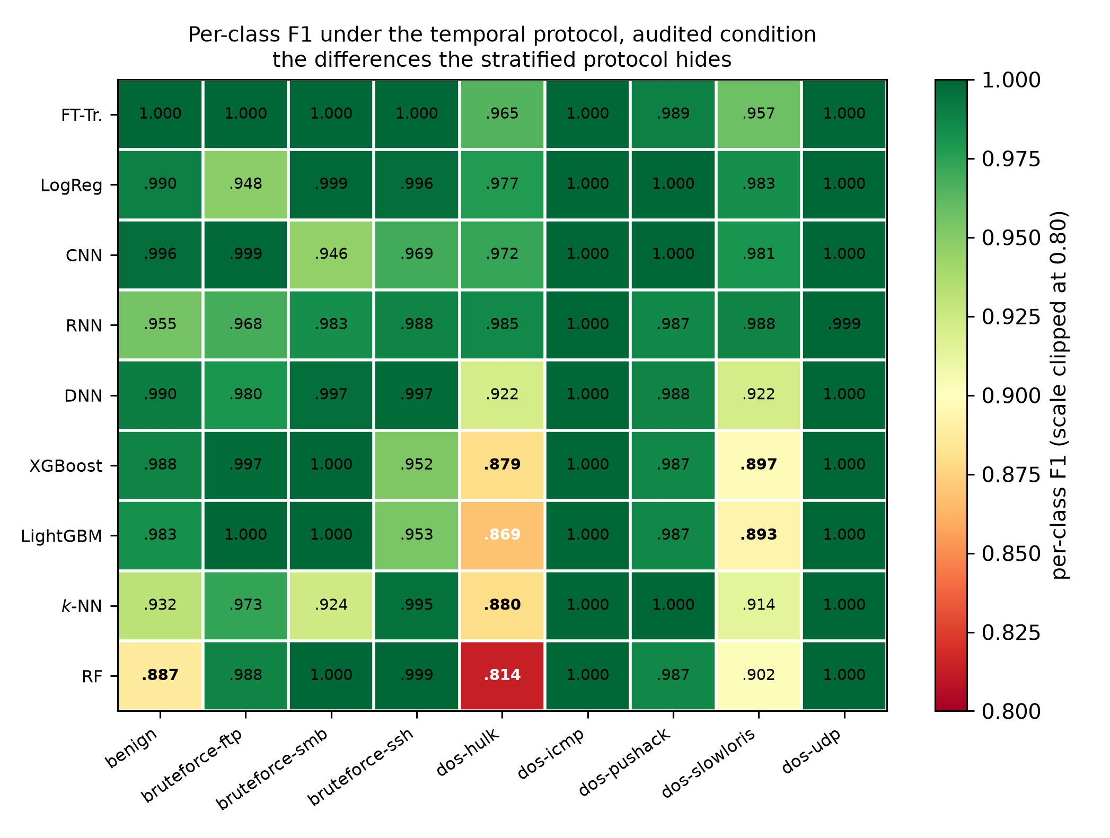
Figure 18. Per-class F1 under the temporal protocol, audited condition, for the nine detectors above macro-F1 0.95, ordered by macro-F1. Naive Bayes and the majority baseline are omitted because both fall far below the colour scale, which is clipped at 0.80, the lowest value in the table being 0.814. Two classes remain free for every detector, dos-icmp within 0.0001 and dos-udp within 0.0006. What changed with the corrected blacklist is that the loss no longer disperses: it concentrates on dos-hulk and dos-slowloris, where the DNN, XGBoost, LightGBM, k-NN and random forest all fall below 0.93, and elsewhere only random forest on benign and k-NN on bruteforce-smb drop that far. The lowest cell is random forest on dos-hulk at 0.814, against 0.957 for the leading detector's worst class; eleven of those twelve cells sat above 0.93 under the published blacklist. The same quantities under the stratified protocol stay above 0.979 and carry no such structure.
What each of these studies licenses a reader to believe. One positioning question remains. Table 1 records which methodological ingredients each study uses. The more useful question for positioning is what each one establishes and at what price, since a benchmark run under a random split on a corpus with disjoint attack windows supports a much weaker claim than the same benchmark run under a protocol that has been audited. Table 14 sets the two side by side, and carries no column of reported accuracies.
Table 14. What the closest related work establishes, under which protocol, and what it leaves open. Table 1 records which methodological ingredients each study uses; this table records what each one licenses a reader to believe. We deliberately do not align reported accuracies in a column: the studies above evaluate different corpora, tasks and splits, and placing their headline numbers side by side is the practice this paper argues against. The only quantitative comparison that would be controlled is with the corpus baseline, and Section 9 records why even that one is indicative rather than controlled.
Work | Corpus and task | Evaluation protocol | What it establishes | What it leaves open
Maseer et al. [11] | CICIDS2017, binary | random split, single run | a broad model-zoo reference on the field's main corpus | no leakage or temporal audit, so its reference numbers inherit whatever artefacts the corpus carries
D'hooge et al. [21] | ten IDS corpora, binary | single-feature probing | metadata contaminates NIDS models: the destination port alone separates ten corpora at 70-100% | stops at metadata; behavioural features are not audited, and no remedy is evaluated end to end
TESSERACT [19] | malware, binary | chronologically consistent splits | ignoring temporal structure inflates results; chronological evaluation is a validity requirement | assumes classes recur over time; says nothing about corpora whose classes occupy one disjoint window each
Talpini et al. [27] | NIDS, binary | uncertainty quantification | confidence is a first-class requirement for trustworthy detection | not evaluated on a saturated task, where calibration may have nothing left to repair
Silva et al. [6] | GeNIS, binary and four-class | single stratified split, no repetition | the corpus baseline: feature selection, tree ensembles and deep networks under the natural distribution, with timing | no confidence interval or significance test; flags an overreliance on traffic volume without localising it
This work | GeNIS, nine-class | stratified (five seeds) and per-class temporal, paired tests | the corpus is saturated under a random split (11 indistinguishable pairs); attribution-based auditing misses redundant shortcuts; temporal splitting alone does not remove a capture-schedule shortcut (0.9862) | the audit is validated on a second corpus (Section 7) but the benchmark is not; the temporal partition is deterministic, so that column carries no variance estimate

Consequences for future work on GeNIS. We release the blacklist, the frozen splits, the scaler parameters and the trained models so that subsequent studies can adopt the audited feature set directly. Our concrete recommendation to anyone benchmarking on this corpus: report macro-F1 under the audited condition and the temporal protocol; state the FPR resolution; and, if the study concerns detection quality alone, do not use the 60-second stratified split as the primary evidence.

9. Threats to validity
A leak our own criterion could not see. The transferability criterion has a blind spot that this corpus contains an instance of, and we found it late. A ratio between two protocols measures how much of a column's predictive power fails to survive the change. A leak frozen within each capture group loses nothing, because it is equally available on both sides of any split of that group, so the ratio reports it as signal. IdleTime is that instance: transferability 0.94 under the published rule, 1.02 under the nested audit, unremarkable in the residual audit, and a binary AUC of 1.0000. It sat in the audited condition of the campaign this paper reports. The test that finds it is in Section 4.3 and reads no labels; it is cheap, and we recommend running it before any transferability audit rather than after. Two things about the episode are worth stating plainly. The first is that attribution did not miss this column — it ranked it first, at 0.2279 — so the failure was ours in reading a high importance as evidence of signal, which is the mirror of the error Section 6.2 documents in the other direction. The second is that our own criterion was documented as having this limit before we hit it, and documenting a limit is not the same as guarding against it. What the omission cost we measured rather than assumed, by retraining every detector under both protocols with the column removed: at most 0.0038 of macro-F1 under the stratified protocol and 0.0263 under the temporal one, a ratio of 7 between protocols, the same signature the other twelve exclusions show. No conclusion of this paper turns on it, and one is sharpened, since under the corrected list the two boosted ensembles fall further from the top of the temporal ranking than they already did. One column adjacent to this question stays unresolved. Offset is not constant within a capture file, so the new test does not return it, yet a tree given it alone separates benign from attack traffic at an AUC of 0.9379 while classifying the nine classes at 0.0601, below the majority-class rate. We report it and retain the column, because excluding it would mean excluding on suspicion rather than on a stated criterion, which is the practice this paper argues against.
The exclusion rule depends on a normalisation we had to choose. The blacklist rests on a threshold, a predictivity filter, and, less visibly, on the decision to compare raw accuracies rather than above-chance accuracies. The last of these is the one that matters. Table 15 gives the full picture: with no correction the rule excludes eight behavioural features and the threshold sits in a 0.047-wide empty interval; with the uniform baseline 1/9 it excludes nine and the interval narrows to 0.034; with the majority-class rate p_{max} = 0.1942, the baseline this paper declares everywhere else, it excludes thirteen and the interval narrows to 0.017. The empty interval is therefore an artefact of the raw ratio, and we withdraw any claim that the boundary is intrinsic to the data. Three consequences, in order of how much they cost us. First, the methodological finding of Section 6.2 is unaffected. All thirteen features flagged under either normalisation have permutation importance below 10⁻⁴, so attribution-based auditing misses them under every reading of the rule. Second, the published blacklist is the conservative end of a range rather than a canonical answer, and we release the full spectrum under both normalisations so that a reader who prefers the stricter rule can regenerate a eighteen-feature blacklist from our artefact without rerunning anything. Third, what we have not established is whether the five additional features are shortcuts or genuine volumetric signal. Their power halves across protocols, which is the signature the rule is built to catch, but a flood is genuinely a high-rate event, so a drop in transferability is also what one would expect from legitimate within-campaign non-stationarity. Separating the two requires retraining under a eighteen-feature exclusion and observing whether macro-F1 holds, which we did not run and which we flag as the immediate next experiment on this corpus.
Table 15. Sensitivity of the blacklist to the normalisation of the transferability ratio. The threshold (0.50) and the predictivity filter (3p_{max}) are held fixed; only the baseline subtracted from both accuracies changes. Computed from the released transferability table.
Baseline subtracted | Behavioural exclusions | Interval at threshold | Width
none (operative rule, τ) | 8 | [0.489, 0.536] | 0.047
uniform, 1/9 | 9 | [0.471, 0.506] | 0.034
majority, p_{max}=0.1942 (τ*) | 13 | [0.484, 0.501] | 0.017
The threshold itself is a choice, not a measurement. The rule excludes a feature when its transferability falls below 0.50, and nothing in the data fixes that number. Table 16 reports what other choices would have produced. Two facts qualify the choice. It is stable locally: the blacklist is exactly the same for any threshold in the interval from 0.49 to 0.54, so the eight excluded columns are not a knife-edge artefact. But it is not the separation the data would have chosen. The widest gap in the transferability distribution of the thirty-eight eligible features lies between 0.67 and 0.79, and a threshold placed in that gap would exclude sixteen behavioural columns rather than eight. Our threshold sits in the fifth-widest gap of that distribution out of thirty-seven, 0.047 wide against 0.125 for the widest, so the local stability reported above is real but modest. We keep 0.50 because it is the rule the published blacklist was produced under, and because doubling the exclusions on a criterion the corpus alone suggests would make the benchmark harder to compare with any other work, but a reader who prefers the data-driven boundary should read the 0.70 row of Table 16 as the alternative. That table counts columns and not consequences. What the choice costs in detection is measured further down in this section, for four of these lists and under both protocols.
We retain 0.50 as the operative threshold not because it is empirically optimal, but for two reasons that a reader can check. A single numeric threshold applied to both normalisations keeps the raw and the chance-corrected rules directly comparable, which a data-driven boundary chosen separately for each would not. And the blacklist it produces is the one under which every model in this paper was trained: moving the threshold after the campaign would mean publishing a feature set that no reported number was produced under. The spectrum is released in full so that this operational choice is not read as an intrinsic boundary in the data.
Table 16. Sensitivity of the blacklist to the transferability threshold. Behavioural columns are those the rule excludes; the blacklist column adds the four positional columns excluded by name, but not the identifier column, which no threshold on this ratio reaches, so the operative row reads twelve where the published blacklist has thirteen, and the τ* column seventeen where Sections 9 and 10 give eighteen. The operative row is the rule this paper applies. Computed from the released transferability table by paper/sensitivity_threshold.py, without retraining.
Threshold on τ | Behavioural, τ | Blacklist, τ | Behavioural, τ* | Blacklist, τ*
0.30 | 0 | 4 | 7 | 11
0.40 | 6 | 10 | 8 | 12
0.50 (operative) | 8 | 12 | 13 | 17
0.60 | 12 | 16 | 16 | 20
0.70 | 16 | 20 | 16 | 20
0.80 | 17 | 21 | 19 | 23
0.90 | 20 | 24 | 20 | 24

The audit detects schedule shortcuts, not topology shortcuts. Transferability compares two evaluation protocols in time, so it can only expose a feature whose predictive power depends on the capture schedule. A feature bound to the network topology is stable in time: it would transfer at a ratio close to one and the rule would retain it. Our protocol therefore rests on two independent remedies and the audit replaces neither. Twenty-three identifier columns, including the topology-bound Ssaddr and Sdaddr counters and the port numbers, are excluded by explicit name before any feature condition is built (Section 4.3), on the argument of D'hooge et al. [21]. The transferability rule then runs on what remains. The cost of omitting that first step is measurable on this corpus. In the 4-preprocessed module, which retains those columns, a decision tree given only Sdaddr classifies the thirteen sub-categories of that module's own holdout at 0.9947 accuracy, against a majority-class rate of 0.1785, and reaches 0.9950 macro-F1 on the four-class task the baseline evaluates. Under a temporal protocol such a feature transfers intact, so no transferability threshold would have removed it. Readers should not read our audit as a complete leakage test.
What the threshold costs, now measured. Section 6.2 shows the blacklist moving from eight to thirteen behavioural columns under the chance-corrected ratio, and Table 16 gives the counts at seven thresholds. Counts are not consequences, so we retrained every detector under four alternative lists, from no behavioural exclusion to sixteen, under both protocols. Figure 19 reports what the choice costs. For the eight detectors this paper draws conclusions from, moving the threshold from 0.40 to 0.70 shifts temporal macro-F1 by at most 0.023, and stratified macro-F1 by at most 0.004; the median shift across all detectors and both protocols is 0.0017. The exception is naive Bayes, at 0.129, and it is the expected one. A classifier that assumes conditional independence is the most sensitive to which correlated columns remain, and Section 6.2 measured that residual correlation directly. Two things follow. The threshold is a declared choice whose downstream cost is now measured rather than asserted, and the choice we published is not the flattering one, since the stricter list at 0.70 scores higher under the temporal protocol for seven of the nine detectors. What remains open is not the cost of the threshold but the meaning of the boundary, which Section 6.2 states.
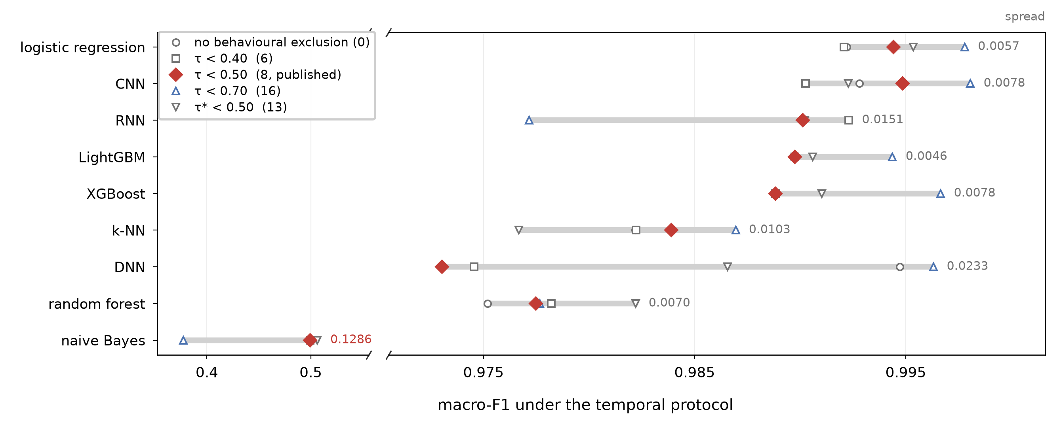
Figure 19. What the threshold costs, measured rather than declared. Each row is one detector retrained under five blacklists, from no behavioural exclusion to sixteen, and evaluated under the temporal protocol; the bar spans the five results and the figure at the right is their spread. The axis is broken to keep naive Bayes, the weak baseline and the only detector that moves materially, on the same page as the eight that do not. The published rule is the filled marker. It is not the flattering choice: the stricter list at 0.70 scores higher for seven of the nine.
The blacklist was selected with test-set information, and is recoverable without it. The transferability scan of the published campaign measured each feature on the test partition of both protocols, and the permutation importances were computed there too, so the blacklist that defines the audited condition was not independent of the partition on which that condition is finally scored. Section 4.3 reports what we did about it. The obvious correction fails, because the validation partition is adjacent to the training window and a ratio measuring decay with temporal distance cannot be estimated there; recomputed on validation, the rule excludes nothing. A nested audit confined to the training partition does work, and it returns exactly the eight published columns, separated from the rest by the largest gap in the distribution. We therefore no longer present this as an open flaw in the feature set. The blacklist is recoverable without test information. What remains open is narrower and we state it as such. The exclusion threshold does not transfer between audit designs, since the nested audit’s shorter horizon compresses every ratio upward, so 0.50 is a value tied to this campaign rather than a constant of the method. The campaign reported here was nonetheless run on the blacklist as originally computed.
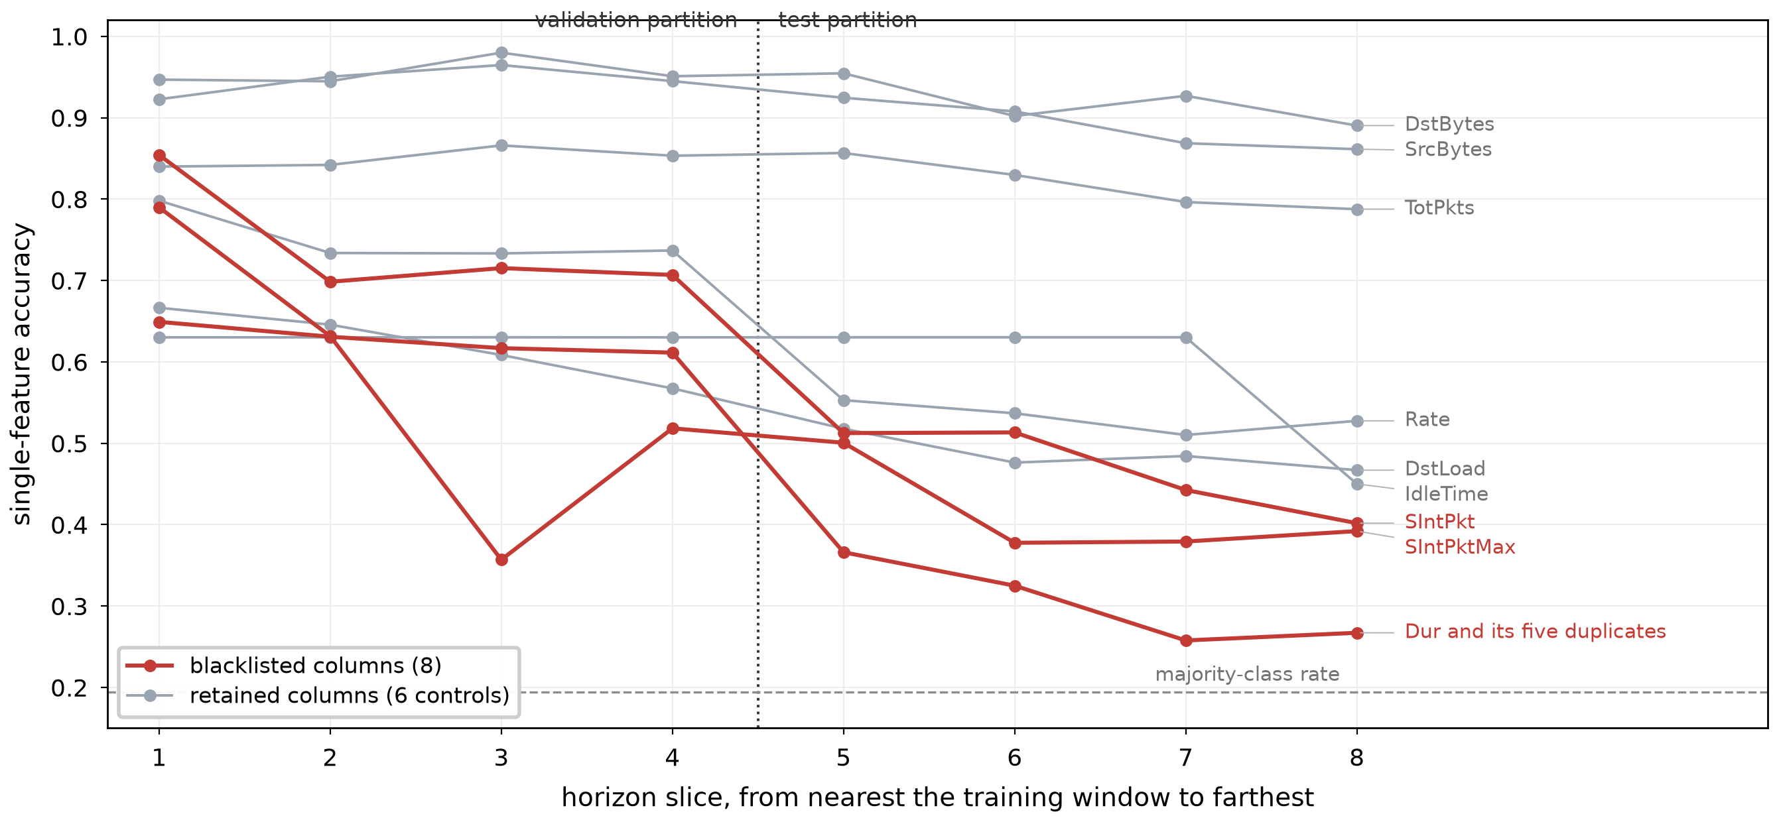
Figure 20. Single-feature accuracy against temporal horizon. Each decision tree is fitted once on the training partition of the temporal protocol, then scored on eight successive slices of the remaining 40% of each class; slices 1–4 make up the validation partition and 5–8 the test partition. The eight blacklisted columns lose 0.393 of accuracy on average between the first slice and the last, against 0.137 for the six retained controls, and the six numerically identical duration columns trace a single curve. One of those six controls is IdleTime, which Section 9 excludes on a criterion this figure does not apply; dropping it lowers the controls' average loss to 0.128 and widens the gap, so the figure as drawn is the conservative reading. This is why the audit is estimated on the most distant partition available: the quantity it measures is decay with temporal distance, and the validation partition is too close to the training window to exhibit it (Section 4.3).
Measurement resolution. With 5 030 benign test flows, the FPR resolution is 0.0199 points and macro-F1 differences below roughly 10⁻⁴ are not meaningful. Several of our reported ties are ties at the resolution limit, not demonstrated equalities.
One run-to-run failure resists explanation. Section 6.4 eliminates the mechanisms we could test for the collapse of one LightGBM run at the 10-second interval, and names none in their place. Row and column resampling are excluded by the recorded configuration; histogram bin construction, which reproduces the observed shape on synthetic data and was our leading candidate, is excluded by direct experiment on the corpus, since making the grid deterministic relocates the failure instead of removing it and lowers its worst case. We report that negative outcome rather than the mechanism we expected to report, and the residue is a limitation. At the 10-second interval the behaviour of this ensemble depends on which flows fall in the training partition, through a path we have not isolated. Two properties of the failure survive both settings and are what a reader should carry away. It is discrete rather than gradual, no run of either arm landing between 0.84 and 0.99, so it cannot be caught by inspecting a spread. A mean over seeds conceals it, which is why Table 6 reports runs. Neither depends on knowing the mechanism. The corresponding caution is that a single fit of a boosted ensemble at short aggregation intervals on this corpus is not evidence, and no configuration change we found makes it one.
Unequal search budgets, and a confound in what caused them. The time cap binds unequally: the FT-Transformer completed one trial and naive Bayes twenty. Two causes are entangled here and we can separate them only partially. The first is model cost, which is intrinsic. The second is that the cap was enforced against wall-clock time in a hosted runtime whose accelerator allocation varied between sessions. One FT-Transformer fit took 31 602 s against a median of 362 s for the same model on the other five splits, a factor of 87 that no property of the model explains. The number of trials a model received therefore reflects hardware availability as well as architecture. We cannot claim that this leaves the reported accuracies untouched. Re-fitting the FT-Transformer in a later session moved its temporal macro-F1 by 0.0187, more than the effect that the feature correction reported above measures, and the runtime records neither which accelerator served a given run nor whether one was attached at all, so the two cannot be separated after the fact. What the confound does not weaken is the FT-Transformer's temporal-protocol lead, obtained with a single and essentially untuned configuration, since a smaller search budget cannot flatter it. But it means the tuned arm is not an equal-effort comparison, for a reason beyond the one we set out to declare. A budget expressed in training steps or epochs rather than wall-clock seconds would not have this defect, and we recommend it for replication. For the same reason our artefact records the runtime environment once per session rather than once per run, so the hardware used for an individual run cannot be recovered from the released results.
Scope of the corpus module. We evaluate the 2-flows module, which lacks standalone reconnaissance captures; our task therefore covers eight attack families rather than the ten in the corpus descriptor. We also recount 29 736 fewer 60-second flows than the descriptor reports, attributable to the absent reconnaissance captures and a 2 003-flow shortfall in benign-background. Comparisons with studies using the 4-preprocessed module are therefore indicative, not controlled.
Calibration is measured under both protocols, and the temporal figures rest on a single partition. Section 6.5 reports it under both, recomputed from the stored probability matrices and without retraining, and the finding that calibration had little left to repair turns out to hold only under the stratified protocol. Two limits remain. The temporal protocol yields a single deterministic partition, so the temporal column of Table 8 carries no variance estimate and the ratios in it should be read as orders of magnitude rather than as point estimates. And the temperature is fitted on the temporal validation partition, which is drawn from an interval of the capture closer to the training window than the test partition is, so it is a slightly optimistic estimate of what a temperature fitted on genuinely held-out time would achieve.
Testbed generalisation. GeNIS is CyberRange-generated traffic representing a small enterprise, dominated by volumetrically separable floods, and its benign traffic is synthesised by a profiler rather than observed. Every benchmark result in this paper was measured on that one corpus. Section 7 tests how far the three methodological findings carry by re-running the audit, unchanged in form, on CICIDS2017: two reproduce and one does not, which bounds the claims more tightly than a single corpus could. Two corpora are still two corpora, and the benchmark itself, the eleven detectors and their ranking, remains a single-corpus result. Where we argue that a finding should carry further, we give the mechanism that would make it carry and state what remains untested. We do not claim that our conclusions about protocol and audit methodology are corpus-independent, and our conclusions about which detector wins are explicitly not.

10. Conclusion
We have audited the GeNIS 2025 corpus with a four-test feature protocol and benchmarked it with eleven supervised detectors, one unsupervised detector, five seeds, two feature conditions beyond the raw one, two evaluation protocols, and paired significance testing: 154 training runs, and the 180 that repeated the audited condition after the correction of Section 9.
Three results have methodological implications that may carry beyond this corpus. First, on GeNIS, a shortcut audit built on attribution scores assigned near-zero importance to the shortcuts we found: all eight behavioural shortcuts had permutation importance below 10⁻⁴ because they are mutually redundant, and six of them are numerically identical columns. Isolated two-protocol evaluation of each feature was required on this corpus, and we give the procedure and the resulting spectrum under two normalisations. What a study on another corpus should carry over is the ranking that procedure produces and the gap that isolates its lowest columns, not the threshold we cut ours at. Second, on GeNIS, temporal splitting alone did not neutralise the capture-schedule shortcut created by disjoint attack windows. A timestamp-only probe still reached 0.9862 under our per-class temporal protocol, against 0.9970 under a random one. Feature exclusion was the operative remedy on this corpus, not chronological ordering alone. Third, the benign-trained autoencoder evaluated here was anti-correlated with volumetric floods, reaching AUROC 0.0000 against dos-pushack, because floods were simpler to reconstruct than legitimate traffic in this benchmark. Two of these three results were re-tested on a second corpus (Section 7). The blindness of attribution reproduces on CICIDS2017, which carries seven pairs of numerically identical columns, ten of whose fourteen columns score exactly zero importance. The insufficiency of temporal splitting does not. There the same probe falls to 0.1028 under temporal ordering, so whether chronological evaluation suffices is a property of the capture schedule that a cheap probe measures and that no study should assume in either direction.
For the corpus itself, we report that the nine-class task is saturated under a random split, with eleven pairs of models statistically indistinguishable, and that the ranking only becomes interpretable under the per-class temporal protocol, a label-using diagnostic rather than a model of deployment, where the FT-Transformer leads and the boosted trees that dominate the random split fall to sixth and seventh of nine, behind every neural detector and the linear model. Calibration follows the same pattern: near-perfect under a random split, it degrades under temporal evaluation for nine of the eleven detectors, by factors of 146 to 1403 for the three that the random split ranks best calibrated, so calibration measured under a random split describes the split rather than the detector. We publish a thirteen-feature blacklist together with the full transferability spectrum under both normalisations, from which a stricter eighteen-feature blacklist can be derived, as well as the frozen splits, the calibrated operating points under both protocols, the CPU cost of every detector, and the trained models, so that future work on GeNIS can start from an audited protocol rather than reconstruct one.

11. Data and code availability
GeNIS is publicly archived at doi:10.5281/zenodo.14919237. Our artefact is released in two parts, a code repository and a data archive under a CC-BY 4.0 licence. Both are withheld here for double anonymized review, since their addresses identify the authors, and both have been supplied to the editorial office; the citations will be restored on acceptance. The archive holds the results file for the 154 runs, which also carries the feature blacklist, the transferability spectrum under both normalisations and the hyperparameter configurations, together with the frozen split indices, the per-run probability matrices and the figures, and a second file with the trained detectors of the reference configuration and their fitted preprocessing parameters.

12. Declaration of generative AI in the writing process
During the preparation of this work the authors used a generative AI assistant to draft and revise portions of the manuscript text and to review the analysis code. After using this tool, the authors reviewed and edited the content as needed and take full responsibility for the content of the publication.

References
[1] G. Engelen, V. Rimmer, W. Joosen, Troubleshooting an intrusion detection dataset: the CICIDS2017 case study, in: IEEE Security and Privacy Workshops (SPW), 2021, pp. 7–12. https://doi.org/10.1109/SPW53761.2021.00009.
[2] L. Liu, G. Engelen, T. Lynar, D. Essam, W. Joosen, Error prevalence in NIDS datasets: A case study on CIC-IDS2017 and CSE-CIC-IDS-2018, in: IEEE Conference on Communications and Network Security (CNS), 2022, pp. 254–262. https://doi.org/10.1109/CNS56114.2022.9947235.
[3] M. Lanvin, P.-F. Gimenez, Y. Han, F. Majorczyk, L. Mé, E. Totel, Errors in the CICIDS2017 dataset and the significant differences in detection performances it makes, in: International Conference on Risks and Security of Internet and Systems (CRiSIS), Springer, 2022, pp. 18–33. https://doi.org/10.1007/978-3-031-31108-6_2.
[4] M. Silva, D. Pinto, J. Vitorino, J. Gonçalves, E. Maia, I. Praça, GeNIS: A modular dataset for network intrusion detection and classification, Data in Brief 60 (2025) 111487, dataset: doi:10.5281/zenodo.14919237. https://doi.org/10.1016/j.dib.2025.111487.
[5] D. Pinto, I. Amorim, E. Maia, I. Praça, A novel approach to network traffic analysis: the HERA tool, in: IEEE 23rd International Conference on Trust, Security and Privacy in Computing and Communications (TrustCom), 2024, pp. 1850–1856, arXiv:2501.07475. https://doi.org/10.1109/TrustCom63139.2024.00255.
[6] M. Silva, D. Pinto, J. Vitorino, E. Maia, I. Praça, I. Amorim, M. J. Viamonte, Binary and multiclass cyberattack classification on the GeNIS dataset, in: Foundations and Practice of Security (FPS 2025), Springer, 2025, arXiv:2511.08660. https://doi.org/10.1007/978-3-032-20018-1_18.
[7] M. A. E. Bahri, F. Jemili, O. Korbaa, Comparative study between ML approaches in intrusion detection context, in: 2023 IEEE Afro-Mediterranean Conference on Artificial Intelligence (AMCAI), 2023, pp. 1–6. https://doi.org/10.1109/AMCAI59331.2023.10431511.
[8] R. Sommer, V. Paxson, Outside the closed world: On using machine learning for network intrusion detection, in: IEEE Symposium on Security and Privacy (S&P), 2010, pp. 305–316. https://doi.org/10.1109/SP.2010.25.
[9] I. Sharafaldin, A. H. Lashkari, A. A. Ghorbani, Toward generating a new intrusion detection dataset and intrusion traffic characterization, in: 4th International Conference on Information Systems Security and Privacy (ICISSP), 2018, pp. 108–116. https://doi.org/10.5220/0006639801080116.
[10] A. Rosay, E. Cheval, F. Carlier, P. Leroux, Network intrusion detection: A comprehensive analysis of CIC-IDS2017, in: 8th International Conference on Information Systems Security and Privacy (ICISSP), SCITEPRESS, 2022, pp. 25–36. https://doi.org/10.5220/0010774000003120.
[11] Z. K. Maseer, R. Yusof, N. Bahaman, S. A. Mostafa, C. F. M. Foozy, Benchmarking of machine learning for anomaly based intrusion detection systems in the CICIDS2017 dataset, IEEE Access 9 (2021) 22351–22370. https://doi.org/10.1109/ACCESS.2021.3056614.
[12] D. Pinto, J. Vitorino, E. Maia, I. Amorim, I. Praça, Flow exporter impact on intelligent intrusion detection systems, in: 11th International Conference on Information Systems Security and Privacy (ICISSP), 2025, pp. 289–298, arXiv:2412.14021. https://doi.org/10.5220/0013131900003899.
[13] P. Goldschmidt, D. Chudá, Network intrusion datasets: A survey, limitations, and recommendations, Computers & Security 156 (2025) 104510. https://doi.org/10.1016/j.cose.2025.104510.
[14] M. Cantone, C. Marrocco, A. Bria, Machine learning in network intrusion detection: A cross-dataset generalization study, IEEE Access 12 (2024) 144489–144508. https://doi.org/10.1109/ACCESS.2024.3472907.
[15] S. Layeghy, M. Portmann, Explainable cross-domain evaluation of ML-based network intrusion detection systems, Computers and Electrical Engineering 108 (2023) 108692. https://doi.org/10.1016/j.compeleceng.2023.108692.
[16] M. Verkerken, L. D'hooge, T. Wauters, B. Volckaert, F. De Turck, Towards model generalization for intrusion detection: Unsupervised machine learning techniques, Journal of Network and Systems Management 30 (1) (2022) 12. https://doi.org/10.1007/s10922-021-09615-7.
[17] R. Geirhos, J.-H. Jacobsen, C. Michaelis, R. Zemel, W. Brendel, M. Bethge, F. A. Wichmann, Shortcut learning in deep neural networks, Nature Machine Intelligence 2 (2020) 665–673. https://doi.org/10.1038/s42256-020-00257-z.
[18] D. Arp, E. Quiring, F. Pendlebury, A. Warnecke, F. Pierazzi, C. Wressnegger, L. Cavallaro, K. Rieck, Dos and don'ts of machine learning in computer security, USENIX Security Symposium (2022).
[19] F. Pendlebury, F. Pierazzi, R. Jordaney, J. Kinder, L. Cavallaro, TESSERACT: Eliminating experimental bias in malware classification across space and time, in: USENIX Security Symposium, 2019.
[20] L. D'hooge, T. Wauters, B. Volckaert, F. De Turck, Inter-dataset generalization strength of supervised machine learning methods for intrusion detection, Journal of Information Security and Applications 54 (2020) 102564. https://doi.org/10.1016/j.jisa.2020.102564.
[21] L. D'hooge, M. Verkerken, B. Volckaert, T. Wauters, F. De Turck, Establishing the contaminating effect of metadata feature inclusion in machine-learned network intrusion detection models, in: Detection of Intrusions and Malware, and Vulnerability Assessment (DIMVA), Springer, 2022. https://doi.org/10.1007/978-3-031-09484-2_2.
[22] S. Kapoor, A. Narayanan, Leakage and the reproducibility crisis in machine-learning-based science, Patterns 4 (9) (2023) 100804. https://doi.org/10.1016/j.patter.2023.100804.
[23] K. Aas, M. Jullum, A. Løland, Explaining individual predictions when features are dependent: More accurate approximations to Shapley values, Artificial Intelligence 298 (2021) 103502. https://doi.org/10.1016/j.artint.2021.103502.
[24] C. Guo, G. Pleiss, Y. Sun, K. Q. Weinberger, On calibration of modern neural networks, in: International Conference on Machine Learning (ICML), 2017, pp. 1321–1330.
[25] Y. Geifman, R. El-Yaniv, Selective classification for deep neural networks, in: Advances in Neural Information Processing Systems (NeurIPS), 2017.
[26] K. Hendrickx, L. Perini, D. Van der Plas, W. Meert, J. Davis, Machine learning with a reject option: A survey, Machine Learning 113 (2024) 3073–3110. https://doi.org/10.1007/s10994-024-06534-x.
[27] J. Talpini, F. Sartori, M. Savi, Enhancing trustworthiness in ML-based network intrusion detection with uncertainty quantification, Journal of Reliable Intelligent Environments 10 (2024) 501–520. https://doi.org/10.1007/s40860-024-00238-8.
[28] D. Chicco, G. Jurman, The advantages of the Matthews correlation coefficient (MCC) over F1 score and accuracy in binary classification evaluation, BMC Genomics 21 (6) (2020). https://doi.org/10.1186/s12864-019-6413-7.
[29] L. Grinsztajn, E. Oyallon, G. Varoquaux, Why do tree-based models still outperform deep learning on typical tabular data?, in: Advances in Neural Information Processing Systems (NeurIPS), Datasets and Benchmarks Track, 2022.
[30] R. Shwartz-Ziv, A. Armon, Tabular data: Deep learning is not all you need, Information Fusion 81 (2022) 84–90. https://doi.org/10.1016/j.inffus.2021.11.011.
[31] Y. Gorishniy, I. Rubachev, V. Khrulkov, A. Babenko, Revisiting deep learning models for tabular data, in: Advances in Neural Information Processing Systems (NeurIPS), 2021.
[32] M. Minderer, J. Djolonga, R. Romijnders, F. Hubis, X. Zhai, N. Houlsby, D. Tran, M. Lucic, Revisiting the calibration of modern neural networks, in: Advances in Neural Information Processing Systems (NeurIPS), 2021, arXiv:2106.07998.
[33] D. Magalhães, E. Maia, J. Vitorino, I. Praça, Machine unlearning for the XGBoost model with network intrusion datasets, in: Recent Trends and Challenges in Information Systems and Technologies (WorldCIST 2026), vol. 3, Springer, 2026, pp. 150–162, arXiv:2606.19220. https://doi.org/10.1007/978-3-032-32026-1_14.
[34] M. Shafi, A. H. Lashkari, V. Rodriguez, R. Nevo, Toward generating a new cloud-based distributed denial of service (DDoS) dataset and cloud intrusion traffic characterization, Information 15 (4) (2024) 195. https://doi.org/10.3390/info15040195.
[35] C. Strobl, A.-L. Boulesteix, T. Kneib, T. Augustin, A. Zeileis, Conditional variable importance for random forests, BMC Bioinformatics 9 (307) (2008). https://doi.org/10.1186/1471-2105-9-307.
[36] G. Hooker, L. Mentch, S. Zhou, Unrestricted permutation forces extrapolation: variable importance requires at least one more model, or there is no free variable importance, Statistics and Computing 31 (82) (2021). https://doi.org/10.1007/s11222-021-10057-z.
[37] J. Snoek, Y. Ovadia, E. Fertig, B. Lakshminarayanan, S. Nowozin, D. Sculley, J. V. Dillon, J. Ren, Z. Nado, Can you trust your model’s uncertainty? Evaluating predictive uncertainty under dataset shift, in: Advances in Neural Information Processing Systems (NeurIPS), 2019.

