**Vacations**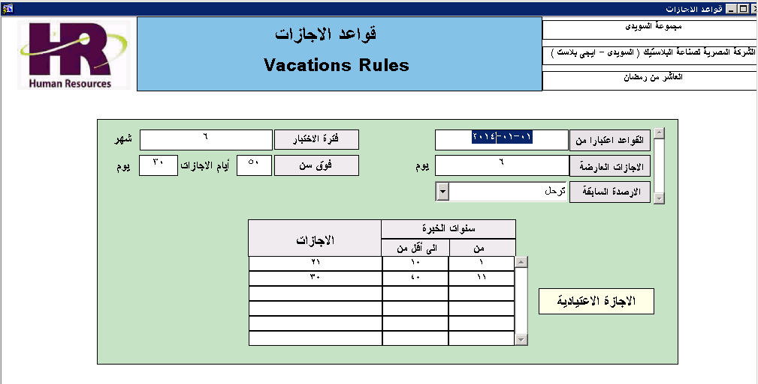

**Vacation Rules**

**As Of Date** : - The effective Date which this Rule will work and every time Befor Setup New Year Vacation Stock we will select the Max Effective Date Rules and will Keep old Rules For History.

**Casual Vacations** : 6 Days Per Year

**Posting Status** : Post the unused Days to the next Year or not

**Testing Period** : 6days after 6 Months

**Age** : 30 Days When passing 50y

**Working Experience Details** :

1 ---- less Than 10Years 21 Days

More Than 10y 30 Days

ERD :

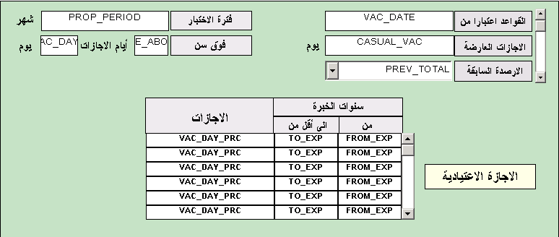

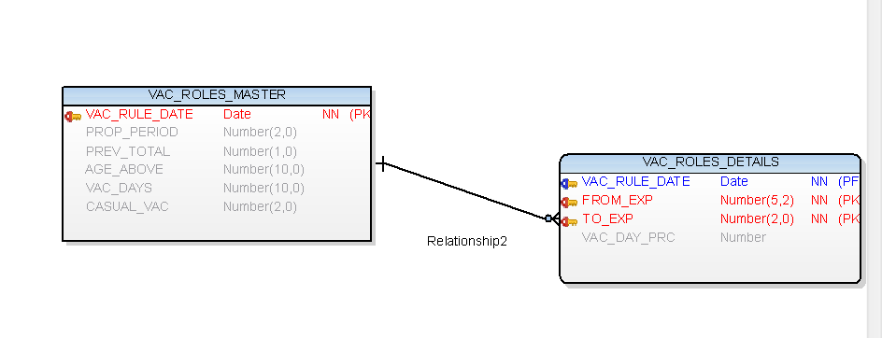

Prepare Vacations

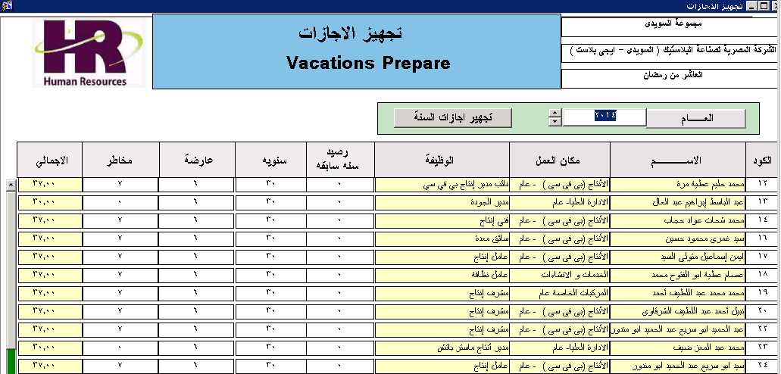

For Every Year --- Prepare the Vacation for the New Year

There are many types of vacations

Planned إعتيادى

Occasional عارضة

Sick مرضى

No_salary بدون مرتب

Risk بدل مخاطر

Stock رصيد سابق

All in Table but the Company Use Only 3 Visual in the Form.

**Prepare button**

SELECT emp_id,EMP_NAME,birth_date,ASSIGNMENT_DATE

FROM EMP_BASIC_DATA -- HR Basic Data

vac_roles_m vac_roles_master%rowtype;

select * into vac_roles_m from vac_roles_master where vac_date =(select max(vac_date) from

vac_roles_master);

Select Max Rule to Be Used With this New Year

If the Company Use Old Vacation Stock Posting

TOTAL STOCK = ( SELCT v_stock + V_PLAINED + V_OCCASIONAL + V_risk where Year -1 ) -- Prev Stock

-

( Select nvl(sum(vac_days),0) from vacations_rec where emp_id=i.emp_id

and year= Year -1 ) -- Prev Used Vacations

Calculate Age

age:=round((to_date('01-01-'||:vac_years.year,'dd-mm-yyyy')-i.BIRTH_DATE)/(30*12));

Calculate Work Experience

Work_EXP:=round((to_date('01-01-'||:vac_years.year,'dd-mm-yyyy')-i.ASSIGNMENT_DATE)/(30*12),2);

----------

vac_roles_d vac_roles_details%rowtype;

select * into vac_roles_d from vac_roles_details where vac_date =(select max(vac_date) from

vac_roles_details ) and from_exp>= Work_EXP and to_exp<Work_EXP

if Age > 50 Insert 30 Days

Work Exp < 10 Insert 21 Days

Work Exp > 10 Insert 30 Days

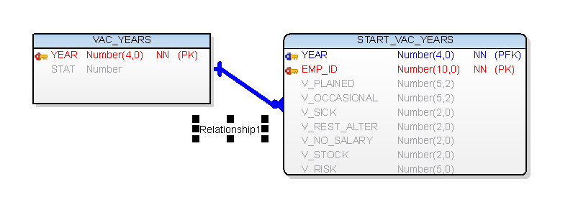

STAT --- Means Year Status (Closed – Open )

**Vacation Record**

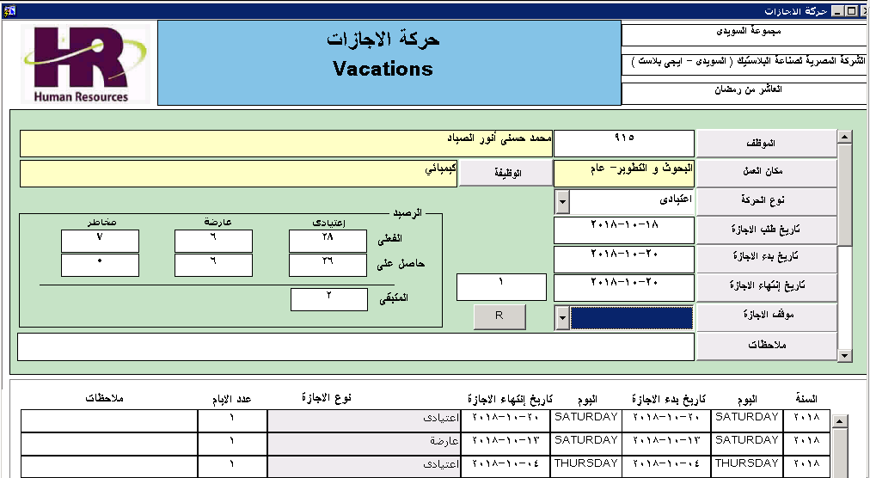

Vacation Record Keeps all Vacations Transactions in this Year

When Select Employee it Auto Select Current Position and Location

Transaction Type :

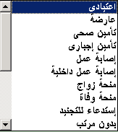 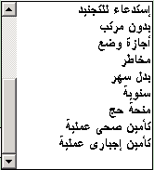

Start Vacation Date and End Vacation Date

Auto Calculate : Vacation Days

Vacation Status : Apply or Hold

The Othes Blocks are Views Only For History Data

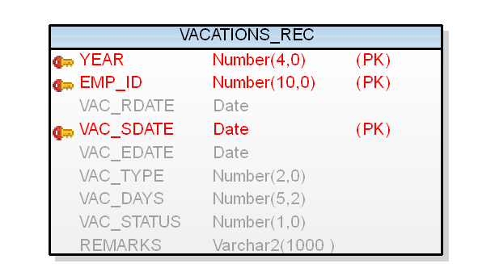

**Mission and Permit ions**

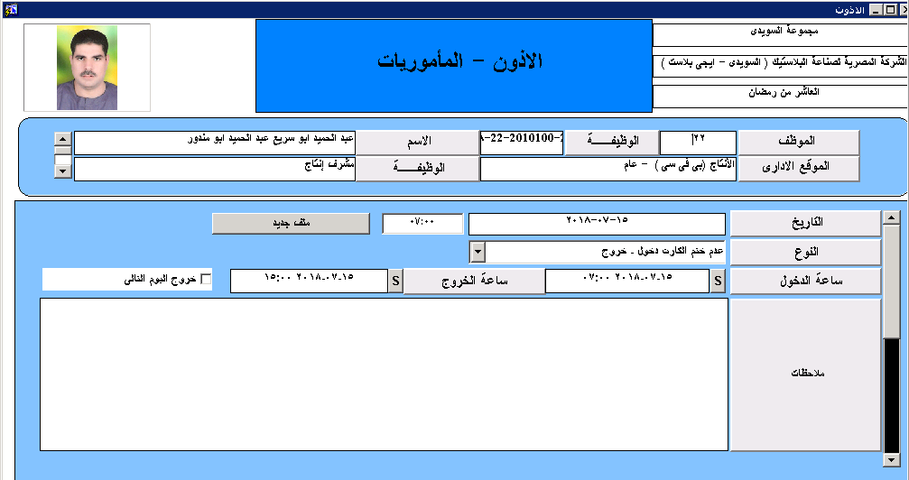

First Block

Query Employee Data

Mission or Permition Date and Time

Type : 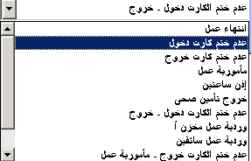 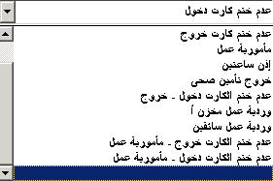

Many Tyoe May be Fixed in The List or Coded in a Form

In & Out Date time

Check Whether the Exit is in the Next Day for time Attendance Application

Create New Record – ملف جديد

