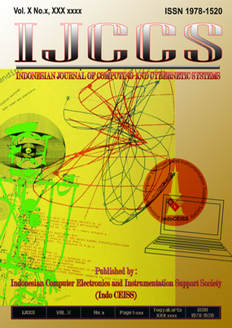

Name | IJCCS (Indonesian Journal of Computing and Cybernetics Systems)
Accreditated | "Sinta 2" by the Ministry of Research-Technology and Higher Education Republic of Indonesia: 51/E/KPT/2017 PERIOD: 2017-2022.
Initials | IJCCS
Abbreviation | Indonesian J. Comput. Cybern. Syst.
DOI | prefix 10.22146
Impact | 5.21 | in Sinta 2

