**Calculator:**

**Software Specification:**

This is a basic calculator which can perform simple calculation like addition, subtraction, multiplication and division.

**Software Design:**

This software is designed using net beans software which is really easy to use and understand.

**Program Code:**

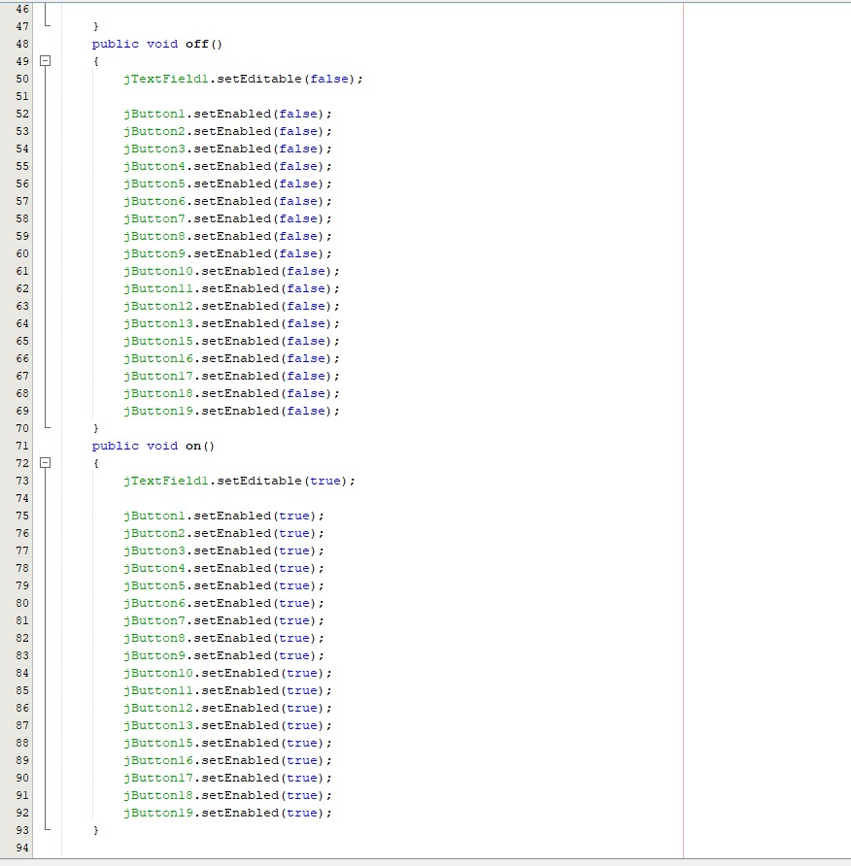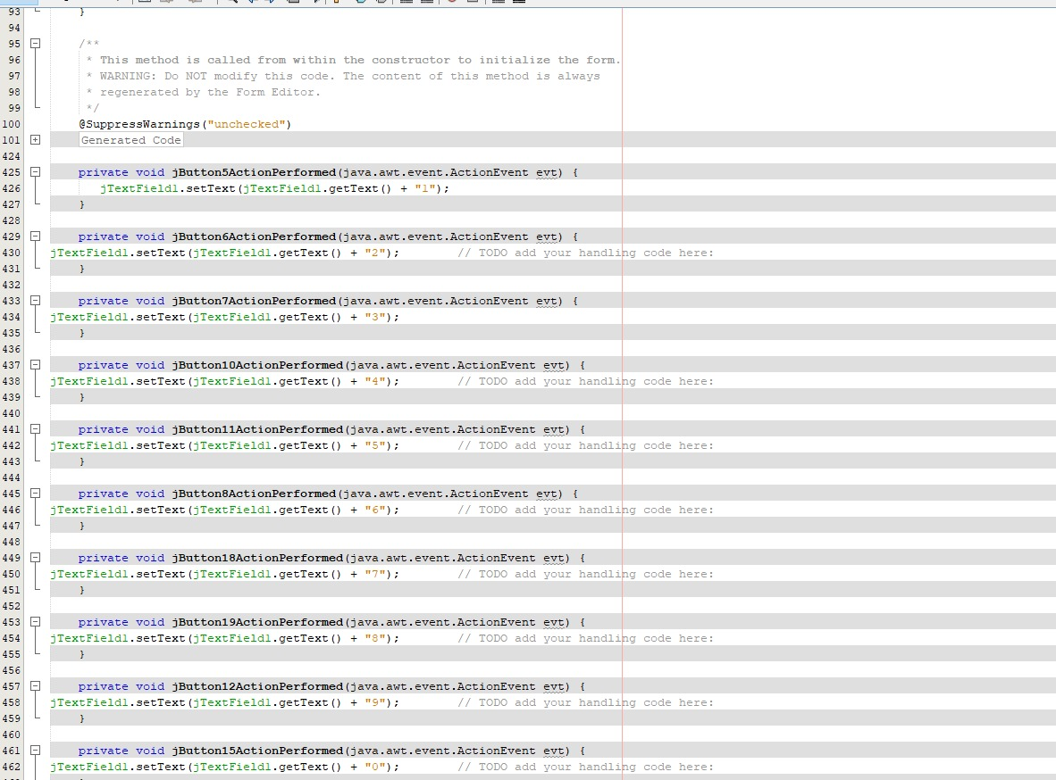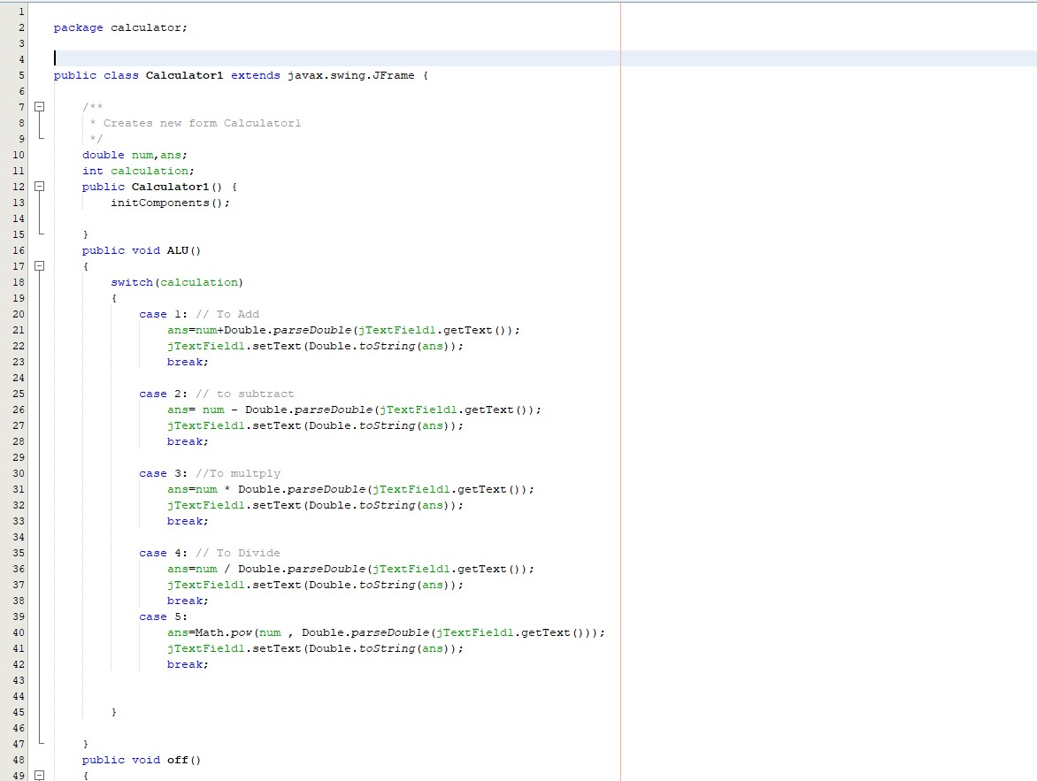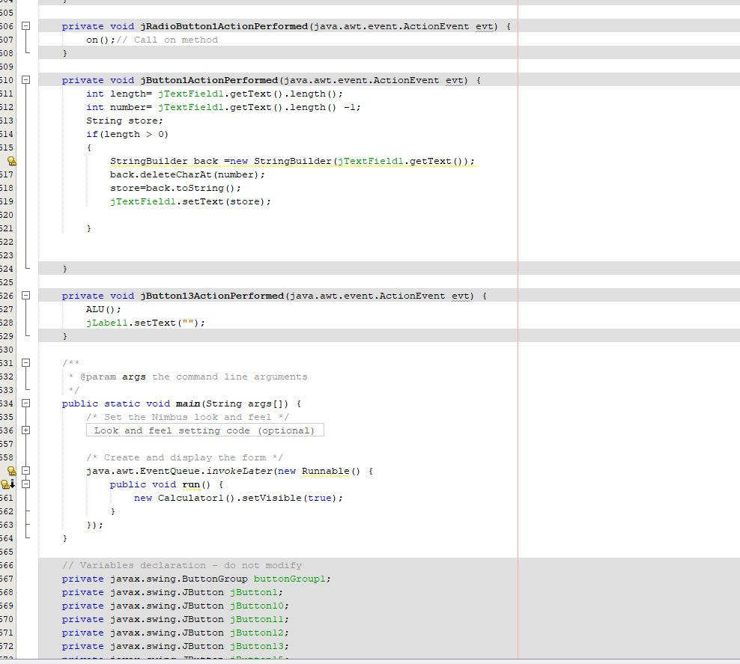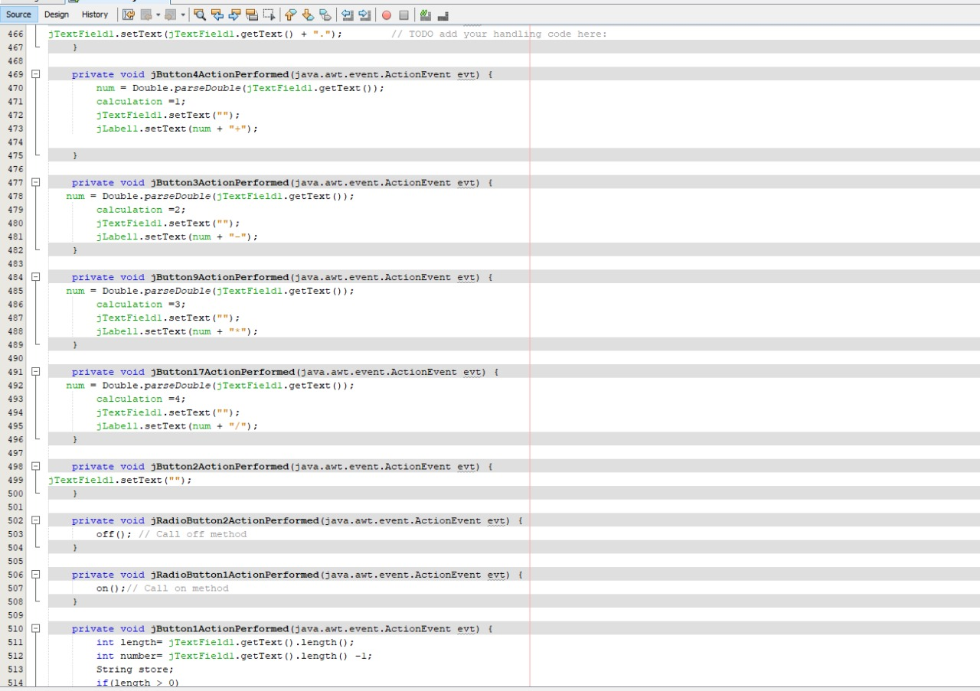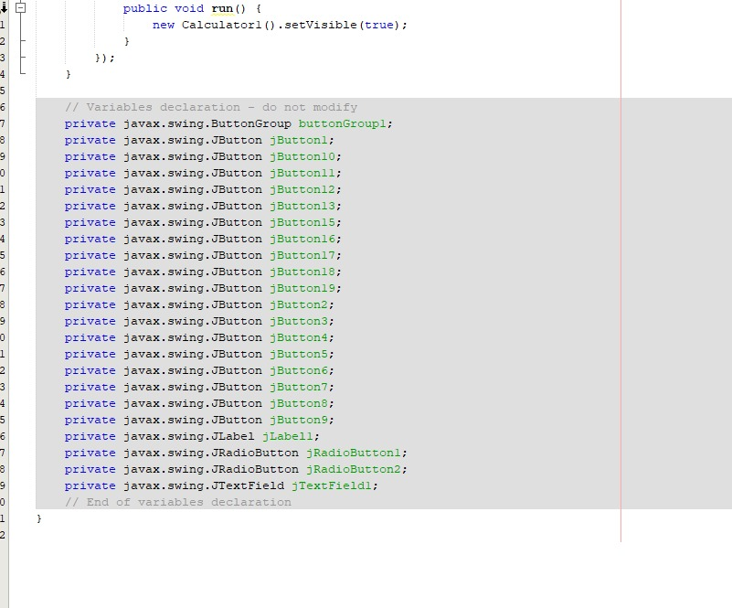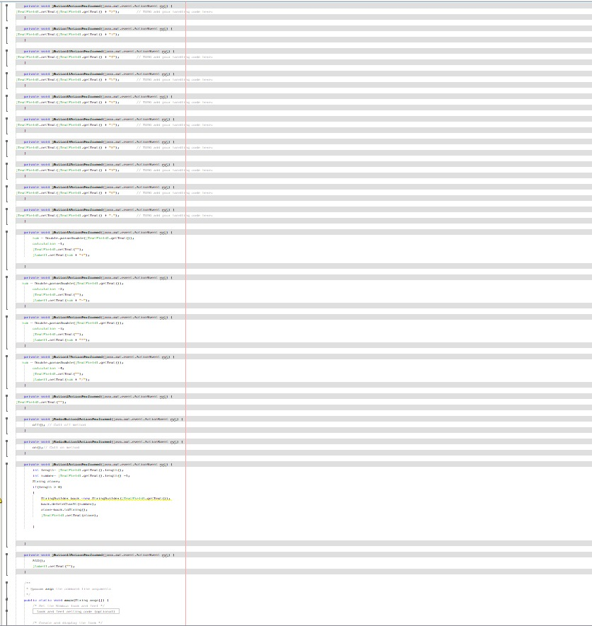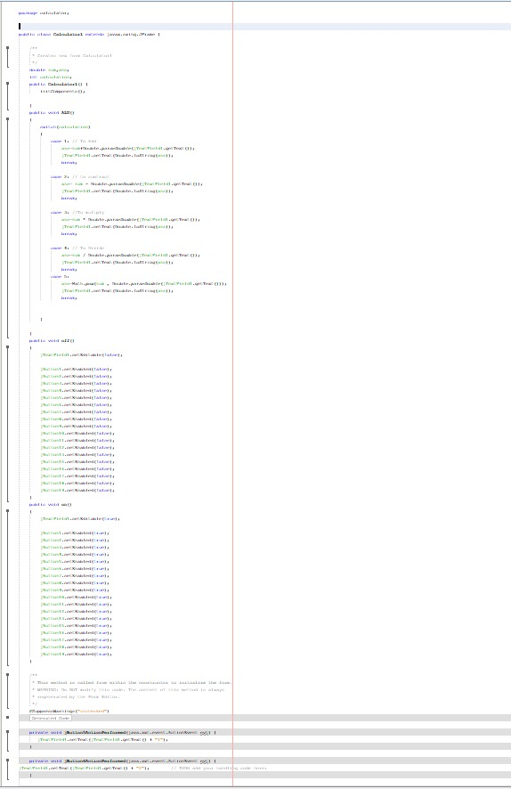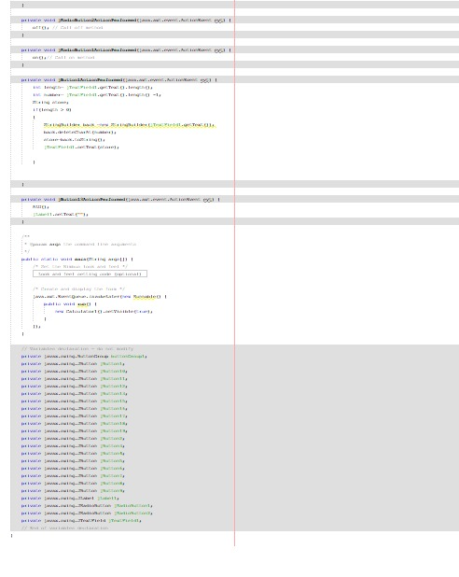

**Program GUI:**

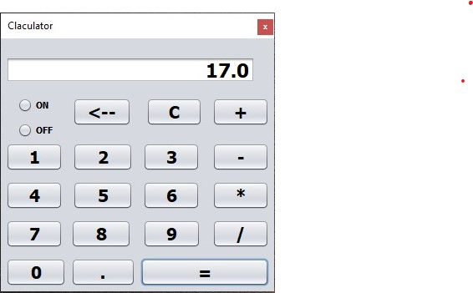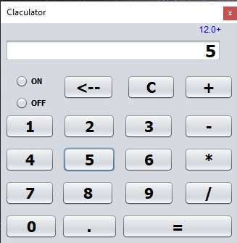

**Case Study:**

**Behavior:**

The program will display on the screen a menu of the four operations, telling the user to enter +, –, *, / to specify the operation to be performed. The program will read the operation from the keyboard. If the user enters, execution will terminate. Otherwise, the program will display on the screen a prompt for the first operand, which it will then read from the keyboard. If the operation requires two operands, the program will display on the screen a prompt for the second operand, which it will then read from the keyboard. The program will then compute the result of performing the specified operation using the operand provided and output this result. The program should repeat this behavior until the user specifies the operation.

**Operations:**

**+**

**-**

**\***

**/**

**Functional Operations:**

**+** Return the sum of operand1 and operand2

**-** Return the difference of operand1 and operand2

**\*** Return the product of operand1 and operand2

**/** Return the quotient of operand1 and operand2

**Test Case:**

1. Check if the calculator is a normal calculator or a scientific calculator.
2. Verify that all the buttons are present and text written on them is readable.
3. Check the arithmetic operations are working fine- +, -, /, * etc.
4. Verify that the calculator gives the correct result in case of operations containing decimal numbers.
5. Check if the calculator is battery operated or works on solar power.
6. Verify the outer body material of the calculator.
7. Verify the spacing between the two buttons, the buttons should not be too closely placed.
8. Check the pressure required to press a button, the pressure required should not be too high.
9. Verify the number of digits allowed to enter in the calculator for any operation.
10. Verify the limit of the response value.
11. Verify the functioning of memory functions.
12. Check if the calculator allows navigating through previous calculations.
13. Verify that hitting ‘C’ cancels any digits or operation added.
14. Verify the working of the ON-OFF button in the calculator.
15. Check if keeping the calculator unused for a certain period of time, turns it off automatically.
16. Verify that on pressing two operators one after the other, the latest one will override the previous operator.
17. Verify the state of the calculator when two buttons are pressed simultaneously.
18. Verify if the user can delete digits one by one using the backspace key.