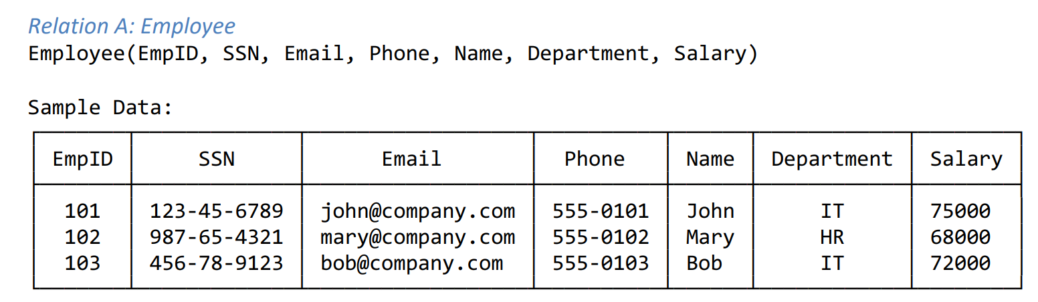
- List at least 6 superkeys.
{EmpID}, {SSN}, {Email}, {Phone}, {EmpID, Name}, {EmpID, Email}
- Identify all candidate keys.
{EmpID}, {SSN}, {Email}, {Phone(if every employee is required to have a unique phone number)}
- Which candidate key would you choose as primary key and why?
EmpID, because it is short, unique, specially created to identify emplyees. While SSN, Email and phone can be change.
- Can two employees have the same phone number?
Based on given data, all employees have different phone numbers. However, we can’t be sure that two employees do not share the same number, unless phone is defined as unique.
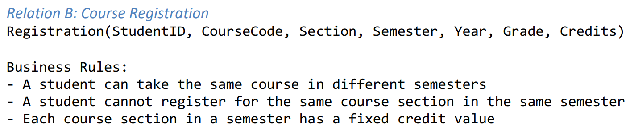
- Determine the minimum attributes needed for the primary key.

StudentID, CourseCode, Section, Semester, Year
- Explain why each attribute in your primary key is necessary.
StudentID tells us which student registered, if we remove it many student can be in the same course section.
If we remove CourseCode there may exist many different courses in the same Section.
What if we remove Section, then we broke the rules that are given where it says that a student cannot register for the same course section in the same semester. Therefore, Section is needed to distinguish registrations.
Semester is necessary because a student can take the same course in different semesters. Year is necessary because the same semester repeats every year. So we cannot remove them both.
- Identify any additional candidate keys(if they exist).
There are actually no additional candidate keys. Because Grade cannot identify a registration because many students can have the same grade, same with Credits because many courses can have the same number of credits.

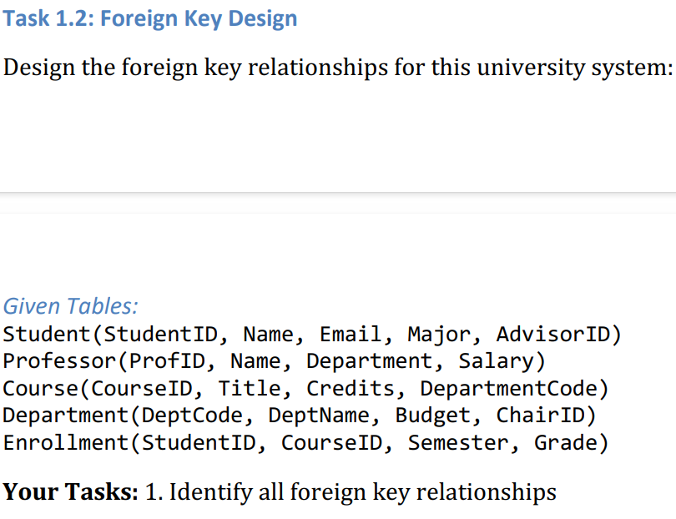

Student.AdvisorID -> Professor.ProfID:
AdvisorID tells us which professor is the student’s advisor.
Course.DepartmentCode -> Department.DeptCode:
DepartamentCode tells us which department offers the course.
Enrollment.StudentID -> Student.StudentID:
Tells us which student is enrolled.
Enrollment.CourseID -> Course.CourseID:
This tells us which course the student is enrolled.
Department.ChairID -> Professor.ProfID:
ChairID tells us which professor is the chair of the department.

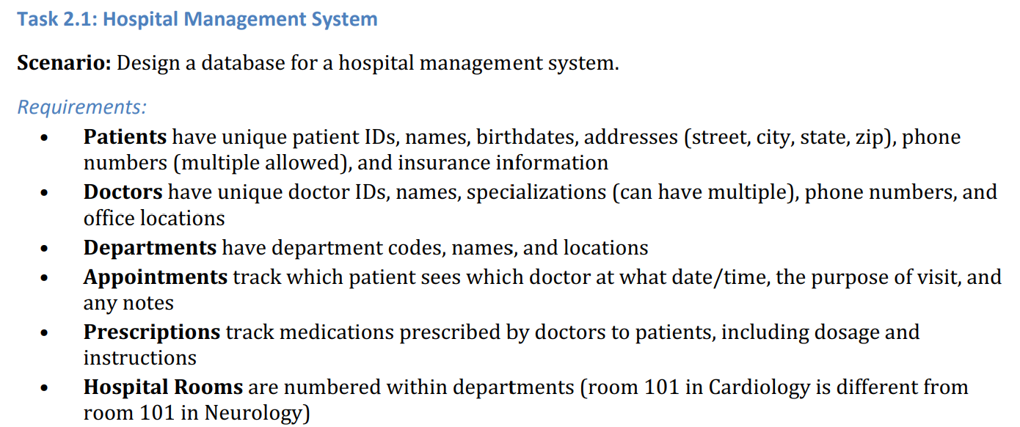
- Identify all entities (specify which are strong and which are weak).
Patients have unique patient IDs, so it is strong entity.
Doctors have unique doctor IDs, so it is also strong entity.
Departments have departments codes, which is unique and also strong entity.
Appointments track is a bit tricky one, because it depends on doctor and patient, therefore we cannot say it is weak or strong. Prescriptions track works the same as appointments, because medications prescribed by doctors to patients, so it is also dependent.
While Hospital Rooms are weak entities. Just departament number is not enough, as in given rules room 101 in Cardiology is not the same as room 101 in Neurology, so room number by itself is not unique.

- Identify all attributes for each entity (classify as simple, composite, multi-valued, or derived)
- Identify all relationships with their cardinalities (1:1, 1:N, M:N).
Patient-Appointment, 1:N:
One patient can have many appointments, each appointment belongs to one patient.
Doctor-Appointment, 1:N:
One doctor can have many appointments, each appointment has one doctor.
Patient-Prescription, 1:N:
One patient can receive many prescriptions, each prescription belongs to one patient.
Doctor-Prescription, 1:N:
One doctor can create many prescriptions, each prescription is created by one doctor.
Department-HospitalRoom, 1:N:
One department can contain many rooms, each room belongs to one department.
Patient-Doctor, M:N through Appointment:
One patient can see many doctors and one doctor can see many patients.
Patient-Doctor, M:N through Prescription:
One patient can receive prescriptions from many doctors and one doctor can prescribe medication to many patients.
- Draw the complete ER diagram using proper notation.
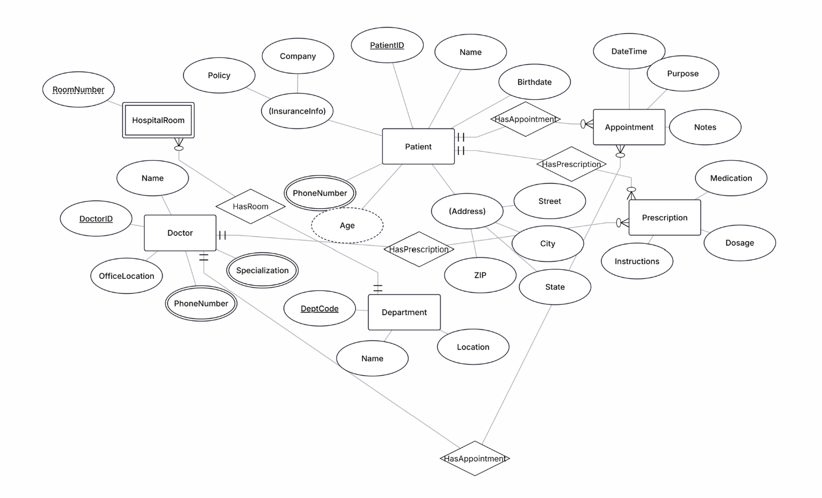

- Mark primary keys.
Primary keys are the attributes that are underlined in the ER diagram: PatientID, DoctorID, DeptCode.
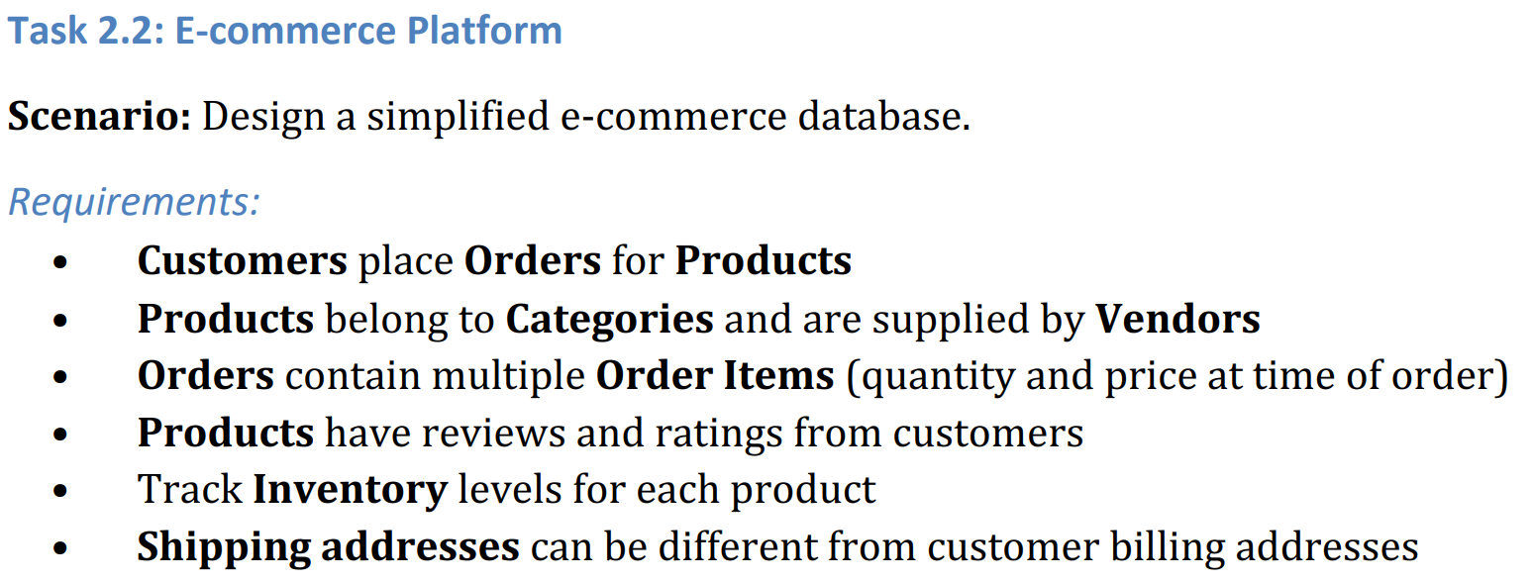
- Create a complete ER diagram.
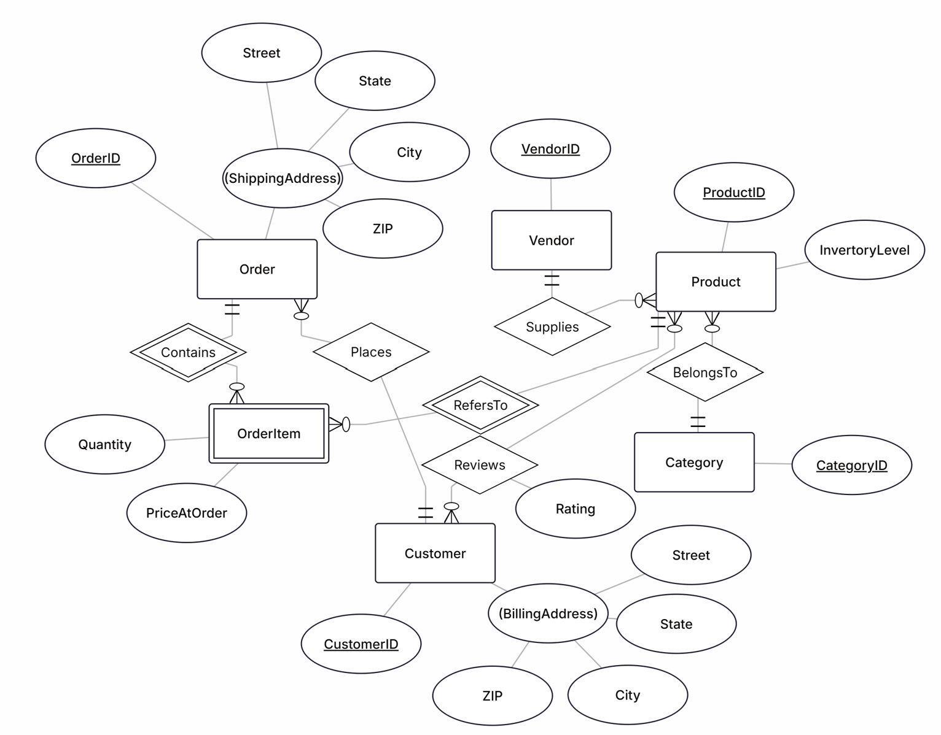
- Identify at least one weak entity and justify why it’s weak.
OrderItem is a weak entity as shown in my diagram, because it has no independent primary key. The combination of OrderID and ProductID identifies each OrderItem.
- Identify at least one many-to-many relationship that needs attributes.
Order and Product have a many-to-many relationship. One order can contain many products, and one product can appear in many orders. Quantity and PriceAtOrder describe a specific product inside a specific order. Therefore, these attributes are stored in OrderItem, which connects Order and Product.
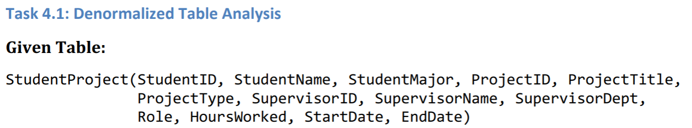

- Identify functional dependencies: List all FDs in the format A -> B.
StudentID -> StudentName,
StudentID -> StudentMajor,
StudentID -> StudentName, StudentMajor,
ProjectID -> ProjectTitle,
ProjectID -> ProjectType,
SupervisorID -> SupervisorName,
SupervisorID -> SupervisorDept,
ProjectID -> StartDate,
ProjectID -> EndDate,
ProjectID -> SupervisorID,
ProjectID -> ProjectTitle, ProjectType, StartDate, EndDate, SupervisorID,
SupervisorID -> SupervisorName, SupervisorDept,
(StudentID, ProjectID) -> Role, HoursWorked.
- Identify problems: - What redundancy exists in this table? – Give specific examples of update, insert, and delete anomalies.
Redundancy
There is a lot of repeated information. Imagine that three different students work on the same project, so it means that ProjectTitle will be the same and also they may have the same Supervisor, which means SupervisorID and SupervisorName can be the same. Also, if one student works on several projects, their StudentName and StudentMajor are repeated.
Update anomaly
Suppose: SupervisorID = SP1
and their department changes from Computer Science to Information Systems,
If SP1 appears in 10 rows, we have to update all 10 rows, if we accidentally update only 9 rows, we could have 2 different information like:
SP1 | Dr. Pitter | Computer Science
SP1 | Dr. Pitter | Information Systems
Database contains inconsistent information, this called update anomaly.
Insert anomaly
Suppose we want to add some new information, but the current table structure forces you to also add unrelated information.
Imagine that the university creates new project:
ProjectID = P10
ProjectTtitle = AI Research, but no student has joined this project yet.
The problem is: table is build around a students working on a project. So a row normally needs both student data and project data.
If I would want to insert:
StudentID | StudentName | ProjectID | ProjectTitle
? | ? | P20 | AI Research
But what do I put in StudentId and StusentName, there is no student yet. So, I will be forced to put NULL, fake data or not insert it at all. This will be an insert anomaly.
Delete anomaly
It happens when deleting one piece of information accidentally removes another piece of information that still is needed.
Imagine that we have the only student Anna working on specific project P10, but she leaves the project, so logically we want to delete only this info. After deleting the row, there may be no other row containing P10. I wanted to delete Anna’s participation in P10, but we deleted information about P10 itself. That is a delete anomaly.
- Apply 1NF: Are there any 1NF violations? How would you fix them?
The StudentProject table is already in 1NF because every column stores only one value for each row. For example, StudentName, ProjectID, Role, and HoursWorked contain single values. There are no lists or multiple values stored in one cell, so there are no 1NF violations.
- Apply 2NF: - What is the primary key of this table? - Identify any partial dependencies - Show the 2NF decomposition.
The StudentProject table has a composite primary key:

{StudentID, ProjectID}

This is because one student can work on many projects, and one project can have many students. Therefore, neither StudentID nor ProjectID alone can uniquely identify a row.

However, the table has partial dependencies. Some attributes depend on only one part of the composite key:

StudentID → StudentName, StudentMajor
ProjectID → ProjectTitle, ProjectType, SupervisorID, StartDate, EndDate

For example, StudentName depends only on StudentID; we do not need ProjectID to know the student's name. Similarly, ProjectTitle depends only on ProjectID.

Therefore, to achieve 2NF, the table should be decomposed into:
Student( StudentID, StudentName, StudentMajor)
Primary Key: StudentID
Project(ProjectID, ProjectTitle, ProjectType, SupervisorID, SupervisorName, SupervisorDept, StartDate, EndDate)
Primary Key: ProjectID
StudentProject(StudentID, ProjectID, Role, HoursWorked)
Primary Key: {StudentID, ProjectID}

Foreign Keys:
StudentID → Student
ProjectID → Project

The original table violates 2NF because some non-key attributes depend on only part of the composite primary key. By separating Student information, Project information, and the Student–Project relationship into different tables, the partial dependencies are removed.

- Apply 3NF: - Identify any transitive dependencies - Show the final 3NF decomposition with all table schemas.
After converting the database to 2NF, we must check for transitive dependencies. A transitive dependency happens when a non-key attribute depends on another non-key attribute.
In the Project table we have: ProjectID → SupervisorID
and: SupervisorID → SupervisorName, SupervisorDept
Therefore:
ProjectID → SupervisorID → SupervisorName, SupervisorDept
This is a transitive dependency because SupervisorName and SupervisorDept depend on SupervisorID, not directly on ProjectID.

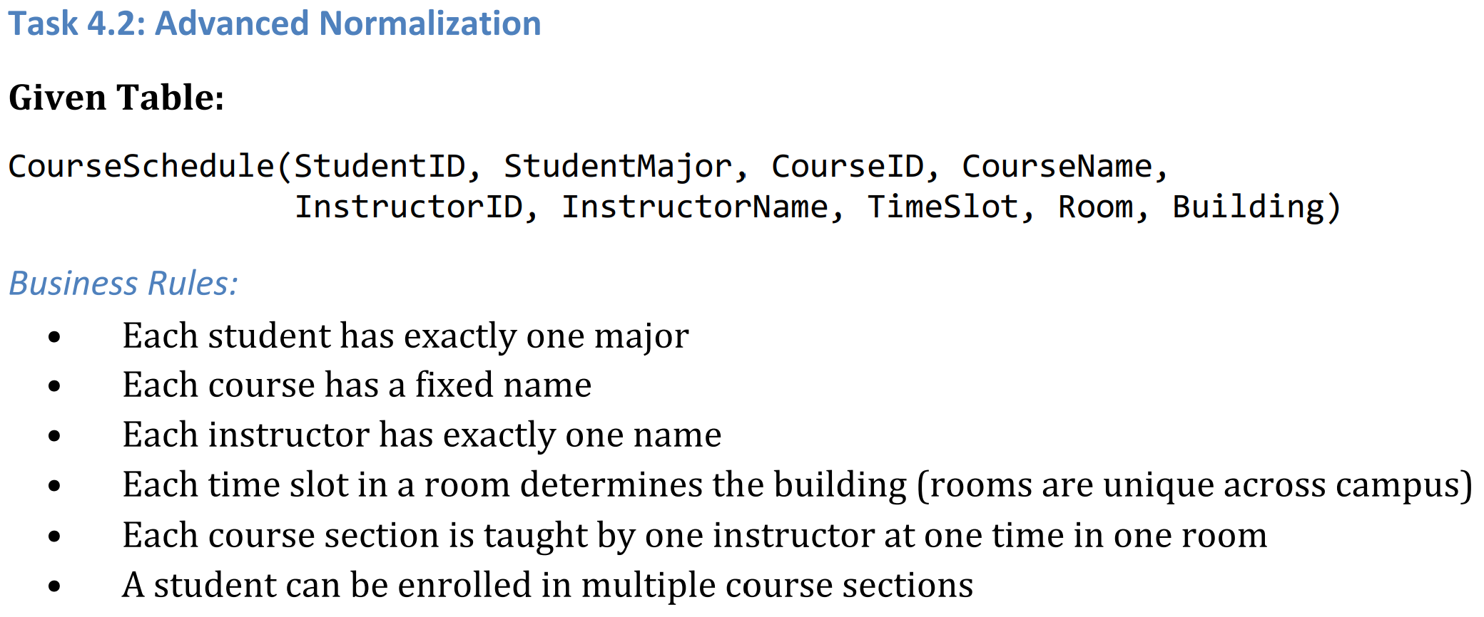

- Determine the primary key of this table (hint: this is tricky!)
StudentID alone is not enough because a student can take many course sections. CourseID alone is not enough because a course may have multiple sections.
We use:
Primary Key = {StudentID, CourseID, TimeSlot, Room}
- List all functional dependencies.
Each student has exactly one major. StudentID → StudentMajor
Each course has a fixed name. CourseID → CourseName
Each instructor has exactly one name. InstructorID → InstructorName
The problem says rooms are unique across campus. Therefore one room belongs to one building: Room → Building
We are assuming:
{CourseID, TimeSlot, Room} identifies one course section.
Each course section has one instructor, therefore:
{CourseID, TimeSlot, Room} → InstructorID
- Check if the table is in BCNF.
StudentID → StudentMajor
Is StudentID a superkey of the entire CourseSchedule table?
No. One student can have many courses.
CourseID → CourseName
Is CourseID a superkey?
No. A course can have many sections and many students.
InstructorID → InstructorName
InstructorID doesn't identify one enrollment row.
Room → Building
Room doesn't identify one enrollment row.
{CourseID, TimeSlot, Room} → InstructorID
This identifies a section, but not which student is enrolled in it. So it is not a superkey of the original table either.
The original CourseSchedule table is not in BCNF because several determinants, such as StudentID, CourseID, InstructorID, and Room, are not superkeys.
- If not in BCNF, decompose it to BCNF showing your work.
Student( StudentID PK, StudentMajor )
Course( CourseID PK, CourseName )
Instructor( InstructorID PK, InstructorName )
Room( Room PK, Building )
CourseSection( CourseID PK, FK, TimeSlot PK, Room PK, FK, InstructorID FK ) Enrollment( StudentID PK, FK, CourseID PK, FK, TimeSlot PK, Room PK, FK )

- Explain any potential loss of information in your decomposition.
StudentID S01
StudentMajor Computer Science
CourseID CS101
CourseName Database Systems
InstructorID I05
InstructorName Dr. Smith
TimeSlot Monday 10:00
Room 201
Building Main
After decomposition, this information is stored across:
Student:
S01 | Computer Science

Course:
CS101 | Database Systems

Instructor:
I05 | Dr. Smith

Room:
201 | Main

CourseSection:
CS101 | Monday 10:00 | 201 | I05

Enrollment:
S01 | CS101 | Monday 10:00 | 201
The decomposition is lossless because the tables can be joined using their primary and foreign keys to reconstruct the original CourseSchedule data. No information is lost. The decomposition also removes redundancy because student, course, instructor, and room information is stored only once.

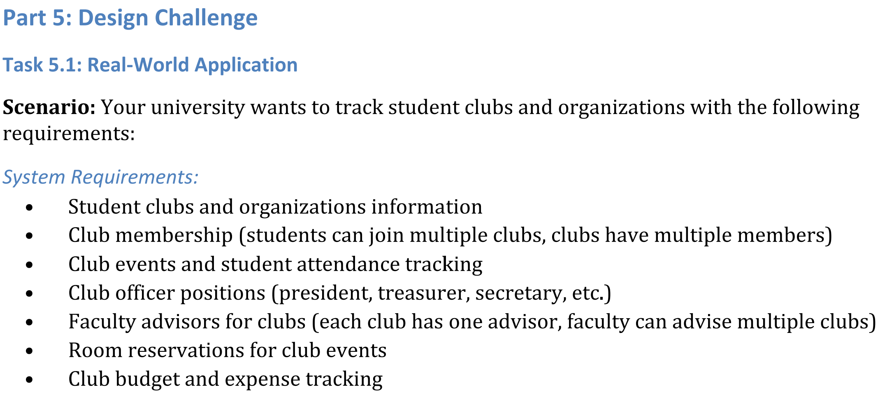
- Create a complete ER diagram for this system
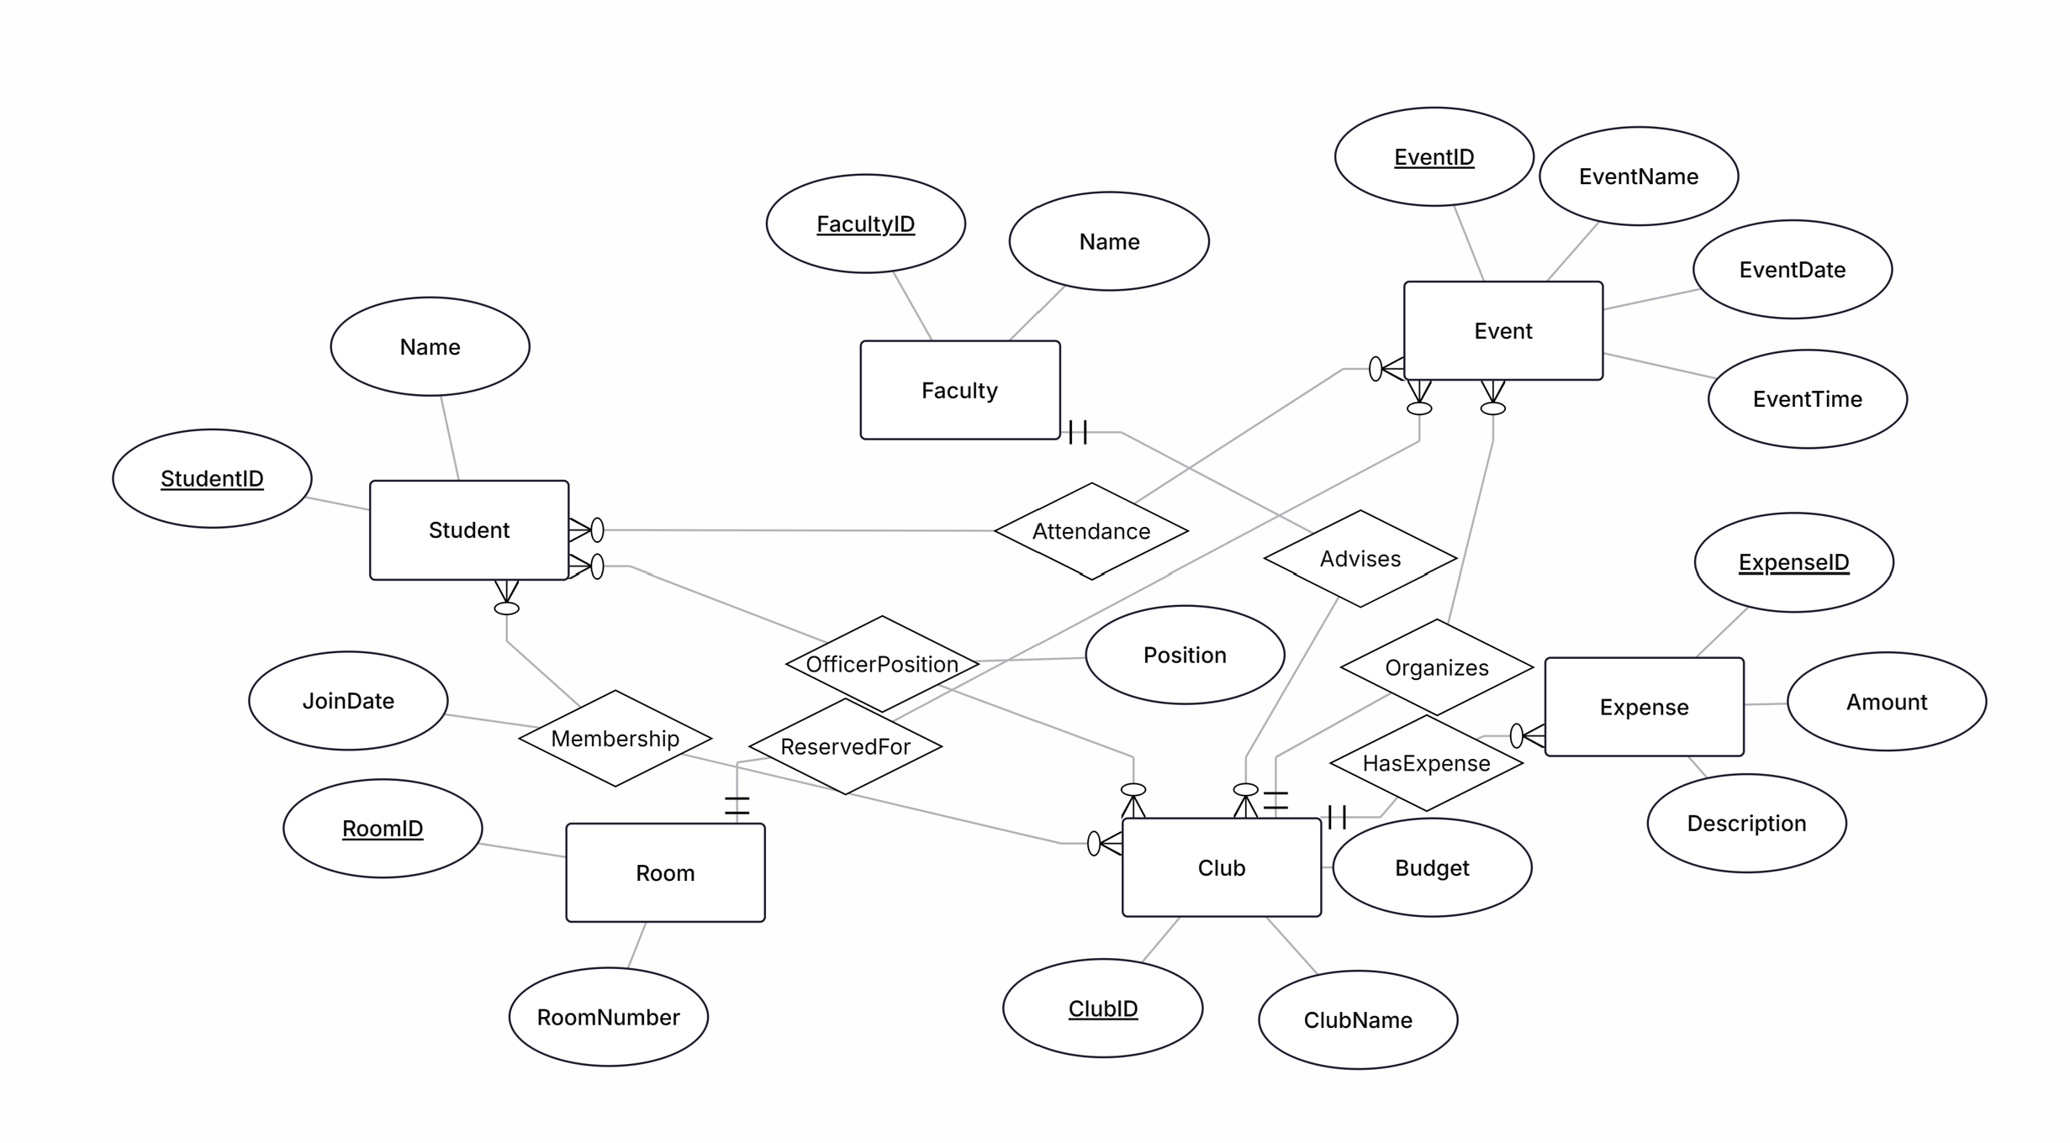
- Convert your ER diagram to a normalized relational schema
Student(StudentID PK, Name)
Faculty(FacultyID PK, Name)
Club(ClubID PK, ClubName, Budget, FacultyID FK)
Membership(StudentID PK/FK, ClubID PK/FK, JoinDate)
Room(RoomID PK, RoomNumber)
Event(EventID PK, ClubID FK, RoomID FK, EventName, EventDate, EventTime) Attendance(StudentID PK/FK, EventID PK/FK) OfficerPosition(StudentID PK/FK, ClubID PK/FK, Position)
Expense(ExpenseID PK, ClubID FK, Amount, Description)
- Identify at least one design decision where you had multiple valid options and explain your choice.
One design decision was how to store club officer positions. I could store PresidentID, TreasurerID, and SecretaryID directly in Club, but I chose a separate OfficerPosition table. This design is more flexible because new officer roles can be added without changing the Club table.
- Write 3 example queries that your database should support (in English, not SQL).
1. Find all students who are members of the Computer Science Club.
2. List all events scheduled for next week together with their room reservations and club names.
3. Show all expenses for each club and the remaining club budget.

