**The Four C’s: How Does Price Chalk Up?**

**By Group 6**

In the modern sales world, companies and brands will seemingly do and say anything for the sake of standing out and acquiring your business. However, can we trust their claims? The target of this think piece is Blue Nile, a diamond company that has put out an internal buyers guide on what diamond characteristics really drive quality and price.

Let’s first identify their claims; Blue Nile’s biggest claim is that Blue Nile’s Astor Diamonds “represent the highest-graded stones available in all of the four C’s” (Blue Nile, n.d.), the “four C’s” referring to Carat, Clarity, Color, and Cut. The Blue Nile website also claims the following:

1. “Cut is responsible for the diamond’s brilliance… cut should be your biggest priority” “Clarity is… the least important”
2. “The higher the quality a diamond, the more expensive it will be.”
3. “Carat weight choice is a matter of preference; one weight is not necessarily better than another. Typically, heavier high-quality diamonds are rarer than ones with lower carat weights and diamond prices can reflect this”

These are some decisive claims, so let’s investigate whether Blue Nile is pushing their own branded diamonds or giving a truly indicative read of the diamond market!

This fourth claim by Blue Nile really sets the tone of this article as it associates quality with price; to assume an increase in quality is to assume an increase in desirability by buyers. If they are willing to pay more for something, economics would suggest that that product has a higher demand or recognized value. This will be important to acknowledge so that we can respond to claims 1, 2, and 3.

To address claims 2 and 3, the research team of Group 6 took a statistical approach using a data set of 1,214 diamonds to compare the qualities of the four Cs against price. When looking at the data, carat seems to have the biggest impact on price. This can be inferred when looking at figures 1-3 as there appears to be a steady increase in price as carat increases, but a less consistent increase as the other variables increase in quality. Ultimately, the team found that for every 1% increase in the carat weight of a diamond, the price of that diamond is expected to increase by approximately 1.944%.

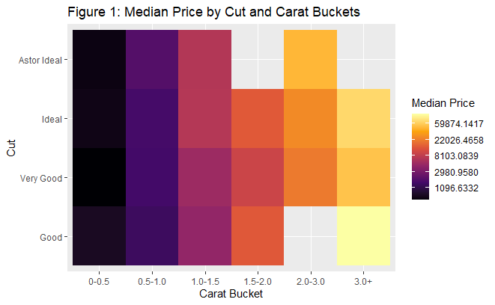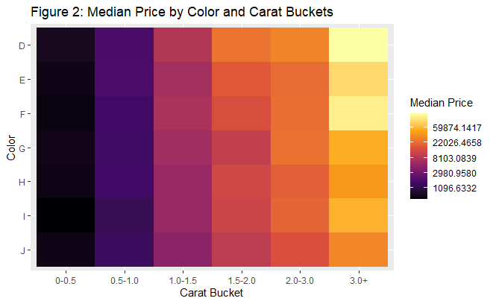

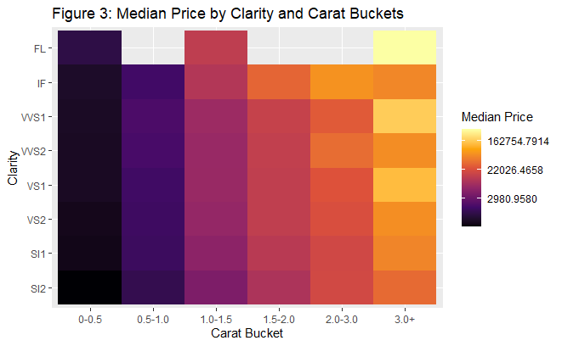

When looking at these same visualizations, you may notice that the lowest cut grade contained the highest median price when the carat was maximized while the middle grade cuts did not see as high of an increase. You can also see that color and clarity seem to consistently increase the median price, just a bit less so than carat!

Now the big one... Can we really put our faith in the Astor Diamond? Well, it's hard to tell. Within the population of the study, Astor Ideal diamonds were quite limited. Seemingly Astor Diamonds had lower carat and clarity than other cuts of the diamonds. From a buyer’s perspective, it's quite suspicious that Astor Diamonds both have lower clarity and the company markets clarity as the least important characteristic. The clarity of FL demonstrated the highest increase to price in Group 6’s study, yet Astor diamonds did not have a single diamond with this level of clarity. From this alone, it's difficult to trust that Astor diamonds represent the best of the four C’s.

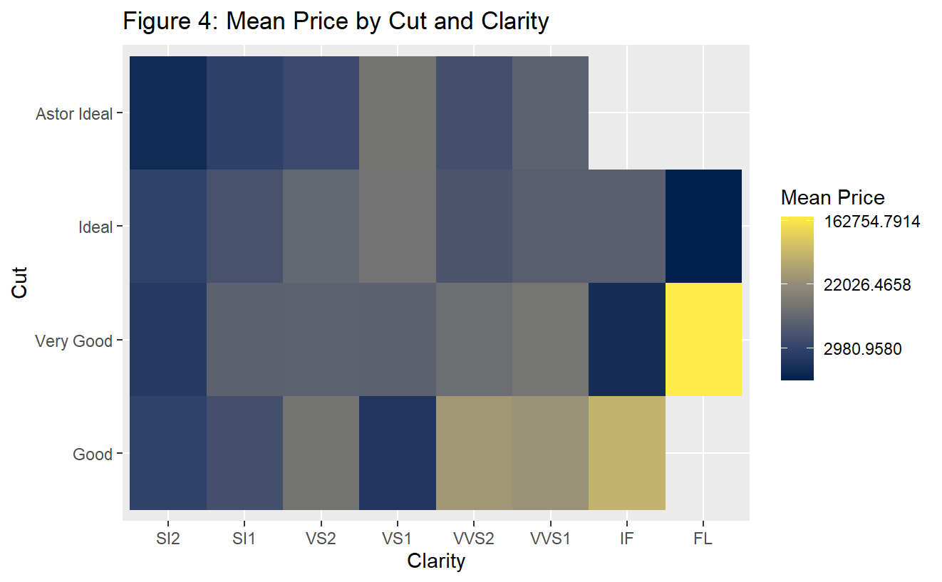

So which diamond should you buy? Buy whatever diamond brings you joy and works with your budget! Here are our final takeaways:

* For the budget friendly shopper, you may want to greatly consider carat size as a location to cut back.
* Clarity is an element of the stone that you might have more flexibility in your budget; there does not appear to be a major increase to price as you shop within a range of SI2 to IF, but you may want to stay away from a clarity of FL. This jump to FL is where you can expect to see a major price increase!
* You can also expect to see a lot of flexibility within affordable cut grades, as this alone does not seem to eat at your pocketbook.
* As for color, you may want to research which color you are willing to accept. This characteristic also seems to drive up prices as you progress towards a clearer diamond!

**SECTION 2: The Study**

This study was conducted in October of 2024 by group 6 comprised of MSDS candidates Angie Yoon, Jett Badalament-Tirrell, Nakisha Fouch, and Shawn Gmurek of the University of Virginia. The data used for the study was a subset of 1,214 unique diamonds with their respective characteristics and prices.

The variables that were accounted for in this study are defined as follows:

**Cut**

Cut measures how well-proportioned a diamond’s dimensions are, including its balance and brilliance. This influences how well a diamond interacts with light, impacting its brilliance, fire and scintillation. A well-cut diamond will look its absolute best with optimal light performance. Diamond cut is considered the most important of the four Cs. No matter which diamond jewelry style you choose, you will always want to prioritize cut.

Allowable values include Ideal, Very Good, Good, Astor --> Astor, Ideal, Very Good, Good

**Color**

Diamond color refers to how colorless a diamond is. Color is the second most important of the 4Cs of diamonds. Colorlessness is a desirable feature in most diamonds and the more colorless diamonds are rarer. The less color a diamond has, the higher the diamond color grade. Certain jewelry metals can complement faint color diamonds, so diamond color is a flexible 4C characteristic that can vary depending on preferences and jewelry settings.

Allowable values include D, E, F (colorless); G, H, I, J (near colorless); and K (faint color)

**Clarity**

Clarity assesses small imperfections within a diamond. Inclusions can occur naturally during the diamond forming process for both natural and lab diamonds. Clarity is used to quantify and specify any inclusions. When it comes to the four Cs of diamonds, clarity is typically not the most important, as many blemishes are too small to be seen without magnification. But some larger blemishes can be visible. Review a diamond’s clarity plot to see its inclusions.

Allowable values include I1, I2, I3 (Included Diamonds (none in data)); SI1, SI2 Slightly Included (SI) Diamonds; VS1, VS2 Very Slightly Included (VS) #Diamonds; VVS1, VVS2 Very, Very Slightly Included (VVS) Diamonds; Internally Flawless (IF) Diamonds; Flawless (FL) Diamonds

**Carat**

Carat measures a diamond’s weight, not its size. These four Cs of diamonds date to the 1500s when carob seeds were used to measure diamonds and gemstones. Today, carat refers to an exact weight of 200 milligrams. Carat weight choice is a matter of preference, one weight is not necessarily better than another. Typically, heavier high-quality diamonds are rarer than ones with lower carat weights and diamond prices can reflect this.

**Addressing Blue Nile Formally:**

Blue Nile makes mention of several claims in their website, but here are the ones that stood out to our team:

1. Blue Nile’s Astor Diamonds “represent the highest-graded stones available in all of the four C’s”
2. “Cut is responsible for the diamond’s brilliance… cut should be your biggest priority”
3. “Clarity is… the least important”
4. “Carat weight choice is a matter of preference; one weight is not necessarily better than another. Typically, heavier high-quality diamonds are rarer than ones with lower carat weights and diamond prices can reflect this”
5. “The higher the quality a diamond, the more expensive it will be.”

Let's address these in reverse order:

For claim 5, Blue Nile asserts the assumption that price is indicative of quality. We will use this to present our findings in the other claims where Blue Nile suggests importance and priorities.

For claim number 4, they state that carat arbitrarily increase price due to rarity. We agree with this statement given the following two figures:

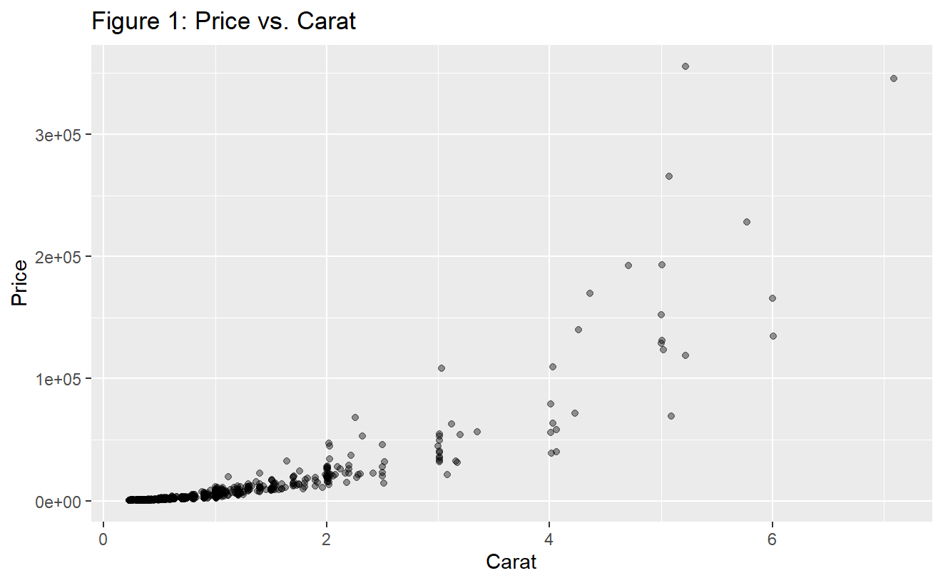

The scatter plot of price against carat shows an almost exponential relationship, we believe this certainly backs the claim that larger weights in the diamonds are quite rare given the drastic increases in price as our diamonds get heavier.

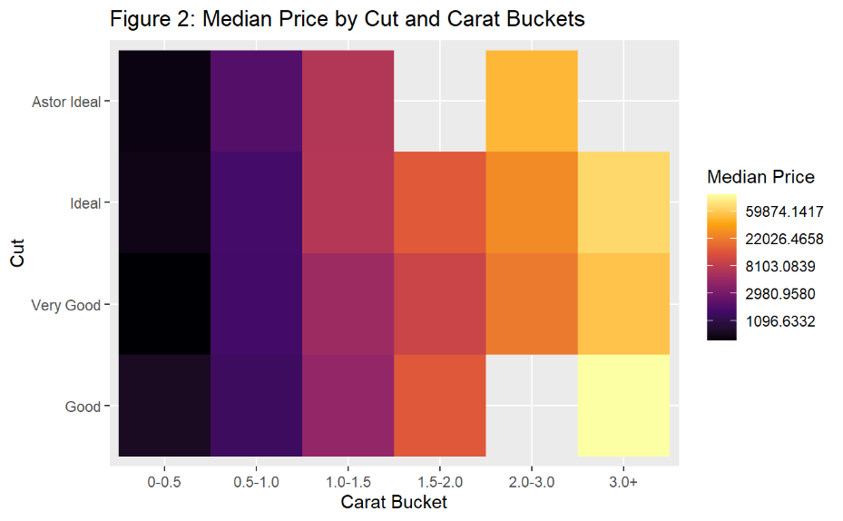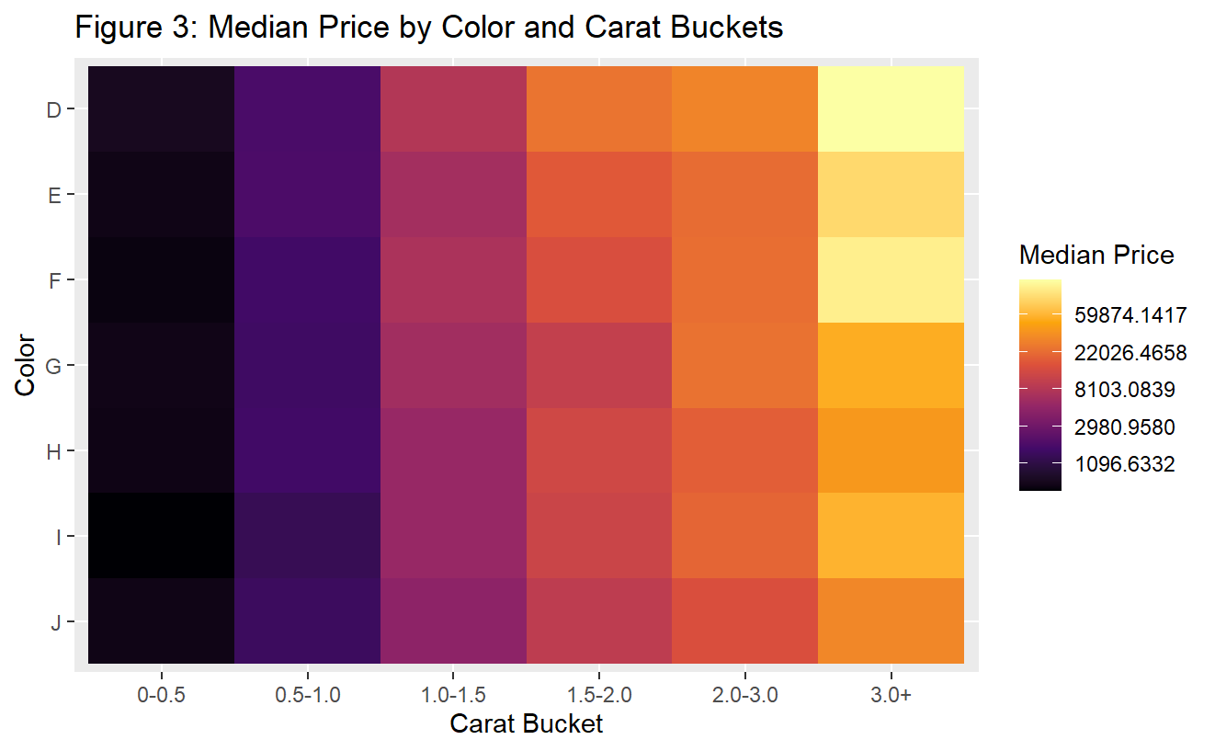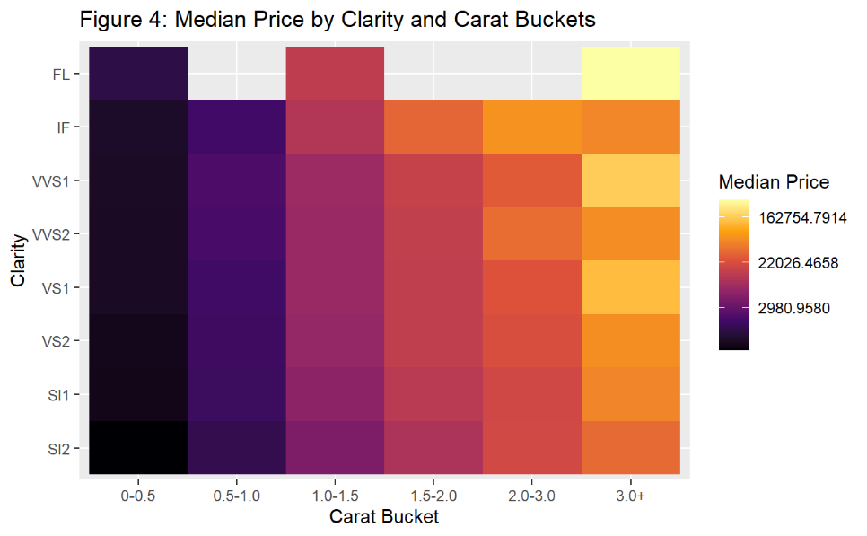

When looking at a heatmap of median price compared to carat and one other variable, we notice that carat is seemingly the most consistent predictor of median price increases. In each graphic, carat lightens from left to right within each category of cut, clarity, and color. However, it is difficult to assert that one weight is necessarily better than another. Yes, the price may be reflective of the rarity of the stones weight, but the increasing price indicates that this inherently has more value to buyers.

For claim 3, it is asserted that clarity is the least important characteristic of a diamond. When looking at a box plot of log(price) (for scaling) against clarity, we see that there does appear to be a lack of consistent increase to the median price. However, a clarity of FL seems to make a drastic impact to price, nearly doubling when compared to other clarity levels.

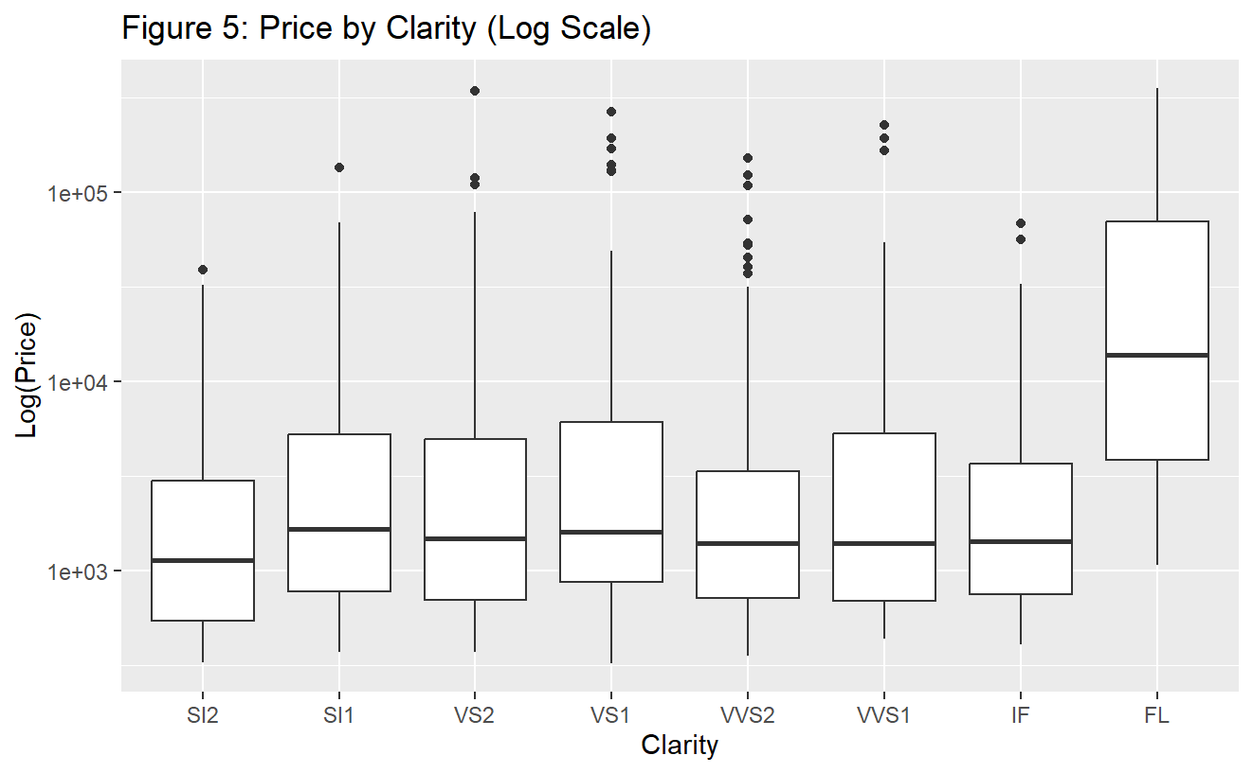

However, to fully address the claim, let us look at the other characteristics compared to log(price):

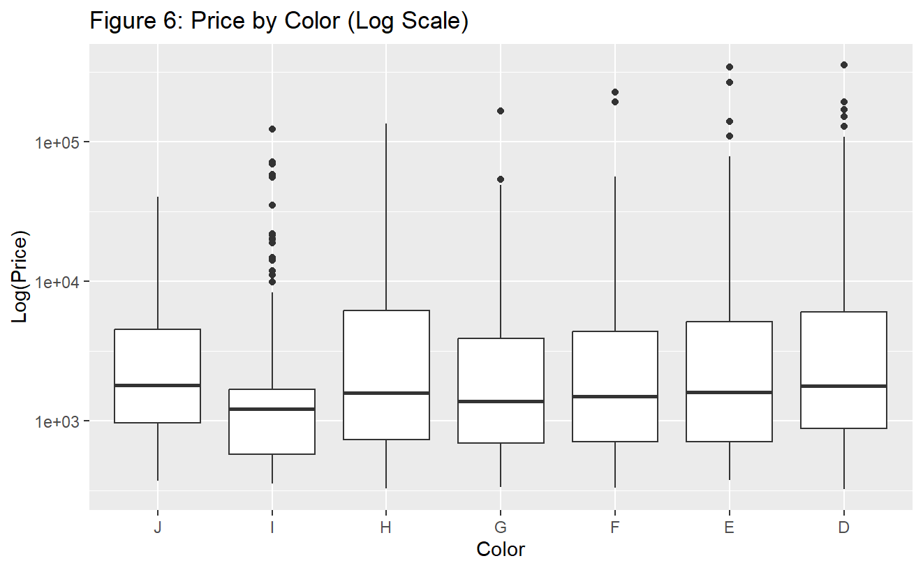 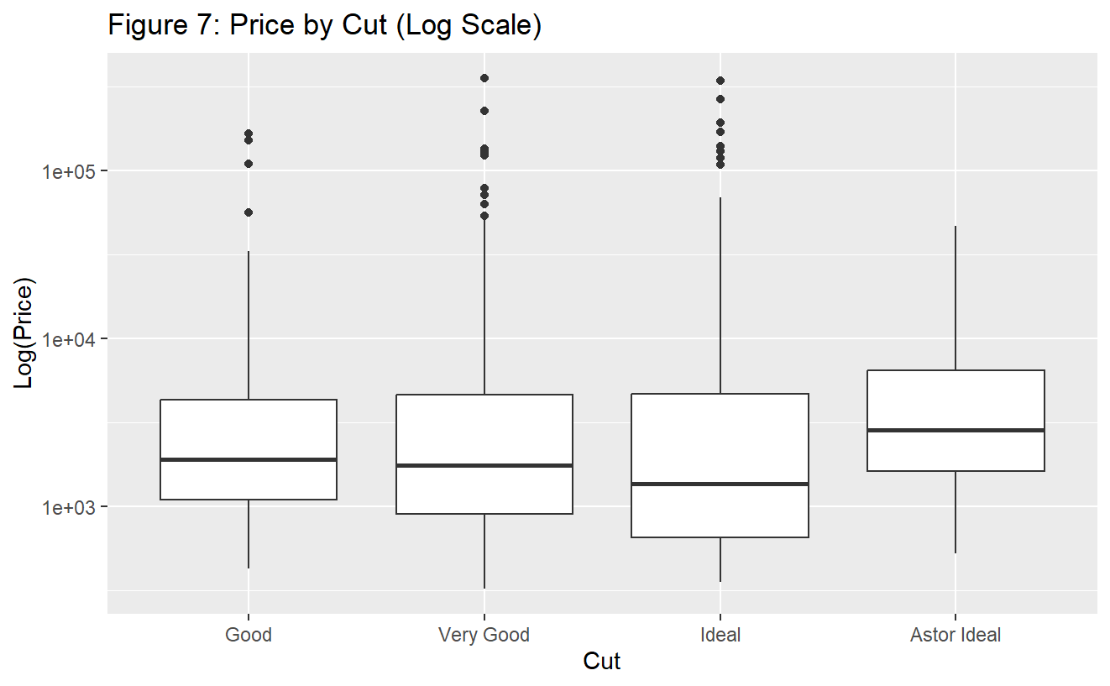

While clarity does seem to be inconsistent at predicting price, it is difficult to say that it is definitively the least important characteristic. The jump to the highest clarity level is so drastic that it must be of importance to buyers to have a clear diamond. When looking at color, it seems to increase positively from lower color to higher color. However, cut seems to break this trend with both very good and ideal having a median log(price) below the lowest cut grade of good.

Claim 2 argues that cut should be the most important characteristic, which does not seem to have merit. Cut does not seem to have a definitively positive relationship with price as the mid-grade cuts do not increase the log(price). The Astor Ideal cut marginally increases price relative to a good cut, so it can be inferred that buyers may not be as interested in higher cut grades. When looking at cut controlled by carat, we also see that price does not seem strongly affected by cut:

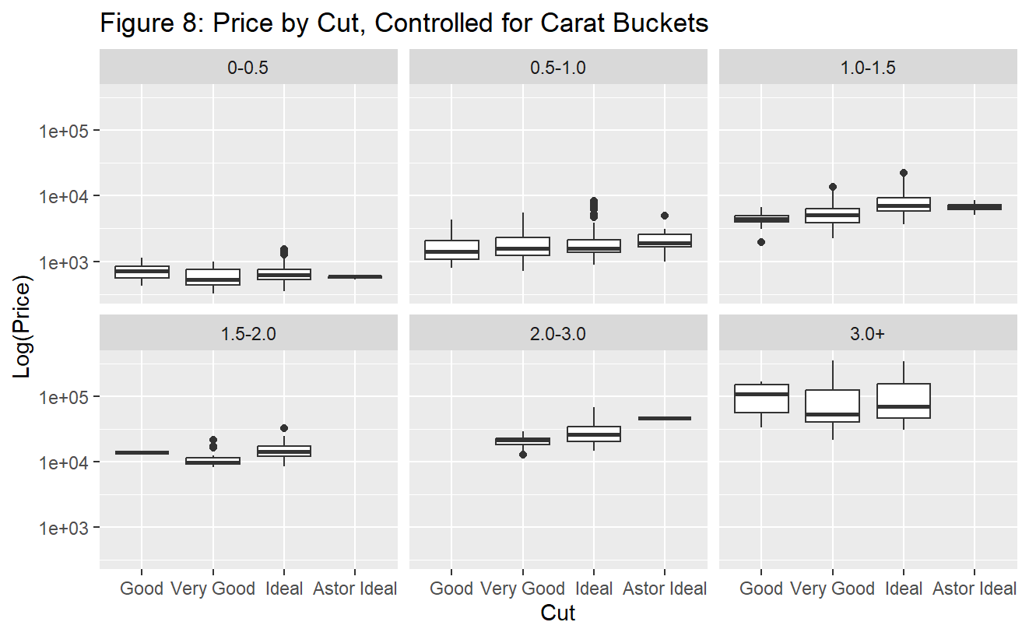

The good cut category also has more outliers and a higher median than the Very Good and Ideal categories; price must be increased by the other characteristics since this is the lowest grade. This increase may indicate that other characteristics are more important to buyers than cut alone, asserting that cut again does not seem to be the most important of the 4.



For claim 1, we do see that the Astor Ideal cut increases the median price relative to other grades, but the increase seems marginal compared to a cut of good. As for how the Astor Cut compares to the four C’s, we notice that it contains lower clarity than the other cuts, which conveniently happens to be the characteristic they have marketed as “least important”.

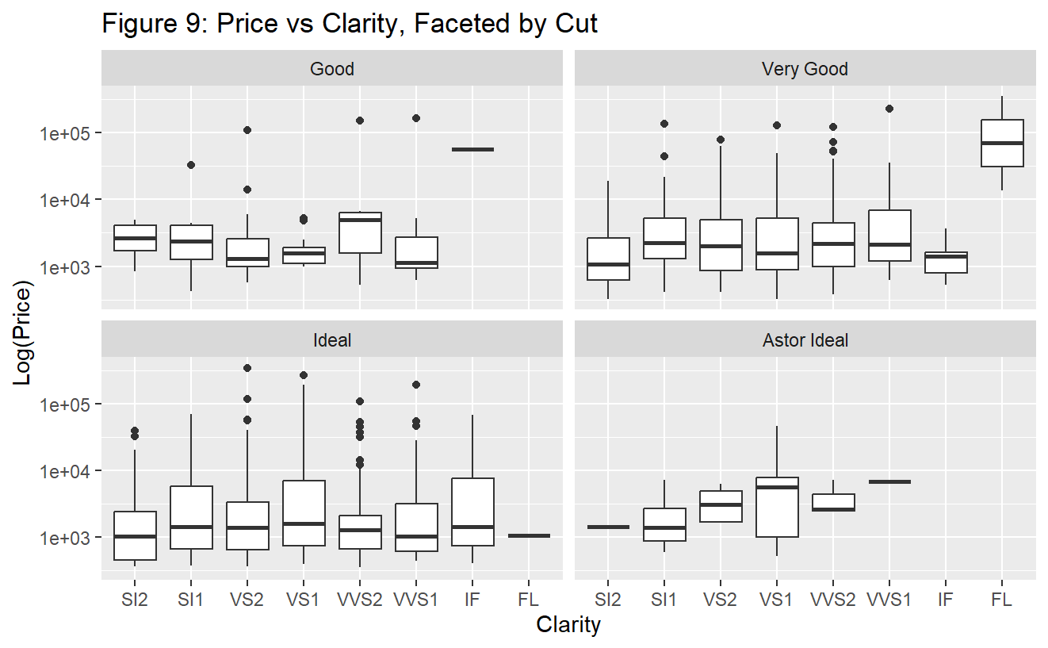

When looking at the graph above, it is almost definitive that the Astor diamonds do not represent the “highest of the four C’s” as clarity alone seems to dispute this hypothesis. Non-Astor Diamonds each contain a clarity of IF or higher. When looking at color as well, we see the following:

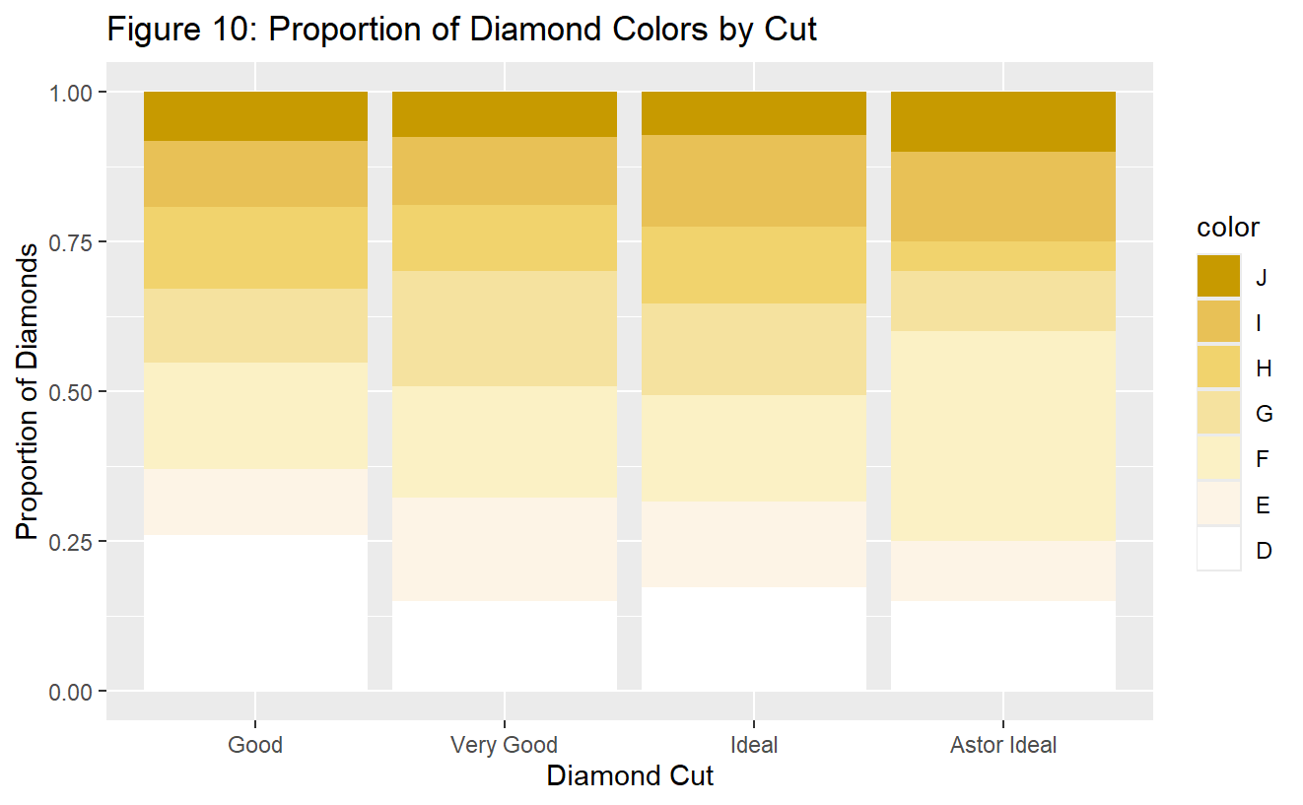

Astor cut diamonds have a spread of lower quality color, with the ideal cut strongly outperforming Blue Nile’s brand in colorless / near-colorless diamonds. Again, there seems to be no basis that Astor Diamonds outperform other diamonds in the other C’s.

**Section 3: SLR**

The initial plotting of Prive vs Carat returned a graph (see Figure 1) that failed to meet both assumptions:

* Assumption 1 was not met as the data points are not evenly scattered on both sides of the regression line as we move from left to right. This plot looks non-linear.
* Assumption 2 was not met as the vertical spread of the data points is not constant as we move from left to right.

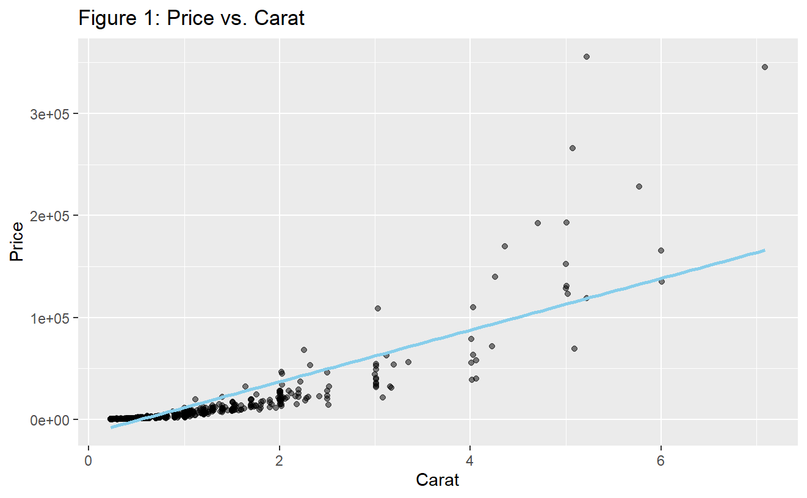

A diagnostic plot (see Figure 2) was then created to confirm these initial observations with the following assessments made:

* Assumption 1 is not met: Within the Residuals vs Fitted plot, the residuals are not evenly scattered around the horizontal axis. This suggests that the model is not linear.
* Assumption 2 is not met: Within the scale-Location plot, the vertical variance of the plots is higher for diamonds that have larger fitted values on the x-axis.
* As both assumptions are not met, we try transforming the response variable first to adjust the variance for a better fitting model. In the scale-location plot, the variance of the residuals is increasing, which grants the assumption that a lambda of less than 1 will be appropriate to transform the response variable (y, price). A Box-Cox plot is needed to identify the best value of lambda.

**Figure 2: Diagnostic Plot for Price vs. Carat**

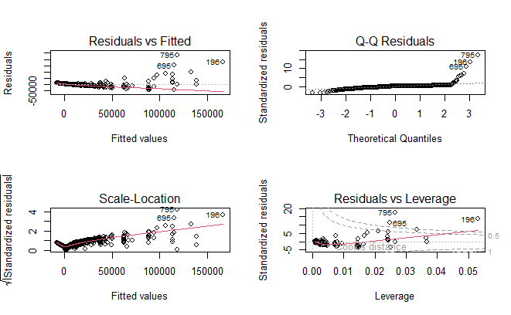

In the Box-cox plot (See Figure 3), a lambda of 0 is excluded from the 95% confidence interval, however, this does not necessarily mean that a log transformation will fail to improve our model. The Scale-Location plot provides compelling evidence that variance increases alongside the fitted values. A log transformation will be attempted as will a transformation with lambda=0.3 which is included in 95% CI in the Box-cox plot, and then compare the models after transformation to determine the best method to proceed.

**Figure 3: Box Cox Plot**

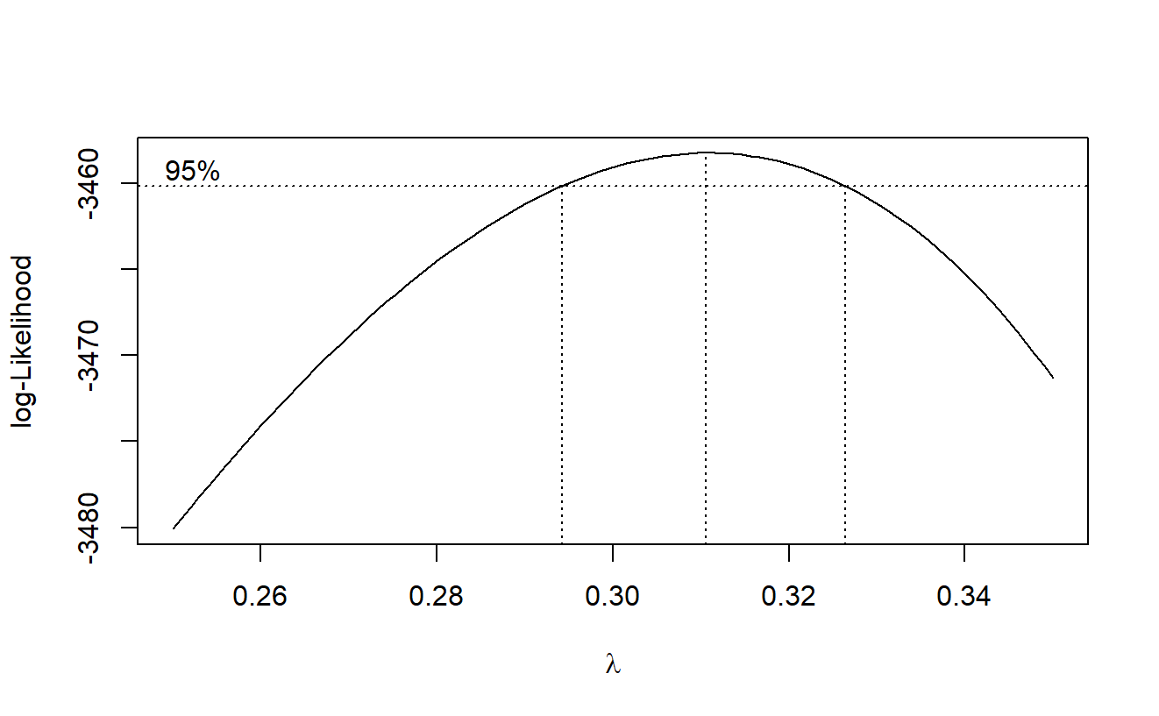

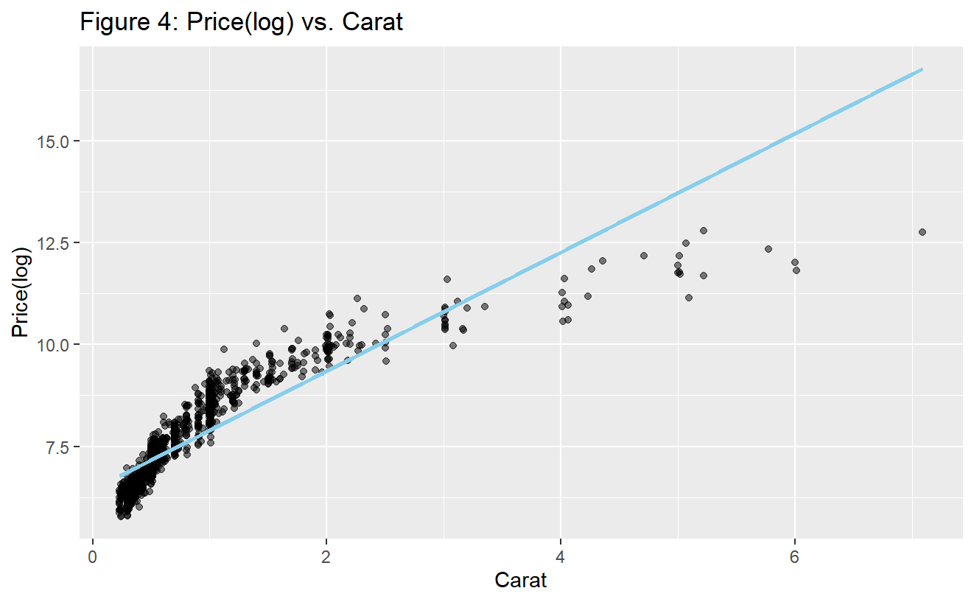

**Figure 5: Diagnostic Plot of Log(Price) vs Carat**

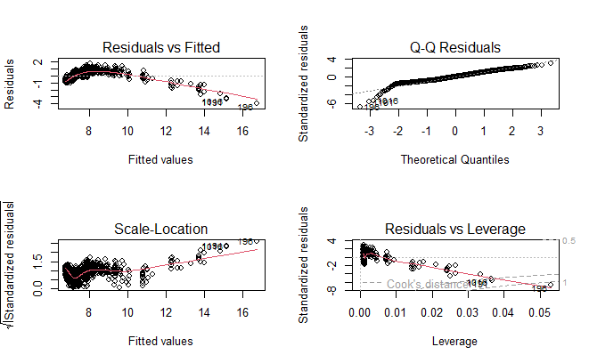

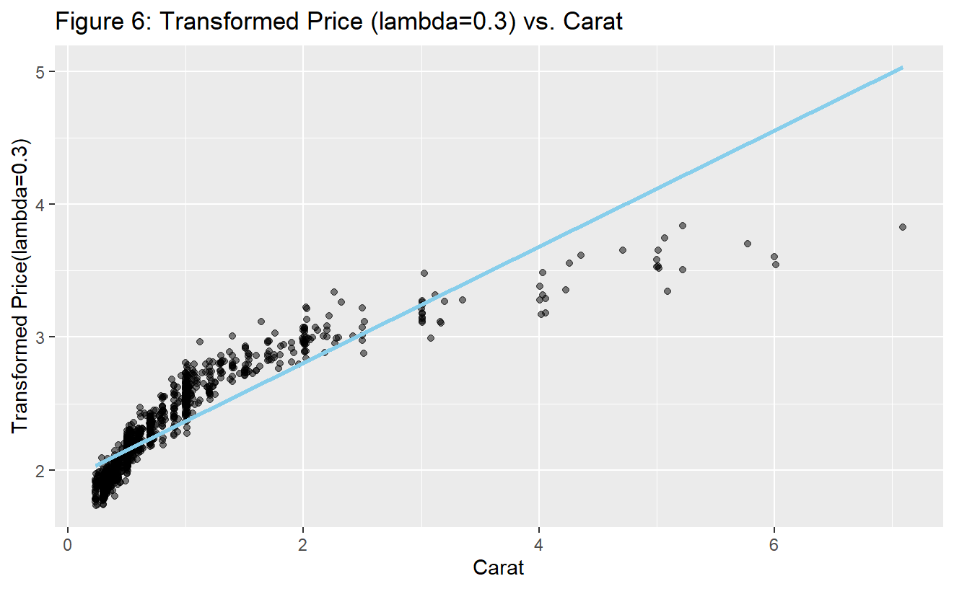

**Figure 7: Diagnostic Plot of Price (Lambda = 0.3) vs Carat**

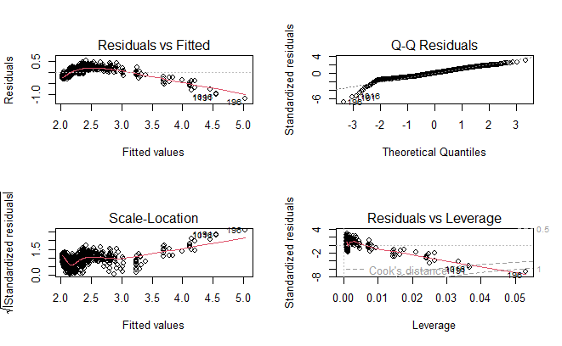

Within both transformations (Figures 5 & 7), the scatter plots, the Residuals vs Fitted plots and Scale-Location plots show a more constant variance than the original model, indicating that assumption 2 is less of a concern. The team proceeded with the log(Price) transformation for two reasons:

* The transformation with lambda 0.3 does not show a significantly better performance in stabilizing the residual variance than the log transformation according to the scatter plots and diagnostic plots.
* Log transformation provides a better opportunity to easily interpret coefficients.

Proceeding with transformations as assumption 2 has been met, another transformation is needed to address assumption 1. Based on the Figure 4 scatter plot, a log transformation of the predictor, Carat, is needed given the shape of the plot around the regression line.

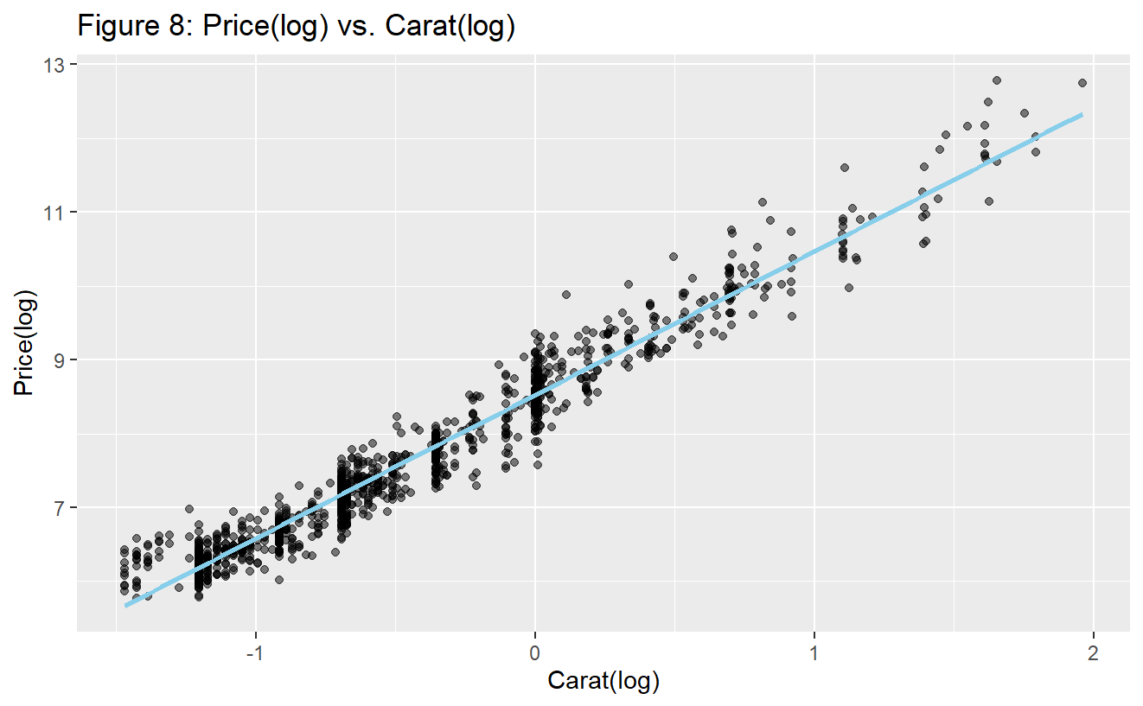

Assessment: From the scatter plot of log(Price) against log(Carat), there appears to be a positive, linear relationship with evenly distributed data points between the line. (Assumption 1 is met). The constant variance is met as the variance does not appear to be increasing nor decreasing (Assumption 2 is met). To be certain, a diagnostic plot (see Figure 9) is needed for the transformed variables, which affirms that the residuals are evenly scattered on both side of the axis (Assumption 1 is met) and the spread of the residuals is also fairly constant (Assumption 2 is met).

**Figure 9: Diagnostic Plot of log(Price) and log(Carat)** A group of graphs showing different values

Description automatically generated

Conclusion:

With both assumptions now met through transformations, a simple linear regression can be generated for the model. This regression equation is:

*yˆ∗ = 8.5212 + 1.9440 x∗, where y^∗ = log(price) and x∗ = log(carat)*

The coefficient of 1.9440 on log(Carat) states that for every 1% increase in the carat weight of a diamond, the price of the diamond increases by approximately 1.944%. This SLR model states that there is a strong positive relationship between the price and carat of a diamond.