软件测试实验1

3015218139_白春赞

1. Install Junit(4.12), Hamcrest(1.3) with Eclipse

下载junit,hamcrest

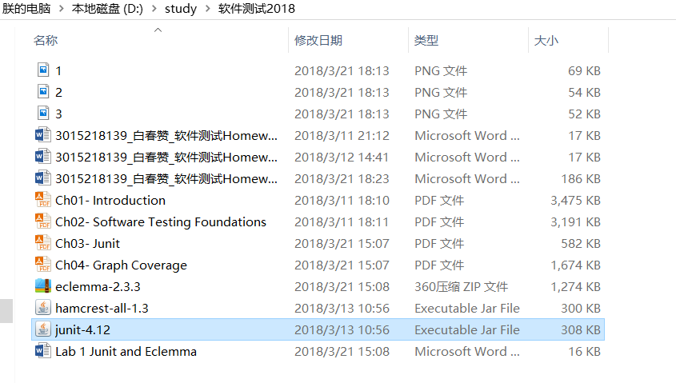

在工程下面新建文件lib，将junit,hamcrest copy到文件夹中，然后右键点击Build Path-Add Extend Archives

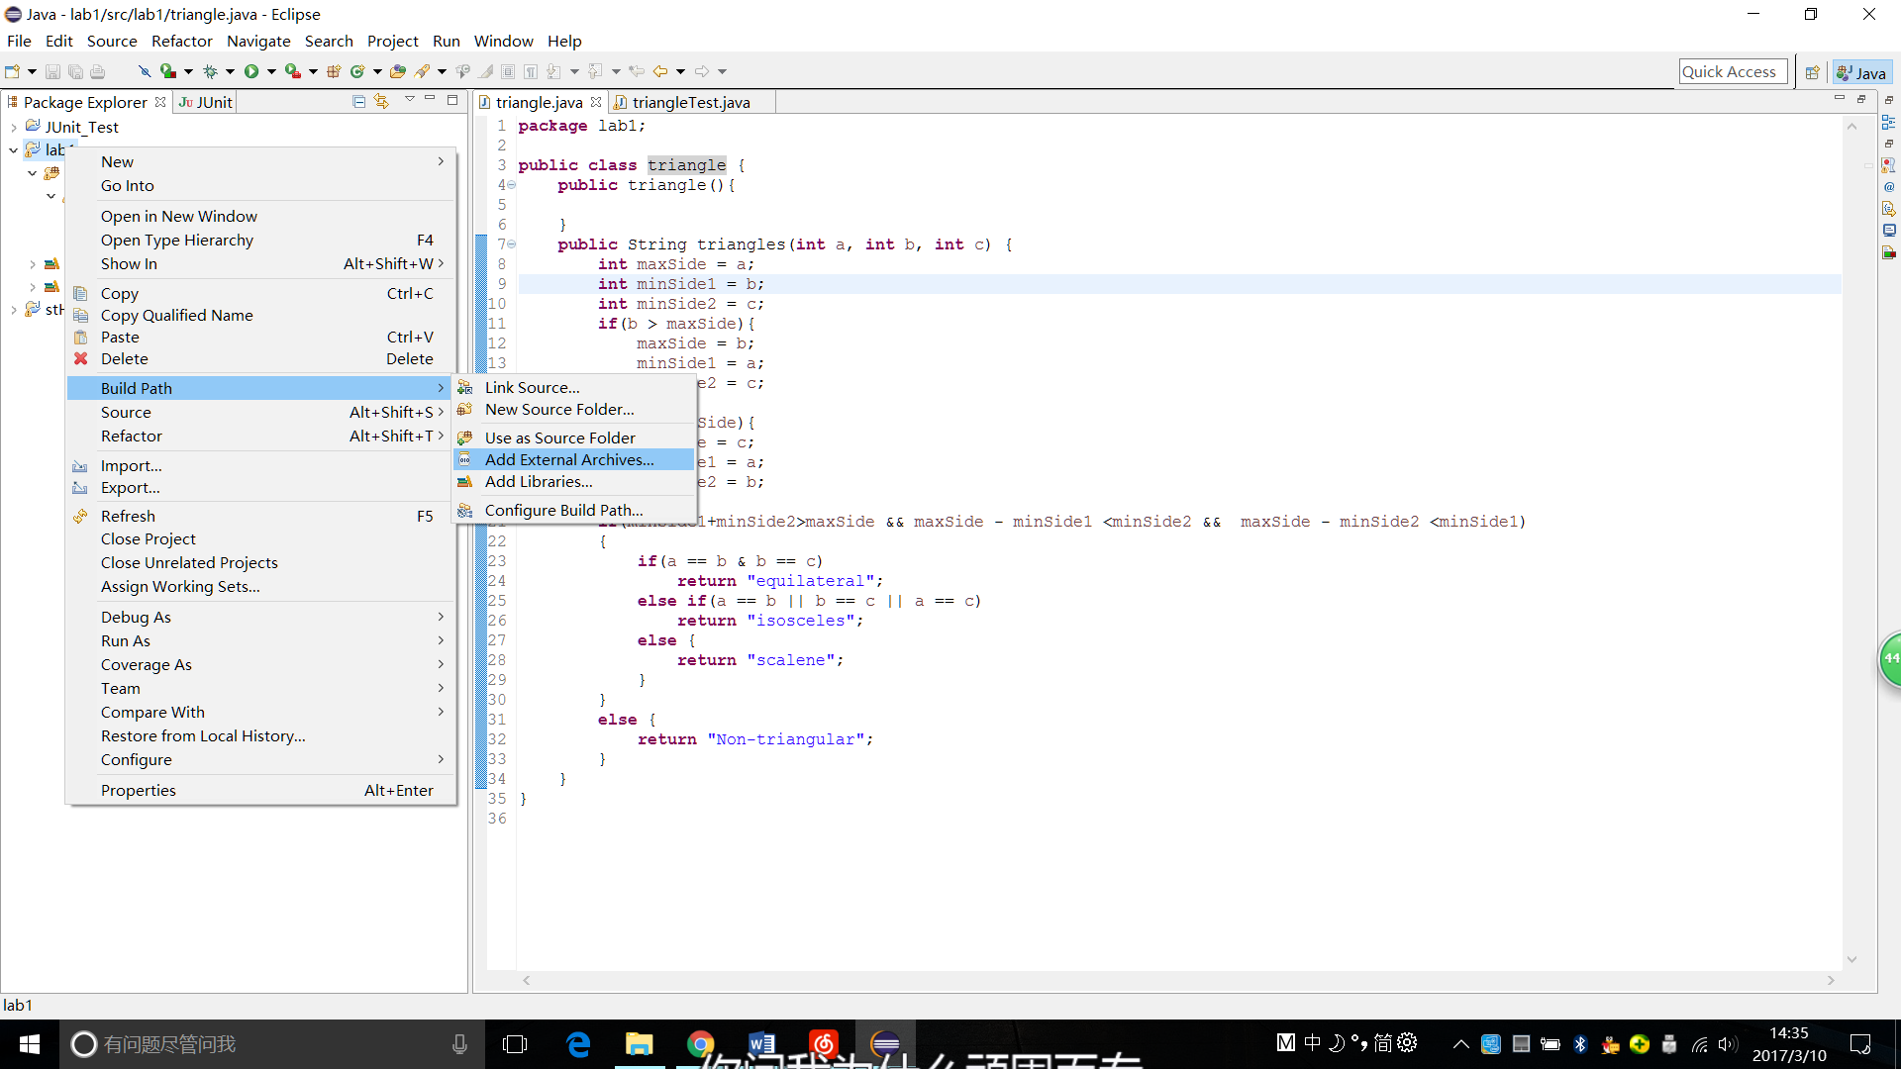

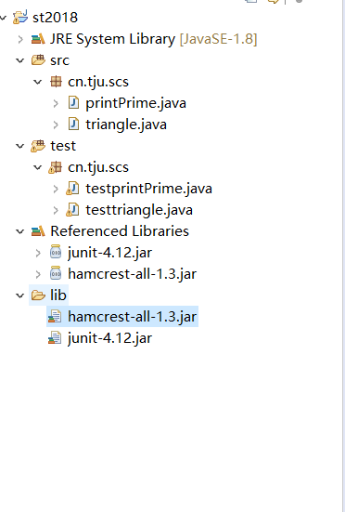

1. Install Eclemma with Eclipse

将eclemma压缩包下载下来后解压到Eclipse本地目录的dropins下，重启Eclipse即可：

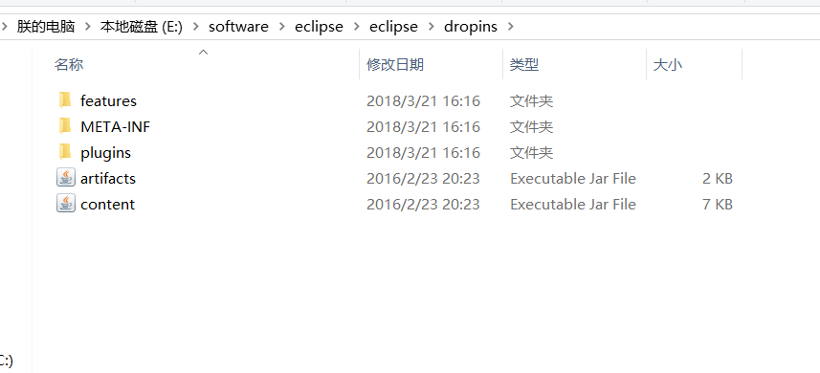

重启后，eclipse上面出现如下标志，则插件安装成功



1. Write a java program for the triangle problem and test the program with Junit.
   1. Description of triangle problem:

Function triangle takes three integers *a,b,c* which are length of triangle sides; calculates whether the triangle is equilateral, isosceles, or scalene.

Triangle code

**package** cn.tju.scs;

**public** **class** triangle {

**public** triangle(){}

**public** String triangles(**int** a, **int** b, **int** c) {

**if**(a + b > c && a + c > b && b + c > a)

{

**if**(a == b && b == c)

**return** "equilateral";

**else** **if**(a == b || b == c || a == c)

**return** "isosceles";

**else** {

**return** "scalene";

}

}

**else** {

**return** "Non-triangular";

}

}

}

Test code

**package** cn.tju.scs;

**import** **static** org.junit.Assert.*;

**import** **static** org.hamcrest.Matchers.*;

**import** org.junit.Before;

**import** org.junit.Test;

**public** **class** testtriangle {

**public** triangle tr = **new** triangle();

@Before

**public** **void** setUp() **throws** Exception {

}

@Test

**public** **void** testTrangle() {

*assertEquals*("equilateral", tr.triangles(3, 3, 3));

*assertEquals*("isosceles", tr.triangles(3, 2, 2));

*assertEquals*("scalene", tr.triangles(3, 4, 2));

*assertEquals*("Non-triangular", tr.triangles(2, 2, 4));

}

}

