**PALAWAN TECHNOLOGICAL COLLEGE INC. SENIOR HIGH SCHOOL ONLINE LEARNING MATERIAL SYSTEM**

PROPONENTS:

Egieboy Justine M. Parales

John Carlo S. Canonigo

Albengerie D. Gonzales Jr.

Jemuel E. Belgado

Zaffia M. Marquina

**AN UNDERGRADUATE THESIS TO THE FACULTY MEMBERS OF PALAWAN TECHNOLOGICAL COLLEGE INC. PUERTO PRINCESA CITY, PALAWAN**

**IN PARTIAL FULFILLMENT OF THE REQUIREMENTS FOR THE DEGREE OF BACHELOR OF SCIENCE IN INFORMATION TECHNOLOGY**

**ABSTRACT**

This research focuses on creating an **Online Material System** for the Senior High School Department of Palawan Technological College Inc. (PTCI). The goal is to make it easier for students and teachers to manage and access learning materials. The system will allow teachers to upload materials and students to download them whenever needed. It also sends notifications about new materials uploaded. The study looks at how the system can save time, reduce costs, and improve access to educational resources. After testing, the results show that the system is effective, and suggestions for further improvement are provided.

**APPROVAL SHEET**

This thesis entitled “Palawan Technological College Inc. SHS Online Learning Material System”, proposed and submitted by Egieboy Justine M. Parales, John Carlo S. Canonigo, Albengerie D. Gonzales Jr.,Jemuel E. Belgado, Zaffia M. Marquina in partial fulfillment of the requirements for the Degree of Bachelor of Science in Information Technology.

**JOZEN PAUL DATILLES**

Adviser

Evaluated by the Panel of examiners for oral defense with a grade of

_________.

Accepted and approved in partial fulfillment of the requirements for the Degree of Bachelor of Science in Information Technology.

Approved by:

**MRS. MARIA FE M. DAVID**

Head of Academic Affair

**ACKNOWLEDGEMENT**

We would like to thank everyone who supported us in this project. To our adviser, thank you for your guidance. To our teachers, classmates, and friends, your feedback and encouragement motivated us. Lastly, we thank our families for their patience and understanding as we worked on this research.

**DEDICATION**

This project is dedicated to the Senior High School students and teachers of Palawan Technological College Inc., whose daily struggles and efforts inspired us to create a better way to manage learning materials.

**CHAPTER 1**

**INTRODUCTION**

**Palawan Technological College Inc.**is one of the private schools here in **Puerto Princesa City, Palawan*,* Palawan Technological College Inc.** also known as (PTCI) has a 500+ student as of January 2024 and it has a senior high school strands Humanities Social Sciences (HUMSS) and Technical Vocational Livelihood (TVL), Therefore there are colleges courses like Bachelor of Science in Information Technology (BSIT), Bachelor of Science in Hospitality Management (BSHM), Associate in Computer Technology (ACT), Bachelor of Science in Information Systems (BSIS), and Bachelor of Science in Office Administration (BSOA) these are the courses that **Palawan Technological College Inc.** has to offer to the students.

They currently employ in person instruction and manual book reading in the school library. We came up with the concept of having educational materials that you may read anywhere, at any time, and without having to check out books from the city or school library.

**Online Learning Material System (OLMS)** is a system where you can write and add some learning material within the system it also helps a reader to review the details that have been added to the system and it also you can read at your own pace.

The value of using technology to enhance learning outcomes and expedite administrative procedures. PTCI wants to integrate online learning platforms that will improve the educational experience for both teachers and students as part of its dedication to providing high-quality education. Personalized learning pathways, collaborative learning, and increased access to educational content are all benefits of developing and integrating an **Online Learning Material System (OLMS).**

**BACKGROUND OF THE STUDY**

We conducted this study to address the problem that students may have that may occur during the fast pace of the school calendar. Having an online learning material system will be a big help to the students who have slow learning or are unable to adapt from **time-to-time** teaching; it also helps to review some details.

The COVID-19 pandemic has accelerated the shift to digital education, leading to the development of **Online Learning Material Systems (OLMS)**. These systems facilitate the creation, management, and dissemination of digital learning content, offering advantages like accessibility, cost-effectiveness, and flexibility. They also provide data-driven insights for educators to track student achievement and refine educational tactics, promoting individualized learning experiences.

**HYPOTHESIS**

Implementing online learning material system helps students to learn individually at their own pace and gain access to different subjects, efficiency in academic performance and overall satisfaction with the learning process.

**OBJECTIVES OF THE STUDY**

**General Objective:** To design and develop **Online Learning Material System** (OLMS) that is made to all PTCI students and faculty members, providing a centralized platform and technology for managing and distributing learning materials.

**Specific Objective:** evaluates the Online Learning Material System's impact on student engagement, access to educational materials, and academic performance, as well as its efficiency in administrative tasks like progress tracking and feedback, and suggests recommendations for its improvement and sustainability.

**SIGNIFANCE OF THE STUDY**

Palawan Technological College Inc. Senior high School Online Learning Material System is significant for several reasons:

* **For Palawan Technological College Inc.:** The study explores the potential of integrating an OLMS in PTCI's educational program, aiming to enhance access, improve learning outcomes, and create a more stimulating learning environment.
* **For Students:** A consolidated platform for learning materials will provide students with more accessible, adaptable, and interactive resources, allowing them to study at their own pace and collaborate with classmates and teachers.
* **For Educators and Administrators:** Faculty members will gain access to resources for effective course content development, simplified administrative procedures, and improved data for monitoring student development.
* **For Future Research:** This study will add to the expanding corpus of research on the use of technology in education, especially as it relates to Philippine higher education institutions. It can provide as a template for other organizations looking to implement comparable systems.

**SCOPE AND DELIMITATION**

**SCOPE**

This project focuses on designing and deploying an online learning material system for Palawan Technological College Inc., obtaining feedback from teachers and students during a pilot deployment, and assessing its efficacy in academic performance, user engagement, and accessibility.

**DELIMITATION**

The study will not address all aspects of the college's digital transformation, including the creation of digital infrastructure and the deployment of additional tools like Learning Management tools (LMS). Furthermore, the study will only cover a restricted number of academic programs and might not be entirely representative of all the subjects the college offers.

**CHAPTER II**

**THEORETICAL FRAMEWORK**

**REVIEW OF RELATED LITERATURE**

In this chapter, the researchers review of existing studies that are relevant to the topic and development of implementation of an **Online Learning Material System (OLMS)**, with a focus on Senior High School (SHS) education. In this review it will cover a range of topics, including online learning contents, the importance of digital learning resources in digital world, integration of technology in the field of education and the adoption of the student and instructors to the technology.

The researchers seek a highlight key concept according to the current trends, challenges, and best practices that can inform the development of an **Online Learning Material System (OLMS)** at **Palawan Technological College Inc. (PTCI)** for its Senior High School programs.

**Related Literature**

Several studies have explored the implementation and impact of OLMS in various educational contexts:

* ***Acedo (2020)*** examined the effectiveness of an OLMS at a university in the Philippines, focusing on how it improved access to learning materials and student engagement. The study found that students who used the online system showed improved academic performance compared to those relying solely on traditional methods.
* ***Sari (2019)*** conducted research on the use of LMS in Indonesian high schools and found that the system significantly enhanced student motivation and collaboration. However, the study also identified challenges related to teacher preparedness and internet infrastructure.
* ***(Cerezo et al., 2016, Lust et al., 2013a, Lust et al., 2013b, You, 2016)*** This study analyzed the system logs recorded in a Learning Management System (LMS) in order to answer four questions. For Question 1, the descriptive statistics revealed several interesting results. First, the students accessed the lecture slides more often and, on average, spent more time on each access than they did for the other learning materials; the lecture slides were followed by video lectures, shared assignments, and posted messages. Lecture slides and video lectures are associated.

**STRENGTHS**

* Increase accessibility
* Cost efficiency
* User Convenience

**WEAKNESSES**

* Potential dependence on internet connectivity
* Frequently maintenance for security
* Potential technical difficulties for non-tech users

**PREVIOUS WORKS**

A previous work relevant to an online learning material system is the study of "E-learning and Recommendation Systems", which highlights the application of machine learning and content-based recommendations in online education environments. This research categorizes recommendation systems into content-based, collaborative filtering, and hybrid approaches to improve the management of educational resources. It also examines methods for better aligning learning materials with learners' preferences and objectives, ultimately enhancing the e-learning experience. Such systems have been tested on datasets, emphasizing personalized learning through semantic filtering and user activity monitoring【19】【21】.

Additionally, systematic reviews, such as the one exploring the effectiveness of online learning during the COVID-19 pandemic, analyze the rapid transition to digital education. These studies highlight the challenges faced by students and educators, especially in under-resourced environments, and propose design improvements for future online learning systems. Insights from these studies focus on optimizing user engagement, interactivity, and support through online platforms【19】【20】.

These examples provide a robust foundation for understanding prior advancements in online learning systems and their application in improving educational access and efficiency.

**CONCEPTUAL FRAMEWORK**

**INPUT**

**OUTPUT**

**PROCESS**

**Palawan Technological College Inc. Senior High School Online Learning Material System**

**Disseminating of learning materials**

**Creating learning materials**



*Figure 1.1 System flow*

In this figure it shows how the online learning material system works from input, process and transform it into an output.

**DEFINITION OF EXISTING TERMS**

**Online Learning Material System (OLMS)** – A digital or online platform that enhances a visualization of student and teacher into the internet. It also creates, facilitates, management and distribution of educational resources, enabling students and instructors to access and interact with and manage learning through online.

**Learning Management System (LMS)** – A software application that used to deliver, manage and track online learning materials and activities.

**DEFINITION OF TERMS**

**Palawan Technological College Inc.** – A higher education institution of Puerto Princesa City, Palawan under of Commission on Higher Education (CHED) that offering undergraduate and graduate programs in various fields of study.

**CHAPTER III**

**PROJECT DESCRIPTION**

**FUNCTION PERFORMED**

In this chapter the function performed of online learning material system was distributing materials, manage user accounts, provides access to the learning resources and commenting on the learning resources to enhance learning capacity of the distributed materials.

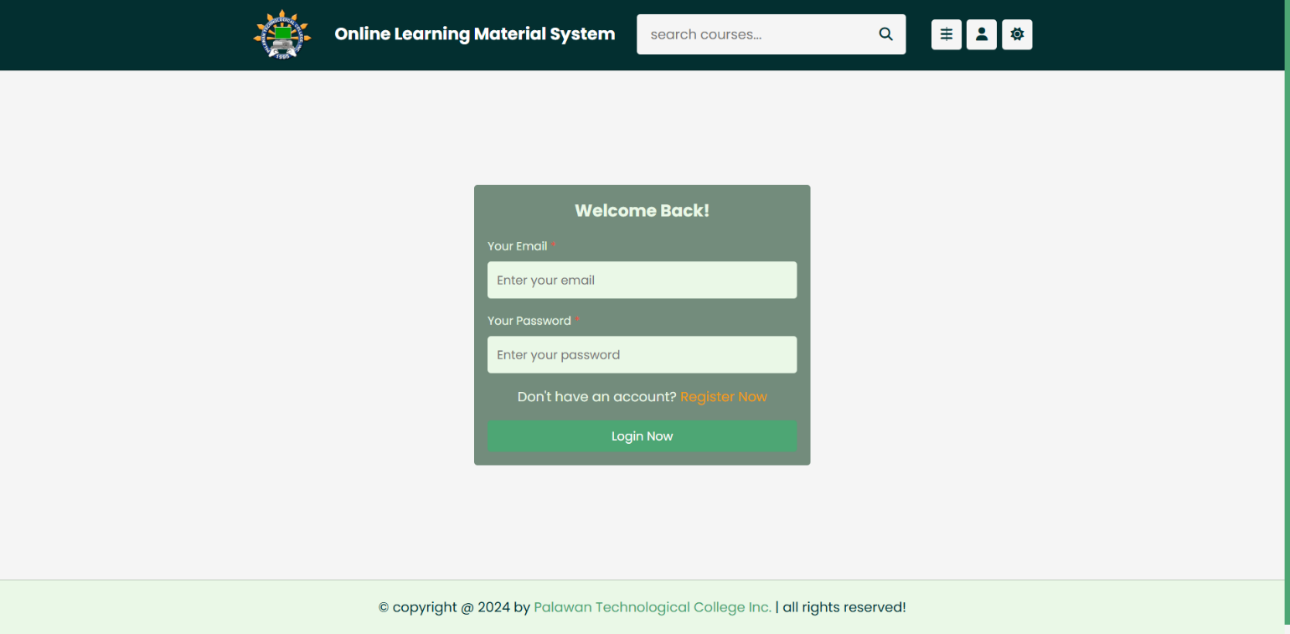

*Figure 1.2* Login Form

In figure 1.2 shows the login form of the system to gain access to the homepage of the system, Here you can login or register account.

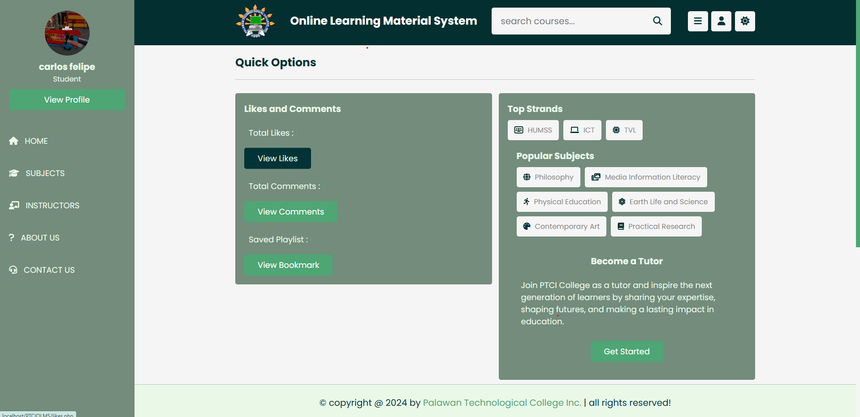

*Figure 1.3* Homepage

Figure 1.3 homepage this figure shows the overview of your account and also has a quick option to gain access to the learning resources.

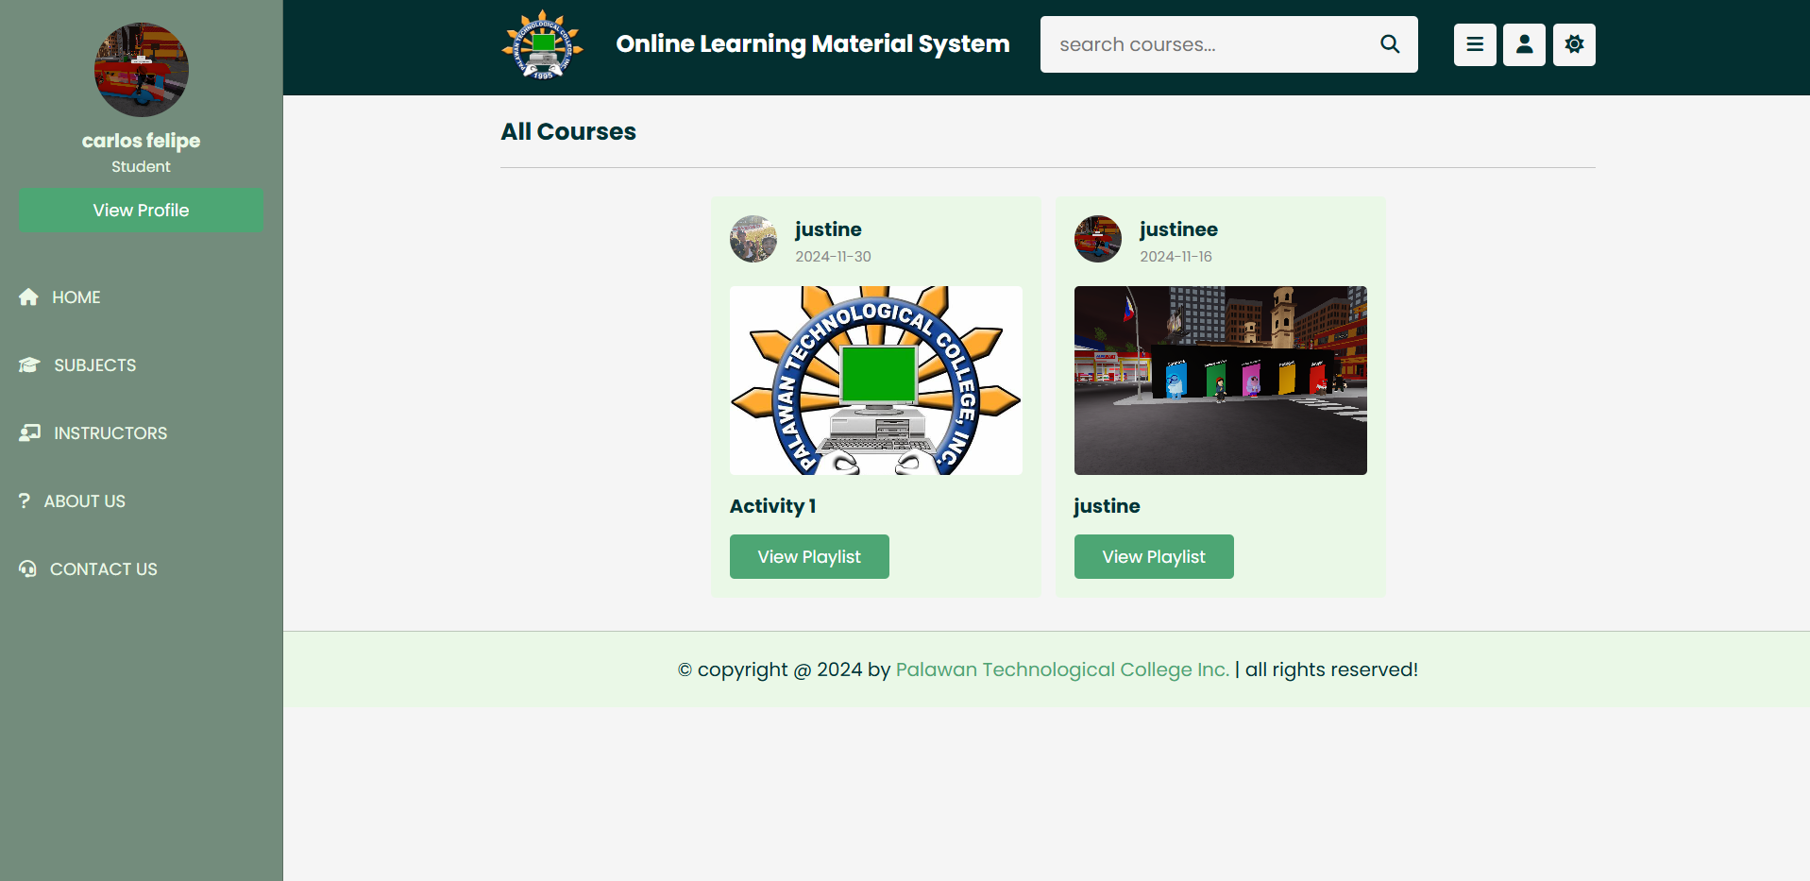

*Figure 1.4* Subjects section

Here in *Figure 1.4* shows the subject section which the users can gain access to the learning resources also here you can comment to the activities that the instructors output.

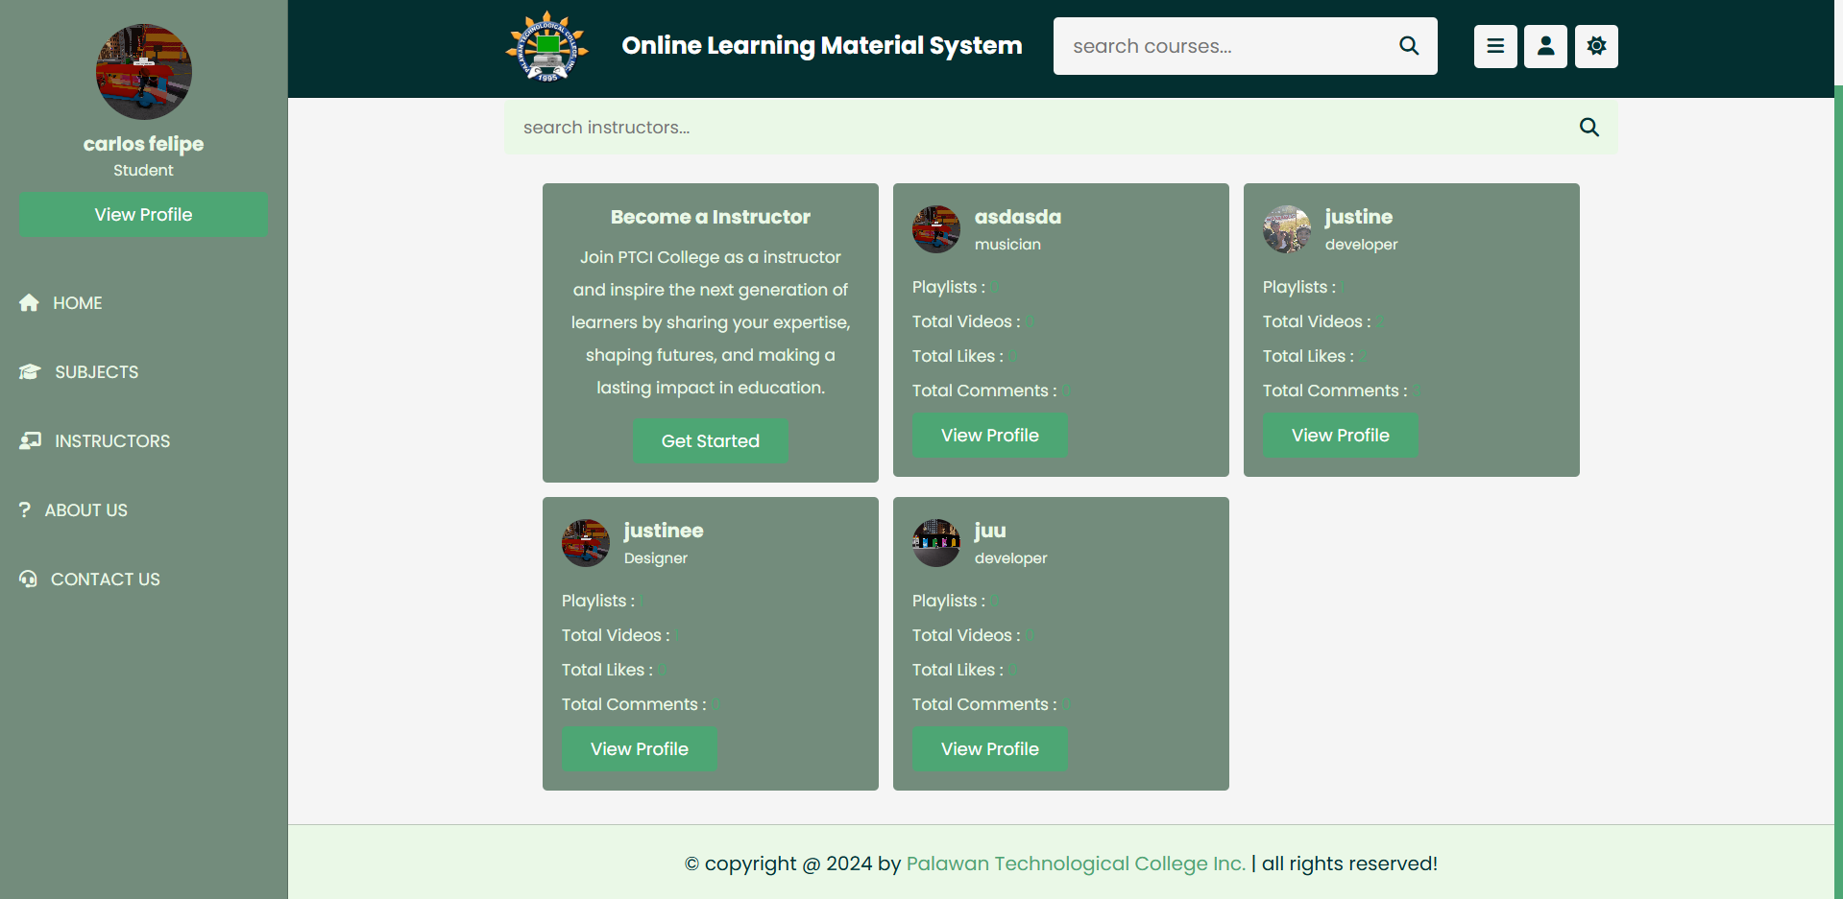

*Figure 1.5* Instructors section

*Figure 1.5* instructor section like in *Figure 1.4* you can also see the outputs of the instructors that have been made of instructors, Here in instructors section you can see all the instructors also their learning resources to view the student users.

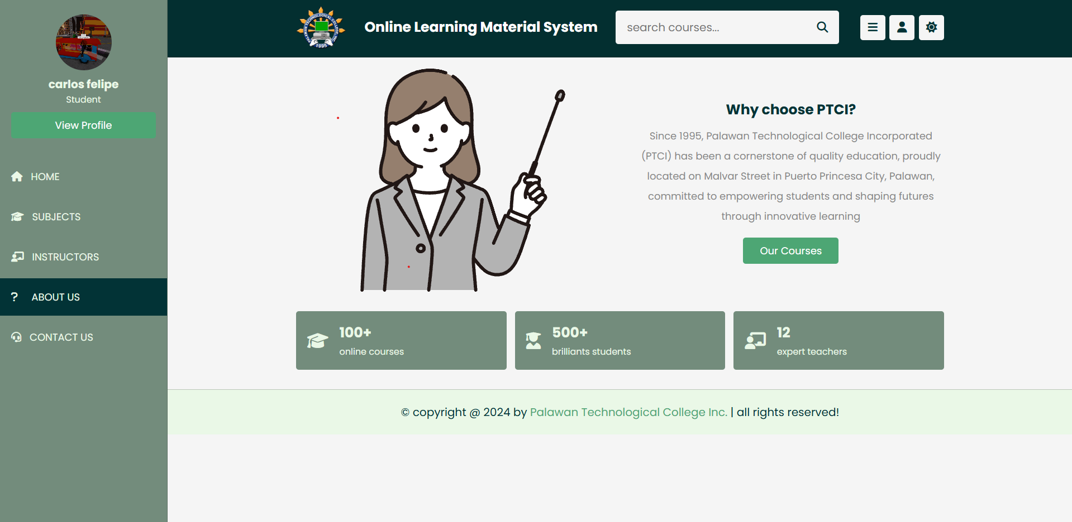

*Figure 1.6* About section

*Figure 1.6* in this figure shows the academically performance of Palawan Technological College Inc. here in Puerto Princesa City.

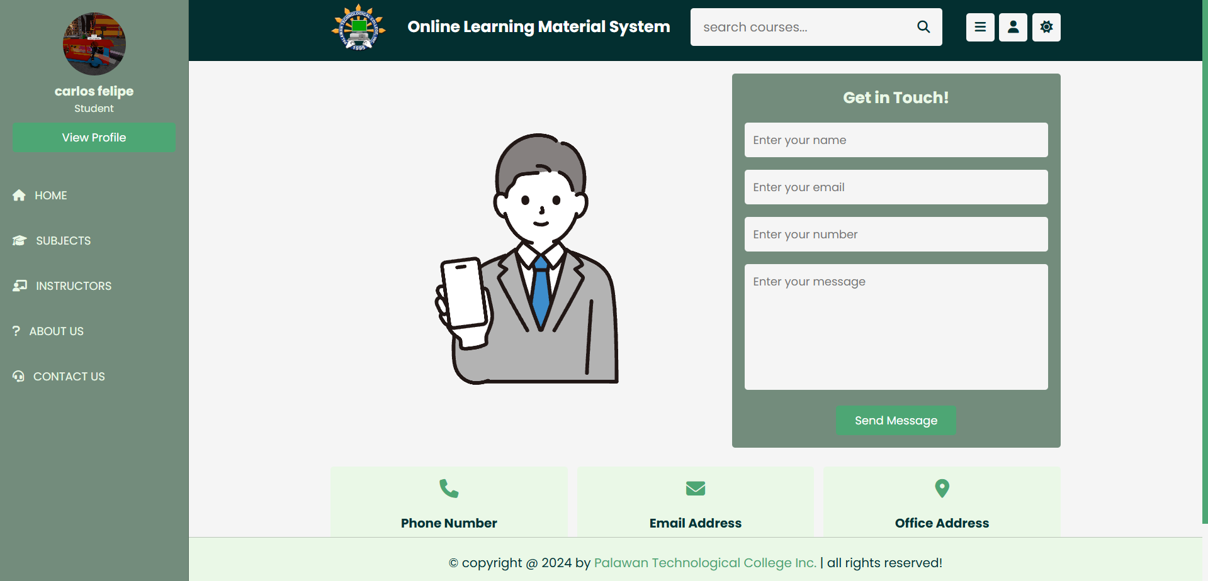

*Figure 1.7* Contacts

*Figure 1.7* contact section where you can email, call, or connect to the administrators to learn more about Palawan Technological College Inc.

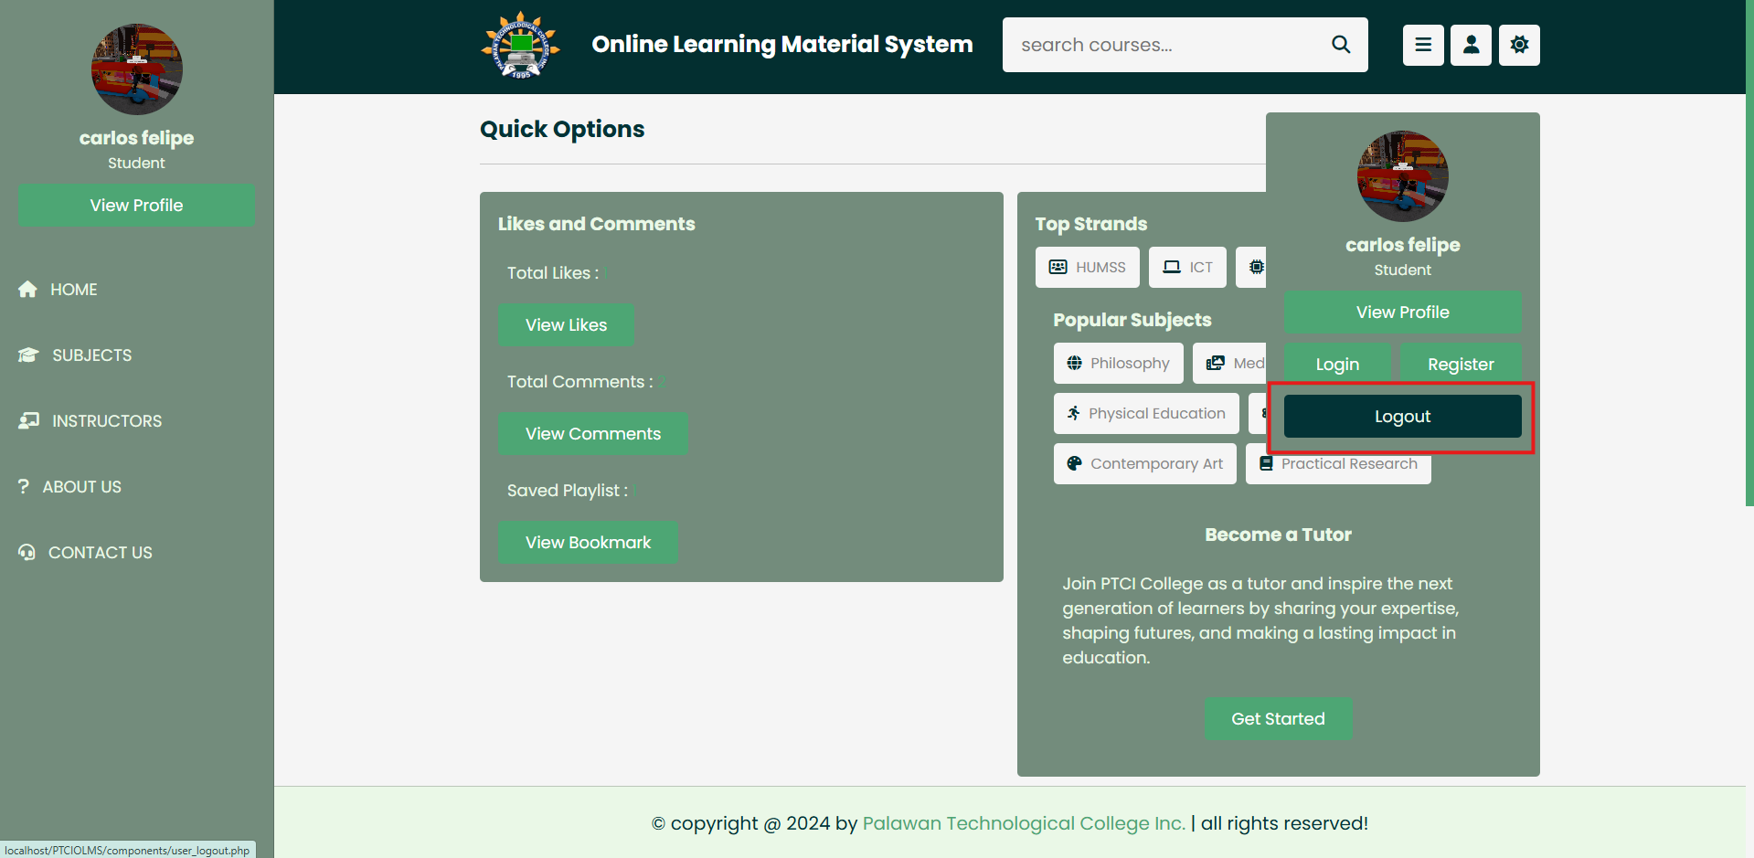

*Figure 1.8* Logout

*Figure 1.8* logging out the system and back again to the homepage where you can log in again.

**RESEARCH DESIGN**

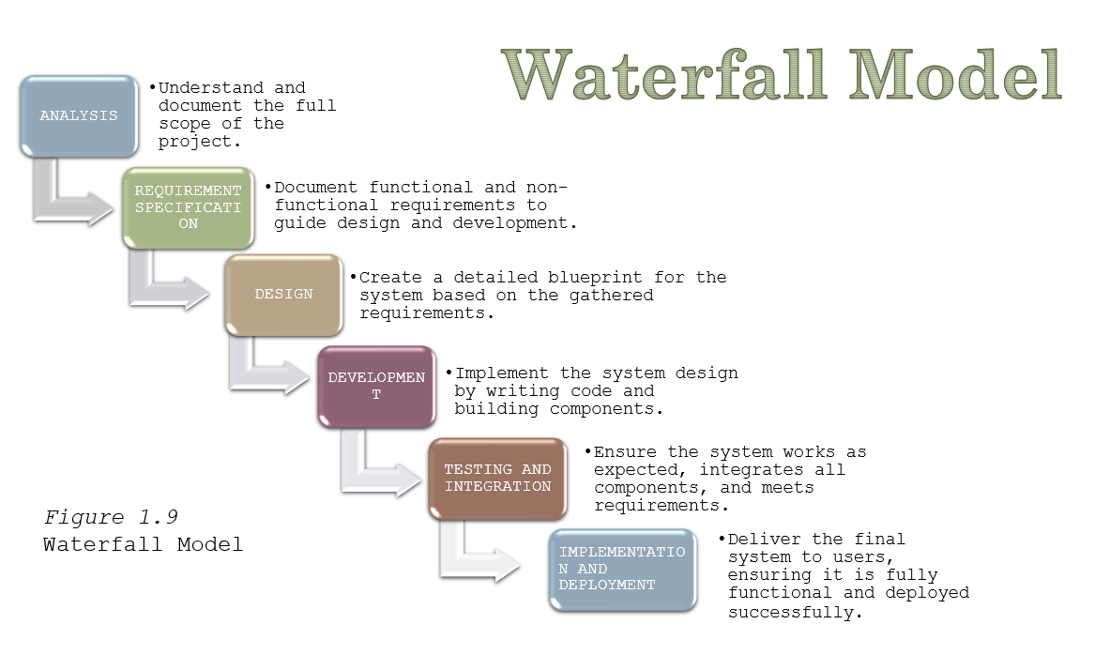

*Figure 1.9* The **Waterfall Model** is a traditional, structured approach that can be very effective for projects where requirements are clear and changes are minimal. However, its inflexibility can be a drawback when dealing with dynamic, evolving projects. Understanding when and how to apply this methodology can help ensure that projects are managed efficiently and successfully.

**DESCRIPTIVE RESEARCH**

The creation , application, and assessment of online learning resources specifically designed for Palawan Technological College Inc.(PTCI) Senior High School students are the main topics of this descriptive study . The attempts to solve educational difficulties , improve teaching practices at the school , and offer a thorough knowledge of how this digital tools affect the learning experience.

**QUALITATIVE RESEARCH**

The usage of online learning resources for Senior High School is examined in this qualitative study via the perspectives, experiences, and insights of teachers and students at Palawan Technological College Inc. (PTCI). With a comprehensive knowledge of how these digital tools affect teaching and learning within the particular setting of the institution, the research seeks to capture the breadth and depth of their lived experiences.

**USER INTEFACE DESIGN**

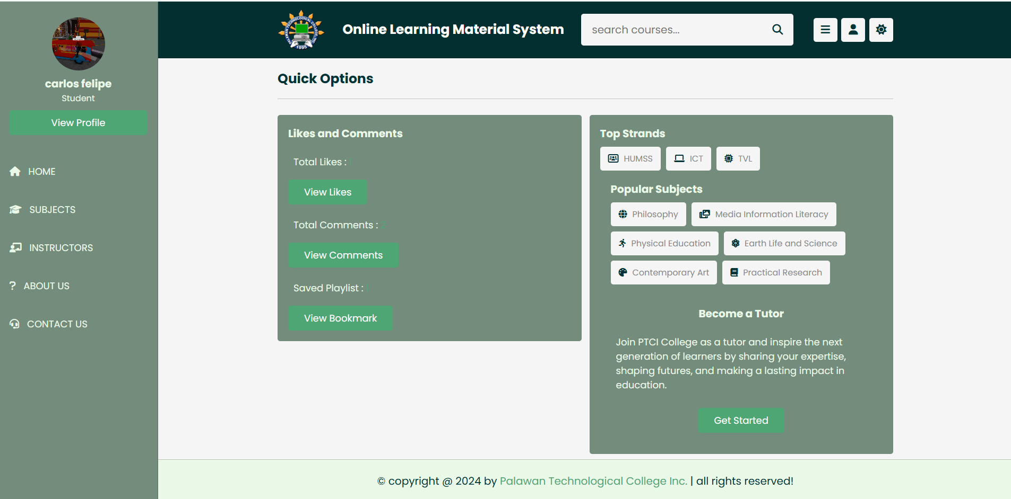

In order to meet the demands of senior high school students and teachers at Palawan Technological College Inc., the online learning system's User Interface (UI) design attempts to provide an easy-to-use, entertaining, and accessible platform. Because usability is given top priority in the design, users with different levels of technical skill may engage and traverse the system with ease.

**SYSTEM DATA FILES**

This is a thorough overview of every data file that might be included in a online learning material system.

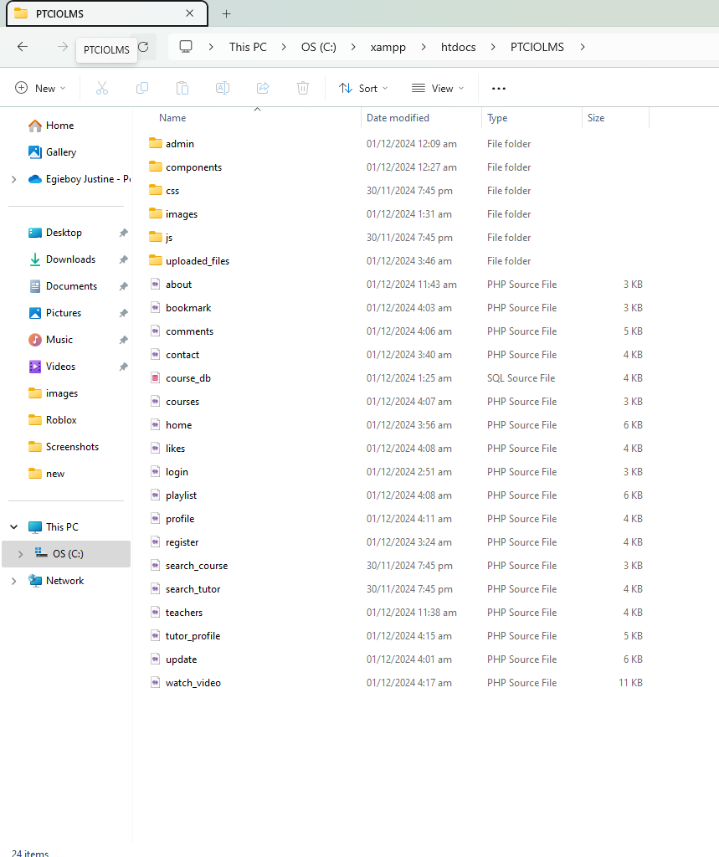

**DESIGN SPECIFICATIONS**

The PTCI Online Learning Management System (OLMS) is designed to support the academic needs of Senior High School students and educators at Palawan Technological College Inc. (PTCI). The system is built to provide an intuitive and engaging online learning experience while enabling educators to effectively manage courses, assignments, and student progress.