RC Car Project
Aiden McBride, Henry Haight, Will Simmons
September 2026 - TBD
Learning Objectives:

- Learn PCB design
- Programming Arduino
- Soldering
- 3D Modeling
- Learning Radio Frequencies
- Learn AI

What needs to be done:

- Program
- Design Circuit
- Choose parts
- Assemble Circuit
- Assemble Car

What are some features we can add?
- Screen on controller to change modes/keep track of things (i.e points)
- A sensor to allow the car to interact with the outside world (i.e finish line)
- A finish line
- Different game modes (think Mario Kart)

Research using ChaptGPT OpenAI:
Q: What kinds of boards should we use for our project?
A: There is a huge list of types of boards we can use. With the idea of a more compact design that allows for simple quick changes to the body of the car and limited connections an Arduino Nano should be good. Upon further research, there has been a developed Nano board with an RF chip integrated into its systems which can shrink the overall size of our electronics but at a higher price. Depending on what we want to do with the controller, such as an LCD screen, we may need to upgrade it to a more advanced board.
Q: How should we deal with differential gear?
A: We can completely avoid it using two motors instead of one to power each wheel separately. We also can go with just 2-wheel drive.
Q: How should we power the RC car?
A: We have some options. This involves using Lithium batteries (which require proper charging and care) or using AA/AAA batteries, which are safer and easier. We should also power the motors through the batteries and not the 5v pin on the Arduino to avoid interference when it turns on and off and the lack of current needed.
Q: How do we control the motor speeds?
A: Use PWM to control the motor speeds through a dual H-bridge motor driver. Chat recommends the DRV8833 because it's compact for small DC motors. This allows us to have the motors separate and use the Arduino to only control how much power the motors get.
Q: How should we use a servo for controlling the direction of the car?
A: We would only use the motors at the same speed and use the servo that is attached to a steering linkage. We would avoid using all 180 degrees. Using to much will cause strain and cause the servo to draw more current. Chat recommends connecting it to a regulated 5-6v.
Q: What kind of sensor should we add to detect a finish?
A: Chat suggests that we use an IR sensor because it can be used in many forms to detect if a car finishes a race. Since we want our car to do other things, it suggests we use it on the car itself.
Q: What kind of screen should we use for the controller?
A: We should use the I2C LCD, which only needs four pins to control it. This would be ideal to allow us to stick with an Arduino Nano.
Q: How should we use the nRF24L01 in our design
A: When we connect it to the Arduino Nano, we need to make sure we add a capacitor to prevent it from receiving interference from the servo and motors. We also need to make sure it's connected to the 3.3V pin and D13-D11. We can use a Struct to create a package to send to the car and for the car to receive.
Current Part List:
Car  - 1 Arduino Nano  - 1 nRF24L01  - 2 motors  - 1 Servo  - 1 IR Sensor  - Motor Driver (H-Bridge)  - 1 5v Voltage Regulator | Controller  - 1 Arduino Nano  - 1 nRF24L01  - 1 L2C LCD  - 1 Joystick  - 4 Buttons  - 1 5V Voltage Regulator

Circuit design/Picking Items
With a quick Google search and by following this blog (In-Depth: Control DC Motors with L293D Motor Driver IC & Arduino), this is how we use an H-bridge to control two motors. Here is the pinout of the suggested DRV8833, which should use a similar method to power the motors in our RC car circuit. This blog shows how to use the DRV8833 with a double motor setup Controlling DC Motors with DRV8833 Motor Driver and Arduino
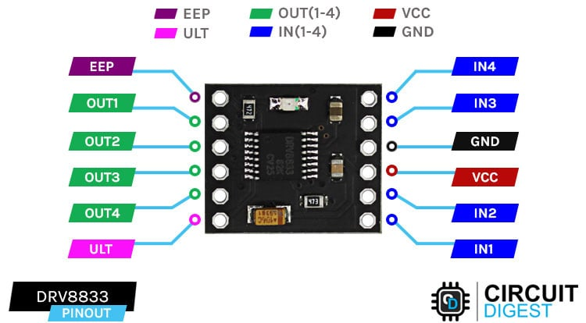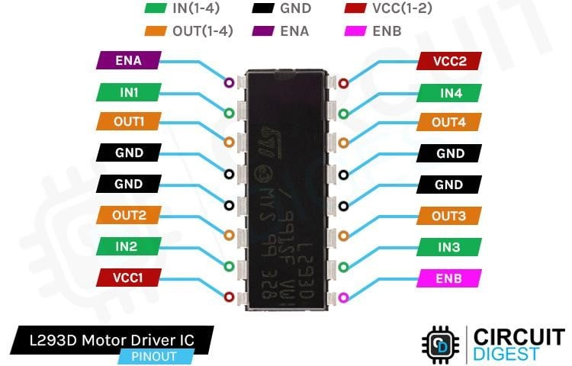
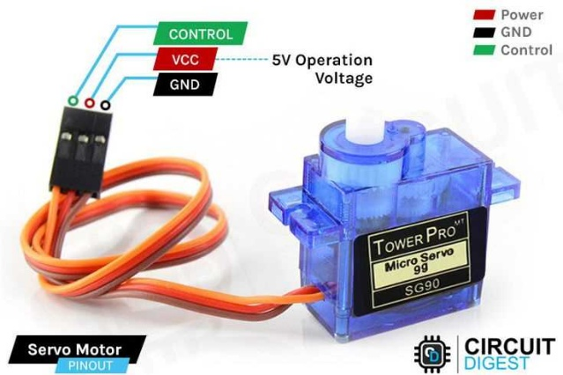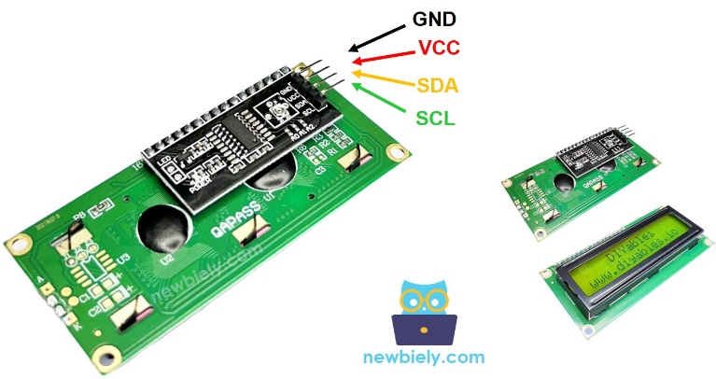
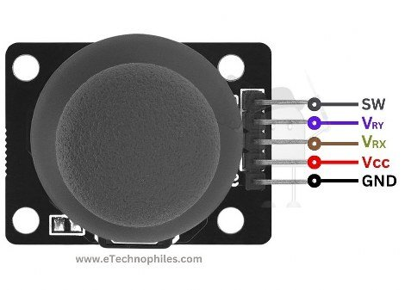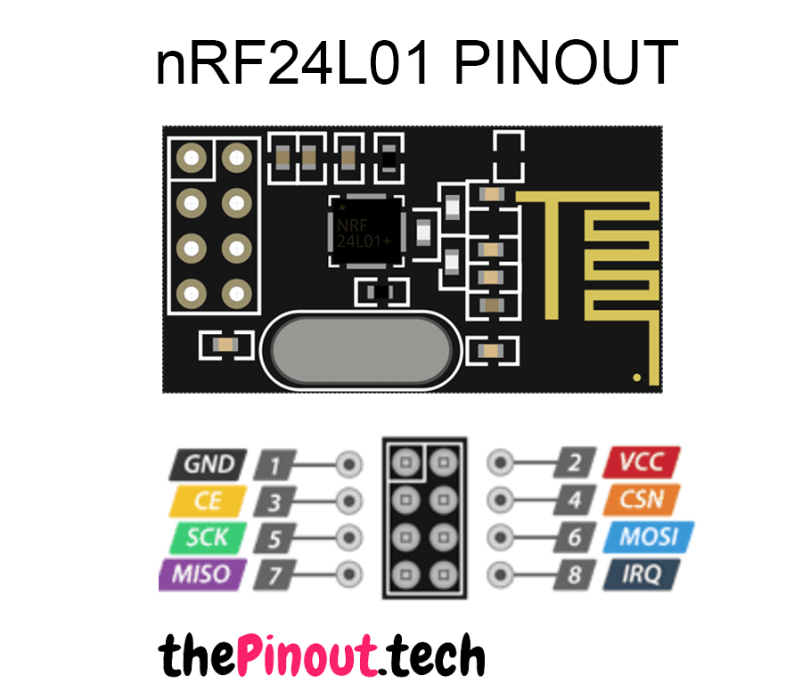
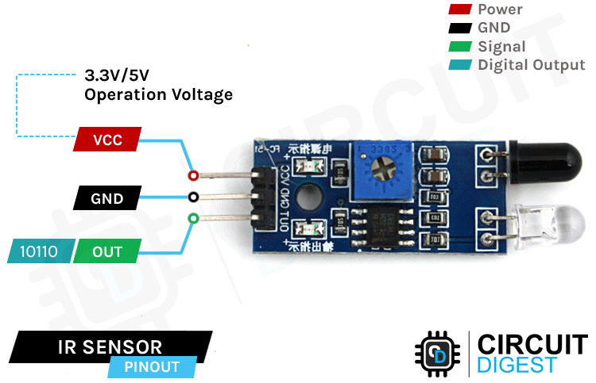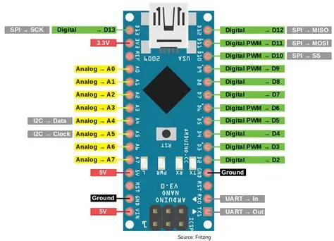

Pin Connections (Arduino)
VIN | 5v Regulator | VIN | 5v Regulator
GND | GND | GND | GND
3.3V | nRF24l01 VCC | 3.3V | nRF24l01 VCC
D13 | nRF24l01 SCK | D13 | nRF24l01 SCK
D12 | nRF24l01 MISO | D12 | nRF24l01 MISO
D11 | nRF24l01 MOSI | D11 | nRF24l01 MOSI
D10 | Right Motor INPUT 1 | D10 | Button 1
D9 | Right Motor INPUT 2 | D9 | Button 2
D8 | nRF24l01 CSN | D8 | nRF24l01 CSN
D7 | nRF24l01 CE | D7 | nRF24l01 CE
D6 | Servo Instructions
D5 | Right Motor PWM Speed | D5 | L2C LCD SDA
D4 | IR Sensor INPUT | D4 | L2C LCD SCL
D3 | Left Motor PWM Speed | D3 | Button 3
D2 | Left Motor INPUT 3 | D2 | Button 4
D1 | Left Motor INPUT 4 | D1 | Joystick button SW
 |  | A1 | Joystick VRY
 |  | A2 | Joystick VRX

Starting
Since we want to know how everything will work together and be able to better tie everything together, we have bought the components we believe we will need and will test them separately and then together. We are going to start with the controller because we believe that it will be easier to set up, and we can find a solution to powering it more easily and better before moving to the more power-dependent build of the RC car.

