算法作业：石块切割

张富威 22920162204078

2018/3/12

Table of Contents

# 1. 问题描述

石材切割问题 给定一块长为L,宽度为W的石板。现需要从板上分别切割出n个长度为li，宽度为wi的石砖。切割的规则是石砖的长度方向与石板的长度方向保持一致，同时满足一刀切的约束。问如何切割使得所使用的石材利用率最高？ 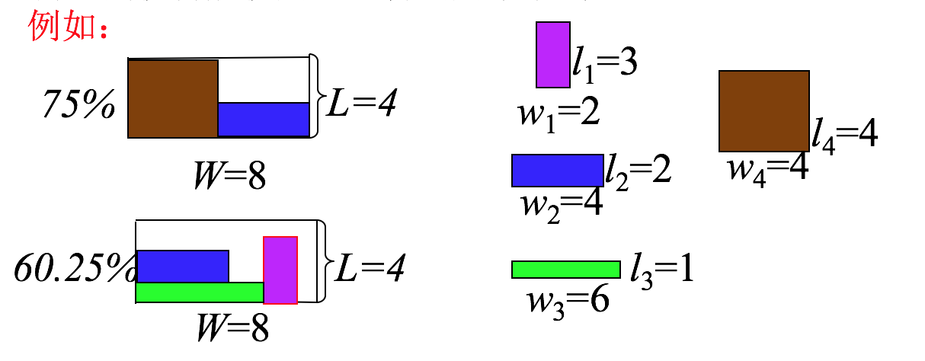

# 2. 算法分析

## 2.1 算法基本思想

算法主要运用递归的思想，从最初的一块大石块，一刀切成两个石块，这样就把问题分解成两个比较简单的问题，在把这两个石块继续往下切，直到找到符合规格的石块，并且计算出使用率，如果使用率更大，则存储答案的数据结构就要进行更新，在不考虑石块翻转的情况下，算法复杂度为{${(4k)}^{n}$}。

## 2.2 算法的优化

如果是要找到绝对最优解，那么必须全部遍历一遍，如果是相对最优解，我们可以使用启发式算法，先搜索大的方块，因为大的方块能够更快的提高使用率。我们增加一个递归结束条件，就是达到 $90$%就结束递归，这样的话就能以最快的速度找到结果。

## 2.3 数据结构

实验中，我使用的数据结构是一个字典树，大致是这样的一个情况:

result = { 'info':[usage, usedarea, fullarea], 'size':[x1, x2, y1, y1],   
 'nextone':{  
 'info':[usage, usedarea, fullarea], 'size':[x1, x2, y1, y1],   
 'nextone':{......},'nexttwo':{......}  
 }, 'nexttwo':{  
 'info':[usage, usedarea, fullarea], 'size':[x1, x2, y1, y1],   
 'nextone':{......},'nexttwo':{......}  
 }  
 }  
 info: 一个列表，包括使用率，使用面积和总面积。  
 size: 分别是石块四个端点的坐标。  
 nextone: 一刀切下去之后，两个石块中的一块  
 nexttwo: 两个石块的另一块

这是一个树状结构，每个大的石块包含两个小的石块的信息。

# 3. 代码实现

## 3.1编程语言

本题使用python实现，虽然时间上肯定比C慢，但是更容易实现，也便于使用matplotlib库和numpy库画出分割之后的结果。

# 4. 代码

## 4.1 python代码

# coding:utf-8  
import matplotlib as mpl  
import matplotlib.pyplot as plt  
import numpy as np  
import time  
class Brick():  
 '''  
 brick_list saves the length and width of all the bricks as a dictionary.   
 example:  
 d = {1:[4, 6], 2:[3,2], 3:[1,1]}   
 there are three types of bricks, as the length and width in d[1],   
 d[2], d[3]raw_material saves the length and width of the raw material as a list  
 example:  
 [100, 100] the length and width of the raw material is 100 and 100  
 bricknums is the sum types of the bricks  
 result save the max usage plan  
 example:  
 dic = { 'info':[usage, usedarea, fullarea], 'size':[x1, x2, y1, y1],   
 'nextone':{  
 'info':[usage, usedarea, fullarea], 'size':[x1, x2, y1, y1],   
 'nextone':{......},'nexttwo':{......}  
 }, 'nexttwo':{  
 'info':[usage, usedarea, fullarea], 'size':[x1, x2, y1, y1],   
 'nextone':{......},'nexttwo':{......}  
 }  
 }  
 info: usage is use ratio of the bricks,   
 usearea is area of the useful bricks, fullarea   
 is calculate by (x2 - x1)*(y2 - y1)  
 size: there are four coordinates ,  
 x1 x2 is the absciass, y1 y2 is the ordinate.  
 nextone: one of the brick cut by knife  
 nexttwo: another brick cut by knife  
 result_point: save the coordinates of all the found bricks  
 example:  
 we find two bricks and the coordinates are   
 [0, 1, 0, 1], [1, 2, 0, 1], .........  
 so the result_point is [[0, 1, 0, 1], [1, 2, 0, 1], [.........]]  
 '''  
 def __init__(self, raw_material, bricknums, brick_list, result, result_point):  
 self.raw_material = raw_material  
 self.bricknums = bricknums  
 self.brick_list = brick_list  
 self.result = result  
 self.result_point = result_point  
 '''  
 inputBrickInfo(): input the infomation of the raw material   
 and all types of the cut-bricks  
 '''  
 def inputBrickInfo(self):  
 leng = 88  
 print leng*'*'  
 self.raw_material = input('请输入原材料的规格（长和宽）:')  
 self.bricknums = input('请输入要切割的砖头种类总数:')  
 for i in range(1, self.bricknums + 1):  
 brick_list[i] = list(input('请输入第 {} 种砖块的规格(长和宽):'.format(i)))  
 '''  
 sortBrickSize(): sort the bricks from large size to small size  
 example:  
 the brick_list is {1:[1, 1], 2:[3, 4], 3:[5, 6]}  
 after finishing this function, we get the brick_list:  
 {1:[5, 6], 2:[3, 4], 3:[1, 1]}  
 '''  
 def sortBrickSize(self):  
 temp_list = ()  
 for i in range(1, self.bricknums + 1):  
 max_area = self.brick_list[i][0] * self.brick_list[i][1]  
 target = 0  
 for j in range(i + 1, self.bricknums + 1):  
 if max_area < self.brick_list[j][0] * self.brick_list[j][1]:  
 target = j  
 max_area = self.brick_list[j][0] * self.brick_list[j][1]  
 if target:  
 self.brick_list[target], self.brick_list[i] = self.brick_list[i],\  
 self.brick_list[target]  
 '''  
 findContentBrick():  
 judge whether the brick now is accored with   
 one of the given bricks in self.brick_list  
 if it contents, the usage change to 1  
 '''  
 def findContentBrick(self, x1, x2, y1, y2):  
 side_length = [x2 - x1, y2 - y1]  
 for i in range(1, self.bricknums + 1):  
 # find it  
 if side_length == self.brick_list[i]:  
 return 1  
 return 0  
 '''  
 calArea(): return the area of the brick  
 '''  
 def calArea(self, x1, x2, y1, y2):  
 return (x2 - x1)*(y2 - y1)  
 '''  
 updateInfo(): update the dict['info'][0] (usage), dict['info'][1] (usedarea)  
 '''  
 def updateInfo(self, usedarea, dict, fullarea):  
 dict['info'][0] = (float)(usedarea) / (float)(fullarea)  
 dict['info'][1] = usedarea  
 '''  
 replaceArrayxy():replace the xy matrix from (x1, y1) to (y1, y2)   
 example:  
 wo got xy [[0, 0],  
 [0, 0]]  
 then replaceArrayxy(xy, 0, 0, 1, 1, 5)  
 we got xy [[5, 5],  
 [5, 5]]  
 '''  
 def replaceArrayxy(self, xy, x1, x2, y1, y2, val):  
 for i in range(x1, x2):  
 for j in range(y1, y2):  
 xy.itemset((j, i), val)  
 '''  
 plotGraph(): using matplotlib and numpy to draw   
 the result of the bricks we just cut  
 '''  
 def plotGraph(self):  
 fig = plt.figure()  
 ax = fig.add_subplot(111)  
 xy = np.zeros([self.raw_material[1], self.raw_material[0]])  
 countlist = {}  
 for i in range(1, len(self.brick_list) + 1):  
 countlist[i] = 0  
 for i in self.result_point:  
 l = [i[1] - i[0], i[3] - i[2]]  
 for j in range(1, len(self.brick_list) + 1):  
 if l == self.brick_list[j]:  
 countlist[j] += 1  
 self.replaceArrayxy(xy, i[0], i[1], i[2], i[3], j)  
 leng = 88  
 print leng*'-'  
 for j in range(1, len(self.brick_list) + 1):  
 print '大小为{0}的石块颜色对应的序号为{1}, 个数为{2}'\  
 .format(self.brick_list[j], j, countlist[j])  
 print '利用率为{0:.2%}, 利用面积为{1}, 原材料总面积为{2}'\  
 .format((float)(self.result['info'][0]), self.result['info'][1]\  
 , self.result['info'][2])  
 print leng*'*'  
 plt.imshow(xy)  
 plt.colorbar()   
 plt.show()  
   
 '''  
 getResult(): get the result_point through dictionary result  
 '''  
 def getResult(self, dict, blank):  
 # print '-'*blank, 'info:', dict['info']  
 # print '-'*blank, 'size', dict['size']  
 # print '*********************************'  
 if dict['nextone']:  
 self.getResult(dict['nextone'], blank + 4)  
 if dict['nexttwo']:  
 self.getResult(dict['nexttwo'], blank + 4)  
 if dict['nextone'] == {} and dict['nexttwo'] == {} and dict['info'][0] == 1:  
 self.result_point.append(dict['size'])  
 '''  
 findOptimalSolution():  
 its function is just like the name it is. through   
 this function, we try all the probability to find the optimal solution  
 '''  
 def findOptimalSolution(self, x1, x2, y1, y2, resdic):  
 resdic['size'] = [x1, x2, y1, y2]  
 resdic['nextone'] = {}  
 resdic['nexttwo'] = {}  
 resdic['info'] = [0, 0, self.calArea(x1, x2, y1, y2)]  
 # judge if it is accorded with one of the given bricks in self.brick_list  
 if self.findContentBrick(x1, x2, y1, y2):  
 resdic['info'] = [1.0, self.calArea(x1, x2, y1, y2), \  
 self.calArea(x1, x2, y1, y2)]   
 return 0  
 for i in range(1, self.bricknums + 1):  
 max = 0  
 '''  
 across cutting  
 '''  
 if x1 + self.brick_list[i][0] < x2:  
 dic1 = {'info':[], 'size':[], 'nextone':{}, 'nexttwo':{}}  
 dic2 = {'info':[], 'size':[], 'nextone':{}, 'nexttwo':{}}  
 self.findOptimalSolution(x1, x1 + self.brick_list[i][0], y1, y2, dic1)  
 self.findOptimalSolution(x1 + self.brick_list[i][0], x2, y1, y2, dic2)  
 # find out a more useful result  
 usedarea = dic1['info'][1] + dic2['info'][1]  
 if usedarea > resdic['info'][1]:  
 self.updateInfo(usedarea, resdic, self.calArea(x1, x2, y1, y2))  
 resdic['nextone'] = dic1  
 resdic['nexttwo'] = dic2  
 '''  
 rip cutting  
 '''  
 if y1 + self.brick_list[i][1] < y2:  
 dic1 = {'info':[], 'size':[], 'nextone':{}, 'nexttwo':{}}  
 dic2 = {'info':[], 'size':[], 'nextone':{}, 'nexttwo':{}}  
 self.findOptimalSolution(x1, x2, y1, y1 + self.brick_list[i][1], dic1)  
 self.findOptimalSolution(x1, x2, y1 + self.brick_list[i][1], y2, dic2)  
 usedarea = dic1['info'][1] + dic2['info'][1]  
 if usedarea > resdic['info'][1]:  
 self.updateInfo(usedarea, resdic, self.calArea(x1, x2, y1, y2))  
 resdic['nextone'] = dic1  
 resdic['nexttwo'] = dic2

执行代码:

if __name__ == '__main__':  
 #initialize the property of the living example  
 raw_material = []  
 brick_list = {}  
 bricknums = 0  
 result = {'info':[], 'size':[], 'nextone':{}, 'nexttwo':{}}  
 result_point = []  
  
 brick = Brick(raw_material, bricknums, brick_list, result, result_point)  
 brick.inputBrickInfo()  
  
 time_start = time.time()  
  
 brick.sortBrickSize()  
 brick.findOptimalSolution(0, brick.raw_material[0], 0, brick.raw_material[1], brick.result)  
 brick.getResult(brick.result, 0)  
 time_end = time.time()  
 print '找到结果'  
 print '用时:{0:.3f}s'.format(time_end - time_start)  
 brick.plotGraph()

# 5. 实验用例以及实验结果

## 5.1 实验用例

### 5.1.1 用例一

**原材料规格:120, 110**

所需要石块的规格:

* 石块一：33,55
* 石块二：27,50
* 石块三：40,60
* 石块四：30,60

结果详见5.2.1

### 5.1.2用例二

**原材料规格:130,140**

所需要石块的规格:

* 石块一：33,44
* 石块二：44,55
* 石块三：55,66
* 石块四：23,56

结果详见5.2.2

### 5.1.3用例三

**原材料规格:130,150**

所需要石块的规格:

* 石块一：29,69
* 石块二：18,34
* 石块三：44,55
* 石块四：67,45

结果详见5.2.3

## 5.2 实验结果

### 5.2.1 用例一结果

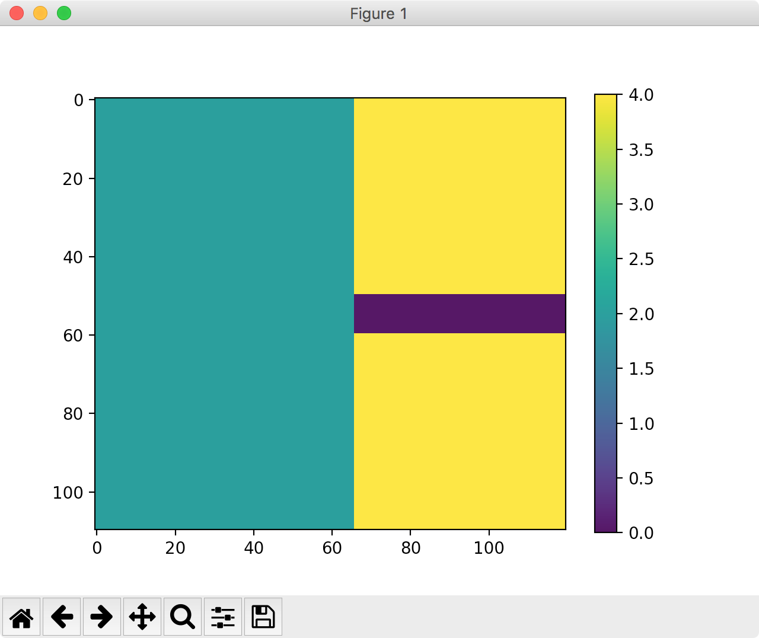 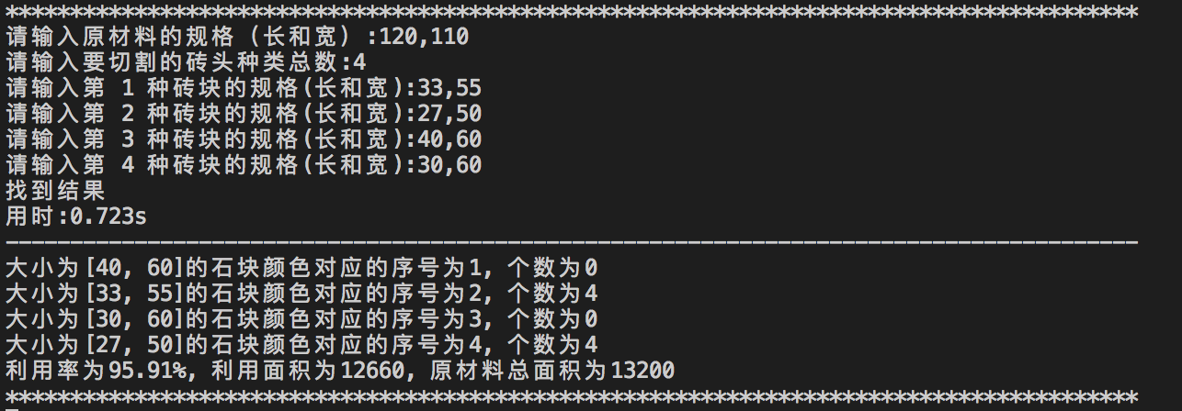

### 5.2.2 用例二结果

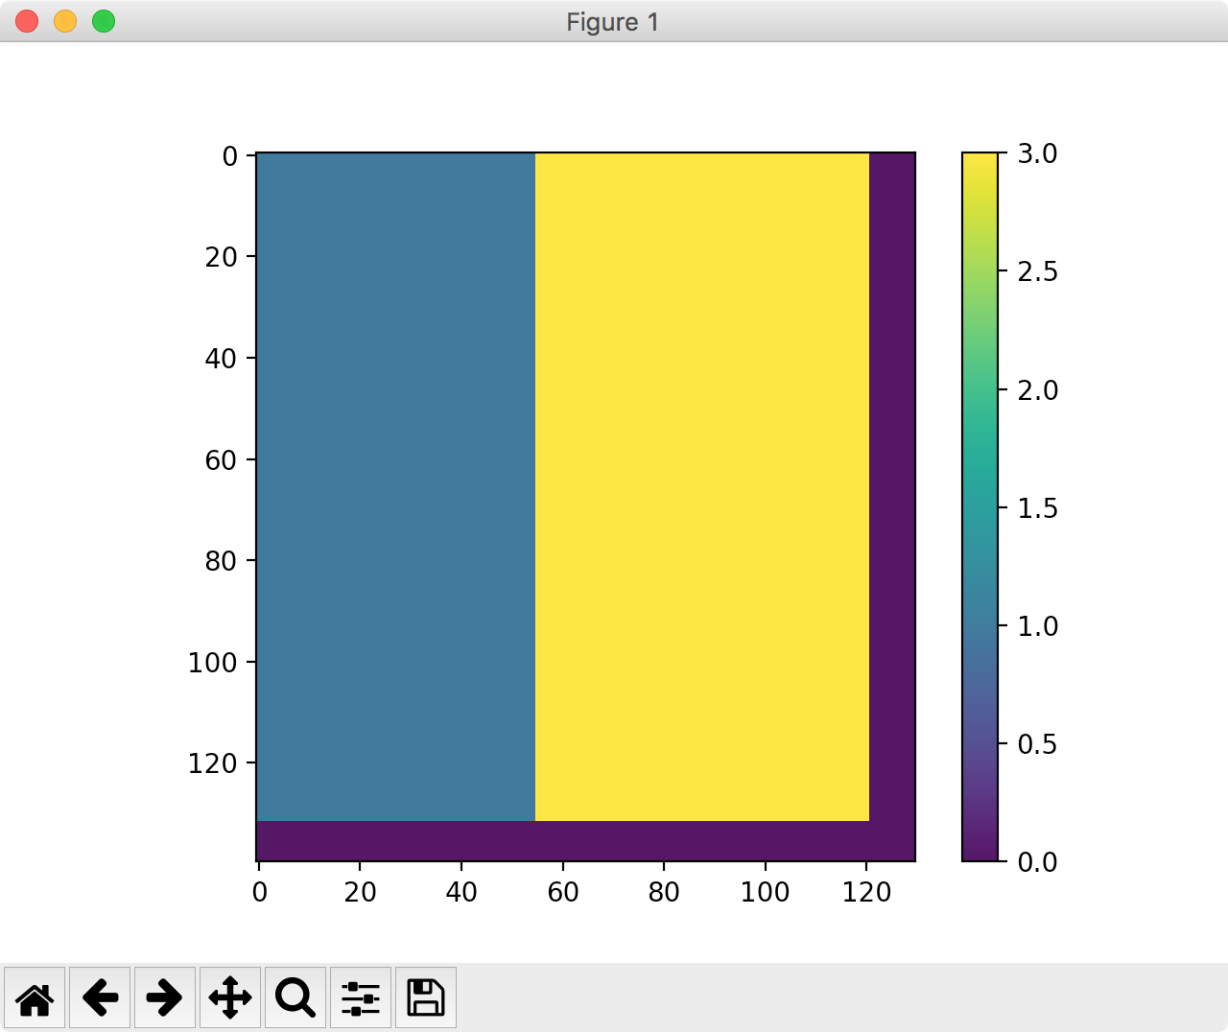 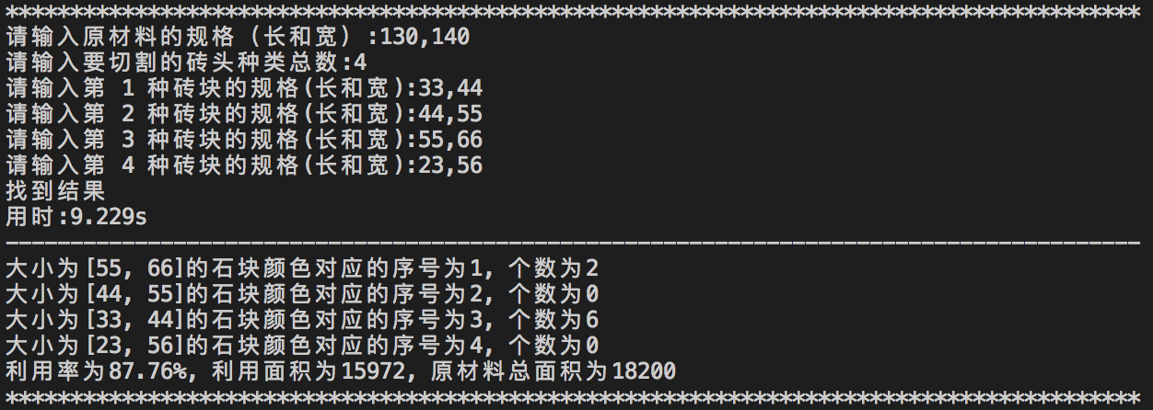

### 5.2.3 用例三结果

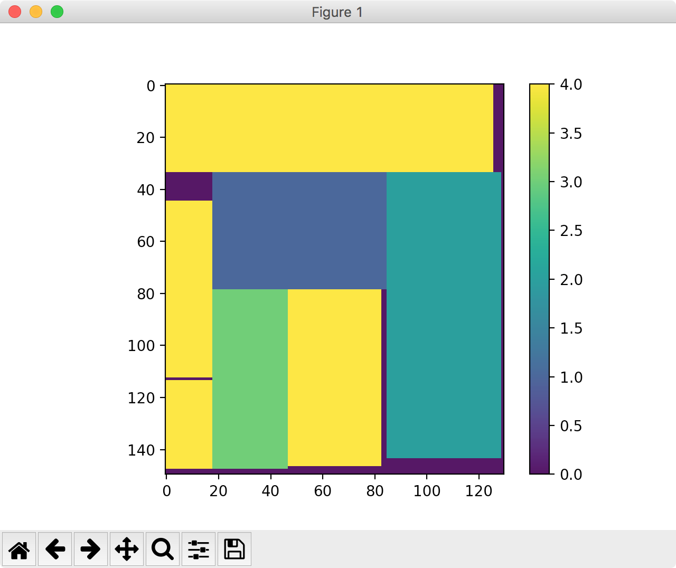 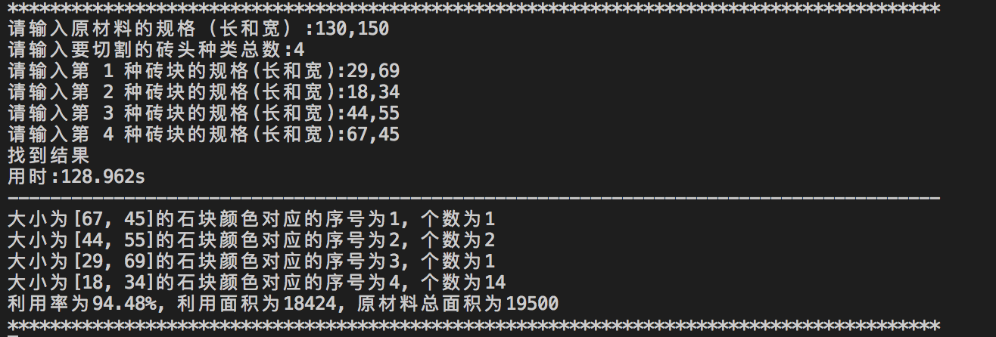

# 6. 实验总结

## 6.1 总结

本次算法实验，考验的是递归的运用，但是递归有一个缺点，就是算法复杂度过大，递归也有好处，就是代码量小，几行代码就能搞定，可以说是有利有弊。如果用启发式算法加上递归结束条件，我觉得代码运行时间会大大缩小，不会像用例三一样花费将近2分钟。

# 7. 参考资料

## 7.1 python库

* numpy
* matplotlib
* time

## 7.2 方法

* python 类，字典，列表等
* 递归
* 实力属性