# Document title

Document subtitle

## Heading 2

### Heading 3

#### Heading 4

##### Heading 5

###### Heading 6

“A block quote.”

- John Smith

Paragraph with a [hyperlink](https://sci.pe/).

Footnote[1]

Endnote[2]

Bookmark

A cross-reference to a Bookmark.

A cross-reference to a footnote1.

A second cross-reference to a footnote1.

A cross-reference to a label (Figure 1).

A cross-reference to a heading: Heading 2.

Full citation (Kilpatrick, 2011).

Citation with author and title suppressed (2011).

Point citation (Kilpatrick, 2011, p. 325).

Commented text Highlights, *Italics*, **Bold**, Underlined, ~~Strikethrough~~

An unordered list:

* Item 1 unordered
* Item 2 unordered

A ordered list:

1. First ordered
2. Second ordered

An unordered, nested list:

* Item 1 unordered, nested
  + Item 2 unordered, nested

An ordered, nested list:

1. First ordered, nested
   1. Second ordered, nested

A mixed, nested list:

1. First
   * Blue
     1. A
     2. B

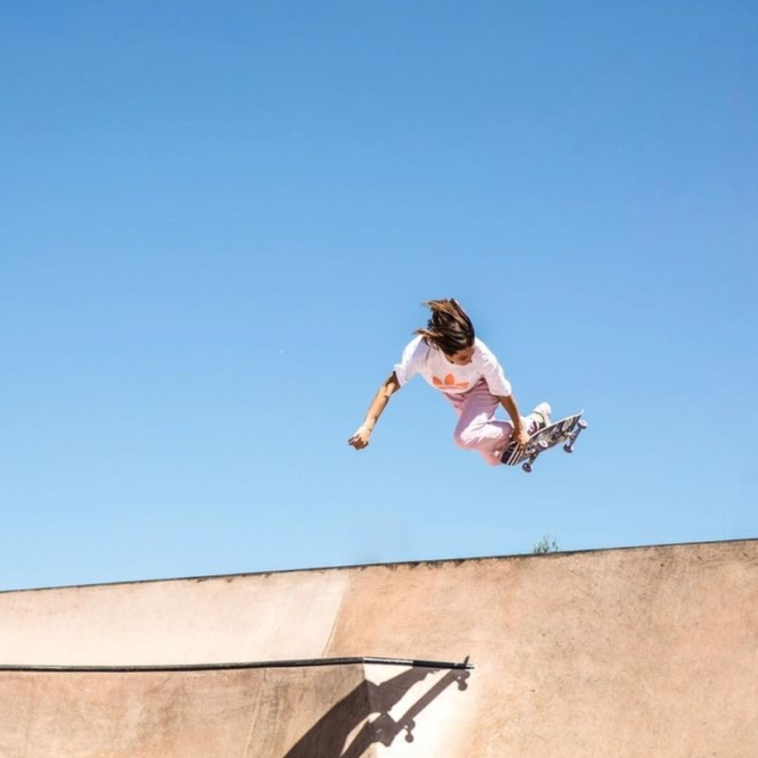



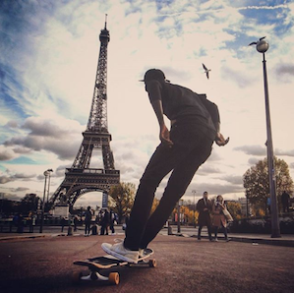

Figure 1 A captioned image.

Figure 2 A multipart figure with caption.

Table 1 A table with images and footnotes.

|  |  |  |  |
| --- | --- | --- | --- |
|  | Header 2 | Header 3 | Total |
| A | Inline image Related image | Image result for chemical structure | Total A |
| B |  | Data[3] | Total B |
| C | Data | Data | Total C |
| Total Row | Total 2 | Total 3 | Total |

Text Box 1 A text box caption.

## Text Box Heading

A text box with only text and a heading.

Text Box 2 A textbox with uncaptioned images.

Inline image 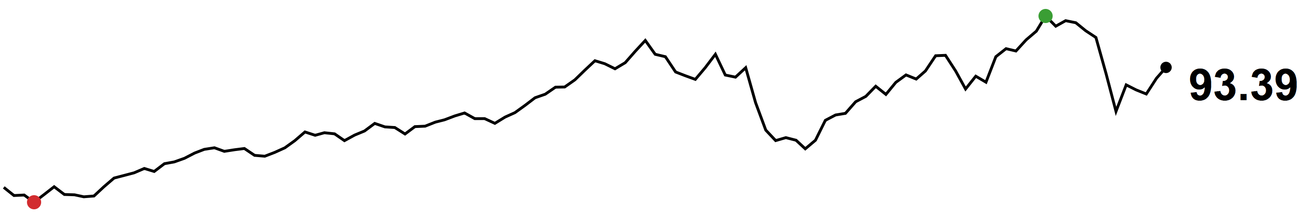



Inline code str.length

# standard tests

x <- runif(100, 0, 10) # 100 draws from U(0,10)

y <- 2 + 3*x + rnorm(100) # beta = [2, 3] and sigma is 1

d <- lm(y ~ x)

summary(d)

Code 1 Code block sample. Programming Language: R.

An inline equation

Equation 1 Binomial theorem.

<https://www.ncbi.nlm.nih.gov/nuccore/NC_012532.1>

Supporting Dataset 1 Genbank.

# References

Kilpatrick, A. M., 2011. Globalization, Land Use, and the Invasion of West Nile Virus. *Science,* 21 October, 334(6054), pp. 323-327.

1. A footnote
2. An endnote
3. Table footnote