# Textbox test

## Introduction

Text Box 1 A textbox with uncaptioned images.

Inline image 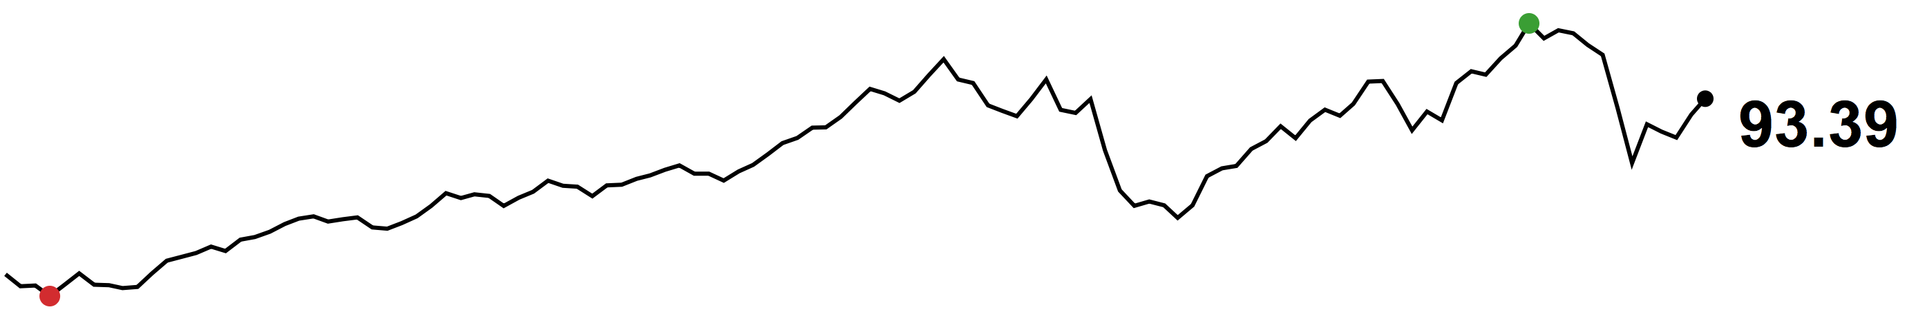



Text Box 1 A textbox with only text

Hello world.