# Uncaptioned image test

## Introduction

Inline image 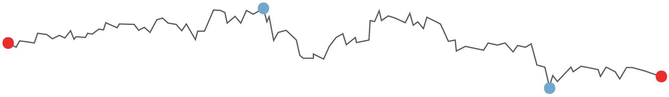

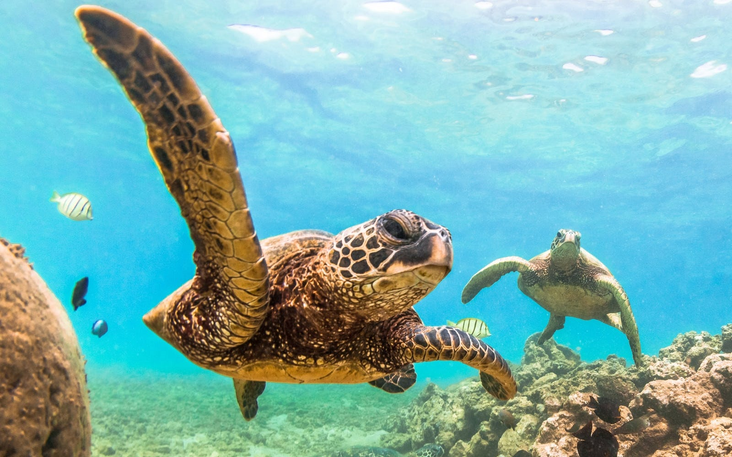

Text Box 1 A textbox with uncaptioned images.

Inline image 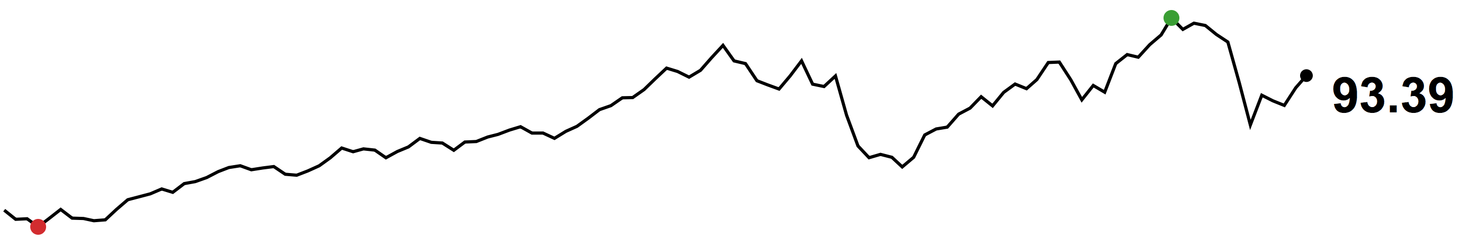



Table 1 A table with uncaptioned images.

|  |  |
| --- | --- |
| Table header 1 | Table header 2 |
| Inline image Related image |  |