
Instruction Manual
for
Quantitative Microbial
Risk Assessment (QMRA)

3rd QMRA Summer Institute,
Michigan State University, East Lansing, Michigan
August 10 – 15, 2008

Joan B. Rose, Charles N. Haas,
Patrick L. Gurian, and James S. Koopman

Center for Advancing Microbial Risk Assessment

Instruction Manual for Quantitative Microbial Risk Assessment (QMRA)

Joan B. Rose, Charles N. Haas, Patrick Gurian and James Koopman

Center for Advancing Microbial Risk Assessment
301 Manly Miles Bldg, 1405 South Harrison Rd, East Lansing, MI 48823

August 1, 2008
Acknowledgements
Instruction Manual for Quantitative Microbial Risk Assessment (QMRA) was prepared for 3rd QMRA Summer Institute, August 10-15, 2008, hosted by the Center for Advancing Microbial Risk Assessment (CAMRA).

CAMRA is co-funded by the U.S. Environmental Protection Agency and the Department of Homeland Security. We are very grateful to the U.S. Department of Homeland Security for additional funding for the 3rd QMRA Summer Institute.

We are deeply appreciated those who assisted for the 3rd QMRA Summer Institute. Dr. Erin Dreelin, Lorie Neuman and Rachel McNinch who prepared and organized all the logistics. Sangeetha Srinivasan, Rebecca Ives and Marc Verhougstraete who provided transportation for the participants. Dr. Gertjan Medema who mentored a group study. In addition Mr. Mark Weir from Drexel University assisted in the mentoring and lecturing.

Authors

Joan B. Rose, Ph.D.
Co-Director of CAMRA, Homer Nowlin Chair in Water Research, Michigan State University,
E-mail: rosejo@msu.edu

Charles N. Haas, Ph.D.
Co-Director of CAMRA, L.D. Betz Chair Professor of Environmental Engineering, Drexel University,
E-mail: haas@drexel.edu

Patrick L. Gurian, Ph.D.,
Co-PI of CAMRA, Assistant Professor, Drexel University
E-mail: plg28@drexel.edu

James S. Koopman, MD., MPH.
Co-PI of CAMRA, Professor, University of Michigan,
E-mail: jkoopman@umich.edu

[AND Tomoyuki Shibata, Ph.D., MSc.
Research Associate, University of Miami]
Table of Contents

Chapter 1 | Quantitative Microbial Risk Assessment Frameworks
Chapter 2 | Measuring Microbes
Chapter 3 | Statistics and Uncertainty
Chapter 4 | Animal and Human Studies for Dose-Response
Chapter 5 | Dose-Response
Chapter 6 | Introduction to Exposure Assessment
Chapter 7 | Transport Phenomena of Biological and Chemical Agents in Water Distribution Systems
Chapter 8 | Fate and Transport Modes: Indoor/Fomites
Chapter 9 | Introduction to Deterministic Computer Modeling: The Case of Linear Disease Risk
Chapter 10 | QMRA Infection Transmission Modeling
Chapter 11 | Risk Perception, Risk Communication, and Risk Management

Chapter 1

Quantitative Microbial Risk Assessment Frameworks

Joan B. Rose

Goal
This chapter will provide an overview of the various frameworks that have been used for risk assessment (RA) and particularly for microbial risk assessment (MRA). A brief history of the developments and advancements will assist in understanding the terminology used to describe MRA and the definitions which have been evolved from other disciplines. The framework provides a structure for taking data from a variety of sources (including information from models) and integrating them in such a way that one could begin to articulate and quantify a complex problem.

Definition
There are many terms used by the medical community and by the news to describe the disease status. These are often confusing. Thus one goal may be to harmonize the terms with a clear understanding of the meanings to improve communications. Address the terms Infection, Disease, Dose, Contagion and Exposure and how these might differ within the QRA community and the medical community.

Exposure: In the risk assessment modeling world this means that the individual actually received some dose; HOWEVER in the real-world situation it means that the individual was exposed to the source of the contaminant (not knowing if they really received a dose or not, e.g. exposed to the swimming pool); in the medical world one may look to see if there is evidence of exposure from some clinical test (antibody response or identification of a biomarker or the biological agent itself).

Infection: In the modeling world this means that the microorganism has been able to begin it’s replication in the host, this is measurable in experiments by antibody response or identification of the biological agent at the site of replication (SEE EXPOSURE ABOVE FOR MEDICAL); in the real-world many use infection to be synonymous with disease (impairment of the persons health status or impairment of some function); in the medical world Contagion: in the modeling world, one can estimate the probability of transmission of the microorganism from the one person who is infected to a susceptible individual based on exposure scenarios and the characteristics of the microorganism, estimates of very low risks can be made: 1 in million (10 ⁻⁶ ) or 1 in 10 million
(10 ⁻⁷ ), or 1 in a billion (10 ⁻⁹ ); in the real-world and medical world very high levels of disease transmission can be evaluated through investigations (1 in 10; 1/100) but generally this is addressed as YES or NO without quantification of probability.

Risk Assessment: The qualitative or quantitative characterization and estimation of potential adverse health effects associated with exposure of individuals or populations to hazards (materials or situations, physical, chemical and or microbial agents.)

Risk management: The process for controlling risks, weighing alternatives, selecting appropriate action, taking into account risk assessment, values, engineering, economics, legal and political issues.

Risk communication: The communication of risks to managers, stakeholders, public officials, and the public, includes public perception and ability to exchange scientific information.

Risk
Risk in most people’s minds is related to some type of harmful event and in fact the assessment of that risk is done a priori in order to determine a way to avoid or reduce the chance of harm occurring (Table 1.1). Thus in the simplest terms this is defined as:

risk =exposure* hazard (1.1)

But in reality this is described as a probability that is what is the chance of exposure to some hazard and if exposed what is the consequence (or how severe is the harm). Time is an element of risk as well, how often is one exposed for how long, as well as who is exposed as this will influence the outcome. Thus risk is the likelihood of (identified?) hazards causing harm in exposed populations in a specified time frame including the severity of the consequences. Some hazards are known and better described than others and may be natural hazards or human induced. One can think of many examples of risks and hazards and ways that we assess these and reduce them. Some are individual choices and some are more societal. Some are greater “risks” for special groups of individuals, like children. Some risks are taken or accepted at certain rates or probabilities (eg 1/100 chance) because of associated benefits associated with the activity or because there are ways to help mitigate the problem after the fact.
Table 1.1 Risk reduction strategies
Examples of risks | Risk reduction strategies
Riding in a car and having an accident | Drive the speed limit; wear seat belts; use child seats. Improve safety features of cars.  Improve roads and key interchanges etc.
Crossing the street and being hit by a car | Use cross-walks, look both ways, install a light or stop sign; install pedestrian overpass.
Second hand smoking and cancer | Ban smoking in public places.
Bridges collapsing | Have inspections, maintenance and repair programs
Hurricanes, infrastructure damage, life lost, illness, stress. | Provide Early warning. Avoid building in susceptible areas. Develop disaster preparedness plans.
Medicines and side effects | Have appropriate testing prior to market. Take only medicines prescribed. Be sure there is consumer awareness of potential side effects.

Microorganisms and Disease Risks
Advances in medicine and microbiology have formed the basis of disease and the understanding of infectious disease risks (Beck, 2004). Ancient medicine addressed diagnosis of illness via the description of symptoms and the first recorded what was described as an epidemic (large numbers of individuals ill at the same place during a similar time period) which took place in ca. 3180 B.C. in Egypt. Early diseases were eluded to as “epidemic fevers” the term written in a papyrus ca. 1500 B.C. discovered in a tomb in Thebes, Egypt. Early in the history of medicine it was proposed that bad air, putrid waters, and crowding were all associated with disease and it was recognized that these maladies were contagious (spread from one ill person to another). “Plagues” were described and in particular associated with the decimation of the Greek Army near the end of the Trojan War (ca. 1190 B.C.) with massive epidemics described in Roman history in 790, 710 and 640 B.C. (Sherman, 2006) One of the best described plagues occurred in Athens in 430 BC. What appeared to be dysentery epidemics (enteric fevers) were described in 580 AD. However, it was not until the 1500-1700s that advances first in microbiology lead the way for discoveries in medicine which solidified the idea of bacteria and led to the “germ theory”, pathogen discovery and the understanding of disease transmission.

The germ theory had been suggested in 1546 by Girolomo Fracastoro ( publishing De contagione). and while infectious diseases were being described it was not until the microscope was invented in 1590 and refined in 1668 that parasites and then bacteria were first seen in 1676 and then fully described in 1773 by Otto Frederik Muller (likely describing Vibrio ). The “germ theory” was further solidified in 1840 and nine years later John Snow was able to show that Cholera was transmitted through water (1849). Yet the translation of this knowledge to other organisms was slow. It was not until 1856 that it was suggested that Typhoid fever was spread by feces and by then a scientific method to identify “contagious agents” using Robert Koch theories (1876) moved the study of cause-and-effect forward. A significant microbiological advancement was the invent of the culture technique using salts and yeast in 1872 and then a plating technique in 1881 using gelatin. Robert Koch not only addressed these plating techniques, but brought into microbiological practice the use of sterilization (what is now known as the autoclave) Gram stains came along and the Escherchia coli was isolated from feces (1884 and 1885, respectively) but it took 25 more years for the “coliform” to make it’s way into water and health issues to address fecal contamination (1910). In that same time period (1884), Koch isolated a pure culture of Vibrio and Georg Gaffky isolated the typhoid bacillus.

Epidemiology the study of the spread of disease in populations was a scientific method for addressing microbial risk assessment and Dr. John Snow is credited as the father of epidemiology .A major turning point in protection of community health and prevention of epidemics came in the mid-19th century. During an epidemic of cholera which had broken out in India in 1846, John Snow observed that cholera was transmitted through drinking water. He was then able to test his theory using one of the first engineering controls, by simply removing handle from a water pump, which he suspected as the cause of the outbreak in a district in London.

Thus it was the convergence of engineering, medicine, epidemiology, and public health that led to an improved understanding of the risks of infectious microbial agents (or Pathogens: those microorganisms that cause illness and disease) and infection transmission models for describing how disease spreads in populations began to develop (See Chapter 10). In addition, in the early development of vaccines and establishment of Koch’s postulates for example for new pathogens like Giardia, human dosing studies were undertaken, where by different groups of volunteers were given different doses (from the 1930s to 1990s) and the disease or infection outcome was monitored, thus dose-response data were obtained. Currently strict ethics rules apply to any type of study using humans for these types of studies.

Epidemiological methods continued to examine disease risks and during outbreaks (more than 1 person ill from a common exposure at a similar time; eg foodborne, waterborne, nursing home; daycare outbreaks) attack rates (ratio of those ill/those exposed) would be related to some exposure and dose to attempt to show a relationship (eg. those individuals that had 3 servings of potato salad had higher attack rates than those who had 1 serving). In prospective studies for example for swimming in polluted waters, Stevenson in 1957 determined that there was a relationship between the amount of pollution as measured by fecal indicator bacteria in the water and the disease rate in swimmers. Thus this also established dose-response data which could be mathematically fitted and modeled.

Quantitative Risk Assessment Frameworks
Formal quantitative risk frameworks were first developed and described as nations industrialized, and in the US, in particular the role of chemicals in the environment causing harm such as DDT, PCBs, and lead in the 1960s created a need to assess environmental pollution risks and approaches for it’s control. The National Academy of Sciences developed a risk framework that was published in the famous “Red Book” that would go on to form the basis of scientific assessment and regulatory strategies for environmental pollutants (Table 1.2). This was an approach to mathematically (through modeling using dose-response relationships) estimate the probability of an adverse outcome.

Table 1.2 NAS Framework for QRA
QRA four steps | Types of information used for pathogens
Hazard Identification | Description of the microorganisms and disease end-points, severity and death rates
Dose-Response | Human feeding studies, clinical studies, less  virulent microbes, vaccines and healthy adults
Exposure | Monitoring data, indicators and modeling used to address exposure. Epidemiological data.
Risk Characterization | Description of the magnitude of the risk, the uncertainty and variability.

These QRAs were then used for management decision and addressing other issues including risk communication, which formed the larger arena of “Risk Analysis”.

QMRA: Quantitative Microbial Risk Assessment
It was recognized early on that the risks and the assessment of the risks associated with microorganisms (pathogens) were very different from chemicals. Epidemiological methods had been used but were limited by sensitivity (in most cases large numbers of people were needed in any given study and the methods could usually only examine risks on the order of 1/1000). Epidemiological studies were poor at addressing quantitatively the exposures. Microbes also can change dramatically in concentrations (grow or die-off), the methods for their destruction or control are in place (disinfection and vaccinations) and they are contagious for the most part, so that one exposure can lead to a cascading effect. Pathogens change genetically (e.g. E.coli and emergence of pathogenic E.coli) and there are new pathogens being discovered (Bird Influenza). Some pathogens are transmitted by many routes (air, food, water, hands) and some are restricted to certain modes of transmission (e.g. Dengue virus being mosquito-borne; tuberculosis, respiratory person-to-person transmission).

The four steps included the following:
- Hazard Identification – To describe acute and chronic human health effects; sensitive populations, immunological response for specific pathogens.
- Dose-Response – To characterize the relationship between various doses administered and subsequent health effects; human data sets are available.
- Exposure Assessment – To determine the size and nature of the population exposed and the route, amount, and duration of exposure. Temporal and spatial exposure with changes in microbial populations a concern.
- Risk Characterization – To integrate the information from exposure, dose response, and health steps to estimate magnitude of health risks. Monte Carlo analysis is used to give distribution of risks and infection transmission models are used to address community risks.

The International Life Sciences Institute (ILSI), working with the U.S. Environmental Protection Agency (EPA), developed a framework that was more specific to addressing microbial risks and moved toward new concepts of risk assessment where by the problem and management were integral to the risk process (Figure 1.1).

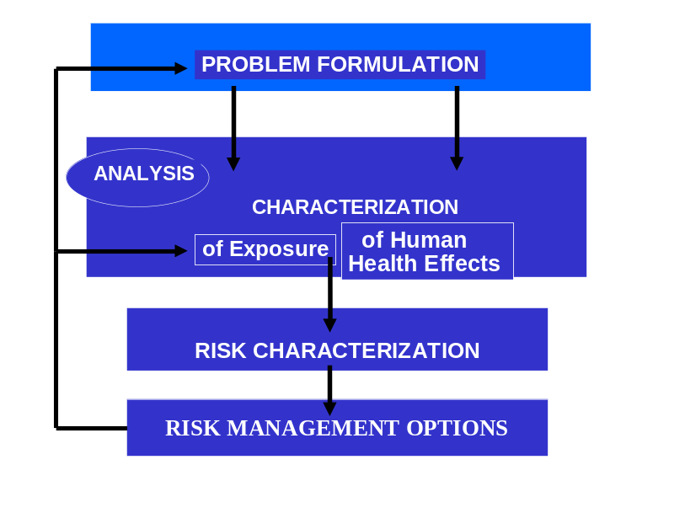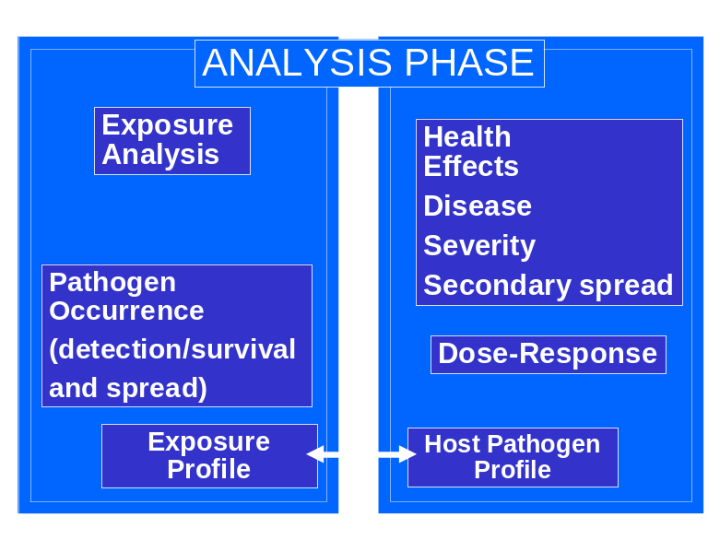
Figure 1.1 ILSI QMRA frame work
The goal for QMRA then is to start with a problem formulation and gather information on the hazards, dose-response models and tie that to the possible exposures over time, in order to address risk characterization not only to individuals but to communities and populations..

For the Hazards we need to need to describe in more detail the microbe, and quantitatively the disease symptoms and severity, particularly in sensitive populations, like the elderly or children.
- Engage the medical community to obtain data
- Address epidemiological data
- Mandate better Outbreak investigations
- Undertake Pathogen Discovery (application of new technologies for genetic characterization)

Bacteria, parasites and viruses may cause a wide range of acute and chronic diseases as well as death (Table 1.3).

Table 1.3 Microorganisms and outcomes of exposures
Microorganisms | Acute disease | Chronic disease
Campylobacter | Diarrhea | Gullain-Barre’ syndrome
E. Coli 015H7 | Diarrhea | Hemolytic uremic syndrome
Helicobacter | Gastritis | Ulcers and stomach cancer
Salmonella,  Shigella, & Yersinia | Diarrhea | Reactive arthrititis
Coxsackievirus B  Adenoviruses | Encephalitis, aseptic Meningitis, diarrhea, respiratory disease | Diabetes  Myocarditis  Obesity
Giardia | Diarrhea | Failure to thrive, lactose intolerance, chronic joint pain
Toxoplama | Newborn syndrome, hearing and visual loss | Mental retardation, dementia, seizures

For Dose-response: There have been over 30 some dose-response data sets modeled to date. However the issues remain and include:
- Human data sets used healthy volunteers
- Vaccine strains or less virulent organisms were used.
- Low doses often not evaluated
- Doses measured with mainly cultivation methods for bacteria and viruses (CFU; PFU) for parasites counted under the microscope.
- Response: excretion in the feces, antibody response and sometimes illness.
- Animal models needed to address human subjects use and limitations in the future, including multiple low doses.
Example of dose and response for Cholera
Probability of Infection of Vibrio cholera associated with ingestion of 1, 10, 100 and 1000 viable bacteria (Beta-poison model Haas and Rose: α=0.5487 and N₅₀ =2.13x10⁴) SEE Chapter 5.

Pi=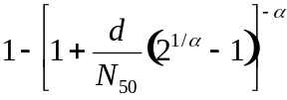 (1.2)

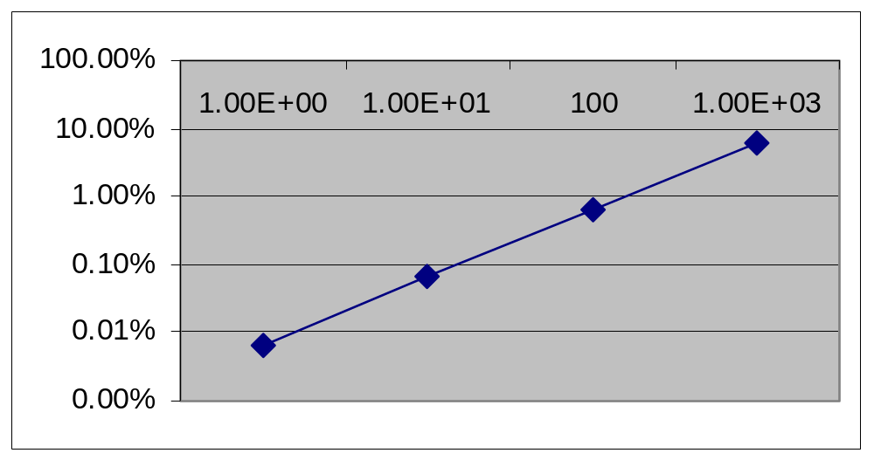
Dose numbers of bacteria ingested
RISK
1/100=1% from single exposure
Risk (Pi)

Figure 1.2. Probabilistic risk of Cholera infection

Exposure assessment and the levels of pathogens in the doses is one of the most important aspects and most difficult for providing input to risk characterization.
- There is a need for better monitoring data and better environmental transport models in air, water, food, soil, on surfaces etc. In particular the ability to model survival of pathogens in the environment will be needed. There will need to be new and better methods used which can address the hazard as well as the exposure (eg. QPCR, see Chapter 2 Measuring Microbes) for better assessment of non-cultivatible but important viruses and bacteria.

Finally for risk characterization probability of infection, morbidity and mortality can be evaluated (Figure 1.3), but in the future a new paradigm will be needed to merge the infection transmission with the environment and dose-response functions (Figure 1.4).

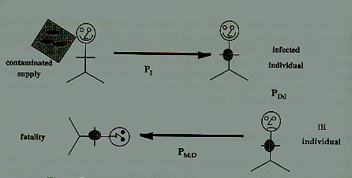
Figure 1.3 Infection Diagram

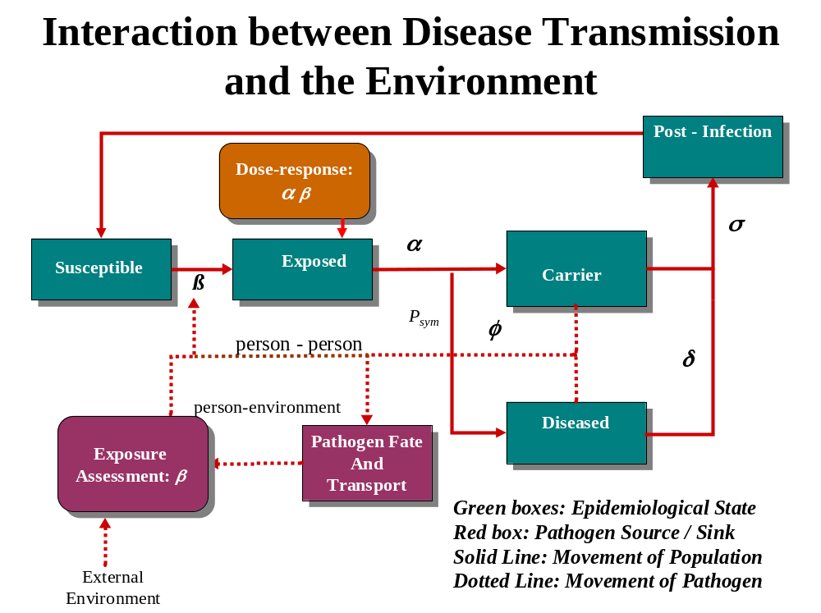
Figure 1.4 Interaction between disease transmission and the environment

Risk Management and QMRA
QMRA has seen application for the most part within the drinking water safety arena and within food safety.
Example: Thus for determining the need for drinking water treatment goals for utilities using surface waters, the USEPA established a potential safety target of 1 infection in 10,000 (10⁻⁴ ) risk when drinking water for 1 year.
Thus the daily risk of contamination for 2 liters of water a day was:
- Source water contamination on average for the year [concentration]
- Treatment reductions (log reductions; percent reductions)
- Exposure 2 liters of water per day, 365 days, calculating annual risk (Figure 1.5).
Figure 1.5 Treatment vs. influent: Endemic risk
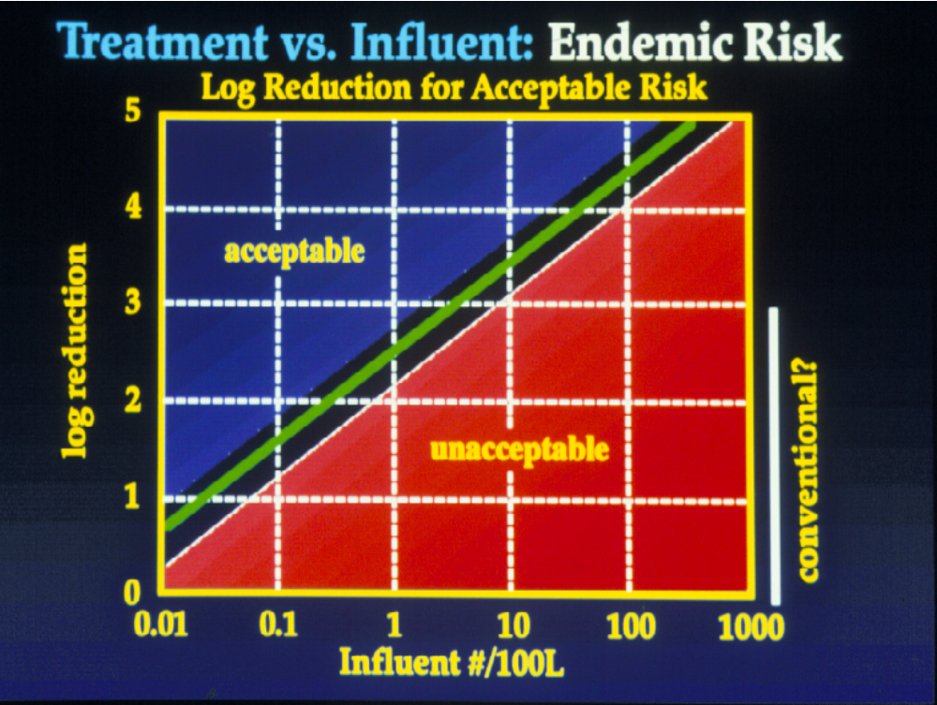

Example 1.1 Framing the QMRA

Goals: To understand the development of the various types of frameworks that could be used to address QMRA and to identify the data sets needed to undertake a microbial risk assessment.

Step 1. Develop a Problem Formulation on some microbial risk
- Group A) TB and air travel, B) Norovirus outbreak, C) Extreme event; Flooding; and D: Beach contamination (sewage spill) and cleanup.
- Articulate the problem, name the stakeholders involved, and address the perception of the problem.

Discussion
Who are the people involved in the problem either helping cause it or fix it or the victims of it? How big is the problem? Geographically (is it a local problem or is it national) Why? How serious is the problem?

Step 2. Hazard Identification: List and Describe
- the microbial hazards
- the transmission route (or routes)
- the populations involved
- the health outcomes
- the types of data you would try to gather

Discussion
Data would include the type or types of microbe, the health effects, the morbidity, hospitalization, special populations, mortality, the spread of the disease, the epidemiological and clinical data available.

Step 3. Dose-response: List the Information important to the dose-response
- Address what you would need if you were going to develop a model
- what information would you need if you already had a model
- what information would you need if you did not have a model but did not have time to develop one

Discussion
Here, the type of information important would include things like, human or animal data, what type of animals?, # of individuals exposed, # exposed to what concentrations, how were the exposure concentrations measured and delivered? What kinds of individuals were exposed (e.g. age), # of times exposed, what response was measured? (e.g. infection, illness, hospitalization, death) how was infection measured?, is there epidemiology data or outbreak data to address dose-response? (e.g. outbreaks and attack rates).

Step 4. Exposure assessment
- Draw the complete exposure route to be considered
- List the information needed in terms of the types of measurements needed to describe this route of exposure.
- Address where you might implement a control strategy to decrease the risk of exposure

Discussion
Here the quantification of the microbe in the source/exposure material should be addressed, the method used (sensitivity/specificity ) to quantify the microbe, it’s transport, it’s survival, susceptibility to disinfection or other treatment, it’s prevalence, distribution, mean, max,. The numbers of exposures over what time frame is important. The group should draw the pathway, e.g. from the cow to the manure to the irrigation water to the spinach to the person eating it.

Step 5. Risk Characterization
- Describe what you think is the biggest uncertainty
- Identify where more data could make the biggest difference?

Discussion
There is no wrong or right answer here, generally the largest uncertainty lies in the assumptions made in the exposure assessment part.

References and Further Reading
Beck, R. W. (2000). A Chronology of Microbiology. ASM Press, Washington DC.
Buchanan R. L. and Whiting R. C. (1996) Risk Assessment and Predictive Microbiology. Journal of Food Protection supplement, 31-36.
Eisenberg, J. N., M. A. Brookhart, G. Rice, M. Brown, and J. M. Colford, Jr. (2002). Disease transmission models for public health decision making: analysis of epidemic and endemic conditions caused by waterborne pathogens. Environ Health Perspect 110: 783-90.)
Haas C. N., Rose J. B. and Gerba C. P. (1999). Quantitative Microbial Risk Assessment. New York, John Wiley.
ILSI Risk Science Institute Pathogen Risk Assessment Working Group. (Eisenberg, Haas, Gerba, and Rose members) (1996). A Conceptual Framework to Assess the Risks of Human Disease Following Exposure to Pathogens. Risk Analysis. 16(6): 841-848.
Sherman, I. W. (2006). The Power of Plagues. ASM Press, Washington DC.
Vinten-Johansen, P., Brody, H., Peneth, N., Rachman, W. and Rip, M. R. (2003). Cholera, Chloroform and the Science of Medicine: A Life of John Snow. Oxford University Press, New York, Oxford.

Chapter 2

Measuring Microbes

Joan B. Rose

GOAL
The goal of this section is to introduce the reader to the terms and methods used to measure microorganisms. This is important to the QMRA framework in terms of hazard identification, dose-response but particularly during the assessment of exposure. The uncertainty that is a part of any QMRA is in large part due to the difficulty in measuring the specific microorganisms in space and time. This is not only a “methods” issue but a sampling issue.

Types of Microbes and Types of Units
The goal for QMRA is to quantitatively describe the exposure in terms of numbers of microorganisms per dose, numbers of doses, the route of the exposure and the duration and numbers of exposure. Thus quantitative information is necessary. Microorganisms fall into different categories or kingdoms of living organisms, thus their shape, structures, sizes, and replication strategies may all be different. One thing that these microbes do have in common is that they carry with them genetic material (DNA and/or RNA). The exceptions to this are prions (infectious proteins associated with the cause of Crutzefelt-Jacob disease).

The types of measurements one can make are via visual methods like microscopy, by cultivation (growing the microbe), by indirect measurements of the components (eg detection of the proteins or genetic material). Some methods are highly specific and some capture a broad range or group of microorganisms and there may need to be further tests to identify the organism.

The measurements can be quantitative (that is one can count the organisms) or quantal (yes/no; presence/absence). Quantal assays can be used to obtain estimates of the numbers via the statistical method most probably number which uses dilution to extinction (to zero) and replicates of these dilutions to assess the concentrations in the original sample. Some methods detect the cell or component of the cell and do not determine whether the organism is alive or not. Only live organisms pose a risk thus estimation of “viable” microorganisms is necessary. Obligate microbes (those that require a host to replicate like the viruses) use cell culture techniques or animal host techniques.
Table 2.1 Microorganisms, methods and units for measurement
Microbe Group | Common  Methods | Units | Notes
Algae | Microscopic  (Experts can identify the types by size and shape and features) | Cells | Indirectly look for chlorophyll a, relates to amount of algae present.
Blue Green toxic algae | SAME AS ABOVE | Cells: but interested in toxin concentrations  nanograms (ng) or micrograms (µg) | Use and Enzyme-linked immuno assay that produces a color if the toxin is present Read on a spectrophotometer
Bacteria | Cultivation using biochemical tests | Colony forming units CFU | Some bacteria are difficult to culture on media, don’t have specific media for all types and in the environment many bacteria move into a “viable but non-cultivatible” state.
Parasites | Microscopic  (does not determine viability) | Look and count specific life stages, eg. eggs, cysts, oocysts, larvae. | Some parasites can be cultured. Many are obligate parasites, may require cell culture or animal models.
Viruses | Assays in mammalian cell culture.  (mosquito-borne viruses can replicate in mosquito cell lines) | Plaque forming units PFU or MPN of CPE [infected cell cultures undergo observable morphological changes called cytopathogenic effects (CPE)] | Scanning electron microscopy shows there may be 100 to 1000 virus particles to every culturable unit. Many viruses can not be cultured.

Genetic Detection and Characterization
The polymerase chain reaction (PCR) detection assay allows for highly sensitive and highly specific detection of nucleic acid sequences via a method that specifically target and amplifies or copies genetic sequences. PCR was initially used as a research tool for the amplification of nucleic acid products. It is fast gaining acceptance in the clinical diagnostic setting and it has been effectively applied to the detection of microorganisms from many types of environmental samples. In order to use PCR one must already know the exact sequence of a given genetic region. Primers (pieces of DNA) are then designed to amplify that specific region of the genome. Primers for the specific detection of many of many pathogens have been published. Genetic information is kept in a “gene bank” which is accessible via the internet and computational programs are available to analyse the data. PCR can be used for hazard identification, and even identification of key genes associated with disease (eg toxin production in bacterial like blue green algae, Shigella or E. coli).

In some cases this is the only way one can detect the pathogen. The chief drawback of PCR methods is that they are incapable of distinguishing between active and inactive targets.

The latest advancement in molecular methods is the development of quantitative real-time PCR. qPCR or referred to as real-time PCR can be used to quantify the original template concentration in the sample. Following DNA extraction, real-time PCR simultaneously amplifies, detects and quantifies viral acid in a single tube within a short time. In addition to being quantitative, real time PCR is also faster than conventional PCR. Real-time PCR requires the use of primers similar to those used in conventional PCR. It also requires oligonucleotide probes labeled with fluorescence dyes, or alternative fluorescent detection chemistry different from conventional gel electrophoresis, and a thermocycler that can measure fluorescence. For quantification, generation of a standard curve is required from an absolute standard with known quantities of the target nucleic acid or organism.

Sampling and Method Development Issues
The goal for exposure assessment is to be able to determine the dose and how this is tied to the exposure route. Thus the level of contamination of water, air, soil, food, surfaces and hands are important. In some cases the transition of contamination from one environment to another is what is most important to monitor or test for (eg. transfer of bacteria from raw chicken to hands to self/others/or other foods; transition of pathogens from feces to sewage, to surface water to drinking water). Models and surrogates microbes that are easily measured are used to examine transition phases (transport).

One of the most important issues is the viability and the survival of the microorganism during transition or over time, under various environmental stresses is extremely important to assess. This is termed inactivation and is the ratio of live organisms to the total over time and is a rate of decay (See Chapter 6).

When sampling the various types of environments, the samples need to be collected by specific approaches over time and space, samples need to be concentrated, purified, separated and finally assayed for the microbe of choice. One of the key issues is recovery (see Chapter 6) the ratio of microorganisms recovered to the numbers that are truly present. Recoveries can be inputs into the uncertainties analysis for risk assessment.

Thus any method, it’s specificity and sensitivity (how well the method detects the specific organism and at what level is a negative meaningful) needs to be addressed in QMRA. Issues that should be addressed include
- ability to detect the target of interest
- recovery of the method influenced by the media (air verus dirty water, versus clean water)
- ability to determine viability
- need to concentrate
- detection limits

Finally, while there are many issues with the methods, pathogens can be detected in a wide range of environments. PCR techniques allow for any pathogen to be identified. Often viable organisms (1 cultivatible enteric virus in 100 liters of groundwater without disinfection) can be found in the absence of observable disease based on the limited community based surveillance that is in place. Exposure assessment while challenging is very possible and the use of appropriate sampling strategies for the problem at hand, methods, models and surrogates have moved QMRA forward (See chapters 7 and 8).

Example 2.1 Evaluation of screening tests
Screening tests, which are to identify asymptomatic diseases or risk factors, are not always perfect because they may yield false positive or false positive outcomes. Therefore, probability lows and concepts are commonly applied in the health sciences to evaluate screening tests and diagnosis criteria.
- False positive: A test result that indicates a positive status when the true status is negative
- False negative: A test result that indicates a negative status when the true status is positive

A variety of probability estimates can be computed from the information organized in a two-way table given in Table 1.
- Sensitivity: Probability of a positive test result (or presence of the symptom) given the presence of the disease
  - 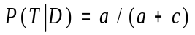
- Specificity: Probability of a negative test result (or absence of the symptom) given the absence of the disease
  - 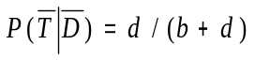
- Predictive value positive: Probability that a subject has the disease given that a subject has a positive screaming test result (or has the symptom)
  - 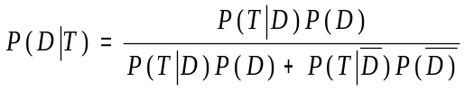
- Predictive value negative: Probability that a subject does not have the disease, given that the subject has a negative screening test result (or does not have the symptom)
  - 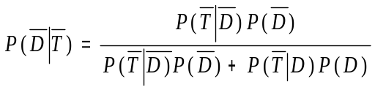

Table 2.1 Two way table for a screening test
 | Disease
Test results | Present (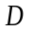) | Absent (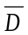) | Total
Positive () | A | b | a + b
Negative () | C | d | c + d
Total | a + c | b + d | n
Where n is the total number of subjects,
a is the number of subjects whose screening results are positive and actually have a disease,
b is the number of subjects whose screening results are positive but actually do not have a disease,
c is the number of subjects whose screening results are negative and actually do have a disease,
d is the number of subjects whose screening results are negative but actually do not have a disease.

Testing a new method: 31 + 119 -

n = total number of tests 150

a = 26 + (true positives as determined by another standard test or via seeded studies)

b = 5 + (but were or tested negative by the gold standard)

c= 11 - (but are really + as determined by another standard test or via seeded studies)

d= 108 - (are truly – as determined by another test or via seeded studies)

IS THIS NEW METHOD ACCEPTABLE????

Reference
Wayne W. Daniel. 1999. Biostatistics: A foundation for analysis in the health science, John Wiley & Sons, Inc, New York, NY
Example 2.2 Primer design and Genbank exercise (Mark Wong, MSU).
GOAL
- Using BLAST, determine the most likely identity of a given nucleotide sequence.
- Starting from a set of given sequences, generate a sequence alignment to determine what are the regions of high similarity and what are the regions of low sequence similarity among a group of adenovirus sequences. [software used: clustal alignment tool]
- Based on the sequence alignment obtained, design a set of generic primers that will amplify all members of the target group. The suggested primers will be analyzed for their suitability. [software used Oligocalc from Northwestern University] A group of primers from published literature will be analyzed for their specificity to their respective targets. [software used BLAST tool from NCBI]

Instructions:
Part 1. BLAST search as a putative identification tool for nucleotide sequences.
You will be provided with a file “adenovirus sequences.txt” which will contain a list of adenovirus sequences. Open the file “adenovirus sequences.txt” using windows notepad or an alternative text reader like wordpad or MS word.
The sequences are provided in a format known as the FASTA format. In bioinformatics, FASTA format is a text-based format for representing either nucleic acid sequences or protein sequences, in which base pairs or protein residues are represented using single-letter codes. For more information on what the FASTA format is about please see http://en.wikipedia.org/wiki/Fasta_format

Select the first sequence given (>human_adenovirus_type41), copy the sequence into your clipboard.

Open the following webpage http://www.ncbi.nlm.nih.gov/BLAST/ click on the link for nucleotide blast. Paste the sequence you just copied into the form shown
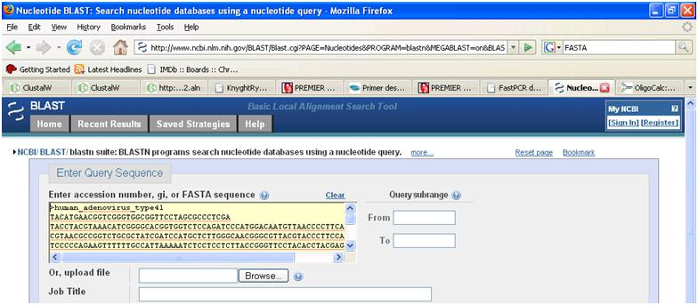
Scroll down until you see “Choose search set”. Make sure under database “Others (nr etc.): “ is selected. In the dropdown bar beneath that make sure that “nucleotide collection (nr/nt)” is chosen.

Under “Program Selection” make sure that “Highly similar sequences (Megablast)” is chosen.

Click on the “BLAST” button to start blasting.

When BLAST is done, look at the output. Ignore the numbers and values given but concentrate instead on the genes that BLAST has determined most closely resembles your sequence.

Q1. What is the possible identity of the sequence you just BLAST’ed?

Part 2. Sequence Alignment
Open the following website http://www.ebi.ac.uk/Tools/clustalw/
Go back to the file adenovirus_sequences.txt highlight and copy all the sequences present.
In the window where it says “Enter or Paste a set of sequences in any supported format:” paste the selection you just copied.
Using the default parameters, click run. Wait for the output.
When Clustalw has finished the alignment click on the alignment file generated. Copy and paste the contents of the alignment file into the Windows Notepad application. Save the file.

Part 3. Primer design
Within the alignment file you will notice that the sequences have been arranged such that the areas of similarity among all the sequences are lined up. Below the sequence block you will see asterisks where there is complete identity among all the sequences given. Design 1 forward and 1 reverse primer that can be used to amplify all of the given sequences. Use the regions of high similarity to design primers that are the most well conserved. Use the following guide to design a suitable primer. A good primer has the following criteria:
- Between 18-24 bases in length
- Has a fairly even distribution of all the 4 bases (G+C residues are ≈ A+T residues)
- Contains as little degenerate bases as possible
- Does not form hairpin loops
- Does not form self complementary pairs
- Has a melting temperature Tm close to that of its opposing primer.
- Ends with at least one ‘G’ or ‘C’ residue
You may wish to use the following information on degenerate codons in designing your primer: M = A / C, W = A/T, Y=C/T, V=A/C/G, D=A/G/T, N=A/G/T/C, R=A/G, S=C/G, K=G/T, H=A/C/T, B=C/G/T.
Melting temperature, hairpin loop formation, self complementary pair formation, G+C % composition can be determined by analyzing your primer at the following website Oligo Calc : http://www.basic.northwestern.edu/biotools/oligocalc.html
Do not spend too much time on the primer design. There are no wrong answers (though some choices are better than others) and while designing the “perfect” primer pair is the holy grail of any molecular biologist, it is often unobtainable!
Remember that your reverse primer must be given in the reverse complement of the sequence. In other words, if the tail end of your sequence is ATTGGTCATGCATAA, the reverse primer that will amplify that is TTATGCATGACCAAT (A complements T, G complements C)

Q2. What is your forward primer? Where in the sequence is it located?:

Q3. How many degenerate bases are there?:

Q4. How many dimers and self complementary pairs does Oligo Calc report?:

Q5. What is its melting temperature?:

Q6. What is your reverse primer? Where in the sequence is it located?:

Q7. How many degenerate bases are there?:

Q8. How many dimers and self complementary pairs does Oligo Calc report?:

Q9. What is its melting temperature?:

Part 4. Specificity Analysis
We often use BLAST as a tool for determining the specificity of the primers that we design. Determine if the set of primers given below is specific primer set to use to amplify human adenoviruses type 40 and 41.
forward primer 5'-TGGCCACCCCCTCGATGA-3'
adenovirus type 40 reverse primer 5'-TTTGGGGGCCAGGGAGTTGTA-3'
adenovirus type 41 reverse primer 5'-TTTAGGAGCCAGGGAGTTATA-3'
- Open the NCBI BLAST website again http://www.ncbi.nlm.nih.gov/BLAST/ click on the link for nucleotide blast. Past the forward primer sequence into the input window.
- Scroll down until you see “Choose search set”. Make sure under database “Others (nr etc.): “ is selected. In the dropdown bar beneath that make sure that “nucleotide collection (nr/nt)” is chosen.
- Under “Program Selection” make sure that “Somewhat similar sequences (blastn)” is chosen.
- This time, before you click on BLAST, click on the link for “Algorithm Parameters”.
- Scroll down, make sure that “Automatically adjust parameters for short input sequences” is selected.
- Reduce the “Word Size” parameter to 7 by clicking on the dropdown box and selecting 7.
- Click on the “BLAST” button to start blasting.

Q10. List the different human adenovirus types that will be amplified by the forward primer. (i.e those which have 100% query coverage and 100% Max ident)
Now do a similar blast search using the adenovirus type 40 and 41 reverse primer.

Q11. From your blast searches, would you regard the three primers as being specific for human adenovirus type 40 and 41?

Q12. What experiments would you need to carry out to confirm your conclusions from this “in-silico” experiment?

Chapter 3

Statistics and Uncertainty

Patrick L. Gurian

Goal
This chapter provides a review of concepts from probability and statistics that are useful for risk assessment. It begins with a review of probability density distribution functions, then covers how these functions are used as models for variability and uncertainty in risk assessment, describes how these functions are fit to it particular cases by estimating parameters, and describes one method, bootstrapping, for quantifying uncertainty in these parameter estimates.

Probability
A probability density distribution function (PDF) describes the probability that some randomly varying quantity, such as the amount of water consumed by an individual, the carcinogenic potency of a chemical toxin, or the concentration of a pollutant in the air, will lie in a particular interval. The PDF is defined as the function that when integrated between limits A and B. gives the probability that the random variable x will fall between those limits A and B. Thus

Prob[A<x<B] = _{A}∫^{B} f(x) dx (3.1)
where f(x) denotes the PDF.

In typical risk assessments a fairly limited number of functional forms of f(x) are used. For example, the normal distribution is a PDF with the following functional form:

f(x) = 1/{σ(2π)^{1/2}} exp{(x-µ)²/2σ²} (3.2)

where µ and sigma in this equation are parameters, or constants that can be tuned to fit particular applications. For a normal distribution the parameter µ corresponds to the mean and the parameter σ to the standard deviation. By choosing different values of these parameters, the same functional form (normal distribution) can be used to describe many different random variables which have different means and different standard deviations. Figure 1 shows the probability density distribution for a standard normal distribution, which is the normal distribution with mean of 0 and standard deviation of 1. A common notation is to use ~ to denote “is distributed as” and then write an abbreviation for the class of distribution with information on the parameters of the distribution in parentheses. For example, if Z is a random variable that follows a standard normal distribution, this can be written as:

Z ~ N (0, 1) (3.3)

where N is a standard abbreviation for a normal distribution and by convention the first number in parentheses is the mean, and the second is the variance (standard deviation squared).

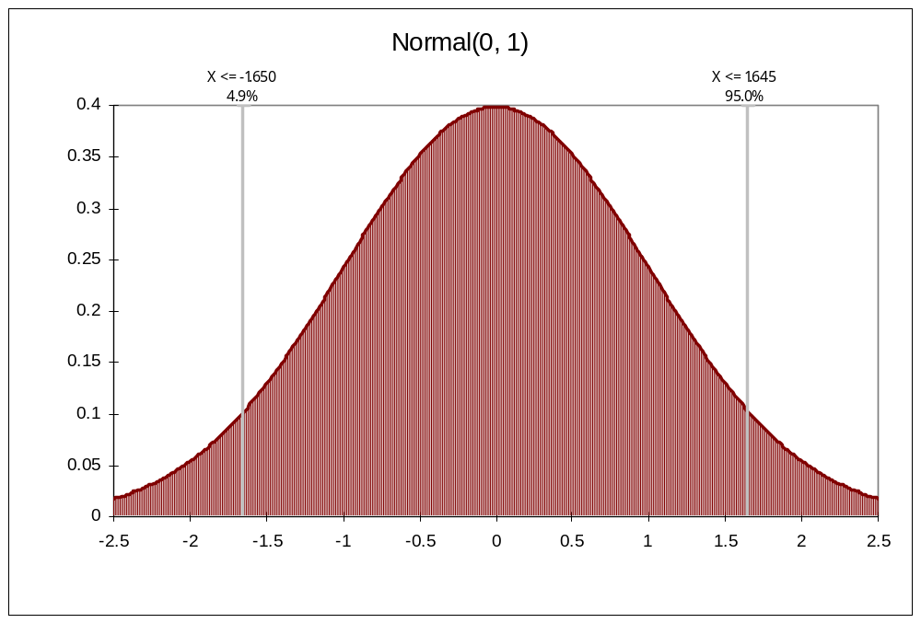
Figure 3.1 The probability density distribution function for a standard normal variable.

It is often useful to evaluate the probability that a random variable is less than a particular value. For example one might be interested in the probability that a particular risk is below a given regulatory benchmark. This is called a cumulative distribution function (CDF) and is found by integrating the PDF from negative infinity to the particular value, X:

F(X) = Prob[x<X] = _{-∞}∫^{X} f(x) dx (3.4)

where F(X) denotes the CDF. CDF values are probabilities and range from 0 to 1. They are often multiplied by 100 to give percentiles, the percentage change that a random variable is below a specified value. Figure 2 shows the CDF of a standard normal distribution.

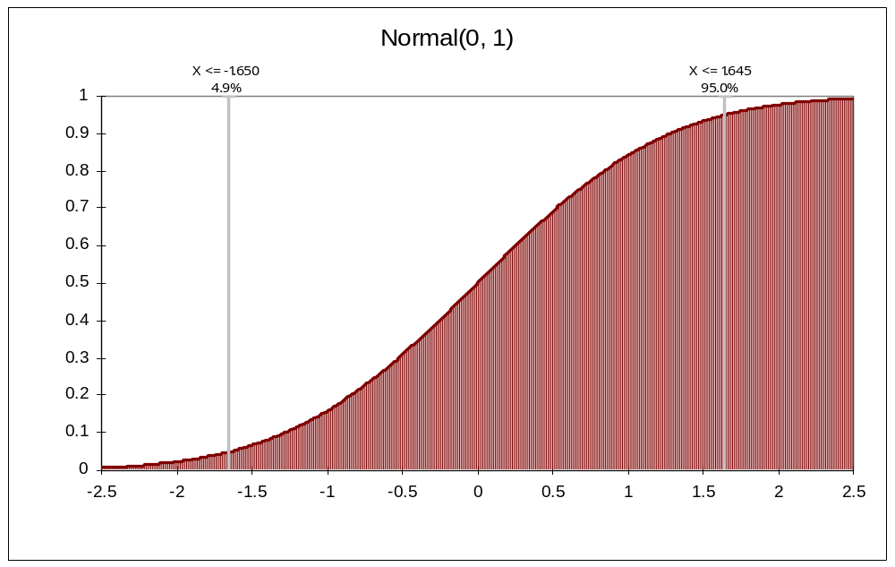
Figure 3.2 The cumulative distribution function for a standard normal distribution.

Evaluating the CDF of a normal distribution require numerical integration. To avoid having to carry out this integration for each of the infinite number of normal distributions, one makes use of the fact that the following transformation will convert any normally distributed random variable, denoted by x, to a standard normal variable, denoted by Z:

Z=(x - μ)/σ (3.5)

Note that this transformation does not change the order of different values of x. Thus the highest value of x will correspond to the highest value of Z, the median value of x will correspond to the median value of Z, the 10th percentile value of x will correspond to the 10th percentile of Z, etc. Thus if one knows the CDF for a standard normal distribution, one can transform X to the corresponding value of Z, evaluate the standard normal CDF at Z and this equals the CDF value of X. To facilitate this approach, CDF values for a standard normal distribution are widely available in standard reference tables. The transformation described above can then be applied to determine the CDF for any of the infinite number of normal distributions.
Example 3.1 Finding the CDF of a normal distribution
Suppose annual repair costs for a particular car follow a normal distribution with a mean of 300 and standard deviation of 100:

Annual repairs ~ N (300, 100²)

and we wish to find the probability that repairs will exceed $450 in a given year. The first step is to find the Z value corresponding to the value of $450:

Z = (X-µ)/σ

Z = (450-300)/100 = 1.5

The next step is to find the CDF value of Z in a standard table found in nearly every introductory statistics textbook:

F(Z) = F(1.5) = 0.933

Note, however, that the CDF is the probability of a random variable being less than a given value. To find the probability of repair being less than $450, we make use of the fact that the probability of an event and its complement (defined as the event not happening) add to one. Thus

Prob [repair<450] = prob[Z<1.5] = 1- prob[Z>1.5] = 1 - 0.933

Prob [repair >450] = 0.067

Parameter Estimates
In the example above the probability distribution was specified. The mean and standard deviation of the repair costs were assumed to be known perfectly. It is common not to know the parameters of a distribution but instead have a data and wish to “tune” the parameters of a PDF to fit the particular data. This process of fitting parameter values to match observations is referred to as parameter estimation. One natural approach might be to observe repair costs for a number of cars and calculate the arithmetic mean and standard deviation of these costs. Then set the mean of the model distribution equal to the observed mean and the standard deviation equal to the observed standard deviation. This is an example of a technique known formally as the method of moments. While the approach is straightforward in this case, it is difficult to generalize to more complicated statistical models, such as the dose-response models used in risk assessment. The emphasis here will instead by on maximum likelihood estimation, because this method is very generally applicable.

Maximum likelihood estimation begins with the question “how likely is the data we observed?” For a single observation, x, by definition this is f(x). Typically data are multiple independent observations. The likelihood of those observations occurring together is then the product of the likelihoods of the individual observations:

L=f(x₁) f(x₂) f(x₃)…f(x_{N}) (3.6)

where the subscripts indicate the individual observations, N is the number of observations, and L is referred to as the likelihood function. For example, if a baseball team is observed to win one game and lose the next two then:

L = Prob[win] prob[loss] prob[loss] (3.7)
If we write the probability of winning as p, then this can be written:

L = p(1-p)² (3.8)

since winning and losing are compliments. Suppose one person posits that the team has a long-run frequency of winning of p=0.5. In this case the likelihood of the observed data is:

L = (0.5) 0.5² = 0.125

If a second person states that the value is only p=0.3, which value do we prefer? One way to assess this is to examine the probability of getting the results we actually observed under these two alternative views of p. If p=0.3 then the likelihood of the sequence of wins and losses that was observed is:

L = 0.3 (0.7²) = 0.147

The probability of the outcome that actually occurred is higher given the second person’s estimate of p than given the first person’s estimate of p. Based on this we generally prefer the second person’s estimate of p, as it is more consistent with the observed data. The next step is to ask if there is another estimate of p which gives an even higher likelihood of observing the data. Ultimately one seeks the value of p which maximizes the probability of observing the data. Calculus provides a method for doing this. One first differentiates the likelihood function, L, with respect to the parameter, p:

L = p(1-p)²

dL/dp = (1-p)² - 2p(1-p)

To find a critical point one sets dL/dp=0

0 = (1-p)² - 2p(1-p)

Now factor out (1-p)

0 = 1-p -2p

Rearrange to:

3p=1

And solve for p:

p=1/3

Thus p=1/3, the observed proportion of wins, is the maximum likelihood estimate of p. (To verify that this is a maximum one can note that the second derivative is negative for this value of p.) In this case it was possible to find the maximum value of L analytically. In many cases with more complicated likelihood functions, it is not possible to find L analytically. In these cases numerical search algorithms are used to identify a maximum.

For very large data sets, one can imagine that the joint probability of all the observations will be quite low (i.e., L is a product of many numbers each of which is ≤1 since all probabilities are ≤1). It is often easier for these numerical search algorithms to work with the log of the likelihood, rather than the likelihood:

Ln L=ln π f(xi| θ) (3.9)

where θ indicates the parameters associated with a particular f(x) and indicates a product. The log of a product can be expressed as the sum of the logs:

Ln L=Σ ln f(xi| θ) (3.10)

and it is this form that is customarily used in numerical optimization routines.

Variability and Uncertainty
Variability refers to differences in outcomes obtained from a process. Uncertainty is lack of knowledge. Probability theory was originally developed to describe variability in the outcomes of repeated events, that is, the long-run frequency of different events. Those who desire to restrict the use of probably to describing objectively measurable variability are referred to as frequentists. Others who view probability more broadly as the subjective assessment of the likelihood of an event are termed subjectivists. This subjectivist viewpoint allows probability distributions to be used to describe not only variability but also uncertainty. Uncertainty can result from variability. For example, I may not know the outcome of a coin flip because if varies between heads and tails. However, uncertainty can result from many other sources, such as lack of understanding of the fundamental process at work. The subjectivist view of probability allows for the use of probability to describe one’s belief as to the value of a quantity that has not yet been observed (i.e., for which there is no frequency information). For example, one might use probability to describe factors such as the sensitivity of the earth’s climate system to a doubling of pre-industrial CO₂, even though this is not strictly speaking a randomly varying quantity. There is one value which is unknown to us.

In many cases both variability and uncertainty are present. For example, a particular drinking water may be contaminated with Cryptosporidium oocysts. The amount of oocysts in different water samples will vary. If the oocysts move randomly in the water, that is they move independently, neither clustering together nor dispersion from each other, then the probability that x oocysts will be found in a given water sample can be described by a Poisson distribution:

Prob [x oocysts] = λ^{x} exp(-λ)/x! (3.11)

where λ is a parameter. One property of this distribution is that the mean is equal to λ. One can think of λ as the long-run mean, that is, the mean if an infinite number of samples from the same Poisson distribution are averaged. Because a finite sample is not guaranteed to be perfectly representative of the population from which it is drawn, even after observing the mean (median, variance, etc.) of a sample, there is still uncertainty as to the population mean (median, variance, etc.). It is uncertainty due to this sampling variability which is quantified through statistical methods.

It is common to first assess an appropriate functional form for f(x) and then, given the chosen form of f(x), assess the uncertainty in the parameters of f(x). In the classical statistical framework, these parameters are fixed values. Based on a sample, estimates are obtained for these parameters. However, given sampling variability, these parameter estimates have variability in them. This variability can be assessed and the standard deviation of the estimate of the parameter quantified. This standard deviation of a parameter estimate is termed a standard error. Thus uncertainty in model parameters (due to sampling variability and only sampling variability) is captured by these standard errors. In the Bayesian framework, model parameters are treated as themselves being random variables. In this framework, the λ value for a Poisson process would follow a probability distribution with a mean (reflecting the central tendency of λ) and a variance (reflecting uncertainty as to the true value of λ). In the classical framework, it is not quite correct to describe the parameters of models as following uncertainty distributions. Instead the standard errors are used to include or exclude different possible values of the model parameters with various levels of confidence. It is not clear that any harm is done in simply treating model parameters as random variables with means equal to their estimates and standard deviations equal to their standard errors. This view essentially adopts the Bayesian framework even for models estimated in a classical framework. It is often a convenient approach to adopt in risk assessments where probability is used quite generally to describe a wide variety of uncertainties.

Example 3.2 Maximum Likelihood Estimation
In this exercise you will fit a Poisson distribution to exposure data for Cryptosporidium oocysts using maximum likelihood estimation (MLE). A Poisson distribution is used to describe a random variable that takes on positive integer values, such as the number of microorganisms in a water sample. It has the mathematical form: prob[x]= λ^{x} exp(-λ)/x!, where λ is a parameter that corresponds to the mean number of counts. Typically for water samples the mean number of bacteria is some average concentration multiplied by the sample volume, so λ=volume*concentration. This assignment uses a numerical search approach to identify the MLE estimate. Numerical approaches are usually generally applicable, but are more computationally expensive and less accurate than analytical solutions. You may wish to find the analytical solution to this problem. To do this, write the joint likelihood of the data, take the log, and apply calculus to find critical point in the log likelihood (i.e., take the first derivative, set it equal to zero, and solve for the concentration).

The following are detailed instructions for a numerical solution.

- Open the spreadsheet “Exercise 2 data.xls”.

- The volume of water sampled is in column A and the number of Cryptosporidium oocysts found is in column B.

- Enter the following formula in cell D1:

=Poisson(B1, A1*G$1,false)

Poisson is a shortcut formula in Excel for the density of a Poisson distribution. The false indicates that the PDF, rather than the CDF is requested. Thus the formula above is the probability of obtaining the observed number of counts, given the long-run average oocyst concentration. In other words, it is the likelihood of the data point. The likelihood is conditional on the concentration, which is the model parameter you are going to estimate. The parameter is in cell G1. The “$” in the formula above allows you to copy down the formula without changing the row number.

- Copy this formula down to obtain the individual likelihood of all the observations.

- It is usually easiest to take the log of the likelihood so in column E put a formula that takes the log of the likelihood for each observation column D.

- The joint log-likelihood is now the sum of all the terms in column D. In cell E54 enter the sum formula to obtain this value.

- Now we want to try different values in cell G1 and see which values maximize the log-likelihood in cell E54. Note that if we put a negative number in cell G1 we will get an error and this will throw off a gradient search for the maximum value in cell E54. To make sure we don’t get a negative value in cell G1, enter the formula =exp(H1). Now we can adjust cell H1 and whether H1 is positive or negative, G1 will always be positive. We need to start somewhere so enter “-4” in cell H1.

- Go to the “Tools” menu and select “Solver”. If “Solver is not on the menu then select “Add-Ins” and check the box for “Solver Add-in”.

- Set E54 as the target cell and maximize it by adjusting cell H1. You do not need to add any constraints. (Because of the trick with exponentiating H1, we know that cell G1 is constrained to be positive and don’t need Solver to constrain anything.)

Complete the following:

- What is the MLE estimate of the concentration of oocysts/liter?

- Suppose that for the data in cell B52, the oocysts are clumped together, and our analyst can not accurately enumerate how many oocysts are present. Instead the analyst determines that there are more than 3 oocysts and records the data as >3. Revise the likelihood for this observation and find the MLE estimate of the concentration. Note that the likelihood will be in terms of the CDF (or complementary CDF) so you will use “true” in Excel’s Poisson function.

Bootstrapping
As described above, sampling variability leads to uncertainty in parameter estimates. In some cases an analytical formula is available to estimate the standard error of a parameter. For complicated model forms, such formulae may not be available. Bootstrapping is a generally applicable method to assess the uncertainty in parameter estimates due to sampling variability. The concept underlying bootstrapping is to treat the sample obtained as the PDF of the model. Each point has probability 1/N where N is the number of observations in the sample. This assumption allows us to create alternative samples from the data. One randomly draws N observations from the observed dataset to create an alternate data set. These observations are drawn with replacement, meaning that if a particular observation is not eliminated from subsequent draws after it is sampled. It is this that allows for each alternative dataset to be slightly different from the original dataset, since some observations will appear multiple times in the alternative dataset and some will not be sampled at all.

The next step is to estimate the desired parameter (or summary statistic, such as mean, variance, 90th percentile, etc.) for each of the alternative datasets. Each combination of generating an alternative dataset and estimating the quantity of interest is termed an iteration of the bootstrap procedure. The values for each dataset are then considered discrete samples from the probability distribution of the parameter. Means, variances, and percentiles for the parameter estimate can be found from this discrete sample. Thus the standard error of the parameter estimate can be estimated as the standard deviation of the different parameter estimates obtained from each iteration. This is essentially a Monte Carlo approach to assessing parameter uncertainty and, as with all Monte Carlo analyses, the number of iterations conducted should be quite large, preferably as large as 10,000 (Morgan and Henrion 1990, Burmaster and Anderson 1994). A smaller number of iterations may be acceptable if convergence of estimates can be observed. In this case one would track the estimate of interest across different iterations. Values will fluctuate greatly at first as the estimate is based on a small number of iterations, but these fluctuations will decrease as a larger sample size is obtained. Convergence is achieved when the estimate no longer shows fluctuations large enough to be of concern to the analysis.

Example 3.3 Bootstrap Uncertainty Analysis
- Open the spreadsheet “Exercise 7 data.xls”.

- The household CO measurements are in column B.

- Enter the following formula in cell E2 which will sample with replacement a value from the observed concentrations:

=VLOOKUP(ROUNDUP(RAND()*15,0),$A$2:$B$16,2)

- Copy this formula down to row 16 and at least 30 columns to the right. Each column is a sample of bootstrapped data.

- Find the 95th percentile of each column. Use the help menus as necessary to find a suitable statistical function for determining percentiles.

- Now find the median of the 95th percentile values and the 95th percentile of the 95th percentile values.

- Repeat this process for the 0.05, 0.1, 0.25, 0.5, 0.75, 0.9, and 0.95 fractiles.

Complete the following:

- Prepare a plot of the median bootstrapped value on the x-axis and the fractile on the y axis. Use a solid line for the plot. Then add the 95th percentile of the bootstrapped estimates and the 5th percentile of the bootstrapped estimates as dashed lines to the graph.

- Suppose you want to estimate how many households are exposed to average levels above 9 ppm (the WHO 8-hour standard). What is a reasonable range for the fraction of households exceeding this level?

- If we collect more data how will this figure change?

References and further Reading
Burmaster DE, Anderson PD. (1994) “Principles of Good Practice for the Use of Monte-carlo Techniques in Human Health and Ecological Risk Assessments,” Risk Analysis, 14 (4): 477-481.
Morgan, M.G., and Henrion, M. 1990. Uncertainty: A Guide to Dealing with Uncertainty in Quantitative Risk and Policy Analysis, Cambridge University Press.

Chapter 4

Animal and Human Studies for Dose-Response

Charles N. Haas

Goal
To quantitatively determine the relationship between dose and response, information from either animal or human studies must be used to develop a dose-response relationship. The goal of this unit is to describe the particular types of studies and indicate how to descriptively analyze the results. A subsequent unit will incorporate discussion of quantitative dose-response analysis.

Human studies to determine relationship between exposure and disease have been done using both analytical and experimental approaches. Analytical approaches relate illness to exposure as both may occur in particular populations. Experimental approaches control or alter exposure and examine the impact of this change on the resulting disease.

Analytical Human Studies
There are two broad classes of analytical human study designs – the cohort study and the case control study. In the cohort study, a sample population is studied, and the subsets whom do and do not experience the exposure are compared with respect to their disease outcome. This study may be conducted prospectively, in other words the progression of disease is followed in time as the study is conducted. Alternatively, a retrospective design may be used in which populations who have and have not been exposed are identified and then their subsequent health status is ascertained.

The second broad class of study is the case-control study, which is generally retrospective. Individuals with a defined disease are identified, along with a matched population without the disease. These two populations are then compared with respect to their exposures.

There are a number of other more sophisticated designs which go beyond these basic designs. Description of these approaches is beyond aims of the current presentation.

There are advantages and disadvantages to each of these designs. Case-control studies are powerful when the frequency of the disease due to the exposure is rare. In a case-control study it is necessarily to carefully match control populations who are identical to the case populations but for the fact of their disease. The definition of the disease state must be precisely given. With a retrospective design (intrinsic to case-control, but also true for retrospective cohort studies), if the exposure status is obtained from interviews, there may be a bias in recall of past activities.

Cohort designs, particularly prospective designs, can identify multiple different health outcomes (e.g., gastroenteritis, respiratory infection, skin infection, etc.) associated with a particular exposure. Case-control designs can identify the influence of multiple different exposures on a given health outcome.

In either case, if the degree of exposure can be quantified it is possible to get an estimate of the dose-response relationship for the illness. In either design, there may be subcomponents of different populations (e.g., by gender, age, etc.) to ascertain the impact of additional variables on the risk due to an exposure.

Examples of Analytical Studies
To illustrate the types of studies, three examples will be given.

Classic Cohort Study
Recreational water outbreaks of cryptosporidiosis were investigated in several states (Alden et al. 2006). In Illinois, 102 persons attending a daycamp during a period of suspect contamination were interviewed. The relationship between those who reported entering the swimming pool and those who had symptoms of diarrhea or vomiting were as follows (Table 4.1)

Table 4.1
 | Ill | Not Ill | TOTALS
Entered pool | 56 | 7 | 63
Did not enter pool | 0 | 39 | 39
TOTALS | 56 | 46 | 102

The risk of illness to those entering the pool was 56/63 = 0.89, while the risk to those not entering the pool was <0.025. Hence, the relative risk (this ratio), which is a standard measure of association used in cohort studies, was >35, hence there is a high degree of evidence that there was a strong association between exposure and effect (we will discuss evaluating statistical significance in the lecture).

In this study design, the difference between the risk in the two groups can be used as a direct measure of the risk that might be incurred by similar exposures. Note that there is a necessary assumption that the population of individuals who entered the pool and who did not enter the pool are identical except for their exposure. Comparing demographic and other attributes of the two sets of persons could at least partially validate this.

Classic Case Control Study
Using the San Francisco AIDS registry, persons who developed cases of cryptosporidiosis were compared to matched controls that did not have cryptosporidiosis. Controls were matched based on age, sex, race/ethnicity, date of diagnosis and level of immune suppression (Aragon et al. 2003). A number of drinking water exposures were examined as potential risk factors. The following is a summary of a portion of the results (Table 4.2).

Table 4.2
 | Cases | Controls | TOTALS
Sometimes or always used tap water at home | 2 | 31 | 33
Never used tap water at home | 47 | 68 | 115
TOTALS | 49 | 99 | 148

In a case control study, the common metric of association is the odds ratio – the ratio of odds of the exposure in the cases (47/2 = 23.5) to that in the controls (68/31 = 2.19). Hence the odds ratio is 23.5/2.19 = 10.73, which is quite high, hence there is strong evidence for the association between cryptosporidiosis in this population and home tap water consumption.

Cohort Study with Quantitative Exposure Metric
Cohort studies are particularly valuable when quantitative measures of exposure can be obtained relating risk to exposure. This is well illustrated by numerous studies on recreational water. In one study of swimmers in the vicinity of Sydney, Australia, the odds ratio of health outcomes in swimming versus non-swimming cohorts on particular half-days on particular beaches was associated with the coliform level at the time at which swimming occurred as shown below (Corbet et al. 1993).
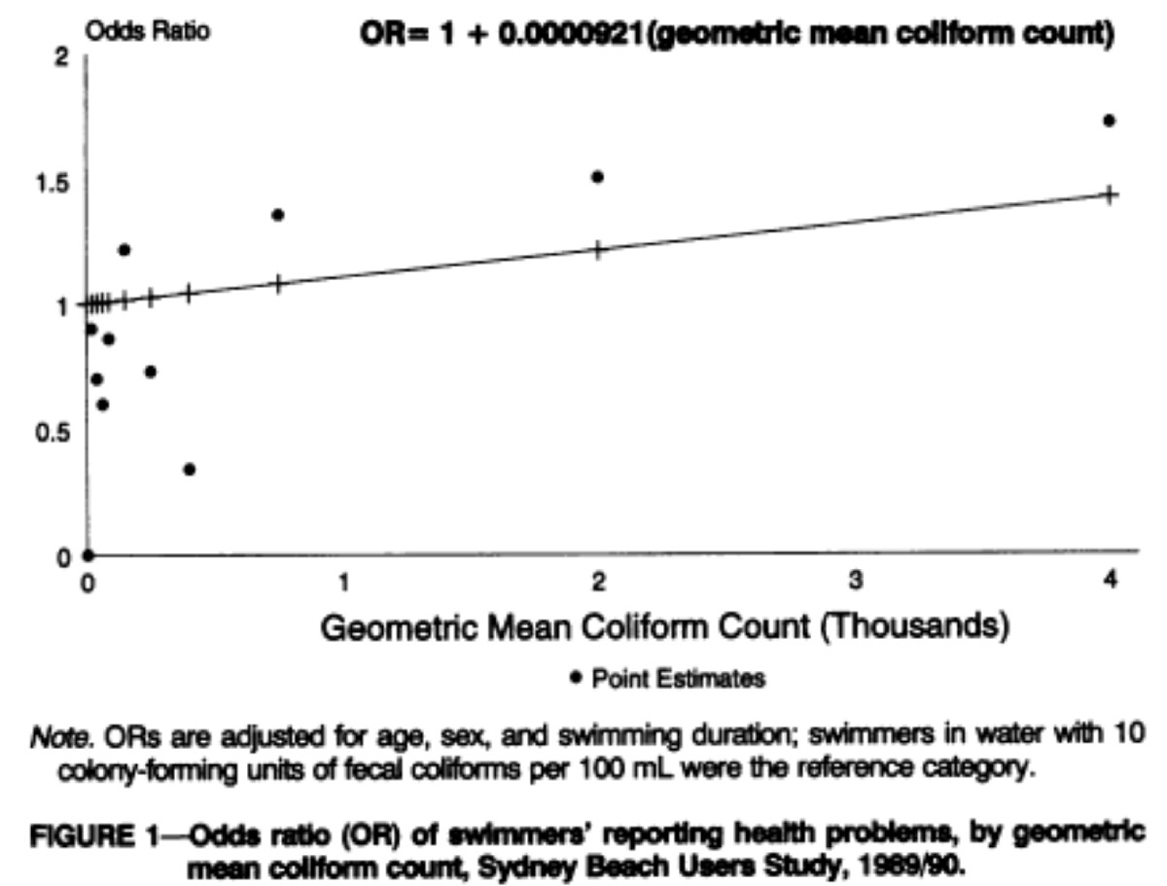
Figure 4.1

This weak, but nonetheless statistically significant association between health outcome incremental risk and the level of exposure could be useful in setting criteria.

Experimental Human and Animal Studies
Experimental studies deliberately manipulate the exposure variable and examine the impact on outcome. Ideally, the subjects assigned to various levels of exposure should be randomized, and in the most rigorous study design neither the subjects nor those who evaluate health outcomes have knowledge of the level of exposure until the termination and analysis of the study results (termed a “double blind” study). These studies can be conducted with either human or animal populations.

In the case of either human or animal populations, the representativeness of the population studied with respect to the entire population that is to be protected is a concern. With animals, this includes the particular issue of whether more homogenous inbred populations are used (compared to outbred).

With animal studies, the additional issue of extrapolation from animals to humans becomes a concern to be addressed.

Experimental Human Study Example
An experimental study of the risk for highly credible gastroenteritis (HCGI) was conducted by Payment et al. In a community in suburban Montreal, family homes were installed with a water purification system or with a “sham” system. The filtration was aimed at reducing infectious microorganisms. By comparing the annual rates of HCGI as in the table below, an estimate of the contribution of microbial contamination in tap water to illness was obtained.

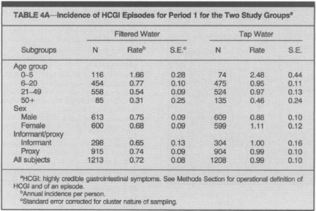
Table 4.3

As a second example of a controlled trial, volunteers were fed controlled doses of oocysts of Cryptosporidium parvum on a randomized basis (Dupont et al. 1995). The subsequent health status of these individuals was ascertained. A definite dose-response behavior was elicited. This type of study will be described in further detail in the subsequent section on dose-response.

References
1. Alden, N.B. and e. al., Cryptosporidiosis Outbreaks Associated with Recreational Water Use - Five States, 2006. Morbidity and Mortality Weekly Report, 2007. 56(29): p. 729-32.
2. Aragon, T.J., et al., Endemic Cryptosporidiosis and Exposure to Municipal Tape Water in Persons with Acquired Immunodeficiency Syndrome (AIDS): A Case-Control Study. BMC Public Health, 2003. 3(2): p. 1-10.
3. Corbett, S.J., et al., The Health Effects of Swimming at Sydney Beaches. American Journal of Public Health, 1993. 83(12): p. 1701-6.
4. Payment, P., et al., A Randomized Trial to Evaluate the Risk of Gastrointestinal Disease Due to Consumption of Drinking Water Meeting Current Microbiological Standards. American. Journal Public Health, 1991. 81: p. 703.
5. Dupont, H., et al., Infectivity of Cryptosporidium parvum in Healthy Volunteers. New England Journal of Medicine, 1995. 332(13): p. 855.

Chapter 5

Dose-Response

Charles N. Haas

Goal
The objective of dose-response assessment is to develop a relationship between the level of microbial exposure and the likelihood of occurrence of an adverse consequence. In general, dose-response analysis would not be necessary if the level of microbial risk that was acceptable was sufficiently high so that actual experimentation (on humans, or perhaps on animals) could be conducted so as to permit the direct assessment of risk in the observable range. However, since frequently the level of risk from a single exposure is much lower than 1/1000, the use of direct experimentation to assess this risk becomes impractical (as well as ethically questionable) since >1000 subjects would be needed to ascertain the “acceptable” dose. Therefore, the use of a parametric dose-response curve to facilitate low dose (and low risk) extrapolation becomes necessary.

A dose response model is, in a most general sense, a mathematical function that takes as an argument a measure of dose -- which can be any non-negative number, and yields the probability of the particular adverse effect -- which is bounded by zero (no effect) and one (complete conversion to adverse state). There are an infinite number of such possible functions.

It is most desirable that the dose-response model(s) chosen for use are biologically plausible. Therefore, we will first review some attributes of a biologically plausible microbial dose-response model for infectious agents. Then some classes of these models will be derived and analyzed. Subsequently, some empirical (albeit lacking in plausibility) models will be presented. The remainder of this chapter will then deal with issues of fitting data to models, and assessing validity using independent data.

Plausible Dose Response Models
There are two key distinguishing features of infectious microorganisms from other human health risks (e.g., chemicals, ionizing radiation). Any dose response model failing to consider these factors lacks biological plausibility.

First, particularly at low levels, the statistics of microbial distribution dictate that a population of humans exposed to infectious agents will of necessity receive a distribution of actual doses. For example, if a group of people each consume exactly 1 liter of water containing an average concentration of 0.1 organisms per liter, we expect (assuming random, Poisson, distributions between doses) that about 90% of persons (exp(-0.1)) would actually consume zero organisms, about 9% of persons (0.1 * exp(-0.1)) would consume one organism, 0.45% of persons would consume two organisms, and 0.015% would consume three or more organisms. If the distribution of organisms between doses was non-random, then the percentages would obviously be different. Any biologically plausible dose-response framework should consider this phenomena. This is very different than with many chemicals, which are present at high enough concentrations (when viewed in terms of molecules) such that the quantal nature of the delivered substance does not affect the actual delivered dose between subjects exposed.

The second distinguishing aspect of infectious microbial agents is their ability to propagate within a susceptible host at an appropriate location within the body. Although there are quite specific mechanisms of pathogenicity, and methods of circumventing the time course of microbial infection can be described by competing processes of birth and death within the host; infection resulting when birth is sufficient to produce a body burden above some critical level to induce the effect (Williams 1965; Armitage et al. 1965).

The process of infection may be considered as requiring two sequential subprocesses to occur (Haas 1983):
- the human host must ingest one or more organisms which are capable of causing disease
- the organisms undergo decay, or are impaired from multiplying to cause infection/disease by host responses and only a fraction of the ingested organisms reach a site where infection can commence

These considerations lead to two mechanistic dose-response models that have found wide utility. Both models are based on a single surviving organism having the capability of multiplying sufficiently to cause the response (Eqs. 5.1 and 5.2).

Exponential model 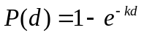 (5.1)
Beta-Poisson model 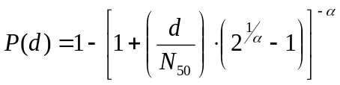 (5.2)

In both cases, d is the average dose administered to the population. The parameter “k” in the exponential represents the probability that one organism will survive to initiate the final end state. In the Beta-Poisson, “N₅₀” is the median effective dose and “α” is the slope parameter – as this value increases, the Beta-Poisson approaches the exponential. The Beta-Poisson dose response relationship is always more shallow than an exponential due to heterogeneity in the microorganism-host interactions. Note that the form of the Beta-Poisson is actually an approximation to an exact form, which is true as long as N₅₀ is not too small – for further details see (Teunis and Havelaar 2000).

While other functional forms (e.g., log-probit, Weibull) can be used to fit data, they have not been derived from basic mechanistic assumptions.

Fitting Available Data
Given a set of data on infectivity, or some other endpoint (such as illness, or even mortality), we would like to ask some basic questions with respect to dose-response estimation. These will be answered in order:
1) Assuming a given dose-response model, what are the best parameter estimates using the experimental data at hand?
2) How do we determine which, of a set of plausible models, provides the best fit to the data?
3) Is the best-fitting model itself adequate, or is there still a significant amount of unexplained variance?
4) What is the uncertainty in the parameters estimates of a particular model for the data at hand?
5) Are the results from two or more data sets adequately describable by a common set of dose-response parameters?
6) How can we explain lack of fit?
We will address these issues in turn, and in the process will also introduce some real dose-response data (as well as some hypothetical data).

Types of Data Sets
In general, the data set available for dose-response analysis is one of two types. In the first type of data, several sets of subjects (either human or animal) are fed replicates with a known mean dose, and the subsequent response, in terms of infection, illness, or mortality, is determined. In the second type of data set, typically resulting from the investigation of an outbreak study, the average dose administered to individual sets of subjects is estimated, and the attack rate in each group is assessed, Both of these data sets can be described using the same nomenclature (Table 5.1).

Table 5.1 Schematic layout of dose-response assay.
set | Average dose of microorganisms | number of subjects in the set | positive subjects (*)
1 | d1 | n1 | p1
2 | d2 | n2 | p2
3 | d3 | n3 | p3
4 | d4 | n4 | p4
(*) with infection, illness, death, or some other positive indicator of response

Best Fit Estimation
A particular dose-response model is selected for study. This model may be characterized by a function, which predicts the proportion of positive responders given dose and values of one or several dose response parameters. In a generic sense, we can write the predicted response as
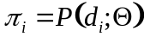 (5.3)
where is the set of dose-response parameters. We will also define the response for each set based strictly on the observations as
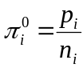 (5.4)

Mathematically the method of maximum likelihood is used to estimate the best set of parameters (). We will use the symbol Y, in this context, to denote the value of a -2 log likelihood ratio -- we will now term this the deviance. For the dose-response assay in Table 5.1, we can define this deviance statistic as:

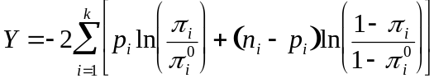 (5.5)

The optimum, maximum likelihood, estimates of dose-response parameters are obtained by finding the values of that, through their influence on π_{i}, minimize the deviance, Y (Morgan et al. 1992).

Example 5.1
This problem is one of unconstrained minimization, albeit possibly in several parameters (if the dose-response model has several parameters). This problem can be solved in EXCEL using the capability of the SOLVER (Haas 1994). Use of this method will be shown in the next example. The data set used will be a human dose-response study using rotavirus, with infection as an endpoint (Ward et al. 1986). The data are shown in Table5.2

Table 5.2. Human Dose-Response Study of Rotavirus (Ward).
Dose | Total subjects | Positive subjects
90000 | 3 | 3
9000 | 7 | 5
900 | 8 | 7
90 | 9 | 8
9 | 11 | 8
0.9 | 7 | 1
0.09 | 7 | 0
0.009 | 7 | 0
________________________________________________________________________

Analyze the above data using the exponential, beta poisson and log-probit models.

Solution
The optimization is performed using the SOLVER in EXCEL™. The following table summarizes the parameters of the best fits (Table 5.3).

Table 5.3 Best fit parameters
Model | best fit parameters | deviance (Y)
exponential | r=0.0126 | 129.48
beta-Poisson | 0.265  N50=5.597 | 6.82
log-probit | q1=10.504  q2=4.137 | 11.87

Clearly, as indicated by the deviance, the beta-Poisson model produces the minimum deviance. In the next section we shall consider whether the fit of any of these models is acceptable, and whether the improvement in fit going from the exponential to the beta-Poisson (since the latter is a special case of the former model) is statistically significant.

The data are compared to the models in the following graph. Clearly, the exponential model provides too sharp of a rise in comparison to the data. Qualitatively, within the observable range, the beta-Poisson model and the log-probit model appear similar, and they both describe the more gradual rise between zero and complete response better than the exponential. However, as shown in the inset graph, there is a considerable difference between the three models at low doses. Interestingly, in this case, the best fit log-probit model gives greater estimated risk at low dose than the other two models (Figure 5.1).
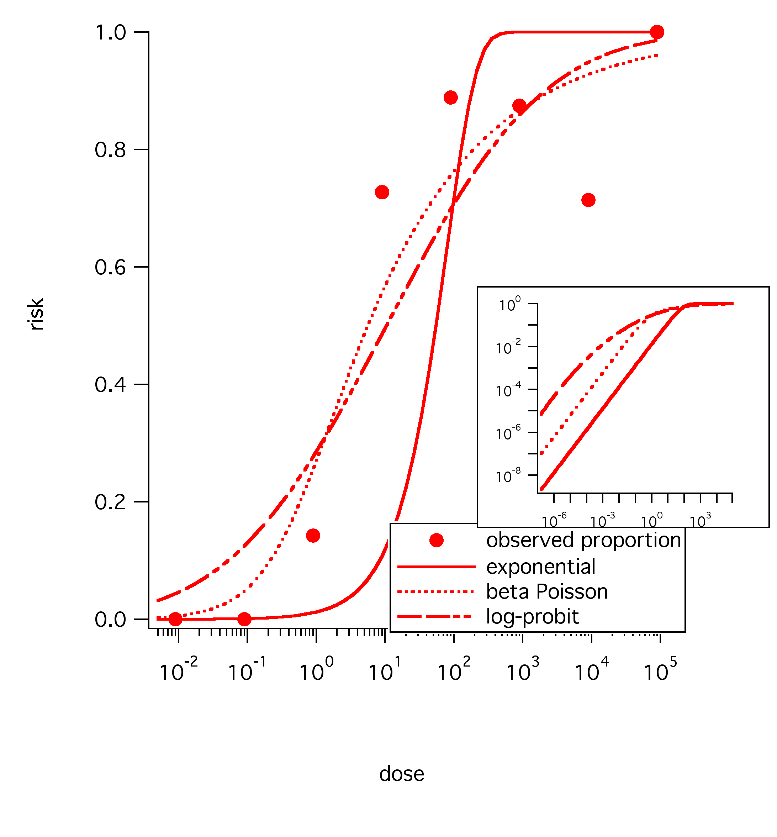
Figure 5.1 Comparison of Fits to Rotavirus Data.

Goodness of Fit Determinations
No model should be accepted for use without examination of goodness of fit. We apply the methods of chapter 4 to this problem. The value of the optimized deviance, which we shall now denote as Y* is compared to a χ² distribution with k-m degrees of freedom (where k is the number of doses, and m is the number of parameters in the dose response model). The null hypothesis of fit acceptability is rejected (i.e., the dose-response model is rejected) if Y* is in excess of an upper (e.g. 5) percentile of the distribution.
_
_______________________________________________________________________

Example 5.2
For the dose-response fits to the rotavirus data in the previous example, determine the goodness of fit for the three alternative models.

Solution
The following table (Table 5.4) presents the degrees of freedom, the upper fifth percentile of the c² distribution, and the p value (i.e., the probability that a fit as poor or poorer would be found if the null hypothesis was in fact true).

Table 5.4
Model | deviance (Y*) | k–m | critical χ² | p value
exponential | 129.48 | 7 | 14.067 | 8.07•10⁻²⁵
beta-poisson | 6.82 | 6 | 12.591 | 0.338
log-probit | 11.87 | 6 | 12.591 | 0.0649

Since the optimized deviance for the exponential model is substantially greater than the critical value, i.e., since the p value is extremely small (<<0.05), the fit of the exponential model to this data is rejected. Similarly, since the residual deviances from the beta-poisson and log-probit models are less than the critical value, or the p value is >0.05, the fits cannot be rejected on statistical grounds.
________________________________________________________________________

Comparison of Nested Models
If we have two dose-response models, where model 2 is a special case of model 1, with numbers of parameters m₁ and m₂, where m₂<m₁, then we can compare the statistical significance of the improvement in fit by examining against a c² distribution with m₁–m₂ degrees of freedom. The null hypothesis (that the fits are indistinguishable) is rejected if the difference in deviances exceeds the critical value, i.e., if the difference is in excess of the critical value, then we are justified in accepting the more complex model (with more parameters) in comparison to the more parsimonious model.

For example, with the if data are analyzed by both the exponential and the beta-poisson (note that the exponential model is a special case of the beta-poisson), the difference can be compared at 1 degree of freedom.

Confidence Intervals and Regions
To assess the precision with which the dose-response curve has been determined, i.e. the uncertainty, we would like to determine the confidence limits to the parameters of the dose response curve, and also the upper and lower envelopes (at a certain confidence coefficient) around the dose-response curve.

An approach to the problem is the use of the bootstrap procedure (Efron and Tibshirani 1993). The bootstrap is a method for developing the sampling distribution of a statistic computed from a set of data by resampling the data, and recomputing the statistic from the resampled data. The distribution of the statistic from many resampled data sets is taken as a estimator of what the distribution of the statistic would be in the population from which our sample was drawn.

The logic of the bootstrap given as follows. The observed dose response data is the vector of observations (x1, x2...xn) -- consisting of triplets (mean dose, subjects exposed, positive subjects). This is presumed to be a random sample of some unobserved population of all subjects. From the real data, we compute a statistic -- the best fit value(s) of the dose response parameters. We want an estimate of what the uncertainty distribution of the dose-response parameters is. By constructing a series of bootstrap replicates (x*) -- in our case, triplets of (average dose, total subjects, positive subjects), and determining (by maximum likelihood fitting) the distribution of dose response parameters among the bootstrap replicates, it is inferred that the latter distribution is a good estimator of the uncertainty distribution from the total population in the “Real World”. The key question then becomes how to construct bootstrap samples from dose-response data.

For dose response data we can use a simple bootstrap as illustrated in Table 5.5.

Table 5.5 Bootstrapped Rotavirus samples.
Dose | Total subjects | Positive subjects | Bootstrap 1 | Bootstrap 2 | Bootstrap 3
90000 | 3 | 3 | 3 | 3 | 3
9000 | 7 | 5 | 5 | 5 | 6
900 | 8 | 7 | 6 | 7 | 7
90 | 9 | 8 | 8 | 7 | 8
9 | 11 | 8 | 8 | 8 | 9
0.9 | 7 | 1 | 1 | 1 | 0
0.09 | 7 | 0 | 0 | 0 | 0
0.009 | 7 | 0 | 0 | 0 | 0

The first three columns represent the original data. To construct the bootstrap samples, a random number of positives is constructed by a binomial distribution with the total number of subjects at that dose, and the proportion of positives equal to the ratio of observed positives to total subjects at that dose. Then for each bootstrap sample (consisting of the dose, total subjects, and bootstrap samples of positive subjects), the maximum likelihood parameter estimation is performed again. From a sufficiently large sample, this distribution of bootstrapped parameters represents the sampling (uncertainty) distribution of the parameters for the original data.

Figure 5.2 presents the results of a run of 1000 bootstrap replications for the rotavirus data. The bootstrap distribution clearly surrounds the maximum likelihood estimate from the original data, and qualitatively covers a similar area as the likelihood based confidence region. These 1000 replications can then be used as an input to subsequent computations -- reflecting the uncertainty distribution to dose response.
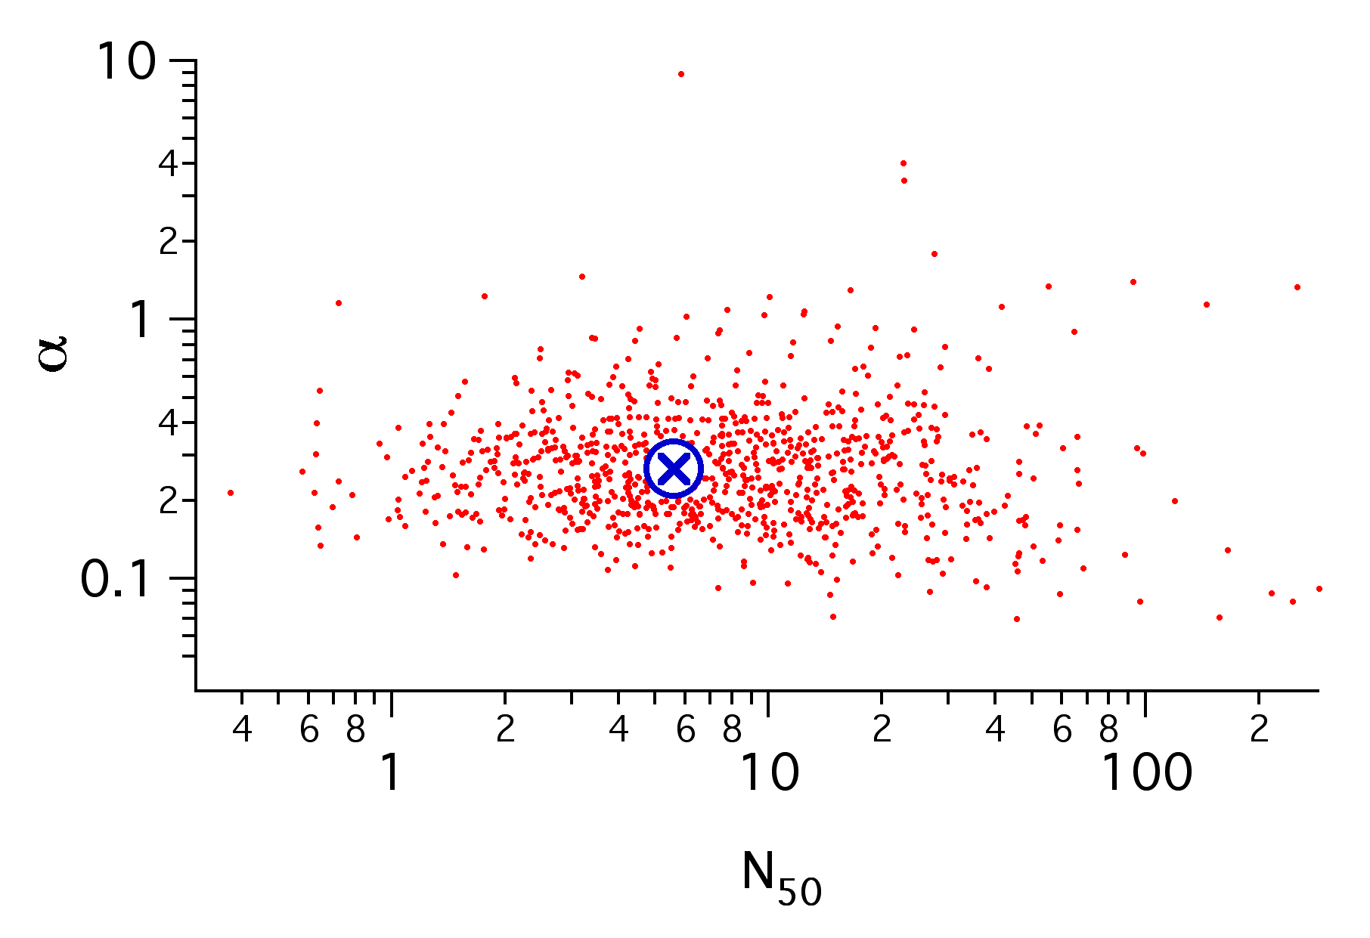
Figure 5.2 Bootstrapped Parameters for Rotavirus Fit to Beta Poisson.

The bootstrapped dose-response parameters can also be used to construct alternative confidence regions to the dose-response curve, in comparison to likelihood based intervals such as in Figure 5.3. At a given dose, each set (say of the 1000 replicates) is used to compute the estimated response (exponential, beta poisson, etc).
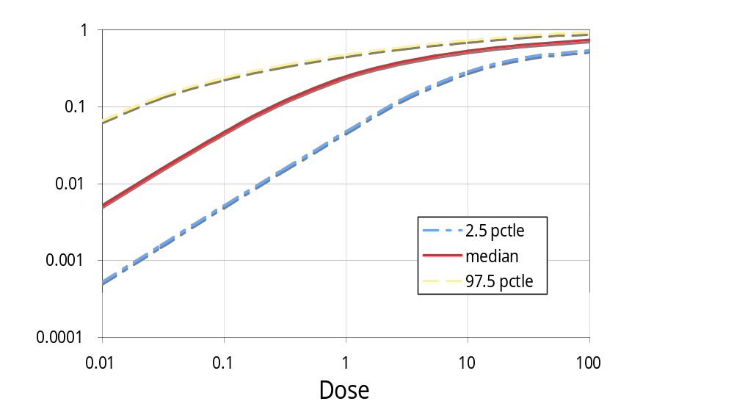
Figure 5.3 Fitted Dose Response with Confidence Limits.

Then to obtain the confidence region (0.95, 0.99, etc.) at a level z, the upper and lower (1-z)/2 proportions of the responses (at that dose) are found -- these define the confidence regions at that concentration.

References
Williams, T., The Basic Birth-Death Model for Microbial Infections. Journal of the Royal Statistical Society Part B, 1965. 27: p. 338-360.
Armitage, P., G.G. Meynell, and T. Williams, Birth-Death and Other Models for Microbial Infection. Nature, 1965. 207: p. 570-2.
Haas, C.N., Estimation of Risk Due to Low Doses of Microorganisms: A Comparison of Alternative Methodologies. American Journal of Epidemiology, 1983. 118(4): p. 573-582.
Teunis, P.F.M. and A.H. Havelaar, The Beta Poisson dose-response model is not a single-hit model. Risk Analysis, 2000. 20(4): p. 513-20.
Morgan, B.J.T., Analysis of Quantal Response Data. 1992, London: Chapman and Hall.
Haas, C.N., Dose-Response Analysis Using Spreadsheets. Risk Analysis, 1994. 14(6): p. 1097-1100.
Ward, R.L., et al., Human Rotavirus Studies in Volunteers: Determination of Infectious Dose and Serological Response to Infection. Journal of Infectious Diseases, 1986. 154(5): p. 871.
Efron, B. and R.J. Tibshirani, An Introduction to the Bootstrap. Monographs on Statistics and Applied Probability. 1993, New York: Chapman & Hall. 436.

Chapter 6

Introduction to Exposure Assessment

Tomoyuki Shibata

Goal
An exposure assessment is a two part process that includes 1) evaluation of pathways that allow microorganisms to be transported from the source to the point of contact with human beings and 2) estimation of the amount of exposure that is possible between humans and contaminants. Conducting a realistic exposure assessment is important for good risk characterization as well as risk management.

The goal of chapter is to become familiar with fundamental computations for 1) changes in microbial concentrations, e.g. die-off and reduction, 2) exposure doses from different exposure routes, and 3) risk characterization and management.

Change in microbial concentrations
Microbial concentrations may vary from the source to the point where a human may contact a pathogen. Many environmental factors, such as temperature, sunlight (UV), moisture content, pH, salinity, nutrients, organics, and other chemicals, may affect microbial fate and transportation.

Some microorganisms may grow or survive longer in moisten and nutrient rich environments, e.g. foods and soils. Growth of microorganisms, e.g. Staphylococcus aureus, Salmonella, Clostridium perfringens, Campylobacter, Listeria monocytogenes, Vibrio parahaemolyticus, Bacillus cereus, and Entero-pathogenic Escherichia coli, cause food poisoning and is a serious problem in the food industry. Regrowth of microbes, e.g. fecal coliform, E. coli, and enterococci in warm environments complicates the use of these microbes as fecal indicators of pollution for recreational water quality assessment. Lower temperatures may support microorganisms to survive longer.

Pathogens may decrease in concentrations due to dilution or natural die-off as they are released into different environments from the original host environments. Sunlight, dry, and low nutrients are major environmental factors that accelerate microbial die-off. Survival rates differ with microorganisms and environmental matrix (water, air, soil, and fomite). In general, microbes survive shorter in seawater compared with freshwater. Microbial inactivation rates in surface water are faster than groundwater.

Transportation of microorganisms can be affected by various environmental conditions, such as distance from the source to the exposure point, flow rate, exchange rate, suspended solid, permeability, and soil sorption. Fate and transportation models for water and air/fomites are discussed in the chapters 7 and 8.

% vs. Log Reduction
Reduction ratios are often expressed in percentage (%) or logarithm (log₁₀ or ln) (Eq. 6.1 and 6.2). It should be noted that given equations can be used to estimate increases in microbial concentrations as well reductions.

% Reduction, %R = 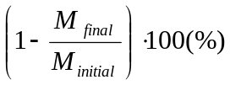 (6.1)

Log₁₀ Reduction, LR = 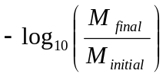 (6.2)
= 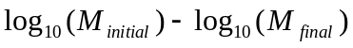

Where %R is the % reduction, LR is the log10 reduction, M_{initial} is the initial number of microorganisms (typically expressed as CFU or PFU), and M_{final} is the final number of microorganisms (after reduction). In general, % reduction is more commonly used in the public sector while log₁₀ reduction is typically used by engineers. It is useful to be able to convert from % reduction to log₁₀ reduction (Eq. 6.3) or vice-versa (Eq 6.4).

% Reduction, %R = 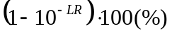 (6.3)

Log₁₀ Reduction, LR = 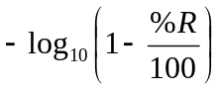 (6.4)

If the initial concentration of a microorganism and reduction (% or log₁₀) are known, the final concentrations can be calculated using Eqs. 6.5 and 6.6.

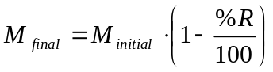 (6.5)

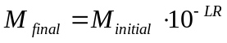 (6.6)

Inactivation Rate
Prediction of survival of microorganisms is an essential part of exposure assessment. Microorganisms die naturally over time or may be inactivated by UV radiation, the presence of materials toxic to them or other features of the environment. An inactivation rate is often expressed in T90 and T99, which are time required for 90 and 99% reductions. The rate may also be expressed as an inactivation coefficient, or k-value, that is a ratio of the initial and final titer in log scale over the survival time. A common unit of k-value is log₁₀ per hour (log₁₀/hr). The k-values can be computed based on T90 and T99 (Eq. 6.7) or initial, final concentrations, and survival time are available from the literature (Eq. 6.8). If you conduct an inactivation study or detailed data are available, the k-values can be calculated using all data (Eq. 6.9) via linear regression.

k_{a} = 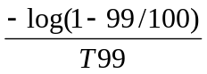 (6.7)

k_{b} = 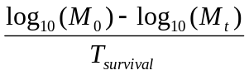 (6.8)

k_{c} = slope (a) of a log-linear equation, 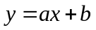 (6.9)

In equation 6.9, y is the log₁₀ reduction (log₁₀(M_{t}/M₀)), x is the monitoring period or survival time (hr), and b is the intercept. Note that assuming k does not vary with time also assume that the features of the environment causing the inactivation (solar radiation, chemical concentrations, etc) also do not vary with time.

Once k-values are obtained, you can predict the microbial concentration at time t (Eqs. 6.10 and 6.11). Predicting microbial concentrations at different times is useful for determining how long it may take to reduce concentrations to a target level (Eq 13).

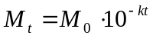 (6.10)

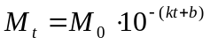 (6.11)
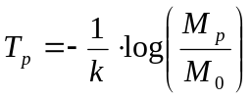 (6.12)

Example 6.1 Recovery and Inactivation on fomites
Scenario: 100 μL of titered Staphylococcus aureus (3.9 x10⁸ colony formed unit (cfu)/mL) solution was inoculated onto 10 cm² non-porous surfaces or fomites (aluminum, ceramic, glass, plastic, stainless steel, and wood laminated). Fomite samples were wiped using pre-moistened antistatic wipes and the wipes were placed in 50-mL test tubes contained 10 mL phosphate buffer saline plus 0.01% Tween-80. Test tubes were vortexed and samples were diluted (-3 log₁₀). 100 μL from the diluted samples were dispensed on to Mannitol Salt Agar (MSA) plates. Average colony counts were 317 on the MSA plates from the first wipes just after the inoculation of fomite. Fomites samples were collected for 3 weeks and the results are summarized in the Table 6.1.

Tasks:
- Calculate initial recovery of S. aureus from fomites using the wipe method.
- Calculate k-values based on T99, the initial and final concentration over the survival time, and log-linear regression equation.
- Compare measured concentrations with models based on calculated k-values
- Predict how long it would take S. aureus level to 1 cfu/cm².

Table 6.1 Survival of S. aureus on fomites
Survival time (hr) | Average concentration (cfu/10cm²)
0 | (calculate)
22 | 2.27 x10⁶
41 | 1.17 x10⁶
66 | 5.62 x10⁵
115 | 2.35 x10⁴
162 | 1.65 x10⁴
332 | 5.29 x10²
522 | 1.30 x10¹

Solution steps:
- Calculate the initial recovery using Eq. 1

% Initial Recovery, %R =
M_{inoculated} = Titer concentration x inoculated volume on fomites
= 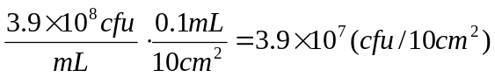

M_{recovered} = 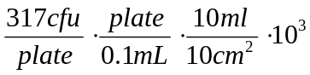= 3.17 x 10⁷ (cfu/10cm²)

% Initial Recovery = 81.2%

- Calculate % and Log₁₀ reductions using Eqs. 6.1 and 6.2.
- Make a figure: y-axis is % reduction and x-axis is time.
- Use the figure and estimate T99 by extrapolation from the best fit curve based on % reductions from 41 to 115 hours. In this case, a power equation fit better than a linear equation (Figure 6.1). T99 = 93.5 hrs
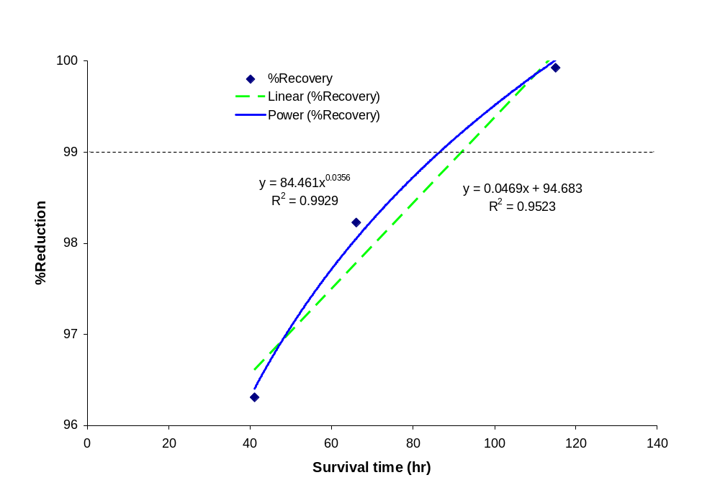
Figure 6.1 Extrapolation of T99

- Calculate the k-value based on T99 (Eq. 6.7)

k_{a} = 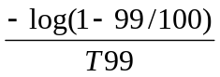 =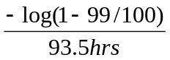 = 0.0214

- Calculate k-value only based on the initial and final concentration over time (Eq. 6.8)
k_{b} = = 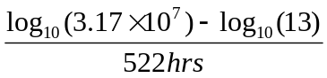= 0.0122

- Calculate k-value (slope) and intercept of a log-linear regression for reduction ratio over time (Eq. 6.9). Using Excel,
Kc = SLOPE(known_y's,known_x's) = 0.0111
Intercept = INTERCEPT(known_y's,known_x's) = 0.986

- Substitute obtained k-values into the inactivation models (Eqs. 6.10 and 6.11)
K_{a} and K_{b} into for
K_{c} into for

- Make a figure (y-axis = S. aureus concentration and x-axis = time in hour) that contains measured concentration and predicted concentrations from the models based on three k-values (Figure 6.2).

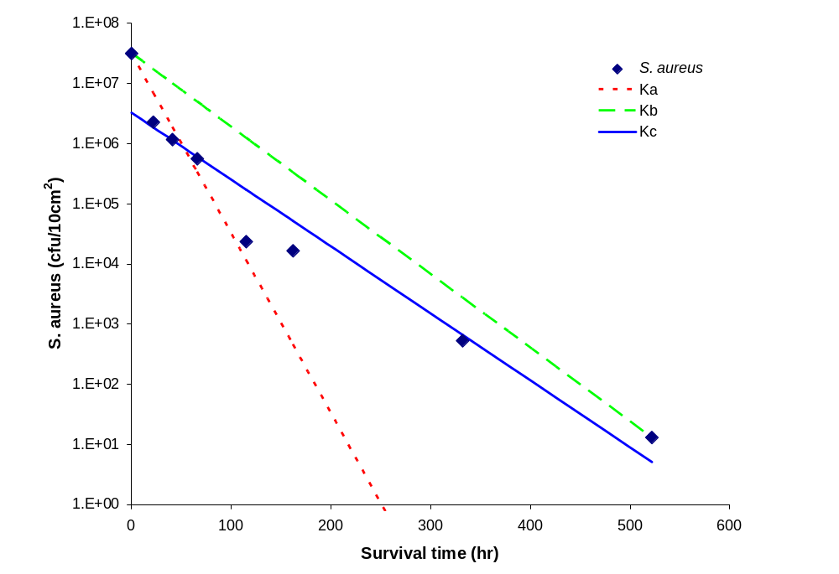
Figure 6.2 S. aureus concentration on fomites based on measurements and inactivation models

- Compute how long it would take S. aureus concentration to be 1 cfu/10cm² from the last observed level. Since the initial rapid reduction is over at this point, it is unnecessary to use interception. Thus, Eq 6.12 can be used for prediction time using these three k-values.

= 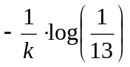

2 days based on K_{a} (T99) and 4 days based on K_{b} and K_{c}

Computations can be done using Microsoft Excel (Table 6.2)

Table 6.2 Summary computations using Excel
 | A | B | C | D | E | F | G
1 |  | S. aureus | Reduction |  | Model
2 | hr | cfu/10cm² | % | Log₁₀ | k_{a} | k_{b} | k_{c}+b
3 | 0 | 3.17E+07 | =(1-B3/$B$3)*100 | =-LOG(B3/$B$3) | =$B$3*10^-($B$17*A3) | 3.17E+07 | 3.27E+06
4 | 22 | 2.27E+06 | 92.84 | 1.15 | 6.97E+06 | 1.71E+07 | 1.86E+06
5 | 41 | 1.17E+06 | 96.31 | 1.43 | 1.88E+06 | 9.99E+06 | 1.14E+06
6 | 66 | 5.62E+05 | 98.23 | 1.75 | 3.37E+05 | 4.94E+06 | 6.03E+05
7 | 115 | 2.35E+04 | 99.93 | 3.13 | 1.15E+04 | 1.24E+06 | 1.72E+05
8 | 162 | 1.65E+04 | 99.95 | 3.28 | 4.54E+02 | 3.30E+05 | 5.16E+04
9 | 332 | 5.29E+02 | 99.998 | 4.78 | 3.75E-03 | 2.75E+03 | 6.63E+02
10 | 522 | 1.30E+01 | 99.99996 | 6.39 | 7.82E-09 | 1.30E+01 | 5.11E+00
11
12 | Best fit for T99 |  | %R=at^b
13 | %R | a | b | t
14 | 99 | 84.461 | 0.035 | =(A14/B14)^(1/C14)
15
16 |  | k-value | intercept
17 | k_{a} | =(-LOG(1-99/100))/D14
18 | k_{b} | =(LOG(B3)-LOG(B10))/A10
19 | k_{c} | =SLOPE(D3:D10,A3:A10) | =INTERCEPT(D3:D10,A3:A10)
20
21 | How long does it take S. aureus level to be 1cfu/cm²
22 | from the last observed concentration?
23 |  | S. aureus
24 | Initial (M₀) | 13
25 | Final (M_{p}) | 0.1
26
27 | Predicted time
28 | Hr | Days | k-value
29 | =-1/B17*LOG($B$25/$B$24) | =A29/24 | ka
30 | 173 | 7 | kb
31 | 190 | 8 | kc

Exposure Dose
One of the simplest methods for estimating exposure dose is shown in Eq. 6.13.

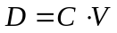 (6.13)
where D is the exposure dose, C is the concentration of microorganism, and D is the amount of the containment to which a person is exposed.

Exposure Pathways: Water, Air, Soil, and Food
Common routes of exposure include inhalation, ingestion, and dermal contact. Because dose-response data for microorganisms through dermal exposures are limited, this section primarily focuses on inhalation and ingestion as route of exposure. The amount of air inhaled, water and food ingested by an individual vary with age, sex, health condition, and activities. Personal exposure factors can be obtained from the literature or the U.S. Environmental Protection (U.E. EPA 1991; 1997). Table 6.2 summarizes common exposure pathways and parameters for case scenarios.

Eq. 13 shows how to calculate the exposure dose in the simplest way. It can be rewritten because the amount of contaminants a person contacts depends on the uptake rate and duration of exposure (Eq. 6.14).

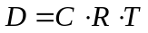 (6.14)

Where D is the exposure dose expressed as numbers of microorganisms inhaled or ingested (cfu or plaque forming unit (pfc)), C is the concentration of the microorganisms in air, water, food, or soil (cfu or pfu per liter (L) or gram (g)), V is the total volume or mass of air inhaled or water, food, or soil ingested (L⁻¹ or g⁻¹ or), R is the intake rate (L or g per time, e.g. hour, day, or year), and T is the exposure duration (hr, day, yr).

Example 6.2 Ingestion of Water
Scenario: Drinking water may contain low levels (1-20 pfu/1000L) of enteric viruses.

Task: Calculate a conservative annual exposure dose of enteric viruses for an adult and a child through drinking tap water.

Solution steps:
- Use the upper rage of concentration 20pfu/1000L and 90th percentile daily intake rates; adult 2.3 L/day and a child (1-10 years old) 1.3 L/day (Table 3-1) for making conservative estimates.
- Substitute the given and assumed parameters into the Eq. 6.14.

For an adult, D = 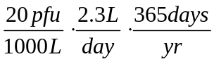= 17 pfu/yr

For a child D = 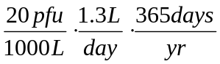 = 9 pfu/yr

Note: write down all units even if a calculation is easy.

Example 6.3 Air
Scenario: Bioaerosols in an office room were collected in AGI-30 impingers, which contained 20 mL of 0.3 mM phosphate buffer water, using a sampling pump with 12.5 L/min flow rate for 10 minutes. 20-mL samples were concentrated to 1 mL using Amicon centrifuge devices. From the concentrated samples, 100 μL were dispensed on TSA agar plates. On average, 10 colonies as total bacteria were observed from the plates after 24 hours incubation at 37ºC. Assume the impinger is 100% efficient in collecting bacteria in the room air.

Task: Estimate how many total bacteria an adult could inhale during a regular work day in the office. Assume that bacteria levels are constant and that air exchange and settling of bacteria are negligible.

Solution steps:
- Calculate bacterial concentrations in the air

=

=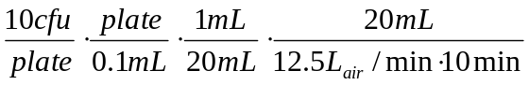= 0.8 cfu/L air

= total bacteria 800 cfu/m³ air

- Since the case scenario was in office, you could assume that the person’s job is desk work. The inhalation rate, R, for a sedentary adult indoors, from Table 1 is 0.5 m³/hr. You can assume that the exposure period, T, is a typical work day or 8 hours. Substitute the given and assumed parameters into the Eq. 2.

D = 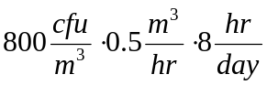= total bacteria 3200 cfu/working day

Table 6.3 Exposure pathways and personal exposure factors 1/2
Exposure pathway | Scenario | Intake | Confidence rating | Reference
Ingestion of potable water | Residential | 2 L/day (adult),  1 L/day (child), | Upper percentile | U.S. EPA 1980; 1991a,b
 |  | 0.30 L/day (1- 10 yrs old)  0.97 L/day (11-19 yrs old)  1.4 L/day (adult)  1.3 L/day (1- 10 yrs old)  1.7 L/day (11-19 yrs old)  2.3 (adult) | Mean  Mean  Mean  90th percentile  90th percentile  90th percentile | Ershow and Cantor 1989;  U.S.EPA 1997
 | Industrial | 1 L |  | U.S. EPA 1991b
Ingestion of water while swimming | Recreational | 50 mL/hr and 2.6 hr/swim |  | Covello and Merkhofer 1993
 |  | 20-50 mL/hr |  | WHO 2003
 |  | 37 (0-145) mL/45 min (child)  16 (0-53) mL/45 min (adult) | Mean  Mean | Dufour et al. 2006
Ingestion of soil and dust | Residential | 100 mg/day (child)  400 mg/day (child)  50 mg/day (adult) | Mean  Upper percentile  Mean | U.S. EPA 1997
 |  | 200 mg/day (child)  100 mg/day (adult) | Conservative mean | U.S. EPA 1991b
 |  | 10 g/day (Pica child) | Mean | Calabrese et al. 1989  U.S. EPA 1997
 | Industrial | 50 mg/day |  | U.S. EPA 1991b

Table 6.3 Exposure pathways and personal exposure factors 2/2
Exposure pathway | Scenario | Intake | Confident rating | Reference
Inhalation of contaminants | Residential | 20 m³/day (adult)  12 m³/day(child) |  | U.S. EPA 1991b
 | Industrial | 20 m³/day |  | U.S. EPA 1991b
 | Long-term | 15.2 m³/day (> 18 yrs old males)  11.3 m³ /day (> 18 yrs females)  15.3 /day (9-18 yrs males)  12.3 m³/day (9-18 yrs females)  7.4 /day (0-8 yrs old) | Mean | Layton 1993  U.S. EPA 1997
 | Short-term  (Indoor) | Activity (Adult and child)  Rest: 0.4 and 0.3 m³/hr  Sedentary: 0.5 and 0.4 m³/hr  Light: 1.0 and 1.0 m³/hr  Moderate: 1.6 and 1.2 m³/hr  Heavy: 3.2 and 1.9 m³/hr | Mean | Layton 1993  U.S. EPA 1997
Consumption of home growth produce | Agricultural | 42 g (fruit)  80 g (vegetable) |  | U.S. EPA 1991b
Consumption of locally caught fish | Recreational | 54 g |  | U.S. EPA 1991b

Exposure Pathway: Fomites
Fomites, which are inanimate objects or surfaces, can be easily contaminated with infectious organisms and thus that may play a key role in disease transmission and in the spread of pathogens (Boone and Gerba 2007). All microorganisms on a fomite do not necessarily transfer to a person’s hand when a person contacts the fomite. Similarly, a pathogen may not be transferred from a person’s hands to their mouth. The proportion of microorganism transferred affects exposure doses. Rusin et al. (2002) summarized transfer efficiencies of bacteria and phage from fomites to hands and from hand to mouth; these are shown in Table 6.4.

Table 6.4 Transfer efficiency (%) from fomite to hand and from hand to mouth
Organisms | Fomite-to-Hand |  | Hand-to-Mouth
Micrococcus luteus | Dishcloth  Sponge  Faucet  Carrot  Hamburger  Phone receiver  Laundry 100%cotton  Laundry 50:50 cotton/polyester | 0.04  0.03  40  0.21  0.06  42  0.13  0.06 | 41
PRD-1 (bacteriophage) | Dishcloth  Sponge  Faucet  Carrot  Hamburger  Phone receiver  Laundry 100%cotton  Laundry 50:50 cotton/polyester | 0.03  0.02  33  0.35  0.01  66  0.005  0.0005 | 34
Serratia rubidea | Dishcloth  Sponge  Faucet  Carrot  Hamburger  Phone receiver  Laundry 100%cotton  Laundry 50:50 cotton/polyester | 0.0045  0.0037  28  0.12  0.002  38  0.003  0.0009 | 34
Source: Rusin et al. 2002

Example 6.4 Fomite Exposure
Scenario: A person’s hands were contaminated with 1 mg of feces after he went to the bathroom. The person used a public phone and 10% of feces were transferred to the phone receiver.

Task: Calculate how many people could ingest at least one microorganism after the person contaminated the phone. Chose one microorganism listed below (Table 6.5) and assume that everyone put his or her hand to the lip (mouth) one time after using the phone.

Table 6.5 Concentration of enteric pathogens in feces
Microorganisms | Concentrations (g⁻¹)
Total coliform | 10⁷-10⁹
Fecal coliform | 10⁶-10⁹
Salmonella spp. | 10⁴-10¹¹
Shigella | 10⁵-10⁹
Ascaris | 10⁴-10⁵
Enteroviruses | 10³-10^{7a}
Rotavirus | 10^{10b}
Adenovirus | 10^{12b}
Protozoan parasites | 10⁶-10⁷
Source: Feachem et al. 1983
ªcell culture assays
^{b}electron microscopic observation of viral particle

Solution steps:
- For this example, we will use total coliforms. Use the concentration of total coliform in feces, 10⁹/g (Table 1) for this computation. The number of total coliform that could be transfered from the hand to phone were:
Total coliform = 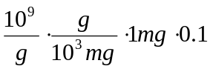= 10⁵ on a phone

- Make a table using Excel. Explain the equations you put into the Excel sheet. The first person could ingest 1.6 x 10⁴ (=10⁵x0.4x0.4), the 2nd person ingest residual from the first person times 0.16, and so on.

- 23 people could ingest at least one total coliform by using the contaminated phone.

Computations can be done using Microsoft Excel (Table 6.6)
Table 6.6 Summary Computation Table using Excel
 | A | B | C | D
1 | Person | Residual | Hand | Mouth
2 | 0 | 100000
3 | 1 | =B2-C3 | =B2*0.4 | =C3*0.4
4 | 2 | 36000 | 24000 | 9600
5 | 3 | 21600 | 14400 | 5760
6 | 4 | 12960 | 8640 | 3456
7 | 5 | 7776 | 5184 | 2074
8 | 6 | 4666 | 3110 | 1244
9 | 7 | 2799 | 1866 | 746
10 | 8 | 1680 | 1120 | 448
11 | 9 | 1008 | 672 | 269
12 | 10 | 605 | 403 | 161
13 | 11 | 363 | 242 | 97
14 | 12 | 218 | 145 | 58
15 | 13 | 131 | 87 | 35
16 | 14 | 78 | 52 | 21
17 | 15 | 47 | 31 | 13
18 | 16 | 28 | 19 | 8
19 | 17 | 17 | 11 | 5
20 | 18 | 10 | 7 | 3
21 | 19 | 6 | 4 | 2
22 | 20 | 4 | 2 | 1
23 | 21 | 2 | 1 | 1
24 | 22 | 1 | 1 | 0

risk Characterization and management
Once you estimate exposure dose, the probabilistic infectious risks can be calculated by plugging obtained doses into infectious dose-response models (exponential or Beta-Poisson). If a dose-response model for a particular route of exposure is not available for the target microorganism, you may need to use available parameters for other similar microorganisms or another exposure route. For exposure assessment, it is important to state all assumptions and parameters you used for the calculation.

Retrospective Assessment
Exposure can also be approached backward from risk characterization to exposure assessment. For example, if you know an infectious risk, you could estimate the number of microorganisms ingested or concentrations of contaminants. Exponential and Beta Poisson models can be rewritten for this approach (Eqs. 6.15 and 6.16) and the corresponding concentration of microorganisms can be estimated using equation 5.

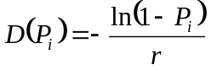 (6.15)

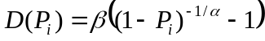 (6.16)

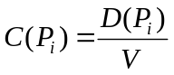 (6.17)

Where P_{i} is the probability of infection (ability of the organism to establish and reproduce in the human host), D is the exposure dose expressed as numbers of microorganisms ingested, V is the volume of contaminant intake and α, β, r are constants for specific organism that define the dose-response in an Exponential or Beta Poisson model. Another version of the beta-Poisson model frequently used in microbial risk assessment is given in equation 6.18:

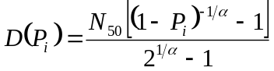 (6.18)

Where N₅₀ is the median infectious dose (the dose at which 50% of the population is infected).

Example 6.5 Retrospective Exposure Assessment
Scenario: A local health department reported that 1% of people who purchased fresh vegetable from an organic market infected with E. coli O157. Prior studies have shown that the dose-response data for ingestion exposure to E. coli O157 are best fit by the beta-Poisson dose-response model and that the parameters of the model are β=1.78×10⁶ and α=0.178.

Task: Estimate the concentration of E. coli O157 in the vegetable.

Solution steps:
- Use the dose-response parameters for pathogenic E. coli and plug the parameters to the revised version of Bata-Poisson equation (Eq. 4).
= 1.78×10⁶ × ((1-0.01)^(-1/0.178)-1) = 10⁵ of E.coli O157 could be ingested
- Estimate the concentration of E. coli O157 in the contaminated vegetable. Assume that people ate 80 g of the vegetable (Table 1). Using Eq. 5,

= 10⁵/80g = 1250/g

Exposure Reduction
Chlorination and boiling of water and heating of food are practices that have been used to reduce concentrations of microorganisms in food and water for centuries. Despite the introduction of advanced technologies for reduction in pathogens or inactivation of pathogens into water and wastewater treatment plants and the food industry, many outbreaks still occur worldwide. Recently, novel means for air and hand sanitation have become popular means for reducing microbial numbers. QMRA can be a useful tool to examine or estimate the reductions of microorganisms necessary to protect public health.

Example 6.6 Hand Wash
Scenario: A graduate student went to a wastewater treatment plant to collect untreated wastewater samples for his research. During sampling, 1 mL of raw sewage splashed onto his bare hands. He washed his hands afterward using an antibiotic soap, which claims to kill 99% of bacteria. The concentrations of microorganisms in the raw sewage are given in Table 6.7.

Tasks:
- Estimate how many fecal coliforms (note that fecal coliforms are a class of “indicator organisms”) are still on his hands after washing.
- How many total reductions are required to reduce fecal coliform level to be less than 1 cfu on the hands?

Table 6.7 Microorganism concentrations in untreated municipal wastewater
Microorganisms | Concentrations (100 mL⁻¹)
Fecal coliforms | 10⁵-10⁷
Fecal streptococci | 10⁴-10⁶
Clostridium perfringens | 10³-10⁵
Salmonella | 10²-10⁴
Shigella | 1-10³
Pseudomonas aeruginosa | 10³-10⁴
Enteric viruses | 10³-10⁴
Helminth ova | 1-10³
Giardia lamblia cysts | 10-10⁴
Cryptosporidium oocysts | 10-10⁵
Entamoeba histolytica cysts | 10²-10⁵
Source: National Resource Council 1996

Solution steps:

- Calculate the initial concentration of fecal coliform on the grad student’s hands
M_{initial} = 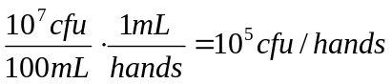

- Calculate the final concentration using Eq. 5
= 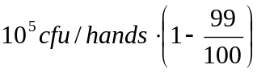= 10³cfu/hands

- Calculate desirable reduction using Eq. 6.1

Reduction > > 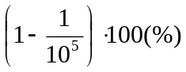

> 99.999% or 5 log₁₀ reduction

Effectiveness of microbial reduction varies with the species of microorganism and type of water treatment (Table 6.8 and 6.9). Clearly wastewater treatment plants have lower removals of microorganisms compared with drinking water plants. As a result, high concentrations of microbes may be released into rivers, lakes, and oceans where humans could be exposed to pathogens during recreational activities. Although drinking water plants remove microbes more effectively, treatment may not good enough for certain pathogens or for highly contaminated source waters.

Table 6.8 Typical removal (%) of microorganisms by conventional wastewater treatment
 | Primary Treatment | Secondary Treatment
Microorganisms |  | Activate Sludge | Trickling Filter
Fecal coliform | <10 | 0-99 | 85-99
Salmonella | 0-15 | 70-99 | 85-99+
Shigella | 15 | 80-90 | 85-99
Mycobacterium tuberculosis | 40-60 | 5-90 | 65-99
Entamoeba histolytica | 0-50 | Limited | Limited
Helminth ova | 50-98 | Limited | 60-75
Enteric viruses | Limited | 75-99 | 0-85
Source: Crook 1992

Table 6.9 Removal (log₁₀) of microorganisms at a reclamation facility in Petersburg, FL
Microorganisms | Activate Sludge & Clarification | Filtration | Chlorination | Storage | Overall
Total coliforms | 1.75 | 0.51 | 4.23 | 0.61 | 7.10
Fecal coliforms | 2.06 | 0.05 | 4.95 | 0.36 | 7.42
Phage | 0.75 | 3.81 | 1.03 | 1.03 | 6.62
Enterovirus | 1.71 | 0.81 | 1.45 | 1.04 | 5.01
Giardia | 1.19 | 2.00 | 0.65 | 0.30 | 4.14
Cryptosporidium | 1.14 | 1.68 | 0 | 0.04 | 2.86
Source: Rose et al. 1996

Example 6.7 Water/Wastewater Treatments
Scenario: A reclamation facility uses raw sewage as a source of water.

Task: How many log₁₀ reductions are required to protect public health? Assume that the sewage contains the following concentrations of pathogens: rotavirus (enteric virus) 10⁴/100mL, Shigella 10³/100mL, and Cryptosporidium 10⁵/100mL.

Solution steps:
- Calculate a daily acceptable infectious risk. Use U.S. EPA’s suggested acceptable annual infection risk for drinking water, which is 1/10,000 (10⁻⁴).

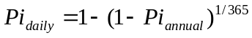= 2.74 x 10⁻⁷ (6.19)

- Calculate daily intake doses that may cause 2.74 x 10⁻⁷ infection based on probabilistic dose-response models (exponential and Beta-Poisson)

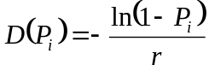 (6.15)

(6.16)

D(P_{i}) = 4.62 x10⁻⁷ for rotavirus, 5.61 x10⁻⁵ for Shigella, and 6.52 x10⁻⁵ for Cryptosporidium.

- Calculate microbial concentrations that meet daily acceptable risk. Assume that people drink 2 L of water daily.

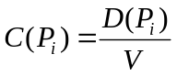 (6.18)

C(P_{i}) = 2.31 x10⁻⁷ pfu/L 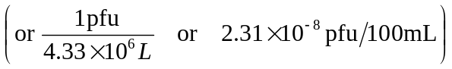for rotavirus, 2.81 x10⁻⁵ cfu/L 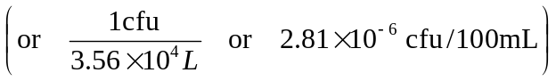for Shigella, and 3.26 x10⁻⁵ oocysts/L 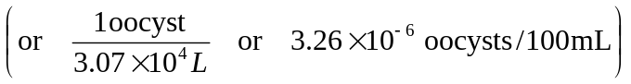for Cryptosporidium.

- Calculate the desirable reduction using Eq. 4 (note that concentration may be used instead of number of microorganisms).

Log₁₀ reduction = 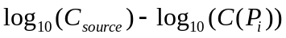

= 12 log₁₀ reduction for rotavirus
= 8.6 log₁₀ reduction for Shigella
= 11 log₁₀ reduction for Cryptosporidium

Computations can be done using Microsoft Excel (Table 6.10)

Table 6.10 Summary Computation Table using Excel
 | A | B |  | C |  | D |  | E
1 |  |  | Pathogens
2 |  | Parameters | Rotavirus |  | Shigella |  | Cryptosporidium
3 |  | Dose-Response
4 |  | a | 0.2531 |  | 0.210
5 |  | B | 0.4265 |  | 43
6 |  | r |  |  |  |  | 0.0042
7
8 |  | Infectious risk, Pi | Exposure dose that may cause infection, D(Pi)
9 | annual | 0.0001 | =$C$5*((1-B9)^(-1/$C$4)-1) |  | 2.04E-02 |  | =-(LN(1-B9)/$E$6)
10 | daily | =1-(1-B9)^(1/365) | 4.62E-07 |  | 5.59E-05 |  | 6.52E-05
11
12 |  | Water intake (L) | Microbial concentrations that may cause infection, C(Pi)
13 |  | 2 | 2.31E-07 |  | =D10/B13 |  | 3.26E-05
14
15 |  |  | Raw sewage concentration, C(source)
16 |  |  | 1.00E+05 |  | 1.00E+04 |  | 1.00E+06
17
18 |  |  | Log Reduction
19 |  |  | =-LOG(C13/C16) |  | 8.6 |  | 10

References
Boone S.A. and Gerba, C.P. 2007. Significance of fomites in the spread of respiratiory and enteric virus disease. Applied and Environmental Microbiology, 76 (6), 1687-1696
Calabrese, EJ., Pastides, H., Barnes, R., Edwards, C., Kostecki, PT., et al. (1989) How much soil do young children ingest: an epidemiologic study. In: Petroleum Contaminated Soils, Lewes Publishers, Chelsea, MI, pp. 363-397
Covello, VT and Merkhofer, MV. (1993) Risk assessment methods. Plenum Pres, New York.
Crook, J. (1992) Water reclamation. In Encyclopedia Physical Science and Technology, vol. 17, 55-589
Dufour, AP., Evans, O., Behymer, TD., and Cantu, R. (2006) Water ingestion during swimming activities in a pool: A pilot study. Journal of Water and Health, 425-429
Ershow, AG. and Cantor, KP. (1989) Total water and tapwater intake in the Unite States: population-based estimates of quantities and sources. Life Sciences Research Office, Federation of American Societies for Experimental Biology.
Layton, DW. (1993) Metabolically consistent breathing rates for use in dose assessments. Health Physics 64 (1):23-36
Rose, JB., Dickinson, LJ., Farrah, SR., and Carnahan, RP. (1996) Removal of pathogenic and indicator microorganisms by a full-scale water reclamation facility. Wat. Res. 30(11): 2785-2797
Rushin, P., Maxwell, S. and Gerba, C.P. 2002. Comparative surface-to-hand and fingertip-to-mouth transfer efficiency of gram-positive bacteria, gram-negative bacteria and phage. Journal of Applied Microbiology, 93, 585-592
U.S. Environmental Protection Agency (EPA) (1980) Water quality criteria documents; availability. Federal Register, 45 (231):79318-79379. U.S. EPA, Washington DC.
U.S. Environmental Protection Agency (EPA) (1991a) National Primary Drinking Water Regulation; Final Rule. Federal Register, 56 (20):3526-3597. U.S. EPA, Washington DC.
U.S. Environmental Protection Agency (EPA) (1991b) Human Health Evaluation Manual, Supplemental Guidance: Standard Default Exposure Factors, OSWER Directive 9285.6-03, U.S EPA, , Washington DC.
U.S. Environmental Protection Agency (EPA) (1997) Exposure Factor Handbook. U.S EPA, National Center for Environmental Assessment, Washington DC.
World Health Organization (WHO) (2003) Guideline for Safe Recreational Water Environments. Vol. 1, Coastal and Fresh Waters, WHO, Geneva, Switzerland

Chapter 7???

Chapter 8

Fate and Transport Models: Indoor Air/Fomites

Mark Nicas

GOAL
To learn the mechanics of posing and running (in MATAB® software) simple fate-and-transport models based on Markov chain techniques. This type of model will be applied to the fate and transport of microbes in air and on environmental surfaces.

DEFINITIONS
first-order rate constant: a constant (often denoted by the symbol λ) with the unit of inverse time, for example, min⁻¹. If the constant λ describes the loss rate of some quantity, and if [t, t + Δt] denotes a small time interval, the product λ × Δt is the fraction of the quantity present at time t that is lost in the interval [t, t + Δt].

well-mixed room (space): a room (space) in which a contaminant released into the air is instantaneously (or very rapidly) dispersed throughout the room (space) such that the contaminant concnetration is the same at all locations within the room (space)

When particles (whether inanimate or containing microbes) are released into air, they can disperse via air currents and can settle to the ground via gravity. If the behavior of individual particles is treated as mutually independent, and if the mechanisms by which particles move are described by “first-order rate constants” (see the Definitions section), the movement of the particles between different physical compartments can be modeled by a set of differential equations. If there is only one compartment considered, for example, a room in which the air is termed “well-mixed” (see the Definitions section), the analytical solution for the particle concentration in room air or particle number deposited onto the room floor is relatively easy to derive. However, if there are two or three compartments (e.g., interconnected rooms or different areas within a room) being considered, the analytical solutions are more tedious to derive. If there are more than five compartments, it is not possible to derive analytical solutions, and numerical methods must be used. In general, the solution to a differential equation is a deterministic value, which is to say that if the model inputs are always the same, the equation output is always the same.

A relatively simple numerical method for analyzing time-dependent transfer between different physical compartments is a Markov chain. The mechanics of the Markov chain technique will be explained by way of an example involving particle release into the air of an empty well-mixed room. Because the example is simple, we will first describe the analytical solution.

EXAMPLE 8.1 Scenario and Analytical Solution
The room has volume V (m³) and height H (m). Air flows into and out of the room at rate Q (m³/min). The ratio Q ÷ V is the number of room air changes per minute, min⁻¹. Note that the ratio Q ÷ V multiplied by 60 is the number of room air changes per hour. Consider V = 100 m³ and Q = 5.0 m³/min, such that Q ÷ V = 0.050 min⁻¹ (3 air changes per hour), and consider H = 3.0 m.
Assume that N spherical particles, each 5.0 μm in diameter, are instantaneously released into room air. The particles have unit density (equal to one g/cc, the density of water at 20 ºC). The aerodynamic diameter (d_{a}, μm) of a spherical unit-density particle is equal to the particle’s physical diameter, so for each of the N particles, d_{a} = 5 μm. A particle released into air quickly attains a terminal settling velocity (V_{TS}, m/min) given by:
V_{TS} = 0.0018 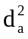 [1 + (0.166/d_{a})]. This expression is satisfactory for particles with d_{a} up to 50 μm. For d_{a} = 5.0 μm, V_{TS} = 0.046 m/min.

If we ignore particle deposition onto the room walls and ceiling (generally negligible compared to deposition onto the floor), the two mechanisms of particle loss from room air are the exhaust ventilation airflow and gravitational settling onto the floor. Each of these loss mechanisms can be described by a first-order loss rate constant.

λ₁ = Q ÷ V is the first-order loss rate constant for particle loss from room air via air flow out of the room. In our example with V = 100 m³ and Q = 5 m³/min, λ₁ = 0.050 min⁻¹. For a particle released into room air that is well-mixed (such that air is moving and not stagnant), the first-order loss rate due to gravitational settling is given by: λ₂ = V_{TS} ÷ H, min⁻¹. In our example with V_{TS} = 0.046 m/min and H = 3 m, λ₂ = 0.015 min⁻¹. Given only two particle loss mechanisms from room air, the overall particle loss rate is the sum of the first-order loss rate constants: λ₁ + λ₂ = 0.050 min⁻¹ + 0.015 min⁻¹ = 0.065 min⁻¹.

It can be shown that the analytical solution for the particle concentration in room air
(C, #/m³) subsequent to the time of release (taken as t = 0) is the following:

C(t), #/m³ = 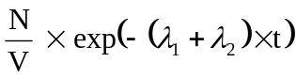 (8.1)

For the inputs N = 1.0 × 10⁶, V = 100 m³, and λ₁ + λ₂ = 0.065 min⁻¹, the equation is:

C(t), #/m³ = (1.0 × 10⁴) × exp(− 0.065 × t)

A graph of the time-dependent particle concentration is shown in Figure 8.1. At 120 minutes after particle release, we expect the particle concentration to have decreased from 10,000 per m³ to 4.1 per m³. This also signifies that at 120 minutes after particle release, 999,590 of the particles released into room air are no longer present in room air, and that 410 particles remain in room air; the latter number is the fraction 0.00041 of the particles released. We can use the constants λ₁ + λ₂ to apportion the loss pathways. A fraction λ₁ ÷ (λ₁ + λ₂) = 0.7692 is lost via exhaust ventilation, and a fraction λ₂ ÷
(λ₁ + λ₂) = 0.2308 is lost via deposition onto the floor. In turn, at 120 minutes after particle release, the number of particles removed from room air via exhaust ventilation versus floor deposition is, respectively, 999,950 × 0.7692 and 999,950 × 0.2308. Finally, at 120 minutes after particle release, the fraction of the original 1 × 10⁶ particles removed from room air via exhaust ventilation is 0.7692 × (1 − 0.00041) = 0.76888, and the fraction removed via floor deposition is 0.23 × (1 − 0.00041) = 0.23071. Note that: 0.00041 + 0.76888 + 0.23071 = 1. Thus, we have accounted for the fate of all the particles released.

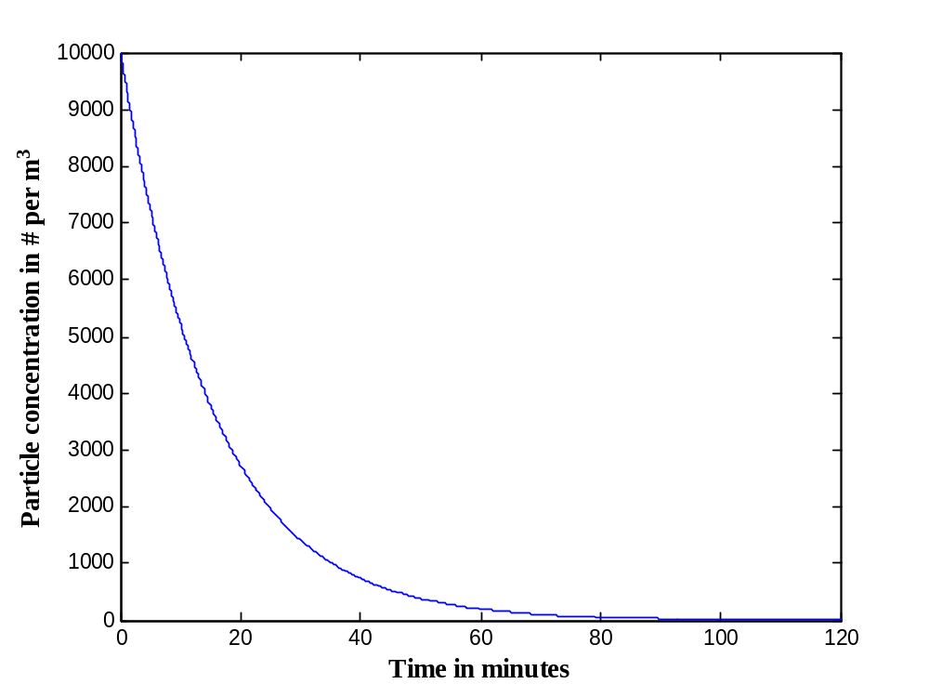

Figure 8.1 Time-dependent particle concentration

EXAMPLE 8.2 The Markov Chain Method
Analysis of the same scenario via the Markov chain method proceeds as follows. Consider a small time step Δt equal to, say, 0.01 minute. The probability that a particle present in room air at some time t remains in room air at time t + Δt is:

Probability Particle Remains in Room Air in Interval Δt =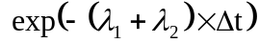 (8.2)

This probability does not depend on the actual time t, only on the length of the time step Δt. The probability that the particle leaves room air in the interval Δt is the complement:

Probability Particle Leaves Room Air in Interval Δt = 1 − (8.3)

Given that the particle leaves room air in interval Δt, the conditional probability that it leaves via exhaust ventilation is:

Conditional Probability Particle Leaves via Exhaust Ventilation = 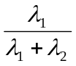 (8.4)

Similarly, given that the particle leaves room air in interval Δt, the conditional probability that it leaves via floor deposition is:

Conditional Probability Particle Leaves via Floor Deposition = 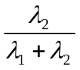 (8.5)

The unconditional probability that the particle leaves room air via exhaust ventilation in interval Δt is:

Unconditional Probability Particle Leaves Room Air via Exhaust Ventilation

= ×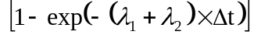 (8.6)

The unconditional probability that the particle leaves room air via floor deposition in interval Δt is:

Unconditional Probability Particle Leaves Room Air via Floor Deposition

= × (8.7)

Next, denote room air as state (compartment) 1, denote being exhausted out of the room as state (compartment) 2, and denote being deposited onto the room floor as state (compartment) 3. In interval Δt, the probability that a particle present in room air at the start of the interval remains in room air is denoted p₁₁, which is equal to the right-hand side of Equation (8.2). In interval Δt, the probability that a particle in room air at the start of the interval is exhausted from the room is denoted p₁₂, which is equal to the right-hand side of Equation (8.6). In interval Δt, the probability that a particle in room air at the start of the interval deposits onto the room floor is denoted p₁₃, which is equal to the right-hand side of Equation (8.7). The sum of the three probabilities is one:

p₁₁ + p₁₂ + p₁₃ = 1 (8.8)

Thus, for a particle present in room air at the start of the interval, we have accounted for all the places where a particle can be at the end of the interval.

What if a particle had already been exhausted from the room (in state 2) or had already deposited onto the room floor (in state 3) at the start of the interval? If we do not permit particle re-entry into room air via the supply airflow or via resuspension from the floor, then particles that enter states 2 and 3 never leave. For exhausted particles, this signifies that: p₂₁ = 0, p₂₂ = 1, and p₂₃ = 0. For deposited particles, this signifies that: p₃₁ = 0,
p₃₂ = 0, and p₃₃ = 1.

Next, we create a matrix P with three rows and three columns. Each row represents a state (where the row number equals the state number), and each column represents a state (where the column number equals the state number). The cell entries are:

P = 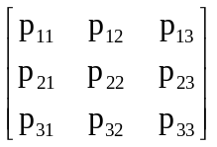 (8.9)

A square matrix P in which the sum of the entries in each row equals one is termed a Markov matrix. P is also termed a single-step transition probability matrix because it contains the probabilities of moving between states in one time step. In our scenario for which λ₁ = 0.050 min⁻¹, λ₁₂ = 0.015 min⁻¹, and Δt = 0.01 min:

P = 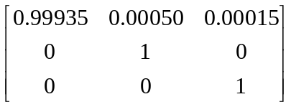 (8.10)

The time course of particle movement is tracked via matrix multiplication. After n time steps (for which t = n × Δt), the expected proportion of particles starting in state 1 that are present in state 1 is the entry in the first cell and first row of the matrix P^{n}, which is the matrix P multiplied by itself n times. This proportion is denoted 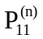. In general, 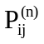 denotes the probability that a particle starting in state i is in state j after n time steps. To illustrate, for the matrix P defined by Equation (8.10), the matrix P³ is:

P³ = P × P × P = 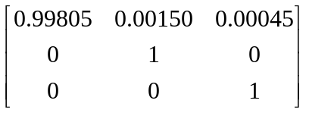

Thus, 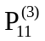 = 0.99805, 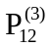 = 0.00150, and 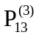 = 0.00045. Note that: + + = 1. The entries in the first row (in fact, in every row) of the P^{n} matrix sum to one, which signifies that we have accounted for the fate of all the particles released. After n time steps, the particle concentration in state 1 (room air) is:

C(t = n × Δt), #/m³ = 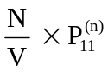 (8.11)
A graph of C(t) in Equation (8.11) over 12,000 time steps (120 minutes) would be coincident with the curve shown in Figure 1. In other words, the numerical solution for C(t) via the Markov chain is the same as the analytical solution for C(t).

The matrix P¹²⁰⁰⁰ is as follows:

P¹²⁰⁰⁰ = 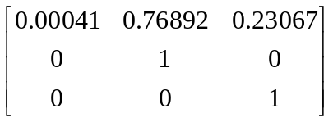

The three proportions in the first row are the proportions of particles in, respectively, state 1 (room air), state 2 (exhausted from the room) and state 3 (deposited on the room floor) at 120 minutes after particle release. They are essentially the same values that we previously computed based on the analytical solution and the λ₁ and λ₂ values, and they sum to one.

A MATLAB code that implements the numerical solution for this scenario, and generates a graph like Figure 8.1.

EXAMPLE 8.3 An airborne pathogen scenario
We consider a hypothetical scenario in which three empty rooms (A,B,C) are connected in series (see Figure 8.2 below). Each room has the same floor area FA (m²), the same height H (m), and the same volume V (m³) equal to FA × H. There is a general supply/exhaust airflow from left to right, such that clean air enters room A at rate Q (m³/min), flows from room A to room B at rate Q, flows from room B to room C at rate Q, and then leaves room C to the building exterior at rate Q. In addition to the overall bulk airflow at rate Q, there is air exchange between rooms A and B at rate β (m³/min), and between rooms B and C at rate β (m³/min). We assume the air within each room is well mixed, but mixing between rooms is limited by the rate β.

Q
Q

β
Room A
Room B
Room C

Figure 8.2 Hypothetical scenario

A total of N pathogens contained in particles with d_{a} = 3 μm are released into the air of room A at time zero. Airborne particles containing pathogens can settle onto the floor by gravity, and can be carried out of a room by air flow. In addition, airborne pathogens can die due to environmental stress with first-order rate λ_{dieoff} (min⁻¹). For simplicity, we assume that pathogens in settled particles cannot be resuspended into room air, but settled pathogens can also die with first-order rate λ_{dieoff}. Note that for a given pathogen, the die-off rate in air may differ markedly from the die-off rate on surfaces.

We have two questions. First, what is the time course of the concentration in air of viable pathogens in each room from t = 0 to t = 60 minutes subsequent to release? Second, at
t = 60 minutes, what is the average density (# per m²) of viable pathogens on the floor surface of each room?

We proceed by identifying the number of states (compartments) to be considered, the first-order loss rate constants for the viable pathogens, and the single-step transition probabilities. Numerical values for the factors FA, H, V, Q, β, V_{TS}/H, λ_{dieoff}, N and Δt will be assigned subsequently.

The air in each room is represented as a state, and the floor surface in each room is represented as a state. The death of a pathogen in the air or on the floor of any room is a state, and being exhausted to the building exterior is the final state. Thus, we have eight states in the Markov chain, and need an 8×8 P matrix. Because pathogens that die or are exhausted cannot move to another state, we could combine the death and exhaust states into a single state and use a 7×7 matrix to answer our questions. However, for clarity, we treat pathogen death and exhaust as separate states. Denote the air and floor of room A as, respectively, states 1 and 2. Denote the air and floor of room B as, respectively, states 3 and 4. Denote the air and floor of room C as, respectively, states 5 and 6. Denote pathogen death as state 7, and being exhausted from the system as state 8.

Loss Rates from State 1(Room A Air): There is airflow out of room A to room B at rate
Q + β, so the corresponding first-order rate of loss is: λ_{AB} = (Q + β) ÷ V, min⁻¹. Particles have a terminal settling velocity V_{TS}, and are lost to the floor of room A with first-order loss rate constant: λ_{settle} = V_{TS} ÷ H, min⁻¹. Note that because all three rooms have the same height H, λ_{settle} is the same value in all rooms. Pathogens die off at rate λ_{dieoff}. Thus, in one time step Δt:

p₁₁ = 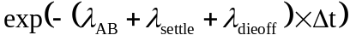

p₁₂ = 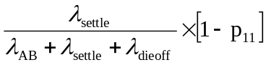

p₁₃ = 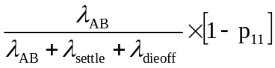

p₁₇ = 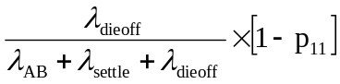

Note that p₁₄, p₁₅, p₁₆ and p₁₈ are all zero. In one time step, a pathogen in the air of room A cannot settle onto the floor of room B or room C, and cannot be directly exhausted out of the system. The particle must first move into the air of room B (from which it can settle onto the floor of room B), and from there move into the air of room C (from which it can settle onto the floor of room C or be exhausted).

Loss Rates from State 2(Room A Floor): There is no removal by airflow or resuspension into air to consider. Pathogens on the floor surface die off at rate λ_{dieoff}. Thus, in one time step Δt:

p₂₂ = 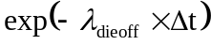

p₂₇ = 1 − p₂₂

Loss Rates from State 3 (Room B Air): There is airflow out of room B to room A at rate
β, so the corresponding first-order rate of loss is: λ_{BA} = β ÷ V, min⁻¹. There is airflow out of room B to room C at rate Q + β, so the corresponding first-order rate of loss is:
λ_{BC} = (Q + β) ÷ V, min⁻¹. Particles are lost to the floor of room B at rate λ_{settle}. Pathogens die off at rate λ_{dieoff}. Thus, in one time step Δt:

p₃₃ =

p₃₁ = 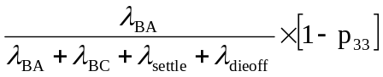

p₃₄ = 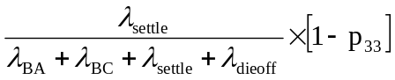

p₃₅ = 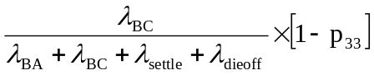

p₃₇ = 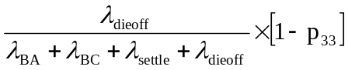

Loss Rates from State 4 (Room B Floor): There is no removal by airflow or resuspension into air to consider. Pathogens on the floor surface die off at rate λ_{dieoff}. Thus, in one time step Δt:

p₄₄ =

p₄₇ = 1 − p₄₄

Loss Rates from State 5 (Room C Air): There is airflow out of room C to room B at rate
β, so the corresponding first-order rate of loss is: λ_{CB} = β ÷ V, min⁻¹. There is exhaust airflow out of room C to the exterior of the building at rate Q, so the corresponding first-order rate of loss is: λ_{EXHAUST} = Q ÷ V, min⁻¹. Particles are lost to the floor of room C at rate λ_{settle}. Pathogens die off at rate λ_{dieoff}. Thus, in one time step Δt:

p₅₅ =

p₅₃ = 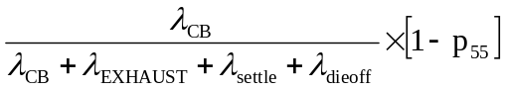

p₅₆ = 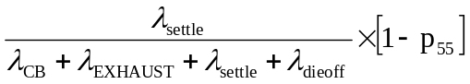

p₅₇ = 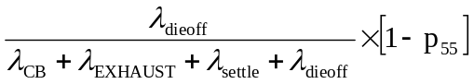

p₅₈ = 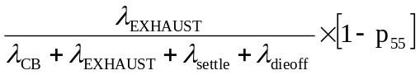

Loss Rates from State 6 (Room C Floor): There is no removal by airflow or resuspension into air to consider. Pathogens on the floor surface die off at rate λ_{dieoff}. Thus, in one time step Δt:

p₆₆ =

p₆₇ = 1 − p₆₆

Loss Rates from State 7 (Pathogen Death): There is no removal from this state, which signifies that p₇₇ = 1.

Loss Rates from State 8 (Exhaust from the System): Because pathogens are assumed not to re-enter the system once exhausted, there is no removal from this state, which signifies that p₈₈ = 1.

Assign the Input Values: At this point, the conceptual work of identifying the loss rates and the single-step transition probabilities is completed. Now we assign numerical values for the factors FA, H, V, Q, β, V_{TS}, λ_{dieoff}, N and Δt. For each room, let FA =
33.3 m² (about 19 ft × 19 ft), and let H = 3.0 m (about 10 ft) such that V = 100 m³. Let
Q = 5 m³/min (or 3 air changes per hour per room) and let β = 5 m³/min. For d_{a} = 3 μm,
V_{TS} = 0.017 m/min. Let λ_{dieoff} = 0.011 min⁻¹, which corresponds to a half life of about one hour. Let N = 1.0 × 10⁶. Let Δt = 0.01 min. It follows that:

λ_{AB} = (Q + β) ÷ V = (10 m³/min) ÷ (100 m³) = 0.10 min⁻¹

λ_{BA} = β ÷ V = (5 m³/min) ÷ (100 m³) = 0.050 min⁻¹

λ_{BC} = (Q + β) ÷ V = (10 m³/min) ÷ (100 m³) = 0.10 min⁻¹

λ_{EXHAUST} = Q ÷ V = (5 m³/min) ÷ (100 m³) = 0.050 min⁻¹

λ_{settle} = V_{TS} ÷ H = (0.017 m/min) ÷ (3.0 m) = 0.0057 min⁻¹

λ_{dieoff} = 0.011 min⁻¹, as given

In turn: p₁₁ = = 0.99883

p₁₂ = (0.0057 /0.1167) × [1 − 0.99883] = 0.000057

p₁₃ = (0.10/0.1167) × [1 − 0.99885] = 0.0010

p₁₇ = (0.011/0.1167) × [1 − 0.99885] = 0.00011

p₂₂ = 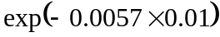 = 0.99989

p₂₇ = 0.00011

p₃₃ = = 0.99833

p₃₁ = (0.05 /0.1667) × [1 − 0.99833] = 0.00050

p₃₄ = (0.0057 /0.1667) × [1 − 0.99833] = 0.00057

p₃₅ = (0.10 /0.1667) × [1 − 0.99833] = 0.0010

p₃₇ = (0.011 /0.1667) × [1 − 0.99833] = 0.00011

p₄₄ = = 0.99989

p₄₇ = 0.00011

p₅₅ = = 0.99883

p₅₃ = (0.05 /0.1167) × [1 − 0.99883] = 0.00050

p₅₆ = (0.0057 /0.1167) × [1 − 0.99883] = 0.000057

p₅₇ = (0.011 /0.1167) × [1 − 0.99883] = 0.00011

p₅₈ = (0.05 /0.1167) × [1 − 0.99883] = 0.00050

p₆₆ = = 0.99989

p₆₇ = 0.00011

These p_{ij} values are entered into an 8×8 matrix P, for which the row number corresponds to the state number. The matrix P is successively multiplied by itself 6,000 times. The concentrations of viable pathogens in the air of room A, B and C at time t (where t = n × Δt) subsequent to pathogen release are given by the following respective equations:

C_{roomA}(t = n × Δt), #/m³ = (8.12)

C_{roomB}(t = n × Δt), #/m³ = 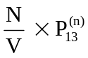 (8.13)

C_{roomC}(t = n × Δt), #/m³ = 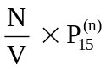 (8.14)

Figure 8.3 answers the first question that was posed, namely, what is the time course of the airborne viable pathogen concentrations in the three rooms from t = 0 to
t = 60 minutes. The answer to the second question concerning the average density
(# per m²) of viable pathogens on the floor surfaces at t = 60 minutes can be obtained from the matrix P⁶⁰⁰⁰. The relevant quantities are: 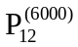 = 0.0431, 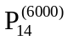 = 0.0358, and 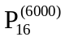= 0.0306. Given N = 1.0 × 10⁶ and a floor area of 33.33 m² in each room, it follows that the viable pathogen densities on the floor surfaces are:

Room A: 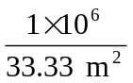 × 0.0431 = 1,293 per m²

Room B: × 0.0358 = 1,074 per m²

Room C: × 0.0306 = 918 per m²

A MATLAB code that implements the numerical solution for this scenario, and generates Figure 8.3

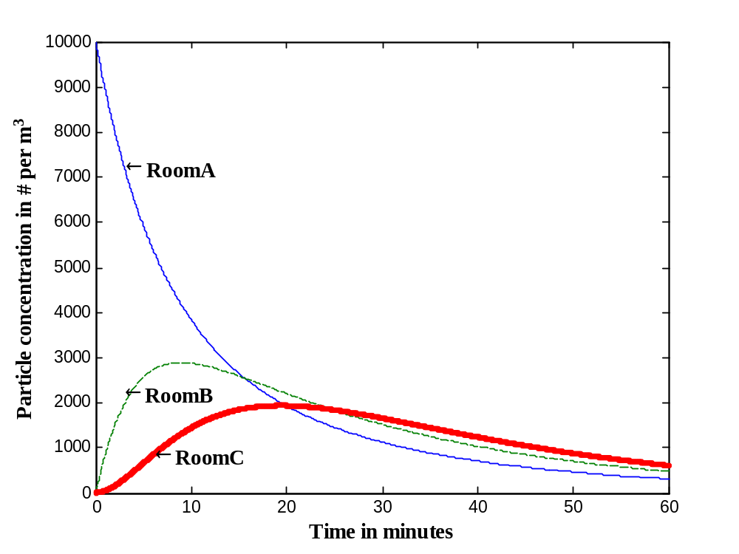
Figure 8.3 Particle concentrations in room A, B, and C

Additional Ideas on Modeling Particle Fate and Transport
Emitted particles are rarely uniform in size, but instead comprise a mixture of sizes. Because the particle settling rate λ_{settle} depends on particle aerodynamic diameter, each particle size or small range of particles sizes should be considered separately, and the final answer should be an appropriate combination of the answers for each particle size. For example, in the previous scenario, what if 1.0 × 10⁶ pathogens associated with particles having d_{a} = 30 μm were released into the air of room A, along with the 1.0 × 10⁶ pathogens associated with particles having d_{a} = 3 μm? The overall pathogen concentration in air and the pathogen density on the floor is the sum of the solutions for the pathogens associated with each particle size. The concentration in room A air increases two-fold at the outset, but there are much smaller increases in the pathogen concentration in the air of rooms B and C. At t = 60 minutes after release, the viable pathogen concentrations on the floor of rooms A, B and C are, respectively, 29,100 per m², 6,010 per m², and 2,400 per m², which is a 12-fold range. When we considered only the 3 μm particles, the correspond-ing deposition values were 1,290 per m², 1,070 per m² and 920 per m², which is a 1.4-fold range. The reason for the 23-fold increase on the floor of room A (29,100 per m² versus 1,290 per m²) and the greater range of values across the three rooms (12-fold versus 1.4-fold) is that the 30 μm particles rapidly settle, so only a small portion ever leave room A. This fact also accounts for the minor increase in the pathogen concentra-tion in the air of rooms B and C despite the release of twice as many pathogens.

An important transport mechanism within a room is turbulent eddy diffusion. Air is always in motion, and a good deal of the motion can be viewed as random. One can envision that a random eddy or swirl of air grabs a small packet of particles and moves the particles to a nearby location, then another eddy or swirl of air grabs some of the latter particles and moves them to a different nearby location, and so forth. In probabilistic terms, turbulent eddy diffusion signifies that the particles take a three-dimensional random walk in room air. In fact, the equation for diffusion in three dimensional space is based on this random walk assumption. The random walk can be understood in discrete time as follows. At the start of a time step, a particle flips three fair coins. The outcome of the first coin flip (heads or tails) indicates which direction the particle moves on the x-axis, the outcome of the second coin flip indicates which direction the particle moves on the y-axis, and the outcome of the third coin flip indicates which direction the particle moves on the z-axis. This turbulent eddy motion can be superimposed on an average directional air flow termed bulk advective flow (which is termed “drift” in random walk theory).

Particle (and molecule) transport by turbulent eddy diffusion can be incorporated into the Markov chain model as a first-order rate constant, but this requires conceptually segment-ing room air into a reasonably large number of small compartments. In any time step, three transport mechanisms can act on a particle in an interior room air cell – turbulent eddy diffusion, bulk advective air flow, and gravitational settling. Due to the greater number of states in the Markov matrix (on the order of hundreds to thousands), the computer coding is more complicated than the simple Matlab codes that have been presented. One of the readings describes a Markov chain fate-and-transport model for molecular contaminants that incorporates turbulent eddy diffusion. Validation of the predictive ability of an analogous Markov chain fate-and-transport model for particles is a current research focus of the author.

Finally, particles can deposit onto the walls and ceilings of a room by mechanisms other than gravitational settling. For relatively large particles with d_{a} > 10 μm that are released in the interior core of a room, wall and ceiling deposition tend to be negligible compared to floor deposition. The reason, in part, is that the large particles settle fairly rapidly and do not reach the wall and ceiling surfaces. However, if the release point is next to a wall surface, we would expect a non-negligible amount of deposition onto the wall. Deposition loss onto walls and ceilings for relatively small particles with d_{a} < 10 μm does occur and should properly be considered in fate-and-transport modeling. Unfortunately, at present there is only a small data base on which to base such modeling.

EXAMPLE 8.4 Fate and Transport on Surfaces (Fomites)
It is thought that a substantial portion of human respiratory tract infections are transmitted via contaminated hand contact with the lips, the conjunctivae of the eyes, and the nostrils, with subsequent transport to target tissue sites in the oro- and naso-pharyngeal region. Aside from rhinovirus infection, which has been shown to occur following contact of the nasal and conjunctival mucosa with fingertips seeded with virus, the evidence for the hand contact route is indirect albeit substantial. A meta-analysis of eight selected intervention studies geared toward the general public showed a 24% decrease in respiratory illness relative to control groups due to handwashing measures. The dose of pathogens delivered to facial target membranes due to hand touches logically should depend on: (i) the rate of hand contact (number per unit time) with environmental surfaces (often termed fomites) and facial target membranes, (ii) the concentration of pathogens on the touched environmental surfaces (fomites), and (iii) the transfer efficiencies from surface-to-hand and from hand-to-facial target membrane during the touch.

In general, there are few published data on the values of these exposure factors. Data on the rate of hand contact with facial target membranes come from two studies. Hendley, et al., observed a total of 124 adults seated either in an amphitheater or a Sunday school for periods of 30 to 50 minutes each, such that there were 89 person-hours of observation. Hendley reported 29 episodes of nose-picking (0.33 hr⁻¹) and 33 episodes of eye-rubbing (0.37 hr⁻¹); the degree and duration of contact that qualified as nose-picking and eye-rubbing were not defined (“Transmission of rhinovirus by self-inoculation,” New Engl. J. Med. 288:1361-1364, 1973). In a study by Daniel Best and this author, 10 adults were observed for 3 hours each (30 person-hours of observation) while the subjects sat alone in a room performing office-type work. The observed rates of contact with the nostrils, eyes and lips were, respectively, 5.3 hr ⁻¹, 2.5 hr⁻¹, and 8.0 hr⁻¹. At least 50% of the nostril and eye touches observed could be classified as, respectively, nose-picking and eye-rubbing, although qualitative judgment is used for that classification. Assuming there was a true difference in the rates of nose-picking and eye-rubbing observed in the two studies, one reason might be that the subjects who were alone did not feel as socially inhibited as they would in a group setting.

A relatively simple, generic Markov chain model is now posed for transfer from room environmental surfaces to facial target membranes. The scenario is that a person enters a room with contaminated surfaces and remains in the room for 60 minutes. The aim is to estimate the number of viable pathogens transferred to facial target membranes during this 60-minute exposure period. The values of the input factors will depend on the specific pathogen and scenario considered.

Let state 1 denote room environmental surfaces that can be touched by a person in the room. For a given pathogen, let C_{surface} (number of pathogens per cm²) be the average viable pathogen density on those environmental surfaces at time zero when a person enters the room. Substantial variability in pathogen density on different room surfaces is expected. The total surface area available for touching is denoted A_{total} (cm²). Pathogens are lost from surfaces by die off with first-order rate constant λ_{dieoffsurface} (min⁻¹), and by transfer to the hands of the person who touches the surfaces. For simplicity, we consider that the same finger pad is always used to touch surfaces, and this finger pad has area A_{finger} (cm²). We also assume that the room surface area touched by this finger pad per touch equals the same A_{finger} value. Thus the fraction of A_{total} contacted per touch is A_{finger} ÷ A_{total}. Let state 2 denote the finger pad. The fraction f₁₂ denotes the fraction of pathogens on the touched surface (with area A_{finger}) that are transferred to the finger pad per touch. Thus, the number of pathogens transferred per touch is C_{surface} × A_{finger} × f₁₂. This number is a fraction of the total number of pathogens on the surfaces available for touching, where the total number is C_{surface} × A_{total}. Let H_{surface} denote the rate of touching room environmental surfaces (touches per minute). The first-order rate of pathogen loss from room environmental surfaces due to touching, denoted λ_{touch} (min⁻¹), is the product of the fraction of all pathogens transferred to the finger pad per touch and the touch rate, or:

λ_{touch12} = 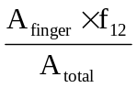 × H_{surface}

Pathogens are lost from the finger pad by die off with first-order rate constant λ_{dieofffhand} (min⁻¹), by transfer back to room environmental surfaces upon touching those surfaces, and by transfer to facial target membranes upon touching those membranes. Let f₂₁ denote the fraction of pathogens on the finger pad that are transferred back to the room environmental surface per touch. The first-order rate of pathogen loss from the finger pad to room environmental surfaces due to touching, denoted λ_{touch21} (min⁻¹), is:

λ_{touch21} = f₂₁ × H_{surface}

Let state 3 denote facial target membranes (the conjunctivae, the nostrils and the lips). Let H_{face} denote the rate that the finger pad touches facial target membranes (touches per minute), and let f₂₃ denote the fraction of pathogens on the finger pad that are transferred to one of these membranes per touch. For simplicity, f₂₃ is assumed to be the same value for all three membranes. The first-order rate of pathogen loss from the finger pad to facial target membranes due to touching, denoted λ_{touch23} (min⁻¹), is:

λ_{touch23} = f₂₃ × H_{face}

For simplicity, it is assumed that pathogens transferred to facial target membranes cannot be removed by subsequent touching, and that they remain active until they reach target tissue sites in the oro- and nasopharyngeal region. Thus, all the pathogens transferred to state 3 comprise the pathogen dose. Let state 4 be pathogen inactivation. Pathogens that enter state 4 never leave.

The single-step transition probabilities for state 1 (room environmental surfaces) are:

p₁₁ = 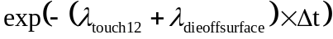

p₁₂ = 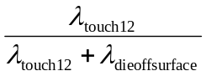 × [1 − p₁₁]

p₁₄ = 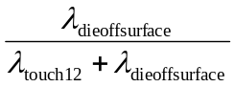 × [1 − p₁₁]

The single-step transition probabilities for state 2 (the finger pad or hand) are:

p₂₂ =

p₂₁ = 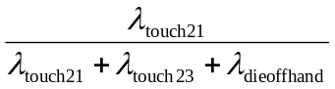 × [1 − p₂₂]

p₂₃ = 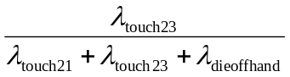 × [1 − p₂₂]

p₂₄ = 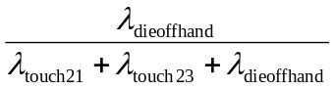 × [1 − p₂₂]

The single-step transition probabilities for state 3 (the facial target membranes) are p₃₃ =1 with the others equal to zero. The single-step transition probabilities for state 4 (patho-gen inactivation) are p₄₄ =1 with the others equal to zero.

At this point, the conceptual work of defining the loss rates and the single-step transition probabilities is completed. Now we assign numerical values for the factors A_{total}, A_{finger}, H_{surface}, H_{face}, λ_{dieoffsurface}, λ_{dieoffhand}, C_{surface}, f₁₂, f₂₁, f₂₃ and Δt. Let A_{total} = 10,000 cm² and let A_{finger} = 2 cm². Let the touch rate to surfaces be H_{surface} = 2 min⁻¹, and the touch rate to facial target membranes be H_{face} = 0.17 min⁻¹ (about 10 per hour). Let λ_{dieoffsurface} = 0.011 min⁻¹, which corresponds to a half life on room surfaces of about one hour. Let λ_{dieoffhand} = 0.069 min⁻¹, which corresponds to a half life on the hands of about 10 minutes. Let C_{surface} = 100 per cm², such that the total number of pathogens in state 1 at time zero is N = C_{surface} × A_{total} = 1.0 × 10⁶. Let Δt = 0.01 min. It follows that:

λ_{touch12} = [(A_{finger} × f₁₂) ÷ A_{total}] × H_{surface} =

[(2 cm² × 0.005) ÷ (10,000 cm²)] × (2 min⁻¹) = 2 × 10⁻⁶ min⁻¹

λ_{touch21} = f₂₁ × H_{surface} = 0.005 × (2 min⁻¹) = 0.010 min⁻¹

λ_{touch23} = f₂₃ × H_{face} = 0.35 × (0.17 min⁻¹) = 0.0595 min⁻¹

λ_{dieoffsurface} = 0.011 min⁻¹, as given

λ_{dieoffhand} = 0.069 min⁻¹, as given

In turn:p₁₁ = 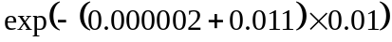 = 0.99989

p₁₂ = (0.000002 /0.011002) × [1 − 0.99989] = 2 × 10⁻⁸

p₁₄ = (0.011/0.011002) × [1 − 0.99989] = 0.00011

p₂₂ = = 0.99862

p₂₁ = (0.010/0.1385) × [1 − 0.99862] = 0.0001

p₂₃ = (0.0595/0.1385) × [1 − 0.99862] = 0.000595

p₂₄ = (0.069/0.1385) × [1 − 0.99862] = 0.00069

p₃₃ = 1

p₄₄ = 1

These p_{ij} values are entered into a 4×4 matrix P, for which the row number corresponds to the state number. The matrix P is successively multiplied by itself 6,000 times. The number of viable pathogens transferred to facial target membranes at t = 60 minutes after room entry is: N × 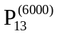 = (1 × 10⁶) × (3.4 × 10⁻⁵) = 34 pathogens.

Sample MATLAB code for running the well-mixed room particle release model

% samplecode1.m
% P is the 3x3 Markov matrix
P = zeros(3,3);
P(1,1) = 0.99935;
P(1,2) = 0.00050;
P(1,3) = 0.00015;
P(2,2) = 1;
P(3,3) = 1;

% Check that the row entries in P sum to one
CHECKP = zeros(3,1);
for i = 1:3
CHECKP(i,1) = sum(P(i,1:3));
end
[CHECKP]

N = 1000000; % number of particles released at time zero
V = 100; % room volume in m3

CONCENTRATION = zeros(12001,1); % concentration in # per m3
CONCENTRATION(1,1) = N/V;
CONCENTRATION(2,1) = (N/V)*P(1,1);
TIME = zeros(12001,1); % time in steps of 0.01 minute
TIME(2,1) = 0.01;
PTEMP = P;
for n = 2:12000
TIME(n+1,1) = n/100;
PTEMP = PTEMP*P;
if n == 3
[PTEMP]
end
CONCENTRATION(n+1,1) = (N/V)*PTEMP(1,1);
end

% Check that the row entries in PTEMP sum to one
CHECKPTEMP = zeros(3,1);
for i = 1:3
CHECKPTEMP(i,1) = sum(PTEMP(i,1:3));
end
[CHECKPTEMP]

plot(TIME, CONCENTRATION)
xlabel('Time in minutes')
ylabel('Particle concentration in # per m^{3}')
Sample MATLAB code for running the three room particle release model

% samplecode2.m
da = 3; % aerodynamic diameter in um
V = 100; % m3
H = 3.0; % m
FA = 33.333; % m2
Q = 5; % m3/min
Beta = 5; % m3/min
VTS = 0.0018*(da^2)*(1 + (0.166/da)); % m/min
deltat = 0.01; % 0.01 minute

lambdaAB = (Q+Beta)/V;
lambdaBA = Beta/V;
lambdaBC = (Q+Beta)/V;
lambdaCB = Beta/V;
lambdaexhaust = Q/V;
lambdasettle = VTS/H;
lambdadieoff = 0.011; % per minute, half life of about 1 hour

% P is the 8x8 Markov matrix
P = zeros(8,8);

totalrate1 = lambdaAB + lambdasettle + lambdadieoff;
p11 = exp(-totalrate1*deltat)
p12 = (lambdasettle/totalrate1)*(1 - p11)
p13 = (lambdaAB/totalrate1)*(1 - p11)
p17 = (lambdadieoff/totalrate1)*(1 - p11)

totalrate2 = lambdadieoff;
p22 = exp(-totalrate2*deltat)
p27 = 1- p22

totalrate3 = lambdaBA + lambdaBC + lambdasettle + lambdadieoff;
p33 = exp(-totalrate3*deltat)
p31 = (lambdaBA/totalrate3)*(1 - p33)
p34 = (lambdasettle/totalrate3)*(1 - p33)
p35 = (lambdaBC/totalrate3)*(1 - p33)
p37 = (lambdadieoff/totalrate3)*(1 - p33)

totalrate4 = lambdadieoff;
p44 = exp(-totalrate4*deltat)
p47 = 1- p44

totalrate5 = lambdaCB + lambdaexhaust + lambdasettle + lambdadieoff;
p55 = exp(-totalrate5*deltat)
p53 = (lambdaCB/totalrate5)*(1 - p55)
p56 = (lambdasettle/totalrate5)*(1 - p55)
p57 = (lambdadieoff/totalrate5)*(1 - p55)
p58 = (lambdaexhaust/totalrate5)*(1 - p55)

totalrate6 = lambdadieoff;
p66 = exp(-totalrate6*deltat)
p67 = 1- p66

P(1,1) = p11; P(1,2) = p12; P(1,3) = p13; P(1,7) = p17;
P(2,2) = p22; P(2,7) = p27;
P(3,1) = p31; P(3,3) = p33; P(3,4) = p34; P(3,5) = p35; P(3,7) = p37;
P(4,4) = p44; P(4,7) = p47;
P(5,3) = p53; P(5,5) = p55; P(5,6) = p56; P(5,7) = p57; P(5,8) = p58;
P(6,6) = p66; P(6,7) = p67;
P(7,7) = 1;
P(8,8) = 1;

% Check that the row entries in P sum to one
CHECKP = zeros(8,1);
for i = 1:8
CHECKP(i,1) = sum(P(i,:));
end
[CHECKP]

N = 1000000; % number of particles released at time zero

CONCENTRATION = zeros(6001,3); % concentration in # per m3
CONCENTRATION(1,1) = N/V; % concentration in room A air at t = 0
CONCENTRATION(2,1) = (N/V)*P(1,1); % concentration in room A air at t = 0.01
CONCENTRATION(2,2) = (N/V)*P(1,3); % concentration in room B air at t = 0.01

TIME = zeros(6001,1); % time in steps of 0.01 minute
TIME(2,1) = 0.01;
PTEMP = P;
for n = 2:6000
TIME(n+1,1) = n/100;
PTEMP = PTEMP*P;
CONCENTRATION(n+1,1) = (N/V)*PTEMP(1,1); % concentration in room A air
CONCENTRATION(n+1,2) = (N/V)*PTEMP(1,3); % concentration in room B air
CONCENTRATION(n+1,3) = (N/V)*PTEMP(1,5); % concentration in room C air
end

X = PTEMP(1,:)'

% Check that the row entries in PTEMP sum to one
CHECKPTEMP = zeros(8,1);
for i = 1:8
CHECKPTEMP(i,1) = sum(PTEMP(i,:));
end
[CHECKPTEMP]

plot(TIME,CONCENTRATION(:,1),'-',TIME,CONCENTRATION(:,2),'--',TIME,CONCENTRATION(:,3),'.-')
xlabel('\bf\fontname{times}\fontsize{12}Time in minutes')
ylabel('\bf\fontname{times}\fontsize{12}Particle concentration in # per m^{3}')
%gtext('\bf\fontname{times}\fontsize{12}\leftarrowRoomA')
%gtext('\bf\fontname{times}\fontsize{12}\leftarrowRoomB')
%gtext('\bf\fontname{times}\fontsize{12}\leftarrowRoomC')

Sample MATLAB code for running the surface-to-hand-to-face transfer model

% samplecode3.m
AreaTotal = 10000; % cm2
AreaFinger = 2; % cm2
f12 = 0.005; % 0.05% per touch
f21 = 0.005;
f23 = 0.35;
Hsurface = 2; % 2 per minute
Hface = 0.17; % 0.17 per minute = 10 touches per hour
deltaT = 0.01;

lambdadieoffsurface = 0.011; % per minute, half-life of 60 minutes
lambdadieoffhand = 0.069; % per minute, half-life of 10 minutes
lambdatouch12 = (AreaFinger/AreaTotal)*f12*Hsurface;
lambdatouch21 = f21*Hsurface;
lambdatouch23 = f23*Hface;

totalrate1 = lambdatouch12 + lambdadieoffsurface;
p11 = exp(-totalrate1*deltaT);
p12 = (lambdatouch12/totalrate1)*(1 - p11);
p14 = (lambdadieoffsurface/totalrate1)*(1 - p11);

totalrate2 = lambdatouch21 + lambdatouch23 + lambdadieoffhand;
p22 = exp(-totalrate2*deltaT);
p21 = (lambdatouch21/totalrate2)*(1 - p22);
p23 = (lambdatouch23/totalrate2)*(1 - p22);
p24 = (lambdadieoffhand/totalrate2)*(1 - p22);

p33 = 1;
p44 = 1;

% P is the 4x4 Markov matrix
P = zeros(4,4);
P(1,1) = p11;
P(1,2) = p12;
P(1,4) = p14;
P(2,1) = p21;
P(2,2) = p22;
P(2,3) = p23;
P(2,4) = p24;
P(3,3) = p33;
P(4,4) = p44;

% Check that the row entries in P sum to one
CHECKP = zeros(4,1);
for i = 1:4
CHECKP(i,1) = sum(P(i,1:4));
end
[CHECKP]

N = 1000000; % number of pathogens on 10,000 cm2 of surface

PTEMP = P;
for n = 1:6000
PTEMP = PTEMP*P;
end

% Check that the row entries in PTEMP sum to one
CHECKPTEMP = zeros(4,1);
for i = 1:4
CHECKPTEMP(i,1) = sum(PTEMP(i,1:4));
end
[CHECKPTEMP]

DOSE = N*PTEMP(1,3);
[PTEMP(1,:)]

Chapter 9

Introduction to Deterministic Computer Modeling: The Case of Linear Disease Risks

Jim Koopman

Analyzing dynamics rather than risks
Controlling infectious disease often requires a different mental set and a different set of analytic skills than the risk factor identification and elimination mentality that dominates classical epidemiology teaching. Instead of seeking to understand why some individuals in a population develop disease while others don’t, infection control often requires us to seek explanations for why infection flows and grows within a population. Instead of using risk or rate ratio measures, odds ratio measures, risk and rate differences, and other simple relationships between presumably independent individuals with and without a risk factor to seek explanations for disease patterns in populations, infection control requires the estimation of parameters that reflect interactions between individuals such as contact rates, transmission probabilities, network cluster sizes and diameters, network connectedness measures and other measures. For infection control we must think about where and how infection is flowing through a population and what we can do about it. That requires a whole different way of thinking. The objective of the exercise we will do in this QMRA session is to get you into this other mode of thinking so that when you have public health responsibilities you will be better prepared to think about the right issues and frame the questions you should be asking in a more effective way.

Most analyses in epidemiology assess risk factor effects under the assumption that the outcome of “exposure” to a risk factor in one individual cannot change the outcome of “exposure” in another person. (Note we often call individuals with a risk factor an "exposed" group but here we will try to reserve the term “exposed” for individuals who have come in contact with infectious individuals.) What that means is that if the risk factor is not washing your hands after going to the bathroom, that if you get infected as the result of such a risk factor you do not change the risks experienced by other individuals. Most statistical analyses of risk factor effects make this independence between individuals assumption. (Note that independence between variables in a single individual is a wholly different independence issue.)

An important issue in infectious disease epidemiology is how the pattern of connections from one individual to another causes infection to flow through a population, epidemics to grow, or endemic levels of infection to be sustained. That is to say, an important issue in infectious disease epidemiology is population dynamics and how dependencies between outcomes in different individuals determine those population dynamics. So instead of using models that assume no infection transmission like the data models that you have learned in statistics courses, we need to use models that parameterize (capture and express) the true nature of this dependency that we need to understand in order to control infection. Instead of thinking about individual risks, we need to think about population dynamics. We need to get our heads turned around from classical epidemiological thinking if we are going to effectively control infections.

Infection transmission models and models of infection and immunity processes within individuals are becoming especially important in using powerful new sources of molecular information about infection that is becoming available. Using micro-array chips, laboratories on a chip, and other magnificent technologies, it is increasingly cost-effective to gather information on the genetic sequences of infectious agents, the genetic make up of hosts that influence their response to infection, and on myriad aspects of the host response to infection. The efficient use of this information requires analyses that make correct assumptions about dependencies between individuals or dependencies between infectious agents, host genetics, and host immune responses. Understanding the basics of infection transmission models is needed to use genetic data to help analyze infection flow. In this regard, infection transmission model analyses are becoming an important part of bioinformatics.

Types of models
Infection transmission system models express the non-linear dynamics of infection spread through populations. To insure you understand what is meant by non-linear dynamics of infection transmission you will want to read the article “The Ecological Effects of Individual Exposures and Nonlinear Disease Dynamics in Populations” supplied to you in the QMRA materials. Another background article that is more comprehensive but more advanced that you might read to orient you to infection transmission system modeling is “Modeling Infection Transmission”.

There are many different forms of infection transmission models that can be used for different purposes. We will discuss a particular modeling form that makes a peculiar set of assumptions that greatly facilitate computer analyses and that do not require you to have great programming or mathematical skills. These are called deterministic compartmental models. In our case, the compartments contain different segments of population defined by their characteristics such as their infection and immunity state or their risk factor status. Risk factors might affect their susceptibility, their contagiousness if infected, or behaviors that affect their exposure to someone who could transmit infection to them.

The particular form of model we will use is called a deterministic compartmental (DC) model. Deterministic means that chance is not playing a role. Every time you run the computer models you construct you will get exactly the same results as long as the starting conditions and parameters are the same. There is no "Monte Carlo" aspect to the model implementation where an individual's chance of experiencing something is determined by a role of the dice. In fact, there are no individuals in the model for chance to act on.

Well, you may ask, if there are no individuals in the model, what are we modeling and how do we deal with interactions between individuals that might occur with specified probabilities and that transmit infection if the interaction takes place with certain probabilities? The answer is: We are modeling continuous segments of population. We assume that any segment of population, no matter how small, can be further subdivided. That is in part what we mean by continuous. We assume that any tiny segment of the population can be further subdivided and also we assume that the population is made up of discrete individuals. Those two assumptions together imply that we are assuming that the population we are modeling is of infinite size. In practice very large does not differ from infinite. But when we have compartments that we want to correspond to just a handful of individuals, the difference in our assumed infinite size and our desired handful size may be important.

Whenever numbers are small, chance might be influencing what fraction of individuals experience an outcome. But as population size becomes infinite, the variation in the fraction of the total population that experiences an outcome becomes infinitesimally small. Thus our properties of infinite population size and deterministic behavior go together. The deterministic models just examine the mean behavior of infinite size populations. Sometimes we may be really interested in the chance of events in small populations. Say for example we are interested in predicting when polio will be eradicated. Well, when we get close to eradication, there are by definition very few individuals in the infected compartments. When the last transmission from any case occurs will be a chance event. In our deterministic continuous population compartmental models eradication will never occur. Some fraction of the population will always be being cured but that means some fraction will always be being left infected. That fraction may be infinitesimally small. It may be too small to register so it shows up on the computer as zero. But that is not theoretically zero. Only stochastic models can get us to theoretical zero infections.

You will note that even though we formally assume that the population we are modeling is continuous, we speak of interactions between different segments of our population or rates of change in different segments of our population as if they were interactions between individuals and risks of events occurring to individuals.

For this QMRA session we do not have to learn a whole lot of words that further classify the types of models we analyze within the set of deterministic models of continuous populations. But if you want to impress someone (other than a mathematician) with what you are learning you can say that you have learned to construct and numerically analyze first order, Markovian, scalar, autonomous, homogeneous, non-linear systems of ordinary differential equations.

First order just means that we model rates of change, not rates of change of the rates of change, which would be second order. Markovian is something you might want to learn. It means that what is happening in a model at any point in time is just a function of the model states at that point in time. Another word for Markovian is "memoryless". What happens in the model does not depend upon what was going on in the model at some past point in time. It only depends on the current state. The model does not have to remember anything from its past to calculate what happens next. It is this Markovian property, together with the deterministic property, that makes DC models so easy to analyze on the computer. The computer does not have to keep in its memory what the state of the model was in the past and use those past states to help determine what happens next. That greatly cuts down on both memory and calculations. But the real world is not usually “memoryless”. This Markovian characteristic, like the continuous population characteristic, is an unrealistic simplifying assumption we make in order to have a tractable model.

To address many important problems we need models with discrete individuals. Such models are harder to program and to analyze because chance events may lead to different outcomes. Thus a single outcome is not enough as is the case with deterministic compartmental models. The ideal in analyzing a discrete individual stochastic model is to keep track of the expected distributions of numbers of individuals in any state. That is a really big and hard task so for such models we often just do a series of Monte Carlo simulations that give us one particular realization of a chance process. If we do hundreds of such simulations, that gives us a feel for the shapes of distributions of expected sizes of compartments. But that is a lot of work and it takes a lot of programming skill. Therefore we will not be dealing with this sort of model in this course. Epid students who want to learn this sort of modeling take courses in the Center for the Study of Complex Systems. If you want to go on to a higher degree in infectious disease epidemiology, we strongly recommend these courses.

There are many other model types besides continuous population deterministic compartmental models and discrete individual stochastic models. But for now we don't need to worry about these. It is better that we get on with our task.

Goals of infection transmission modeling
There are many different ways to classify the purposes of modeling. I variously use classifications that have from 5 to 28 different categories. Here is the five category division of purposes.

Generate and clarify insights into non-linear processes
All processes in the world have non-linear dynamics at some level. One reason epidemiologists don’t include more non-linear dynamics in their models is that non-linear dynamics often don’t fit in well with the intuitive predictive processes that have evolved in human cognitive processes. Ontologically, it is not until the adolescent years that many intuitive predictions of joint effects of two forces come into play. When two different non-linear processes interact in a model, intuitive prediction of effects usually breaks down. But experience analyzing simple systems can help build the intuitive capacities needed to be a great scientist. Simple non-linear systems can generate incredibly complex patterns. Computer simulation experience with such systems can be an essential learning experience for pursuing any of the subsequent four purposes listed here. It is almost wholly for the purpose of providing you with insights about the non-linear dynamics of infection transmission in populations that we pursue modeling analyses in this course. You will be learning to use a software tool that will be helpful to you in advancing and clarifying your thinking about infection transmission or about many other types of systems. This tool will help you to learn on your own.

A base for formal theory presentation and analysis
When a mathematical or computer simulation relationship is found to express a real world relationship of interest, the potential for scientific progress is expanded. Mathematics and computer science have developed powerfully productive traditions for advancing the analysis of systems and whenever these can be applied to any system, more compact and comprehensible ways of communicating and analyzing theory become available. Epidemiology does not have the tradition of having separate theorists who purely dedicate themselves to advancing theory as other sciences like physics, chemistry, computer science, and some others do. That is because the theories epidemiology has been developing are simple exposure causes disease types of theory expressed in terms of risks rather than dynamic processes. As epidemiologists begin formulating more universal theories that encompass broader sets of conditions, epidemiology theories will inevitably involve non-linear dynamics and will undoubtedly be more complex and provide a better basis for new theory construction. Then the need for more epidemiologists to dedicate themselves more strongly to theory elaboration and development will be more evident.

Prediction
The main virtue of sound theory is predictive power. The predictive power of regression relationships is always limited. If one had lots of data on the rate of speed at which objects fall under different conditions on earth, one could make just as good predictions about rates of fall using regression relationships as one could make using gravity and friction theories. But one could not make any predictions for the moon or other planetary bodies as one could by using the theoretical relationships. Epidemiology is in a far less favorable position for regression relationships to predict disease risks than physics is to use regression relationships to predict falling body rates. The reason is the evolved complexity of processes affecting disease risks. Yet epidemiology continues to make most predictions on the basis of data relationships with little theory.

All perception requires both data and theory. All prediction requires both data and theory. And the role of theory in either perception or prediction cannot be separated from the role of data. Data alone or theory alone can do nothing. They must work together. Epidemiology makes predictions on the basis of observed risks in the past. But conditions change from the past to the future. Epidemiology makes predictions of risks in one population from observations on another. Yet if conditions differ, only relationships based on solidly verified theory will continue to hold across populations or across time. As we enter an era where the complexities and variations in each individual become a basis for assessing their risks, the need for predictive theory becomes greater.

Theoreticians are needed to develop predictions of risks under different conditions. Good theory evaluation will allow one to specify the conditions under which competing theories make different predictions for things that have up to now not been observed. Observations then become the basis for distinguishing theories. No observations, however, can be theory free. As much as possible it is useful to be able to specify the theoretical assumptions that lie behind any observation. That helps prediction advance science and it helps public health make inferences about what actions should be taken. We will make brief comments later on how that works after discussing different types of models.

Study design
Studies need to be designed so that they lead to valid inferences with minimal expenditure of resources. Epidemiologists tend to categorize study designs into a limited number of classes and then make rules for what classes are to be used under what conditions. But this limits the creativity that should go into study design and the number of options that should be explored. Study design is ideally carried out by specifying a series of causal models that one thinks might apply to the situation where one is seeking to make a particular inference and then imposing different study designs that will generate the data from those underlying causal models. Then one assesses the power and validity of inferences from those study designs under different causal model specifications. Modern computer simulation methodology and analytic power makes this a much more feasible process now than it was at the turn of the century. But study design really requires stochastic discrete individual models.

Data analysis
If the model that one is using to analyze data does not correspond to the causal processes that generated the data and upon which the inferences being sought depend, then one should always feel that inferences based on that data analysis might not be robust. Fortunately there have been many advances in statistics, both in biostatistics and in other sciences, like physics, that now make it much easier to build statistical analyses on the basis of causal models. These are usually highly computer intensive. The biggest driver of new advances in this regard is not necessarily greater micro-processor power and greater numbers of micro-processors used. As much a driver of progress in this area is the development of ingenious new algorithms that computer scientists and other scientists come up with.

Again using transmission system models for data analysis is beyond this course. We will, however, learn a little bit about fitting models to data. That is a sort of data analysis and the methods we will learn are parameter estimation methods. They are just not the best parameter estimation methods. The best methods are based on discrete individual models which we do not use in this course.

Berkeley Madonna Software
We use the Berkeley Madonna software to formulate and numerically solve systems of differential equations. The differential equations describe flows of individuals from one compartment into another as they change their state. For example, as individuals become infected they flow from the susceptible compartment to the infected compartment. Numerically solving the equations means that we calculate the flows tiny time step by tiny time step. We label the tiny time steps DT for “delta time” or small change in time. We take steps that are tiny enough so that each flow is not significantly affecting the calculation of other flows. If we take too large of a time step we do not get results that correspond to continuous differential equations. Instead we might get chaotic results. For detailed clarification of this and an explanation of the mathematics relating big time steps across which we calculate risks to small time steps corresponding to rates, you could read and do the exercises in the document "Rates and Risks: Modeling a constant rate process in a fixed Population". We will do a simpler version of that later in this exercise. I have put that exercise in the “Supplementary Exercises” folder on C-tools for those of you feeling the need for more in depth material.

The software allows you to construct models just using symbols in a point and click manner. As you go about pointing and clicking and filling in formulas determining flows, the software goes about formulating the differential equations that correspond to what you have constructed. The software also allows you to put in the equations directly. That allows for greater flexibility and ease of use than the pointing and clicking method. But it leaves you without a visual image of the system. Most likely for most of your class projects, should you choose to do a project that involves modeling, you will want to try formulating the equations directly.

The Madonna software then has a number of features that allow you to analyze your model. When doing causal analyses and when constructing theory, the analysis of models always precedes the analysis of data. The analysis of a model might consist of examining how fast different flows occur under different conditions. For example we might examine how fast well individuals flow into the diseased state as a function of the rate of disease development given various incubation processes between the start of the disease process and the manifestation of disease. One common analysis consists of examining how equilibrium infection levels or the final number of individuals infected in epidemics changes as different parameters are changed. It is in this analysis process where you learn about dynamics and improve your intuitions about how you expect infection to behave in populations.

The process of improving your intuitions goes hand in hand with the process of learning how to construct valid models. In a differential equation model we set the initial values of the different compartments, we set up the pattern of flows, and we establish what will determine the different flow rates. Then we run the model. That is to say, we numerically solve the model tiny time step by tiny time step and see how the flows change the values in the compartments as time goes on. Every time before you hit the run button, you should predict what behavior you expect given your current model settings. Your predictions should be both qualitative and quantitative. You will find that it does not take a lot of model complexity before it becomes difficult to make accurate predictions. When you observe something unexpected, then one of two things will happen. Either you will discover that you made some mistake in your model, such as typing in a times sign when you meant raise to an exponent or some such thing. Or you will realize that your prediction was wrong. In that case you should proceed to explore your model to determine how it is that the model behaves as it does and why you made a wrong prediction. This is where the most important learning takes place. A good way to learn using this software is just to play with a lot of models and make a lot of predictions as to how each model is going to behave and then examine why it behaves as it does. This forces you to think in ways you would not think otherwise.

Making a valid model that does what you think it is doing requires either being very careful so that you never make a mistake or being able to recognize that something is not behaving as it would be expected to behave when you do make a mistake. Since we are all fallible humans, it could really pay to be able to recognize when we have made an error. Only after you have sharpened your intuitions with a lot of experience predicting and then observing will you be really good at recognizing when something is not as predicted.

The software has a number of things to help you describe how things change as you change the values of parameters. It has features that help you determine what parameter values will make the model behavior most similar to some data on observed behaviors in the real world. It helps you to visualize how flows change over time throughout the system.

There are two reference documents to help you when using Berkeley Madonna. The first is the Manual and the second is all the things under the help tab. Most of what is in the manual is covered under the help tab, but not all. Make sure you download the manual from the Madonna website.

Rates and Risks for non-contagious infections
Let's get into the software. We begin with very simple models that are wholly consistent with what you might have learned in your introductory epidemiology courses. We begin with models that are dynamically linear. That means that what happens to individuals in the segment of a population represented by a compartment is only a function of the system parameters and the characteristics of the population in the compartment. What happens to one individual in the compartment is not dependent upon the number of individuals in that compartment or in any other compartment. When dealing with infections, that will not be the case and a lot of things change from what you learned in introductory epidemiology.

You have two big changes in thinking to go through. You must start thinking about dynamics of systems and not just prevalence or risks. And you must learn how dynamically non-linear systems (which encompass almost all of the systems in the real world) behave differently from the idealized dynamically linear systems that are consistent with what you have learned about quantitative analysis so far in your epidemiology training. So I think it might help to first think about dynamics for simple linear systems before we jump into non-linear systems. That is why I have constructed this exercise.

We have one copy of the software per group. Each of you can make a copy of the software and install it on your computer for the duration of this course. Then if you have not paid for the software, you must destroy your copy. On the installed version for the group, under the help tab look at the “About Berkeley Madonna” selection. Note exactly the “licensed to” spelling and the registration number for installing on your computer. Make sure that JRE 1.4 (Java Runtime Environment) is installed on your system. If it is not, Google JRE 1.4 and make sure you download and install the J2SE JRE and not the J2SE SDK.

We are going to work mostly in the point and click mode so under file, select "new flowchart". From the Madonna tutorials and from the in class demonstration, you should be able to point and click to generate a simple linear flow diagram below from well to diseased. When you put new compartments (What Madonna calls “reservoirs”), new parameters (made with what Madonna labels as “formulas”) or flow pipes into your model, they will initially have question marks on them. You double click on them to fill in values or formulas. When you connect an arc to a reservoir, formula, or flow, the source of the arc must be used to define that formula, reservoir, or flow. So point and click to generate the following where the flow is the source reservoir of well times the rate at which the well develop disease.

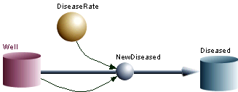

Figure 9.1

This has the following equations which you can see by clicking equations under the model menu.

{Top model}

{Reservoirs}
d/dt (Well) = - NewDiseased
INIT Well = 1
d/dt (Diseased) = + NewDiseased
INIT Diseased = 0

{Flows}
NewDiseased = Well*DiseaseRate

{Functions}
DiseaseRate = 0.1
{Globals}
{End Globals}

Note that this model has two compartments so the set of differential equations describing this model has two equations. There is only one flow. That is the flow out of the Well compartment which exactly equals the flow into the diseased compartment. If you were reading an article in the literature, you would more likely see these equations written something like:
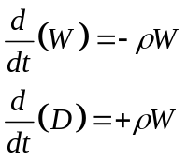 (9.1)

Where ρ = DiseaseRate. Note that all the compartment flow terms on the right hand sides of the equations have exponents that sum up to one. (note: W = W¹)
Of course Equation set 9.1 could have been written with just a single equation since we set up the original total population to have a size of 1 and there are no inflows or outflows from the total population. Thus if we know W, we also know D.

Run the model by choosing “run” under the model menu. You see that it ran for ten time units because that is the default. All model settings for running the model are in the “parameters” window which you can see by clicking “parameter window” under the parameter menu. Change the “stoptime” to 100 and rerun to get the following graph.
**!!**IMPORTANT POINT**!!**. Your models always run with the parameters in the parameter window -- not with the values in the equations. You can run models by clicking run buttons on graphs or the run selection under the model tab but it will be running whatever is in the parameter window so it might be a good practice to always run models for the parameter window so you know what parameter settings you are running.

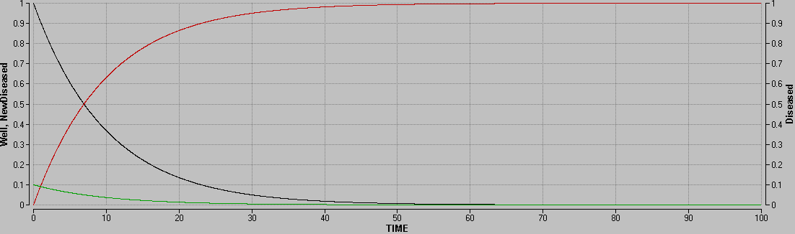

Click on the overlapping squares icon to change from a graph to a table like the following:
TIME Well:1 Diseased:1 NewDiseased:1
0 1 0 0.1
0.02 0.998002 0.001998 0.0998002
0.04 0.996008 0.00399201 0.0996008
0.06 0.994018 0.00598204 0.0994018
0.08 0.992032 0.00796808 0.0992032
0.1 0.99005 0.00995017 0.099005
0.12 0.988072 0.0119283 0.0988072
0.14 0.986098 0.0139025 0.0986098
0.16 0.984127 0.0158727 0.0984127
0.18 0.982161 0.017839 0.0982161
0.2 0.980199 0.0198013 0.0980199

What is in a compartment and what values does it have?
Note that I gave the initial well compartment a value of 1. We could interpret that 1 to correspond to the entire population and then as long as the value of all compartments continues to add up to one, we could interpret the value of each compartment as the fraction of the population that is in that compartment. That works well on closed systems with no inflows or outflows. But if inflows and outflows might be changing the total population size with time, then we can't interpret compartment values as fractions of the total population. So we might want to use numbers that correspond to the total number of individuals. For example we might be following a cohort of 100,000 people in Ann Arbor. So we could give the initial well compartment a value of 100,000 instead of 1. No matter what number we put there, however, the methods we are using make an intrinsic assumption that any compartment and any flow can be divided into many parts. If we are thinking of individuals, this translates into an assumption that there are an infinite number of individuals in any compartment. You can't escape from that assumption by putting a value of 10 on the total population as if you were modeling 10 individuals. When the compartment has a value of 0.01 when the total population size is 10, you have one out of a thousand individuals who are in that compartment. That means you must really have at least 1000 individuals, not 10.

Answer the following questions:

If people develop disease at the rate of 0.1 per year, will one tenth of the people develop disease in the first year? Why or why not? When will everyone be diseased? If you double the rate of disease, will there always be twice as many diseased individuals at any point in time? ((To answer this click on the O (for overlay) icon on the graph or table but view the output in table form)). Explain why there will or will not be twice as many people. Explore all the variables (compartment values) and flows in seeking your explanation. This explanation is exceedingly simple. But you will have gained a lifetime learning tool to help you think about systems if you learn to explore dynamics in the computer output to make sure you have solid explanations for what is happening.

What output value gives you the risk of disease in this model at any point in time? What output value gives you the incidence of disease? Note that the word "incidence" is sometimes used just to mean the number of incident cases and is sometimes meant to reflect the rate of new cases in the population that can generate new cases. Consider both definitions.

Now let us consider the average time that individuals spend in a compartment when they have a constant rate of leaving that compartment. The slower they flow out of a compartment, the longer time they will be spending in a compartment. The faster they flow out, the less time they will be spending. Let us now just empirically explore the relationship between time in a compartment and a constant rate parameter for the flow out. We add a counter labeled “TimeWell” to our simple model as seen in the following:
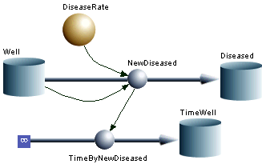

Figure 9.2

TimeByNewDiseased is just NewDiseased*TIME. "TIME" is an automatic Madonna variable that is the amount of time elapsed since the first small time step DT was taken. So if we take the total amount of time divided by the number of people that spent that time, we have the average time spent. Run the model with a DT of 0.02 and a disease rate of 0.02 out to a stoptime of 1000. The value of TimeWell at the very end when there is almost no one left in the well is 1/0.02 = 50. That is to say that the average time spent is 50 when the rate out is 0.02. The average time spent in a compartment when population leaves the compartment at a constant rate is always 1/rate.

For now, I just want you to gain some familiarity with the parameter plot function of Madonna so you can see that this relationship holds. Under the "parameters" pull down menu select "parameter plot". In the parameter pull down, select the parameter "DiseaseRate". Do 10 runs from an initial value of 0.1 to a final value of 1. In the variables window select "TimeWell". Click the add button and then click on final. That will give the value of TimeWell when StopTime is reached for each of the 10 runs. In the parameter window make sure your “StopTime is set to a large value like 100 so that when that time is reached there is almost no one left in the Well compartment. Hit the run button. If you want to rerun a parameter plot with some parameters other than the one whose value is being plotted, you must change the other parameter in the parameters window but you must run from the parameter plot window.

Interpret your output and state how the TimeWell divided by the initial number of well relates to the disease rate. Explain why this relationship holds.

How is Madonna running the model?
Madonna solves the equations you formulated numerically using numerical integration methods. You can choose a number of different step by step processes (numerical solution algorithms) for solving the differential equations. Look in the parameter window at the pull down menu just to the right of the "run" button to see the five choices there. In this class we won’t go into a lot of detail as to how or why to choose different integration methods. The simplest numerical solving procedure is called the Euler procedure. It just calculates the rate of flow at a particular point in time and assumes that rate will stay constant across the tiny time step. If in your model rates are changing very fast with time, you will have to take an even tinier time step. For example at A in the figure below taking a step size of DT doesn't get us off the true curve much because the slope is not changing much with time. But at B the same time step generates a larger error. So if you are using the Euler method, you need to take very short time steps if you have any potential for the flows affecting the quantities you are modeling to change rapidly.

A
B
DT
Time
Value
DT
Figure 9.3

The Runge-Kutta methods that you can choose with Berkeley Madonna takes 2 or 4 additional time points to figure out how the rate of change (the slope) is changing to calculate the next point. If all the curves are smooth, this can save calculations all in all and so the model runs faster. But if there is some sudden change in the model at one point in time, such as a bolus of input at that point in time, your only choice is to use the Euler method. Other numerical solution algorithms include ones that adjust the DT by calculating how fast things might be changing.

To insure that errors are not being introduced by having too short of a DT, it is necessary to further shorten the DT and then be sure that nothing changes. If you see really chaotic behavior in your model, the reason for that behavior might be from having the DT too long so that errors get multiplied or signs get changed when they shouldn't. There are a number of ways to insure that such things don't happen, such as the use of "Limit" equations. But those are technical details that you need now worry about until you find yourself having such a problem.

Chapter 10

QMRA Infection Transmission Modeling Exercise

Jim Koopman

This exercise introduces infection transmission system modeling and its potential role in Quantitative Microbial Risk Assessment (QMRA). QMRA usually focuses on the environment as the source of risk. When the infections of concern are never transmitted in any way from one person to another, the risk assessment methods developed for toxins or carcinogens can be adapted to QMRA. Whenever someone who was infected from the environment returns new contamination from their infection to that environment, however, the feedbacks of an infection transmission are established. In that case risk assessment must analyze the transmission system. Analyses that ignore such feedbacks are not an option. The feedback effects are just too strong.

The goal of this exercise is to start you thinking about how you can integrate complex systems modeling into the process of theory formulation and testing needed for microbial risk assessment. That is a big task made more difficult by the fact that scientific work on this is in its infancy and there are not many publications yet that advance this task. But it is better that you start thinking about this early in the process of learning about QMRA. The complex system approach requires a rather marked change in thinking about the scientific process. We cannot give you a full introduction to this in a 3 hour exercise. This exercise will just illustrate one way we use models to help clarify our understanding of the principles on which we conduct risk assessments.

In this exercise you will do some numerical analysis of infection transmission system models using the first two forms of the transmission functions presented by McCallum et al “How Should Pathogen Transmission Be Modeled” TREE, 2001;16:295-300. These are the “density dependent” and “frequency dependent” formulations of infection transmission. Your professor will construct the density dependent model first and perform a simple analysis involving both dynamic time plots and parameter plots of total accumulated infections at the end of an epidemic. Then you will construct the frequency dependent model and do a similar analysis. These are both SIR models where all individuals are identical and can be in one of three states: S for susceptible, I for infected and infectious, and R for immune. The R originally stood for “removed” as all early epidemic models were of the density dependent variety in which immune individuals can be treated as removed since their contacts with others have no effect on epidemic dynamics. These models completely ignore the reality that most infection transmission occurs through the environment in one way or another.

At this point the professor will construct the density dependent model and analyze the effect of population size on the cumulative incidence or the final fraction of individuals infected over the course of an epidemic. Then the students will construct the frequency dependent model and do the same sort of analysis. The image and equations for both the frequency and density dependent models are found in the next section of this exercise. You can use them as a guide. The software we will be using is Berkeley Madonna. You will be using Madonna’s point and click interface where Madonna constructs the actual equations for you.

Example 10.1
Run the model you have constructed to get a plot of variables by time. Check to see that your model gives the same curve for the values of I or R as QMRA1 does. To do that, under the “parameters” tab, select “parameter window. In the parameter window set the stoptime to 1000. Then hit run. If PrevF or CumIncidF do not appear on your time plot graph, then double click on the graph, add them to the output, and run again. Note that if we want to get the final size of an epidemic, we have to run the model long enough so the PrevF goes to zero. Change some parameter value and before running the model predict what the effect of that parameter change will be on the epidemic. Making such predictions and then figuring out why your predictions were wrong is a powerful way you can use this system dynamics software as a learning tool.

Now for the model you have constructed, construct a parameter plot of the CumIncidF as a function of population size from 5000 to 50000. The parameter plot you will construct is the final size of the epidemic at the end of the epidemic as a function of the size of the population. Under the Parameters window, select Parameter Plot. In the window that comes up, in the top window select PopSize and set the range from 5,000 to 50,000. Now add the cumulative incidence to the output at the bottom of the window and click on the “Final” option. That will give you the final fraction infected at whatever StopTime you have set in the parameters window. You just saw these values for the time plots you ran.

I have constructed both models in the same program called QMRA1 so that when we run one, we are always running the other as well. So as to keep them separate, we label all variables and parameters in them with a D or an F at the end of the name. We keep the parameter expressing the average duration of infection the same between the two models. Below please find the image and the equations generated by Berkeley Madonna for this model.
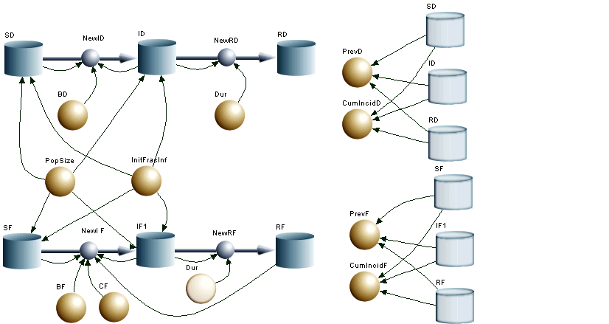

Figure 10.1

{Top model}
{Reservoirs}
d/dt (SD) = - NewID
INIT SD = PopSize*(1-InitFracInf)
d/dt (ID) = + NewID - NewRD
INIT ID = PopSize*InitFracInf
d/dt (RD) = + NewRD
INIT RD = 0
d/dt (SF) = - NewI_F
INIT SF = PopSize*(1-InitFracInf)
d/dt (IF1) = - NewRF + NewI_F
INIT IF1 = PopSize*InitFracInf
d/dt (RF) = + NewRF
INIT RF = 0

{Flows}
NewID = SD*BD*ID
NewRD = ID/Dur
NewI_F = SF*BF*CF*(IF1 / (SF+IF1+RF))
NewRF = IF1/Dur

{Functions}
Dur = 2
BD = .000052
PrevD = ID / (SD+ID+RD)
CumIncidD = (ID+RD) / (SD+ID+RD)
BF = .52
PrevF = IF1 / (SF+IF1+RF)
CumIncidF = (IF1+RF) / (SF+IF1+RF)
CF = 1
PopSize = 10000
InitFracInf = .00001

Here are some questions for each group to answer about this model:
- What are the parameters of the density dependent formulation model?
  - SD, ID, and RD
  - CumIncidD and PrevD
  - BD and Dur

- What characteristic distinguishes parameters from variables?

- Which two of the following are correct dimensional descriptions of BD?
  - The number of contacts that transmit infection between an S individual and all I individuals per unit time
  - The rate at which each S individual contacts each I individual per unit time times the probability that each contact results in transmission
  - The number of contacts an S or I individual makes per unit time times the fraction of contacts that result in transmission
  - The rate at which each I individual transmits infection to each I individual per unit time
  - The number of transmissions per unit time that an I individual makes to all S individuals

- Which 2 of the following are correct dimensional descriptions of BF?
  - The rate at which each I individual transmits infection to all S individuals
  - The fraction of contacts between S and I individuals that result in transmissions
  - The rate at which each I individual transmits infection to each S individual divided by the contact rate between individuals CF
  - The rate at which each I individual transmits infection to all other S individuals combined divided by the contact rate between individuals CF
  - The rate at which each S individual gets infected from each I individual

- Which 2 of the following are correct dimensional descriptions of CF?
  - The rate at which each individual of type I contacts each individual of type S
  - The rate at which each individual in the population contacts each other individual in the population
  - The number of contacts per unit time which each individual makes with all other individuals
  - The rate at which each individual of type S contacts all infected individuals in the population divided by the fraction of the population that is infected.

In QMRA1 parameter plots as a function of population size have already been set up. Each group is to explain why the parameter plots of CumIncidD and CumIncidF differ. To help in your explanation, you may want to click on the different variables that have been included in the parameter plots (not too helpful here but in other cases it can be helpful) or you may want to run time plots at particular values, or you may just want to analyze the equations.

Here are some more questions to answer:
- If we have an airborne infection in a classroom where the airborne infectious particles become very quickly mixed into the entire air in the room, which of these two models will better represent this situation? What assumptions do both models make that are inconsistent with this situation?

- If we have a sexually transmitted infection, which of these two models will better represent this situation? What assumptions do both models make that are inconsistent with this situation?

- If we have an infection that is spread either by two individuals touching each other or by an infected individual touching something that a susceptible individual later touches, which of these two models will better represent this situation? What assumptions do both models make that are inconsistent with this situation?

- If we have a purely waterborne infection in a population where everyone drinks from the same water source and contaminates the same water source, which of these two models will better represent this situation? What assumptions do both models make that are inconsistent with this situation?

Example 10.2 An environmentally mediated transmission model
It can be pretty hard to answer the above questions without exploring models that add the realistic details of each mode of transmission. So let's do some exploring of a more detailed model that in some ways elaborates on the mode of transmission in the last question. Look at the model QMRA2 below.

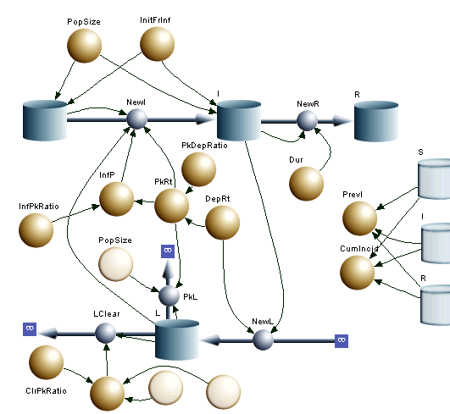

Figure 10.2

{Top model}

{Reservoirs}
d/dt (S) = - NewI
INIT S = PopSize*(1-InitFrInf)
d/dt (I) = + NewI - NewR
INIT I = PopSize*InitFrInf
d/dt (R) = + NewR
INIT R = 0
d/dt (L) = + NewL - LClear - PkL
INIT L = 0

{Flows}
NewI = L*S*PkRt*InfP
NewR = I / Dur
NewL = I*DepRt
LClear = L*ClRate
PkL = L*PopSize*PkRt

{Functions}
PkDepRatio = 1/1000000
DepRt = 500000000
ClrPkRatio = 10
InfPkRatio = 2/100000
Dur = 2
ClRate = DepRt*PkDepRatio*ClrPkRatio
PopSize = 10000
InitFrInf = 0.000001
PrevI = I / (S+I+R)
CumIncid = (I+R) / (S+I+R)
PkRt = DepRt*PkDepRatio
InfP = PkRt*InfPkRatio
{Globals}
InitInf = InitFrInf
Prev = I/(S+I+R)
{End Globals}

Here you see the same SIR compartments but also an L compartment for “Live Pathogens”. Using a single compartment L that determines the infection rate in S makes assumptions that are unlikely to hold. It assumes everyone contaminates the same environmental like air or water and that environment instantaneously thoroughly mixed so that everyone’s exposure to everyone else’s contamination is identical. Clearly deviations from that assumption will be at the heart of any real QMRA.

Our purpose, however, is just to gain insights, not conduct a real QMRA. We should be able to gain some insights about this system even if it does not correspond to the real world. Once we have insights from a highly oversimplified system like this, we will have to worry about whether those insights will hold in the real world. Thus we will want to know if those insights are robust to realistic violation of our assumptions. The first task in assessing inference robustness is to be able to state what our assumptions are and how they can be realistically relaxed.

- What assumptions are being made about the compartment L and the interaction of humans with it for enteric infections like Clostridia dificile where bacterial spores persist in environments for long times or norovirus where they persist for some time but become non-infectious much more quickly than for Clostridia dificile?
- Specify one model characteristic that might begin to realistically relax the radical simplifying assumptions in QMRA2.

This model has two very different types of entities whose quantitative dynamics are quite different. The pathogens are many orders of magnitude higher in number than the humans and they die far more rapidly. This model ignores human deaths and assumes that the epidemic occurs fast enough so that such deaths will not play any role in epidemic dynamics.

In the real world the biggest determinant of infection risk in a system like this is probably the chance that one person will encounter the contamination left in the environment by another person. But in our model there is a continual certainty of encountering all the contamination left by all other individuals at all times. An issue addressed by this model is how fast humans are going to develop infection from such contact. Because of the huge disparity in scale between the humans and the pathogens and because of our assumption of continual contact of all humans with all environmental contamination, there is a relatively narrow range of parameter values where one gets realistic variations in infection levels. At most parameter values one gets either almost no infection or one infects almost everyone. The only successful pathogens, however, are the ones that fall into the range where there is some variation. Pathogens that spread too quickly either eliminate too many hosts to keep circulating, or they stimulate immunity in everyone at the same time and thus cause the pathogen to die out. Consequently if you explore these parameter ranges too widely, you may get out of the range where there are real results. Also because of the huge disparity in scale between humans and pathogens, computer issues ocan easily arise in some parameter ranges that either create false results or make the model work too slowly to get useful results. We can’t go into issues like this in this class, so for the class, just stick to the parameters values in the parameter window specified below. Outside of class you might find it fun to explore other parameter values and make predictions about the effects of changing parameter values. As stated earlier, that is the way to use such models as self teaching guides.

The professor will run parameter plots for population sizes from 4,000 to 100,000 (33 steps works well) for the set 1 parameter values. The students will then do the same for Set 2.

- Set 1
  - StopTime = 1000 (We have to make sure that every epidemic has run to completion so we need to make this longer than the slowest epidemic.)
  - PkDepRatio = 1e-8 (The rate that any infected individual deposits contamination in the environment is 100 million times the rate that any individual will pick up that contamination.)
  - DepRt = 1e+6 (One million pathogens are deposited every unit of time for an average of 2 million total pathogens over the course of an infection.)
  - ClrPkRatio = 1e-4 (Pathogens are dying or otherwise being removed at an extremely low rate (1e-6 = DepRt*PkDepRatio*ClrPkRatio)). In otherwords they persist on average for a million time units.
  - InfPkRatio = 1e-4 (It takes on the average ten thousand organisms picked up to infect someone)
  - Dur = 2 (the average duration of infectiousness)

Question: Why at these parameter settings does this model behave like the frequency dependent SIR model?

- Set 2
  - StopTime = 10,000 (In this case we have some epidemics that develop very slowly so we have to increase the time to make sure we cover all of the epidemic at each setting.)
  - PkDepRatio = 1e-8 (The rate that any infected individual deposits contamination in the environment is 100 million times the rate that any individual will pick up that contamination.)
  - DepRt = 1e+6 (One million pathogens are deposited every unit of time for an average of 2 million total pathogens over the course of an infection.)
  - ClrPkRatio = 1e+4 (Pathogens are dying or otherwise being removed at a relatively high rate (100 = DepRt*PkDepRatio*ClrPkRatio)). In other words, they persist for 1/100 of a time unit.
  - InfPkRatio = 1e-4 (It takes on the average ten thousand organisms picked up to infect someone)
  - Dur = 2 (the average duration of infectiousness)

Why at these parameters does this system behave more like a density dependent SIR model?

How does seeing the behavior of this model change your concepts about the assumptions made by the frequency or density dependent models?

A major lesson from this exercise is that any QMRA is dependent upon the assumptions in the model used and for QMRA inferences to be valid they must be robust to realistic relaxation of the assumptions in those models.

Chapter 11

Risk Perception, Risk Communication, and Risk Management

Patrick L. Gurian

Goal
This chapter considers the social science of risk, that is, how society responds to risk. This societal response is typically viewed from three perspectives. One is the descriptive perspective which addresses the question “How do people perceive and react to risk?” A second viewpoint is prescriptive, concerned with the question of “How should we communicate with members of society about risk?” A third viewpoint is normative and asks “How should we manage this risk?” Each of these perspectives is addressed briefly below.

Risk Perception
It became apparent fairly soon after a quantitative science of risk assessment was developed that experts and the public perceive risks in different ways. Cognitive psychologists investigating these discrepancies developed a body of knowledge related to how both experts and the public perceive risk (Slovic 1987, Slovic et al. 1980, Slovic et al. 2004). It was found that expert assessments of risk were driven largely by the expected number of fatalities. On the other hand, the public’s perception of risk was actually richer in that it was based on a far broader range of factors. For example, public perception of risk is driven by not only expected fatalities but also factors such as the newness of the technology, the threat that the technology might present to future generations, the dread that the technology inspires on a gut level, the uncertainty associated with the risk, whether exposure to the risk is voluntary or involuntary, and many other attributes. In fact, responses to a very wide range of questions can be correlated to the public’s perception of risk. However, many of these questions would touch on the same underlying factor. For example, the gut level dread inspired by a risk and its catastrophic potential would likely be highly correlated, since both stem from the possibility that a technology might have the potential to produce massive numbers of casualties in the event of a malfunction. A statistical technique called factor analysis can be used to interpret highly correlated responses on surveys in terms of a much smaller number of underlying factors.

In the case of risk perception, three underlying factors have commonly been identified. The first is usually labeled “dread” and encompasses factors such as the gut-level, emotional reaction inspired by the risk, the threat the risk presents to future generations, and the catastrophic potential of the risk (i.e., potential to produce mass casualties). The second factor is “familiarity”. This includes whether the risk is old or new, whether the risk is well understood by science or poorly understood by science, and whether it is something the public deals with on a daily basis or that is less commonly encountered by the public. The third common factor is the number of people exposed to the risk. Scores on each of these factors can be computed, and the location of a particular risk in this factor space identified. Figure 11.1 is an example of such a plot with the x-axis showing the factors score on the dread factor, and the y-axis showing the factor score on the familiarity factor.

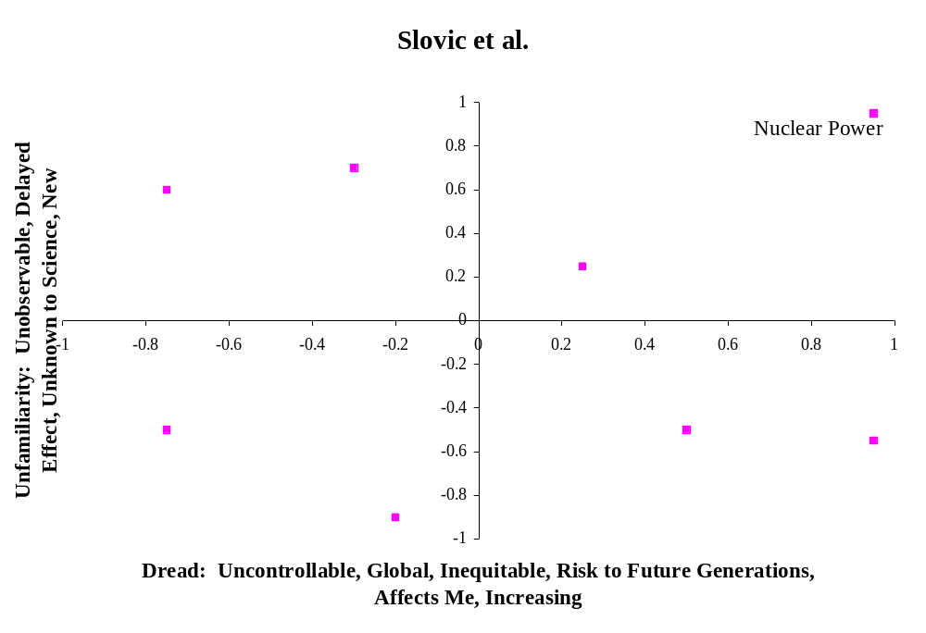
Figure 11.1 Location of risks in factor space (based on Slovic et al. 1980).

Nuclear power is notable as it occupies the space at the extreme upper right hand quadrant of the factor space. As nuclear power is considered both unfamiliar and dread, it is a high-profile risk that elicits concern on the part of the public. In general risks in the upper right hand corner of Figure 1 are higher profile risks, which will attract more public attention. Conversely risks in the lower left hand quadrant scored low on both of these two factors and will tend to attract less public attention and concern. While this conceptual framework is very helpful in describing how the public response to various risks, its ability as a predictive framework to anticipate how the public will react to any particular risk has not been established.

It is also worth noting how this body of literature is often summarized in an overly simplistic fashion. In some cases public perception of risk may be described as being driven solely by “dread”. In other cases, the distinction between voluntary and involuntary risks may be presented as the only distinction that the public makes. It is true that emotional factors, such as “dread” impact public perception of risk, and it is also true that the public tolerates higher levels of risk for voluntary activities such as paragliding, than for involuntary activities, such as living in an area where a nuclear power plant is proposed to be located. Nevertheless, one should be mindful that public perception is driven not just by these two factors of dread and voluntariness, but by a very wide variety of other factors as well.

A second framework for understanding the public perception of risk is based on understanding the distinction between analytical and affective thought. Analytical thought is what the experts do in the formal process of risk assessment. It consists of applying systematic methods and mathematical models to developing quantitative estimates of risk. In contrast, affective thought is an emotional, gut-level response. While the analytical approaches to risk assessment are considered more precise and accurate than affective approaches, affective methods can actually be seen as necessary shortcuts for coping with the large number of risks we face given limited cognitive resources. Affective responses can be seen as a sort of heuristic approach to risk assessment.

As an example, one can consider how the two different systems can be applied to the same risk problem. An individual considering buying an automobile might compare the fatality risks and costs of different models. The risk reduction could be converted to an equivalent monetary value using benchmark values for rate of investment to avert fatal risk. The individual could then select the model with the lowest sum of monetized risk and purchasing price. Another individual might lack either the training or necessary information to conduct this quantitative assessment and might instead simply buy a vehicle that is rated as highly safe by a trusted consumer watchdog group.

Figure 11.2 shows a framework suggested by Slovic et al. (2004) for understanding how affective assessments function. An overall assessment is first developed which then impacts the perceived costs and benefits of the risk. For example, nuclear power may have a highly negative affective response due to concerns over a Chernobyl-scale release of radioactivity. This negative affect will influence assessments of the benefits of nuclear power to be low and costs to be high. In contrast, in the analytical system the risk of a catastrophic failure would be weighted by its probability of occurrence (presumably very low). In addition the costs and benefits are typically separate calculations.
Affect
Perceived
Benefits
Perceived
Risks

Figure 11.2 Influence of affect on perceived risks and perceived benefits
(Slovic 2004).

While affective thinking is a necessary shortcut to enable us to live our daily lives, it also has real weaknesses. For example, cigarette smoking may be associated with positive affect (peer acceptance, effects of nicotine, etc.) which leads individuals to downplay risk estimates in their decision to smoke (Slovic et al. 2004).

Risk Communication
The discussion above has contrasted public and expert views of risk but has not addressed how one should reconcile them. This is the prescriptive issue of “How should one give advice to the public about how to deal with difficult technological risk issues?” Clearly a first step is recognizing that the public will view risks differently from how experts view risks, and recognizing that the public’s broad, multi-attribute view of risk is in many ways legitimate. One should not expect the public to drop their risk preferences in favor of those of expert assessors. Nevertheless there are times when experts really do have important information which could help inform public preferences and actions regarding risks.

The Mental Models risk communication framework is a method to target risk communication efforts at the key knowledge deficiencies in the public (Morgan et al. 2002). A risk communication effort should not waste time telling people what they already know. Instead it should empirically determine what people know and do not know and direct risk communication efforts towards the latter.

Identify gaps between public and expert knowledge
Create expert model
Semi-structured Interviews with public participants

Structured survey to elicit public knowledge on larger scale
Assess frequency of public misconceptions and knowledge gaps
Identify key information gaps
Develop risk communication instrument
Evaluate risk communication instrument
Revise risk communication instrument

Figure 10.3 The Mental Models risk communication framework.

Figure 11.3 shows the key steps in the mental models framework. First expert knowledge is compiled into an expert model of the risk through a review of the literature and interviews with subject matter experts. Then a series of semi-structured interviews are conducted with members of the public. The interviewer first asks the subject to describe his or her knowledge about the particular risk. The interviewer then asks follow-up questions aimed at eliciting the subjects’ causal understanding of the process. Interview transcripts are analyzed to identify deviations between the expert and public models. The semi-structured interviews are an exploratory research technique to aid in the development of hypotheses as to what are common and important deviations between public and expert understanding. However, they are very time consuming which limits the number that can be performed. Because of the small sample size, one cannot conclude definitively how frequently a given misconception occurs among members of the public. For this reason the semi-structured interviews are followed by a more structured elicitation of public knowledge, often in the form of a written survey. This survey questions respondents about particular misconceptions or information gaps which are hypothesized to be prevalent in the subject population, based on the results of the semi-structured interviews.

After the structured survey is completed, the data are analyzed to assess the frequency of particular misconceptions and gaps in the subject population. One must determine whether these gaps occur frequently enough in the subject population to merit their inclusion in a risk communication instrument. One must consider not only frequency of occurrence of different information gaps, but also how frequently this information gap would lead to an incorrect decision. Some knowledge deficiencies may be more or less harmless, while other information deficiencies can lead to incorrect decisions and for this reason should receive priority in risk communication efforts. Once the key information gaps to be addressed have been identified, information designed to address these knowledge deficiencies is put into a risk communication instrument, such as a pamphlet or video. The next step in the mental models framework is the evaluation of this risk communication instrument. This may be done through a simple pretest and posttest in which subjects’ knowledge is assessed before they are exposed to the instrument and after they are exposed to the instrument. If any problems are identified with the instrument, then the instrument should be revised to address these problems, and the revised instrument should be we evaluated empirically again. This process of revision and reevaluation is repeated as often as necessary in order to develop a satisfactory risk communication instrument.

While the Mental Models risk communication framework has been effectively applied to several different risks, this is not to say that there is a simple algorithm for how to undertake risk communication. Often decisions about risk involve difficult tradeoffs and serious conflicts between expert and public valuations of risk. The simple provision of additional information will not necessarily resolve these conflicts even if the information that is to be provided has been precisely targeted at key knowledge gaps by the Mental Models framework

While there is no simple algorithm for how to deal with difficult risk communication issues, there are at least some guidelines that have been learned from past experience. Fischhoff (1995) reviewed how such guidelines have evolved over the course of twenty years and summarized eight stages in the historical evolution of risk communication:

- All we need to do is get the numbers right
- All we have to do is tell them the numbers
- All we nave to do is explain what we mean by the numbers
- All we have to do is show them that they’ve accepted similar risks in the past
- All we have to do is show them that it’s a good deal for them
- All we have to do is treat them with respect
- All we have to do is make them partners
- All of the above

This process evolved from one that did not involve the public, to one that involved the public as passive receivers of risk information, and finally to one in which the public is a partner in the risk management process. While one cannot formulate universally effective guidelines for risk communication, the best chances for success lie in adopting an attitude of respect for the public’s point of view and ongoing engagement with the public. This engagement should seek to instruct the public and improve their knowledge of the issue and also to learn from the public what their concerns are and what their values are.

Risk Management
Risk management is the process of deciding how one ought to respond to risks. While one would clearly like to eliminate all risks, this is not feasible goal. People willingly accept risks when they undertake a wide range of activities, such as driving automobiles, crossing the street, and eating a hamburger. The question of whether a risk is acceptable is not a purely technical question. Rather it is a question that depends on values. While it might simplify matters if we could set a simple threshold for acceptable risk, perhaps a one in a million lifetime risk, and say that activities more risky than this are “unacceptable” and those less risky than this are “acceptable”, there are two reasons why this approach does not work. The first is related to the above discussion of risk perception. The public does not react to risk simply in terms of its expected annual fatalities. Thus the acceptability of a risk in the public’s eyes is not simply a matter of the probabilities of fatality but includes other aspects of the activity, such as whether the activities are undertaken voluntarily whether the process that leads to the risk is a new process or an old and familiar process, and whether their risk provokes a gut level, emotional dread reaction or not. This aspect of defining acceptable risk must be worked through using the process of risk communication and engagement described above.

There is a second issue as well. Some activities are considered essential and must be tolerated even if they produce relatively high risks. In other cases there may be inexpensive alternatives to the activity which are less risky or modifications to the activity which make it less risky. In these cases the risk might well be judged unacceptable because such readily available alternatives exist.

This second issue is an economic issue in that deals with the question of how many resources one should devote to reducing a risk. In other words, what dollar amount should one be willing to spend to reduce risk by a given amount. As with all economic problems one must consider risks not in terms of absolute values but in terms of the incremental differences between alternatives. Often it is not possible to completely eliminate risk; rather one must choose among different risks.

Just as there is no single acceptable threshold of allowable risk, there is also no single appropriate monetized value for risk reduction. Societal willingness to invest in risk reduction depends on the wide range of factors that drive risk perception, such as the dread associated with the risk, its catastrophic potential, etc. In a review of attempts to estimate values from labor market premiums for accepting more dangerous employment, Viscusi and Aldy (2003) conclude that a range of $4-9 million is typical.

Risk assessors typically seek to perform the technical task of providing objective information to risk managers and try to avoid making value judgments or imposing a particular preferred solution. Thus, they are generally cautious about assigning a particular dollar value to a given reduction in risk. Instead analyses are customarily done in terms of cost-effectiveness, in which different prospective risk management measures are evaluated, and quantitative estimates of their costs and reduction in risk are determined. The cost divided by the reduction in risk is the cost-effectiveness of the measure.

One might assume that the most cost-effective solution would be preferred, but this is not necessarily the case. Like most economic goods, risk-reduction strategies tend to exhibit declining marginal returns. One naturally pursues the less expensive measures first, and then if one seeks additional risk reduction, one must pursue more expensive measures. Thus the most cost-effective solution will typically also be the solution their results in the least overall reduction in risk.

Gurian et al. (2001) provide an example of one such risk management situation. This study examined the costs and risk reduction achieved by different drinking water standards for arsenic. A standard of 20µg/l was estimated to save 47 lives per year and cost $120 million/year. Its cost-effectiveness is therefore $2.6 million/life saved. If the standard is set at 10µg/l, it was estimated that compliance would cost $300 million/year and 55 lives would be saved for a cost-effectiveness of $5.5 million/life. However, this is not the appropriate manner in which to assess the cost-effectiveness of the 10µg/l standard. Instead one should consider the additional, or incremental, lives saved and the additional costs incurred by selecting 10 instead of 20. From an intuitive viewpoint, most of the lives saved by the 10µg/l standard will also be saved by the 20µg/l standard. One should not give the 10µg/l standard credit for these lives which would have been saved by the less costly standard. A similar argument applies on the cost side. Thus the appropriate estimate of the cost effectiveness of the 10 µg/l standard is:

(cost of 10µg/l - cost of 20 µg/l) – (benefit of 10µg/l - benefit of 20 µg/l)

Using the numbers from Gurian et al. (2001):

(300-120) / (55-47) = $22.5 million/life.

Note that this incremental value is much greater than the average value of $5.5 million/life. A decision to regulate at 10µg/l implies a value of statistical life that is greater than $22.5 million/life, while a decision to set the standard at 20µg/l implies a value of statistical life that is less than $22.5 million but greater than 2.6 million.

Figure 11.4 shows a simple example of how this type of analysis can be conducted for multiple, discrete risk management options. Based on technical knowledge, the analyst first calculates the risk reduction and costs of each option. Each option can then be plotted as a point with lives saved on the x-axis and cost on the y-axis. A point which is above and to the left of another option is dominated by the other option, because this other option offers greater risk reduction at lower cost (i.e., is superior on both attributes). The set of non-dominated options can thus be connected by an upward sloping line. Due to decreasing marginal returns, the slope is almost always continuously increasing. Thus one can calculate the slope of the line connecting the point in the lowest left corner to the next highest and to the right. This slope is the incremental cost effectiveness of implementing the more costly measure. Decision makers can then be informed that selecting an option to the right of a given line implies a statistical value of life larger than the slope of the line. Likewise, selection of an option to the left of a given line implies a value of life lower than the slope of the line.

Lives saved
Cost
Dominated by the point below and to the right
Slope is marginal cost-effectiveness Saving lives becomes more expensive as you try to save more people
A
C
B
If we choose A implicit value of life is <slope of A-B,
If we choose B, implicit value of life is >A-B and <B-C
If we choose C, implicit value>B-C
Figure 11.4 Implicit value of life for three different risk management alternatives, A, B, and C.

Acknowledgement
The author drew on notes contributed by Elizabeth Casman in developing and structuring this chapter. The assistance of Heather Galada, who prepared Figure 3 and assisted with editing, is gratefully acknowledged.

References/Suggested Reading
Fischhoff, B. (1995) “Risk Perception and Communication Unplugged – 20 Years of Process,” Risk Analysis, 15(2):137-145.
Gurian, PL., Small, MJ, Lockwood JR, and Schervish MJ. (2001) “Benefit-Cost Estimation for Alternative Drinking Water MCLs,” Water Resources Research, 37(8):2213-2226.
Morgan, M.G., Fishhoff, B. Bostrom A., & Atman, C.J. 2002. Risk communication: A mental models approach. New York: Cambridge University Press
Slovic P, Finucane ML, Peters E, MacGregor DG. (2004) “Risk as analysis and risk as feelings: Some thoughts about affect, reason, risk, and rationality,” Risk Analysis, 24 (2): 311-322.
Slovic, P (1987), “Perception of Risk,” Science, 236(4799), pp. 280-285.
Slovic P, Fischhoff B, and Lichtenstein S. (1980) “Facts and Fears: Understanding Perceived Risk” Societal Risk Assessment: How Safe is Safe Enough. Edited by Richard Schwing and Walter Albers, Plenum Press, pp. 181-214.
Viscusi, WK. and Aldy, J. (2003) The Value of a Statistical Life: A Critical Review of Market Estimates Throughout the World. The Journal of Risk and Uncertainty, 27(1), 5–76.

