Evaluation of screening tests

Screening tests, which are to identify asymptomatic diseases or risk factors, are not always perfect because they may yield false positive or false positive outcomes. Therefore, probability lows and concepts are commonly applied in the health sciences to evaluate screening tests and diagnosis criteria.
- False positive: A test result that indicates a positive status when the true status is negative
- False negative: A test result that indicates a negative status when the true status is positive

A variety of probability estimates can be computed from the information organized in a two-way table given in Table 1.
- Sensitivity: Probability of a positive test result (or presence of the symptom) given the presence of the disease
  - 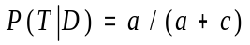
- Specificity: Probability of a negative test result (or absence of the symptom) given the absence of the disease
  - 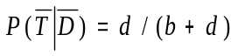
- Predictive value positive: Probability that a subject has the disease given that a subject has a positive screaming test result (or has the symptom)
  - 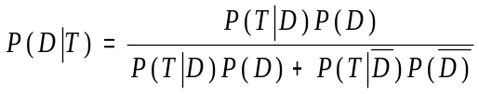
- Predictive value negative: Probability that a subject does not have the disease, given that the subject has a negative screening test result (or does not have the symptom)
  - 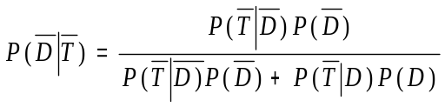

Table 1: Two way table for a screening test
 | Disease
Test results | Present (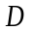) | Absent (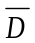) | Total
Positive () | A | b | a + b
Negative () | C | d | c + d
Total | a + c | b + d | n
Where n is the total number of subjects,
a is the number of subjects whose screening results are positive and actually have a disease,
b is the number of subjects whose screening results are positive but actually do not have a disease,
c is the number of subjects whose screening results are negative and actually do have a disease,
d is the number of subjects whose screening results are negative but actually do not have a disease.

Reference
Wayne W. Daniel. 1999. Biostatistics: A foundation for analysis in the health science, John Wiley & Sons, Inc, New York, NY
Testing a new method: 31 + 119 -

n = total number of tests 150

a = 26 + (true positives as determined by another standard test or via seeded studies)

b = 5 + (but were or tested negative by the gold standard)

c= 11 - (but are really + as determined by another standard test or via seeded studies)

d= 108 - (are truly – as determined by another test or via seeded studies)

IS THIS NEW METHOD ACCEPTABLE????

