Lab #1 - Overview of MATLAB

Solutions

I. Introduction to MATLAB.

Task
Using the functions ones and zeros, and the various operators including the colon (' : ') operator
- Create matrix D = 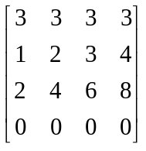

There are many ways to do this. I envisioned something like
D = [3*ones(1,4); 1:4; 2*(1:4); zeros(1,4)]
Again, the nice thing about MATLAB is that assignments can be made compactly.
- Assign to d the sub-matrix 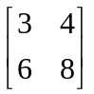

d = D(2:3,3:4)

- Calculate the sum 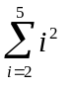, in a single command. Hint: consider a row vector times a column vector.

s= [2 3 4 5] * [2 3 4 5]’

- Consider the row vector, a = [2 4 7 11 16 22]. Using a single command, create a row vector consisting of the differences of successive elements from vector a. Hint: Consider using the colon operator.

da = a(1,2: 6) - a(1,1:5)
If you don’t know the length of the vector a, you can use the function size(). This function can return either the number of rows, the number of columns, or the number of rows and columns of a given vector or matrix. Using the size function, the statement looks as follows:
da = a(1,2: size(a)) - a(1,1:size(a)-1)

II. Data manipulation

Population growth

Analyzing the data

- Calculate the growth rate for each time period and save it in a vector called r.

The solution to the above equation is
ri = ( ln(Pi) - ln(Pi-1) ) / (ti - ti-1)
Using the data structure popdat, in which the first column is time and the second column is population level, we can calculate ri using the following syntax.

( log( popdat(2:size(popdat,1),2) ) - log(popdat(1:size(popdat,1)-1,2) ) ) ./ ( popdat(2:size(popdat,1),1) - popdat(1:size(popdat,1)-1,1) )

Note that
- In MATLAB log in the natural log (ln)
- I used the ./ operator to designate element by element division.
- The numerator and denominator are constructed exactly like in the previous task

ans: r = [5.5x10-5 1.6x10-5 4.61x10-4 5.55x10-4 3.5x10-3 8.8x10-3 0.185] yr-1.

- From the growth rates calculate the doubling time (DT) for each time period, where DT = 0.69/r.
dt = 0.69 ./ r

ans: dt = [1.25x104 4.3x104 1500 1200 200 79 37] yr.

- Plot the doubling time for the seven time periods.
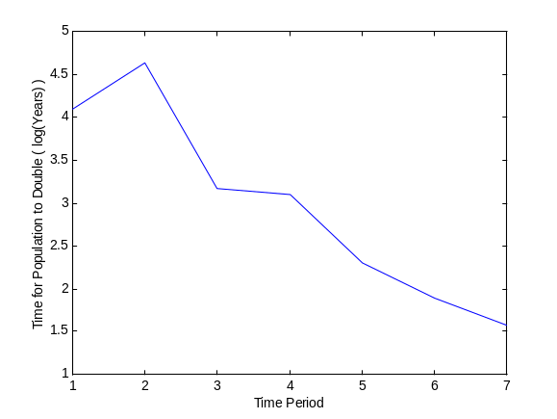

Epidemics

The Reed-Frost model

For different values of q (0.99, 0.98, 0.97, etc.) and different initial number of susceptibles (100, 200, 500, etc), simulate and plot the number of susceptibles and number of cases in the same figure.
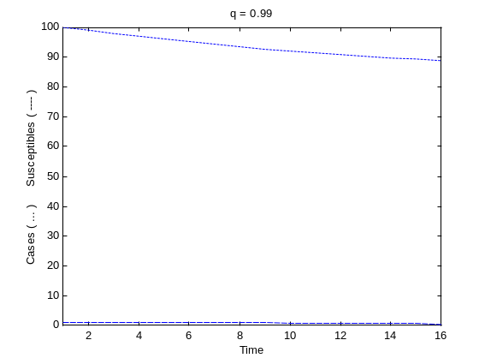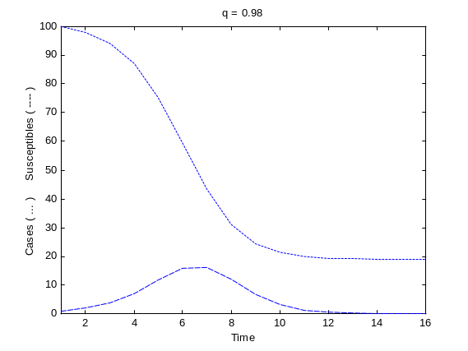
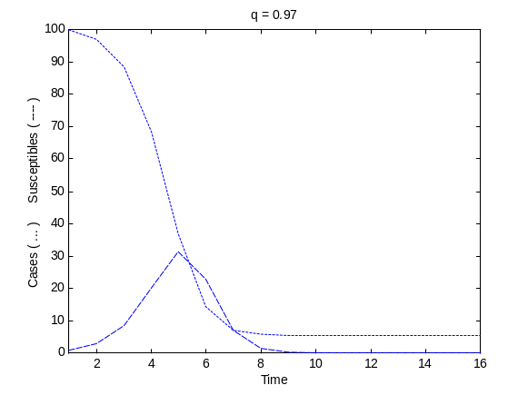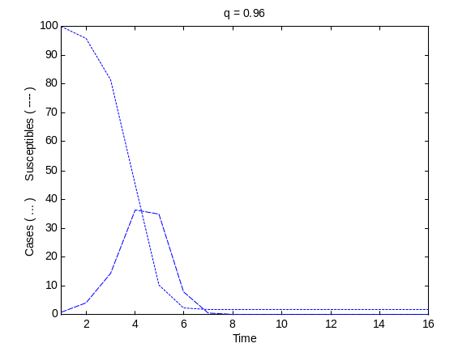

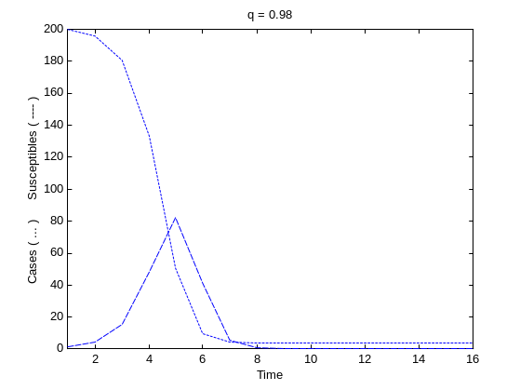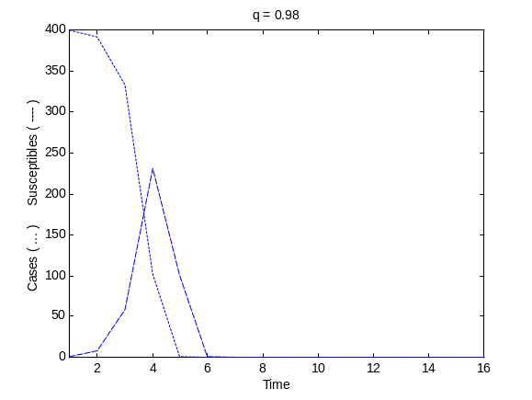
Why does the epidemic die out?

For lack of infected individuals, rather than for lack of susceptible individuals.

Collect data on the q, Sinitial and Sfinal, and create two representative plots showing how the number of susceptibles after the end of the epidemic depends on the contact rate and the initial number of susceptibles.

q | S initial | S final | Cmax | TCmax | q | S initial | S final | Cmax | TCmax
0.99 | 100 | 89 | N/A | N/A | 0.97 | 100 | 5.4 | 30 | 5
0.99 | 200 | 39 | 30 | 8 | 0.97 | 200 | 0.4 | 100 | 4
0.99 | 300 | 17 | 90 | 6 | 0.97 | 300 | 0.03 | 185 | 4
0.99 | 400 | 7.7 | 140 | 6 | 0.97 | 400 | 0.002 | 250 | 4
0.99 | 500 | 3.4 | 230 | 5 | 0.97 | 500 | 0.0001 | 300 | 4
0.98 | 100 | 19 | 17 | 7 | 0.96 | 100 | 1.7 | 35 | 4
0.98 | 200 | 3.74 | 80 | 5 | 0.96 | 200 | 0.05 | 120 | 4
0.98 | 300 | 0.7 | 125 | 4 | 0.96 | 300 | 0.0014 | 165 | 4
0.98 | 400 | 0.12 | 230 | 4 | 0.96 | 400 | 0.0 | 200 | 4
0.98 | 500 | 0.02 | 330 | 4 | 0.96 | 500 | 0.0 | 260 | 3

To plot Sinitial vs. Sfinal for q = 0.97, use the find command
>> plot(OP(find(OP(:,1)==.97),2), OP(find(OP(:,1)==.97),3))

Compare model prediction with measles epidemic data (Abbey, 1952).

Find the value of q that looks to be the best fit of the data and plot the observed number of cases (using markers) with the expected number of cases (using a continuous line).

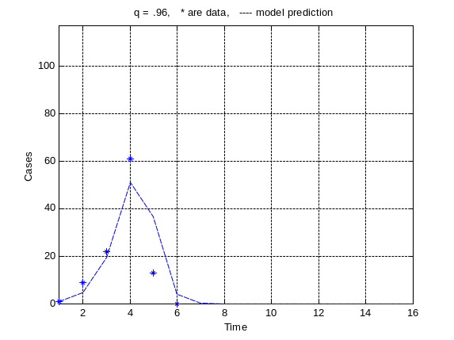

Assessing goodness-of-fit
Write a script that assesses the goodness-of-fit using the following equation

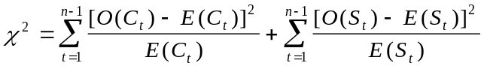

where O(.) are observed values and E(.) are expected or predicted values. Fine tune your best-fit estimate for q.

I used the following to calculate the chi square.

chiC = sum( ( aycock(:,2) - c(1:6) ) .* ( aycock(:,2) - c(1:6) ) ./ c(1:6) );
chiS = sum( ( aycock(:,3) - s(1:6) ) .* ( aycock(:,3) - s(1:6) ) ./ s(1:6) );
chiT = chiC + chiS

I then used a for loop in the script to print out a series of (q, χ)2 pairs. I then proceeded to fine tune my estimate of q.
q | χ2 | q | χ2 | q | χ2 | q | χ2
0.99 | 2980 | 0.975 | 249 | 0.970 | 137 | 0.965 | 100
0.98 | 472 | 0.965 | 100 | 0.969 | 124 | 0.964 | 101
0.97 | 137 |  |  | 0.968 | 114 | 0.963 | 106
0.96 | 142 |  |  | 0.967 | 106 | 0.962 | 114
0.95 | 665 |  |  | 0.966 | 101 | 0.961 | 126
 |  |  |  |  |  | 0.960 | 142

