**What is cloud computing?**

Cloud computing is the delivery of computing services over the internet. Computing services include common IT infrastructure such as virtual machines, storage, databases, and networking. Cloud services also expand the traditional IT offerings to include things like Internet of Things (IoT), machine learning (ML), and artificial intelligence (AI).

Because cloud computing uses the internet to deliver these services, it doesn’t have to be constrained by physical infrastructure the same way that a traditional datacenter is. That means if you need to increase your IT infrastructure rapidly, you don’t have to wait to build a new datacenter—you can use the cloud to rapidly expand your IT footprint.

# Describe the shared responsibility model

Start with a traditional corporate datacenter. The company is responsible for maintaining the physical space, ensuring security, and maintaining or replacing the servers if anything happens. The IT department is responsible for maintaining all the infrastructure and software needed to keep the datacenter up and running. They’re also likely to be responsible for keeping all systems patched and on the correct version.

With the shared responsibility model, these responsibilities get shared between the cloud provider and the consumer. Physical security, power, cooling, and network connectivity are the responsibility of the cloud provider. The consumer isn’t collocated with the datacenter, so it wouldn’t make sense for the consumer to have any of those responsibilities.

You’ll always be responsible for:

* The information and data stored in the cloud
* Devices that are allowed to connect to your cloud (cell phones, computers, and so on)
* The accounts and identities of the people, services, and devices within your organization

The cloud provider is always responsible for:

* The physical datacenter
* The physical network
* The physical hosts

Your service model will determine responsibility for things like:

* Operating systems
* Network controls
* Applications
* Identity and infrastructure

# Define cloud models

## Private cloud

Let’s start with a private cloud. A private cloud is, in some ways, the natural evolution from a corporate datacenter. It’s a cloud (delivering IT services over the internet) that’s used by a single entity. Private cloud provides much greater control for the company and its IT department. However, it also comes with greater cost and fewer of the benefits of a public cloud deployment. Finally, a private cloud may be hosted from your on site datacenter. It may also be hosted in a dedicated datacenter offsite, potentially even by a third party that has dedicated that datacenter to your company.

## Public cloud

A public cloud is built, controlled, and maintained by a third-party cloud provider. With a public cloud, anyone that wants to purchase cloud services can access and use resources. The general public availability is a key difference between public and private clouds.

## Hybrid cloud

A hybrid cloud is a computing environment that uses both public and private clouds in an inter-connected environment. A hybrid cloud environment can be used to allow a private cloud to surge for increased, temporary demand by deploying public cloud resources. Hybrid cloud can be used to provide an extra layer of security. For example, users can flexibly choose which services to keep in public cloud and which to deploy to their private cloud infrastructure.

## Multi-cloud

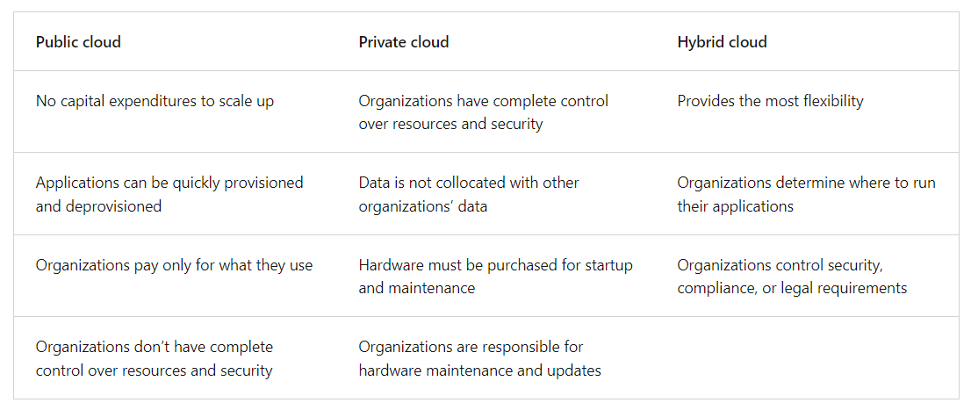A fourth, and increasingly likely scenario is a multi-cloud scenario. In a multi-cloud scenario, you use multiple public cloud providers. Maybe you use different features from different cloud providers. Or maybe you started your cloud journey with one provider and are in the process of migrating to a different provider. Regardless, in a multi-cloud environment you deal with two (or more) public cloud providers and manage resources and security in both environments.

## Azure Arc

Azure Arc is a set of technologies that helps manage your cloud environment. Azure Arc can help manage your cloud environment, whether it's a public cloud solely on Azure, a private cloud in your datacenter, a hybrid configuration, or even a multi-cloud environment running on multiple cloud providers at once.

## Azure VMware Solution

What if you’re already established with VMware in a private cloud environment but want to migrate to a public or hybrid cloud? Azure VMware Solution lets you run your VMware workloads in Azure with seamless integration and scalability.

# Describe the consumption-based model

When comparing IT infrastructure models, there are two types of expenses to consider. Capital expenditure (CapEx) and operational expenditure (OpEx).

CapEx is typically a one-time, up-front expenditure to purchase or secure tangible resources. A new building, repaving the parking lot, building a datacenter, or buying a company vehicle are examples of CapEx.

In contrast, OpEx is spending money on services or products over time. Renting a convention center, leasing a company vehicle, or signing up for cloud services are all examples of OpEx.

Cloud computing falls under OpEx because cloud computing operates on a consumption-based model. With cloud computing, you don’t pay for the physical infrastructure, the electricity, the security, or anything else associated with maintaining a datacenter. Instead, you pay for the IT resources you use. If you don’t use any IT resources this month, you don’t pay for any IT resources.

This consumption-based model has many benefits, including:

* No upfront costs.
* No need to purchase and manage costly infrastructure that users might not use to its fullest potential.
* The ability to pay for more resources when they're needed.
* The ability to stop paying for resources that are no longer needed.

With a traditional datacenter, you try to estimate the future resource needs. If you overestimate, you spend more on your datacenter than you need to and potentially waste money. If you underestimate, your datacenter will quickly reach capacity and your applications and services may suffer from decreased performance. Fixing an under-provisioned datacenter can take a long time. You may need to order, receive, and install more hardware. You'll also need to add power, cooling, and networking for the extra hardware.

In a cloud-based model, you don’t have to worry about getting the resource needs just right. If you find that you need more virtual machines, you add more. If the demand drops and you don’t need as many virtual machines, you remove machines as needed. Either way, you’re only paying for the virtual machines that you use, not the “extra capacity” that the cloud provider has on hand.

## Compare cloud pricing models

Cloud computing is the delivery of computing services over the internet by using a pay-as-you-go pricing model. You typically pay only for the cloud services you use, which helps you:

* Plan and manage your operating costs.
* Run your infrastructure more efficiently.
* Scale as your business needs change.

To put it another way, cloud computing is a way to rent compute power and storage from someone else’s datacenter. You can treat cloud resources like you would resources in your own datacenter. However, unlike in your own datacenter, when you're done using cloud resources, you give them back. You’re billed only for what you use.

Instead of maintaining CPUs and storage in your datacenter, you rent them for the time that you need them. The cloud provider takes care of maintaining the underlying infrastructure for you. The cloud enables you to quickly solve your toughest business challenges and bring cutting-edge solutions to your users.

# Describe the benefits of high availability and scalability in the cloud

## High availability

When you’re deploying an application, a service, or any IT resources, it’s important the resources are available when needed. High availability focuses on ensuring maximum availability, regardless of disruptions or events that may occur.

When you’re architecting your solution, you’ll need to account for service availability guarantees. Azure is a highly available cloud environment with uptime guarantees depending on the service. These guarantees are part of the service-level agreements (SLAs).

## Scalability

Another major benefit of cloud computing is the scalability of cloud resources. Scalability refers to the ability to adjust resources to meet demand. If you suddenly experience peak traffic and your systems are overwhelmed, the ability to scale means you can add more resources to better handle the increased demand.

The other benefit of scalability is that you aren't overpaying for services. Because the cloud is a consumption-based model, you only pay for what you use. If demand drops off, you can reduce your resources and thereby reduce your costs.

Scaling generally comes in two varieties: vertical and horizontal. Vertical scaling is focused on increasing or decreasing the capabilities of resources. Horizontal scaling is adding or subtracting the number of resources.

### Vertical scaling

With vertical scaling, if you were developing an app and you needed more processing power, you could vertically scale up to add more CPUs or RAM to the virtual machine. Conversely, if you realized you had over-specified the needs, you could vertically scale down by lowering the CPU or RAM specifications.

### Horizontal scaling

With horizontal scaling, if you suddenly experienced a steep jump in demand, your deployed resources could be scaled out (either automatically or manually). For example, you could add additional virtual machines or containers, scaling out. In the same manner, if there was a significant drop in demand, deployed resources could be scaled in (either automatically or manually), scaling in.

# Describe the benefits of reliability and predictability in the cloud

## Reliability

Reliability is the ability of a system to recover from failures and continue to function. It's also one of the pillars of the Microsoft Azure Well-Architected Framework.

The cloud, by virtue of its decentralized design, naturally supports a reliable and resilient infrastructure. With a decentralized design, the cloud enables you to have resources deployed in regions around the world. With this global scale, even if one region has a catastrophic event other regions are still up and running. You can design your applications to automatically take advantage of this increased reliability. In some cases, your cloud environment itself will automatically shift to a different region for you, with no action needed on your part. You’ll learn more about how Azure leverages global scale to provide reliability later in this series.

## Predictability

Predictability in the cloud lets you move forward with confidence. Predictability can be focused on performance predictability or cost predictability. Both performance and cost predictability are heavily influenced by the Microsoft Azure Well-Architected Framework. Deploy a solution that’s built around this framework and you have a solution whose cost and performance are predictable.

### Performance

Performance predictability focuses on predicting the resources needed to deliver a positive experience for your customers. Autoscaling, load balancing, and high availability are just some of the cloud concepts that support performance predictability. If you suddenly need more resources, autoscaling can deploy additional resources to meet the demand, and then scale back when the demand drops. Or if the traffic is heavily focused on one area, load balancing will help redirect some of the overload to less stressed areas.

### Cost

Cost predictability is focused on predicting or forecasting the cost of the cloud spend. With the cloud, you can track your resource use in real time, monitor resources to ensure that you’re using them in the most efficient way, and apply data analytics to find patterns and trends that help better plan resource deployments. By operating in the cloud and using cloud analytics and information, you can predict future costs and adjust your resources as needed. You can even use tools like the Total Cost of Ownership (TCO) or Pricing Calculator to get an estimate of potential cloud spend.

# Describe the benefits of security and governance in the cloud

Whether you’re deploying infrastructure as a service or software as a service, cloud features support governance and compliance. Things like set templates help ensure that all your deployed resources meet corporate standards and government regulatory requirements. Plus, you can update all your deployed resources to new standards as standards change. Cloud-based auditing helps flag any resource that’s out of compliance with your corporate standards and provides mitigation strategies. Depending on your operating model, software patches and updates may also automatically be applied, which helps with both governance and security.

On the security side, you can find a cloud solution that matches your security needs. If you want maximum control of security, infrastructure as a service provides you with physical resources but lets you manage the operating systems and installed software, including patches and maintenance. If you want patches and maintenance taken care of automatically, platform as a service or software as a service deployments may be the best cloud strategies for you.

And because the cloud is intended as an over-the-internet delivery of IT resources, cloud providers are typically well suited to handle things like distributed denial of service (DDoS) attacks, making your network more robust and secure.

By establishing a good governance footprint early, you can keep your cloud footprint updated, secure, and well managed.

## Management of the cloud

Management of the cloud speaks to managing your cloud resources. In the cloud, you can:

* Automatically scale resource deployment based on need.
* Deploy resources based on a preconfigured template, removing the need for manual configuration.
* Monitor the health of resources and automatically replace failing resources.
* Receive automatic alerts based on configured metrics, so you’re aware of performance in real time.

# Describe Software as a Service

Software as a service (SaaS) is the most complete cloud service model from a product perspective. With SaaS, you’re essentially renting or using a fully developed application. Email, financial software, messaging applications, and connectivity software are all common examples of a SaaS implementation.

While the SaaS model may be the least flexible, it’s also the easiest to get up and running. It requires the least amount of technical knowledge or expertise to fully employ.

## Scenarios

Some common scenarios for SaaS are:

* Email and messaging.
* Business productivity applications.
* Finance and expense tracking.

## What can I do with Azure?

Azure provides more than 100 services that enable you to do everything from running your existing applications on virtual machines to exploring new software paradigms, such as intelligent bots and mixed reality.

Many teams start exploring the cloud by moving their existing applications to virtual machines (VMs) that run in Azure. Migrating your existing apps to VMs is a good start, but the cloud is much more than a different place to run your VMs.

For example, Azure provides artificial intelligence (AI) and machine-learning (ML) services that can naturally communicate with your users through vision, hearing, and speech. It also provides storage solutions that dynamically grow to accommodate massive amounts of data. Azure services enable solutions that aren't feasible without the power of the cloud.

### What is the Azure free account?

The Azure free account includes:

* Free access to popular Azure products for 12 months.
* A credit to use for the first 30 days.
* Access to more than 25 products that are always free.

## Use the PowerShell CLI

Use the PowerShell Get-date command to get the current date and time.

Get-date

Most Azure specific commands will start with the letters az. The Get-date command you just ran is a PowerShell specific command. Let's try an Azure command to check what version of the CLI you're using right now.

az version

## Use the BASH CLI

Bash

Use the date command to get the current date and time.

Just like in the PowerShell mode of the CLI, you can use the letters az to start an Azure command in the BASH mode. Try to run an update to the CLI with az upgrade.

az upgrade

## Use Azure CLI interactive mode

Another way to interact is using the Azure CLI interactive mode. This changes CLI behavior to more closely resemble an integrated development environment (IDE). Interactive mode provides autocompletion, command descriptions, and even examples. If you’re unfamiliar with BASH and PowerShell, but want to use the command line, interactive mode may help you.

Enter az interactive to enter interactive mode.

Use the exit command to leave interactive mode.

Exit

#### Use availability zones in your apps

You want to ensure your services and data are redundant so you can protect your information in case of failure. When you host your infrastructure, setting up your own redundancy requires that you create duplicate hardware environments. Azure can help make your app highly available through availability zones.

You can use availability zones to run mission-critical applications and build high-availability into your application architecture by co-locating your compute, storage, networking, and data resources within an availability zone and replicating in other availability zones. Keep in mind that there could be a cost to duplicating your services and transferring data between availability zones.

## Azure management groups

The final piece is the management group. Resources are gathered into resource groups, and resource groups are gathered into subscriptions. If you’re just starting in Azure that might seem like enough hierarchy to keep things organized. But imagine if you’re dealing with multiple applications, multiple development teams, in multiple geographies.

If you have many subscriptions, you might need a way to efficiently manage access, policies, and compliance for those subscriptions. Azure management groups provide a level of scope above subscriptions. You organize subscriptions into containers called management groups and apply governance conditions to the management groups. All subscriptions within a management group automatically inherit the conditions applied to the management group, the same way that resource groups inherit settings from subscriptions and resources inherit from resource groups. Management groups give you enterprise-grade management at a large scale, no matter what type of subscriptions you might have. Management groups can be neste

Important facts about management groups:

* 10,000 management groups can be supported in a single directory.
* A management group tree can support up to six levels of depth. This limit doesn't include the root level or the subscription level.
* Each management group and subscription can support only one parent.

## Task 1: Create a virtual machine

In this task, you’ll create a virtual machine using the Azure portal.

1. Sign in to the [Azure portal](https://portal.azure.com/learn.docs.microsoft.com).
2. Select Create a resource > Compute > Virtual Machine > Create.
3. The Create a virtual machine pane opens to the basics tab.
4. Verify or enter the following values for each setting. If a setting isn’t specified, leave the default value.
5. Select Review and Create
6. Select Create

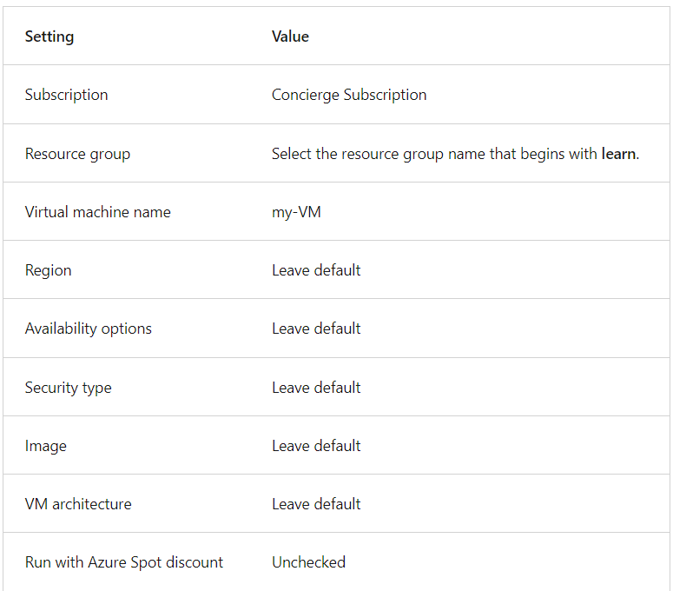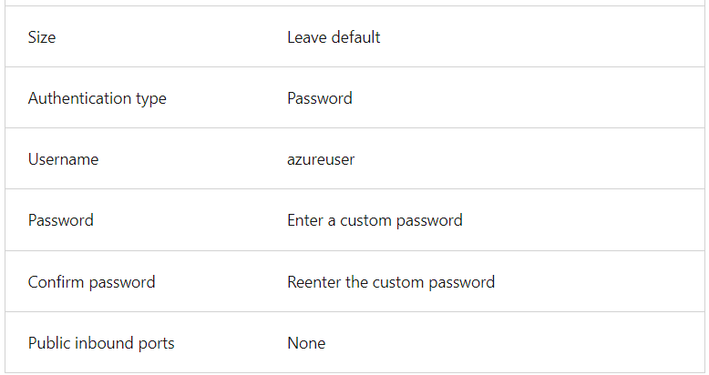

Username: azureuser

Password: azureuserUtsab@123

## Verify resources created

Once the deployment is created, you can verify that Azure created not only a VM, but all of the associated resources the VM needs.

1. Select Home
2. Select Resource groups

Select the learn-0a4c81e9-56f5-4f47-be0e-0d70e77214dc resource group

You should see a list of resources in the resource group. The storage account and virtual network are associated with the Learn sandbox. However, the rest of the resources were created when you created the virtual machine. By default, Azure gave them all a similar name to help with association and grouped them in the same resource group.

Congratulations! You've created a resource in Azure and had a chance to see how resources get grouped on creation.

## Clean up

The sandbox automatically cleans up your resources when you're finished with this module.

When you're working in your own subscription, it's a good idea at the end of a project to identify whether you still need the resources you created. Resources that you leave running can cost you money. You can delete resources individually or delete the resource group to delete the entire set of resources.

# Describe Azure virtual machines

With Azure Virtual Machines (VMs), you can create and use VMs in the cloud. VMs provide infrastructure as a service (IaaS) in the form of a virtualized server and can be used in many ways. Just like a physical computer, you can customize all of the software running on your VM. VMs are an ideal choice when you need:

* Total control over the operating system (OS).
* The ability to run custom software.
* To use custom hosting configurations.

## Scale VMs in Azure

You can run single VMs for testing, development, or minor tasks. Or you can group VMs together to provide high availability, scalability, and redundancy. Azure can also manage the grouping of VMs for you with features such as scale sets and availability sets.

## Examples of when to use VMs

Some common examples or use cases for virtual machines include:

* **During testing and development**. VMs provide a quick and easy way to create different OS and application configurations. Test and development personnel can then easily delete the VMs when they no longer need them.
* **When running applications in the cloud**. The ability to run certain applications in the public cloud as opposed to creating a traditional infrastructure to run them can provide substantial economic benefits. For example, an application might need to handle fluctuations in demand. Shutting down VMs when you don't need them or quickly starting them up to meet a sudden increase in demand means you pay only for the resources you use.
* **When extending your datacenter to the cloud**: An organization can extend the capabilities of its own on-premises network by creating a virtual network in Azure and adding VMs to that virtual network. Applications like SharePoint can then run on an Azure VM instead of running locally. This arrangement makes it easier or less expensive to deploy than in an on-premises environment.
* **During disaster recovery**: As with running certain types of applications in the cloud and extending an on-premises network to the cloud, you can get significant cost savings by using an IaaS-based approach to disaster recovery. If a primary datacenter fails, you can create VMs running on Azure to run your critical applications and then shut them down when the primary datacenter becomes operational again.

## Create a Linux virtual machine and install Nginx

Use the following Azure CLI commands to create a Linux VM and install Nginx. After your VM is created, you'll use the Custom Script Extension to install Nginx. The Custom Script Extension is an easy way to download and run scripts on your Azure VMs. It's just one of the many ways you can configure the system after your VM is up and running.

From Cloud Shell, run the following az vm create command to create a Linux VM:

az vm create --resource-group "[sandbox resource group name]" --name my-vm --public-ip-sku Standard --image Ubuntu2204 --admin-username azureuser --generate-ssh-keys

Your VM will take a few moments to come up. You named the VM **my-vm**. You use this name to refer to the VM in later steps.

Run the following az vm extension set command to configure Nginx on your VM:

az vm extension set --resource-group "[sandbox resource group name]" --vm-name my-vm --name customScript --publisher Microsoft.Azure.Extensions --version 2.1 --settings '{"fileUris":["https://raw.githubusercontent.com/MicrosoftDocs/mslearn-welcome-to-azure/master/configure-nginx.sh"]}' --protected-settings '{"commandToExecute": "./configure-nginx.sh"}'

This command uses the Custom Script Extension to run a Bash script on your VM. The script is stored on GitHub. While the command runs, you can choose to [examine the Bash script](https://raw.githubusercontent.com/MicrosoftDocs/mslearn-welcome-to-azure/master/configure-nginx.sh) from a separate browser tab. To summarize, the script:

1. Runs apt-get update to download the latest package information from the internet. This step helps ensure that the next command can locate the latest version of the Nginx package.
2. Installs Nginx.
3. Sets the home page, */var/www/html/index.html*, to print a welcome message that includes your VM's host name.

# Describe Azure virtual desktop

Another type of virtual machine is the Azure Virtual Desktop. Azure Virtual Desktop is a desktop and application virtualization service that runs on the cloud. It enables you to use a cloud-hosted version of Windows from any location. Azure Virtual Desktop works across devices and operating systems, and works with apps that you can use to access remote desktops or most modern browsers.