University of Engineering and Technology
New Campus, Lahore
Department of Computer Science



FoodExpress Dispatch Optimization Engine
UML / Design Documentation

Submitted by:
Mirza Zain Ali Baig 2025(S)-SE-20
Muhammad Hamza Shahid 2025(S)-SE-08
Muhammad Sohaib Aslam 2025(S)-SE-13
Submitted to:
Sir Ali Raza

Table of Contents
1. System Architecture Overview 3
1.1 Architecture Layers 3
1.2 Module-to-Data-Structure Mapping 4
2. Class Diagram & Relationships 4
2.1 Entity Classes 5
2.2 Data Structure Classes 6
2.3 Class Relationships 7
3. Module Design 8
3.1 Module 1 — Dynamic Order Scheduling Engine 8
3.2 Module 2 — Kitchen Load Balancing Module 8
3.3 Module 3 — Rider Dispatch & Assignment Optimization 8
3.4 Module 4 — Real-Time Route Optimization 9
3.5 Module 5 — Search & Retrieval Engine 9
3.6 Module 6 — Order History & Tracking Module 10
3.7 Module 7 — Performance Analysis Module 10
4. Algorithm Flowcharts 11
4.1 Max-Heap Insertion (bubbleUp) 11
4.2 Max-Heap Extract Highest Priority (bubbleDown) 12
4.3 Dijkstra Shortest Path 13
4.4 Hash Table Insert with Chaining 14
4.5 Order Status Undo Operation 15
4.6 Rider Best-Fit Selection 16
5. Complexity Analysis 17
5.1 Time Complexity 17
5.2 Space Complexity 17
6. Ethical & Professional Practices 18
6.1 Customer Data Privacy 18
6.2 Responsible Rider Workload Management 18
6.3 Scalability Limits & Production Considerations 18
6.4 Algorithm Design Justification 19
6.5 Professional Engineering Standards 19

1. System Architecture Overview
The FoodExpress Dispatch Optimization Engine is a CLI-based C++ application structured as a single-executable system with a unified Main Menu that acts as a central dispatcher to 9 functional modules. All modules share a single FoodExpressSystem object (global pointer) which owns the entity collections and all six core data structures. Persistent storage is handled via seven plain-text .txt files, read at startup and written incrementally as operations occur.
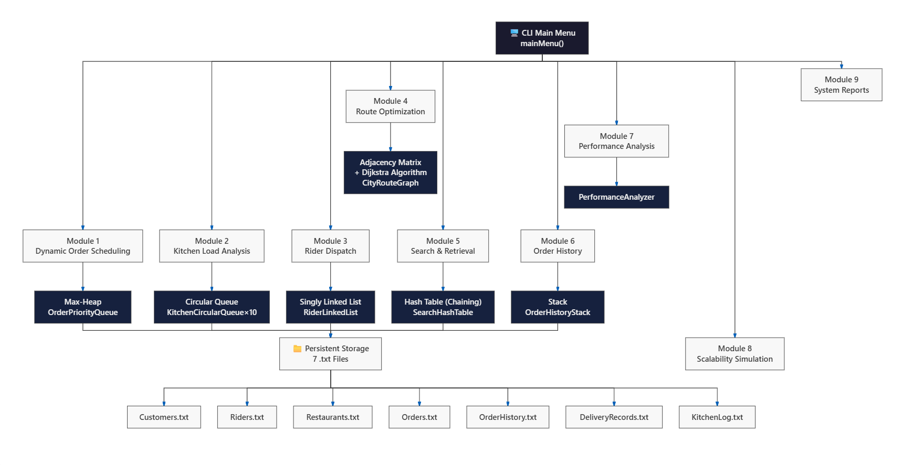

1.1 Architecture Layers
Layer | Component | Technology
Presentation | CLI Menu System (mainMenu + 9 module menus) | C++ cout/cin
Business Logic | FoodExpressSystem class | C++ OOP
Data Structures | Max-Heap, Circular Queue, Linked List, Graph, Hash Table, Stack | Custom C++ (No STL)
Persistence | 7 .txt flat files | C++ fstream

1.2 Module-to-Data-Structure Mapping
Module | Data Structure | Class Name | Capacity
Dynamic Order Scheduling | Max-Heap | OrderPriorityQueue | 500 orders
Kitchen Load Balancing | Circular Queue (×10) | KitchenCircularQueue | 50 orders each
Rider Dispatch | Singly Linked List | RiderLinkedList | Dynamic
Route Optimization | Adjacency Matrix | CityRouteGraph | 15 locations
Search & Retrieval | Hash Table (Chaining) | SearchHashTable | 101 buckets
Order History | Stack | OrderHistoryStack | 2000 entries
Performance Analysis | Algorithm Benchmarker | PerformanceAnalyzer | N/A

2. Class Diagram & Relationships
The system is built around 13 custom classes. The FoodExpressSystem class acts as the facade — it composes all six data structures and manages the four entity collections. No inheritance hierarchy is used; the design favors composition over inheritance to keep each class independently testable.

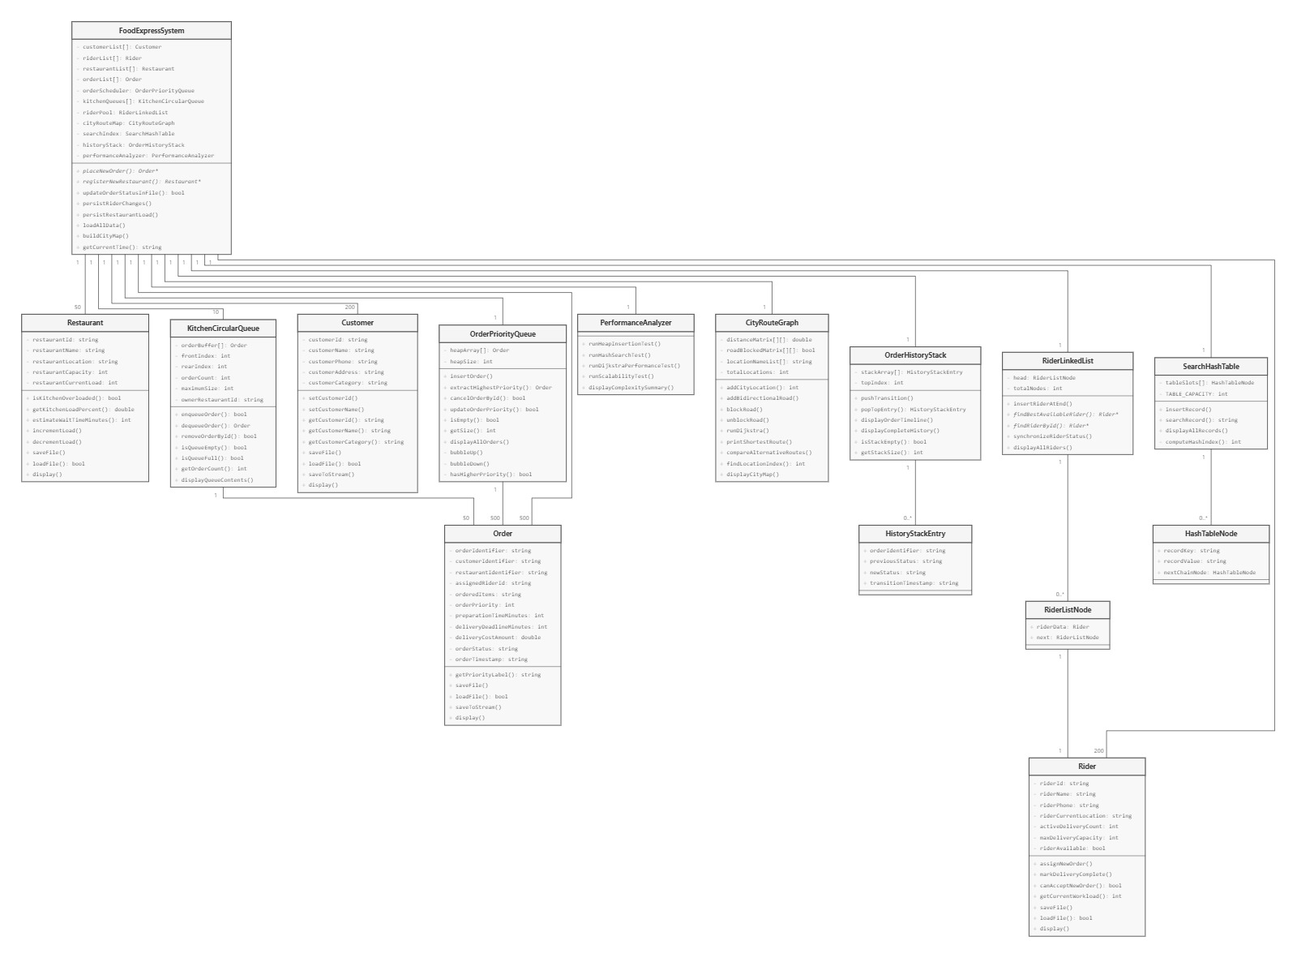

2.1 Entity Classes

Class | Key Fields | Responsibility
Customer | customerId, customerName,  customerPhone, customerAddress,  customerCategory | Stores customer profile. Supports file persistence (saveFile / loadFile / saveToStream). Used to auto-determine order priority tier.
Rider | riderId, riderName,  riderCurrentLocation,  activeDeliveryCount, maxDeliveryCapacity,  riderAvailable | Stores rider state. Exposes canAcceptNewOrder() and getCurrentWorkload() used by dispatch algorithm.
Restaurant | restaurantId, restaurantName,  restaurantLocation,  restaurantCapacity, restaurantCurrentLoad | Stores restaurant capacity state. Exposes isKitchenOverloaded(), getKitchenLoadPercent(), estimateWaitTimeMinutes().
Order | orderIdentifier, customerIdentifier,  restaurantIdentifier, orderPriority,  preparationTimeMinutes, deliveryCostAmount,  orderStatus, orderTimestamp | Core data object. Carried through all modules — scheduled in heap, queued in kitchen, assigned to rider, tracked in history stack.

2.2 Data Structure Classes
Class | Internal Structure | Key Methods
OrderPriorityQueue | Order heapArray[500]; int heapSize | insertOrder(), extractHighestPriority(), cancelOrderById(), updateOrderPriority(), displayAllOrders()
KitchenCircularQueue | Order orderBuffer[CAPACITY];  int front, rear, count | enqueueOrder(), dequeueOrder(), removeOrderById(), isQueueFull(), displayQueueContents()
RiderLinkedList | RiderListNode* head;  int totalNodes | insertRiderAtEnd(), findBestAvailableRider(), findRiderById(), synchronizeRiderStatus()
CityRouteGraph | double distanceMatrix[15][15];  bool roadBlockedMatrix[15][15];  string locationNameList[15] | runDijkstra(), printShortestRoute(), compareAlternativeRoutes(), blockRoad(), unblockRoad()
SearchHashTable | HashTableNode* tableSlots[101] | insertRecord(), searchRecord(), displayAllRecords()
OrderHistoryStack | HistoryStackEntry stackArray[2000];  int topIndex | pushTransition(), popTopEntry(), displayOrderTimeline(), displayCompleteHistory()
PerformanceAnalyzer | No persistent state | runHeapInsertionTest(), runHashSearchTest(), runDijkstraPerformanceTest(), runScalabilityTest(), displayComplexitySummary()

2.3 Class Relationships
Relationship | From | To | Type | Multiplicity
Composition | FoodExpressSystem | OrderPriorityQueue | owns | 1 → 1
Composition | FoodExpressSystem | KitchenCircularQueue | owns | 1 → 10
Composition | FoodExpressSystem | RiderLinkedList | owns | 1 → 1
Composition | FoodExpressSystem | CityRouteGraph | owns | 1 → 1
Composition | FoodExpressSystem | SearchHashTable | owns | 1 → 1
Composition | FoodExpressSystem | OrderHistoryStack | owns | 1 → 1
Composition | FoodExpressSystem | PerformanceAnalyzer | owns | 1 → 1
Aggregation | FoodExpressSystem | Customer[] | manages | 1 → 0..200
Aggregation | FoodExpressSystem | Rider[] | manages | 1 → 0..200
Aggregation | FoodExpressSystem | Restaurant[] | manages | 1 → 0..50
Aggregation | FoodExpressSystem | Order[] | manages | 1 → 0..500
Composition | OrderPriorityQueue | Order | stores copies | 1 → 0..500
Composition | KitchenCircularQueue | Order | stores copies | 1 → 0..50
Composition | RiderLinkedList | RiderListNode | links | 1 → 0..*
Composition | RiderListNode | Rider | wraps | 1 → 1
Composition | OrderHistoryStack | HistoryStackEntry | stores | 1 → 0..2000
Composition | SearchHashTable | HashTableNode | chains | 1 → 0..*

3. Module Design

3.1 Module 1 — Dynamic Order Scheduling Engine
Data Structure: Max-Heap | Class: OrderPriorityQueue | Capacity: 500 orders
A Max-Heap provides O(log n) insertion and O(log n) extraction of the highest-priority order. This is optimal for a real-time scheduling engine where VIP orders must be processed before standard ones. A sorted linked list would give O(n) extraction; a FIFO queue would completely ignore priority.
Priority Levels
Level | Label | Customer Tier | Processing Policy
4 | CRITICAL | VIP | Always first
3 | HIGH | Premium | Before Regular
2 | MEDIUM | Regular | Default tier
1 | LOW | Basic | Last processed

Supported Operations
Operation | Method | Complexity
Insert new order | insertOrder() | O(log n)
Get highest priority order | extractHighestPriority() | O(log n)
Cancel order by ID | cancelOrderById() | O(n) scan + O(log n)
Update order priority | updateOrderPriority() | O(n) scan + O(log n)
Peek top order | peekTopOrder() | O(1)
View all orders | displayAllOrders() | O(n)

3.2 Module 2 — Kitchen Load Balancing Module
Data Structure: Circular Queue | Class: KitchenCircularQueue | Instances: Up to 10
A Circular Queue models kitchen order flow — orders enter the rear and are prepared from the front. The circular design avoids wasted array space with O(1) enqueue/dequeue. When a kitchen exceeds 80% load, the system detects overload and can rebalance by routing new orders to a less-loaded queue.
Operation | Method | Complexity
Enqueue order | enqueueOrder() | O(1)
Dequeue order | dequeueOrder() | O(1)
Remove by ID | removeOrderById() | O(n)
Detect overload | isKitchenOverloaded() | O(1)
Get load percent | getKitchenLoadPercent() | O(1)
Estimate wait time | estimateWaitTimeMinutes() | O(1)
Register restaurant | registerNewRestaurant() | O(1)

3.3 Module 3 — Rider Dispatch & Assignment Optimization
Data Structure: Singly Linked List | Class: RiderLinkedList | Algorithm: Greedy Best-Fit
A singly linked list is used for the rider pool because riders are dynamically added and the system only needs sequential traversal to find the best available rider. Pointer-based allocation avoids fixed array sizing. The greedy best-fit algorithm selects the least-loaded eligible rider — minimizing per-rider delivery delay while balancing fleet workload.
Rider Selection Criteria (in order)
- riderAvailable == true
- activeDeliveryCount < maxDeliveryCapacity
- Among eligible: lowest getCurrentWorkload() wins

3.4 Module 4 — Real-Time Route Optimization
Data Structure: Adjacency Matrix | Algorithm: Dijkstra's O(V²) | V = 15 locations
An adjacency matrix is chosen because the city graph is dense (many roads between 15 fixed locations) and V=15 is small. Matrix gives O(1) edge lookup. Dijkstra's algorithm (unvisited-set scan, O(V²)) finds the optimal delivery route. A priority-queue Dijkstra (O(E log V)) would only outperform at V > 1000.
City Locations (15 nodes)
Index | Location | Index | Location | Index | Location
0 | Mall Road | 5 | Cantt | 10 | Shadman
1 | Gulberg | 6 | Bahria Town | 11 | Ichra
2 | DHA Phase 1 | 7 | Wapda Town | 12 | Bhatta Chowk
3 | Model Town | 8 | Faisal Town | 13 | Allama Iqbal Airport
4 | Johar Town | 9 | Garden Town | 14 | Ring Road

Delivery Cost Formula: Cost (Rs.) = 50 + Distance(km) × 15

3.5 Module 5 — Search & Retrieval Engine
Data Structure: Hash Table (Separate Chaining) | Buckets: 101 | Hash: Polynomial Rolling
A hash table with chaining provides O(1) average-case search — critical for a dispatch engine resolving thousands of ID lookups. A prime bucket count (101) minimizes hash collisions. Chaining handles collisions gracefully without clustering problems of open addressing.
Hash Function
hash = 0
for each character c in key:
hash = (hash * 31 + ascii(c)) % 101
return hash
Indexed Entities
- Customers (prefix: C-)
- Riders (prefix: R-)
- Restaurants (custom ID)
- Orders (prefix: ORD-)

3.6 Module 6 — Order History & Tracking Module
Data Structure: Stack | Class: OrderHistoryStack | Capacity: 2000 transitions
A stack is the natural structure for undo/redo — LIFO ordering ensures the most recent status change is always at the top. Every status update pushes a HistoryStackEntry. The entire stack can be scanned to reconstruct any order's complete timeline. Undo pops the top and restores the previous status.
Tracked Status Transitions
new → placed → accepted → queued → prepared → assigned → picked → delivered
Any state → delayed | cancelled | rerouted

3.7 Module 7 — Performance Analysis Module
Class: PerformanceAnalyzer | Tests: Heap insertion, Hash search, Dijkstra, Scalability, Complexity
Test | What It Measures | Dataset Sizes
Heap Insertion Test | Actual insert time vs theoretical O(log n) | 10, 50, 100, 250, 500 orders
Hash Search Test | O(1) avg vs O(n) worst-case analysis | Load factor at 50%, 75%, 100%
Dijkstra Performance | Route calc time at different V sizes | V = 5, 10, 15 locations
Scalability Test | All structures under increasing N | N = 100, 250, 500 records
Complexity Summary | Theoretical Big-O table for all modules | All 6 data structures

4. Algorithm Flowcharts
The following describes the step-by-step logic of each core algorithm. Mermaid diagram source is provided in the accompanying UML_Design_Documentation.md.

4.1 Max-Heap Insertion (bubbleUp)
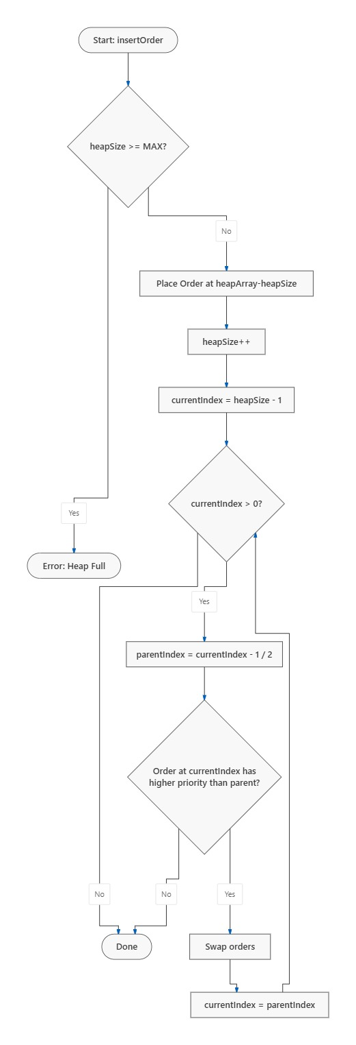

4.2 Max-Heap Extract Highest Priority (bubbleDown)
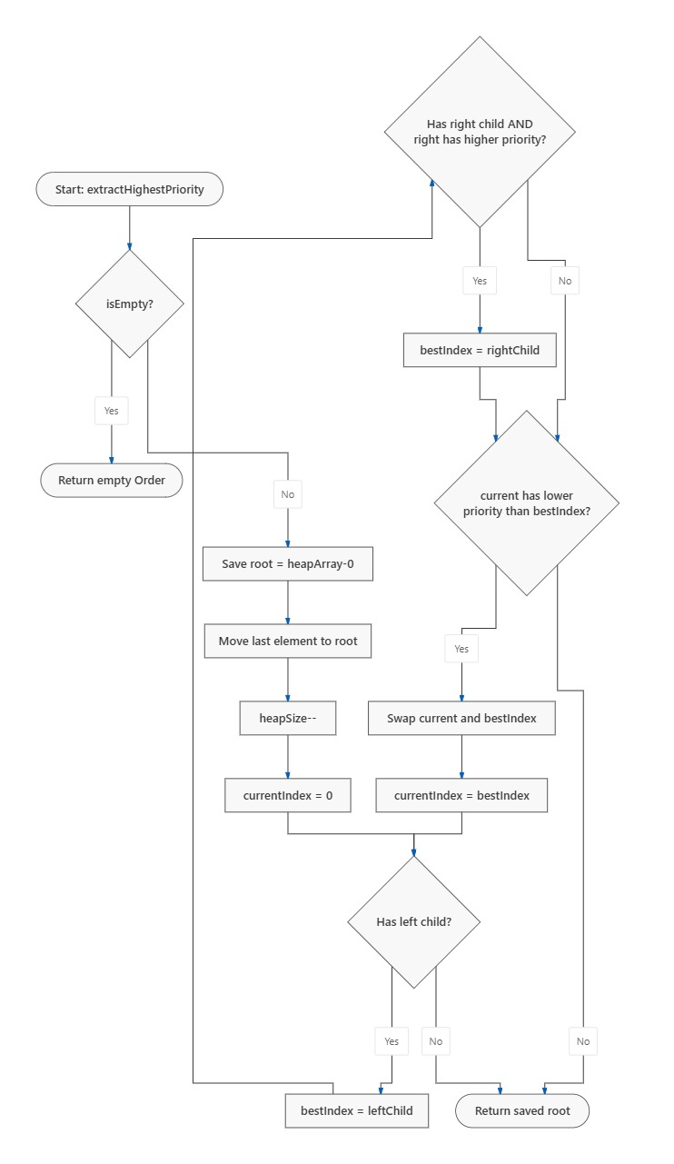

4.3 Dijkstra Shortest Path
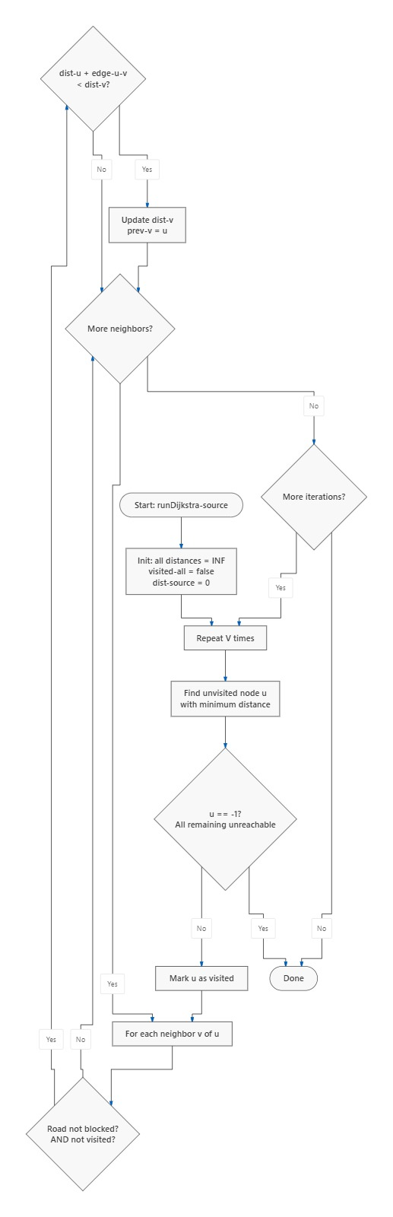

4.4 Hash Table Insert with Chaining
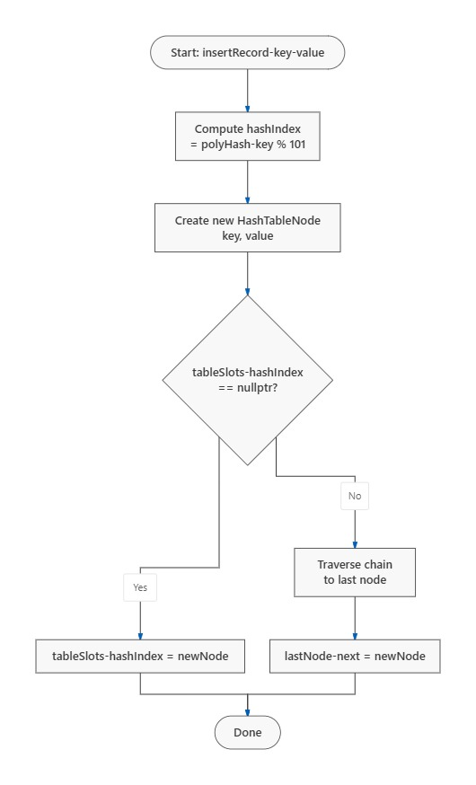

4.5 Order Status Undo Operation
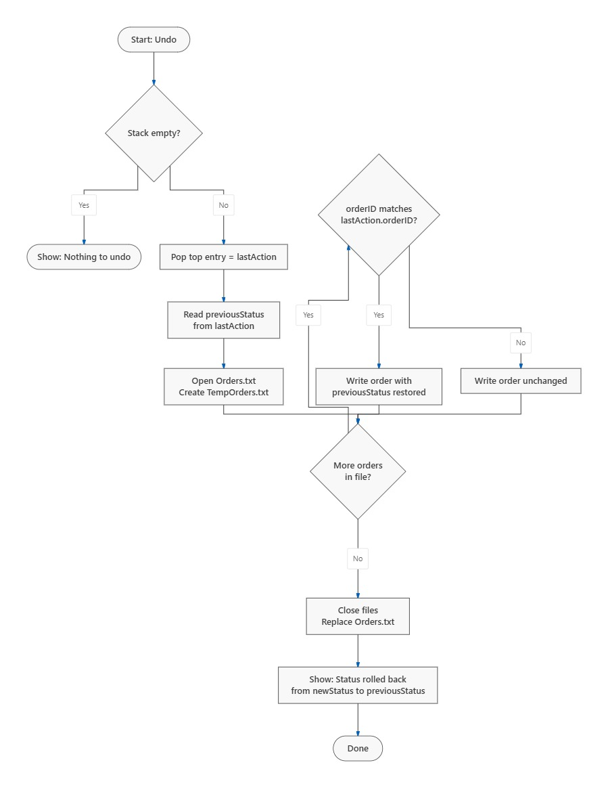

4.6 Rider Best-Fit Selection
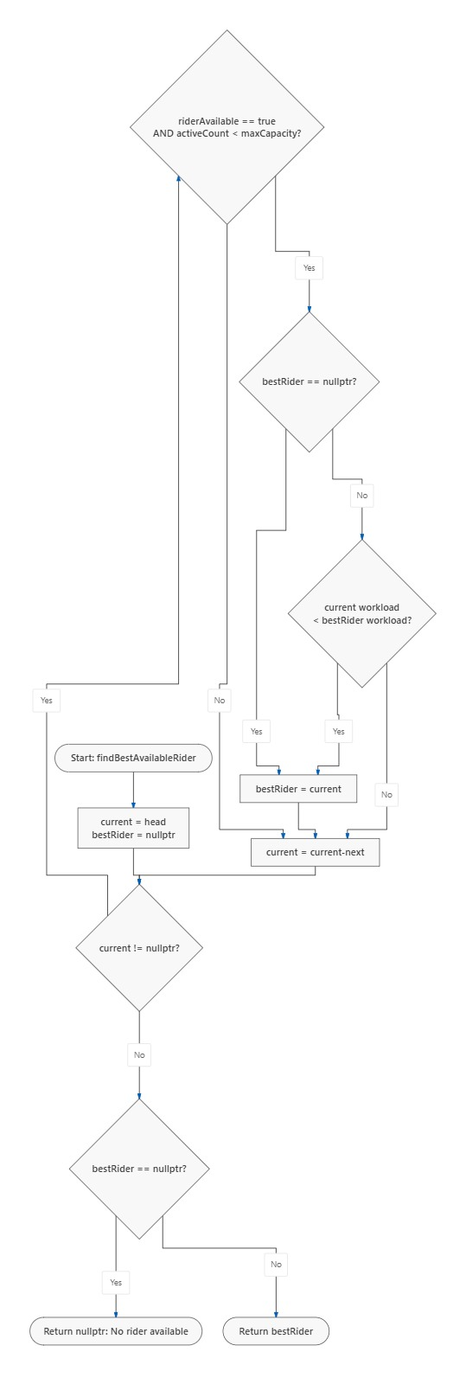

5. Complexity Analysis

5.1 Time Complexity
Module | Operation | Data Structure | Best | Average | Worst
Order Scheduling | Insert | Max-Heap | O(1) | O(log n) | O(log n)
Order Scheduling | Extract Max | Max-Heap | O(log n) | O(log n) | O(log n)
Order Scheduling | Cancel / Update | Max-Heap | O(n) | O(n) | O(n)
Order Scheduling | Peek Top | Max-Heap | O(1) | O(1) | O(1)
Kitchen Load | Enqueue | Circular Queue | O(1) | O(1) | O(1)
Kitchen Load | Dequeue | Circular Queue | O(1) | O(1) | O(1)
Kitchen Load | Remove by ID | Circular Queue | O(1) | O(n) | O(n)
Rider Dispatch | Find Best Rider | Linked List | O(1) | O(n) | O(n)
Rider Dispatch | Insert Rider | Linked List | O(1) | O(n) | O(n)
Rider Dispatch | Find by ID | Linked List | O(1) | O(n) | O(n)
Route Optimization | Dijkstra | Adj Matrix | O(V²) | O(V²) | O(V²)
Route Optimization | Edge lookup | Adj Matrix | O(1) | O(1) | O(1)
Route Optimization | Block/Unblock | Adj Matrix | O(1) | O(1) | O(1)
Search & Retrieval | Insert record | Hash Table | O(1) | O(1) | O(n)
Search & Retrieval | Search by ID | Hash Table | O(1) | O(1) | O(n)
Order History | Push transition | Stack | O(1) | O(1) | O(1)
Order History | Pop (Undo) | Stack | O(1) | O(1) | O(1)
Order History | View Timeline | Stack | O(n) | O(n) | O(n)

5.2 Space Complexity
Data Structure | Space Complexity | Fixed Capacity | Notes
Max-Heap | O(n) | 500 orders | Static array allocation
Circular Queue (×10) | O(k) per queue | 50 orders / queue | k = queue capacity
Linked List | O(n) | Dynamic | Heap-allocated nodes
Adjacency Matrix | O(V²) | 15×15 = 225 cells | Constant (V fixed)
Hash Table | O(n + m) | 101 buckets | n=records, m=buckets
Stack | O(n) | 2000 entries | Static array allocation

6. Ethical & Professional Practices

6.1 Customer Data Privacy
The system stores customer name, phone number, delivery address, order history, and customer category in plain-text .txt files. The following ethical safeguards are applied in this prototype:
- Minimal Data Collection: Only data required for order processing is stored. No payment card details or financial credentials are persisted.
- Access Layer Control: All file access is channelled through the FoodExpressSystem class — no module accesses files directly.
- Data Retention Awareness: A production deployment would enforce retention limits (e.g., auto-purge after 90 days per GDPR / PEC guidelines).
- Anonymized Simulation: The performance analysis module uses only synthetic dummy data — no real customer records are exposed during benchmarking.
- No Authentication Bypass: System is CLI-based and deployed locally — no network exposure in this lab prototype.

6.2 Responsible Rider Workload Management
- Each rider's active delivery count is capped at their declared maxDeliveryCapacity — preventing forced overloading.
- The greedy dispatcher always assigns the least-loaded eligible rider — distributing work fairly across the fleet.
- Rider availability flag allows riders to mark themselves unavailable without system interference.

6.3 Scalability Limits & Production Considerations
Resource | Prototype Limit | Production Recommendation
Max Customers | 200 (static array) | Dynamic allocation / DB-backed
Max Riders | 200 (static array) | Dynamic allocation
Max Restaurants | 50 (static array) | Dynamic allocation
Max Orders | 500 (static array) | Streaming / DB storage
History Stack | 2000 entries (static) | File-backed append log
File Storage | .txt flat files | SQLite / PostgreSQL
Concurrency | Single-threaded | Thread-safe DS + mutex

6.4 Algorithm Design Justification
Design Choice | Alternative Considered | Why Our Choice Wins
Max-Heap for scheduling | Sorted linked list | O(log n) vs O(n) extraction at scale
Circular Queue for kitchen | Regular array queue | O(1) enqueue/dequeue, no wasted space, no shifting
Linked List for riders | Static array | Dynamic sizing; sequential traversal sufficient for small fleet
Adjacency Matrix + Dijkstra | Adjacency list + A* | Dense graph, V=15 is constant; matrix gives O(1) edge lookup
Hash Table chaining | Open addressing | No clustering; handles load factor > 0.7 gracefully
Stack for history | Array with index pointer | Natural undo semantics; O(1) push/pop; entire scan for timeline

6.5 Professional Engineering Standards
Modular Design: Each DSA module is encapsulated in its own class with a clear public interface — single responsibility principle enforced.
Defensive Coding: All file operations verify open success before reading/writing. Null pointer guards protect all dynamic dereferences.
No Memory Leaks: The FoodExpressSystem destructor explicitly frees all heap-allocated Customer, Rider, Restaurant, and Order objects.
Consistent Error Reporting: All failure paths output descriptive error messages to the user. No silent failures.
No STL Containers Used: All data structures (heap, queue, list, graph, hash table, stack) are fully custom-implemented per lab requirements.
Code Documentation: Each class and major method is preceded by a structured comment header explaining purpose, data structure used, and complexity.

