CS5854 Homework1

Author: Huajun Bai (hb364)

Collaborators: Zongcheng Yang(zy338), Ang Li(al2386)

Part 1 Game Theory

Q1

(i) all strictly dominant strategies, (ii) the action pro les which survive iterative removal of strictly dominated strategies, and (iii) all pure-strategy Nash equilibria.

Use graph representation of game to solve this problem. In each graph, a node represents an action profile and there is an edge between action profiles whenever we can go from the first action profile to the second in one step of BRD. In my graph, I wrote utilities for both players in the node and labelled which player would take an action to deviate.

(a)

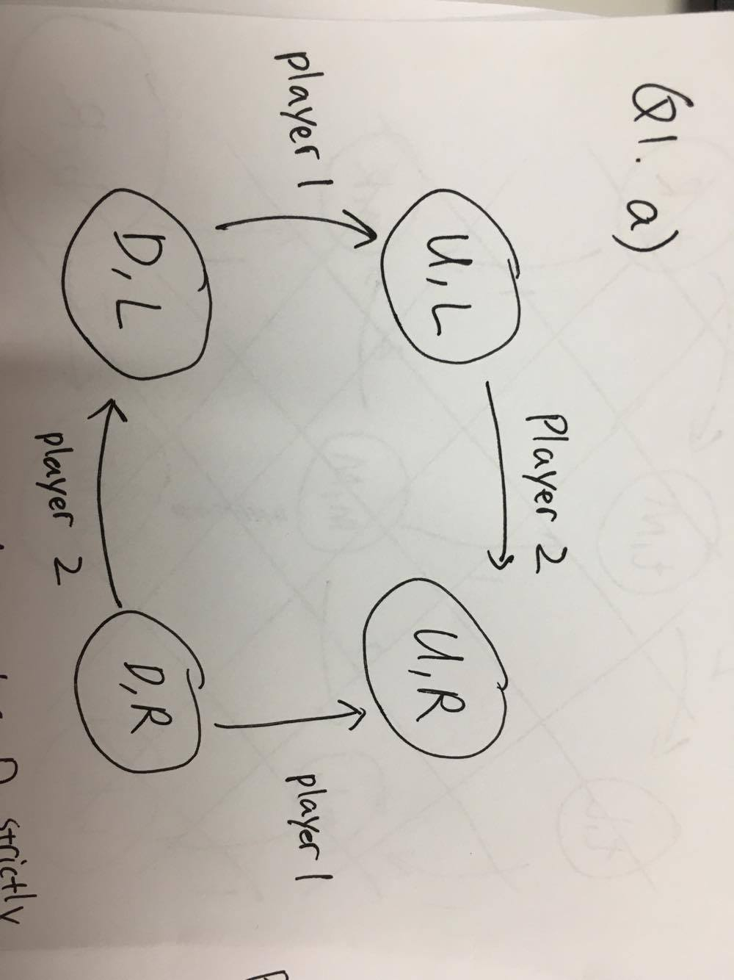

(i) For player 1, U strictly dominates D because player 1 deviates to (U,*) whenever (D,*) situation he is in.

(ii) (U,R) survive iterative removal. We remove (D,*) as D is dominated by U, then (U,L) is removed because player 2 wants to deviate to (U,R). At last, we have (U,R) left.

(iii) (U, R) is PNE since it’s the only node survived ISD.

(b)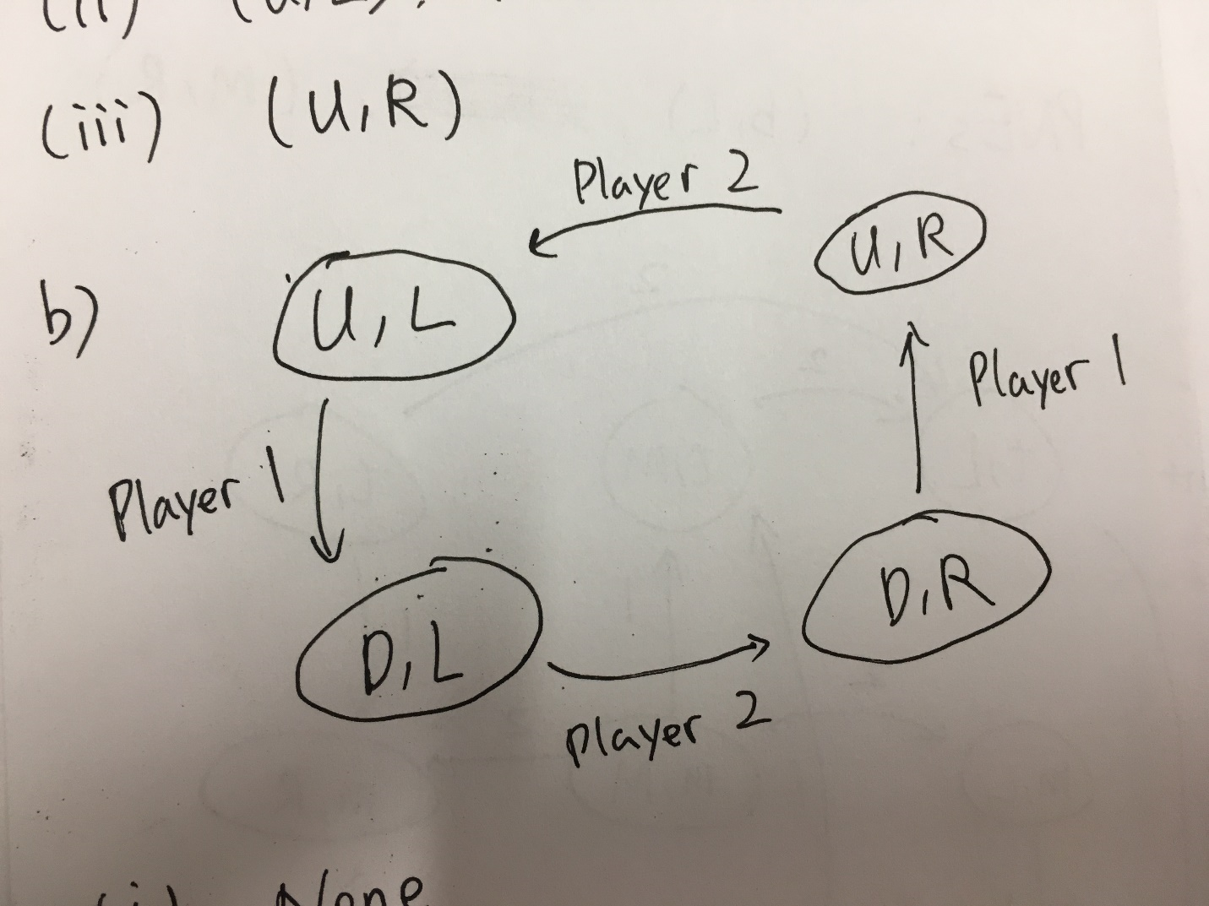

(i) There is no strictly dominate strategy because all nodes form a cycle in the graph;

(ii) All action profiles survive iterative removal as each of them is pointed to;

(iii) There is no PNE because there is no sink in the graph.

(c)

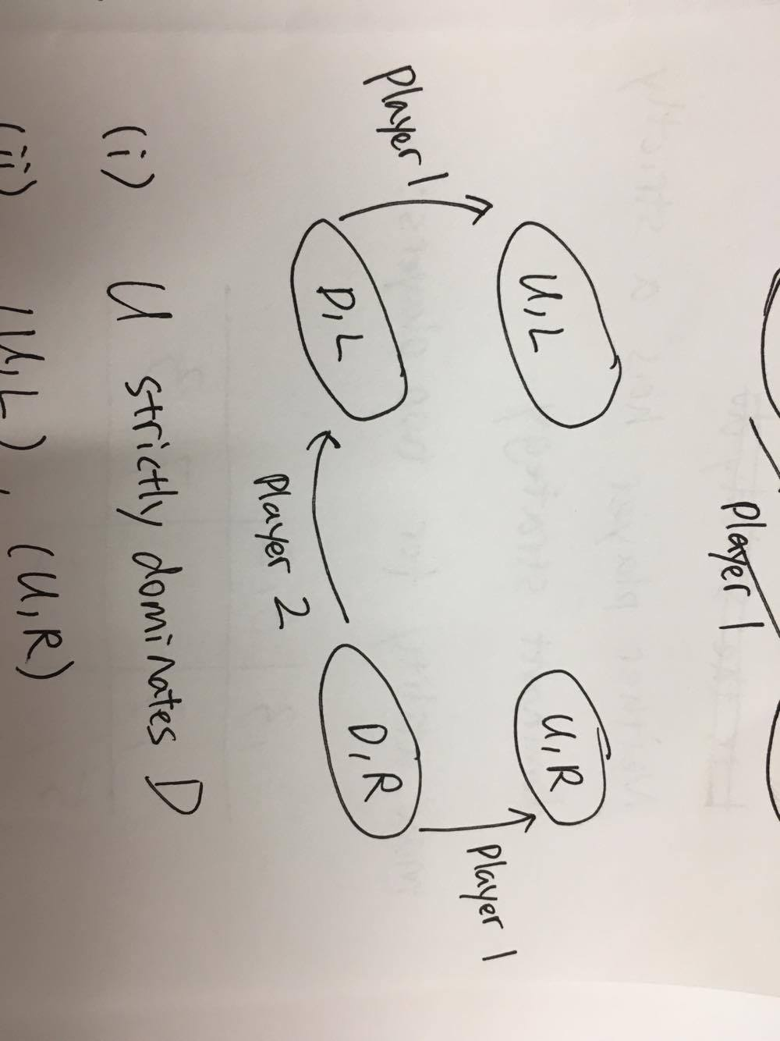

(i) For player 1, U strictly dominates D because he deviates to U no matter which (D,*) he is;

(ii) (U,L) and (U,R) survive iterative removal, while (D,L) and (D,R) are eliminated since D is dominated by U;

(ii) (U,L) and (U,R) are PNE because they are sinks in the graph.

Q2

(a) Neither player has a strictly dominant strategy. We need to change at least 2 entries to have a strictly dominant strategy.

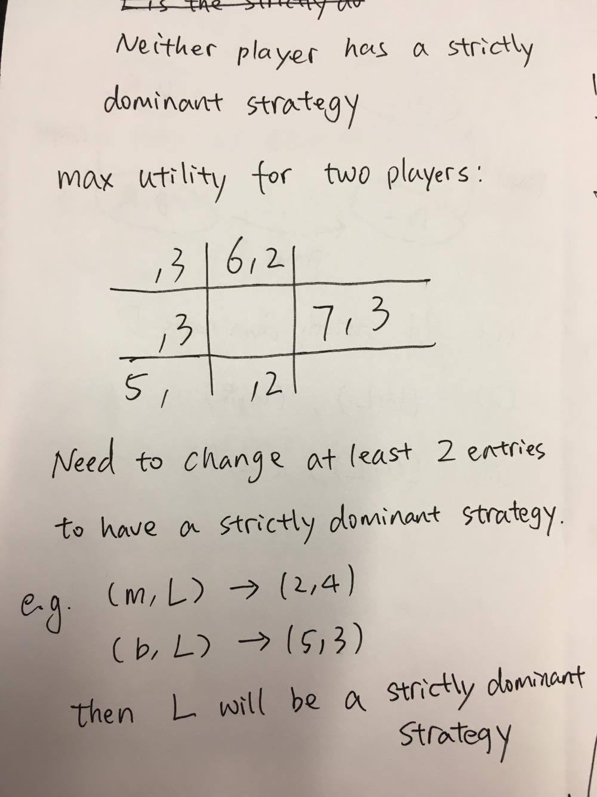

(b) Player 1 deviates to ‘b’ since (5,2) is better than (2,3); Player 2 won’t deviate since utility 3 is the best he can get given first player plays ‘m’.

(c)

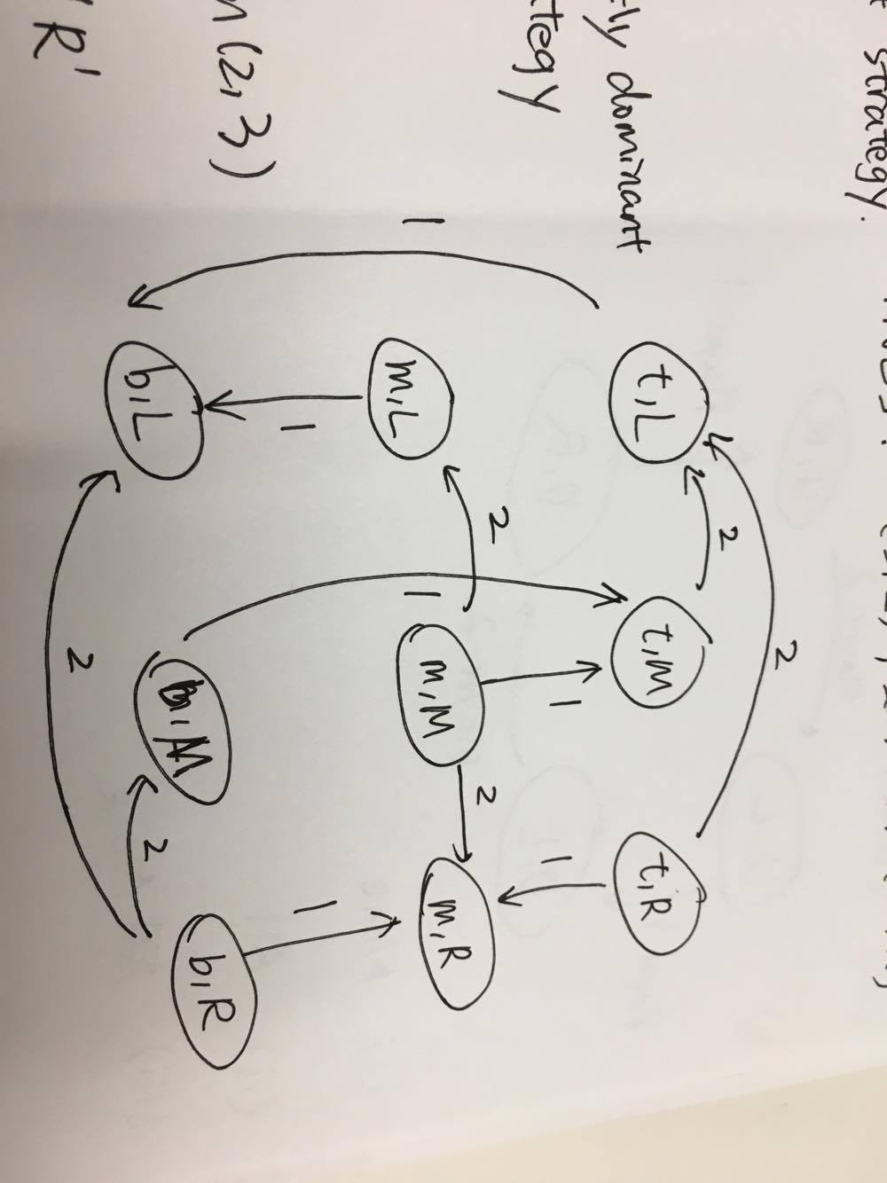

As the BRD graph shown above, we find the sinks in the graph are (b,L) and (m,R), which are the PNE by theorem. Follow arrows on the graph, we find BRD converges to PNEs.

Q3

(a) By definition of dominant strategy, player 1 has no other actions that improves his utility if he plays . Likewise, when player 2 plays the best response to , he has no other actions that improves his utility. By definition of PNE, no player can increase their own utility by unilaterally deviating and thus we say achieves PNE.

(b) No. For example, there could be . Then is also a PNE and a different one from .

(c) Yes. For example, there could be where is also a dominant strategy. Then is also a PNE.

(d) strictly dominant

(a) Same proof: By definition of dominant strategy, player 1 has no other actions that improves his utility if he plays . Likewise, when player 2 plays the best response to , he has no other actions that improves his utility. By definition of PNE, no player can increase their own utility by unilaterally deviating and thus we say achieves PNE.

(b) No. . For example, there could be . Then is also a PNE and a different one from .

(c) No. If player don’t play and we are given is a strictly dominant strategy, then player 1 can deviate to for a greater utility. Therefore, there is not PNE where player 1 does not play .

Q4

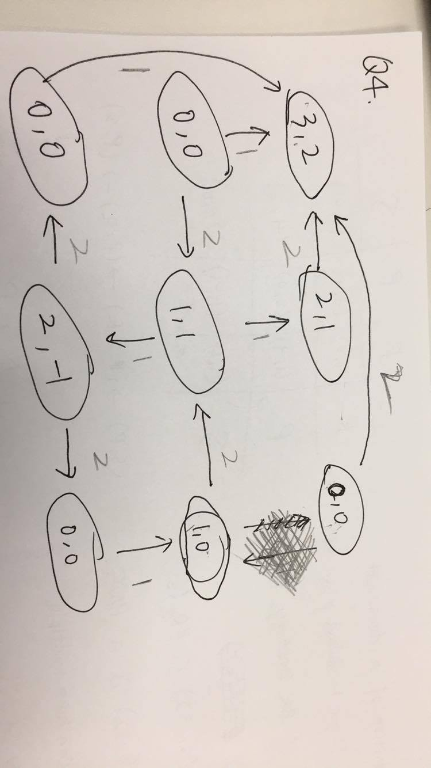

We can construct a Rock, Paper, Scissor game represented by the graph above. Here is the action profile utility map:

|  |  |  |  |
| --- | --- | --- | --- |
| Player 1, Player 2 | R, * | P, * | S,* |
| R, * | 3,2 | 2,1 | 0,0 |
| P, * | 0,0 | 1,1 | 1,0 |
| S, * | 0,0 | 2,-1 | 0,0 |

(R,R) is the only sink in the graph, so it is the unique PNE.

There is a circle in the lower-right corner of the graph, therefore BRD does not converge.

Part 2 Graph Theory

Q5

(a)

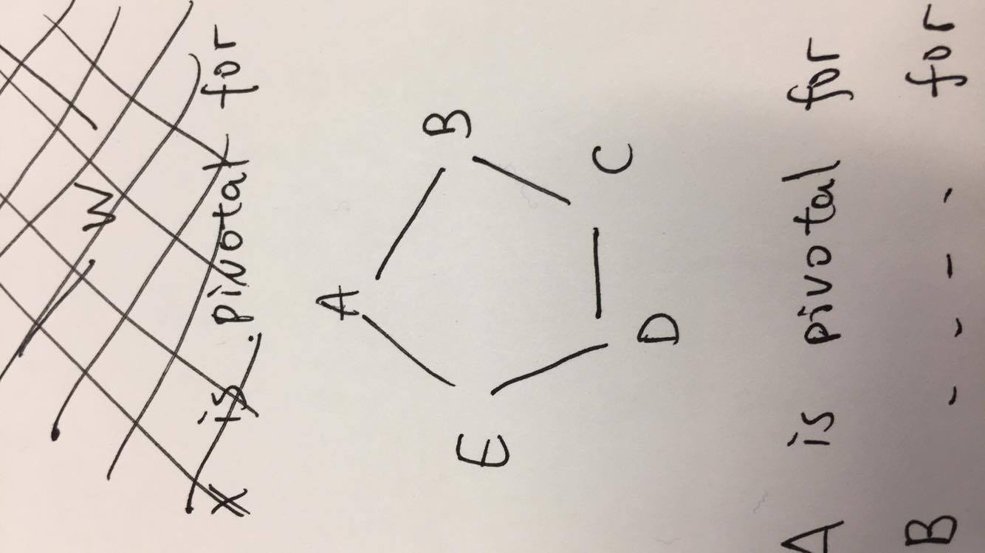

A is pivotal for (B,E);

B is pivotal for (A,C);

C is pivotal for (B,D);

D is pivotal for (C,E);

E is pivotal for (A,D);

Therefore, the graph above is the graph wanted.

(b)

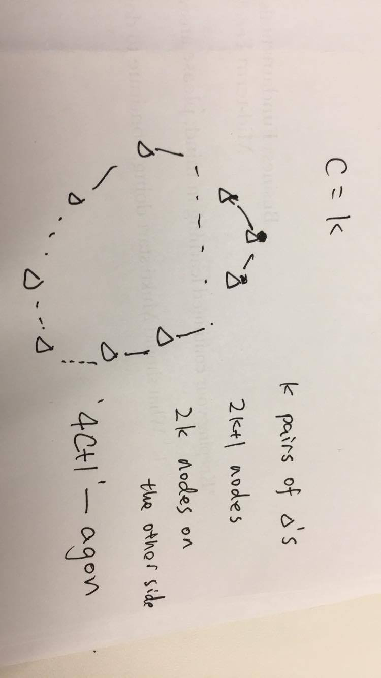

First, we construct the top node. Then we construct c nodes on each side of the top node, so that the top node is pivotal for at least c different pair of nodes. To ensure that top node lies in every shortest path of those c different pair of nodes, we need to add nodes on the other side. Adding 2c more nodes should suffice. Then we have a ‘4c+1’-agon where each node only connects with adjacent two nodes and meets the acquirement.

(c)

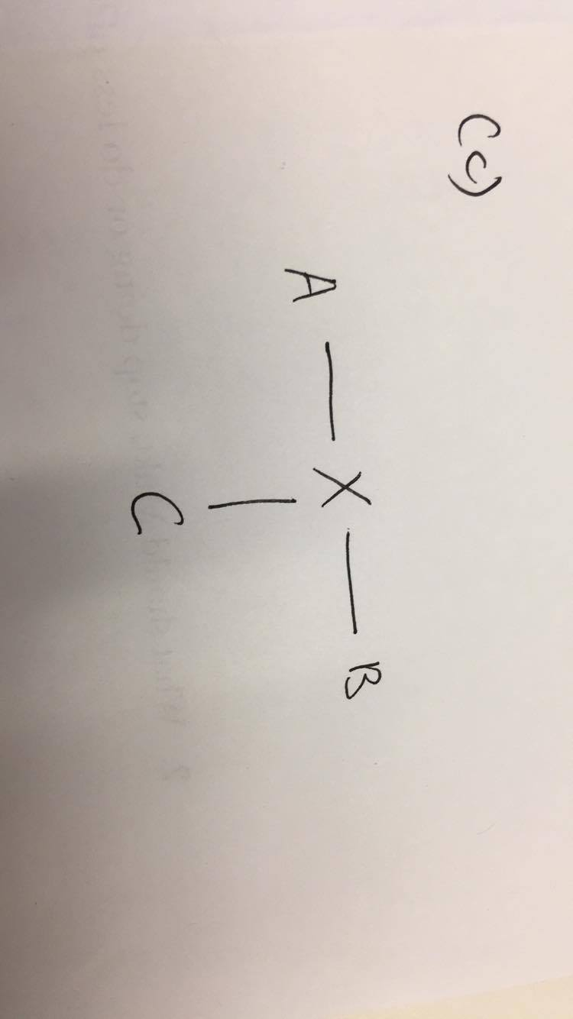

X is pivotal for (A, B);

X is pivotal for (A, C);

X is pivotal for (B, C);

Therefore, X is pivotal for every pair of nodes.

Q6

(a)

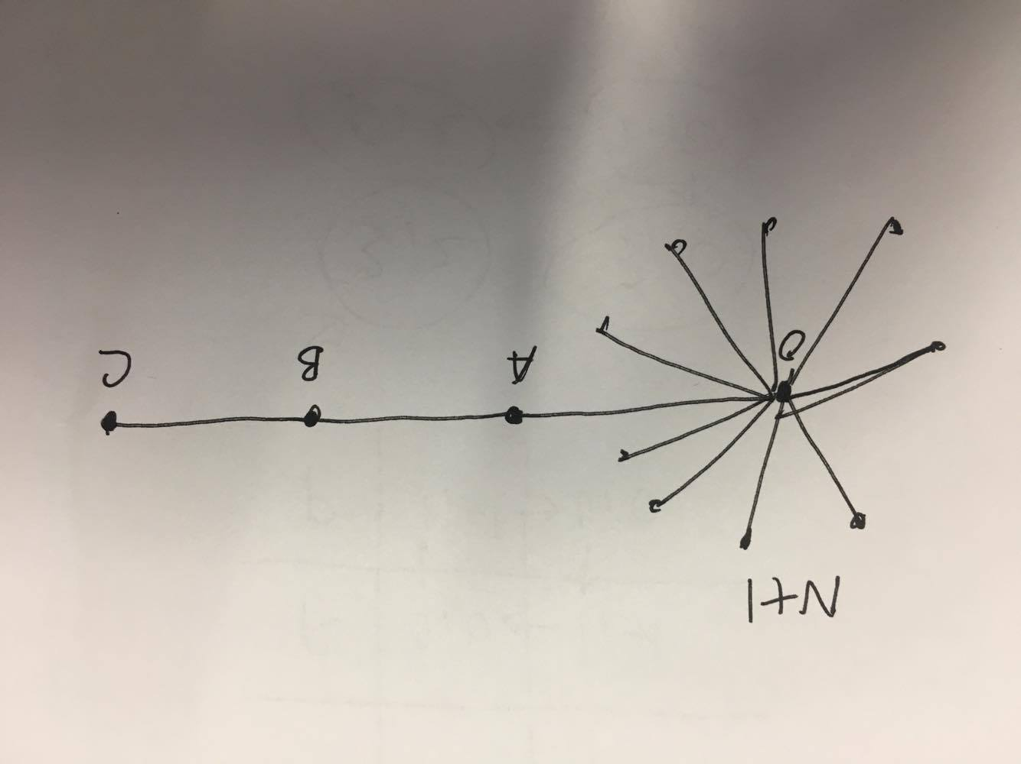

In the above graph, diameter = 4. Left side is a complete subgraph with N+1 nodes and a center node we labelled O. Each pair of nodes in the N+1 subgraph is connected.

Avg Dist = Total distance/ total number of pair of nodes

Total distance is computed by the chart below

|  |  |  |
| --- | --- | --- |
| Node | Number of edges | Total Distance for a node |
| i ( in N) | N+3 | N-1+10 |
| O | N+3 | N+6 |
| A | N+3 | 2N+4 |
| B | N+3 | 3N+4 |
| C | N+3 | 4N+6 |
| Total | (N+4)(N+3)/2 | (N^2+19N+20)/2 |

So we need

Plug in , we find .

(b)

Similar to part a, we construct a complete graph with N nodes and stick out c nodes.

Then we can have a diameter c+1

|  |  |  |
| --- | --- | --- |
| Node | Number of edges | Total Distance for a node, counted once |
| i ( in N-1) | N+c-1 | (N-1)+2+…+c+1 |
| O | N+c-1 | 1+2+…+c |
| A_1 | N+c-1 | 1+2+..+c-1 |
| A_2 | N+c-1 | 1+2+…+c-2 |
| … | … | … |
| A_{C-1} | N+c-1 | 1 |
| A_C | N+c-1 | 0 |
| Total | (c+N)(c+N-1)/2 | N(N-1)/2+(N-1)c(c+3)/2+c(c+1)(c+2)/6 |

By Tetrahedral number(<https://en.wikipedia.org/wiki/Tetrahedral_number>),

Solved by online program (https://www.symbolab.com/solver/solve-for-equation-calculator/solve%20for%20n%2C%20%5Cleft(n%2Bc%5Cright)%5Cleft(n%2Bc-1%5Cright)%5Cleft(c%2B1%5Cright)%3Dc%5Cleft(%5Cfrac%7Bc%5Cleft(c%2B1%5Cright)%5Cleft(c%2B2%5Cright)%7D%7B3%7D%2Bn%5Cleft(n-1%5Cright)%2Bc%5Cleft(c%2B3%5Cright)%5Cleft(n-1%5Cright)%5Cright))

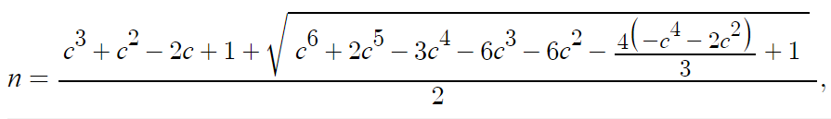

When N is significantly large (greater than the critical value given above), the inequality will be easily achieved.

Q7

(a) If there are n nodes in the graph, there should be at least n-1 edges such that the graph is connected. A graph of n nodes on a line is an easy example.

(b) n(n-1)/2. Since any two nodes have a shortest path of 1, any two nodes must be connected. Since there are n nodes in total, then at least we need [n choose 2] = n(n-1)/2 edges. Such graph satisfy the requirement so n(n-1)/2 is the minimum.

(c) Construct the graph such that there is a central node, and (n-1) outer nodes which only connects with the central node. Then number of edges we need is (n-1) and we have a graph such that any two nodes have a shortest path length of at most 2.

To satisfy the requirement, the graph must be connected. According to Q7a, the graph should have at least n-1 edges. Since we can achieve n-1 edges, the minimum is guaranteed.

