

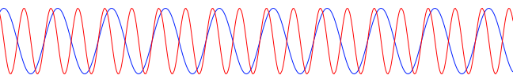



t

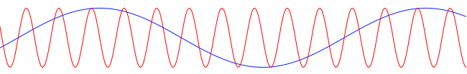



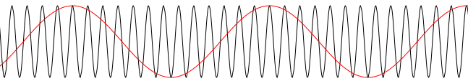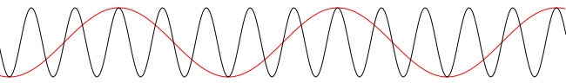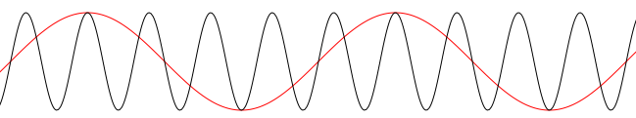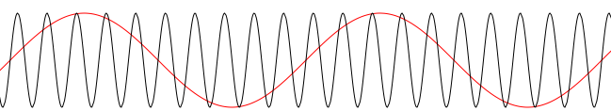



*constant*



t



*constant*



t

t



t

t