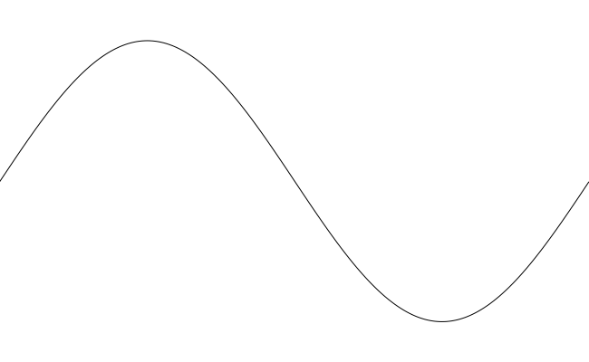

f

Injection

Acceleration

**Synchronization**

SIS18 Cycle

Extraction

Compression

and Merging

**Synchronization**

Extraction

Compression

and Merging

Injection

time

Step 5

Step 6

Step 4

Step 3

Step 2

Step 1