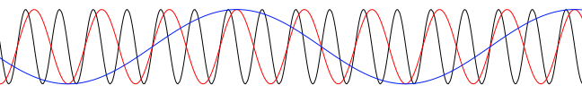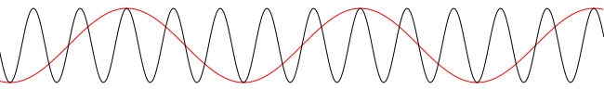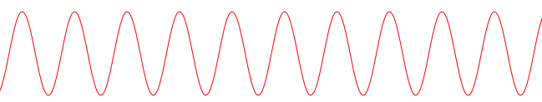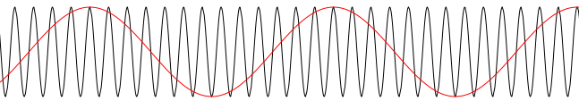

#7 #9

#8 #10

#1

#1 ##3

#1 #3

#1 #3 #5 #7 #9

#1 ##3

#1 #3

#2 #4 #6 #8 #10

#1

qqqq

#1

qqqq

#1

qqqq



t

t

00

00

00

00

00

00

00

00



1

1

t

t



≈

≈

Bucket indication

signal marker



≈

Bucket indication

signal marker

t

t

*Phase beating indication*