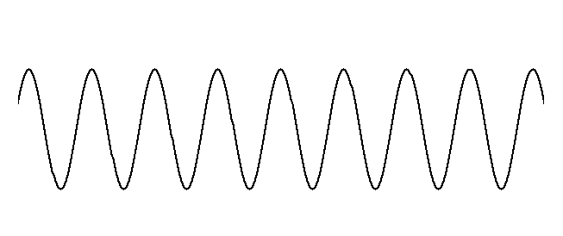图片1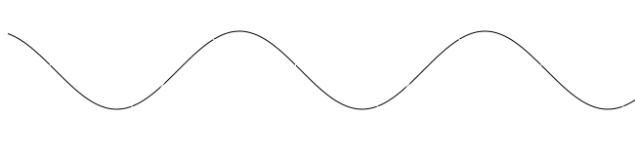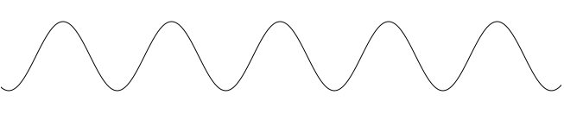

Beating period



frfs=

hs•frevs

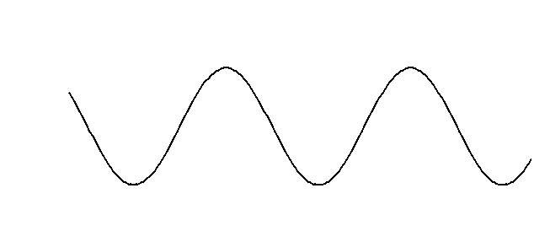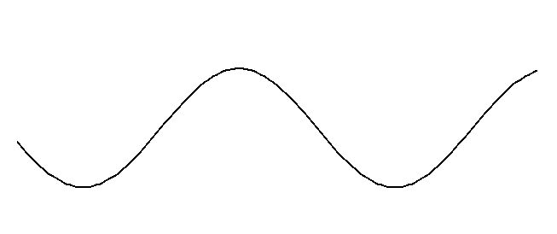

frfl=

hl•frevl



*constant*



t

t



t



t

frfl=

hl•frevl

frfs=

hs•frevs