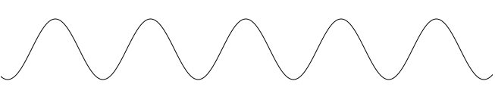

*Phase alignment indication*

frf src

t

t

*First bucket indication*

frf trg

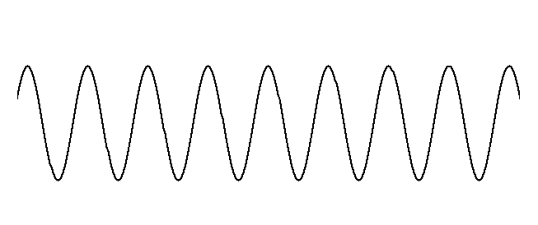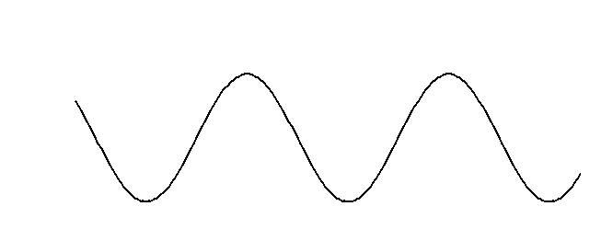

(a)

(b)



t

t

*First bucket indication*

*Phase alignment indication*

frf src

frf trg

Revolution period

Beating period

Beating period



frf trg

frf src

*Phase alignment indication*

*Phase beating indication*

*First bucket indication*



t



t