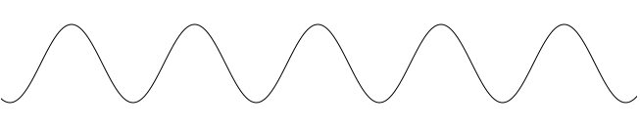

t

fsyn src



Revolution period

*First bucket indication*

t

*Phase beating indication*

frf trg

t

fsyn trg

*Phase alignment indication*

(a) In the case of the phase shift method



t

(b) In the case of the frequency beating method



*Phase alignment indication*

t

*First bucket indication*

frf trg

fsyn trg