- Purpose:
This test simulates the real traffic of the WR network, in order to measure the delay of the telegrams in each VLAN.
- Explanation:
The WR network contains the following traffic:
(1) DM VLAN broadcast 100Mbps 11 packets/100us (3-5 normal)
(2) DM VLAN unicast 10Mbps 3 packets/300us + 2 B2B packets/10ms
(3) B2B VLAN 10 packets/10ms totally 28 packets/s
(4) Low priority noise broadcast random 10Mbps
Table 1. The list of the traffic for all VLANs
VLAN name | Type | Payload length | VLAN ID | Priority | Traffic
DM VLAN | broadcast | 110 bytes | 7 | 7 | 100Mbps 11 packets/100us
DM VLAN | unicast | 110 bytes | 7 | 7 | 10Mbps 3 packets/300us  4packets/s 2 B2B packets/10ms
B2B VLAN | broadcast | 110 bytes | 6 | 6 | 28 packets/s 10 packets/10ms
Other VLAN | broadcast | Random | 5 | 5 | Random 10Mbps

- Test configuration:

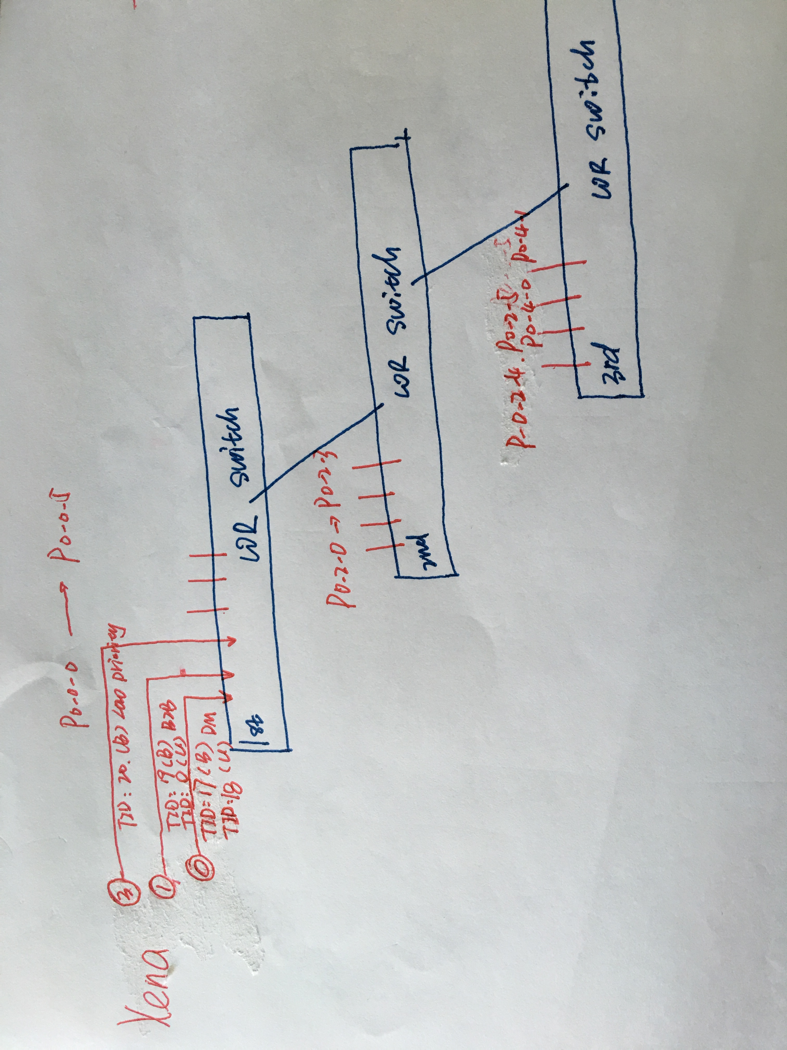
- Configuration of the VLAN
For three switches,
1.Use PUTTY to login to the timing server timing@tsl006.acc.gsi.de
2.Login the wr switch root@wrip
3.Copy the VLAN_config.sh to the WR switch
4.Run ./VLAN_config.sh
All ports of three switches belong to three VLANs.
- Configuration of Xena 2G
- Open Xena2M
- Load configuration file /Network_simulation/WRnetwork_simulation_Xena_configuration/XenaM_configure_for_3layer_test/Xena2M_config.xmcfg

