WR switch 2nd
WR switch 1st
Xena
Port 1
Port 6
Port 1
Port 2
P2
P4

Xena P2 produces the stream 100Mbps, burst size 13 packets, random packet size from 100 to 1500 bytes.
1. Reboot 2 switchs
No packet loss
2. Optical fiber plug in/out about 20 times during the traffic running period. It begins to lose packet only wr0 at the speed of 50 packets/s
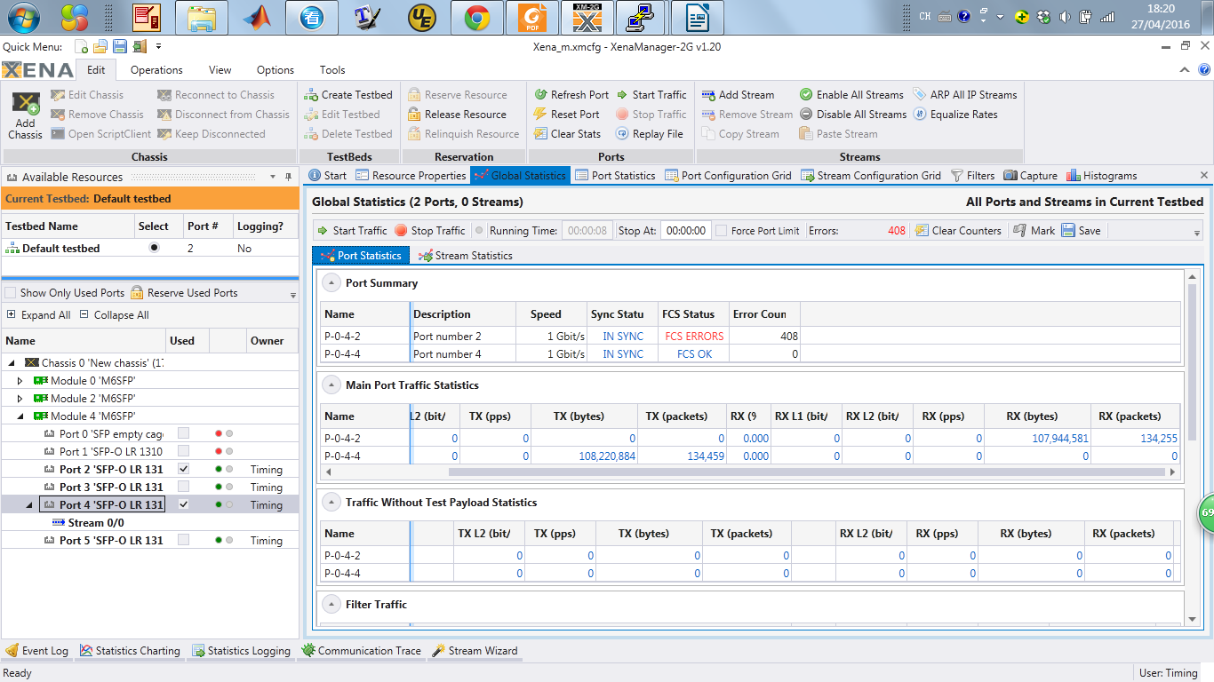
The 2nd layer switch
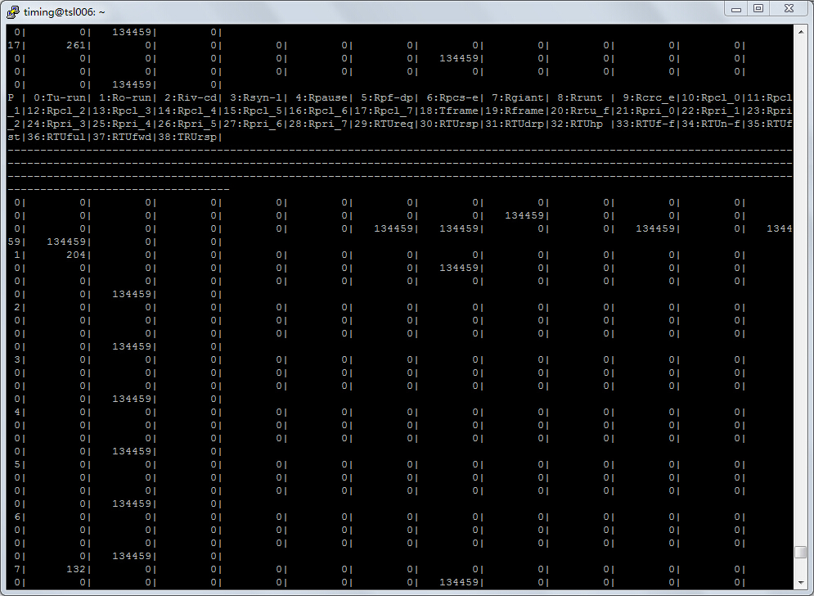
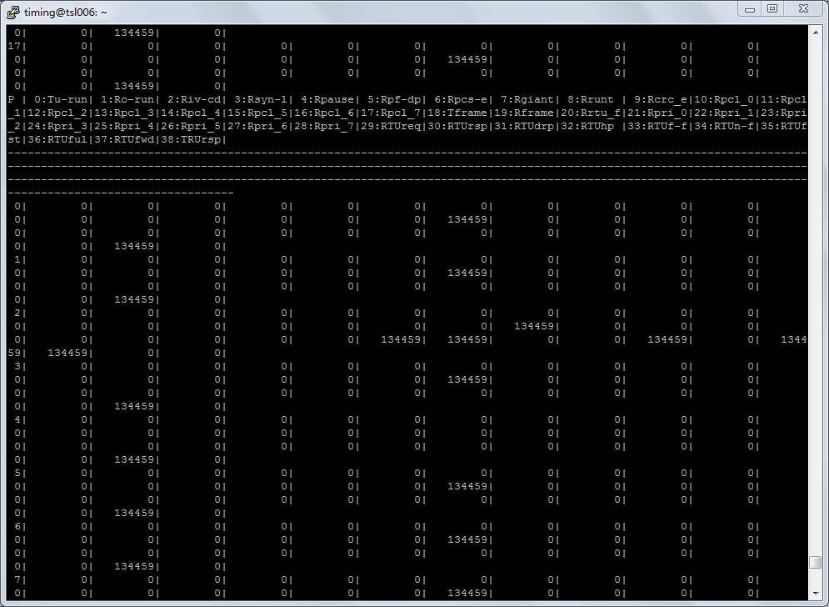
The 1st layer switch

