WR switch 2nd
WR switch 1st
Xena
Port 2
Port 1
Port 2
Port 3
P1
P2

1 Layer Priority 7 100Mbps 13burst/100us
6 100Mbps 13burst/100us
5 100Mbps 13burst/100us
... 100Mbps 13burst/100us
0 100Mbps 13burst/100us
No packet loss.

2 Layers Priority 7 100Mbps 13burst/100us
6.5.4 10Mbps 5 burst/3ms
No packet loss
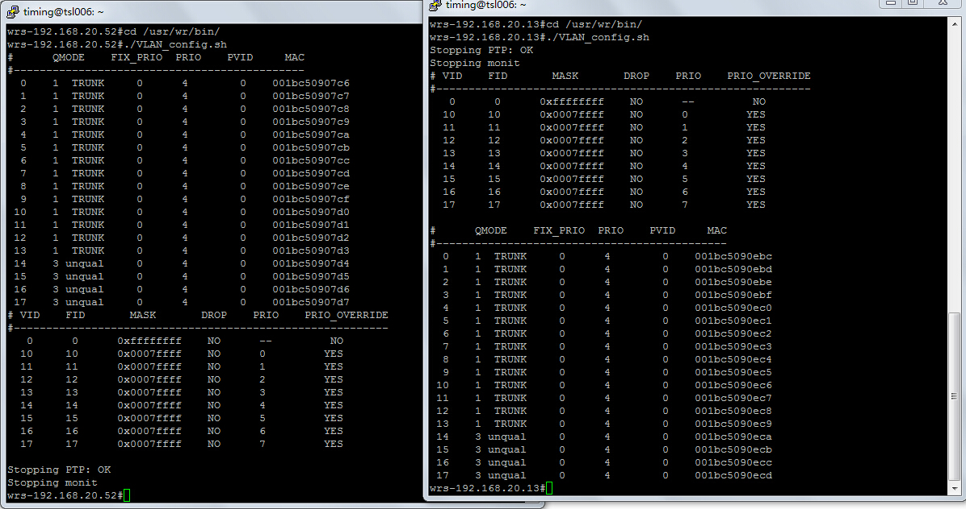
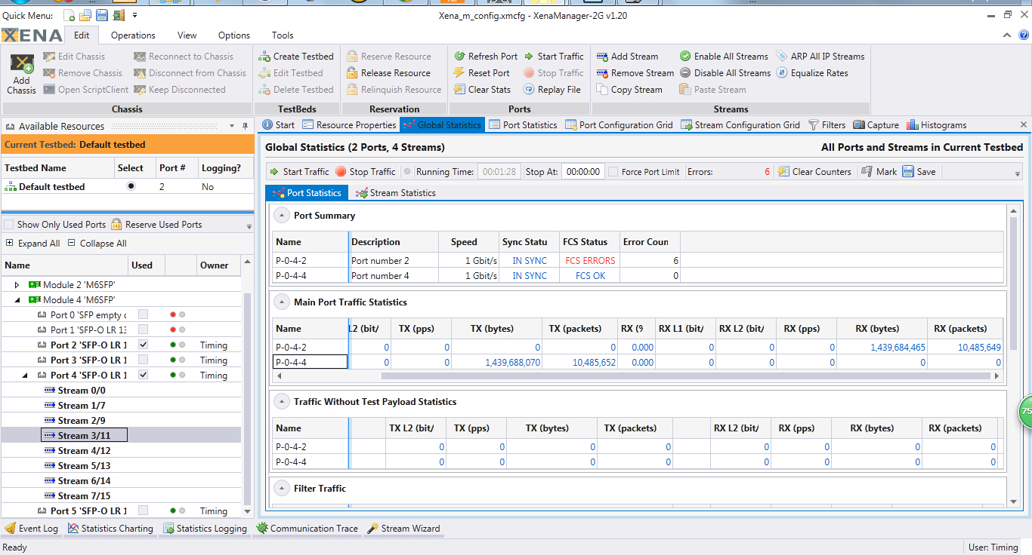
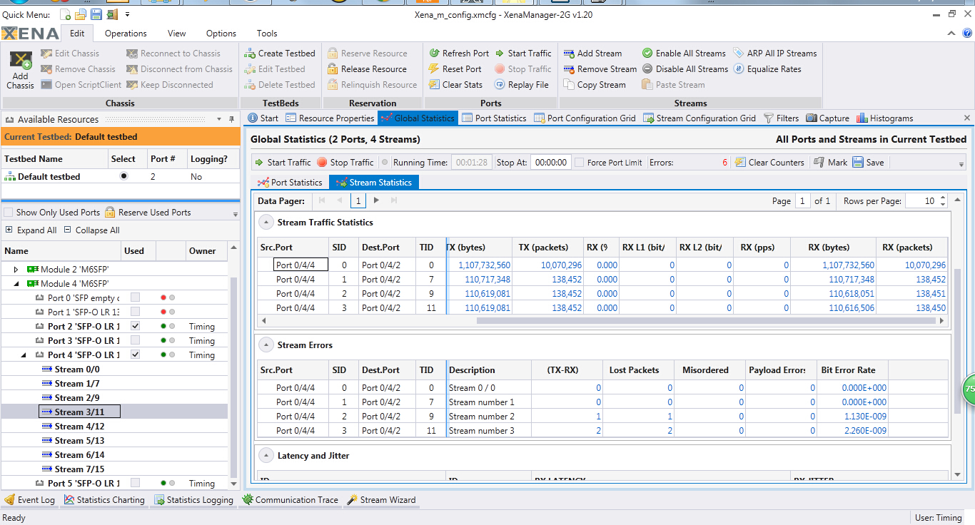
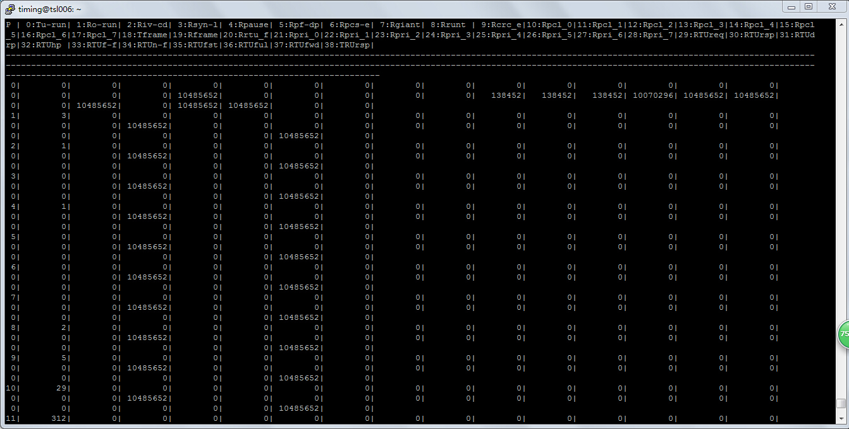

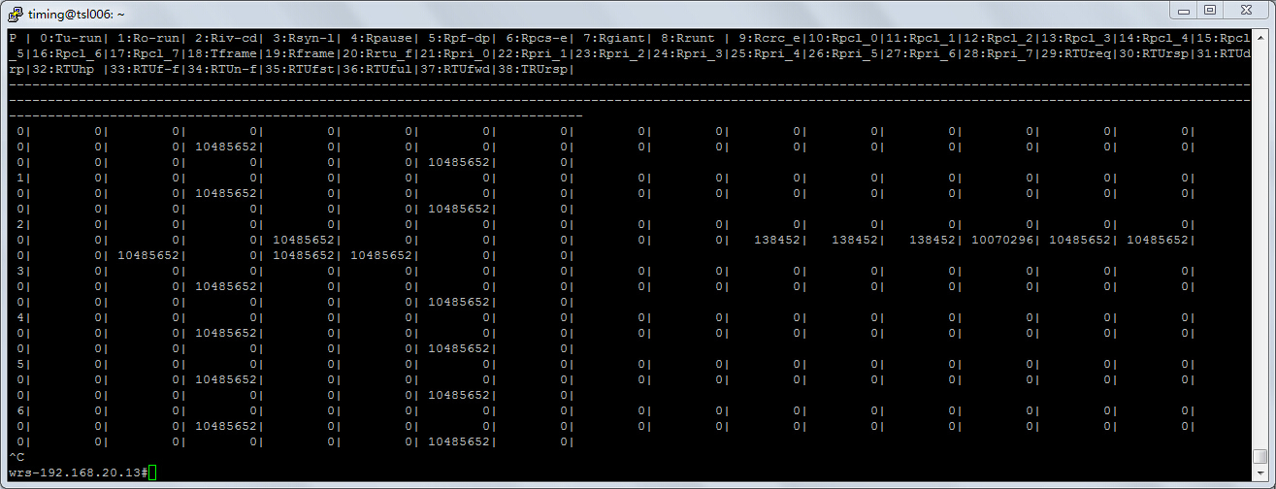

2 WR switch layer
Priority 7 100Mbps 13burst/100us
Priority 6.5.4 10Mbps 5 burst/3ms
Pritory 3 10Mbps 5 burst/3ms
=> Packet loss
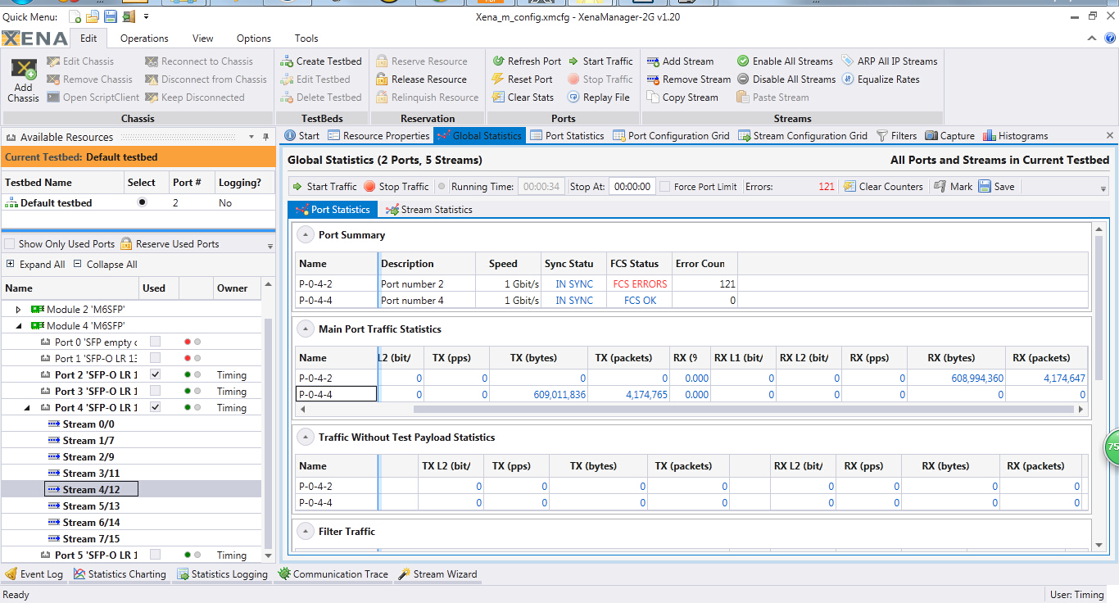
Priority 7 100Mbps
6 10Mbps
5 10Mbps
4 10Mbps
3 10Mbps

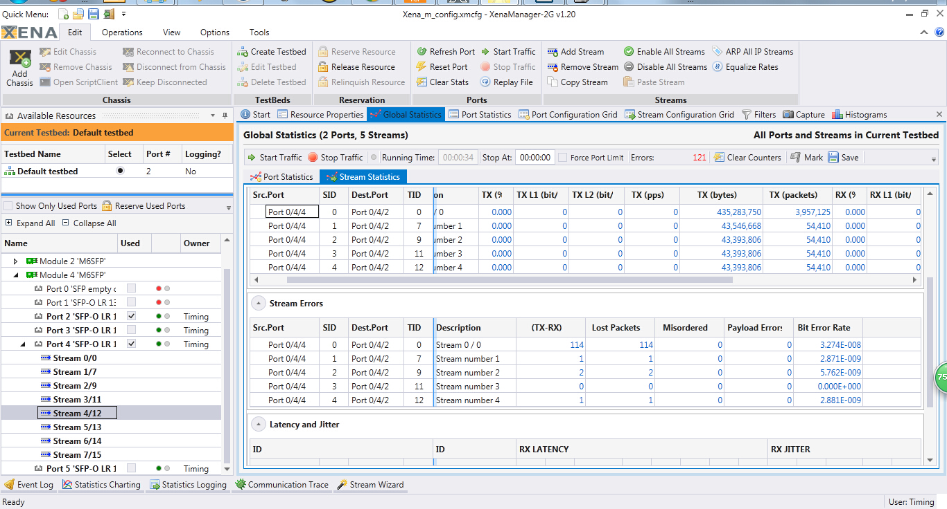
The 1st layer switch
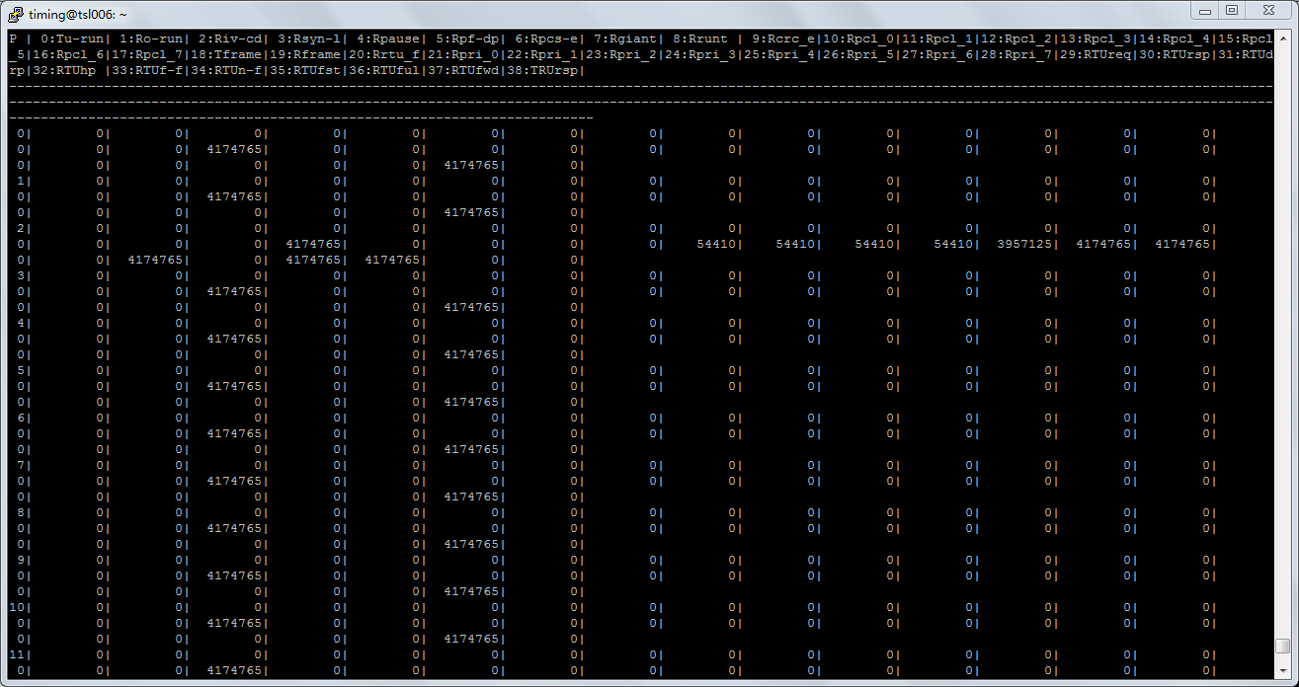
The 2nd layer switch


