Bug Name: Packets lose between R_{frame} and RTU_{req} after the optical fibers are plugged in and out about 20 times during the traffic on.
WR switch Version: v4.2
Reported By: Cesar Prados, Jiaoni Bai
Reported On: 03.05.2016
Description:
During the traffic on status, the optical fibers are plugged in and out for about 20 times, the WR switch begins to lose packets between R_{frame} and RTU_{req}.

Reproduce steps:
1. Reboot the WR switch.
2. Stop the ppsi and monitor of the wr switch.
/etc/init.d/monit.sh stop
/etc/init.d/ppsi.sh stop
3. One port of the switch is used for the traffic input. We use Xena traffic generator to produce 100Mbps bit stream with random packet size from 110 bytes to 1200 bytes and broadcast. One port of the switch is used for the traffic output.
4. After the traffic is on, the optical fibers connected to the switch are plugged out and in to other switch ports about 20 times. Then stop the traffic.
5. With "wrs_pstats -a" to monitor the switch, the traffic is started again and running about 1 minutes.
6. Stop the traffic and check the wrs_pstats result.
Expected result:
The value of R_{frame} should be same as the value of RTU_{req}, RTU_{res}, RTU_{fwd} and T_{frame}.
Actual result:
The value of R_{frame} is bigger than the value of RTU_{req}. The packets are lost between R_{frame} and RTU_{req}.

Bug screen shot:
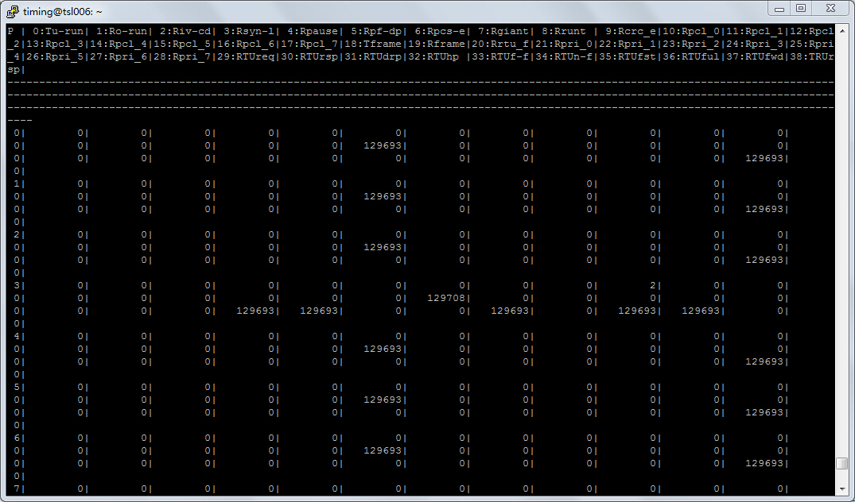
Switch received packet number
RTU request packet number

