Android



Agenda

Mobile Application Development

Intro to Android platform

Platform architecture

Application building blocks

Development tools

Hello Android

Few reasons for Mob App Dev …
• Smart Phones - Internet access anywhere - Social networking

• Millions of mobile users.

• Open standards
Introduction to Android

• Open software platform for mobile development.
• A complete stack – OS, Middleware, Applications.
• An Open Handset Alliance (OHA) project.
• Powered by Linux operating system.
• Fast application development in Java. • Open source under the Apache 2 license.

OHA(Open Handset Alliance)

The OHA is the group that is in charge of the Android smartphone operating system . It was created by Google.

Google’s Definition for Android

“The first truly open and comprehensive platform for mobile devices, all of the software to run a mobile phone . But without the proprietary obstacles that have hindered mobile innovation”
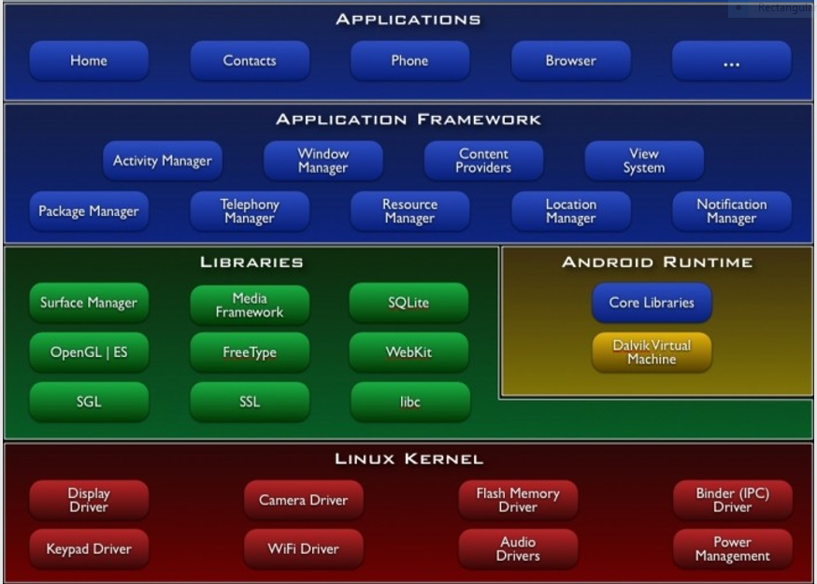

Android Layers

1. LINUX KERNEL
Device Drivers
Memory Management
Process Management
Networking
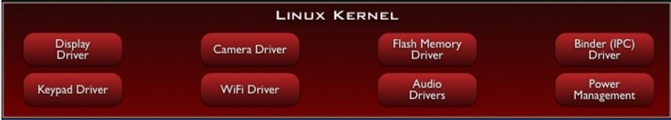
2. LIBRARIES
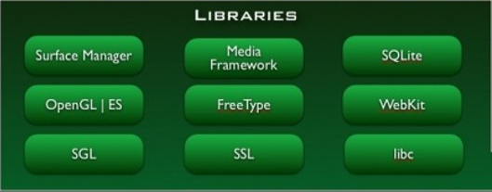
3. ANDROID RUNTIME
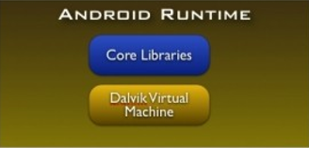
4. APPLICATION FRAMEWORK
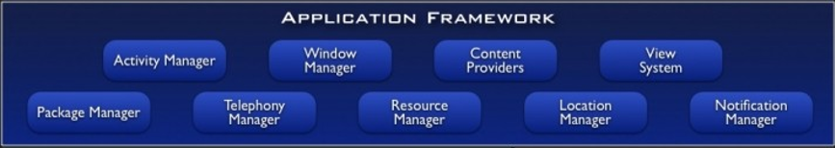
5. APPLICATIONS

LIBRARIES
• C/C++ libraries
• Interface through Java
• Surface manager – Handling UI Windows
• 2D and 3D graphics
• Media codecs, SQLite, Browser engine
ANDROID RUNTIME

Dalvik VM

– Dex files
– Compact and efficient than class files – Limited memory and battery power

• Core Libraries

– Java 5 Std edition – Collections, I/O etc…
APPLICATION FRAMEWORK
• API interface
• Activity manager – manages application life cycle.
APPLICATIONS
• Built in and user apps
• Can replace built in apps
DVM (Dalvik Virtual Machine)
-Android’s virtual machine.

-Multiple instance of VM run efficientlty on a single device.

-DVM uses devices underlying Linux Kernel to handle
-Security
-Threading
-Process & memory management

• DVM executes Dalvik executable files.

WORKING OF DVM
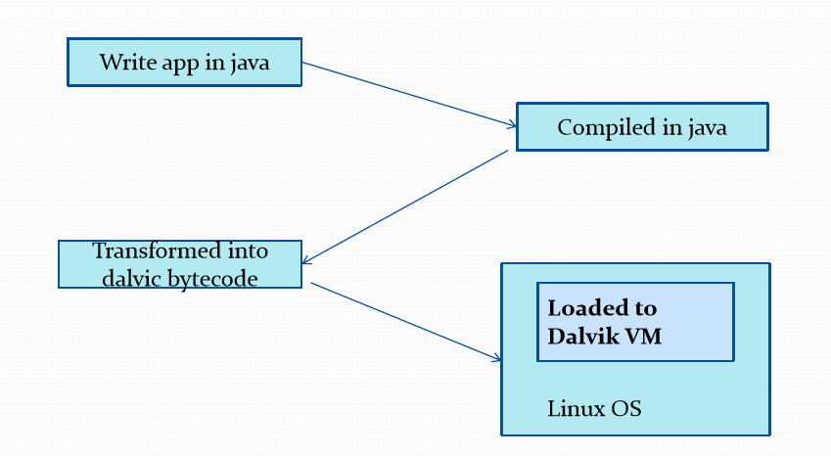
DVM v/s JVM
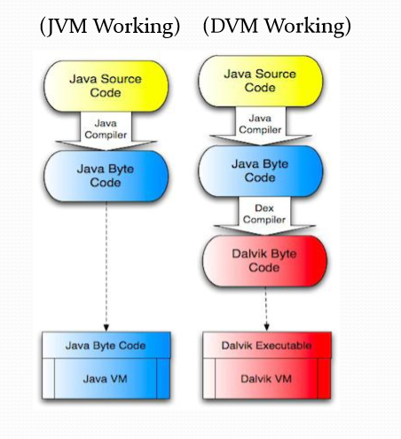
Difference of DVM from JVM
• DVM run multiple VMs efficiently

• In DVM each app has its own VM

• Minimal memory footprint

Native Android Applications
-An e-mail client compatible with
Gmail
- An SMS management application
- A full Personal Information Management suite
- A fully featured mobile Google Maps application
- A web based browser
- An instant messaging client
- Music player & picture viewer
- Android market place client

Android Features
• Access to hardware including camera, gps, accelerometer
• Native goolge maps, geocoding and location based services
• Background services
• SQLite database for data storage & retrievel
• Shared data and interapplication communication
• P2p services with google talk
• Extensive media support

Android Libraries
This category encompasses those Java-based libraries that are specific to Android development. Examples of libraries in this category include the application framework libraries in addition to those that facilitate user interface building, graphics drawing and database access.
A summary of some key core Android libraries available to the Android developer is as follows:
- android.app – Provides access to the application model and is the cornerstone of all Android applications.
- android.content – Facilitates content access, publishing and messaging between applications and application components.
- android.database – Used to access data published by content providers and includes SQLite database management classes.
- android.graphics – A low-level 2D graphics drawing API including colors, points, filters, rectangles and canvases.
- android.hardware – Presents an API providing access to hardware such as the accelerometer and light sensor.
- android.opengl – A Java interface to the OpenGL ES 3D graphics rendering API.
- android.os – Provides applications with access to standard operating system services including messages, system services and inter-process communication.
- android.media – Provides classes to enable playback of audio and video.
- android.net – A set of APIs providing access to the network stack. Includes android.net.wifi, which provides access to the device’s wireless stack.
- android.provider – A set of convenience classes that provide access to standard Android content provider databases such as those maintained by the calendar and contact applications.
- android.text – Used to render and manipulate text on a device display.
- android.util – A set of utility classes for performing tasks such as string and number conversion, XML handling and date and time manipulation.
- android.view – The fundamental building blocks of application user interfaces.
- android.widget - A rich collection of pre-built user interface components such as buttons, labels, list views, layout managers, radio buttons etc.
- android.webkit – A set of classes intended to allow web-browsing capabilities to be built into applications.

Application Components
a. Activity
b. Intent
c. Intent Receiver
d. Broadcast Receiver
e. Content Provider
f. Notification
g. Services

Activity
• Individual user interface screen in an Android application
• Here visual elements called Views can be placed
• Can be created in two ways -by pure java code -by adding XML code

An activity represents a single screen with a user interface,in-short Activity performs actions on the screen. For example, an email application might have one activity that shows a list of new emails, another activity to compose an email, and another activity for reading emails. If an application has more than one activity, then one of them should be marked as the activity that is presented when the application is launched.
An activity is implemented as a subclass of Activity class as follows −
public class MainActivity extends Activity {

}

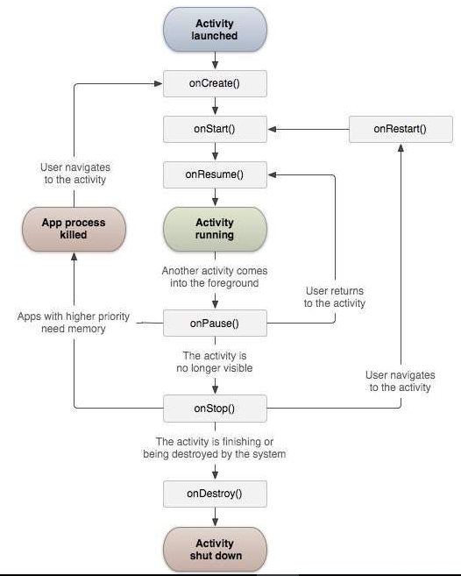
Android

Android app module

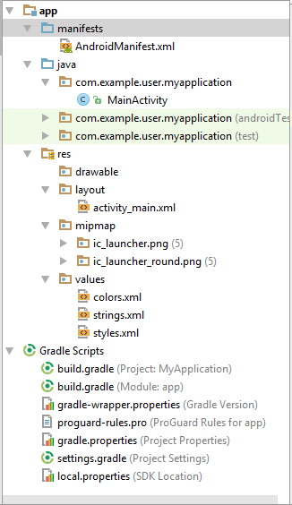

AndroidManifest.xml
Describes the nature of the application and each of its components.

Every app project must have an AndroidManifest.xml file (with precisely that name) at the root of the project source set. The manifest file describes essential information about your app to the Android build tools, the Android operating system, and Google Play.

File features
The following sections describe how some of the most important characteristics of your app are reflected in the manifest file.

Package name and application ID
The manifest file's root element requires an attribute for your app's package name (usually matching your project directory structure—the Java namespace).
For example, the following snippet shows the root <manifest> element with the package name "com.example.myapp":
<?xml version="1.0" encoding="utf-8"?>
<manifest xmlns:android="http://schemas.android.com/apk/res/android"
package="com.example.myapp"
android:versionCode="1"
android:versionName="1.0" >
...
</manifest>
While building your app into the final application package (APK), the Android build tools use the packageattribute for two things:
- It applies this name as the namespace for your app's generated R.java class (used to access your app resources).
Example: With the above manifest, the R class is created at com.example.myapp.R.
- It uses this name to resolve any relative class names that are declared in the manifest file.
Example: With the above manifest, an activity declared as <activity android:name=".MainActivity">is resolved to be com.example.myapp.MainActivity.

App components
For each app component that you create in your app, you must declare a corresponding XML element in the manifest file:
- <activity> for each subclass of Activity.
- <service> for each subclass of Service.
- <receiver> for each subclass of BroadcastReceiver.
- <provider> for each subclass of ContentProvider.
If you subclass any of these components without declaring it in the manifest file, the system cannot start it.
The name of your subclass must be specified with the name attribute, using the full package designation. For example, an Activity subclass can be declared as follows:
<manifest ... >
<application ... >
<activity android:name="com.example.myapp.MainActivity" ... >
</activity>
</application>
</manifest>
However, if the first character in the name value is a period, the app's package name (from the <manifest>element's package attribute) is prefixed to the name. For example, the following activity name is resolved to `"com.example.myapp.MainActivity"`:
<manifest package="com.example.myapp" ... >
<application ... >
<activity android:name=".MainActivity" ... >
...
</activity>
</application>
</manifest>
If you have app components that reside in sub-packages (such as in com.example.myapp.purchases), the name value must add the missing sub-package names (such as ".purchases.PayActivity") or use the fully-qualified package name.

Intent filters
App activities, services, and broadcast receivers are activated by intents. An intent is a message defined by an Intent object that describes an action to perform, including the data to be acted upon, the category of component that should perform the action, and other instructions.
When an app issues an intent to the system, the system locates an app component that can handle the intent based on intent filter declarations in each app's manifest file. The system launches an instance of the matching component and passes the Intent object to that component. If more than one app can handle the intent, then the user can select which app to use.
An app component can have any number of intent filters (defined with the <intent-filter> element), each one describing a different capability of that component.
.

Icons and labels
A number of manifest elements have icon and label attributes for displaying a small icon and a text label, respectively, to users for the corresponding app component.
In every case, the icon and label that are set in a parent element become the default icon and label value for all child elements.
The icon and label that are set in a component's <intent-filter> are shown to the user whenever that component is presented as an option to fulfill an intent. By default, this icon is inherited from whichever icon is declared for the parent component (either the <activity> or <application> element), but you might want to change the icon for an intent filter if it provides a unique action that you'd like to better indicate in the chooser dialog.

Permissions
Android apps must request permission to access sensitive user data (such as contacts and SMS) or certain system features (such as the camera and internet access). Each permission is identified by a unique label.
<manifest ... >
<uses-permission android:name="android.permission.SEND_SMS"/>
...
</manifest>

java/
Contains Java code sources.
res/
Contains application resources, such as drawable files, layout files, and UI string.

Directory | Resource Type
animator/ | XML files that define property animations.
anim/ | XML files that define tween animations. (Property animations can also be saved in this directory, but the animator/ directory is preferred for property animations to distinguish between the two types.)
color/ | XML files that define a state list of colors. See Color State List Resource
drawable/ | Bitmap files (.png, .9.png, .jpg, .gif) or XML files that are compiled into the following drawable resource subtypes:  - Bitmap files  - Nine-Patches (re-sizable bitmaps)  - State lists  - Shapes  - Animation drawables  - Other drawables  See Drawable Resources.
mipmap/ | Drawable files for different launcher icon densities. For more information on managing launcher icons with mipmap/ folders, see Managing Projects Overview.
layout/ | XML files that define a user interface layout. See Layout Resource.
menu/ | XML files that define app menus, such as an Options Menu, Context Menu, or Sub Menu. See Menu Resource.
raw/ | Arbitrary files to save in their raw form. To open these resources with a raw InputStream, callResources.openRawResource() with the resource ID, which is R.raw.filename.  However, if you need access to original file names and file hierarchy, you might consider saving some resources in the assets/ directory (instead of res/raw/). Files in assets/ aren't given a resource ID, so you can read them only using AssetManager.
values/ | XML files that contain simple values, such as strings, integers, and colors.  Whereas XML resource files in other res/ subdirectories define a single resource based on the XML filename, files in the values/ directory describe multiple resources. For a file in this directory, each child of the <resources> element defines a single resource. For example, a <string> element creates an R.stringresource and a <color> element creates an R.color resource.  Because each resource is defined with its own XML element, you can name the file whatever you want and place different resource types in one file. However, for clarity, you might want to place unique resource types in different files. For example, here are some filename conventions for resources you can create in this directory:  - arrays.xml for resource arrays (typed arrays).  - colors.xml for color values  - dimens.xml for dimension values.  - strings.xml for string values.  - styles.xml for styles.  See String Resources, Style Resource, and More Resource Types.
xml/ | Arbitrary XML files that can be read at runtime by calling Resources.getXML(). Various XML configuration files must be saved here, such as a searchable configuration.
font/ | Font files with extensions such as .ttf, .otf, or .ttc, or XML files that include a <font-family> element. For more information about fonts as resources, go to Fonts in XML.

build.gradle (module)
This defines the module-specific build configurations.
build.gradle (project)
This defines your build configuration that apply to all modules. This file is integral to the project, so you should maintain them in revision control with all other source code.

Layout resource
A layout resource defines the architecture for the UI in an Activity or a component of a UI.
file location:
res/layout/filename.xml
The filename will be used as the resource ID.
compiled resource datatype:
Resource pointer to a View (or subclass) resource.
resource reference:
In Java: R.layout.filename
In XML: @[package:]layout/filename

syntax:
<?xml version="1.0" encoding="utf-8"?>
<ViewGroup
xmlns:android="http://schemas.android.com/apk/res/android"
android:id="@[+][package:]id/resource_name"
android:layout_height=["dimension" | "match_parent" | "wrap_content"]
android:layout_width=["dimension" | "match_parent" | "wrap_content"]
[ViewGroup-specific attributes] >
<View
android:id="@[+][package:]id/resource_name"
android:layout_height=["dimension" | "match_parent" | "wrap_content"]
android:layout_width=["dimension" | "match_parent" | "wrap_content"]
[View-specific attributes] >
<requestFocus/>
</View>
<ViewGroup >
<View />
</ViewGroup>
<include layout="@layout/layout_resource"/>
</ViewGroup>
<ViewGroup>
A container for other View elements. There are many different kinds of ViewGroup objects and each one lets you specify the layout of the child elements in different ways. Different kinds of ViewGroupobjects include LinearLayout, RelativeLayout, and FrameLayout.
You should not assume that any derivation of ViewGroup will accept nested Views. Some ViewGroups are implementations of the AdapterView class, which determines its children only from an Adapter.
attributes:
android:id
Resource ID. A unique resource name for the element, which you can use to obtain a reference to the ViewGroup from your application. See more about the value for android:id below.
android:layout_height
Dimension or keyword. Required. The height for the group, as a dimension value (or dimension resource) or a keyword ("match_parent" or "wrap_content"). See the valid values below.
android:layout_width
Dimension or keyword. Required. The width for the group, as a dimension value (or dimension resource) or a keyword ("match_parent" or "wrap_content"). See the valid values below.
More attributes are supported by the ViewGroup base class, and many more are supported by each implementation of ViewGroup. For a reference of all available attributes, see the corresponding reference documentation for the ViewGroup class (for example, the LinearLayout XML attributes).
<View>
An individual UI component, generally referred to as a "widget". Different kinds of View objects include TextView, Button, and CheckBox.
attributes:
android:id
Resource ID. A unique resource name for the element, which you can use to obtain a reference to the View from your application. See more about the value for android:id below.
android:layout_height
Dimension or keyword. Required. The height for the element, as a dimension value (or dimension resource) or a keyword ("match_parent" or "wrap_content"). See the valid values below.
android:layout_width
Dimension or keyword. Required. The width for the element, as a dimension value (or dimension resource) or a keyword ("match_parent" or "wrap_content"). See the valid values below.
More attributes are supported by the View base class, and many more are supported by each implementation of View. Read Layouts for more information. For a reference of all available attributes, see the corresponding reference documentation (for example, the TextView XML attributes).
<requestFocus>
Any element representing a View object can include this empty element, which gives its parent initial focus on the screen. You can have only one of these elements per file.
<include>
Includes a layout file into this layout.
attributes:
layout
Layout resource. Required. Reference to a layout resource.
android:id
Resource ID. Overrides the ID given to the root view in the included layout.
android:layout_height
Dimension or keyword. Overrides the height given to the root view in the included layout. Only effective if android:layout_width is also declared.
android:layout_width
Dimension or keyword. Overrides the width given to the root view in the included layout. Only effective if android:layout_height is also declared.

Accessing resources in code
You can use a resource in code by passing the resource ID as a method parameter. For example, you can set an ImageView to use the res/drawable/myimage.png resource using setImageResource():
ImageView imageView = (ImageView) findViewById(R.id.myimageview);
imageView.setImageResource(R.drawable.myimage);
You can also retrieve individual resources using methods in Resources, which you can get an instance of with getResources().

Syntax
Here's the syntax to reference a resource in code:
[<package_name>.]R.<resource_type>.<resource_name>
- <package_name> is the name of the package in which the resource is located (not required when referencing resources from your own package).
- <resource_type> is the R subclass for the resource type.
- <resource_name> is either the resource filename without the extension or the android:name attribute value in the XML element (for simple values).

Intents
• Component activating mechanism in
Constitutes the core message system on Android
• Defines a message to activate a particular component
• Two types of intents in Android -Explicit intents -Implicit intents

Intent Receiver
• Android intent receivers are part of event handling mechanism
• Can handles broadcast intents
• Intent receiver entry has to be done in the AndroidManifest.xml file

Broadcast Receiver

• Component that respond to system-wide broadcast announcements
• They don’t display a user interface, but they may create a status bar notification
• It initiate a service to perform some work based on the event
• Implemented as a subclass of BroadcastReceiver

Content Providers
• Manages a shared set of application data
• Through Content Provider, other application can query or even
modify the data • Implemented as a subclass of ContentProvider
• Must implement a standard set of API’s that enable other
application to perform transactions
Notifications
• A message you can display to the user outside of
your application’s normal UI
• Appears as an icon in the notification area

Services
• Component that runs in the background to
perform long-running operations
• A service does not provide a user interface
• Implemented as a subclass of Service
Android File Types
a. .java
b. .class
c. .dex
d. .jar
e. .xml

Types of Android Applications
1. Foreground Activity
2. Background Services
3. Intermittent Activity

Foreground Activity
• An application that’s only useful when it is in the
foreground
• Effectively suspended when it is not visible
• Example :games
• Uses Intents for getting current running activity

Background Services
• An application with limited interactions
• Spends most of life hidden
• Example SMS auto response
• Implemented as a subclass of android.app.Service

Intermittent Activity
• Expects some interactivity
• Does most of its work in the background
• Example: Media player
button.setOnClickListener(new View.OnClickListener() {
- @Override
- public void onClick(View view){
- //code
- }
- });
- <Button
- android:onClick="methodName"
- />

Application Life Cycle

Activity Stages

• Active
• Paused
• Stopped
• Inactive

Active Stage

When an Activity is at the top of the stack, it is the visible, focused, foreground activity that is receiving user input.
Paused Stage
In some cases, your Activity will be visible but will not have focus, at this point, its is paused

Stopped
When an Activity isn't visible, it stops.
Inactive
After an Activity has been killed and before it's been launched, it's inactive.
XML File Structure
<?xmlversion="1.0"encoding="utf8"?> <TextView xmlns:android="http://schemas.android.com/apk/res/android" android:id="@+id/tv" android:layout_width="fill_parent" android:layout_height="wrap_content" android:text="Hello> </TextView>
View & Widgets
• TextView
• Button
• CheckBox
• RadioButton
• ImageView
• EditText

TextView
• A standard read only text label
• xml code

<?xml version="1.0" encoding="utf-8"?><TextView xmlns:android="http://schemas.android.com/apk/res/android" android:id="@+id/tv" android:layout_width="fill_parent" android:layout_height="wrap_content" android:text="Hello" />
Database
Organized collection of data, in rows and columns format
Collection of tables
table:
Collection of rows(records)
itemid | Item_name | item_price | item_quantity
100B | apple | 110 | 23
124C | Orange | 72 | 76
345S | Jackfruit | 20 | 25

SQLIte

Android SQLite
SQLite is an open-source relational database i.e. used to perform database operations on android devices such as storing, manipulating or retrieving persistent data from the database.
SQLiteOpenHelper class
The android.database.sqlite.SQLiteOpenHelper class is used for database creation and version management. For performing any database operation, you have to provide the implementation of onCreate() and onUpgrade() methods of SQLiteOpenHelper class.

Constructors of SQLiteOpenHelper class
There are two constructors of SQLiteOpenHelper class.
Constructor | Description
SQLiteOpenHelper(Context context, String name, SQLiteDatabase.CursorFactory factory, int version) | creates an object for creating, opening and managing the database.
SQLiteOpenHelper(Context context, String name, SQLiteDatabase.CursorFactory factory, int version, DatabaseErrorHandler errorHandler) | creates an object for creating, opening and managing the database. It specifies the error handler.

Methods of SQLiteOpenHelper class
There are many methods in SQLiteOpenHelper class. Some of them are as follows:
Method | Description
public abstract void onCreate(SQLiteDatabase db) | called only once when database is created for the first time.
public abstract void onUpgrade(SQLiteDatabase db, int oldVersion, int newVersion) | called when database needs to be upgraded.
public synchronized void close () | closes the database object.
public void onDowngrade(SQLiteDatabase db, int oldVersion, int newVersion)

SQLiteDatabase class
It contains methods to be performed on sqlite database such as create, update, delete, select etc.

Methods of SQLiteDatabase class
There are many methods in SQLiteDatabase class. Some of them are as follows:
Method | Description
void execSQL(String sql) | executes the sql query not select query.
long insert(String table, String nullColumnHack, ContentValues values) | inserts a record on the database. The table specifies the table name, nullColumnHack doesn't allow completely null values. If second argument is null, android will store null values if values are empty. The third argument specifies the values to be stored.
int update(String table, ContentValues values, String whereClause, String[] whereArgs) | updates a row.
Cursor query(String table, String[] columns, String selection, String[] selectionArgs, String groupBy, String having, String orderBy) | returns a cursor over the resultset.
package com.example.user.myapplication;
/**
* Created by user on 22-07-2018.
*/
public class Contact {
int _id;
String _name;
String _phone_number;
public Contact(){ }
public Contact(int id, String name, String _phone_number){
this._id = id;
this._name = name;
this._phone_number = _phone_number;
}
public Contact(String name, String _phone_number){
this._name = name;
this._phone_number = _phone_number;
}
public int getID(){
return this._id;
}
public void setID(int id){
this._id = id;
}
public String getName(){
return this._name;
}
public void setName(String name){
this._name = name;
}
public String getPhoneNumber(){
return this._phone_number;
}
public void setPhoneNumber(String phone_number){
this._phone_number = phone_number;
}
}

package com.example.user.myapplication;
import android.content.ContentValues;
import android.content.Context;
import android.database.Cursor;
import android.database.sqlite.SQLiteDatabase;
import android.database.sqlite.SQLiteOpenHelper;
import java.util.ArrayList;
import java.util.List;
public class DatabaseHandler extends SQLiteOpenHelper {
private static final int DATABASE_VERSION = 1;
private static final String DATABASE_NAME = "contactsManager";
private static final String TABLE_CONTACTS = "contacts";
private static final String KEY_ID = "id";
private static final String KEY_NAME = "name";
private static final String KEY_PH_NO = "phone_number";
public DatabaseHandler(Context context) {
super(context, DATABASE_NAME, null, DATABASE_VERSION);
//3rd argument to be passed is CursorFactory instance
}
// Creating Tables
@Override
public void onCreate(SQLiteDatabase db) {
String CREATE_CONTACTS_TABLE = "CREATE TABLE " + TABLE_CONTACTS + "("
+ KEY_ID + " INTEGER PRIMARY KEY," + KEY_NAME + " TEXT,"
+ KEY_PH_NO + " TEXT" + ")";
db.execSQL(CREATE_CONTACTS_TABLE);
}
// Upgrading database
@Override
public void onUpgrade(SQLiteDatabase db, int oldVersion, int newVersion) {
// Drop older table if existed
db.execSQL("DROP TABLE IF EXISTS " + TABLE_CONTACTS);
// Create tables again
onCreate(db);
}
// code to add the new contact
void addContact(Contact contact) {
SQLiteDatabase db = this.getWritableDatabase();
ContentValues values = new ContentValues();
values.put(KEY_NAME, contact.getName()); // Contact Name
values.put(KEY_PH_NO, contact.getPhoneNumber()); // Contact Phone
// Inserting Row
db.insert(TABLE_CONTACTS, null, values);
//2nd argument is String containing nullColumnHack
db.close(); // Closing database connection
}
// code to get the single contact
Contact getContact(int id) {
SQLiteDatabase db = this.getReadableDatabase();
Cursor cursor = db.query(TABLE_CONTACTS, new String[] { KEY_ID,
KEY_NAME, KEY_PH_NO }, KEY_ID + "=?",
new String[] { String.valueOf(id) }, null, null, null, null);
if (cursor != null)
cursor.moveToFirst();
Contact contact = new Contact(Integer.parseInt(cursor.getString(0)),
cursor.getString(1), cursor.getString(2));
// return contact
return contact;
}
// code to get all contacts in a list view
public List<Contact> getAllContacts() {
List<Contact> contactList = new ArrayList<Contact>();
// Select All Query
String selectQuery = "SELECT * FROM " + TABLE_CONTACTS;
SQLiteDatabase db = this.getWritableDatabase();
Cursor cursor = db.rawQuery(selectQuery, null);
// looping through all rows and adding to list
if (cursor.moveToFirst()) {
do {
Contact contact = new Contact();
contact.setID(Integer.parseInt(cursor.getString(0)));
contact.setName(cursor.getString(1));
contact.setPhoneNumber(cursor.getString(2));
// Adding contact to list
contactList.add(contact);
} while (cursor.moveToNext());
}
// return contact list
return contactList;
}
// code to update the single contact
public int updateContact(Contact contact) {
SQLiteDatabase db = this.getWritableDatabase();
ContentValues values = new ContentValues();
values.put(KEY_NAME, contact.getName());
values.put(KEY_PH_NO, contact.getPhoneNumber());
// updating row
return db.update(TABLE_CONTACTS, values, KEY_ID + " = ?",
new String[] { String.valueOf(contact.getID()) });
}
// Deleting single contact
public void deleteContact(Contact contact) {
SQLiteDatabase db = this.getWritableDatabase();
db.delete(TABLE_CONTACTS, KEY_ID + " = ?",
new String[] { String.valueOf(contact.getID()) });
db.close();
}
// Getting contacts Count
public int getContactsCount() {
String countQuery = "SELECT * FROM " + TABLE_CONTACTS;
SQLiteDatabase db = this.getReadableDatabase();
Cursor cursor = db.rawQuery(countQuery, null);
cursor.close();
// return count
return cursor.getCount();
}
}

package com.example.user.myapplication;
import android.support.v7.app.AppCompatActivity;
import android.os.Bundle;
import android.webkit.WebView;
import android.util.Log;
import java.util.List;
public class MainActivity extends AppCompatActivity {
@Override
protected void onCreate(Bundle savedInstanceState) {
super.onCreate(savedInstanceState);
setContentView(R.layout.activity_main);
DatabaseHandler db = new DatabaseHandler(this);
// Inserting Contacts
Log.d("Insert: ", "Inserting ..");
//db.addContact(new Contact("Ravi", "9100000000"));
db.addContact(new Contact("Srinivas", "9199999999"));
//db.addContact(new Contact("Tommy", "9522222222"));
//db.addContact(new Contact("Karthik", "9533333333"));
// Reading all contacts
Log.d("Reading: ", "Reading all contacts..");
List<Contact> contacts = db.getAllContacts();
for (Contact cn : contacts) {
String log = "Id: " + cn.getID() + " ,Name: " + cn.getName() + " ,Phone: " +
cn.getPhoneNumber();
// Writing Contacts to log
Log.d("Name: ", log);
}
}
}

